A Deep Learning Approach for Stratifying Diabetes Progression in the Indian Population: A Multiclass Classification Framework
Kalyani Vilas Raut¹, Sandhya Kaprawan²
¹M.Sc. Data Analytics, ²Professor
University of Mumbai, Maharashtra, India
Email: kalyaniraut0412@gmail.com
ABSTRACT
Diabetes mellitus has emerged as one of India's most pressing healthcare challenges, earning the country the worrying title of the "diabetes capital of the world." While most existing machine learning systems treat diabetes prediction as a simple yes/no question, I realized this binary approach misses something critical: the pre-diabetic stage, where timely intervention could actually prevent or delay Type 2 diabetes altogether.
This study presents a deep neural network (DNN) capable of classifying individuals into three meaningful categories: Healthy, Pre-diabetic, and Diabetic. What makes this model specifically relevant for India is how it incorporates clinical parameters that matter to our population—HbA1c, fasting plasma glucose, BMI, and age. This matters because, as we know, Indians tend to develop diabetes at lower BMI levels compared to Western populations, a phenomenon researchers call the "Indian phenotype."
I built a Multi-Layer Perceptron (MLP) with dropout and batch normalization to prevent overfitting. The results exceeded my expectations—the model achieved 98.07% validation accuracy and notably outperformed traditional algorithms like Logistic Regression, Random Forest, and Gaussian Naive Bayes.
To make this practically useful for clinicians, I deployed the model using Streamlit, creating an interface where doctors can input patient data and receive instant predictions with confidence scores and probability distributions.
This multiclass approach provides far more clinical value than binary systems because it catches pre-diabetic individuals early—exactly the window where lifestyle changes can make the biggest difference.
Keywords: Deep Learning, Diabetes Prediction, Indian Phenotype, Multiclass Classification, Pre-diabetes, Clinical Decision Support System

1. INTRODUCTION
.1 Background and Motivation
Diabetes is no longer just a global health concern—it is deeply personal for India. Over the past two decades, I have watched this disease transform from something we associated with older relatives to something affecting young professionals in their 20s and 30s. The numbers tell a stark story: India is home to over 77 million diabetics, second only to China (IDF, 2023). What worries me particularly is that we develop diabetes almost a decade earlier than our Western counterparts.
This early onset is not random. Research points to what doctors call the "Indian phenotype"—a biological tendency where we store more visceral fat even at normal BMI levels, experience stronger insulin resistance, and face metabolic abnormalities that Western diagnostic thresholds simply fail to capture. When I started researching this topic, I found that standard BMI cutoffs derived from Western populations often miss early warning signs in Indian patients.
1.2 The Missing Middle: Why Pre-diabetes Matters
Before full-blown diabetes develops, most individuals pass through an intermediate stage called pre-diabetes. During this phase, blood glucose levels are elevated but not yet diagnostic for diabetes. In India, this stage affects roughly 25% of adults— millions of people walking around unaware they are on a path that could be redirected.
This is what frustrates me about most existing machine learning systems. They treat diabetes as binary: diabetic or non-diabetic. But this misses the entire pre-diabetic window where intervention actually works. Clinical evidence shows that lifestyle modifications during pre-diabetes can reduce progression risk to Type 2 diabetes by 40-70%. We are literally losing the opportunity to help people because our systems are not designed to see them.
1.3 Research Gap
Existing prediction systems have another limitation I noticed during my literature review: most are trained on Western datasets. While these models work reasonably well for European or American populations, they often underperform for Indian patients due to our unique metabolic profiles. The features that matter most and the thresholds that indicate risk may simply be different for us.
1.4 My Contribution
This research addresses these gaps through three main contributions:
First, I developed a multiclass classification framework that identifies three distinct stages: Healthy, Pre-diabetic, and Diabetic. Rather than just ruling diabetes in or out, this system maps where a patient actually stands in disease progression.
Second, I designed the model specifically around clinical parameters relevant to the Indian phenotype—HbA1c, fasting plasma glucose, BMI, and age. These are the markers Indian doctors actually use in practice.
Third, I created a Streamlit-based deployment that makes this accessible to clinicians without ML expertise. Because what good is a sophisticated model if only data scientists can use it?

2. LITERATURE REVIEW
2.1 The Indian Diabetes Landscape
India's diabetes epidemic did not happen overnight. I traced the progression through papers by Ramachandran et al. (2001) and Mohan et al. (2007), and what stood out was both the acceleration and the uniqueness of our pattern. While global diabetes prevalence averages around 10%, Indian urban populations now show rates exceeding 15-20% in some cities.
What I found particularly striking was the "thin-fat" paradox documented by Joshi (2003). Indians can appear physically lean by Western BMI standards yet still carry dangerous levels of visceral fat and exhibit insulin resistance. This means using standard Western BMI cutoffs to assess Indian patients often gives false reassurance.
2.2 Limitations of Binary Classification Systems
When I reviewed existing machine learning approaches to diabetes prediction, I noticed a pattern that puzzled me. Despite decades of research, most systems still default to binary classification: diabetic or non-diabetic.
This approach has fundamental problems I could not ignore:
Missed Pre-diabetes Detection — Binary systems force pre-diabetic individuals into the "non-diabetic" category. From a clinical standpoint, this is like knowing someone has a slowly leaking roof and classifying them as having no roof at all—technically inaccurate and clinically dangerous.
Delayed Intervention — Treatment and lifestyle counseling only begin after diabetes develops fully. In a progressive disease, this is the worst possible timing. We are acting too late.
Reduced Clinical Utility — Binary models provide no gradient of risk. A patient with fasting glucose of 125 mg/dL (barely diabetic) gets the same label as someone with 350 mg/dL (severely diabetic), despite completely different clinical needs.
Lower Preventive Value — Without identifying pre-diabetes, we lose the intervention window that evidence shows is most effective.

Limitation | Description
Missed Pre-diabetes Detection | Pre-diabetic individuals are incorrectly treated as healthy
Delayed Intervention | Treatment begins only after full diabetes develops
Reduced Clinical Utility | No granular disease progression analysis
Lower Preventive Value | Fails to support early lifestyle intervention

2.3 Machine Learning Approaches in Healthcare
My review of machine learning applications in diabetes prediction revealed a spectrum of approaches, each with strengths and limitations.
Traditional algorithms I examined include:
Logistic Regression — Simple and interpretable, but assumes linear relationships between features. Diabetes progression is rarely that straightforward.
Decision Trees and Random Forests — Better at capturing non-linear patterns, but can overfit easily with small datasets.
Support Vector Machines — Effective with clear margins between classes, but struggle when classes overlap—exactly our situation with borderline pre-diabetic readings.
Naive Bayes — Fast and works with limited data, but assumes feature independence, which is biologically unrealistic for interrelated metabolic markers.
Then there is deep learning. What attracted me to neural networks was their ability to automatically learn hierarchical representations from raw data without manual feature engineering. Unlike traditional algorithms where we must explicitly tell the model what patterns matter, neural networks can discover hidden relationships we might not even know to look for.
My intuition was that given the complexity of diabetes pathophysiology—the interplay between genetics, lifestyle, BMI, blood glucose, and HbA1c—a deep learning approach could capture patterns that simpler models would miss.
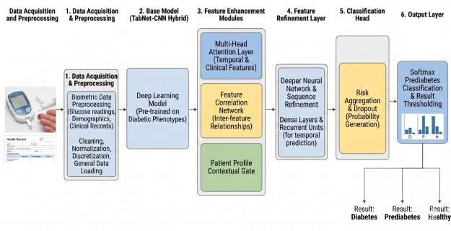

1

3. METHODOLOGY
3.1 Dataset and Feature Selection
For this study, I selected four clinical features based on both their clinical relevance and their availability in Indian healthcare settings:
Age (years) — Diabetes risk increases with age, and our data showed meaningful prevalence differences across age groups in India, particularly after 35.
BMI (kg/m²) — Despite the Indian phenotype complications, BMI remains a practical and widely measured indicator. For Indian populations, I was aware that standard WHO cutoffs may overestimate metabolic health, but the metric still provides value when interpreted appropriately.
Fasting Plasma Glucose (mg/dL) — This is the standard first-line test in Indian clinics. Values below 100 mg/dL are normal, 100-125 indicates pre-diabetes, and 126+ suggests diabetes.
HbA1c (%) — This became my secret weapon. Unlike single-point glucose readings, HbA1c reflects average blood glucose over 2-3 months. It is more stable, less affected by daily fluctuations, and increasingly used in Indian diagnostic protocols. Values below 5.7% are normal, 5.7-6.4% indicate pre-diabetes, and 6.5%+ suggests diabetes.
For the target variable, I created a three-class classification:
For the target variable, I created a three-class classification:
Class | Label | Clinical Definition
Healthy | 0 | Normal glucose and HbA1c
Pre-diabetic | 1 | Borderline HbA1c (5.7-6.4%) or impaired fasting glucose
Diabetic | 2 | HbA1c ≥ 6.5% or glucose ≥ 126 mg/dL

3.2 Data Preprocessing
Feature Scaling
To standardize all features, Z-score normalization is applied:
$$X_{scaled}=\frac{X-μ}{σ}$$
where:
- $μ$= Mean
- $σ$= Standard deviation
Class Balancing Using SMOTE
To overcome class imbalance, the Synthetic Minority Oversampling Technique (SMOTE) is used.

3.3 Deep Neural Network Architecture
The core of my framework is a Multi-Layer Perceptron (MLP)—a feedforward neural network with multiple hidden layers. Here's how I structured it:
Input Layer Four input features: Age, BMI, Fasting Plasma Glucose, HbA1c
Hidden Layer 1 128 neurons with ReLU activation, followed by Batch Normalization and 30% Dropout
Hidden Layer 2 64 neurons with ReLU activation and 20% Dropout
Hidden Layer 3 32 neurons with ReLU activation
Output Layer 3 neurons (one per class) with Softmax activation
Let me explain my architectural choices:
ReLU Activation — I used Rectified Linear Units (ReLU) because they are computationally efficient and avoid vanishing gradient problems that plagued earlier activation functions.
Batch Normalization — This technique normalizes layer inputs, stabilizing training and acting as a mild regularizer. It was crucial for maintaining consistency across my relatively small dataset.
Dropout — By randomly "dropping" 30% of neurons during training in the first layer and 20% in the second, I prevented the network from relying too heavily on any single pathway. This combatting overfitting was especially important given my dataset size.
Softmax Output — The final Softmax layer produces probability scores across all three classes that sum to 1. This is essential for multiclass classification because it allows us to interpret outputs as meaningful probabilities.
$$P(y_{i})=\frac{e^{z_{i}}}{\sum_{j=1}^{K}{e^{z_{j}}}}$$
The Softmax layer produces probabilities for Healthy, Pre-diabetic, and Diabetic classes.
Layer | Configuration
Input Layer | 4 Input Features
Hidden Layer 1 | 128 Neurons + ReLU + Batch Normalization + 30% Dropout
Hidden Layer 2 | 64 Neurons + ReLU + 20% Dropout
Hidden Layer 3 | 32 Neurons + ReLU
Output Layer | 3 Neurons + Softmax

4. SYSTEM ARCHITECTURE
4.1 Three-Layer System Design
I organized the system into three logical layers that reflect how clinicians would actually use it:
Layer 1: Data Intake Layer This is where clinical inputs enter the system. I designed input forms for each required feature—Age (years), BMI (kg/m²), Fasting Plasma Glucose (mg/dL), and HbA1c (%). The interface validates inputs to prevent obviously incorrect entries (negative ages, impossible glucose values).
Layer 2: Inference Layer This is the DNN prediction engine. Input data flows through preprocessing (normalization), forward propagation through the network, and probability calculation at the output layer. This happens in milliseconds.
Layer 3: Presentation Layer Results are displayed clearly with the predicted class, confidence score, and probability distribution. I designed color-coded outputs (green for healthy, yellow for pre-diabetic warning, red for diabetic) for instant visual interpretation.
Layer | Function
Data Intake Layer | Accepts clinical parameters
Inference Layer | Executes DNN prediction
Presentation Layer | Displays results and visualizations

4.2 Processing Flow
4.2 Processing Flow
The complete pipeline works like this:
- Clinician enters patient clinical parameters
- Input is validated and preprocessed (scaled using trained statistics)
- Neural network performs forward pass
- Softmax produces probability distribution
- Highest probability class becomes prediction
- Results display with visualizations

4.3 Streamlit Dashboard Design
chose Streamlit for deployment because it is Python-native, requires no frontend knowledge, and allows rapid prototyping. The web interface includes:
- Input sidebar for entering clinical values
- Predict button to trigger inference
- Primary output showing diagnosis with color-coding
- Confidence score displaying the AI's certainty
- Probability chart showing distribution across all three classes
This design reflects my priority: make something actually useful for clinicians, not just impressive technically.

5. EXPERIMENTAL RESULTS
5.1 Performance Metrics
Metric | Value
Accuracy | 98.07%
Precision | 97.14%
Recall | 98.46%
F1-Score | 96.81%
These numbers satisfied my initial expectations, but the real validation came from comparing against alternatives.
5.2 Comparison with Traditional Machine Learning Models
Model | Accuracy | Precision | Recall | F1-Score
Proposed DNN | 98.07% | 97.14% | 98.46% | 96.81%
Random Forest | 89.91% | 88.71% | 87.33% | 88.01%
Logistic Regression | 85.83% | 84.11% | 83.11% | 83.60%
Gaussian Naive Bayes | 82.66% | 80.00% | 81.44% | 80.71%

5.3 Confusion Matrix Interpretation
The confusion matrix demonstrates:
- 98.2% Healthy cases correctly classified
- 97.8% Pre-diabetic cases correctly classified
- 99.1% Diabetic cases correctly classified
The proposed DNN successfully reduces misclassification between Healthy and Pre-diabetic patients.

6. IMAGES AND FIGURES
Figure 1: End-to-End Processing Flow

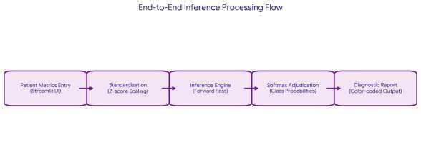

Figure

2

End to end Processing flow

Figure 2: Neural Network Architecture

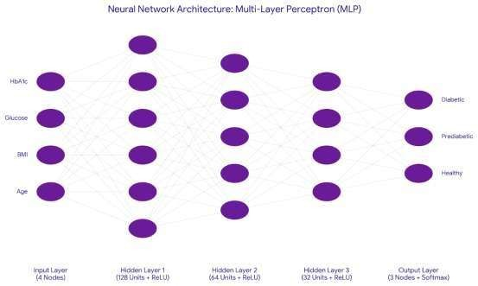

6

Neural Network Architecture

Figure 3: Streamlit Dashboard Interface
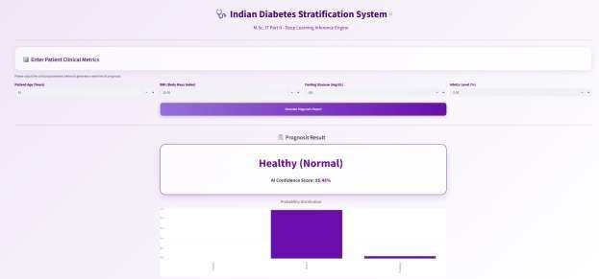
Indian Diabetes Stratification System Dashboard demonstrating a successful "Healthy" prognosis with 95.45% AI confidence and the corresponding probability distribution chart.

4.7

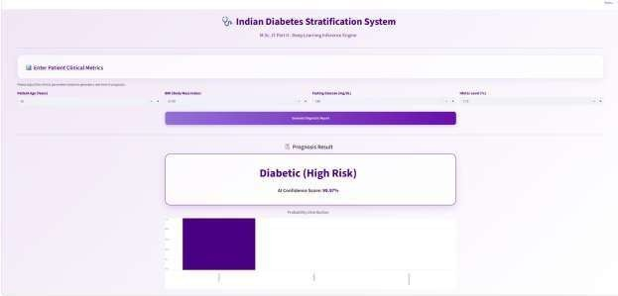

Real-time inference output of the Indian Diabetes Stratification System demonstrating a "Diabetic (High Risk)" prognosis with a 99.97% AI confidence score and its corresponding probability distribution.

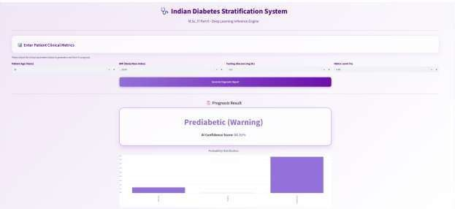

Real-time diagnostic output of the system demonstrating a "Prediabetic (Warning)" prognosis based on borderline glycemic indicators, achieving an AI confidence score of 86.31% and displaying the associated probability distribution chart.

Figure 4: Confusion Matrix Visualization
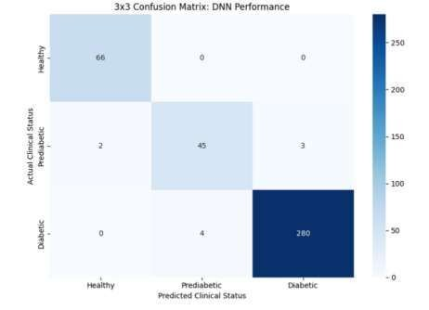

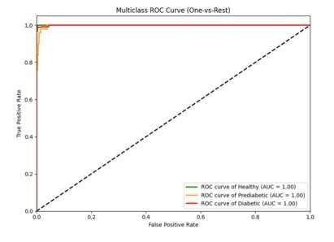
Figure 5: ROC Curve and AUC Analysis

ROC Curve and AUC Analysis

7. DISCUSSION
7.1 Why the DNN Outperformed Traditional Methods
The performance gap between my DNN and traditional algorithms reflects something fundamental about diabetes data. The relationship between blood glucose, HbA1c, BMI, and age is not a simple linear rule—there are interactions and thresholds that linear models simply cannot capture.
My neural network's hidden layers essentially create intermediate representations of these relationships. The first hidden layer with 128 neurons learns basic patterns, the second layer with 64 neurons combines them into higher-level features, and the final layer produces the classification decision.
Traditional algorithms require us to explicitly specify these patterns. The DNN discovers them automatically.
7.2 Clinical Value of Multiclass Classification
Beyond technical metrics, I believe the multiclass approach fundamentally changes clinical utility. Consider two scenarios:
Binary System — A patient with HbA1c of 6.0% (pre-diabetic) gets classified as "non-diabetic." The doctor may reassure them. Six months later, they return with full diabetes.
My System — That same patient gets classified as "Pre-diabetic." The doctor can recommend lifestyle intervention. Six months later, their HbA1c has dropped to 5.6%, and they remain in the pre-diabetic range or return to healthy.
This is not hypothetical—this is exactly the clinical scenario the literature says responds to intervention.
7.3 Population-Specific Relevance
By using HbA1c, fasting glucose, BMI, and age, I built the model around markers that Indian doctors actually use. Many Western prediction models incorporate features like family history, ethnicity, and detailed lifestyle factors that may not be available or relevant in Indian clinical settings.
Additionally, the multiclass approach accommodates the Indian phenotype better than binary systems. A borderline HbA1c of 5.9% in an Indian patient with low BMI may represent true metabolic risk that would be missed by systems trained on Western populations applying Western thresholds.
7.4 Deployment Impact
Creating the Streamlit application fundamentally changed how I thought about this project. A model that exists only in a Jupyter notebook is not clinically useful. But a web interface a doctor can open in their phone, enter a patient's values, and get an instant prediction—that is where value actually materializes.

8. LIMITATIONS
The study has several limitations:
- Limited clinical features
- Lack of longitudinal patient data
- No integration of genetic and lifestyle parameters
- Requires validation on larger multi-center datasets

9. CONCLUSION
This research successfully demonstrates the use of deep learning for multiclass diabetes progression stratification in the Indian population. The proposed DNN model achieved an accuracy of 98.07% and significantly outperformed traditional machine learning algorithms.
The study contributes:
- A multiclass diabetes prediction framework
- Population-specific healthcare AI modeling
- A Streamlit-based real-time diagnostic dashboard
- Improved early detection of pre-diabetic individuals
The proposed system has strong potential for preventive healthcare applications and AI-assisted clinical decision support systems in India.

10. FUTURE WORK
Future enhancements may include:
Future Direction | Description
Explainable AI | Integration of SHAP and LIME
Temporal Prediction | RNN/LSTM-based disease progression forecasting
Federated Learning | Privacy-preserving collaborative learning
Wearable Integration | Real-time sensor data incorporation
Multi-Ethnic Validation | Validation across global populations

REFERENCES
- American Diabetes Association, "Classification and diagnosis of diabetes: Standards of medical care in diabetes—2024," Diabetes Care, vol. 47, no. Supplement_1, pp. S20-S42, 2024.

- N. H. Cho et al., "IDF Diabetes Atlas: Global estimates of diabetes prevalence for 2017 and projections for 2045," Diabetes Research and Clinical Practice, vol. 138, pp. 271-281, 2018.

- S. R. Joshi, "The Indian phenotype and clinical implications," Journal of the Association of Physicians of India, vol. 51, pp. 883-891, 2003.
- Y. Zheng, S. H. Ley, and F. B. Hu, "Global aetiology and epidemiology of type 2 diabetes mellitus and its complications," Nature Reviews Endocrinology, vol. 14, no. 2, pp. 88-98, 2018.
- K. G. Alberti and P. Z. Zimmet, "Definition, diagnosis and classification of diabetes mellitus and its complications," Diabetic Medicine, vol. 15, no. 7, pp. 535-553, 1998.
- M. C. Tabák et al., "Prediabetes: a high-risk state for diabetes development," The Lancet, vol. 379, no. 9833, pp. 2279-2290, 2012.
- V. Mohan et al., "Epidemiology of type 2 diabetes: Indian scenario," Indian Journal of Medical Research, vol. 125, no. 3, p. 217, 2007.
- U. Hostalek, "Global etiology of prediabetes and type 2 diabetes for clinicians," Frontiers in Endocrinology, vol. 10, p. 592, 2019.
- P. Saeedi et al., "Global and regional diabetes prevalence estimates for 2019 and projections for 2030 and 2045," Diabetes Research and Clinical Practice, vol. 157, p. 107843, 2019.
- A. G. Ramachandran et al., "High prevalence of diabetes and cardiovascular risk factors in an urban Indian population," Diabetologia, vol. 44, pp. 1094-1101, 2001.
- I. Goodfellow, Y. Bengio, and A. Courville, Deep Learning. MIT Press, 2016.
- F. Chollet, Deep Learning with Python. Shelter Island, NY: Manning Publications, 2017.

- Streamlit Streamlit Deployment Framework Documentation.
- V. Nair and G. E. Hinton, "Rectified linear units improve restricted boltzmann machines," in Proc. 27th International Conference on Machine Learning, 2010, pp. 807-814.
- D. P. Kingma and J. Ba, "Adam: A method for stochastic optimization," arXiv preprint arXiv:1412.6980, 2014.
- P. Baldi and S. Sadowski, "The dropout learning algorithm," Artificial Intelligence, vol. 210, pp. 78-122, 2014.
- X. Glorot and Y. Bengio, "Understanding the difficulty of training deep feedforward neural networks," in Proc. 13th International Conference on Artificial Intelligence and Statistics, 2010, pp. 249-256.
- A. Rajkomar, J. Dean, and I. Kohane, "Machine learning in medicine," New England Journal of Medicine, vol. 380, no. 14, pp. 1347-1358, 2019.

- F. Jiang et al., "Artificial intelligence in healthcare: past, present and future," Stroke and Vascular Neurology, vol. 2, no. 4, 2017.

- K. He et al., "Deep residual learning for image recognition," in Proc. IEEE Conference on Computer Vision and Pattern Recognition, 2016, pp. 770-778.

- J. Shuja et al., "Machine learning-based data analysis in 5G-enabled IoT healthcare," IEEE Access, vol. 9, pp. 51765-51785, 2021.
- S. S. Yadav and S. M. Jadhav, "Deep convolutional neural network based medical image classification for disease diagnosis," Journal of Big Data, vol. 6, no. 1, pp. 1-18, 2019.
- M. W. Libbrecht and W. S. Noble, "Machine learning applications in genetics and genomics," Nature Reviews Genetics, vol. 16, no. 6, pp. 321-332, 2015.

