Design and Simulation of a Metamaterial-Based Square Split Ring Octagonal Antenna for Sub-Terahertz 6G Wireless Applications

ABSTRACT
Wireless communication has transitioned from fifth to sixth generation (6G) due to increased services, applications, and use case scenarios. 6G uses sub-THz and THz bands, but high path loss is a challenge. Antennas with larger gain and efficiency across a wider frequency range are more beneficial. This work develops a novel square split ring (SSR) octagonal shaped radiator suitable for metamaterial structure. The Rogers substrate with a dielectric constant of 2.2, 0.8 mm thickness, and 0.00009 loss tangent is used in the design. The antenna operates between 190-300 GHz, spanning 102 GHz to 278 GHz. The antenna was adopted at the World Radio Conference (WRC) 2023 for advanced use cases of 6G. Simulation results show the unit cell has a reflection coefficient between -10 dB and -35 dB within 190-300 GHz, an effective stop-band at 210 GHz and 255 GHz, and near zero permeability and permittivity at 219 GHz and 290 GHz. The antenna consists of 3 by 3-unit cells with 0.20 mm spacing, Rogers substrate, and ground plane. Simulation results show the antenna has a value of S11 ≤ -10 dBi and S12 ≤ -10 dBi at all frequencies, making it suitable for Sub Terahertz applications.
Keywords—component, Sixth Generation, Metamaterial, Antenna, SSR, Terahertz, Unit Cell.
INTRODUCTION
The sixth-generation (6G) wireless network is designed to support massive internet connections with high data rates, low latency, reliability, intelligence, energy efficiency, and security (Dhinesh & Suresh, 2022). Achieving these goals requires advanced physical layer techniques, new modulation and multi-access methods, edge computing, cell-free massive MIMO, blockchain and quantum technologies, integration of terrestrial and non-terrestrial networks, and the adoption of AI and machine learning. Future 6G technologies will also leverage reconfigurable intelligent surfaces (RISs), extra-large MIMO, holographic radio, full-duplex communication, and the use of both sub-10 GHz and higher frequency bands to ensure seamless connectivity, high speed, and ultra-low latency (Chataut et al., 2024)(Rajatheva et al., 2020).
Conventional antennas struggle to transmit and receive terahertz waves due to their fixed radiation patterns and limited frequency range. Metamaterials, with their unique electromagnetic properties, are being researched to overcome these limitations and create antennas with low profiles, broadband capabilities, and high directivity (Akyildiz et al., 2020)(Bariah et al., 2020). This work proposes a novel metamaterial-based antenna operating in the THz frequency range of 190–300 GHz, designed as a compact circularly polarized waveguide suitable for advanced 6G applications.
The major contributions of this work in the development of metamaterial-based antenna for sixth generation applications are:
A unique octagonal square split ring (SSR) metamaterial antenna was developed to operate effectively within the sub-THz frequency range of 190–300 GHz, aligning with World Radio Conference 2023 guidelines for advanced 6G applications. The design used a miniaturized 3x3 unit cell array with 0.20 mm spacing, achieving reduced overall size while maintaining high performance and circular polarization. The antenna utilized metamaterial properties, including near-zero permeability and permittivity, to enhance performance in beam steering and radiation pattern control. Simulations using CST Microwave Studio 2019 showed excellent results, with the reflection coefficient (S11) maintained between -10 dB and -35 dB across the operating frequency range.
LITERATURE REVIEW
The sixth-generation (6G) wireless network is designed to support massive internet connections with high data rates, low latency, reliability, intelligence, energy efficiency, and security (Dhinesh & Suresh, 2022). Achieving these goals requires advanced physical layer techniques, new modulation and multi-access methods, edge computing, cell-free massive MIMO, blockchain and quantum technologies, integration of terrestrial and non-terrestrial networks, and the adoption of AI and machine learning. Future 6G technologies will also leverage reconfigurable intelligent surfaces (RISs), extra-large MIMO, holographic radio, full-duplex communication, and the use of both sub-10 GHz and higher frequency bands to ensure seamless connectivity, high speed, and ultra-low latency (Chataut et al., 2024)(Rajatheva et al., 2020).
The significant growth in data traffic and demand for higher data rates for IoT applications has led researchers to exploit existing spectrum and pushed to higher servicing frequency bands like mmWave and THz leading to more energy-efficient and less sensitive to interference networks (Tang et al., 2020). mmWave communications are essential for future 6G networks due to their large bandwidth and capacity improvements. They are suitable for mobile wideband and delay-sensitive applications. IEEE 802.11ad considers mmWave for short-range stationary scenarios. However, they face propagation issues like high signal attenuation, absorption, and penetration loss (Ichkov et al., 2023). THz communication is a potential enabler of 6G networks, achieving ultra-highspeed data and supporting bandwidth-intensive applications. It can reduce spectrum scarcity and be suitable for distant sensing, IoNT, IoBT, and future micro-scale applications (El Ghzaoui et al., 2022).
Recently, the idea of digital metamaterials has emerged. They can be programmable, allowing a single metamaterial to perform different functions with different coding sequences. The capacity of metamaterials to manipulate electromagnetic wavefields arbitrarily has led to the emergence of several fascinating physical phenomena and useful devices. The most recent wireless networks such as 6G relies on the evolution of adaptive antenna. This gave birth to a new phase in antenna designs that are able to adapt themselves to changing radio frequency environment. Such Antenna in which the frequency, radiation pattern and polarization can be varied is called Reconfigurable Antenna. Several research works have been done on the design of reconfigurable antennas. This includes: Its evolution, the need for different reconfigurations and their design specifications (Karthika & Kavitha, 2021).
Modern antennas should be small, low-profile, and high bandwidth, with sufficient radiation pattern and gain. Antennas for 6G network are expected to resonate at high frequency, be highly directional, reconfigurable and operate at wide bandwidth. The new spectrum envisioned for 6G is characterized by high path loss and atmospheric absorption (Milias et al., 2021). One of the germane challenges towards realizing 6G networks is the design of an antenna that will meet this requirement. Three broad classification of antennas design, structures and configuration for 6G have been proposed: Large array antennas, patch antenna, and metamaterial antenna.
Recent research to explore the future aiming to meet the communication needs of the 2030s. The study examined critical issues and potential features of 6G, focusing on its vision, key features, challenges, potential solutions, and ongoing research activities. Conducted as a comprehensive literature review, it analyzed various controversial research topics and sub-domains to draw precise and concrete conclusions. The results highlighted promising research directions and opened new horizons for future studies in 6G development and deployment (Alsharif et al., 2020).
Metamaterials (MMs) are artificially designed objects or materials having qualities that vary from those found in nature and whose electromagnetic (EM) properties are described by electric permittivity (ε) and or magnetic permeability (µ) (Hussain et al., 2023). Dielectrics are specialized insulators that influence the properties of MMs. They have unique ability to undergo polarization when subjected to an electric field. This polarization process is germane because it defines how the material will respond with electromagnetic waves, majorly at high frequencies.
Recent research on metamaterial antennas for 6G terahertz applications has shown promising advancements. (Shi et al., 2024) developed an all-dielectric integrated meta-antenna with high efficiency (84.1%) and a sub-wavelength focal spot for 6G terahertz communication. (Vadlamudi & Kumar, 2023) designed broadband THz antennas for 6G applications, achieving a gain of 7.27 dBi with half-circle-shaped directors. (Khan et al., 2024) presented high-gain metamaterial-associated antennas, polarized circularly for mm-wave 5G and 6G sub-THz communication, achieving gains of 34.759 dBi and 36.3155 dBi for two different designs. These studies demonstrate the potential of metamaterial antennas in enhancing performance, reducing size, and improving efficiency for future 6G terahertz communication systems. Despite that metamaterial antennas are advantageous in terms of low cost, miniaturized, less complex, reduced power consumption, increased bandwidth, and Reconfigurable, yet they are limited and complex in terms of design, fabrication of Nano-element, and design of tunnable elements.
There are ongoing efforts in developing advanced antenna technologies for 6G communication systems. Several studies leverage metamaterials to enhance antenna performance, including circular polarization, gain enhancement, and bandwidth improvement. More so, researchers explore integrated approaches, such as combining metagratings with dielectric materials for efficient beam focusing and integrating Through-Silicon Vias (TSV) with Integrated Substrate Gap Waveguides (ISGW) for compact designs. Also, novel Luneburg lens designs are proposed with improved bandwidth and radiation efficiency, suitable for multibeam applications. While challenges remain,
The exploration of metamaterials, integrated designs, and novel structures offers promising avenues for achieving high-performance, efficient, and compact antennas for future wireless networks. However, fabrication complexity is a common challenge, particularly with intricate metamaterial structures and integrated designs. Additionally, some designs exhibit limitations in overall efficiency. Finally, achieving precise control over metamaterial properties and complex geometries can be challenging
METHODOLOGY
Design and analysis of unit cell metamaterial
The creation of a metamaterial unit cell varies based on desired properties. In designing metamaterial antenna, identification of the desired characteristics of the final metamaterial, selection of unit cell geometry. determination of material properties of the unit cell, and design of the meta cell on CST MWS are the procedure. Designing a unit cell radiator is crucial when designing a metamaterial antenna for high performance applications. The SSR resonator has been widely adopted for the design of 6G antennas.
Antenna performance is largely dependent on its design, with many formulas being used to compute the design parameters (Colaco & Lohani, 2020)(Merlin & Umamaheswari, 2022). In this work, the unit cell structure is designed using an inexpensive 2.2 relative permittivity rogers substrate, 0.08 mm of thickness, and copper cladding. The unit cell was simulated using the CST MWS. The MTM unit cell consists of SSR unit cell combined with octagonal shape structure with 0.2mm slab operating at 190GHz to 300GHz (0.19THZ-0.30THZ). The geometry of the designed unit cell is shown in Fig. 1 and Table 1 shows the unit cell parameters.
Configuration of metallic rings, stubs, and gaps often controls the metamaterial structure's resonance characteristics. The metamaterial unit cell structure with meander lines is positioned in the wave ports along z-axis (negative and positive). Fig. 2 shows the simulation setup to validate the unit cell's operating principle.
Selecting the right unit cell for an antenna often requires doing simulations for several parameters including S11 and S12, to carry out the performance of the meta cell. In this work CST MWS 2019 software is used to model the unit cell and display its performance regarding S11 parameters for two set up. The suitability of a unit cell for metamaterial is also determined by the permeability and permittivity of the unit cell, the permittivity and permeability of the designed unit cell was visualize using CST MWS.
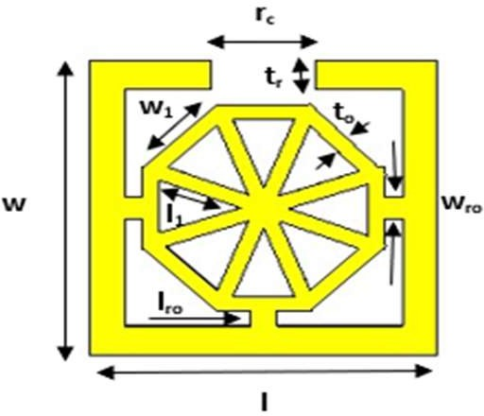
Figure 1. Geometry view of the proposed unit cell
Design and analysis of metamaterial Antenna based on unit cell structure
The metamaterial antenna was designed based on the effective parameters. The antenna's configuration includes a microstrip line, 3 by 3 SSR with octagonal shape unit cells. Fig. 3 shows the geometry, simulation set up and design view of the designed antenna. The parameters of the designed Antenna is presented in Table 2. The performance evaluation of the designed antenna is done based on the key performance metrics such as; Radiation Pattern, Gain, Axial Ratio, and Forward to back ratio.
Table 1. Unit Cell’s Parametters
Parameter | Value (mm) | Description
l | 2.0 | Length of the patch
w | 2.0 | Width of the patch
Rc | 0.60 | Square ring cut
ts | 0.80 | Substrate thickness
w1 | 0.59 | Width of each octagonal side
l1 | 0.50 | lenght of each octagonal side
wro | 0.15 | Width of ring to octagon connector.
lro | 0.10 | Length of ring to octagon connector
st | 0.20 | Thickness of square ring
ot | 0.10 | Thickness of octagon.

Table 2. Full Antenna Parameters
Parameter | Value (mm) | Description
l | 6.46 | Length of the patch
b | 6.46 | Breath of the patch
g | 0.20 | Gap between the patch
f_{g} | 1.00 | Feed gap
f₁ | 0.80 | Feed length
s₁ | 8.00 | length of the substrate
s_{b} | 8.00 | breath of the substrate
s_{w} | 0.80 | Thickness of substrate

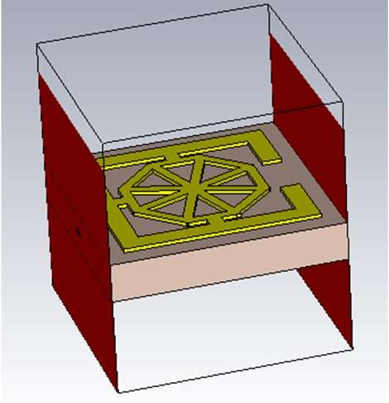
Figure 2. Simulation setup

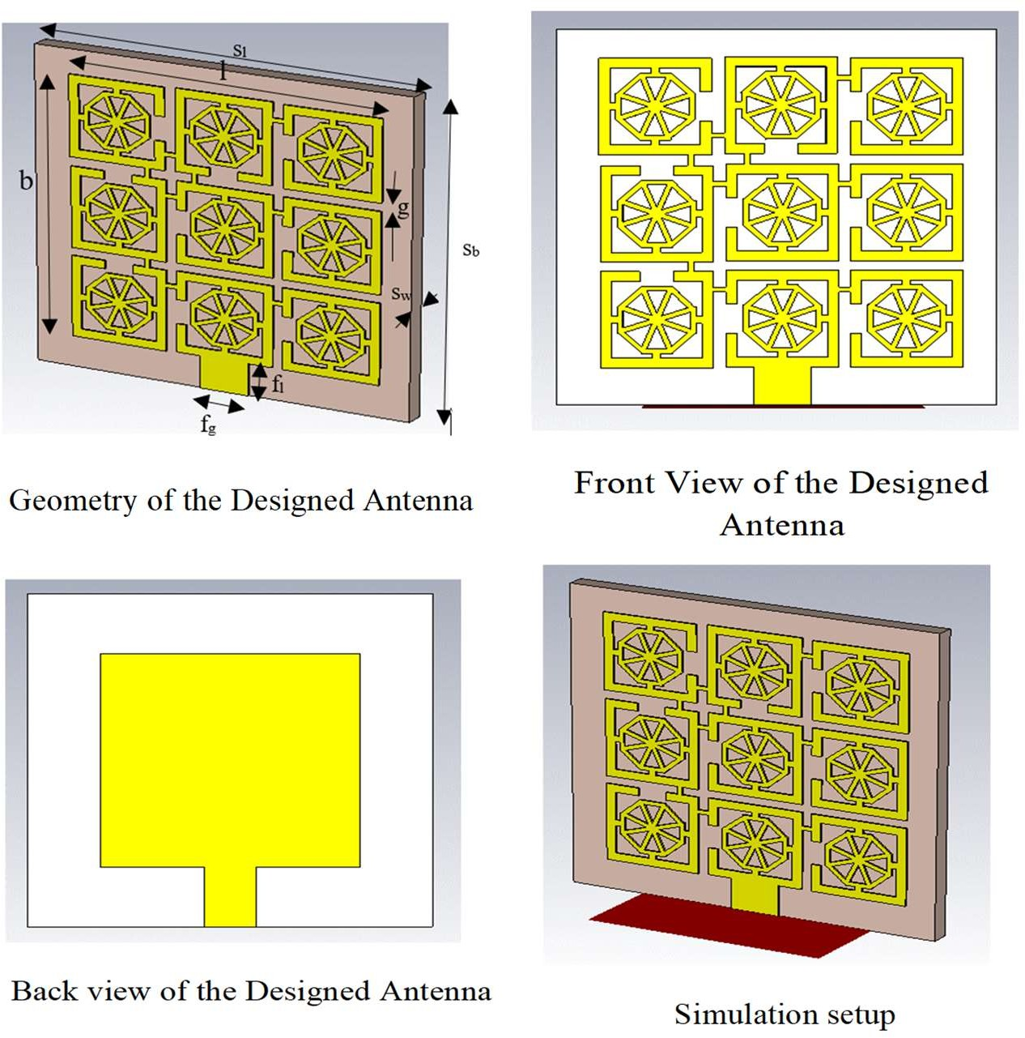
Figure 3. Design view and simulation set up of designed Antenna
RESULTS AND DISCUSSION
Results of the Designed Unit Cell
Fig. 4 display the workings of the unit cell regarding S11 parameter for the simulation setup. The reflection coefficient, which is represented by (S11), is also known as return loss, with -10 dB denote good, -15 dB means better and if is 0 dB then no radiation has occurred. It can be seen from Fig. 4 that at 210 GHz and 255 GHz the unit cell creates an effective stop-band. This result makes it suitable for metamaterial antenna.
Refractive index, permittivity, and permeability, features of the metamaterial structure are ascertained in Figures 5 and 6. In the designed metamaterial construction, the frequency ranges of 190–300 and 195–288 GHz, for the two set up, respectively, exhibit close to zero metamaterial characteristics (almost zero refractive index and negative permeability within these frequency ranges). The results of the designed unit cell, as shown in Fig. 6 and 7, is near zero, indicating that it performs well and may be utilized to create a high-performance radiator for wireless systems.
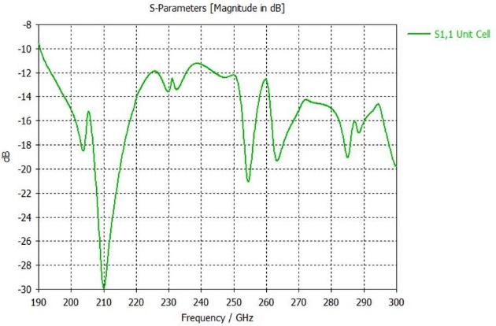
Figure. 4. S11 result of unit cell
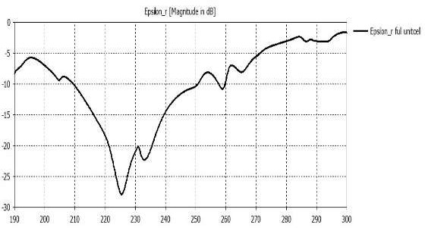
Figure 6. Permittivity of the unit cell
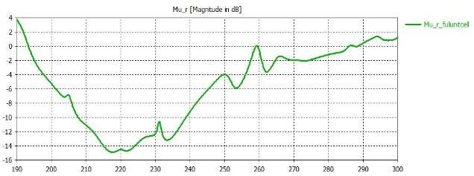
Figure 7. Permeability of the unit cell
Results for Metamaterial Antenna
The performance of the Designed Antenna under different conditions is simulated, Figs. 8 and 9 display the performance of the designed antenna regarding S11 parameter and S12 parameters respectively. The designed antenna has good performance, S11 ≤ -15 dB and S12 ≤ -24 dB in all operating frequency
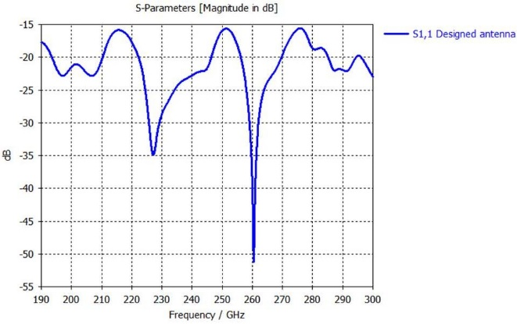
Figure 8. S11 parameter result of Designed Antenna
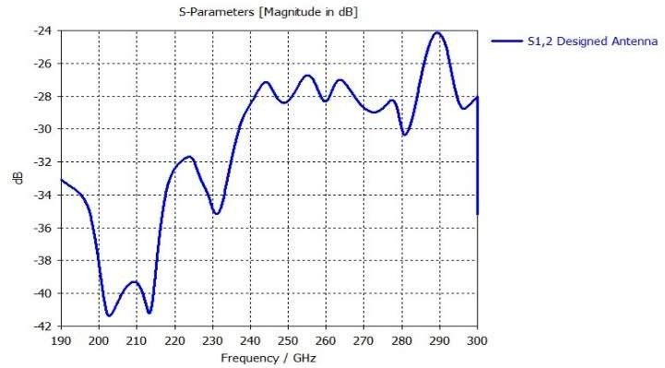
Figure 9. S12 parameter result of Designed Antenna
CONCLUSION
The limitations of 5G have triggered the evolution towards 6G, which will use sub-THz (90–300 GHz) and THz (0.1–10 THz) bands. However, these high frequencies face challenges like high path loss and atmospheric absorption. To address this, a novel square split ring (SSR) octagonal-shaped radiator suitable for metamaterial structures was designed and simulated. Results for S11, S12, permittivity, and permeability showed the unit cell's suitability for metamaterial antenna design. Using nine unit cells in a 3x3 arrangement on a Rogers substrate (thickness 0.8 mm, epsilon 2.2, Mu 1), an antenna operating between 190 GHz and 300 GHz was developed, covering the allocated 102–109 GHz band for advanced 6G applications.
Although the antenna performed well in simulations across all frequencies in terms of S11 and S12, real-world performance needs evaluation through fabrication and testing. Future research should focus on validating simulated results with experimental data, and assess other performance metrics such as radiation pattern, gain, axial ratio, and front-to-back ratio to ensure its practical viability for 6G use cases.

Acknowledgment
Our profound gratitude goes to The Nigeria Communication Commission (NCC) Professorial Chair Endowment, Federal University of Technology Minna, for the kind support and finance of this work. The NCC, which has been instrumental in promoting research and innovation in the field of communication technology in Nigeria, made this initiative feasible.
We would like to sincerely appreciate the NCC for their dedication to elevating academic standards and encouraging industry-academia cooperation. Thanks to their assistance, we have been able to investigate novel research topics and possibilities related to 6G and terahertz applications. We also acknowledged the invaluable contributions of our research team, whose dedication and expertise have been instrumental in the successful execution of this project. Their hard work and enthusiasm have enriched our understanding and propelled our endeavors forward.
References
- Akyildiz, I. F., Kak, A., & Nie, S. (2020). 6G and Beyond: The Future of Wireless Communications Systems. IEEE Access, 8, 133995–134030. https://doi.org/10.1109/ACCESS.2020.3010896
- Alsharif, M. H., Kelechi, A. H., Albreem, M. A., Chaudhry, S. A., Sultan Zia, M., & Kim, S. (2020). Sixth generation (6G)wireless networks: Vision, research activities, challenges and potential solutions. Symmetry, 12(4). https://doi.org/10.3390/SYM12040676
- Bariah, L., Mohjazi, L., Muhaidat, S., Sofotasios, P. C., Kurt, G. K., Yanikomeroglu, H., & Dobre, O. A. (2020). A prospective look: Key enabling technologies, applications and open research topics in 6G networks. IEEE Access, 8, 174792–174820. https://doi.org/10.1109/ACCESS.2020.3019590
- Chataut, R., Nankya, M., & Akl, R. (2024). 6G Networks and the AI Revolution—Exploring Technologies, Applications, and Emerging Challenges. Sensors, 24(6), 1–29. https://doi.org/10.3390/s24061888
- Colaco, J., & Lohani, R. (2020). Design and Implementation of Microstrip Patch Antenna for 5G applications. Icces, 682–685.
- Dhinesh, K. R., & Suresh, C. (2022). Shift to 6G: Exploration on trends, vision, requirements, technologies, research, and standardization efforts. Sustainable Energy Technologies and Assessments, 54, 102666. https://doi.org/https://doi.org/10.1016/j.seta.2022.102666
- El Ghzaoui, M., Das, S., Lenka, T. R., & Biswas, A. (2022). Terahertz Wireless Communication Components and System Technologies. Terahertz Wireless Communication Components and System Technologies, April 2022, 1–310. https://doi.org/10.1007/978-981-16-9182-9
- Hussain, M., Awan, W. A., Alzaidi, M. S., Hussain, N., Ali, E. M., & Falcone, F. (2023). Metamaterials and Their Application in the Performance Enhancement of Reconfigurable Antennas : A Review. Micromachines, 14(349), 1–26.
- Ichkov, A., Mähönen, P., & Simić, L. (2023). Interference-Aware User Association and Beam Pair Link Allocation in mm-Wave Cellular Networks. 2023 IEEE Wireless Communications and Networking Conference (WCNC), 1–7. https://doi.org/10.1109/WCNC55385.2023.10118751
- Karthika, K., & Kavitha, K. (2021). Reconfigurable Antennas for Advanced Wireless Communications: A Review. In Wireless Personal Communications (Vol. 120, Issue 4). Springer US. https://doi.org/10.1007/s11277-021-08555-4
- Khan, A., Ahmad, A., & Alam, M. (2024). High Gain Metamaterial Implemented Antenna Design with Circular Polarization for mm-Wave 5G and 6G Sub-THz Communication. Journal of Electronics and Informatics, 5(4), 423–441.
- Merlin, T. P., & Umamaheswari, G. (2022). Compact Slotted Microstrip Antenna for 5G Applications Operating at 28 GHz. IETE Journal of Research, 68(5), 3778–3785. https://doi.org/10.1080/03772063.2020.1779620
- Milias, C., Andersen, R. B., Lazaridis, P. I., Zaharis, Z. D., Muhammad, B., Kristensen, J. T. B., Mihovska, A., & Hermansen, D. D. S. (2021). Metamaterial-Inspired Antennas: A Review of the State of the Art and Future Design Challenges. IEEE Access, 9(47), 89846–89865. https://doi.org/10.1109/ACCESS.2021.3091479
- Rajatheva, N., Atzeni, I., Bjornson, E., Bourdoux, A., Buzzi, S., Dore, J.-B., Erkucuk, S., Fuentes, M., Guan, K., Hu, Y., Huang, X., Hulkkonen, J., Jornet, J. M., Katz, M., Nilsson, R., Panayirci, E., Rabie, K., Rajapaksha, N., Salehi, M., … Xu, W. (2020). White Paper on Broadband Connectivity in 6G. ArXiv, 1, 1–46. http://arxiv.org/abs/2004.14247
- Shi, J., Li, M., Tang, L., Li, X., Jia, X., Guo, C., Bai, H., Ma, H., Wang, X., & Niu, P. (2024). All‐Dielectric Integrated Meta‐Antenna Operating in 6G Terahertz Communication Window. Small, 20(18), 2308958.
- Tang, W., Chen, M. Z., Dai, J. Y., Zeng, Y., Zhao, X., Jin, S., Cheng, Q., & Cui, T. J. (2020). Wireless Communications with Programmable Metasurface: New Paradigms, Opportunities, and Challenges on Transceiver Design. IEEE Wireless Communications, 27(2), 180–187. https://doi.org/10.1109/MWC.001.1900308
- Vadlamudi, R., & Kumar, D. S. (2023). Design of a THz Antenna with Broadband Radiation Characteristics for 6G Applications. 2023 IEEE Wireless Antenna and Microwave Symposium (WAMS), 1–4.

