DESIGNING OF AUTONOMOUS EV VEHICLE

Pillalamarri Madhavi, Assistant Professor, Department of EEE, Hyderabad Institute of Technology and Management, India, madhavipillalamarry@gmail.com
Salava V Satyanarayana, Associate Professor, Department of EEE, Hyderabad Institute of
Technology and Management, India, pshve2011@gmail.com
Saibharath UG Scholar, Department of EEE, Hyderabad Institute of Technology and
Management, India, saibharathgajula82@gmail.com
Naresh UG Scholar, Department Of EEE, Hyderabad Institute Of Technology And
Management, India, nareshshivaratri0503@gmail.com
Virinchi UG Scholar, Department of EEE, Hyderabad Institute of Technology and
Management, India, Virinchi.bunny@gmail.com
Divya UG Scholar, Department of EEE, Hyderabad Institute of Technology and
Management, India, divyasheshasrithota@gmail.com

ABSTRACT
This project focuses on the design and development of a four-seater autonomous electric vehicle (EV) engineered to provide an affordable, efficient, and sustainable mode of transportation for urban and closed-city environments. The vehicle is powered by a 2 kW BLDC motor and a 60V, 100Ah lithium-ion battery, delivering a top speed of around 60 km/h and a driving range of nearly 100 km per full charge. The system integrates essential EV technologies including the powertrain, battery system, differential mechanism, lightweight chassis, and basic autonomous functionalities to enhance safety and driving convenience. The project demonstrates a practical approach to creating a low-cost EV solution that supports clean mobility and aligns with global goals of reducing emissions and promoting environmentally responsible transportation
Keyword:
Power inverter, 4 seater, Battery, AC-DC Converter, High Efficiency, EV, Autonomous

I. Introduction
The global transportation sector is undergoing a major transformation due to rising fuel costs, environmental concerns, and increasing demand for safer and more efficient mobility solutions. Conventional internal combustion engine vehicles contribute significantly to air pollution, greenhouse gas emissions, and energy dependency on fossil fuels. Electric vehicles (EVs) have emerged as a promising alternative, offering high energy efficiency, reduced emissions, and lower operating costs. However, along with electrification, the integration of autonomous driving technologies has become a key focus area in modern transportation research.

Autonomous vehicles aim to reduce human intervention by using sensors, embedded systems, and intelligent control algorithms to perceive the environment and make real-time driving decisions. Such systems have the potential to significantly improve road safety by minimizing human errors, optimize traffic flow, and enhance accessibility. When combined with electric propulsion, autonomous vehicles provide a sustainable and intelligent solution for future smart cities, campus mobility, and controlled industrial environments.

This paper presents the design and implementation of an Autonomous Electric Vehicle (AEV) that integrates electric drivetrain technology with sensor-based autonomous navigation. The proposed system employs a high-efficiency BLDC motor, a lithium-ion battery pack, a motor controller, and a differential steering mechanism to ensure smooth propulsion and stable vehicle dynamics. Autonomous functionality is achieved using ultrasonic and infrared sensors that continuously monitor the surroundings, while a microcontroller processes sensor data to control steering, speed, and obstacle avoidance in real time.

The primary objective of this work is to develop a low-cost, scalable, and reliable autonomous EV prototype capable of operating in controlled environments. The system emphasizes simplicity, safety, and modularity, allowing future expansion with advanced perception systems such as cameras, LiDAR, GPS, and AI-based decision-making algorithms. The results of this project demonstrate the feasibility of integrating autonomous intelligence with electric mobility, contributing to ongoing research in smart transportation and sustainable vehicle technologies

II. Methodology

The development of the Autonomous Electric Vehicle (AEV) follows a systematic methodology that integrates mechanical design, electrical power systems, sensing, control, and testing. The approach ensures reliable autonomous operation in a controlled environment.

1. System Design & Architecture:
The overall architecture is defined by separating the system into propulsion, energy storage, sensing, control, and mechanical subsystems. Component ratings are selected based on vehicle load, desired speed, range, and safety margins.

2. Mechanical Integration:
A lightweight yet rigid chassis is fabricated to mount the BLDC motor, differential, steering mechanism, battery pack, and sensors. Proper alignment of the 46-inch axle and steering geometry ensures stable handling and smooth turning.

3. Electrical & Power System Implementation:
A 60V lithium-ion battery supplies power to the motor controller and onboard electronics. Protection elements such as fuses and a Battery Management System (BMS) are incorporated to ensure safe operation, voltage balancing, and thermal protection.

4. Sensing & Perception:
Ultrasonic and IR sensors are positioned strategically to detect obstacles and measure distances in real time. Sensor data is continuously sampled and filtered to reduce noise and improve detection accuracy.

5. Control & Processing:
A microcontroller processes sensor inputs and executes autonomous decision-making algorithms. Based on obstacle distance and path conditions, control signals are generated for the motor controller and steering actuator to regulate speed and direction.

6. Autonomous Navigation Logic:
Rule-based logic is implemented for path following, obstacle avoidance, controlled turning angles, and safe stopping. The system prioritizes safety by reducing speed or halting the vehicle when obstacles are detected within a threshold range.

7. Testing & Validation:
The AEV is tested in a controlled test track to evaluate propulsion performance, steering response, obstacle detection accuracy, and energy consumption. Observed results are analyzed to fine-tune control parameters and ensure reliable autonomous behavior.

III. Block Diagram
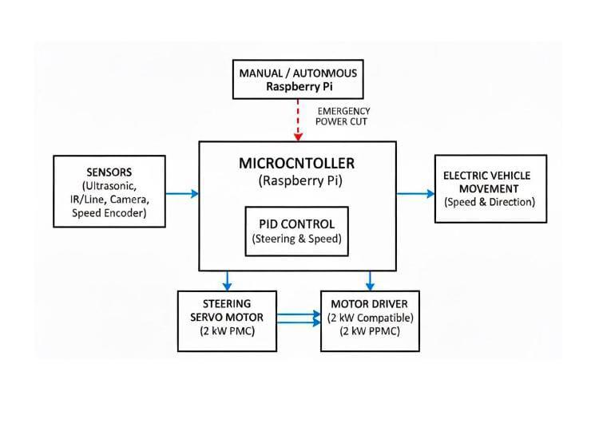
Fig.3.1: Block Diagram.

The block diagram of the Autonomous Electric Vehicle (AEV) represents the flow of power, data, and control signals among the major system components. At the core of the system is the lithium-ion battery pack, which serves as the primary power source. The battery supplies energy to the motor controller for propulsion and to a DC–DC converter that provides regulated power to the microcontroller and sensors. The autonomous sensor block, consisting of ultrasonic and IR sensors, continuously monitors the surrounding environment and sends distance and obstacle data to the microcontroller/processing unit. The microcontroller acts as the central control unit, processing sensor inputs and executing autonomous decision-making algorithms. Based on this logic, it generates control signals for both the motor controller and the steering actuator. The motor controller regulates speed and torque of the BLDC motor, which drives the vehicle through the differential and axle system, enabling smooth motion and stable turning. Simultaneously, the steering actuator adjusts wheel orientation according to microcontroller commands, allowing accurate maneuvering and obstacle avoidance. This closed-loop interaction between sensing, processing, and actuation ensures safe and reliable autonomous operation of the vehicle.

Parameters and specifications of the inverter
BLDC Motor – 2 kW
Motor Controller – 60 V
Battery – 60 V, 100 Ah (Li-ion)
BMS – Cell-balancing
Differential – 46-inch
Axle & Steering Kit – 46-inch
Steering Actuator – Servo/Linear
Turning Angle – 30°–35°
Microcontroller – ESP32/Arduino
Ultrasonic Sensor – HC-SR04
IR Sensor – Obstacle-type
DC–DC Converter – 60 V–12 V
Chassis – Mild-steel
Wheels & Tyres – EV-rated
Braking System – Regenerative
Communication – Serial

IV. Results and Discussion

The Autonomous Electric Vehicle (AEV) prototype was successfully developed and tested in a controlled environment to evaluate its propulsion performance, autonomous navigation, and system reliability. The integration of a 2 kW BLDC motor with a 60V lithium-ion battery provided smooth acceleration and consistent speed control, demonstrating efficient power utilization. The vehicle maintained stable motion during straight-line travel and achieved reliable turning performance within the designed turning angle of 30°–35°, ensuring safe maneuverability without mechanical strain. The autonomous sensor system effectively detected obstacles within the predefined range and enabled timely decision-making by the microcontroller. Ultrasonic and IR sensors provided accurate distance measurements, allowing the vehicle to slow down, stop, or change direction as required. The motor controller responded precisely to control commands, ensuring smooth speed transitions and preventing abrupt movements. The 46-inch differential and steering mechanism contributed to balanced torque distribution and improved handling during turns. Battery performance remained stable throughout the test duration, with the BMS ensuring safe voltage levels, thermal protection, and balanced cell operation. Minor limitations were observed under complex obstacle arrangements, where sensor overlap occasionally affected detection accuracy. However, these issues can be addressed through sensor fusion and advanced perception algorithms. Overall, the results validate the effectiveness of the proposed AEV design and demonstrate its potential as a scalable platform for future autonomous and electric mobility research.

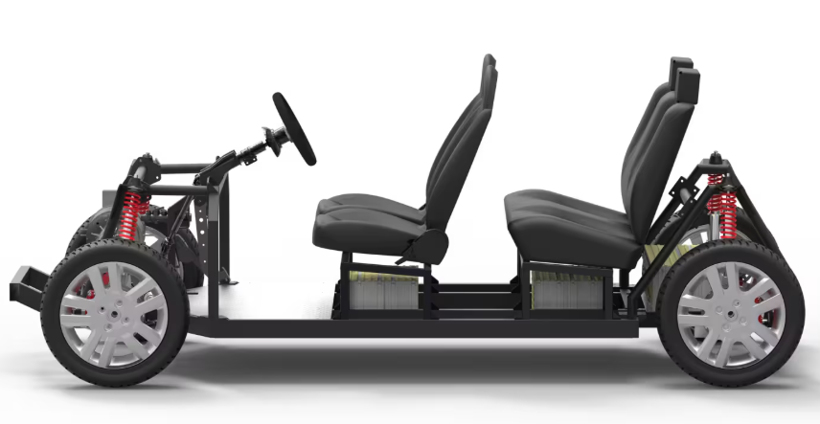
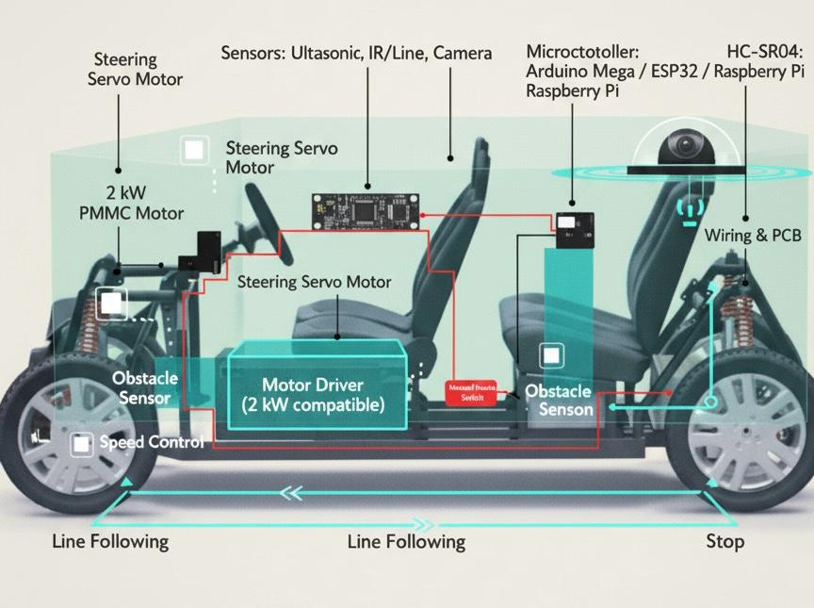

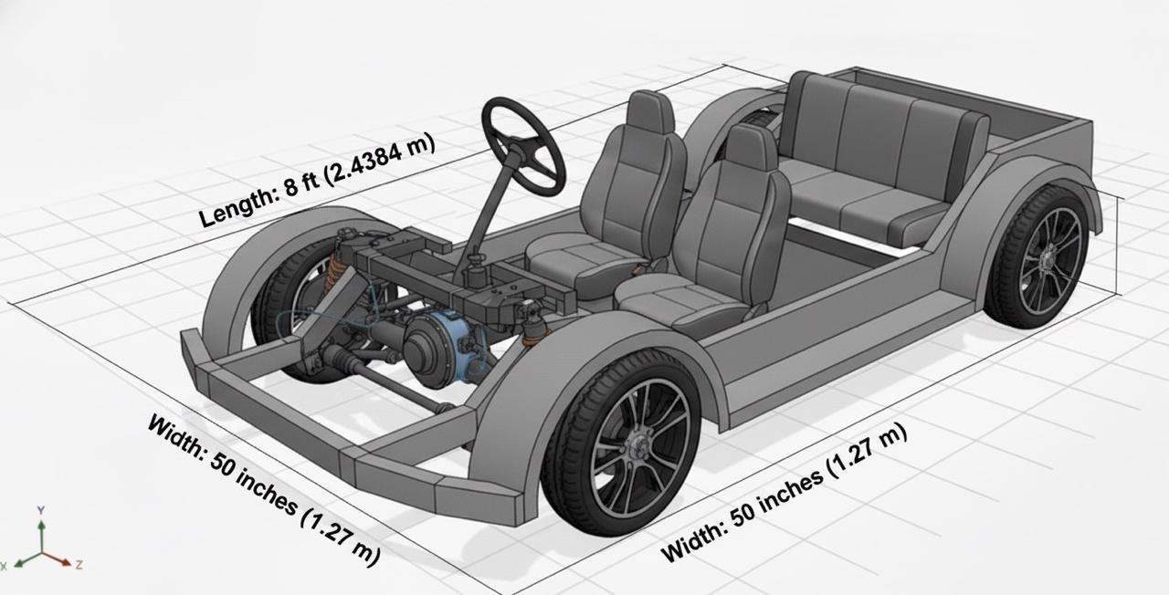

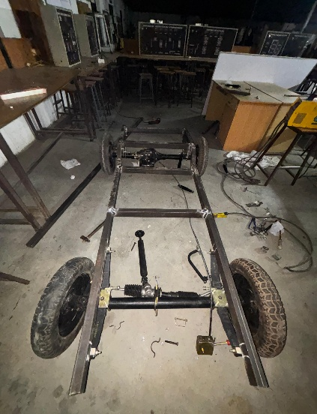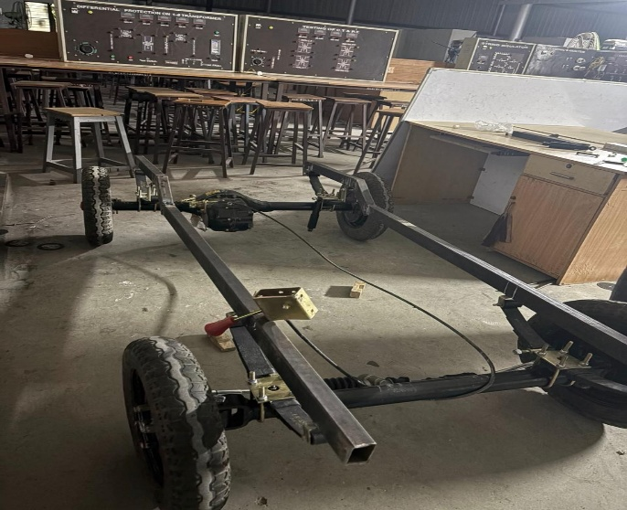
V. Conclusion

The autonomous electric vehicle developed in this project demonstrates a practical approach toward creating a low-cost, eco-friendly mobility solution for urban environments. By integrating a 2 kW BLDC motor, 60V 100Ah battery system, differential drive, and basic autonomous obstacle detection, the vehicle operates efficiently while maintaining safety and stability. The project successfully meets its objectives of achieving moderate speed, reliable range, and autonomous assistance within an affordable budget. Overall, this work proves that accessible technologies can be combined to build a functional and intelligent EV suitable for academic research and future transportation needs.

References
[1] M.J. Sergot, F. Sadri, R.A. Kowalski, F. Kriwaczek, P. Hammond, H.T. Cory, “The British Nationality Act as a logic program ”. Commun. ACM, 1986
[2] A. Rizaldi, J. Keinholz, M. Huber, J. Feldle, F. Immler, M. Althoff, E. Hilgendorf, and T. Nipkow, “Formalising traffic rules for autonomous vehicles involving multiple lanes in Isabelle/HOL ”, Proc. of the 13th International Conf. on integrated Formal Methods, 2017.
[3] D.M. Costescu, “Keeping the autonomous vehicles accountable: Legal and Logic Analysis on Traffic Code ”, Proc. of the International Scientific Conference “Vision Zero for Sustainable Road Safety in Baltic Sea Region ”, Vilnius, 2018.
[4] L. Penghui, H. Mengxia, Z. Wenhui, H. Xiaoqing, L. Yibing, “Steering Behavior during Overtaking on Freeways ”, Fifth International Conference on Computing for Geospatial Research and Application, Washington DC, USA, 2014..
[5] J. R. Chapman, D. A. Noyce, “Influence of roadway geometric elements on driver behavior when overtaking bicycles on rural roads ”, Journal of Traffic and Transportation Engineering, vol. 1 ( 1 ), pp. 28–38, 2014.

