Curvature-Guided Derivative Peak Filtering for Robust Initialization of Sequential XPS Spectral Deconvolution

ABSTRACT
X-ray Photoelectron Spectroscopy (XPS) peak fitting depends critically on accurate initial parameter estimation. Conventional derivative-based peak detection routinely produces excessive false positives on noisy, overlapping, or weak spectral features, degrading sequential fitting convergence. Existing derivative-based and generic peak detection methods provide limited support for transparent, user-adjustable filtering of candidate peaks while maintaining a reproducible initialization workflow for sequential XPS spectral deconvolution. Curvature-Guided Derivative Peak Filtering (CG-DPF) presents a human-in-the-loop framework that augments first-derivative zero-crossing detection with tune-able second-derivative curvature thresholding. Unlike fully automatic detectors, CG-DPF exposes an interpretable curvature threshold on the d²I/dE² chart, enabling analysts to navigate the precision-recall trade-off transparently. The contribution is a filtering strategy and reproducible workflow: whereas existing derivative spectroscopy uses the second derivative primarily to locate extrema, CG-DPF treats curvature as a continuously adjustable acceptance criterion applied after candidate generation. CG-DPF was evaluated against adaptive multi-scale baselines on eight benchmark spectra: one in-house spectrum and seven published spectra. Evaluation uses reconstruction quality, FWHM compliance, and expert-identified peak assignments on spectra with lacking ground-truth peak list. With σ = 8 eV, k = 1, multi-step sigmoid background subtraction, and FWHM bounds 0.2–5.5 eV, CG-DPF detects 5 peaks on the in-house benchmark with Phys. Ratio = 1.0 and Corr. R² = 0.981. Unfiltered curvature (θ = 0) produces 47 candidates (Phys. Ratio = 0.19). Across seven Suliga spectra, CG-DPF averages 5.1 ± 1.1 detected peaks with Phys. Ratio 0.66 ± 0.16, versus 19.9 ± 2.7 peaks and Phys. Ratio 0.30 ± 0.05 for Adaptive Medium. CG-DPF optimizes conservative, FWHM-compliant initialization rather than exhaustive residual minimization. Detection averaged 2 ms per spectrum versus 18 ms for adaptive methods. CG-DPF provides a reproducible initialization workflow with analyst control over the curvature threshold, integrated FWHM screening, with auditable export of parameters, metrics, and figures.
Keywords: X-ray photoelectron spectroscopy, peak detection, derivative spectroscopy, spectral deconvolution, curvature filtering

INTRODUCTION
XPS is a cornerstone technique for surface chemical analysis. Extracting chemical-state information requires deconvolution of overlapping photoemission features through peak fitting, typically with Gaussian, Lorentzian, or Voigt profiles optimized to reconstruct the measured spectrum [2].
Fitting quality is notoriously sensitive to initialization [2,4]. Poor initial estimates of peak position, width, amplitude, or even peak count can lead nonlinear optimizers such as Levenberg–Marquardt or Trust Region Reflective to converge to local minima, produce unstable solutions, or fail to converge.
Traditional initialization is either manual (subjective, labor-intensive, poorly reproducible) or automatic via derivative spectroscopy [13,7] or general-purpose peak finders (e.g., SciPy [12]). Automatic methods frequently over-detect: the first derivative of a noisy spectrum yields numerous zero-crossings from noise as well as genuine peaks [13,4], and unconstrained peak finders applied to survey-scale data can return hundreds of candidates [5,12]. A peak produces a positive-to-negative crossing in dI/dE and negative curvature in d²I/dE², but so do minor fluctuations and baseline irregularities.

Contribution
The objective of this work is to develop an interpretable derivative-based filtering framework that reduces false-positive peak initialization while preserving reproducibility and analyst control for sequential XPS spectral deconvolution. CG-DPF is proposed, a filtering framework that post-processes derivative-based candidates with an interpretable curvature threshold. The contribution is primarily methodological: a new filtering strategy and reproducible workflow that combines derivative spectroscopy, curvature-based candidate rejection, analyst-guided threshold selection, and auditable export (not a novel smoothing kernel or derivative estimator).
Classical derivative spectroscopy uses d²I/dE² primarily to identify extrema and confirm peak locations [13,7]. CG-DPF instead treats curvature as a continuously adjustable acceptance criterion applied after first-derivative candidate generation, allowing analysts to trade recall against precision while preserving a reproducible, logged threshold value. This workflow is generally not provided by standard derivative plots or typical off-the-shelf peak finders that return a fixed candidate set without an interpretable, spectrum-specific curvature gate.
Novel aspects relative to classical derivative spectroscopy and generic peak picking are listed below. Unlike multi-scale consensus detectors, CG-DPF deliberately reduces candidate count before nonlinear optimization rather than increasing candidate recall:
- Post-crossing curvature filtering (algorithmic): θ = μ - kσ applied to interpolated crossings, with transparent control on the d²I/dE² chart.
- FWHM compliance screening (workflow): configurable width bounds integrated into initialization and export.
- Sequential fitting workflow integration (workflow): prominence-ranked peak addition with supplied initial centers.
- Reproducible audit trail (software): exported workbooks with parameters, metrics, and chart PNGs.
Items (2) to (4) are engineering integrations that make the method usable in routine XPS analysis. Item (1) is the core detection rule that distinguishes CG-DPF from unfiltered derivative crossings.

RELATED WORK
Derivative spectroscopy uses dI/dE sign changes and d²I/dE² extrema to locate peaks [7]. Pre-smoothing via Savitzky-Golay [8] or Gaussian convolution is essential because differentiation amplifies noise. Multi-scale approaches detect peaks across several σ values and merge by consensus [5]. High-sensitivity settings can yield hundreds of candidates with low FWHM compliance under survey-scale screening.
General signal-processing peak finders, including scipy.signal.find_peaks (implemented in SciPy [12]), MATLAB findpeaks, and wavelet-based methods, are widely used outside XPS. These approaches generally optimize signal characteristics such as peak height, prominence, width, or multi-scale consistency on raw or lightly processed intensity data, rather than combining first-derivative zero-crossing detection with an interpretable second-derivative curvature-gating strategy tailored for sequential XPS spectral deconvolution. Consequently, their objectives differ from that of CG-DPF, which emphasizes conservative, reproducible initialization with analyst-controlled filtering. Quantitative comparisons in this study are therefore limited to the in-tool Adaptive Detection presets, which provide a strong multi-scale baseline under identical preprocessing, fitting, and export conditions. Overall, CG-DPF differs from existing derivative-based and general-purpose peak detection methods by introducing a transparent post-detection curvature-filtering workflow that integrates FWHM compliance screening, sequential fitting initialization, and reproducible parameter logging for XPS analysis.
Sequential fitting, adding peaks incrementally with re-optimization, is standard in XPS practice [2,4]. CG-DPF is positioned as an interpretable filtering layer for initialization rather than a fully autonomous detector. Adaptive multi-step baseline estimation, when used in the same software, addresses a complementary problem (background modeling) and is not combined with the present peak-initialization study.
Conventional XPS peak fitting commonly employs Gaussian, Lorentzian, or Voigt line-shape models optimized using nonlinear least-squares methods, with the Levenberg–Marquardt (LM) algorithm being widely used in established XPS software packages. Trust Region Reflective (TRF) optimization is also widely used, particularly when parameter bounds are required to enforce physically meaningful constraints. Regardless of the optimization algorithm, convergence remains highly dependent on the quality of the initial peak estimates.

METHODOLOGY

Algorithm
CG-DPF operates in two stages:
- Candidate detection: First-derivative zero crossings on a Gaussian-smoothed spectrum (configurable σ, default 8 eV).
- Curvature filtering: Retain only candidates whose d²I/dE² at the interpolated crossing lies below threshold θ.
The CG-DPF workflow consists of five sequential stages. First, the raw spectrum is smoothed using Gaussian convolution to reduce noise while preserving peak shapes. Next, candidate peaks are identified from positive-to-negative zero crossings of the first derivative. Each candidate is then evaluated using the second derivative, where a curvature threshold is applied to reject weak or noise-induced detections. The remaining filtered peaks constitute the final candidate set used to initialize the sequential XPS spectral deconvolution process.

Mathematical Formulation
Given energy axis E and intensity I, the smoothed spectrum is:
$$\tilde{I}(E,σ)=G(E,σ)*I(E)$$
where G is a Gaussian kernel. Derivatives use central finite differences on the smoothed data:
$$I^{'}(E_{i})=\frac{\tilde{I}(E_{i+1})-\tilde{I}(E_{i-1})}{E_{i+1}-E_{i-1}}, I^{″}(E_{i})=\frac{I^{'}(E_{i+1})-I^{'}(E_{i-1})}{E_{i+1}-E_{i-1}}$$
Zero crossings occur where I’(Ei) > 0 and I’(Ei+1) ≤ 0. The crossing energy is refined by linear interpolation:
$$E_{0}=E_{i}-I^{'}(E_{i}) \frac{E_{i+1}-E_{i}}{I^{'}(E_{i+1})-I^{'}(E_{i})}$$
The curvature threshold is ${θ = μI}^{″}- k·σI^{″}$, where ${μI}^{″}$ and ${σI}^{″}$ are the mean and standard deviation of d²I/dE² on the smoothed spectrum. The dimensionless multiplier is:
$$k=\frac{μ_{I^{″}}-θ}{σ_{I^{″}}}$$
A candidate at E0 is retained if $I^{″}(E0) < θ$. Default k = 1 sets θ = μ − σ, i.e., a conventional one-standard-deviation tail threshold familiar from robust statistics. On the in-house benchmark this default maximized FWHM compliance while retaining the major core levels. For routine survey analysis, k ≈ 0.3-0.5 often balances recall and FWHM compliance better than k = 1.

Implementation
In the reference implementation (v2.3) [5]: smoothing uses scipy.ndimage.gaussian_filter1d with mode reflect, derivatives use numpy.gradient and second-derivative values at interpolated crossings use linear interpolation.

Sequential Fitting Integration
Filtered peaks supply initial centers for sequential deconvolution. The procedure is:
- Ordering: CG-DPF candidates are sorted by descending local prominence before fitting [5].
- Initialization: For peak i, the center is fixed to the i-th supplied energy and amplitude is taken from the current residual at that center and width is initialized from a survey-span heuristic (≥ ΔE × 10, bounded relative to the energy axis).
- Optimization: A single Gaussian is fit to the current residual (background-corrected intensity minus previously fitted components) using Trust Region Reflective (TRF) nonlinear least-squares optimization (scipy.optimize.curve_fit, method trf, ftol = xtol = 10⁻⁶, maxfev ≥ 10⁴). TRF was selected because it supports bounded optimization, allowing physically meaningful constraints on peak parameters during sequential fitting.
- Update: The fitted component is subtracted from the residual (clipped to non-negative values).
- Stopping: The loop terminates after all N detected centers have been fit. There is no additional residual-based peak insertion in the benchmark pipeline.
FWHM compliance is evaluated post-fit from FWHM = 2√(2 ln 2) σ ≈ 2.355σ for Gaussian components, compared against configurable bounds (the Metrics section). CG-DPF does not assign chemical states. Binding-energy labels in the Peak Assignments section are illustrative comparisons to tabulated references [6].

Benchmark Spectra
Table 1. CG-DPF is evaluated on eight survey-scale spectra.
Dataset | Source | Role
example_spectrum.csv | In-house benchmark | Primary detailed comparison (40-750 eV, 2841 points, ΔE ≈ 0.25 eV)
AS Sample 0-AS Sample 6 | Suliga et al. [10] | External validation (seven independent survey spectra)
The in-house spectrum contains Si 2p, Si 2s, C 1s, N 1s, O 1s, and F 1s features on a background from ~1,280 counts (high BE) to >125,000 counts (low BE). High-BE noise σ ≈ 974 counts (bulk SNR ~3.9). This corpus is modest in size (eight spectra) but spans independent survey data suitable for a software-methods paper. The larger corpora with expert-annotated peak lists remain future work (the Discussion section).

Configuration
CG-DPF defaults: σ = 8 eV, k = 1.0, minimum prominence 0.1% of max intensity, minimum spacing 0.5 eV, configured FWHM bounds 0.2-5.5 eV (UI default 0.2-5.0 eV).
Background subtraction: All tabulated benchmark deconvolutions used multi-step sigmoid background subtraction (linear baseline plus two logistic steps), which better models survey-scale step continua than a single straight line. Shirley [9] and Tougaard [11] models are available in the tool but were not used for the tabulated runs.
Baselines: (1) unfiltered first-derivative crossings with θ = 0 at σ = 8 (computed via test/k_sensitivity_example.py), (2) adaptive multi-scale detection (Medium and Research presets) [5] and (3) CG-DPF at default and relaxed k.

Metrics and Evaluation Rationale
Absence of ground truth. XPS survey spectra generally lack an authoritative, peer-reviewed peak-count reference. Quantitative precision, recall, and F1 against a gold standard are therefore not reported in Table 3, surrogate metrics are used instead:
- Phys. Ratio: fraction of fitted peaks whose FWHM lies within the configured range. This measures compliance with a width prior, not chemical correctness or assignment accuracy.
- Corr. RMSE / Corr. R²: reconstruction quality on background-corrected intensities after sequential fitting.
- Peak count: number of initialized and fitted components.
- Timing: wall-clock detection and process durations from export.
On the in-house benchmark, six major core levels are identifiable by binding energy [6]. The default CG-DPF recovers five (missing weak N 1s), providing informal support for conservative recall without constituting a formal detection benchmark.
FWHM bounds. The lower bound 0.2 eV is a permissive limit for narrow, well-resolved photoemission lines on modern instruments, the upper bound 5.5 eV (batch script with UI default 5.0 eV) accommodates broadened or poorly resolved survey features while excluding grossly out-of-range widths. Typical condensed-phase core-level FWHM values fall in the ~0.5-3 eV range for many elements [2,4]. The configured window is intentionally wide so that screening flags widths outside typical instrument/core-level ranges rather than enforcing a tight chemical-state prior. Future work will add area, SNR, and binding-energy priors (the Sequential Fitting Integration section).
Table 2. An example (σ = 8, k = 1), multi-step sigmoid background, 5 peaks, all within the FWHM window with Phys. Ratio = 1.00.
Peak Number | Center (eV) | Amplitude | FWHM (eV) | Physically Reasonable (0.2–5.5 eV) | Width σ (eV)
1 | 532.5256999 | 103312.2951 | 2.4879 | Yes | 1.056493376
2 | 687.9106958 | 22978.4212 | 5.3262 | Yes | 2.261844828
3 | 285.6015587 | 29624.95374 | 2.91 | Yes | 1.235755566
4 | 154.1615011 | 17439.17379 | 3.1539 | Yes | 1.33932264
5 | 103.2546256 | 21190.11936 | 2.4928 | Yes | 1.058582832
Exported workbooks record smoothing σ, standard deviation of d²I/dE², θ, multiplier k = (μ − θ)/σI’’, peak parameters, metrics, and embedded chart PNGs (Input Parameters, Peak Parameters, Deconvolution Results, Charts sheets).

Computing Environment
Timing values were recorded during batch export on a single workstation: Windows 10 (build 19041), AMD64 processor (R7 5700X, 16 logical cores), Python 3.11, NumPy 1.26.2, SciPy 1.11.4. Detection times are wall-clock values from the exported Peak Detection Time (s) field (single-process batch run). Absolute timing will vary with hardware and load. The relative comparison between CG-DPF and Adaptive Detection under identical conditions is the intended use.

Statistical Analysis
For paired comparisons across the seven Suliga spectra (CG-DPF default vs. Adaptive Medium), paired t-tests and Wilcoxon signed-rank tests is reported on per-spectrum Phys. Ratio, peak count, and Corr. R² [3]. Tests are exploratory given n = 7 and p < 0.05 is noted where applicable.

RESULTS

Detection Performance (In-House Benchmark)
Table 3. Detection and fitting comparison on example_spectrum.csv (FWHM range 0.2-5.5 eV, multi-step sigmoid background and values from Deconvolution Results sheets in data/results/). Precision, recall, and F1 are omitted because no reference peak list exists for this spectrum (the Metrics section).
Method | Peaks | FWHM-compliant | Phys. Ratio | Corr. RMSE | Corr. R²
CG-DPF, unfiltered (σ=8, θ=0) † | 47 | 9 | 0.19 | 708.64 | 0.986
CG-DPF, relaxed (σ=8, k≈0.32) | 7 | 7 | 1.00 | 740.54 | 0.985
CG-DPF, default (σ=8, k=1) | 5 | 5 | 1.00 | 816.42 | 0.981
Adaptive, Medium | 10 | 6 | 0.60 | 814.89 | 0.981
Adaptive, Research | 120 | 12 | 0.10 | 1138.07 | 0.963
† Unfiltered curvature at σ = 8 (θ = 0), from test/k_sensitivity_example.py.
CG-DPF optimizes conservative initialization rather than maximum residual reduction. Adaptive Medium achieves comparable R² (0.981 vs. 0.981) but only 60% FWHM compliance, whereas the CG-DPF default retains five major core-level features with Phys. Ratio = 1.0. Unfiltered curvature (θ = 0) detects 47 peaks and only 9 (19%) satisfy the FWHM window despite R² = 0.986 which is indicative of over-parameterization. Adaptive Research detects 120 peaks (12 FWHM-compliant, 10%) with substantially higher fitting time.
At default k = 1, all five detected peaks (Si 2p, Si 2s, C 1s, O 1s, F 1s) fall within the FWHM window and N 1s (~399 eV) is excluded. Relaxing to k ≈ 0.32 (θ ≈ −248 eV²) recovers N 1s at 399.67 eV (FWHM = 3.89 eV) while maintaining Phys. Ratio = 1.0 and R² = 0.985.

Multi-Spectrum Validation (Suliga Dataset)
Table 4. Per-spectrum summary for CG-DPF default (σ = 8, k = 1) versus Adaptive Medium (multi-step sigmoid background).
Spectrum | CG-DPF Peaks | CG-DPF Phys. Ratio | CG-DPF R² | Adaptive Peaks | Adaptive Phys. Ratio | Adaptive R²
AS Sample 0 | 4 | 0.75 | 0.903 | 14 | 0.29 | 0.944
AS Sample 1 | 4 | 0.75 | 0.894 | 19 | 0.26 | 0.959
AS Sample 2 | 6 | 0.50 | 0.888 | 23 | 0.26 | 0.933
AS Sample 3 | 5 | 0.80 | 0.882 | 20 | 0.25 | 0.874
AS Sample 4 | 7 | 0.71 | 0.909 | 22 | 0.41 | 0.902
AS Sample 5 | 4 | 0.75 | 0.896 | 21 | 0.29 | 0.951
AS Sample 6 | 6 | 0.33 | 0.871 | 20 | 0.35 | 0.878
Mean ± SD | 5.1 ± 1.1 | 0.66 ± 0.16 | 0.89 ± 0.01 | 19.9 ± 2.7 | 0.30 ± 0.05 | 0.92 ± 0.03
Across seven independent survey spectra, CG-DPF consistently proposes fewer peaks with higher mean FWHM compliance than Adaptive Medium, at the cost of lower mean R² on several samples (notably AS Sample 6, where conservative filtering yields Phys. Ratio = 0.33 despite R² = 0.871). This trade-off is expected: CG-DPF is designed for trustworthy initialization, not exhaustive residual minimization.
Statistical significance (n = 7 paired spectra). CG-DPF yielded higher Phys. Ratio than Adaptive Medium (Wilcoxon W = 1, p = 0.031 and paired t-test p = 0.003) and fewer detected peaks (Wilcoxon p = 0.016 and paired t-test p < 0.001), although the sample size is small. Mean Corr. R² was lower for CG-DPF (paired t-test p = 0.051 and Wilcoxon p = 0.156), consistent with the distinct optimization objectives. These tests are therefore supportive rather than definitive [3].
Table 5. Aggregate comparison including high-recall configurations (Suliga samples 0-6, mean ± SD).
Method | Peaks | Phys. Ratio | Corr. R²
CG-DPF, default (σ=8, k=1) | 5.1 ± 1.1 | 0.66 ± 0.16 | 0.89 ± 0.01
CG-DPF, no smoothing (σ=0, k=1) | 43.3 ± 13.4 | 0.14 ± 0.03 | 0.90 ± 0.03
Adaptive, Medium | 19.9 ± 2.7 | 0.30 ± 0.05 | 0.92 ± 0.03
Adaptive, Research | 249.7 ± 32.4 | 0.04 ± 0.01 | 0.81 ± 0.06

Parameter Sensitivity
Table 6. Curvature threshold (k), σ = 8 eV (example_spectrum.csv).
Configuration | k | θ (eV²) | Peaks | Phys. Ratio | Corr. R²
Unfiltered | 0.00 | 0 | 47 | 0.19 | 0.986
Relaxed | 0.32 | −248 | 7 | 1.00 | 0.985
Default | 1.00 | −776 | 5 | 1.00 | 0.981
Smoothing σ (k = 1): σ = 0 yields 129 candidates (Phys. Ratio = 0.09), σ = 1 yields 27 (Phys. Ratio = 0.19), σ = 2 yields four peaks (Phys. Ratio = 1.0), and σ = 4, 8, and 16 each yield five peaks at Phys. Ratio = 1.0 on the in-house benchmark. σ = 8 was retained as the survey-scale default.
CG-DPF peak detection averaged 2 ms per spectrum versus 18 ms for adaptive methods across the eight benchmark spectra (the Computing Environment section).

Peak Assignments
Table 7. CG-DPF centers with default (σ = 8, k = 1) on example_spectrum.csv. Binding-energy labels are illustrative comparisons to tabulated core-level values [6]. CG-DPF does not perform chemical-state assignments.
Peak (eV) | Assignment (illustrative) | FWHM (eV) | Within FWHM window
103.25 | Si 2p | 2.49 | Yes
154.16 | Si 2s | 3.15 | Yes
285.60 | C 1s | 2.91 | Yes
532.53 | O 1s | 2.49 | Yes
687.91 | F 1s | 5.33 | Yes
With relaxed threshold (θ ≈ −248 eV²), N 1s at 399.67 eV (FWHM = 3.89 eV) is recovered with Phys. Ratio = 1.0.

Visual Results
Figures are embedded in the exported workbook Charts sheet:
Figure 1. Spectrum: original, background-corrected, fitted overlay, and peak components (σ = 8, k = 1).
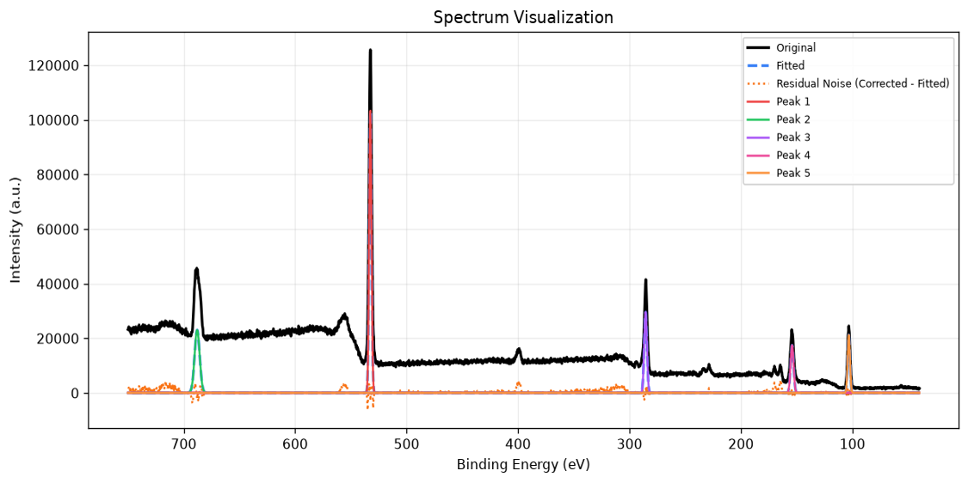
Figure 2. First derivative dI/dE with zero-crossing positions.
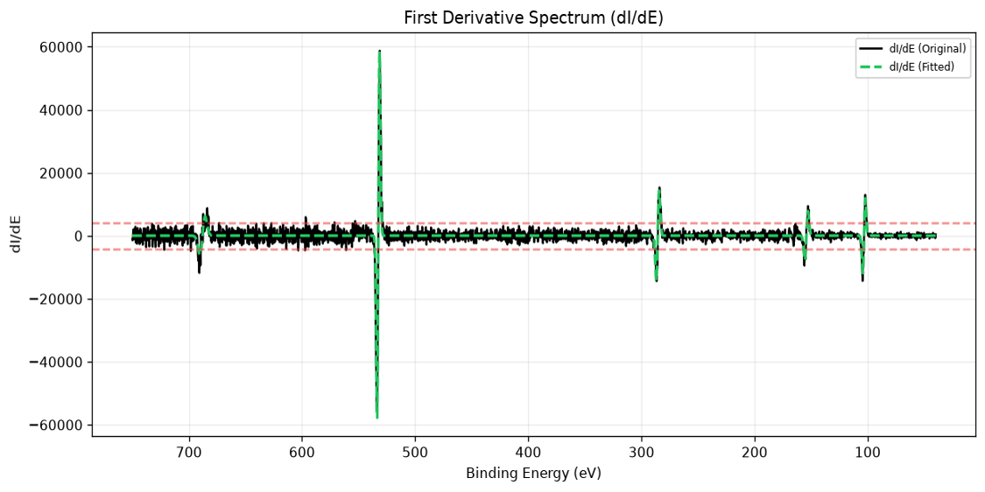
Figure 3. Second derivative d²I/dE² with θ = −776 eV² (k = 1).
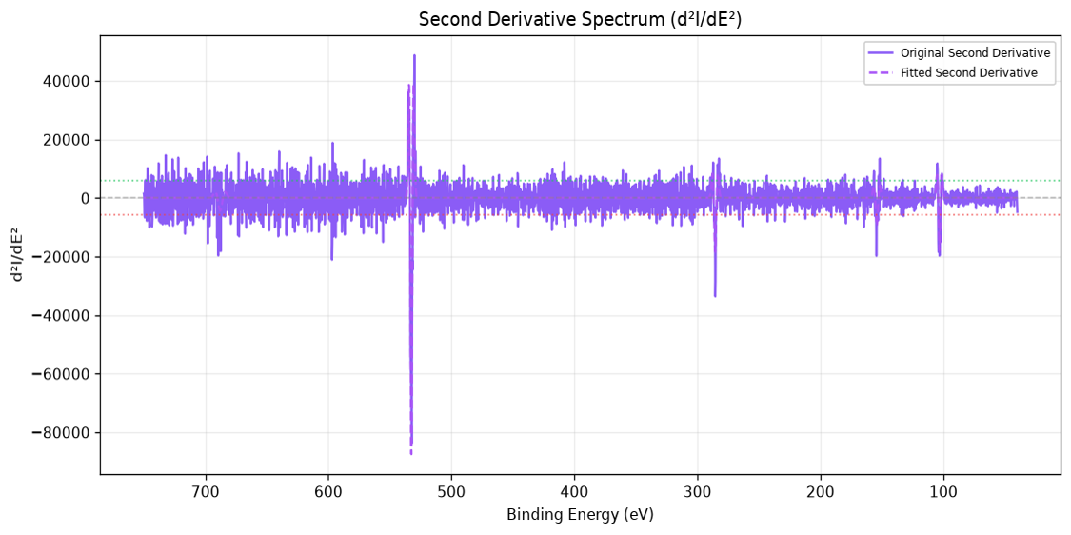
In the system [1], Candidates below the threshold line (negative curvature exceeding θ) are retained. The green/red markers denote FWHM-compliant / out-of-range widths after fitting.

DISCUSSION
CG-DPF does not replace expert interpretation and does not determine chemical-state assignments, it supplies reproducible initial centers and width screening only. FWHM compliance does not imply chemical correctness.
Evaluation limits. The benchmark comprises eight survey spectra without expert-annotated ground-truth peak lists, reported metrics are surrogate measures. Precision, recall, and F1 require reference annotations not available here. The small corpus limits generalization, bootstrap or cross-validation on larger annotated datasets remains future work [3].
Baseline coverage. Quantitative comparison is limited to in-tool Adaptive Detection presets under identical preprocessing. Benchmark against Savitzky-Golay derivative peak picking [8], scipy.signal.find_peaks (implemented in SciPy [12]), MATLAB findpeaks, or wavelet detectors, was not conducted as such comparisons would strengthen claims of practical advantage but are outside the present software-unified study.
Method limits. CG-DPF requires expert threshold tuning for difficult spectra, derivative quality depends on energy sampling, low-SNR features may remain undetectable at conservative k, single-scale σ cannot optimally resolve peaks of very different widths, and peak-type classification (core-level vs. satellite vs. plasmon) remains the analyst’s responsibility. Asymmetric line shapes, minimum area, and binding-energy priors are not enforced. Full reproducibility additionally requires reporting TRF stopping tolerances and any non-default background model.
CG-DPF should therefore be regarded as an optimizer-independent preprocessing and initialization strategy. It can be integrated with conventional Gaussian, Lorentzian, Voigt, or pseudo-Voigt fitting workflows using Levenberg-Marquardt, Trust Region Reflective, or other nonlinear least-squares optimizers.

CONCLUSION
This work aimed to improve the robustness and reproducibility of initial peak selection for sequential XPS spectral deconvolution by introducing an interpretable curvature-guided filtering framework. CG-DPF augments first-derivative zero-crossing detection with tunable second-derivative curvature filtering, reducing false positives (47 to 5 at σ = 8, k = 1 on the in-house benchmark) while retaining major core-level features. The scientific contribution is a filtering strategy and reproducible workflow curvature as a post-crossing acceptance criterion with logged thresholds, rather than a new differentiation formula. Validation on seven independent Suliga survey spectra confirms that CG-DPF consistently favors FWHM-compliant initialization over peak count relative to adaptive baselines (mean Phys. Ratio 0.66 vs. 0.30 for Adaptive Medium, Wilcoxon p = 0.031, although the sample size is small). The default setting (k = 1) supports conservative initialization, operational survey analysis may prefer k ≈ 0.3-0.5 for improved recall (R² = 0.985 at k ≈ 0.32 on the in-house benchmark). Transparent threshold control, integrated width screening, sequential fitting support, and reproducible workbook export provide an auditable initialization path between manual peak placement and fully automatic detection. The method is implemented in XPS Spectra Deconvolution Tool v2.3 [5]. The proposed workflow provides a practical middle ground between manual peak selection and fully automatic detection, offering improved transparency, reproducibility, and analyst control. Future work will evaluate CG-DPF on larger annotated XPS datasets and extend the framework with adaptive threshold selection and chemically informed constraints.

ACKNOWLEDGEMENTS
This work was developed as part of the XPS Spectra Deconvolution Tool project. Thanks to the open-source Python ecosystem (NumPy, SciPy, Pandas, Flask) for the computational foundation. The Suliga survey spectra are used under their published Figshare license for external validation.

REFERENCES
- Bajrai, S., “XPS_Spectra_Deconvolution,” v2.4, Zenodo, 2026. https://doi.org/10.5281/zenodo.21143077
- Briggs, D. and Seah, M. P. (Eds.), Practical Surface Analysis, Volume 1: Auger and X-ray Photoelectron Spectroscopy, 2nd ed. Chichester, UK: John Wiley & Sons, 1990.
- Efron, B. and Tibshirani, R. J., An Introduction to the Bootstrap. New York, NY, USA: Chapman & Hall/CRC, 1993.
- Fairley, N., Fernandez, V., Richard-Plouet, M., Guillot-Deudon, C., Walton, M., Smith, E., Flahaut, D., Greiner, S., Biesinger, M., Tougaard, M., and Morgan, S., “Systematic and Collaborative Approach to Problem Solving Using X-ray Photoelectron Spectroscopy,” Applied Surface Science Advances, vol. 5, Article 100112, 2021. https://doi.org/10.1016/j.apsadv.2021.100112
- Hiro, XPS Spectra Deconvolution Tool v2.3: Curvature-Guided Derivative Peak Filtering for Sequential XPS Spectral Deconvolution (software), Version 2.3, 2026. Source code and benchmark datasets available from the project repository.
- Lee, A. Y., Powell, C. J., Gorham, J. M., Morey, A., Scott, J. H. J., and Hanisch, R. J., “Development of the NIST X-ray Photoelectron Spectroscopy (XPS) Database, Version 5,” Data Science Journal, vol. 23, Article 45, 2024. https://doi.org/10.5334/dsj-2024-045
- O’Haver, T. C., Introduction to Signal Processing in Chemical Spectroscopy. University of Maryland. Available: https://www.terpconnect.umd.edu/~toh/spectrum/Differentiation.html (accessed July 2026).
- Savitzky, A. and Golay, M. J. E., “Smoothing and Differentiation of Data by Simplified Least Squares Procedures,” Analytical Chemistry, vol. 36, no. 8, pp. 1627-1639, 1964. https://doi.org/10.1021/ac60214a047
- Shirley, D. A., “High-Resolution X-ray Photoemission Spectrum of the Valence Bands of Gold,” Physical Review B, vol. 5, no. 12, pp. 4709-4714, 1972. https://doi.org/10.1103/PhysRevB.5.4709
- Suliga, A., “XPS data,” Figshare, 2018. https://doi.org/10.6084/m9.figshare.5671645
- Tougaard, S., “Quantitative Analysis of the Inelastic Background in Surface Electron Spectroscopy,” Surface and Interface Analysis, vol. 11, no. 9, pp. 453-472, 1988. https://doi.org/10.1002/sia.740110902
- Virtanen, P. et al., “SciPy 1.0: Fundamental Algorithms for Scientific Computing in Python,” Nature Methods, vol. 17, pp. 261-272, 2020. https://doi.org/10.1038/s41592-019-0686-2
- Workman Jr., J. and Weyer, L., “Derivative Spectroscopy,” in L. Weyer and J. Workman Jr. (Eds.), Handbook of Signal Processing in Spectroscopy, Academic Press, 2012, ch. 15, pp. 1-28.

