REVOCALIZE: AI-Powered Lip Reading for Instant Voice Output

Parvathy Nair
Computer Science and Engineering Adi Shankara Institute of Engineering & Technology
Kalady, Kerala parvathy.cs@adishankara.ac.in

Abhinav S
Computer Science and Engineering Adi Shankara Institute of Engineering & Technology
Kalady, Kerala abhinav.thanal@gmail.com

Adithya A V
Computer Science and Engineering Adi Shankara Institute of Engineering & Technology
Kalady, Kerala adithyaav425@gmail.com

Ananya Vijayan
Computer Science and Engineering Adi Shankara Institute of Engineering & Technology
Kalady, Kerala ananyavijayan4@gmail.com

Aneena Biju
Computer Science and Engineering Adi Shankara Institute of Engineering & Technology
Kalady, Kerala aneenabiju2003@gmail.com

Abstract—Visual Speech Recognition (VSR) makes it possible to understand speech by analyzing lip movements instead of relying on audio signals. This paper presents Revocalize, an AI-based lip-reading system that converts visual lip movements into spoken output in real time. The system captures video through a camera and processes the frames using computer vision techniques to detect facial landmarks and isolate the mouth region. A deep learning model then analyzes the spatial and temporal patterns of lip movements to predict the corresponding text. The generated text is refined using a lightweight language model and finally converted into speech using an offline text-to- speech engine. The entire system runs on edge hardware, allowing real-time processing without the need for cloud connectivity. Experimental results show that the system can successfully interpret lip movements and generate understandable speech under controlled conditions. Revocalize offers a portable and affordable assistive communication solution for individuals with speech impairments and can also be useful in noisy environments where audio-based systems may not perform effectively.
Index Terms—Visual Speech Recognition, Lip Reading, Trans- former Networks, Deep Learning, Natural Language Processing.

- Introduction
Speech is the most natural form of communication between humans. However, most automatic speech recognition systems rely heavily on acoustic signals captured through microphones. In environments with high levels of noise or situations where speech must remain silent, traditional audio-based speech recognition becomes unreliable or unusable. Visual Speech Recognition (VSR), commonly referred to as lip reading, offers an alternative approach by interpreting speech from the movements of a speaker’s lips and facial expressions.
Lip reading has long been a challenging research problem because many phonemes share similar visual appearances when articulated by the mouth. Additionally, variations in
head pose, lighting conditions, facial occlusions, and speaking styles make accurate lip recognition difficult. Traditional rule- based approaches struggled to capture the complex temporal dynamics of lip motion. However, recent advances in deep learning and computer vision have significantly improved the performance of VSR systems. Modern deep learning architec- tures such as convolutional neural networks (CNNs), recurrent neural networks (RNNs), and Transformers can effectively model spatio-temporal patterns in visual data. These models can analyze sequences of lip movements and learn correlations between visual cues and spoken words. Despite these ad- vancements, many existing systems require high-performance GPU hardware and are difficult to deploy in real-time edge environments.

This research proposes Revocalize, a real-time visual speech recognition system that converts lip movements into mean- ingful spoken output. The system integrates computer vision techniques for face detection and lip extraction, deep learning for visual speech recognition, natural language processing for grammar correction, and text-to-speech synthesis for voice generation. A key objective of this work is to design an efficient architecture capable of running entirely on CPU hardware, making it suitable for low-power edge devices such as Raspberry Pi.

The proposed system contributes to the development of assistive communication technologies, particularly for indi- viduals with hearing or speech impairments. Furthermore, the system demonstrates how modern AI techniques can be combined to create a fully offline, privacy-preserving speech interface that operates without relying on audio signals or cloud-based services

- Related Works
Visual speech recognition has gained significant attention in recent years due to advancements in deep learning and multimodal artificial intelligence. Early research primarily focused on handcrafted features extracted from lip movements, but these approaches struggled to capture complex temporal patterns. Modern systems rely on deep neural networks ca- pable of learning robust representations directly from visual data.
Several studies have explored the use of encoder–decoder architectures for lip-to-speech reconstruction. For example, the LipSound2 framework employs self-supervised learning techniques to reconstruct speech from lip movements without requiring extensive manual annotations. By leveraging cross- modal learning, this approach improves generalization across multiple languages and datasets. However, such systems typ- ically require large-scale pretraining and high computational resources.
Cross-modal language modeling approaches have also been proposed to improve lip reading accuracy. These methods integrate motion-based visual features with language models to capture contextual relationships between words. While they achieve high accuracy on benchmark datasets, their computa- tional complexity often limits real-time deployment.
Recent studies have also explored alternative sensing modal- ities for lip reading. Radar-based systems use micro-Doppler signatures generated by lip movements to detect speech pat- terns, enabling operation in complete darkness. Similarly, RFID-based lip reading systems detect mouth movements using radio signals and deep convolutional networks. Although these methods offer privacy benefits, they require specialized hardware and sensor calibration.
Deep learning architectures combining CNNs, recurrent networks, and CTC loss functions have also demonstrated promising results. These models can learn spatio-temporal features from sequences of lip images and predict speech transcripts without explicit phoneme alignment. Transformer- based architectures have further improved performance by capturing long-range temporal dependencies through self- attention mechanisms.
Despite these advancements, many existing solutions remain computationally intensive and require GPU acceleration. This limitation restricts their applicability in real-time edge envi- ronments. The proposed REVOCALIZE system addresses this challenge by implementing an efficient pipeline optimized for CPU-based hardware while maintaining competitive recogni- tion performance.
- System Architecture
The proposed system follows a modular architecture that processes visual speech data through multiple stages, ulti- mately converting lip movements into audible speech output. The system integrates components from computer vision, deep learning, and natural language processing to create an end-to- end visual speech recognition pipeline.
The process begins with video acquisition using a webcam connected to the system. Video frames are captured at a fixed frame rate to preserve the temporal structure of speech move- ments. Each frame is then analyzed using a facial landmark detection algorithm that identifies key points on the face, including the eyes, nose, and mouth. These landmarks enable precise alignment of the face and extraction of the lip region.
Once the lip region is isolated, the frames undergo pre- processing steps such as grayscale conversion, normalization, and resizing. These operations reduce computational complex- ity while ensuring consistent input dimensions for the deep learning model. The processed lip frames are then organized into temporal sequences representing the progression of mouth movements during speech.
The core recognition component is a Transformer-based visual speech recognition model trained on the LRS3 dataset. The model analyzes the sequence of lip images and learns relationships between visual features and spoken words. By leveraging self-attention mechanisms, the Transformer can capture both short-term and long-range dependencies within the visual sequence.
After generating a preliminary transcription, the output is passed to a lightweight local language model that performs grammar refinement. This step improves readability and cor- rects potential grammatical errors produced by the recognition model. The refined text is then converted into speech using an offline text-to-speech engine, producing an audible output for the user.
The entire system is optimized for CPU execution and can run on embedded devices such as Raspberry Pi. Through efficient preprocessing, asynchronous processing, and model optimization, the system achieves real-time performance with- out requiring GPU acceleration.

- Methodology

- Video Acquisition and Frame Capture
The first stage of the system involves capturing real-time video input from a webcam. The camera continuously records facial video frames at a fixed frame rate to maintain temporal consistency between frames. Maintaining a constant frame rate is essential because lip-reading models rely on sequential visual information to understand speech dynamics.
OpenCV is used to access the webcam and capture frames in real time. Each frame is stored temporarily and passed to the next stage of processing. The recorded video sequence contains the full facial region, including the eyes, nose, and mouth. Capturing the entire face initially ensures that sufficient contextual information is available for reliable face detection and alignment.
To ensure stable processing, frames are captured at a standard resolution and frame rate. The consistent temporal spacing between frames allows the model to correctly interpret the sequence of lip movements associated with spoken words.

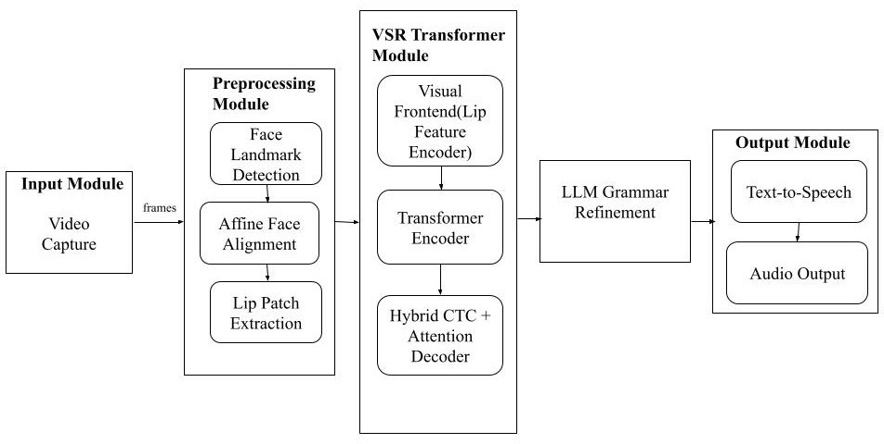

Fig. 1. Architecture

- Facial Landmark Detection and Alignment
After video frames are captured, facial landmark detection is performed to identify key facial points. MediaPipe’s face detection framework is used to locate important landmarks such as the eyes, nose tip, and mouth center. These landmarks provide geometric reference points that help identify the exact position and orientation of the face.
Using the detected landmarks, the system performs facial alignment through affine transformation. The purpose of align- ment is to normalize the face orientation so that variations in head tilt, rotation, or distance from the camera do not affect the recognition process. By mapping detected landmarks to a standard reference face structure, the system ensures consistent positioning of facial features across frames.
If landmark detection fails in certain frames due to motion blur or temporary occlusion, interpolation techniques are ap- plied to estimate missing landmark positions. This prevents in- terruptions in the lip movement sequence and ensures smooth temporal continuity during processing. differences.
- Lip Region Extraction and Preprocessing
Once the face is aligned, the system extracts the lip region from each frame. The mouth region is cropped using the detected mouth landmark as the center point. The cropped lip region is resized into a fixed-size patch to maintain uniform input dimensions for the neural network model.
Several preprocessing steps are applied to the extracted lip images to improve model efficiency and robustness. First, the images are converted to grayscale because color information
is not necessary for lip-reading tasks. This step reduces computational complexity and memory usage.
Next, normalization techniques are applied to standardize pixel values across frames. Center cropping is also performed to remove unnecessary background areas around the lips. These preprocessing steps ensure that the deep learning model receives consistent and noise-free input data.
The resulting lip frames are then arranged into temporal sequences that represent the progression of lip movements during speech.
- Visual Speech Recognition using Transformer Model
The processed lip image sequences are fed into a Transformer-based Visual Speech Recognition (VSR) model. The Transformer architecture is well suited for sequence modeling because it uses self-attention mechanisms to capture relationships between elements within a sequence.
In this system, the Transformer analyzes the temporal sequence of lip images and extracts visual speech features that correspond to spoken words. The model learns complex motion patterns of the lips and maps them to linguistic representations.
To generate text predictions, the system uses a hybrid decoding strategy that combines Connectionist Temporal Clas- sification (CTC) with attention-based decoding. CTC helps align input video frames with output text tokens, while the attention mechanism enables the model to focus on relevant portions of the visual sequence.
Beam search decoding is applied to explore multiple possi- ble output sequences and select the most probable transcrip-

tion. This approach improves recognition accuracy compared to greedy decoding.
- Language Refinement using Local Language Model
The raw transcription generated by the VSR model may contain minor grammatical errors or missing punctuation. To improve readability and linguistic correctness, the predicted text is processed using a lightweight local language model.
A locally deployed LLM performs grammar correction while maintaining the original meaning of the sentence. The model operates under controlled decoding parameters to pre- vent hallucination or excessive modifications. Additional val- idation checks ensure that the corrected text does not become significantly longer than the original prediction and does not contain repeated words.
By applying this refinement step, the system produces more natural and grammatically correct sentences before generating speech output.
- Text-to-Speech Conversion
In the final stage, the refined text is converted into audible speech using an offline text-to-speech (TTS) engine. The pyttsx3 library is used to synthesize speech locally without requiring internet connectivity.
To ensure smooth operation, the TTS module runs on a dedicated background thread. This design prevents the speech generation process from blocking the main video processing pipeline. As a result, the system can continue capturing and analyzing video frames while audio output is being produced. The generated speech is played through connected speakers, allowing the system to convert silent lip movements into
audible voice output in real time.
- Edge Deployment and System Optimization
The entire pipeline is optimized to operate efficiently on CPU-based systems. Lightweight preprocessing techniques and model optimization strategies are employed to reduce computational overhead. Multithreading is used to separate video capture, inference, and audio synthesis tasks.
The system is deployed on Raspberry Pi hardware to demonstrate its capability as an edge AI application. By elimi- nating the need for GPU hardware and cloud-based processing, the proposed architecture enables fully offline operation with enhanced privacy and portability.
- Experimental Evaluation
The performance of the proposed Revocalize system was evaluated using publicly available visual speech recognition datasets that contain video sequences of speakers articulating different words and short phrases. These datasets provide realistic examples of lip movements under different speaking styles, lighting conditions, and facial orientations. The exper- imental setup follows evaluation procedures commonly used in recent visual speech recognition research.
For model training and evaluation, the dataset was divided into training and testing subsets using an 80:20 split. This
approach ensures that the model is trained on a large portion of the dataset while reserving unseen data for performance evaluation. The Transformer-based visual speech recognition model was trained for 50 epochs with a batch size of 32 using the Adam optimizer, which is widely used in deep learning due to its efficient gradient-based optimization and stable convergence during training.
To evaluate the effectiveness of the proposed system, several standard metrics used in speech recognition and classification tasks were employed. These metrics provide a comprehensive understanding of the model’s performance.
- Accuracy: Measures the percentage of correctly pre- dicted words compared to the total number of predictions.
- Precision: Indicates how many of the predicted words were actually correct.
- Recall: Measures the model’s ability to correctly identify all relevant words from the dataset.
- F1-Score: Represents the harmonic mean of precision and recall, providing a balanced evaluation of model performance.
- Word Error Rate (WER): A standard metric in speech recognition that calculates the number of insertion, dele- tion, and substitution errors relative to the reference transcription.
- Performance Comparison of Models
To evaluate the effectiveness of the proposed approach, the performance of several machine learning models was compared with the proposed Transformer-based Visual Speech Recognition model. Traditional machine learning algorithms were tested alongside deep learning architectures to analyze their ability to recognize speech from lip movements.
The results show that the Transformer-based VSR model significantly outperforms traditional machine learning algo- rithms. Traditional models rely on manually extracted fea- tures and have limited capability to capture complex spatial and temporal patterns in lip movements. In contrast, the Transformer model automatically learns visual patterns and temporal relationships directly from sequences of lip images. The use of the self-attention mechanism in the Transformer architecture allows the model to analyze relationships between all frames in the sequence simultaneously. This enables the system to capture subtle variations in lip movement and
improves the overall recognition accuracy.
- Word Error Rate (WER) Evaluation
In addition to classification metrics, the performance of different deep learning approaches was evaluated using Word Error Rate (WER), which is a widely used metric in speech recognition systems. WER measures how many errors occur in the predicted transcription compared to the reference text. Lower WER values indicate better recognition performance. The proposed Transformer-based VSR model achieves the lowest WER, demonstrating its ability to accurately recognize
speech from lip movements.

Model Accuracy (%) Precision Recall F1 Score
only improves portability but also enhances user privacy by

Random Forest
83.1 0.83 0.82 0.82
ensuring that sensitive data is processed locally rather than being transmitted to cloud servers.

k-Nearest Neighbors

Support Vector Machine (RBF)

Transformer VSR
(Proposed)
71.6 0.70 0.71 0.70

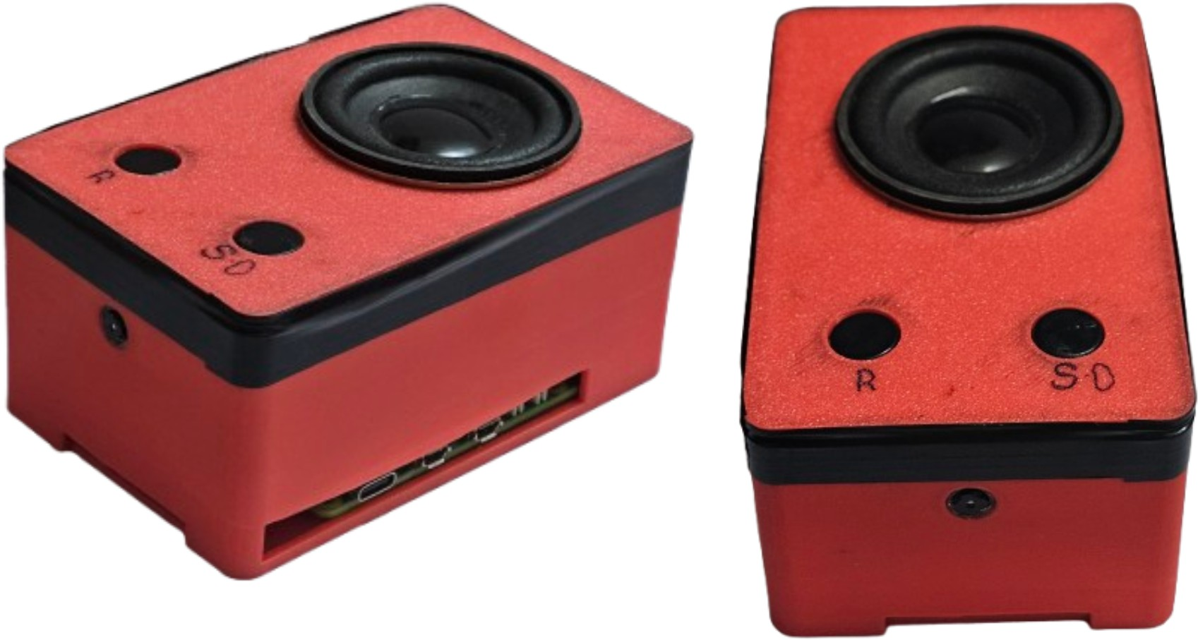
77.4 0.76 0.75 0.75

94.2 0.94 0.93 0.93

TABLE I

Performance Comparison of Models

Model | Word Error Rate (%)
CNN-based Model | 19.1
RNN / LSTM Model | 16.4
Transformer VSR (Proposed) | 8.7
TABLE II
Word Error Rate Comparison of Models

This improvement is mainly due to the Transformer’s ability to model long-range dependencies in video sequences through the self-attention mechanism. Additionally, the use of beam search decoding improves transcription accuracy by evaluating multiple candidate word sequences before selecting the final output.
Overall, the experimental results confirm that the proposed Transformer-based approach provides higher recognition accu- racy and lower transcription error rates compared to traditional and earlier deep learning models for visual speech recognition.
- Applications and Impact
The Revocalize system has strong potential to improve as- sistive communication technologies. It can support individuals with speech or hearing impairments by translating their lip movements into audible speech, enabling smoother and more effective interaction with others.
In addition, the system can be useful in environments where audio-based speech recognition struggles, such as noisy industrial workplaces, crowded public areas, or transportation hubs. Since Revocalize relies on visual information rather than sound, it can still function effectively even when background noise is high.
The technology can also be applied in areas such as silent command recognition, language learning tools, and accessibil- ity features for smart devices. These applications could help create more inclusive and user-friendly technologies.
Because the system operates directly on edge devices, it does not require continuous internet connectivity. This not
Fig. 2. Prototype

- Conclusion
This paper introduced Revocalize, an AI-based visual speech recognition system that converts lip movements into spoken audio in real time. The system combines computer vision techniques, deep learning models, and text-to-speech technology to build a complete pipeline that transforms visual speech into audible output.
The results demonstrate that visual speech recognition can be effectively implemented even on resource-constrained edge devices. By deploying the system on lightweight hardware, Revocalize shows the potential of making assistive communi- cation technologies more accessible and portable.
In future work, efforts will focus on improving recognition accuracy by training with larger and more diverse datasets. Additional enhancements such as advanced decoding methods and improved robustness under varying lighting and environ- mental conditions will also be explored to further strengthen the system’s performance.
References
- G. Potamianos, C. Neti, J. Luettin, and I. Matthews, “Audio-visual speech recognition: An overview,” IEEE Signal Processing Magazine, 2003.
- D. Chung and A. Zisserman, “Lip reading in the wild,” Proceedings of the Asian Conference on Computer Vision, 2016.
- S. Petridis and M. Pantic, “Deep learning for audio-visual speech recognition,” IEEE Transactions on Pattern Analysis and Machine Intelligence, 2018.
- H. Hameed et al., “Pushing the limits of remote RF sensing by reading lips under the face mask,” Nature Communications, 2022.
- S. Zhang et al., “HearMe: Accurate and real-time lip reading based on commercial RFID devices,” IEEE Transactions on Mobile Computing, 2022.
- K. Noda et al., “Audio-visual speech recognition using deep learning,”
Applied Intelligence, 2015.
- J. Chung, C. Gulcehre, K. Cho, and Y. Bengio, “Empirical evaluation of gated recurrent neural networks,” NIPS Workshop, 2014.
- A. Graves, “Connectionist temporal classification,” Proceedings of ICML, 2006.
- H. Sak et al., “Long short-term memory recurrent neural network architectures for large scale acoustic modeling,” Interspeech, 2014.

- S. Hochreiter and J. Schmidhuber, “Long short-term memory,” Neural Computation, 1997.
- Y. LeCun et al., “Gradient-based learning applied to document recogni- tion,” IEEE, 1998.
- I. Goodfellow, Y. Bengio, and A. Courville, Deep Learning, MIT Press, 2016.
- T. Afouras et al., “Deep audio-visual speech recognition,” IEEE Trans- actions on Pattern Analysis and Machine Intelligence, 2019.
- M. Wand et al., “Lipreading with long short-term memory,” ICASSP, 2016.
- Z. Assaleh et al., “RF sensing based lip-reading system,” IEEE Sensors Journal, 2023.

