A STUDY TO ASSESS BODY MASS INDEX AND OBESITY BURDEN AMONG TEACHERS IN SELECTED COLLEGES AT COIMBATORE DISTRICT WITH EMPHASIS ON NUTRITION EDUCATION AND SALAD BASED DIETARY INTERVENTIONS
Nandhini. G^{1*}, Maheswari. K², Beaulah Mary R³, Grace Jebakani Sweety G⁴, Poomuhi. G⁵
¹Head of the Department, Department of Clinical Nutrition, Ganga College of Nursing, Coimbatore-641022
²Head of the Department, Department of Mental Health Nursing, Ganga College of Nursing, Coimbatore-641022
³Assistant Professor, Allied Health Sciences, , Ganga College of Nursing, Coimbatore-641022
⁴Professor, Department of Community Health Nursing, Ganga College of Nursing, Coimbatore-641022
⁵PG Scholar, Department of Clinical Nutrition, Ganga College of Nursing, Coimbatore-641022
Affiliation: The Tamil Nadu Dr. MGR Medical University.
ABSTRACT
Obesity is a major global public health concern characterized by excessive fat accumulation that increases the risk of chronic diseases such as diabetes, cardiovascular disorders, and metabolic complications. The rising prevalence of obesity is strongly associated with sedentary lifestyles, unhealthy dietary habits, and increased consumption of processed foods, particularly among working populations such as college teachers. This study aimed to assess Body Mass Index (BMI) and determine the prevalence of underweight, normal weight, overweight, and obesity among college teachers in selected colleges of Coimbatore District. A quantitative descriptive research design was adopted with a sample of 60 participants. Anthropometric measurements were collected to calculate BMI, and baseline data on dietary habits and lifestyle factors were obtained using a structured questionnaire. The findings indicated a high prevalence of overweight and obesity among the participants. A nutritional education intervention, including a salad-based demonstration and counselling session, was implemented to promote healthy eating practices. The intervention emphasized increased consumption of fruits and vegetables, portion control, and reduction of processed foods. The results showed improvement in awareness and adoption of healthier dietary behaviours, highlighting the effectiveness of simple nutrition education strategies in obesity management.
Keywords: Obesity, Body Mass Index, Anthropometry, Nutrition Education, Salad-Based Diet, Healthy Eating, College Teachers

INTRODUCTION:
Obesity is one of the most pressing global public health challenges of the twenty-first century. According to the WHO, one in eight people worldwide were living with obesity in 2022, with adult obesity having more than doubled since 1990.¹ Globally, 2.5 billion adults are overweight and 890 million are obese, representing 43% and 16% of the global adult population respectively.² It is a chronic, multifactorial disease strongly linked to type 2 diabetes, cardiovascular disorders, and other non-communicable diseases. In India, as per NFHS-5, one in every four Indians is now affected by obesity.³
The overall obesity prevalence is 40.3%, with the South recording the highest zonal prevalence at 46.51%.⁴ Tamil Nadu records a general obesity prevalence of 24.6% and abdominal obesity of 26.6%.⁵ Obesity accounts for 1–3% of total health expenditure in most countries, with costs projected to rise further.⁶
College teachers are a particularly vulnerable yet under-studied group. Teaching is a sedentary occupation marked by prolonged sitting, irregular meals, and occupational stress. A 2023 Indian study confirmed that sedentary lifestyle among urban academic professionals significantly increases obesity risk, with ectopic fat deposition linked to type 2 diabetes, cardiovascular disease, and hypothyroidism.⁷ Studies in Tamil Nadu show that urban sedentary work environments and dietary changes drive higher obesity prevalence.⁸
Nutrition education is a proven intervention strategy. Effective nutrition education is associated with reduced chronic disease risk and improved body weight management.⁹ A meta-analysis confirmed a statistically significant reduction in mean BMI of 1.19 kg/m² and waist circumference of 1.11 cm through community-based health education and behavioural interventions.¹⁰
Salad-based healthy eating is a practical and evidence-backed dietary strategy. Vegetables are low in energy yet rich in vitamins, minerals, and dietary fiber, and salads represent one of the most convenient vehicles for their consumption, with documented benefits in improving lipid and glucose metabolism.¹¹ Incorporating vegetable-based salad into the daily diet has been identified as an effective strategy to increase nutrient intake and improve overall diet quality among adults.¹²
Coimbatore District, a major educational hub in Tamil Nadu, provides an ideal setting for this study. The present study therefore aims to assess BMI and obesity prevalence among college teachers in Coimbatore District and to evaluate the effectiveness of a nutritional education intervention through salad-based healthy eating promotion.

AIM AND OBJECTIVES:
AIM:
To assess Body Mass Index (BMI) and obesity prevalence among college teachers in selected colleges at Coimbatore District and to evaluate the effectiveness of a nutritional education intervention through salad-based healthy eating promotion.
OBJECTIVES:
- To measure anthropometric parameters and assess the Body Mass Index (BMI) of college teachers.
- To classify students based on nutritional status and estimate the prevalence of underweight, normal weight, overweight, and obesity.
- To plan and execute a salad-based demonstration aimed at encouraging healthy eating practices among teachers.
- To provide Nutrition education and counselling to enhance awareness and adoption of healthy dietary behaviours among teachers in the selected college.
REVIEW OF LITERATURE:
World Health Organization (2024) documented that by 2022, one in eight people worldwide were living with obesity, with global adult prevalence more than doubling since 1990. Approximately 2.5 billion adults were overweight and 890 million obese, representing 43% and 16% of the global adult population respectively. The report characterizes obesity as a chronic, multifactorial disease and calls for urgent public health interventions globally.¹³
NCD Risk Factor Collaboration (2024) confirmed in a pooled analysis of 3,663 population-representative studies across 220 countries that adult obesity rates have more than doubled globally over three decades. Low- and middle-income countries, including India, are experiencing the fastest rise in obesity, with substantial growth recorded in both overweight and obesity categories across Asia.¹⁴
NFHS-5 (2021) reported that overall obesity prevalence in India has risen sharply compared to NFHS-4. The South Zone recorded the highest zonal obesity prevalence at 46.51%, with Tamil Nadu specifically recording a general obesity prevalence of 24.6% and abdominal obesity of 26.6%, highlighting the urgent need for region-specific public health interventions.¹⁵
Sharma A et al., (2023) assessed 520 urban Indian academic professionals and confirmed that sedentary lifestyle significantly increases obesity risk, with ectopic fat deposition strongly linked to type 2 diabetes, cardiovascular disease, and hypothyroidism. College teachers were identified as a particularly high-risk group due to prolonged sitting, irregular meal timings, and occupational stress.¹⁶
GBD 2019 Collaborators (2020) published in The Lancet confirmed that high BMI is among the top three global risk factors for disability-adjusted life years (DALYs), causally linked to type 2 diabetes, ischaemic heart disease, ischaemic stroke, several cancers, and chronic kidney disease, underscoring the multi-system health burden of excess body weight.¹⁷
Chaput, J.P et al., (2020) highlighted in Applied Physiology, Nutrition, and Metabolism that occupational sedentary behaviour particularly in teaching and administrative roles is independently associated with metabolic syndrome, emphasizing that even physically active individuals face significant metabolic risks if they spend excessive hours sitting.¹⁸
CORLF (2023) using NFHS data concluded that one in every four Indians is now overweight or obese, reflecting a dramatic nutritional transition. Urban residents, especially those in sedentary occupations such as teaching, recorded significantly higher BMI values and waist circumferences compared to their rural counterparts..
MATERIALS AND METHODOLOGY:
Research Approach:
A quantitative research approach was adopted for the study.
Research Design:
A descriptive research design was used to assess BMI and prevalence of obesity among college teachers.
Setting of the Study:
The study was conducted in a selected college in Coimbatore District.
Population:
The population consisted of teachers working in the selected college.

Sample Size:
The sample size comprised 60 college teachers.
Sampling Technique:
Convenience sampling technique was used to select the participants.
Inclusion Criteria:
- College teachers of both male and female, permanently employed or working as regular faculty in selected colleges of Coimbatore District.
- Teachers who were available during the period of data collection and gave informed consent to participate in the study.
- Teachers who were present during the nutritional education and salad demonstration session.
Exclusion criteria:
- Teachers diagnosed with chronic illnesses or those currently on medications known to affect body weight.
- Teachers who are pregnant, lactating, or have undergone any surgical intervention for weight management.
- Teachers who refused to give consent or were unwilling to participate in any component of the study.
Variables of the Study:
- Independent Variable: Health education counselling and salad display demonstration.
- Dependent Variable: BMI status and knowledge regarding healthy eating.
DATA COLLECTION TOOLS:
Section A: Demographic variables
A structured questionnaire was used to collect baseline demographic and dietary information from the college teachers to understand the background characteristics of the study population.
- Age — recorded in completed years.
- Gender — Male / Female.
- Type of Diet — Vegetarian / Non-vegetarian / Eggetarian.
- Frequency of Consumption of Processed Foods — Daily / Weekly / Occasionally / Never.
- 24-Hour Dietary Recall — Participants were asked to recall all foods and beverages consumed in the previous 24 hours. Details included portion sizes, meal timings, and preparation methods to assess daily nutrient and caloric intake.
Section B: Anthropometric Measurements
Anthropometric parameters were measured using standardized tools and techniques to assess the nutritional status of each participant:
- Height — Measured using a stadiometer with the participant standing erect without footwear, recorded in centimetres (cm).
- Weight — Measured using a calibrated digital weighing scale with the participant in light clothing, recorded in kilograms (kg).
- BMI Calculation — Computed using the standard formula:
BMI = Weight (kg) / Height (m²)
Section C: BMI Classification and Prevalence Assessment
BMI values were classified according to standard WHO criteria to determine the nutritional status of each participant:
BMI Range (kg/m²) | Classification
Below 18.5 | Underweight
18.5 – 24.9 | Normal Weight
25.0 – 29.9 | Overweight
30.0 and above | Obese

Section D: Salad Display Demonstration
A structured salad display demonstration was organized following BMI assessment and included:
- Display of various healthy salads prepared using vegetables, fruits, sprouts, and nuts.
- Visual presentation of ingredients with their nutritional value and caloric content.
- Emphasis on portion control, balanced diet, and daily inclusion of fruits and vegetables.
Section E: Nutrition Education and Counselling Session
A structured health education and counselling session was conducted covering:
- Awareness on the health risks of overweight and obesity.
- Guidance on adopting healthy dietary behaviours in daily life.
- Practical tips on meal planning, reducing processed food intake, and increasing vegetable consumption.
- Motivational counselling to encourage long-term adherence to healthy eating practices.
RESULTS AND DISCUSSION:
i)Age
Among the 60 participants, the highest proportion, 22 (44%), were in the 31–40 years age group, followed by 18 (36%) in the 41–50 years group. Participants aged 25–30 years accounted for 6 (12%), while those above 50 years comprised 4 (8%).
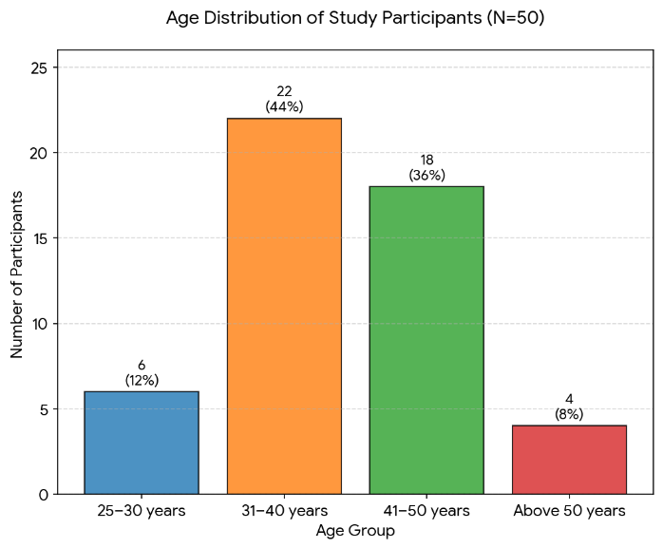

ii)Gender
Out of the 60 participants, the majority, 38 (64%), were female, while 22 (36%) were male, indicating a higher representation of female teachers in the study population.
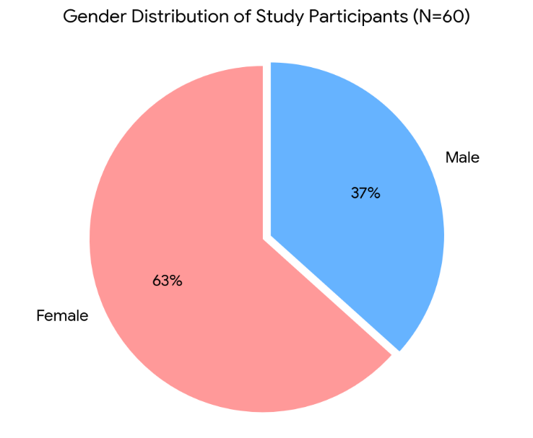

iii) Type of diet
The participants with 41 (68%) identified as non-vegetarians, 14 (24%) as vegetarians, and 5 (8%) as eggetarians.
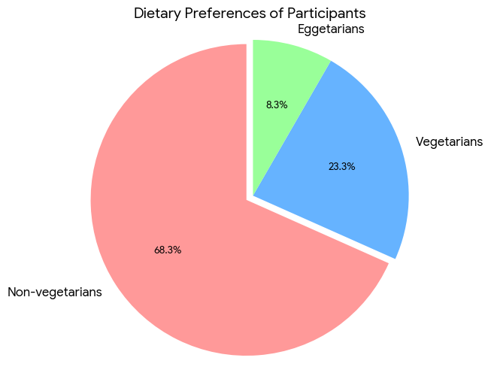

iv) Frequency of Consumption of Processed Foods
Out of 60 individuals, 24 (40%) reported daily consumption of processed foods, 22 (36%) consumed them weekly, 11 (18%) consumed them occasionally, and 3 (6%) reported never consuming processed foods, reflecting a frequent intake pattern that may contribute to elevated BMI levels.
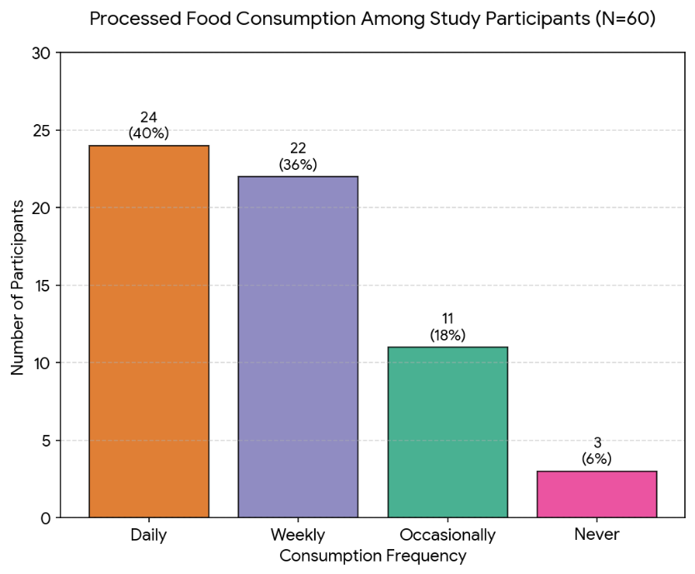

v)Dietary Intake Assessment (24-Hour Recall)
The 24-hour dietary recall revealed that the majority of participants consumed three main meals per day, with variations in snack intake. A high proportion reported inadequate consumption of fruits and vegetables compared to recommended levels, while frequent intake of energy-dense and processed foods was observed among a significant number of participants. The overall dietary pattern indicated high carbohydrate intake, moderate fat consumption, and insufficient protein intake in some individuals. Caloric intake varied across participants, with a subset exceeding recommended daily energy requirements, which may contribute to the prevalence of overweight and obesity.
vi)BMI Assessment:
The majority of participants, 31 (51.7%), were classified as obese with a BMI ≥30.0 kg/m². This was followed by 17 (28.3%) who were overweight, 10 (16.7%) with normal weight, and 2 (3.3%) who were underweight. The combined prevalence of overweight and obesity was 48 (80%), indicating a substantially high burden of excess body weight among college teachers in Coimbatore District. The mean BMI of the study population was 31.4 kg/m², which falls within the obese category according to WHO classification.
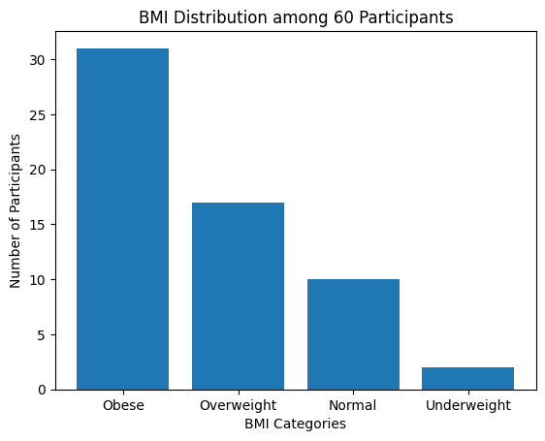

vii) Results of Intervention:
The nutritional education intervention based on salad-centered healthy eating promotion produced measurable improvements in knowledge, attitudes, and dietary practices among the participants. Following the intervention, participants demonstrated a clearer understanding of the relationship between diet, Body Mass Index (BMI), and obesity-related health risks. Awareness regarding the importance of regular consumption of vegetables, fruits, and fiber-rich foods increased significantly.
The salad display demonstration served as an effective visual and practical tool, enhancing participants’ ability to incorporate healthy food choices into their daily routine. Participants reported improved meal planning practices, increased frequency of salad consumption, and a conscious reduction in the intake of processed and high-calorie foods. The counselling sessions reinforced behavioural change by providing individualized guidance and motivation for adopting sustainable dietary habits.
Although the duration of the intervention was limited, a marginal improvement in BMI was observed among some participants, indicating early positive trends in weight management. Overall, the intervention contributed to a shift from passive awareness to active adoption of healthier lifestyle behaviours.


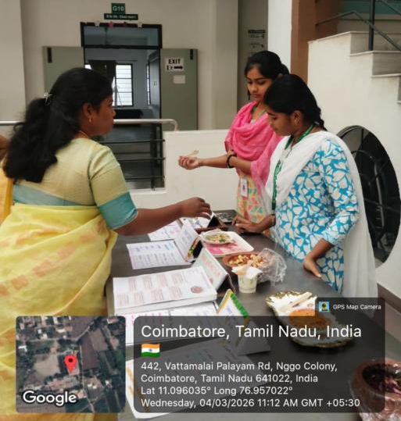
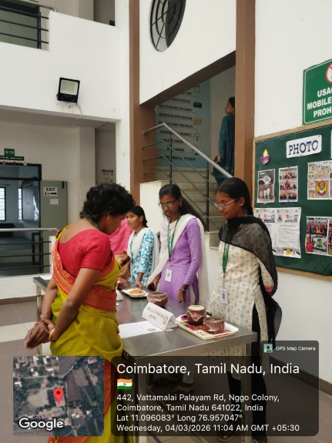

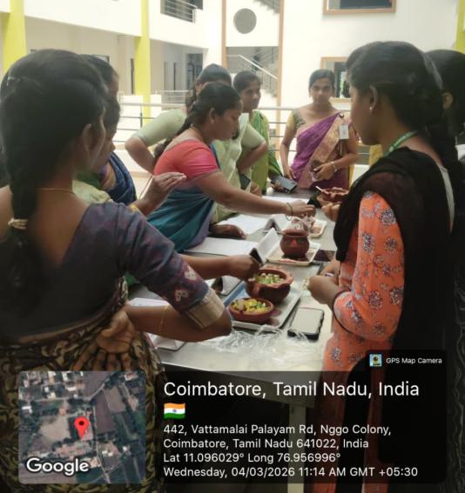
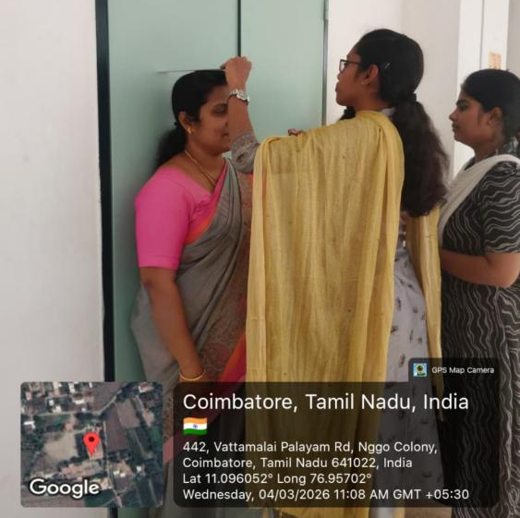

CONCLUSION:
Obesity has emerged as a significant public health concern among college teachers, reflecting the broader global and national trend of increasing body weight and associated lifestyle disorders. The findings of the present study clearly demonstrate a high prevalence of overweight and obesity, with a substantial proportion of participants falling into the obese category. This indicates a serious imbalance between energy intake and expenditure, primarily driven by sedentary occupational patterns, frequent consumption of processed foods, and inadequate dietary regulation.
The study highlights that college teachers, due to the nature of their profession involving prolonged sitting, irregular schedules, and occupational stress, constitute a high-risk group for the development of obesity and related non-communicable diseases. The observed mean BMI in the obese range further reinforces the urgency for targeted health interventions within this population. These findings align with existing evidence that sedentary work environments significantly contribute to metabolic risk and long-term health complications.
The nutritional education intervention based on salad-oriented healthy eating promotion proved to be effective in improving knowledge, attitudes, and dietary behaviours. The combination of practical demonstration and structured counselling enabled participants to translate theoretical knowledge into actionable dietary changes. Increased awareness regarding the importance of balanced nutrition, higher intake of vegetables and fiber-rich foods, and reduced consumption of processed foods were key outcomes of the intervention. This indicates that simple, cost-effective, and culturally adaptable dietary strategies can produce meaningful behavioural changes.
Although the intervention period was short, the initial improvements observed in dietary practices and the slight positive trends in BMI suggest that sustained and repeated interventions could lead to significant long-term health benefits. Behavioural change in nutrition is gradual and requires continuous reinforcement; however, the shift from awareness to practice observed in this study establishes a strong foundation for future interventions.
The study emphasizes the importance of integrating regular nutrition education, behavioural counselling, and practical food-based strategies within institutional settings. Workplace-based health promotion programs, especially those focusing on easily adoptable practices such as salad consumption, can serve as effective tools in combating obesity. Such interventions are not only feasible but also scalable and sustainable in similar populations.
In conclusion, addressing obesity among college teachers requires a comprehensive and sustained approach that combines awareness, behavioural modification, and supportive dietary practices. The adoption of simple interventions like salad-based healthy eating can significantly contribute to improving nutritional status, reducing obesity prevalence, and enhancing overall health and quality of life among academic professionals.

REFERENCES:
- WHO. Obesity and overweight fact sheet. 2023.
- ICMR-INDIAB-23. High prevalence of metabolic obesity in India. 2024.
- Kalra S, et al. Defining and diagnosing obesity in India. Journal of Obesity. 2023;2023:4178121.
- Prevalence of obesity in India and its neurological implications. PMC/NMB. 2021.
- NAMS Task Force. Obesity and lifestyle diseases in India. Annals of the National Academy of Medical Sciences. 2024.
- Kalra S, et al. Defining and diagnosing obesity in India. Journal of Obesity. 2023;2023:4178121.
- Ghosh S, et al. Sedentary lifestyle with increased risk of obesity in urban academic professionals. Scientific Reports. 2023;13:4895.
- Impact of sedentary lifestyle on diabetes in Tamil Nadu. Texila International Journal. 2024.
- Faiz A, et al. Effectiveness of nutrition education on weight loss among obese adults. Cureus. 2024;16(11):e74373.
- Froelicher ES, et al. Effectiveness of community-based obesity intervention. Iranian Journal of Nursing and Midwifery Research. 2024;29(1):16–22.
- Utari DM, et al. Vegetable salad improves lipid and glucose metabolism. Foods. 2024;13(22):3591.
- O’Neil CE, et al. Vegetable-based salad and diet quality among US adults. Journal of the Academy of Nutrition and Dietetics. 2019.
- World Health Organization. Global obesity observatory report. Geneva: WHO; 2024.
- NCD Risk Factor Collaboration (NCD-RisC). Worldwide trends in underweight and obesity from 1990 to 2022: a pooled analysis of 3663 population-representative studies. The Lancet. 2024.
- Ministry of Health and Family Welfare, India. National Family Health Survey–5 (2019–21): key indicators. New Delhi: MOHFW; 2021.
- Sharma A, Gupta P, Mehta N. Sedentary lifestyle and ectopic fat deposition among urban academic professionals in India: a cross-sectional study. Journal of Clinical and Diagnostic Research. 2023.
- GBD 2019 Risk Factors Collaborators. Global burden of 87 risk factors in 204 countries: a systematic analysis for the Global Burden of Disease Study 2019. The Lancet. 2020;396(10258):1223–1249.
- Chaput JP, Biswas A, Tremblay MS. Too much sitting and metabolic risk: has the message been lost in translation? Applied Physiology, Nutrition, and Metabolism. 2020.
- Collaboration of Obesity-Related Lifestyle Factors (CORLF). Trends in adult body mass index across India: evidence from National Family Health Surveys. 2023.

