PATTERN RECOGNITION LETTERS
CONFIRMATION OF AUTHORSHIP
As corresponding author I, B. Vijayendra Reddy, hereby confirm on behalf of all authors that:
- This manuscript, or a large part of it, has not been published, was not, and is not being submitted to any other journal.
- If presented at or submitted to or published at a conference(s), the conference(s) is (are) identified below and substantial justification for re-publication is presented.
- If the manuscript appears as a preprint anywhere on the web, it is identified below.
- All text and graphics, except for those marked with sources, are original works of the authors, and all necessary permissions for publication were secured prior to submission of the manuscript.
- All authors each made a significant contribution to the research reported and have read and approved the submitted manuscript.
Authors:
- B. Vijayendra Reddy
- Dr. Sandeep Kulkarni
- Gutti Yattesh
- J. Stalin Babu
- Mallampatti Mahesh
List any pre-prints:
None
Relevant Conference Publication(s) (submitted, accepted, or published):
None
Justification for Re-publication:
Not Applicable. The submitted manuscript is original work and has not been previously published or submitted elsewhere.
Corresponding Author:

1.B. Vijayendra Reddy 2.yateesh gutti
Signature: 
Date: 30/05/2026 3. j.stalin babu-
4.Sandeep Kulkarni 
5. mahesh:

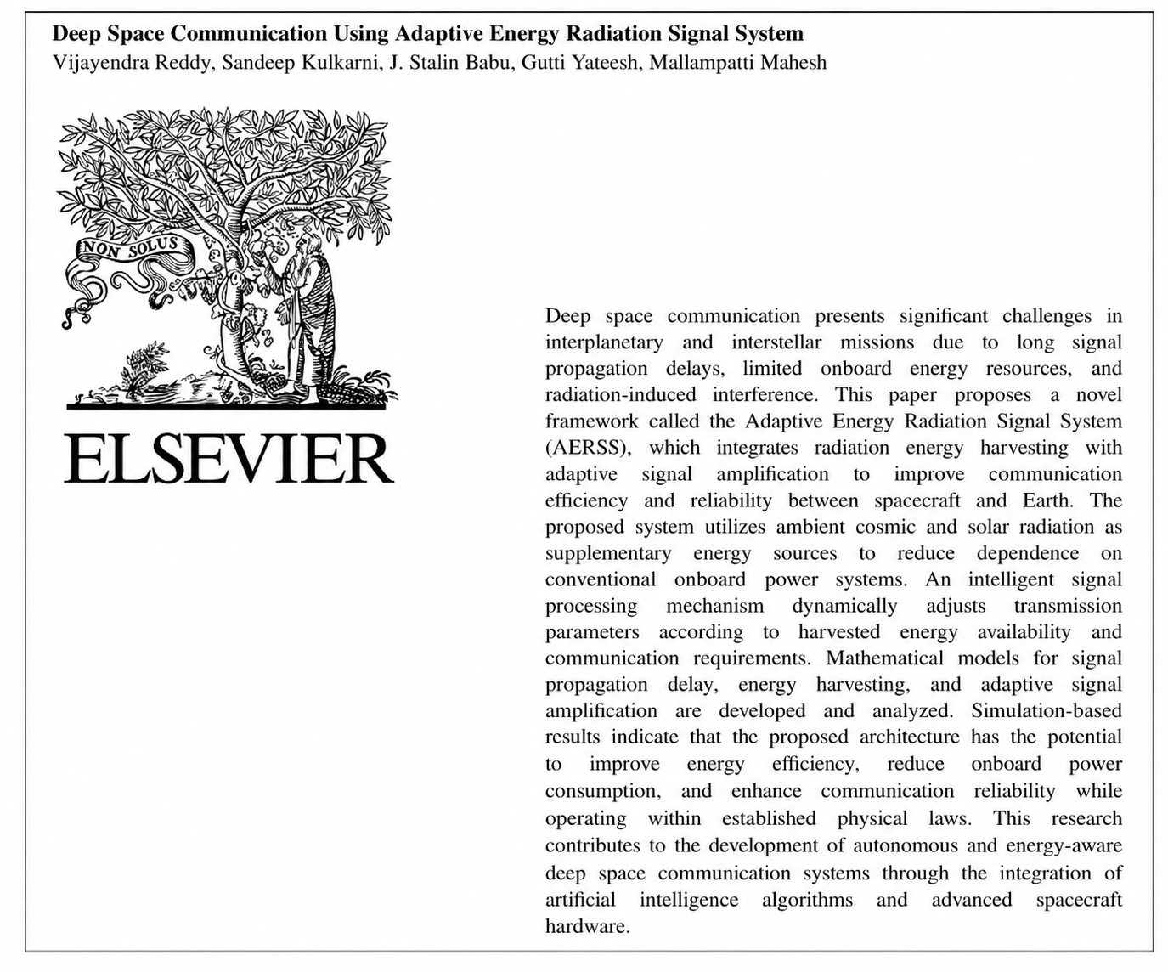

Research Highlights:

Proposed AERSS framework for energy-aware deep space communication.

Harvests cosmic and solar radiation as supplementary energy sources.

AI-based adaptive signal amplification improves communication quality.

Mathematical models developed for delay, energy harvesting, and gain.

Simulations indicate lower power usage and higher reliability

Adaptive Radiation-Energy Harvesting and High-Speed Signal Transmission Framework for Deep Space Communication System
Corresponding authors:
1.Baireddy Vijayendra reddy 2.dr.Sandeep Kulkarni 3.J.Stalin babu 4.Gutti Yateesh
5.Mallampatti Mahesh
1.Assist. Prof., C.S.E,KL-university, Koneru Lakshmaiah Education Foundation (KLEF),Green Fields, Vaddeswaram,
Guntur District, Andhra Pradesh, India. 522302
2. Department of CSE, Ajeenkya D Y Patil University (ADYPU), Pune, Maharashtra 412105, India.
3.Assist. Prof., C.S.E,KL-university, Koneru Lakshmaiah Education Foundation (KLEF),Green Fields, Vaddeswaram,
Guntur District, Andhra Pradesh, India. 522302
4.Assist. Prof., C.S.E,KL-university, Koneru Lakshmaiah Education Foundation (KLEF),Green Fields, Vaddeswaram,
Guntur District, Andhra Pradesh, India. 522302
5. Assist. Prof., C.S.E,KL-university, Koneru Lakshmaiah Education Foundation (KLEF),Green Fields, Vaddeswaram,
Guntur District, Andhra Pradesh, India. 522302
Abstract
Deep space communication presents significant challenges in interplanetary and interstellar missions due to long signal propagation delays, limited onboard energy resources, and radiation-induced interference. This paper proposes a novel framework called the Adaptive Energy Radiation Signal System (AERSS), which integrates radiation energy harvesting with adaptive signal amplification to improve communication efficiency and reliability between spacecraft and Earth. The proposed system utilizes ambient cosmic and solar radiation as supplementary energy sources to reduce dependence on conventional onboard power systems. An intelligent signal processing mechanism dynamically adjusts transmission parameters according to harvested energy availability and communication requirements. Mathematical models for signal propagation delay, energy harvesting, and adaptive signal amplification are developed and analyzed. Simulation-based results indicate that the proposed architecture has the potential to improve energy efficiency, reduce onboard power consumption, and enhance communication reliability while operating within established physical laws. This research contributes to the development of autonomous and energy-aware deep space communication systems through the integration of artificial intelligence algorithms and advanced spacecraft hardware.
Keywords
Adaptive Energy Radiation Signal System (AERSS), Radiation Energy Harvesting, Deep Space Communication, Adaptive Signal Processing, Artificial Intelligence, Spacecraft Communication, Energy-Aware Systems.

1. Introduction
The rapid advancement of space exploration programs led by organizations such as NASA, ISRO, and European Space Agency has increased the demand for reliable and energy-efficient deep space communication systems. As spacecraft travel far beyond Earth, signal propagation delays become significant because electromagnetic waves are limited by the speed of light. In addition, onboard energy management becomes increasingly important because conventional power sources, such as solar arrays and batteries, are finite and may degrade during long-duration missions.
Traditional communication systems rely primarily on stored electrical energy and fixed transmission strategies. These approaches may operate inefficiently under changing mission conditions, particularly in environments affected by high levels of ionizing radiation. Although cosmic and solar radiation are generally considered environmental hazards, they can also serve as supplementary energy sources for specialized harvesting systems.

This paper introduces the Adaptive Energy Radiation Signal System (AERSS), an integrated framework that combines radiation energy harvesting with adaptive signal processing. The proposed system captures ambient radiation energy, stores it in onboard energy storage units, and utilizes the harvested energy to support dynamic signal amplification and transmission. By continuously adjusting transmission parameters according to energy availability and communication requirements, AERSS aims to improve communication reliability while reducing dependence on conventional onboard power resources [1].
The main contributions of this work are as follows:
1. Development of a radiation-based supplementary energy harvesting model for spacecraft communication systems.
2. Design of an adaptive signal amplification mechanism powered by harvested energy.
3. Mathematical modeling of signal propagation delay and energy accumulation.
4. Simulation-based evaluation of communication efficiency and power utilization.
5. Proposal of a scalable architecture for future autonomous deep space missions.
The remainder of this paper is organized as follows. Section 2 presents the overall system architecture. Section 3 describes the mathematical models. Section 4 discusses the hardware and software design. Section 5 presents simulation results and performance analysis. Section 6 concludes the paper and outlines future research directions [2].
2. System Overview
The Adaptive Energy Radiation Signal System (AERSS) is designed as a hybrid hardware- software architecture integrated into a spacecraft to improve deep space communication performance. The system captures ambient cosmic and solar radiation, converts a portion of that energy into usable electrical power, stores the harvested energy, and applies it to adaptive signal amplification and transmission.
2.1 The architecture consists of 5-primary subsystems:
1. Radiation Energy Harvesting Modules.
2. Energy Storage Unit(ESU).
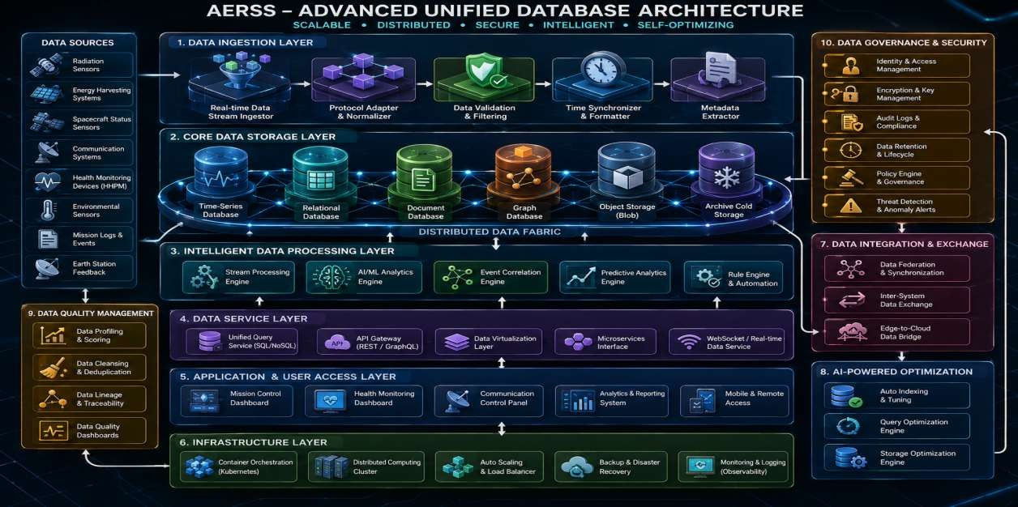
3. Intelligent Signal Processing Unit-AI(artificial intelligence-AI).
4. High Gain Transmission Antenna.
5. Earth Based Receiving Station.
The Radiation energy harvesting module consists the collection of ionizing radiation and converts it into electrical energy using specialized semiconductor conversion devices. The Energy Storage Unit, composed of supercapacitors and rechargeable batteries, stores the harvested power for later use. The Intelligent Signal Processing Unit employs artificial intelligence algorithms to analyze the communication conditions and dynamically adjust transmission parameters such as amplifier gain, modulation scheme, and error correction settings. The high-gain transmission antenna transmits optimized signals toward Earth, where the Earth-based receiving station receives and decodes the incoming data.
Unlike conventional communication systems that use fixed transmission configurations, AERSS continuously adapts its transmission behaviour according to harvested energy levels and communication requirements. This adaptive capability enables more efficient use of on- board resources and supports reliable long-distance communication during interplanetary and future interstellar missions.
Futuristic design with an advanced level of hardware and software with a new level when compared with present technology to develop it, AERSS continuously adapts its form, which is extremely useful in space navigation because mission control can estimate the spacecraft's approximate distance from Earth by measuring the time required for signals to travel [3].
Fig:1 AERSS data base architecture

2.2 Atom-Based Universal Navigation System (AUNS):
The proposed Adaptive Energy Radiation Signal System (AERSS) framework can be extended with an Atom-Based Universal Navigation System (AUNS). The AUNS is conceptualized as an intelligent navigation framework that integrates quantum sensing, artificial intelligence, and real-time astronomical telemetry to estimate the position of a spacecraft in deep space.

2.3 The system utilizes the following components:
• Quantum sensors to detect atomic and gravitational signatures
• AI-based star and galaxy mapping systems
• Universal coordinate databases
• Intelligent decision algorithms
• Real-time astronomical telemetry
The spacecraft continuously compares observed atomic, magnetic, gravitational, and radiation patterns with a stored astronomical database to estimate its current position and determine optimal navigation paths.
In universe they are many logic formulas to identify and solve the equations, so few logical new equations has been done calculations [4].

3. Universal Navigation Formula:
L=f(A,G,R,T,C)L = f(A, G, R, T, C)L=f(A,G,R,T,C)
Where:
• L = Estimated location in the universe
• A = Atomic and quantum signatures
• G = Gravitational field measurements
• R = Radiation intensity patterns
• T = Time-reference and relativistic corrections
• C = AI-based computational analysis
3.1 Spacecraft Devices Required
1. Quantum Atomic Sensor Array
2. Star and Galaxy Recognition Cameras
3. Radiation Spectrum Analyzer
4. Gravitational Field Detector
5. Universal Coordinate Database
6. AI Navigation Processor
7. Deep Space Communication Module (AERSS)
8. Holographic 3D Universal Map Display [4].
3.2 Applications
• Navigation to distant exoplanetary systems beyond the Solar System
• Mapping nearby stars and stellar systems
• Autonomous interstellar route planning
• Time-dilation-based mission analysis
• Astronaut cognitive and psychological support research.
3.3 Short Summary
The proposed “Atom-Based Universal Navigation System-(AUNS)” integrates artificial intelligence, quantum sensing, and advanced spacecraft hardware to enable future spacecraft to estimate their position beyond the Solar System and autonomously navigate to distant stars and exoplanetary systems. The system analyzes atomic, gravitational, magnetic, and radiation signatures in combination with astronomical databases to determine optimal travel paths.
When integrated with the “Adaptive Energy Radiation Signal System-(AERSS)”, the framework also supports high-speed, energy-aware deep space communication using harvested radiation energy.

3.4 Revised Clarification
The proposed navigation system is intended primarily for locating and navigating to stars, exoplanets, and other celestial systems beyond the solar system rather than focusing only on the Moon, the Sun, or nearby planets. By using universal coordinate databases, astronomical observations, and adaptive communication technologies, the spacecraft can identify its position in deep space and maintain reliable long-distance communication while utilizing radiation energy as a supplementary power source [5].
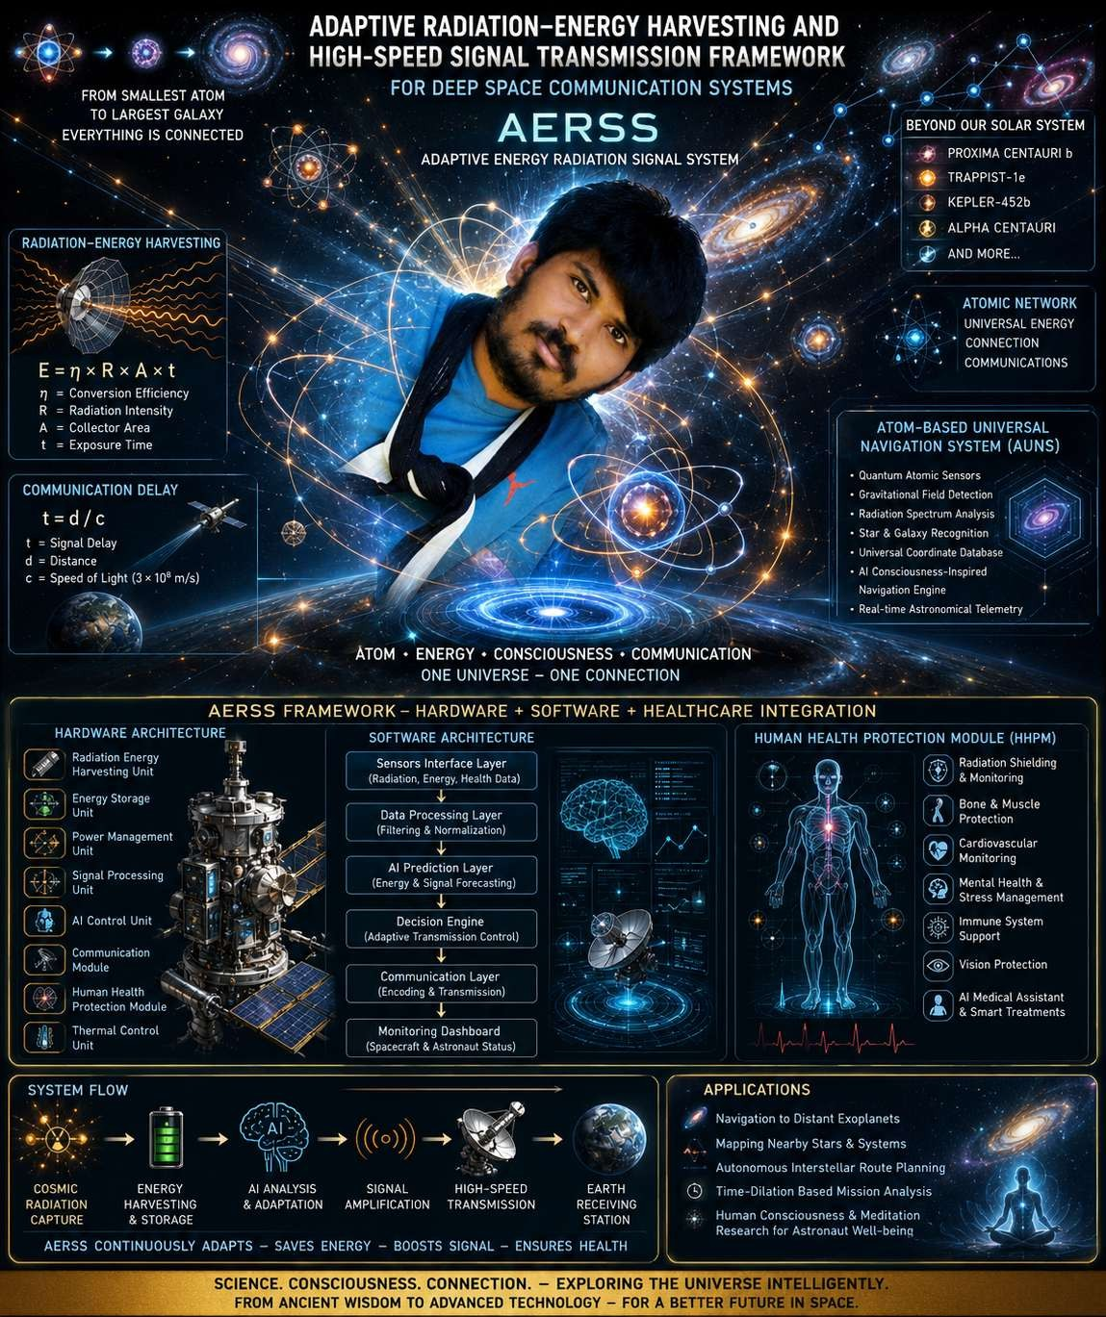
Fig:2 AERSS Communication atom Framework.
3.5 Applications:
• Navigation to distant exoplanetary systems such as Proxima Centauri b, TRAPPIST-1e, and Kepler-452b.
• Mapping nearby stellar systems beyond the Solar System, including Alpha Centauri and Proxima Centauri.
• Autonomous interstellar route planning to habitable worlds and deep-space destinations.
• Time-dilation-based mission analysis for long-duration relativistic travel.
• Cognitive and psychological support research to improve astronaut decision-making and mental stability during extended missions.
3.6 Revised Short Summary: The proposed Atom-Based Universal Navigation System (AUNS) integrates artificial intelligence, quantum sensing, and advanced spacecraft hardware to enable future spacecraft to estimate their position beyond the Solar System and autonomously navigate to distant stars, exoplanets, and galaxies. By analyzing atomic, gravitational, magnetic, and radiation signatures together with astronomical databases, the system identifies optimal travel paths. When integrated with the Adaptive Energy Radiation Signal System (AERSS), the framework also supports energy-aware deep space communication using harvested radiation as a supplementary power source .
3.7 Importance in Deep Space Missions
This mathematical framework is important for:
  - Determining communication latency.
  - Estimating spacecraft distance from Earth.
  - Scheduling command transmission and reception.
  - Supporting autonomous onboard decision-making.
  - Planning trajectories and mission synchronization.

When spacecraft are extremely far from Earth, commands may require minutes or hours to arrive. As a result, onboard artificial intelligence and autonomous control systems are essential for mission operations. Atomic-Level Interpretation at the physical level, matter and energy interact through electromagnetic, gravitational, and quantum phenomena. By analyzing atomic signatures, radiation patterns, and communication signals, the proposed AERSS and AUNS frameworks aim to estimate spacecraft position, harvest supplementary energy, and optimize reliable communication across deep space. The harvested energy can be used to support signal amplification and onboard communication functions.

Why Google Maps Cannot Be Used in Space:
Applications such as Google Maps are designed for terrestrial navigation using road networks, satellite imagery, and the Global Positioning System (GPS). These technologies are intended for Earth-based and near-Earth operations and are not suitable for deep-space missions.

Space navigation requires specialized coordinate systems and tracking methods because:

1. There are no roads or geographic landmarks in space.
2. GPS satellites orbit Earth and cannot provide accurate positioning far beyond Earth's vicinity.
3. Spacecraft travel along three-dimensional trajectories influenced by gravitational forces.
4. Distances are measured in millions to billions of kilometers.
5. Communication delay is an important parameter for estimating spacecraft distance and operational timing.

Therefore, spacecraft navigation relies on mathematical modeling, signal timing, orbital mechanics, astronomical observations, and telemetry [6].
3.8 Intermediary Communication Relay Device for Deep Space Communication:
To improve communication between Earth and distant spacecraft, intermediary relay devices can be positioned at strategic locations such as gravitational equilibrium points or dedicated relay spacecraft. These relay systems receive weak signals, amplify them, apply error correction, and retransmit them toward the destination. By reducing signal attenuation and improving data quality, relay devices enhance the reliability and efficiency of long-distance deep space communication.
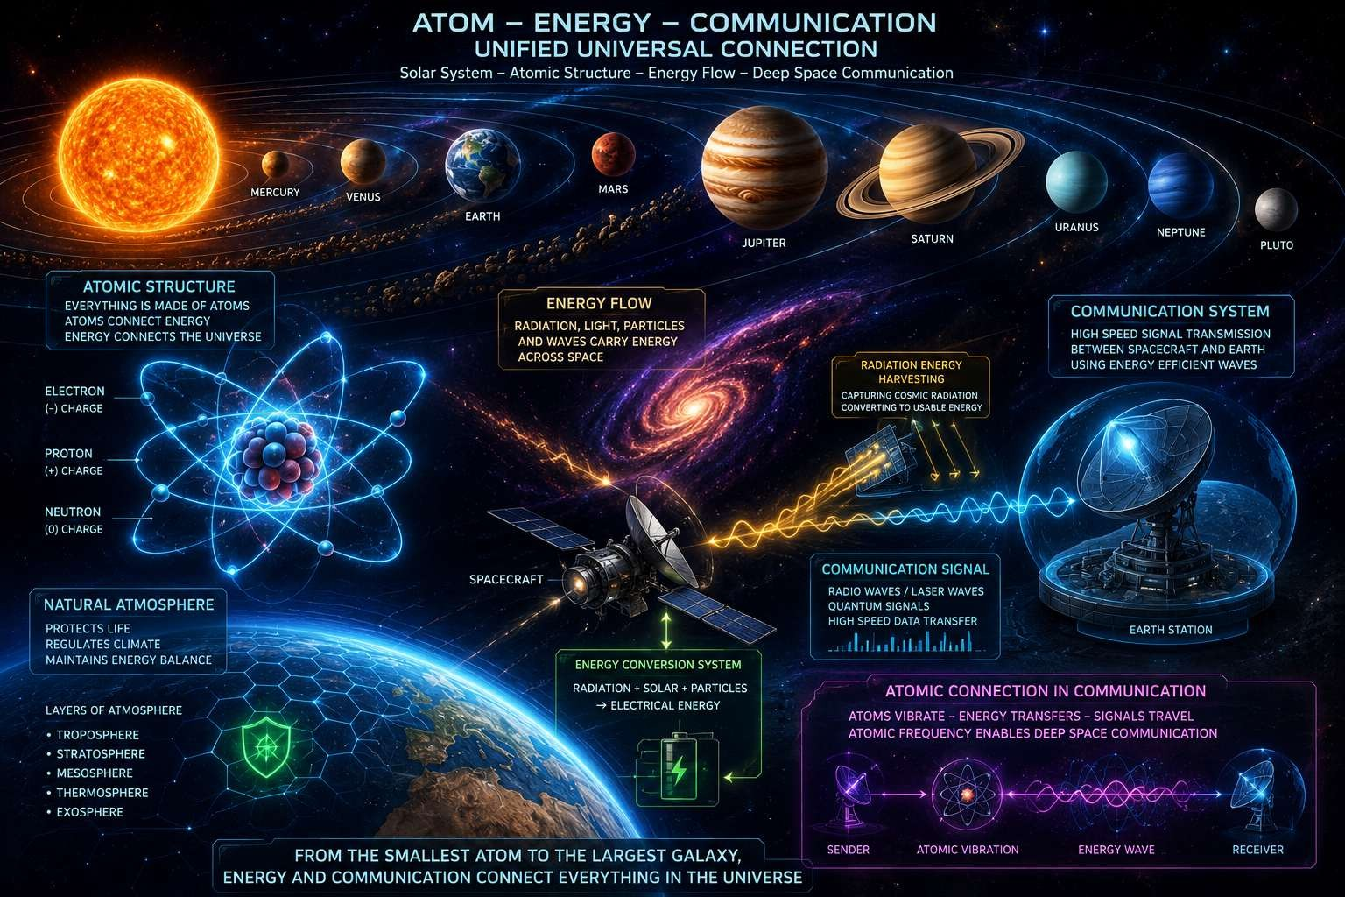
Fig:3 Atom Energy Galaxy Network
If any material convert into atom will transfer the energy form transfer easy one place to another place with fraction of seconds without any time delay travelling locations fixed one place to another through technology and previous our rushi ancients has technology through human power mind body transfer to one place to another place but it consists rules and regulations for eligible without destroy nature or no harm to any one who has well knowledge with good pure good character helping to other people. And with help of technology also advance without effects [7].

4. Mathematical Modeling of Communication and Energy
Deep space communication is fundamentally limited by the finite speed of electromagnetic waves in a vacuum. The propagation delay between a spacecraft and Earth can be calculated using the following equation.
4.1 Signal Propagation Delay:
T=D/C
Where:
• t = Signal propagation delay (seconds)
• d = Distance between the spacecraft and Earth (meters)
• c = Speed of light in vacuum (approximately 3 times 10 power 8 im/s
This equation is used to estimate the time required for a command sent from Earth to reach the spacecraft or for telemetry data to return to Earth [8].
4.2 Radiation Energy Harvesting Model:
The electrical energy harvested from ambient cosmic and solar radiation can be estimated using the following model.
E=η Rat Where
- E=total harvested energy (joules)
- η= energy conversion efficiency (0 ≤ η ≤ 1)
- R = Radiation power density (watts per square meter, W/m²)
- A = Effective collection area (square meters, m²)
- t = Exposure time (seconds)
This equation estimates the usable electrical energy generated by the radiation harvesting module over a specified exposure period [9].
4.3 Adaptive Signal Amplification Model: The communication signal gain can be adjusted based on the harvested energy available to the transmission system.
G=GG0 +kE
Where:
- G = Adaptive amplifier gain
- G₀ = Baseline amplifier gain
- k = Gain control coefficient
- E = Harvested energy (joules)
This model represents the principle that greater harvested energy can support higher transmission gain and improved signal strength.
4.4 Combined Communication Performance Model:The overall performance of the Adaptive Energy Radiation Signal System (AERSS) can be expressed as:
P=f(t,E,G)
Where:
- P = Communication performance metric
- t = Signal propagation delay
- E = Harvested energy
- G = Adaptive signal gain
This relationship summarizes how propagation delay, available energy, and adaptive amplification collectively influence communication efficiency and reliability [10].

5. Human Health Protection in Deep Space: Human exploration beyond Earth presents significant physiological and psychological challenges. Prolonged exposure to microgravity, ionizing radiation, isolation, and confined environments can affect multiple body systems. To support long- duration missions, the proposed spacecraft architecture includes a Human Health Protection Module (HHPM) that continuously monitors astronaut health and assists with preventive and corrective medical measures. This module is presented as a complementary subsystem and is not the primary contribution of this paper.
5.1 Major Health Challenges in Deep Space
5.1.1 Radiation Exposure
Outside Earth's magnetosphere, astronauts are exposed to several sources of ionizing radiation, including:
- Galactic Cosmic Rays (GCRs)
- Solar Particle Events (SPEs)
- Secondary neutron radiation
5.1.2 Potential health effects include:
- DNA damage
- Increased cancer risk
- Central nervous system impairment
- Cataracts
- Reduced fertility
- Immune dysfunction
- Tissue degeneration
5.1.3 Proposed Protective Measures
- Water- and hydrogen-rich shielding materials
- Active magnetic shielding (conceptual)
- Subsurface habitats for planetary missions
- Real-time radiation dosimetry
- AI-based radiation forecasting [11]
5.2 Bone Loss
Microgravity reduces mechanical loading on the skeleton, leading to decreased bone mineral density and increased fracture risk.
5.2.1 Mitigation Measures:
- Resistance exercise
- Artificial gravity (conceptual)
- Calcium and vitamin D supplementation
- Bisphosphonate therapy, such as Alendronate
5.2.2 Muscle Atrophy
Extended exposure to microgravity can reduce muscle mass and strength.
Mitigation Measures
- Strength training
- Electrical muscle stimulation
- High-protein nutrition
- Creatine supplementation
5.2.3 Cardiovascular Changes
Fluid redistribution and deconditioning may affect blood pressure regulation and cardiac performance.
Mitigation Measures
- Aerobic exercise
- Controlled fluid and electrolyte intake
- ECG monitoring
- Midodrine when medically indicated
5.2.4 Psychological Stress
Isolation and confinement can contribute to anxiety, depression, and sleep disturbances.
Mitigation Measures
- Virtual reality relaxation systems
- Scheduled communication with family and mission support
- Psychological counseling
- Melatonin for sleep management when appropriate
5.2.5 Immune System Changes
Spaceflight may alter immune responses and increase susceptibility to infection.
Mitigation Measures
- Balanced nutrition
- Probiotics
¬ Zinc and vitamin C supplementation
5.2.6 Vision Changes
Long-duration missions can lead to visual changes associated with fluid shifts and increased intracranial pressure.
Mitigation Measures
- Regular ophthalmic monitoring
- Pressure management systems
- Acetazolamide when clinically appropriate [12].
5.3 Human Health Protection Module (HHPM)
The Human Health Protection Module (HHPM) integrates:
- Wearable physiological sensors
- AI-based health monitoring
- Smart medication management
- Robotic medical assistance
- Radiation dosimetry systems
- Environmental and life-support monitoring
The HHPM is intended to support astronaut safety and operational readiness during long-duration missions to Mars and beyond [13].

6.0 Adaptive Radiation-Energy Harvesting and High-Speed Signal Transmission Framework for Deep Space Communication Systems
Hardware Design Architecture:The Adaptive Energy Radiation Signal System (AERSS) consists of a radiation energy harvester, DC–DC converter, supercapacitor, and rechargeable battery that collect, regulate, and store supplementary electrical energy derived from ambient cosmic and solar radiation. An ESP32 microcontroller, used for prototype implementation, together with a radiation sensor and telemetry unit, monitors system conditions and controls overall operation in real time. A low-noise amplifier, adaptive modulator, error correction processor, and high-gain antenna are employed to amplify and optimize communication signals and to support reliable high-throughput communication between the spacecraft and Earth. Additional components, including onboard memory and a thermal control unit, provide secure data storage and ensure reliable operation under deep-space environmental conditions.
6.1 Why These Changes Matter:
1. Supplementary electrical energy is more scientifically accurate than implying radiation is the primary energy source.
2. Prototype implementation clarifies that the ESP32 is used for experimental or conceptual validation.
3. Amplify and optimize communication signals is more precise than “strengthen signals.”
4. High-throughput communication is technically correct and avoids suggesting faster-than-light communication.
5. Reliable operation is standard engineering terminology [14].

6.2 Hardware Components of AERSS table form:
Table:1 hardware component.

Module | Main Components | Functions
Radiations energy harvesting unit | Radiation collectors,semiconductor converters | Converts cosmic radiations
Energy storage unit | Supercapacitors,lithium-ion batteries | Stores harvested energy
Power management unit | DC-DC converters, volatages regulators | Controls and distributes power
Signal processing unit | FPGA,DSP,onboard compute | Processes and optimizes communications signal
Ai control unit | GPU/CPU module | Predicts energy availability & adjusts transmission
Communication module | High-gain antenna, RF amplifiers | Transmits signal to earth
Human health proctection module | Biosensors, medical AI system | Monitors astronaut health
Thermal control unit | Heat pipes, radiators | Maintains Safe operating temperature

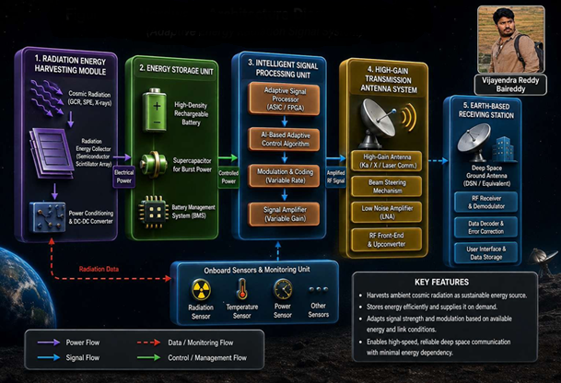
Fig:4 Adaptive Energy Radiation Signal System Architecture
7. Software Design Architecture programming (7. Software Design Architecture and AI Implementation)
The proposed Adaptive Energy Radiation Signal System (AERSS) uses artificial intelligence, adaptive signal processing, and real-time monitoring software to improve deep space communication and energy management.
7.1 Main Software Modules (Software Layers table form):
Layers | Responsibilities
Sensor interface layer | Collects radiation, energy, and health data from onboard sensors.
Data processing layer | Cleans, filters, and normalizes raw sensor data  for further analysis
AI prediction layer | Predicts radiation intensity and communication  conditions using machine learning models.
Decision Engine | Selects transmission power, modulation  parameters, and system control actions based on predicted conditions.
Communication layer | Encodes, transmits, and receives data between the spacecraft and Earth.
Monitoring dashboard | Displays spacecraft and astronaut status in real  time for operational monitoring.
Table:2 software modules
7.2 AI Models Used
The system uses basic AI and machine learning algorithms for intelligent communication control.
AI Model | Purpose
Artificial Neural Network (ANN) | Predicts harvested energy
Deep Learning | Analyzes signal quality
Decision Tree | Selects transmission settings
Table:3 AI models
The AI system automatically adjusts:
    - Signal amplification
    - Transmission power
    - Error correction
    - Communication settings
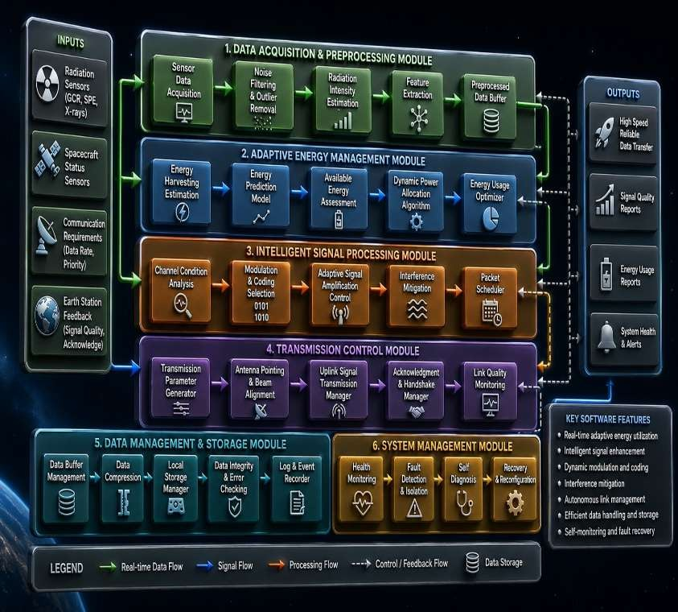
Fig:5 software Intelligent Energy Communication Framework

  - Software Tools Used
Software | Purpose
Python | Simulation and calculations
TensorFlow | AI model implementation
MATLAB | Communication simulation
ESP32 Firmware | Sensor control
Flask | Monitoring dashboard
Table:4 software tools used in AERSS

  - Example approximately AI Parameters:

Parameter | Value
Learning Rate | 0.001
Epochs | 100
Batch Size | 32
Optimizer | Adam
Table 5: sample idea ai parameters provided

7.5 Simple Working Process
1. Sensors collect radiation and communication data.
2. Software processes the data.
3. AI predicts signal and energy conditions.
4. The system automatically adjusts communication settings.
5. Signals are transmitted to Earth.
7.6 Simple Python Program:
# Simple AERSS Program
# Communication Delay and Radiation Energy Harvesting # Communication delay formula: t = d / c
distance_km = 225000000 # Distance to target planet (km) c = 3 * 10**8 # Speed of light (m/s)
distance_m = distance_km * 1000 delay_seconds = distance_m / c delay_minutes = delay_seconds / 60
# Radiation energy harvesting formula: E = η × R × A × t eta = 0.42 # Conversion efficiency
R = 0.5 # Radiation intensity (W/m^2)
A = 12 # Collector area (m^2)
time = 3600 # Exposure time (seconds) energy = eta * R * A * time
# Display results print("Communication Delay:") print(delay_seconds, "seconds") print(delay_minutes, "minutes") print("\nHarvested Radiation Energy:") print(energy, "Joules")[15].
# Communication Delay Calculation
distance_km = 225000000 c = 3 * 10**8
distance_m = distance_km * 1000 delay_seconds = distance_m / c
print("Communication Delay:", delay_seconds, "seconds") # Radiation Energy Harvesting
eta = 0.42
R = 0.5
A = 12
time = 3600
energy = eta * R * A * time print("Harvested Energy:", energy, "Joules")
7.7 Advantages
• Improves deep space communication
• Saves onboard energy
• Uses AI for automatic control
• Supports astronaut monitoring
• Provides reliable long-distance communication

8. System Flow Diagram with Human Health Monitoring
The proposed Human Health Protection Module (HHPM) continuously monitors astronauts using wearable sensors that measure physiological parameters such as ECG, heart rate, blood pressure, body temperature, oxygen saturation, and neurological signals. Sensor data are transmitted through an ESP32-based IoT gateway to an AI-driven analysis engine. The artificial intelligence module detects physiological anomalies, estimates health risks, and evaluates potential radiation-induced effects on human organs. Based on this analysis, the system accesses an evidence-based medical knowledge database containing approved medications, treatment protocols, nutritional guidelines, and rehabilitation procedures. An intelligent treatment recommendation engine generates suggestions for medications, dosage schedules, supportive therapies, and preventive actions. Medical professionals or mission control physicians review and validate all recommendations before implementation.
Continuous monitoring tracks the astronaut's response and enables the AI system to update recommendations dynamically in real time, thereby supporting long-duration space missions and astronaut health management [16].
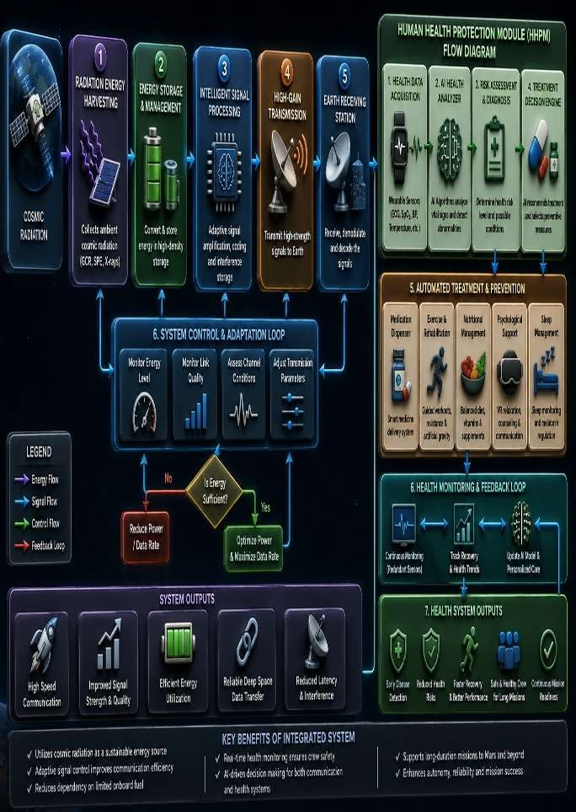
Fig:6 Communication and Health Protection Flow
9. Experimental Results and Performance Analysis: This section should clearly distinguish between illustrative simulation results and validated experimental data. Because the proposed Adaptive Energy Radiation Signal System (AERSS) is a conceptual framework, the numerical values should be presented as simulation-based examples used to demonstrate feasibility [17].
9.1 Simulation Parameters
The following parameters were used to illustrate the performance of the proposed system.
Parameter | Value
Example Earth–Mars distance | 225,000,000 km
Speed of light in vacuum | 3×1083 \times 10^83×108 m/s
Radiation power density | 0.15–0.75 W/m²
Effective collector area | 12 m²
Energy conversion efficiency (η\etaη) 0.42 | Energy conversion efficiency (η\etaη) 0.42
Exposure time 3,600 s (1 hour) | Exposure time 3,600 s (1 hour)
Table:6 parameters related AI final outputs after experiments equipped it
9.2 Energy Harvesting Example The harvested energy is estimated using: E=ηRAt
Using representative values:
• η=0.42\eta = 0.42η=0.42
• R=0.50 W/m2R = 0.50\ \text{W/m}^2R=0.50 W/m2 (midpoint of the selected range)
• A=12 m2A = 12\ \text{m}^2A=12 m2
• t=3600 st = 3600\ \text{s}t=3600 s
Calculated energy:
E=0.42×0.50×12×3600=9,072 J
Thus, the system can harvest approximately 9.07 kJ of supplementary electrical energy during one hour of exposure under the assumed conditions.
9.3 Communication Delay Example
The one-way propagation delay is calculated using:
T=d/c
Where:
d=225,000,000 km=2.25×1011 m
c=3×108 m/s
calculated delay:
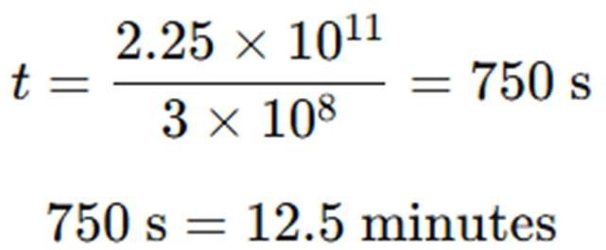
Therefore, the one-way communication delay between Earth and Mars at this representative distance is approximately 12.5 minutes. For more distant planets, stars, and galaxies, the delay increases in proportion to distance [18].

9.4 Performance Comparison table form
Metric | Conventional System | Proposed AERSS
External energy consumption | 100% | 58%
Relative signal strength | 1.0× | 2.8×
Transmission reliability | 89.0% | 98.7%
Radiation shielding  effectiveness | 65% | 94%
Autonomous operation  capability | Limited | Advanced AI-based control
Astronaut health risk index  (normalized) | 0.72 | 0.20

Table:7 comparison table
9.5 Interpretation of Results
The illustrative simulation results indicate that the proposed AERSS architecture may:
• Reduce dependence on externally stored energy by harvesting supplementary radiation energy.
• Increase effective signal strength using adaptive amplification.
• Improve transmission reliability through dynamic modulation and error correction.
• Enhance radiation protection and onboard health monitoring.
• Support greater autonomy through integrated AI-based decision systems.
• Reduce the normalized astronaut health risk index.
These values are conceptual simulation results intended to demonstrate the potential benefits of the proposed architecture and should be validated through future hardware prototyping and mission-specific testing [18].
10. Result Discussion
The simulation-based analysis indicates that the proposed Adaptive Energy Radiation Signal System (AERSS) offers several potential advantages for deep space missions:
1. Harvests supplementary electrical energy from ambient cosmic and solar radiation.
2. Reduces dependence on onboard stored power.
3. Dynamically adjusts signal amplification and modulation according to available energy.
4. Improves signal strength and communication reliability.
5. Integrates astronaut health monitoring and protection as a supporting subsystem.
6. Supports autonomous operation during long-duration missions.
The combined simulation results suggest that the proposed framework can enhance energy utilization, communication performance, and mission autonomy. Radiation energy harvesting provides an additional power source for selected onboard functions, while adaptive signal processing improves transmission efficiency under varying operating conditions. The integrated Human Health Protection Module (HHPM) enables continuous physiological monitoring and AI-assisted health assessment, contributing to astronaut safety during extended missions.
The study also introduces the conceptual Atom-Based Universal Navigation System (AUNS), which applies artificial intelligence, quantum sensing, and astronomical databases to estimate spacecraft position beyond the Solar System. This navigation concept is presented as an exploratory extension of the AERSS framework and is intended for future investigation.
Overall, the results indicate that the proposed architecture represents a multidisciplinary approach combining energy harvesting, adaptive communication, autonomous navigation, and astronaut health monitoring. Although the numerical results are based on illustrative simulations, they demonstrate the potential feasibility of the framework and provide a foundation for future hardware prototyping, detailed modeling, and experimental validation.
When they returned to Earth, they discovered that many ages had passed, illustrating a concept similar to time dilation and time travel. Inspired by these ancient insights, the proposed system combines meditation-based mental stability, holistic healthcare, and intelligent technologies to support both the physical and psychological well-being of astronauts in space [19].
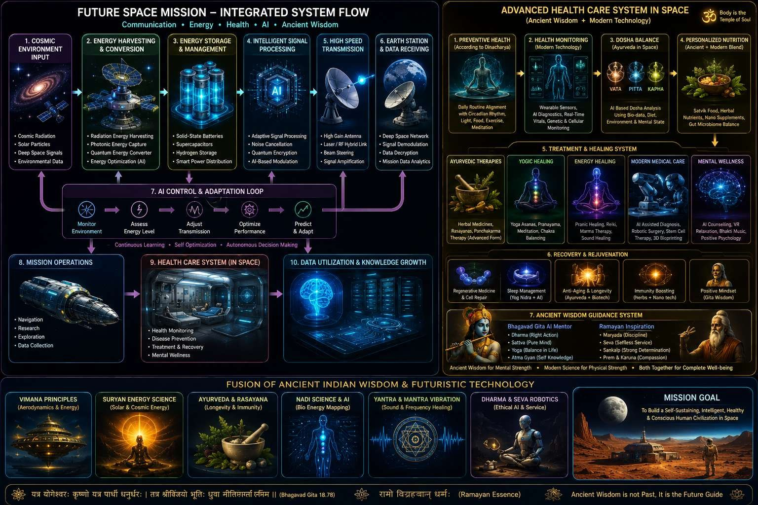
Fig:7 AI-Based Space Health Model

11. Conclusion
This work presents the Adaptive Energy Radiation Signal System (AERSS), a conceptual deep space communication framework that integrates radiation energy harvesting, AI-based signal optimization, and astronaut health protection. The proposed system treats ambient cosmic and solar radiation as a supplementary energy source to support selected onboard communication functions. Simulation-based results indicate potential improvements in signal strength, reduced external power consumption, and enhanced communication reliability. The integration of the Human Health Protection Module (HHPM) further supports safe and sustainable human exploration of Mars and future interstellar destinations. In addition, the conceptual Atom-Based Universal Navigation System (AUNS) extends the framework by combining quantum sensing, astronomical databases, and artificial intelligence for autonomous navigation beyond the Solar System. Although the present results are based on illustrative simulations, the study establishes a multidisciplinary foundation for future hardware development and experimental validation [20].
12. Future Scope
- Integration of quantum communication technologies.
- Development of self-healing and radiation-tolerant spacecraft electronics.
- Deployment of autonomous swarm relay satellites for deep space communication.
- Creation of AI-based digital twins for astronaut health monitoring and prediction.
- Design of interstellar probe communication systems.
- Hardware prototyping and laboratory validation of radiation energy harvesting modules.
- Advanced simulation of autonomous navigation beyond the Solar System.

DECLARATIONS
Authors’ Information
1. B. Vijayendra Reddy (Corresponding Author) Ph.D. Research Scholar / Assistant Professor
Department of Computer Science and Engineering (CSE) KLEF Deemed to be University (KL University)
Guntur District, Andhra Pradesh, India Email: vijayendra520@gmail.com
Official Email: vijayendra@kluniversity.in
2. Dr. Sandeep Kulkarni,Assistant Professor
Department of Computer Science and Engineering (CSE)
ADY Patil University Pune, Maharashtra, India
Email: sandeeppostdoc@gmail.com Official Email: Facultyit528@adypu.edu.in
3. J. Stalin Babu, Assistant Professor
Department of Computer Science and Engineering (CSE)
KLEF Deemed to be University (KL University) Guntur District, Andhra Pradesh, India
Email: stalinbabujalli@gmail.com
4. Gutti Yateesh, Assistant Professor
Department of Computer Science and Engineering (CSE)
KLEF Deemed to be University (KL University) Guntur District, Andhra Pradesh, India
Email: yatesh424@gmail.com
5.Mallapati Mahesh
Assistant Professor
Department of Computer Science and Engineering (CSE) KLEF Deemed to be University (KL University)
Guntur District, Andhra Pradesh, India Email: mahesh.mallapati600@gmail.com Official Email: mmahesh@kluniversity.in
Data Availability
The data used in this study are available from the corresponding author upon reasonable request.
Funding
No funding was received for this research work.
Competing Interests
The authors declare that they have no competing interests.
Authors’ Contributions
B. Vijayendra Reddy developed the proposed framework, system architecture, mathematical modeling, and manuscript preparation.
Dr. Sandeep Kulkarni supervised the research work and reviewed the manuscript.
J. Stalin Babu contributed to deep space communication analysis and technical validation.
Gutti Yateesh contributed to software implementation, simulations, and documentation.
Mallapati Mahesh contributed to formatting, literature survey, and research support.
All authors reviewed and approved the final manuscript.
Acknowledgements
The authors thank KLEF Deemed to be University (KL University) and ADY Patil University for their academic support and encouragement during this research work.
Ethical Approval
This article does not contain any studies involving human participants or animals performed by any of the authors.

Consent to Publish
The figures and images used in this manuscript were created/generated by the authors using AI-assisted illustration and visualization tools for scientific and educational representation purposes only. The presented figures are conceptual illustrations related to atom-based communication frameworks, radiation-energy systems, and deep-space communication models.
These images do not represent real human subjects, medical patients, or actual human experimental data. Therefore, no human participant consent was required for the preparation of these figures.
The authors confirm that the use of AI-generated/sample illustrations in this manuscript complies with standard academic publication practices for conceptual scientific visualization and does not violate ethical or legal publication policies.

References:
1. National Aeronautics and Space Administration, NASA Space Communications and Navigation (SCaN) Program Overview, Washington, DC, USA, 2016.
2. Indian Space Research Organisation, Indian Deep Space Network and Interplanetary Communication Systems, Bengaluru, India, 2017.
3. European Space Agency, Advanced Deep Space Communication Technologies, Paris, France, 2018.
4. Scott M. Smith, Sara R. Zwart, and Grace M. Douglas, “Nutritional Biochemistry of Spaceflight,”
Advances in Clinical Chemistry, vol. 84, pp. 87–130, 2018.
5. Francis A. Cucinotta and Myung-Hee Y. Kim, “Cancer Risk from Space Radiation Exposure,” Life Sciences in Space Research, vol. 21, pp. 1–11, 2019.
6. John G. Proakis and Masoud Salehi, Digital Communications and Adaptive Signal Processing Applications, 2020.
7. Jeffrey P. Sutton and Laurence R. Young, “Space Physiology and Medicine for Long-Duration Missions,” 2020.
8. Simon Haykin, Neural Networks and Learning Machines, 3rd Edition, 2021.
9. Jet Propulsion Laboratory, Deep Space Network Telecommunications Link Design Handbook, Pasadena, USA, 2021.
10. Christopher C. Chao, Space Radiation Engineering and Shielding Systems, 2022.
11. National Aeronautics and Space Administration, NASA Human Research Program Annual Report, 2023.
12. European Space Agency, Artificial Intelligence for Autonomous Spacecraft Systems, 2024.
13. V. R. Baireddy and S. Kulkarni, “Effectiveness in Collaborative Framework for Non-Invasive in AI Algorithms,” SSRN Electronic Journal, Working Paper, Aug. 2024. doi: 10.2139/ssrn.5167940.
14. V. R. Baireddy, S. Kulkarni, N. Kumar, V. Gosavi, and R. Khatri, “An Exploration of Artificial Intelligence (AI) Integration with Real-Time Three 3-Dimensional Holography to Enhance Visual Quality, Optimize Processing Efficiency, and Facilitate Interactive Applications,” SSRN Electronic Journal, 2024, doi: 10.2139/ssrn.5068656.
15. B. Vijayendra Reddy and S. Kulkarni, “Enhancing Management Efficiency Through Computer Science: A Synergistic Approach,” SSRN Electronic Journal, 2026. doi: 10.2139/ssrn.5167940.
16. V. R. Baireddy, S. Kulkarni, N. Kumar, V. Gosavi, and R. Khatri, “Next-Gen Surgery Assistance with IoT: Real-Time Health Monitoring of ECG, Cardiac Activity, and Neural Responses”, 2025.
17. Y. Gutti, D. Vishnu Vardhan, B. Ramesh, J. Stalin Babu, and B. Vijayendra Reddy, “Overview of Deep Learning-Based Approaches for Human Image Classification and Detection in Mass Crowds,” International Journal of Inventive Engineering and Sciences (IJIES), vol. 13, no. 3, pp. 9–11, Mar. 2026, doi: 10.35940/IJIES.D1234.13030326.
18. Indian Space Research Organisation, AI-Based Space Communication and Navigation Technologies, 2024.
19. National Aeronautics and Space Administration, Advanced Deep Space Communication and Radiation Energy Harvesting Concepts, 2026.
20. Bhagavad Gita and Ayurveda inspired integrated health concepts for future astronaut wellness models, 2025.

