PEDIAVENTURE: Implementing Gamified Advanced Learning Materials for Young Minds

Abstract – This study of gamified learning discusses the development and implementation of e-learning materials to provide support for 3rd grade students at Colegio San Jose de Alaminos Inc. (CSJA). Interactive and engaging games designed to enhance critical thinking, linguistic skills, and problems-solving skills are integrated to recognize the challenges young learners or students face in reading comprehension and basic mathematical equations. Gamified elements such as points, rewards, and feedback are leveraged, linking to both traditional and modern teaching methods and approaches. To sustain motivation and improve learning outcomes, real-time feedbacks are also sustained to the young learners and teachers. The subjects, English, Filipino, and mathematics, in which the web-based application provides, are tailored to the students’ levels, complemented by a reward system to encourage the young learners to continue learning. With the ISO/IEC 25010 standards, usability is assessed to ensure the system’s functionality, reliability, and flexibility. The project offers a promising supplementary tool for teachers and students while the system is dependent on stable internet connectivity. Findings underscore the potential of gamified resources to foster engagement, comprehension, critical-thinking, problem-solving, and retention while also highlighting areas for future research to optimize e-learning for long-term educational effectiveness.
Keywords – Gamification, Pedagogy, Literacy, Academic Literacy, Interactive Learning
I. INTRODUCTION
Technologies have significantly emerged and influenced online and technology-oriented learning by improving student engagement, motivation, and technical skills. E-learning or gamified learning materials help provide and sustain students’ knowledge and motivation by turning curriculum-based lessons into interactive quizzes and fun activities to improve critical thinking, mathematical ability, and comprehension in both reading and choosing the right words.
The private educational institution in Alaminos City, Pangasinan, Colegio San Jose de Alaminos Inc. (CSJA) currently undergoes a transition from traditional to modern teaching approaches and methods. Despite the usage of Microsoft applications such as PowerPoint and Excel, the educational institution continues to face certain challenges in delivering lessons, however the school has adapted the mentioned basic, conventional applications to sustain in this modern century. 3rd grade students in particular, have encountered academic barriers: many students find it difficult to comprehend and interpret English texts, operations in mathematics, problem-solving, memorize the multiplication table, or encounter linguistic difficulties with advanced Filipino terminologies.
The investigation into the fundamental causes of these issues indicate that existing teaching strategies frequently lack the dynamic interactivity, instantaneous correction, and incentive structures required to prevent a disinterested and passive educational experience. Students who receive feedback hinders their ability tot rectify misunderstandings as they occur, as traditional grading and the resulting lapse in time are relied, which hinders them. These gaps will be resolved by a requirement for a comprehensive, effective, and efficient digital framework.
This educational research focuses on the development of the system “Pediaventure”, a web-based game provided to the young learners in grade 3 at Colegio San Jose de Alaminos Inc. The developed system is designed to enhance English literacy, Filipino literacy, and mathematical skills through a structured 10-level progression system that aligns with the curriculum. The project aims for foster a more inclusive and adaptable learning environment by bridging the gap between traditional and modern technological advancements.
The general purpose of this project is to provide a timely and attractive gamified activities that young learners can use to improve their participation and understanding across various subjects. Specifically, the study aims to achieve the following: To identify the learning materials and teaching strategies currently used by teachers in Colegio San Jose de Alaminos, to identify the challenges encountered by teachers with their current materials and delivery methods, improve system features needed to design and develop Pediaventure to address those identified challenges, and to measure the level of acceptance of the developed system among its target users.

II. METHODOLOGY
The proposed gamified system utilizes a methodology called Rapid Application Development (RAD) to combine descriptive and developmental approaches as the research framework. Descriptive research, conducted through interviews and surveys, was employed to collect data regarding current pedagogical challenges and teacher needs at Colegio San Jose de Alaminos Inc. (CSJA). The RAD methodology, chosen for its fast project turnaround and emphasis on user involvement, consists of four phases: Requirements Planning, User Design, Construction, and Cutover. During Requirements Planning, the team gathered project goals and system requirements by interviewing the school principal and teachers using surveys and voice recordings, ensuring alignment with Grade 3 curricular standards. The User Design phase involved the creation of UI prototypes in Figma, flowcharts, and Entity-Relationship Diagrams (ERDs) to represent the system’s structure and interactions. The Construction phase involved coding and implementing the system using Visual Studio Code and PHP, integrating features such as interactive subject-based games, quizzes, and reward systems until all requirements were satisfied. Finally, during the Cutover phase, usability testing occurred to ensure system stability while performing user training for educators and students, leading to final deployment and feedback collection to measure the system’s adequacy and functional suitability. The development method of the mobile application follows an adapted RAD model as shown in Fig. 1.
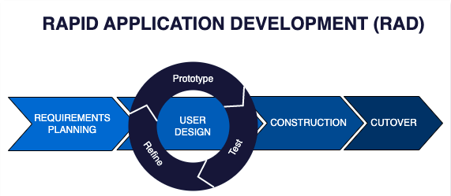
Figure 1.
Rapid Application Development Model

The researchers employed a purposive sampling strategy to target individuals who could offer the most pertinent expertise in early childhood pedagogy and classroom management for the selection of participants. The participants featured a wide range of stakeholders, including the school administration, faculty such as teachers, and the students to ensure a holistic data set for the refinement of the Pediaventure game. The participant pool was compromised of the School BED Principal, one educator, fifteen students, and two technical consultants, resulting in a total of nineteen participants. A detailed breakdown of these contributors is presented in Table 1.

Table I
Respondents of the Study Respondents of the Study

Respondents | Number of Respondents
School BED Principal | 1
Teacher | 1
Students | 15
IT Experts | 2
Total | 19

To evaluate the degree of user approval and potential for system refinement, a survey instrument was developed to capture organized quantitative information. The application of systematic statistical assessment to the gathered data verified the platform's practical utility. The study's authors employed a specific metric system to determine the functional quality, user immersion, and general success of the game-based educational tool.
For the purpose of evaluating and optimizing the system, a five-tier Likert Scale was adopted, assigning a maximum score of 5 for "Excellent" performance and a minimum score of 1 for "Poor" performance. The specific gradations of this scale and their associated mathematical boundaries are detailed in the following table:
Table II
Scale of Measurement for Acceptance Test
Scale | Statistical Boundaries | Rating Description | Descriptive Interpretation
5 | 4.21-5.00 | Excellent | Accepted
4 | 3.41-4.20 | Very Good | Accepted
3 | 2.61-3.40 | Good | Accepted
2 | 1.81-2.60 | Fair | Not
1 | 1.00-1.80 | Poor | Not
Statistical methods processed data from the Likert Scale survey, which enabled meaningful conclusion-drawing along with statistical significance discovery and broad user-satisfaction interpretation. Research on contemporary systems supporting gamified learning and educational technology uncovered effective practices, and existing academic analyses in the same region helped Pediaventure development ensure proper support for 3rd-grade learners and teachers at Colegio San Jose de Alaminos Inc. (CSJA). A combination of PHP and Laravel altogether with Visual Studio Code and Phoenix Code enabled the development team to create interactive lessons and real-time system updates that simplified programming and debugging. Students gained easy subject navigation and level-tracking capability through mobile-responsive application design work done with Figma, a web-based prototyping tool. The application platform and the MySQL database was implemented to deliver precise, up-to-date information on student progress and lesson completion status on real-time data communication.
The factor analysis influencing the project system’s functionality and user experience required the implementation of a Fishbone Diagram, which illustrated potential system issues and performance barriers in existing methods. There were five main categories which included methods, technology, and resources, alongside students and assessment. Specific causes identified a reliance on status PowerPoint presentations, limited digital interactivity, and the absence of instant feedback for learners. Through its systematic categorization process, the diagram clarified the possible causes that also need improvement such as manual checking and short attention spans while protecting the operational system for students, teachers, and other staffs.
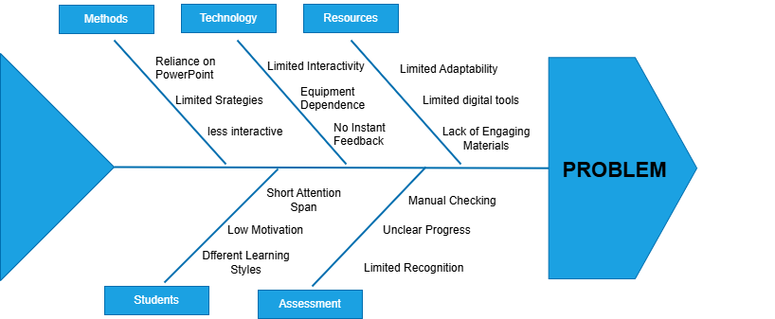
Figure 2.
Fishbone Diagram

Through the integration of these methodologies, tools, and technologies, the Pediaventure development process ensured a comprehensive, efficient, and user-centered solution for improving the early-grade learning experience. By addressing key challenges in literacy, numeracy, and instructional delivery, the system aims to optimize educational efficiency and enhance student satisfaction. The thoughtful design, grounded in Rapid Application Development (RAD), and the strong development utilizing a robust tech stack ensure that the platform meets the needs of both students and teachers. This approach contributes to a more streamlined and reliable educational experience, bridging the gap between traditional instruction and modern technological advancements.

III. RESULTS AND DISCUSSION
The proposed gamified learning system utilizes a three-tier architecture, a well-established software application structure known for its scalability and efficiency. This architecture comprises the presentation tier, application tier, and data tier.
In the architecture of the Pediaventure system, the presentation tier serves as the system’s user interface caters to the diverse needs of both teachers and students. The system utilizes a colourful, visually stimulating and child-friendly interface to access lessons and games, while teachers benefit from the developed admin panel for monitoring student records. This tier encapsulated functionalities such as user registration, login, authentication or security features, and subject selection to serve as the primary gateway for user interaction within the platform.
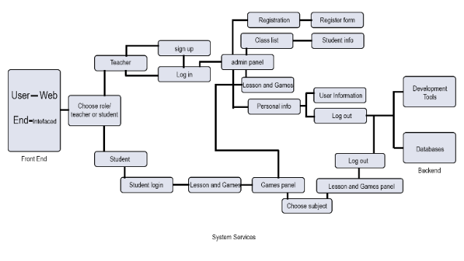
Figure 3.
System Architecture Framework
The application tier serves as the core of the system, which is responsible for processing user inputs, managing role-based access, and ensuring data security. Core functionalities such as scoring, reward distribution, and activity progression are handled at this tier to facilitate efficient communication between the user interface and the data storage layers or back-end. The application tier ensures the system’s reliability and responsiveness to learner demands by managing critical tasks such as enforcing sequence rules for lessons and providing real-time feedback.
The data tier constitutes the fundamental base of the entire system, providing a secure environment for the retention of vital information, such as accounts of students, teachers’ data, and lessons history. This tier is critical for maintaining the accuracy and consistency of records, which in turn supports the platform’s ability to upscale and function smoothly. It allows the system to manage high volumes of information and complex searches with each, such as updating academic growth charts or organizing competitive ranking on leaderboards by utilizing an efficient MySQL database setup.
The comprehensive three-tier model establishes a versatile and productive infrastructure for the gamified environment of Pediaventure. Prospective improvements, particularly regarding mobile responsiveness and more sophisticated pedagogical content could further improve the user’s journey and system efficiency and effectiveness. The ongoing collaboration with school stakeholders and a commitment to repeated developmental cycles will remain essential for the long-term viability of the platform and its ability to adapt to the changing requirements of the students at Colegio San Jose de Alaminos Inc.

FEATURES OF THE GAMIFIED SYSTEM
The gamified system was developed to address the challenges among young learners and faculty, and to provide a sustainable, efficient quality education for better comprehension and learning. The system is composed of numerous educational topics and levels in each subject such as English, Filipino, and Mathematics.
Figure 4.
User Type Selection

The User Type Selection interface lets users to identify their role or position within the educational game prior to accessing its features. Each user are required to choose between the options to be able to be directed to the correct interface and functionalities
Figure 5.
Subject Selection

The subject selection interface allows students to choose a specific subject that they want to start learning within the educational game.

Figure 6.
Filipino Topic Selection

Figure 7.
English Topic Selection

Figure 8.
Mathematics Topic Selection

The topic selection of subjects: English, Filipino and Mathematics show various topics sorted by first up to fourth quarter based on the modern curriculum of the target locale.

Figure 9.
Level Selection
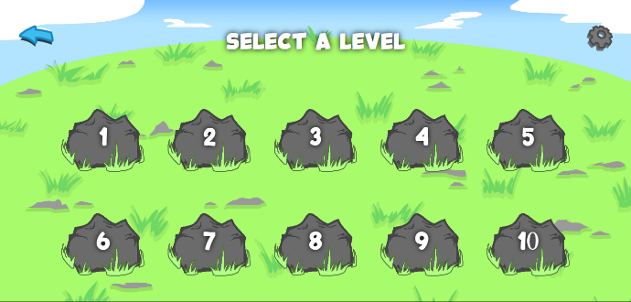
After the user selects a topic in the topic selection, they will be taken to the level selection from one up to the tenth level, where the difficulty of each level progressively increases.
Figure 10.
Level
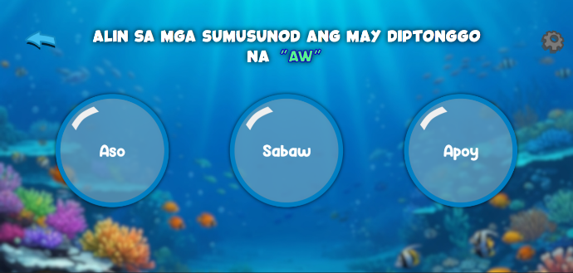
The user is given some choices based on the question above. The choices can be either one word or a sentence based on the chosen subject topic.
Figure 11.
Settings
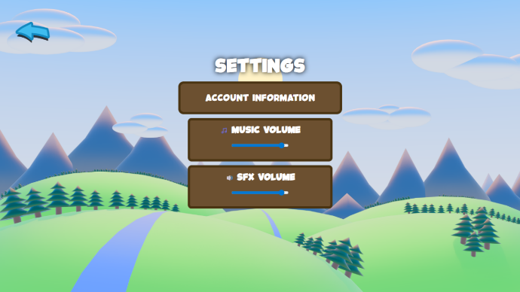
The settings screen allows all types of user to view currently logged-in information and change certain adjustments based on their personal preference such as the loudness of music and sound effects.

Figure 12.
Admin Panel
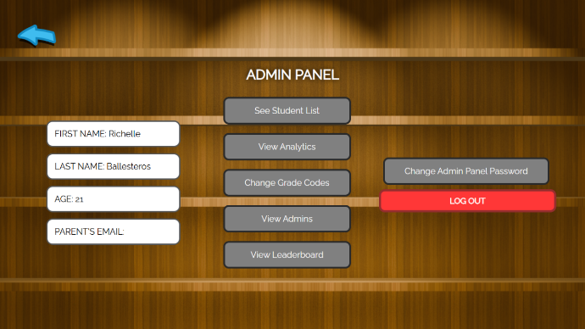
The admin panel serves as the central management interface of the gamified learning system to provide administrators and school staffs full control over student accounts, learning content, progress monitoring, and system settings to ensure smooth operations and high-quality experiences for students.
ACCEPTABILITY EVALUATION OF THE SYSTEM
The acceptability of the gamified learning system were primarily evaluated across several key software quality characteristics based on the ISO/IEC 25010 standard. The evaluation was conducted among 19 respondents, including the principal, teachers, students, and IT experts.
The proponents’ internal testing confirmed that the gamified learning system successfully performs the core tasks and objectives it was designed to achieve. The weighted mean in functionality was 3.40 which is rated “very good”.
The reliability of the gamified learning system was evaluated based on the consistency of its performance and the stability of its operation. The system was found to be a reliable and secure learning tool, in which the weighted mean is 3.41, which is rated “very good.”
The usability of the system was evaluated to determine how intuitive, engaging, and easy to navigate the platform is for its target users. The system was assessed based on factors like ease of use, accessibility, and the design/interface.
The efficiency of the system was evaluated on its ability to allow users to complete learning tasks smoothly and quickly to ensure a seamless experience across devices. The internal testing confirmed the system’s high performance efficiency, in which the weighted mean is 4.00 which is rated as “excellent”.
The maintainability of the system was evaluated based on the perception that the platform can be updated, expanded, and easily sustained for future improvements, in which the weighted mean is 3.89 which is rated as “very good”.
The portability of the system was also evaluated based on its ability to be accessed and perform effectively across different devices and environments. The web-based design was key to ensuring wide accessibility, in which the weighted mean is 4.45 which is “excellent”.

IV. CONCLUSION
The digital framework of Pediaventure represents a significant advancement in addressing the traditional and modern educational obstacles identified at Colegio San Jose de Alaminos Inc. (CSJA), delivering a notable boost in student involvement and teacher productivity. The application seeks to alleviate academic difficulties in basic literacy in English, Filipino, and mathematics while enriching the total educational journey by incorporating sophisticated web technologies such as subject-specific interactive e-learning, constant progress reports, and a systematic hierarchical advancement model.
Pediaventure effectively tackles hurdles like tedious manual documentation and limited student focus while fostering a culture of technological proficiency and digital growth by providing grade 3 students intuitive access to vibrant, developmentally tailored materials and simplified enrolment procedures.
The implementation of the three-tier architectural design guarantees efficient data security and future system expansion, whereas the continuous participation of stakeholders throughout the Rapid Application Development (RAD) lifecycle ensures the software remains accurately aligned with the instructional and institutional requirements of both educators and students.
Pediaventure aids in the creation of a more-structured, productive, and student-oriented academic environment to encourage better scholastic results and personal growth through the improvement of teaching approaches in English, Filipino, and mathematics.
The outcome of the usability ratings of the gamified system provided the proponents feedback for improvising the system.
To summarize, the initiative of Pediaventure establishes a vital model for resolving comparable learning gaps in resource-constrained schools, providing an all-encompassing strategy to strengthen early-level education and build a more integrated and capable digital learning infrastructure and environment.

REFERENCE
- Al-Dosakee, K., & Ozdamli, F. (2021). Gamification in Teaching and Learning Languages. https://doi.org/10.18662/rrem/13.2/436.
- Alotaibi (2024). Game-based learning in early childhood education. https://doi.org/10.3389/fpsyg.2024.1307881
- Asanza et al. (2024). Gamification as a Didactic Motivator in Ecuador. https://doi.org/10.37811/cl_rcm.v8i2.10951
- Chen (2025). Low-tech serious games in higher education. https://doi.org/10.1057/s41599-024-04341-2
- Kadek et al. (2023). Game Website-Based English Learning (Grade 4). https://journal.ceddi.id/index.php/cje/article/view/156
- Lampropoulos, G., & Sidiropoulos, A. (2024). Impact of gamification on gtudents’ learning outcomes and academic performance: a longitudinal study comparing online, traditional, and gamified learning.
https://doi.org/10.3390/educsci14040367
- Li (2024). Adapting to the Digital Learning Environment.
https://doi.org/10.54254/2753-7048/37/20230910
- Minzi et al. (2023). Examining the effectiveness of gamification as a tool promoting teaching and learning in educational settings: a meta-analysis.
https://doi.org/10.3389/fpsyg.2023.1253549
- Aguilos et al. (2022). Gamification of virtual language learning. https://doi.org/10.18178/ijiet.2022.12.10.1718
- Liu et al. (2024). Impacts of motivation and engagement. https://doi.org/10.3389/fpsyg.2024.1357936
- Mohammed et al (2024). Effects of gamification on motivations of elementary school students: an action research field experiment.
https://doi.org/10.1177/10468781241237389

