360º Navigate App: An Interactive University Companion Map With Panoramic Perspective

Introduction
Navigating university campuses can pose significant challenges, particularly in large or constantly developing institutions. At Eastern Visayas State University (EVSU), researchers found persistent concerns regarding wayfinding and spatial orientation based on interviews conducted with students, staff, and visitors. Despite the daily presence of many students on campus, a common issue was the difficulty in identifying specific buildings and locations. New and returning students frequently sought directions, indicating a lack of intuitive or visible navigational aids.
The difficulty was especially apparent when locating essential structures such as faculty buildings and departmental offices, which are often situated in separate and scattered locations. These findings align with prior studies that emphasize the importance of effective campus signage and navigational systems in enhancing student experience and institutional efficiency [1]. Moreover, visitors to the campus reported similar frustrations, particularly when trying to locate transaction offices for administrative purposes such as admissions, registration, and financial aid. These offices play a crucial role in the delivery of student services, and the inability to find them easily led to delays and dissatisfaction [2][3]. The issue was further compounded for faculty and staff members, who often encountered difficulties when office locations were changed without prior notice. These relocations, typically due to departmental restructuring or campus development projects, disrupted daily operations and highlighted the need for more effective internal communication and signage systems.
These challenges underscore the importance of accessible and reliable campus navigation tools. Addressing these issues is vital not only for improving user experience but also for ensuring the efficiency of academic and administrative functions within the university environment.
Addressing these challenges required the development of a comprehensive digital campus navigation system that used modern technologies. Such a system would enhance accessibility, improve efficiency, and ultimately increase overall user satisfaction. This study designed and developed an interactive campus navigation mobile application for Eastern Visayas State University (EVSU). The application aimed to address common navigation challenges faced by students, staff, and visitors on campus. Specifically, the study achieved several key objectives: to develop a 2D map that updates in real-time to display the user's current location and intended destination, providing a dynamic and responsive navigation experience; to incorporate a 360-degree panoramic views of key landmarks and points of interest around the campus, offering users an immersive and visually guided experience; to implement a route optimization through Dijkstra’s algorithm to determine and recommend the shortest possible path between two selected points on the map, ensuring efficient and user-friendly campus navigation, and to evaluate the system’s quality based on the ISO/IEC 25010 software quality model.

Review of Related Studies

Interactive Maps
Interactive mapping and navigation tools have become increasingly essential for users, providing a more engaging and immersive experience compared to traditional static maps [4]. These tools leverage the advanced sensors and capabilities of modern mobile devices, such as GPS, gyroscopes, and cameras, to track the user’s precise location and orientation within the physical environment, enabling seamless integration of digital information and visualization.
The field of interactive maps has advanced dramatically during the last decade. Driven by advancements in technology and user expectations, these tools have become increasingly sophisticated and versatile. Location awareness through GPS integration, real-time traffic updates, and the seamless integration of various data points have all contributed to this transition. Interactive maps facilitate various areas of spatial knowledge acquisition. 2D maps can improve comprehension of spatial features in large-scale situations. It provides a bird's-eye view, which is useful for understanding metric characteristics and spatial orientation [5].
In an educational context, interactive maps help students learn more deeply by visualizing complicated subjects in geography, history, and environmental sciences. It allows users to interact with spatial data, investigate historical trends, and recreate geographic phenomena. For example, in geography lectures, users might view climate patterns, population demographics, and geological formations to have a better grasp of spatial relationships [6].
Moreover, interactive maps are beneficial for tourists by providing guides to attractions, historic places, and cultural icons. It makes it easier for travelers to plan itineraries, navigate unfamiliar regions, and find local points of interest. Multimedia components such as images, videos, and reviews further enhance the travel experience by offering personalized recommendations based on individual interests and preferences [7].

Panoramic Perspectives and Geographical Information Systems
The integration of panoramic perspective in the field of design research has been a topic of growing interest in recent years. This multi-faceted approach aims to bridge the gap between different aspects of design, including education, practice, and research. By adopting an integrated viewpoint, designers and researchers can explore the complex interplay between these domains, leading to a more holistic understanding of design processes and outcomes [8].
Virtual tours are a type of panoramic perspective technology that allows users to explore a scene or environment in a virtual environment. Virtual tours can be created using panoramic images and videos, and can be used to provide users with a more immersive and interactive experience [9] The use of virtual tours has been shown to improve user engagement and retention, making it a popular tool for education and training [10].
Interactive 360-degree panoramic views have emerged as powerful tools for exploration and knowledge acquisition. These immersive experiences, exemplified by platforms like Google Street View, enable users to virtually navigate environments and scrutinize points of interest. Such interactions increase user engagement and enhance spatial awareness [11].
The development of campus navigation systems using Geographic Information Systems (GIS) technology has become increasingly important in recent years. As university campuses continue to grow and gain complexity, providing effective wayfinding solutions for students, faculty, and visitors is crucial. Several studies have explored the application of a GIS-based approach to campus navigation, highlighting the benefits and challenges of these systems.
OpenStreetMap (OSM) is a prominent example of a collaborative mapping project that utilizes GIS principles. It allows contributors worldwide to create and edit map data, making it a valuable resource for developing interactive maps in mobile apps. OSM data can be customized and integrated into applications to provide accurate and up-to-date geographic information. Incorporating OSM into digital campus systems has effectively enhanced campus navigation and visualization. Beyond basic road networks and building footprints, OSM often includes intricate details such as pedestrian walkways, bicycle paths, or even specific points of interest relevant to the educational setting [12].
The integration of 360° imaging with GIS data requires significant storage and bandwidth, which can be limiting for mobile applications. Efficient data compression and transmission techniques must be employed to handle these large datasets without compromising on speed or quality [13].

Route Optimization
Dijkstra's algorithm has been implemented for campus navigation apps to help users find the shortest routes between locations. This involves creating a website-based application with a mobile-friendly interface that calculates the shortest distance between points of interest using the Dijkstra algorithm. The calculation begins by determining the nodes that will form the graph [14].
A study by Minhang Zhou and Nina Gao (2019) optimized the Dijkstra algorithm for practical applications where the optimal path selection is influenced by multiple conditions and requirements [15]. The researchers proposed a new weight matrix that combines various factors to guide the path selection, improving the search efficiency and satisfying diverse user needs. Their experiments showed that the optimized algorithm can outperform the traditional Dijkstra algorithm when dealing with more complex real-world scenarios.

MethodS
The study employed a Rapid Application Development (RAD) methodology to develop the 360° NAVIGATE mobile application. RAD is an adaptive software development approach that prioritizes rapid prototyping and iterative feedback over traditional, time-consuming planning and design phases [16].
The RAD model was used for this project because it promoted rapid iteration and active user participation, both of which were important for creating an application that fulfilled the different needs of campus navigation. Given the 360° NAVIGATE app's interactive and visual nature, which included panoramic views and real-time location tracking, it was critical to continuously improve the user interface and functionality based on feedback from potential users.
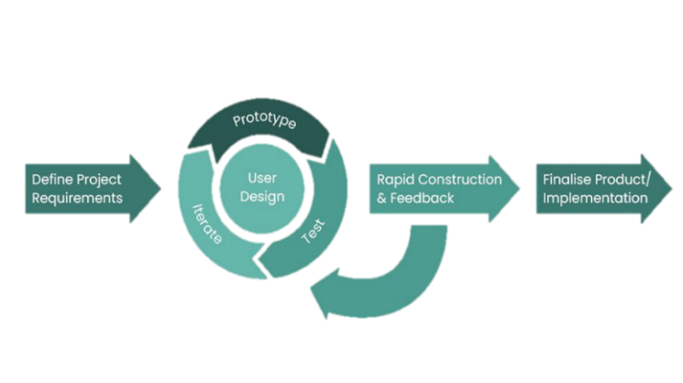

Fig. 1. Rapid Application Development Model

Rapid Application Development Process

Define Project Requirments. In this stage, the researchers outlined the key features and goals of the 360° NAVIGATE mobile application. It involved defining the project's scope, identifying stakeholders, and gathering requirements through various methods such as surveys and interviews at EVSU.

User Design. This phase focused on building user prototypes, incorporating user feedback, and refining the design. The process was iterative, involving the following steps:

Prototype: Developing initial versions of the application.

Test: Evaluating the prototypes to identify any issues or areas for improvement.

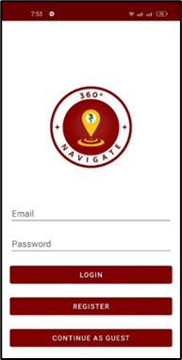
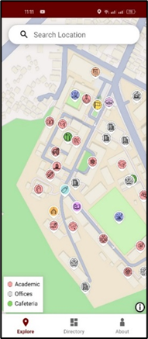
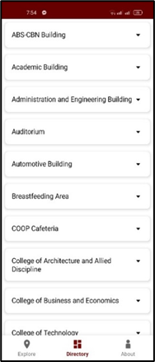
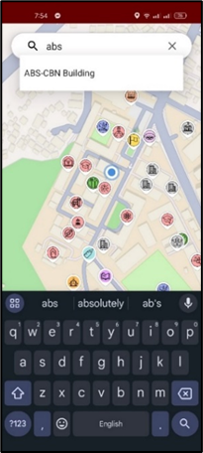
Iterate: Refining the prototypes based on test results and user feedback.

Fig. 2. Sample UI Designs

Rapid Construction & Feedback. In this phase, the researchers implemented features, integrated OpenStreetMap, and developed navigation algorithms (such as Dijkstra’s). Continuous user feedback was essential to ensure the application met user needs.

Pseudocode for Dijkstra's Algorithm. The Dijkstra algorithm computes the shortest path between a starting node and any other node in a graph. The main concept is to iteratively compute the shortest distance from the initial node while updating the distances between nearby nodes. The algorithm includes the following steps:

Initialization of all nodes with distance "infinite"; initialization of the starting node with 0.
- Marking of the distance of the starting node as permanent, all other distances as temporarily.
- Setting of starting node as active.
- Calculation of the temporary distances of all neighbor nodes of the active node by summing up its distance with the weights of the edges.
- If such a calculated distance of a node is smaller as the current one, update the distance and set the current node as antecessor. This step is also called update and is Dijkstra's central idea.
- Setting of the node with the minimal temporary distance as active. Mark its distance as permanent.
- Repeating of steps 4 to 7 until there aren't any nodes left with a permanent distance, which neighbors still have temporary distances.
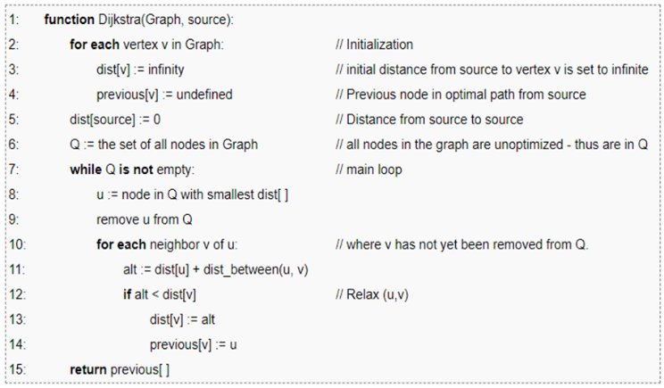

Fig. 2. Dijkstra’s Algorithm Pseudocode

Finalize Product/Implementation. This final phase includes testing, evaluation, and deployment. The application underwent thorough testing to ensure its functionality and usability. After successful testing, the app was deployed.

System Architecture
. The system architecture includes several components, including the expanded system, all of which are intended to work together to achieve the complete navigation solution. Each component is critical to the system's integration and functionality.

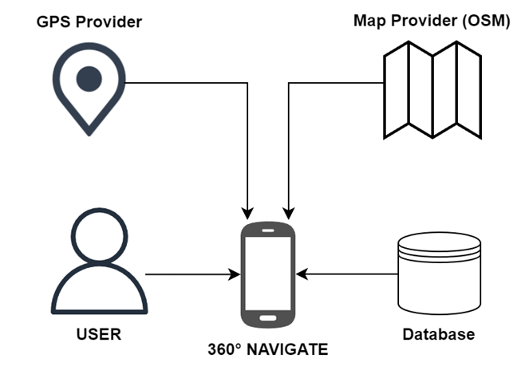
Fig. 3. System Architecture

Figure 3 presents how the navigation system integrates user input with GPS data, OpenStreetMap (OSM) map information, and the database that provided the location services and navigation. The user interacts with the system, which processes information from multiple sources to provide accurate navigation assistance.

Materials
The development and implementation of the mobile application required the integration of various software and hardware components. For the software tools, Android Studio version 2024.1.1 served as the primary integrated development environment (IDE), facilitating the design, coding, and testing of the application. The project utilized Android Gradle Plugin version 8.5.0 for build automation and dependency management. Kotlin version 1.9.20 was chosen as the main programming language due to its modern features and seamless integration with Android development tools. To support real-time data storage and backend services, Google Firebase version 13.8.0 was employed. For geospatial mapping, the application relied on OpenStreetMap to provide detailed and accurate map data. Mapbox version 6.1.18 was also incorporated as a library to enable the integration and display of OpenStreetMap within the Android environment, offering enhanced visualization and user interaction capabilities.
In terms of hardware, the development work was carried out using a Victus Gaming Laptop 15-fb1000ca, running on Windows 11 Home. This device was equipped with an AMD Ryzen™ 5 7535HS processor, NVIDIA RTX 2050 GPU, 16 GB of RAM, and a 1 TB solid-state drive (SSD), providing the necessary computing power and storage for efficient software development and data handling. For testing the mobile application on an actual device, a Narzo 50 Pro 5G smartphone was used, which runs on Android 14 and features a DIMENSITY 920 processor, 8 GB of RAM, and 128 GB of internal storage. Additionally, an Insta360 One X2 360-degree camera was utilized for capturing immersive spatial data. This device supports 360-degree resolution at 6080×3040 pixels (2:1 aspect ratio) and panoramic shots at 4320×1440 pixels (3:1 aspect ratio), which were useful for enhancing visual content and environmental context within the application.

Evaluation
The evaluation of the 360° NAVIGATE: Interactive EVSU Companion Map with Panoramic Perspective was conducted to ensure the system met its intended objectives and adhered to user expectations. To achieve a comprehensive assessment, the researchers employed a structured evaluation instrument and conducted surveys among diverse groups, including students, faculty, staff, and visitors.
The evaluation instrument used was carefully designed to capture various aspects of software quality, aligning with ISO 25010 Software Quality Standards. The instrument consisted of multiple indicators categorized under the following criteria: Functional suitability, Performance efficiency, Compatibility, Usability, Reliability, Security, Maintainability, and Portability.
Each indicator was rated using a five-point Likert scale, with responses ranging from Strongly Disagree (1) to Highly Acceptable (5). This structured approach enabled quantitative and qualitative analysis of the system's performance.
The evaluation utilized a Likert Scale to assess user perceptions across multiple software quality criteria. The scale ranged from 1 (Strongly Disagree) to 5 (Highly Acceptable), providing a structured way to quantify user feedback.

Results and Discussion
This section presents the findings of the study and the result of the system evaluation.

Interactive Map with User Location
The interactive map is the central feature of the 360° NAVIGATE application, combining real-time OpenStreetMap data with campus-specific information to provide users with a dynamic navigation experience. Users can pan, zoom, and interact with the map, allowing them to explore the entire campus or zoom in on specific areas.
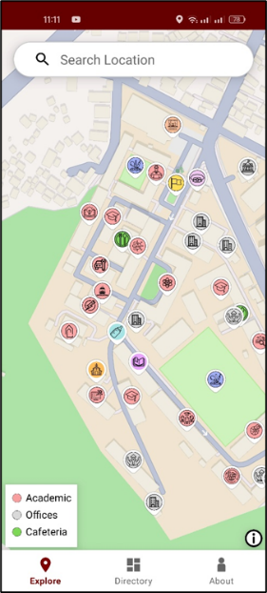

Fig. 4. Interactive Map Page

Figure 4 presents the interactive map feature providing a detailed layout of the EVSU campus, displaying points of interest (POIs) using categorized icons. It shows the user’s real-time location and their desired destination on a 2D map of the EVSU campus. By utilizing live GPS data, the map updates dynamically to display the user’s position and the route to their destination. Users can pan, zoom, and interact with the map to explore locations such as academic buildings, offices, and cafeteria.

360-Degree Panoramic Views of Landmarks and Points of Interest
The 360 NAVIGATE provided an immersive campus experience through its 360-degree panoramic view feature, which allowed users to virtually explore key campus landmarks. This feature helped users familiarize themselves with important locations such as academic buildings, administrative offices, and recreational areas. The 360-degree views were integrated directly into the app, enabling users to navigate locations visually before physically visiting them.
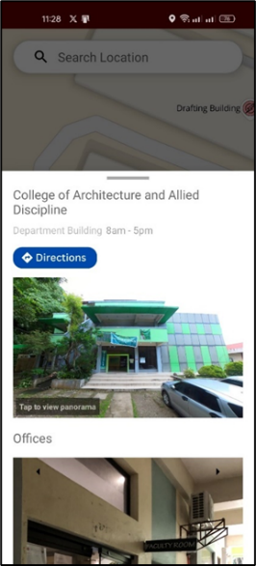
Fig. 5. Interactive Map Page

Figure 5 shows the Point of Interest (POI) card view, which includes a preview of the 360-degree panoramic view of the location along with details about the office or building. This feature helps users virtually explore the campus and get familiar with key landmarks.
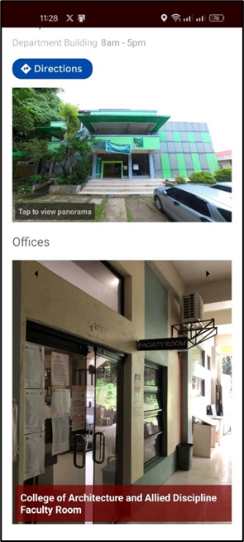
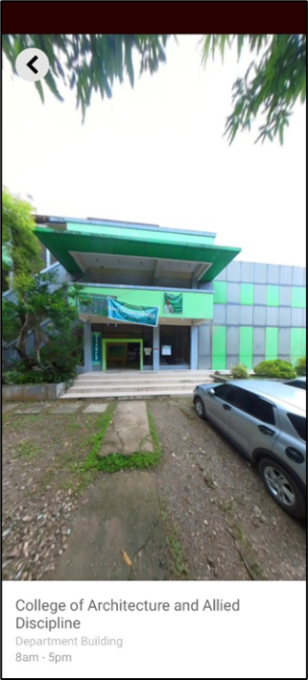

Fig. 6. 360-degree Panoramic View

Figure 6 displays the 360-degree panoramic view of the selected point of interest, providing users with an immersive, interactive visual experience.

Route Optimization Using Dijkstra’s Algorithm
The system used Dijkstra’s algorithm to optimize routes, calculating the shortest path between the user’s current location and their destination. This feature ensured that users were provided with the quickest routes, reducing travel time and improving campus navigation.

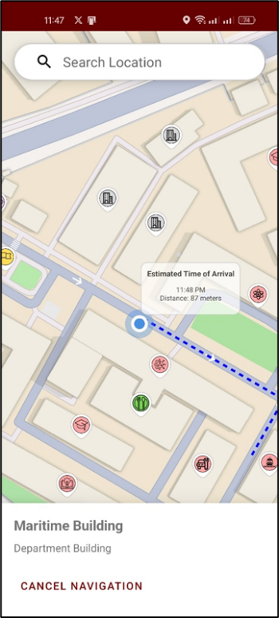

Fig. 6. 360-degree Panoramic View

Figure 6 displays the navigation mode view, which shows the results when the user clicks "Directions." This feature presents the route between the user's current location and their selected destination, based on the shortest path calculated by Dijkstra's algorithm. The visual representation helps users easily follow the recommended route, ensuring a smooth and efficient navigation experience across the campus.

System Evaluation Overview
The evaluation presented the mobile application based on ISO 25010 Software Quality Standards. It focused on the following quality characteristics: Functional Suitability, Performance Efficiency, Compatibility, Usability, Reliability, Security, Maintainability, and Portability. The primary purpose of this evaluation was to determine the system's success in meeting user requirements and delivering the expected quality.
- System Evaluation Results
ISO 25010 System Evaluation
Category | Average Weighted Mean | Interpretation
Functionality | 4.20 | Acceptable
Performance Efficiency | 4.20 | Acceptable
Compatibility | 4.26 | Highly Acceptable
Usability | 4.23 | Highly Acceptable
Reliability | 4.23 | Highly Acceptable
Security | 4.23 | Highly Acceptable
Maintainability | 4.23 | Highly Acceptable
Portability | 4.26 | Highly Acceptable

Table I summarizes the ISO/IEC 25010-based system evaluation using the categories presents an average weighted mean ranging from 4.20 to 4.26, reflecting strong user approval. While functional suitability, usability, and reliability were well-rated, the results underscore the importance of addressing minor performance issues and expanding feature adaptability to further enhance the user experience.

Conclusion and Recommendation
The project successfully achieved its primary objectives of developing an advanced navigation system designed to enhance user experience through real-time map updates, immersive 360-degree panoramic views, and optimized route suggestions. The system incorporated key features such as location tracking, POI exploration, and offline functionality, which were well-received by users during the evaluation phase. Based on the study's findings, the following conclusions were drawn in alignment with the objectives:
The integration of a dynamic 2D map with real-time location updates was successfully implemented using OpenStreetMap. This feature allowed users to track their movements accurately, enhancing their navigation experience. The system performed well in updating the user's location in real-time, meeting the intended objective of providing an interactive and responsive navigation tool.
The addition of 360-degree panoramic views improved the user experience, allowing users to virtually explore important landmarks and POIs. User feedback indicated that this feature provided an immersive and engaging way to learn about and interact with significant locations, fulfilling the objective of enhancing the exploration of POIs.
The implementation of Dijkstra’s algorithm for route optimization successfully delivered the shortest and most efficient paths between two points. This feature met the project's goal of providing users with accurate, optimal routes. However, some performance improvements are needed to enhance efficiency when handling larger datasets or more complex map features.
The system was evaluated based on the ISO 25010 Software Quality Standards, which assessed several critical aspects, including functional suitability, performance efficiency, usability, security, and reliability. The evaluation results showed that the system generally met the desired criteria, with positive feedback on functionality, usability, and reliability. However, performance efficiency, particularly when processing larger datasets, indicated areas for future improvement.
The 360 NAVIGATE system proved to be a functional, reliable, and user-friendly navigation tool that met its original objectives. While future improvements could focus on optimizing performance and increasing scalability, the project lays a robust foundation for further advancements. Potential applications extend beyond campus navigation, with opportunities to integrate technologies such as artificial intelligence for enhanced route optimization and predictive navigation. These developments could contribute to a more advanced and adaptive navigation experience in various real-world contexts.
Future researchers aiming to enhance the system and mobile application are encouraged to integrate an interactive street view feature for immersive navigation, implement real-time notifications and alerts for critical updates, expand multi-platform support including iOS and web access for broader usability, and provide turn-by-turn directions to improve route guidance.

Acknowledgment
The authors wish to thank the Information Technology Department, School of Engineering, Eastern Visayas State University, for their support and collaboration throughout the research process. Their assistance in providing resources and institutional backing was invaluable to the completion of this study..

References

- Ayyanchira, A., Mahfoud, E., Wang, W., & Lu, A. (2022). Toward cross-platform immersive visualization for indoor navigation and collaboration with augmented reality. Journal of Visualization. doi:10.1007/s12650-022-00852-9
- Ruotsalainen, L., Morrison, A., Mäkelä, M., Rantanen, J., & Sokolova, N. (2022). Improving Computer Vision-Based Perception for Collaborative Indoor Navigation. IEEE Sensors Journal. doi:10.1109/JSEN.2021.3106257
- López, J., Otero, C., Sanz, R., Paz, E., Molinos, E., & Barea, R. (2019). A new approach to local navigation for autonomous driving vehicles based on the curvature velocity method. International Conference on Robotics and Automation. doi:10.1109/ICRA.2019.8794380
- Cardoso, J. C., & Cavadas da Costa, R. F. (2022). Mapscapes: Applying Anachronic Techniques in Contemporary Maps as a Design Strategy for New Ways of Seeing. The Cartographic Journal. doi:https://doi.org/10.1080/14606925.2019.1560719
- König, S. U., Clay, V., Noite, D., Duesberg, L., Kuske, N., & König, P. (2019, July). Learning of Spatial Properties of a Large-Scale Virtual City With an Interactive Map. doi:https://doi.org/10.3389/fnhum.2019.00240
- Xefteris, S., Palaigeorgiou, G., & Tsorbari, A. (2019). A Learning Environment for Geography. Springer, Cham. doi:https://doi.org/10.1007/978-3-030-11935-5_11
- Liu, Y. (2020). Evaluating visitor experience of digital interpretation and presentation technologies at cultural heritage sites: a case study of the old town, Zuoying. doi:10.1186/s43238-020-00016-4
- Eilouti, B. (2020). Form follows users: a framework for system-based design. Architectural Engineering and Design Management. doi:10.1080/17452007.2020.1833831
- Zhang, G., & Kou, X. (2020). Research and implementation of digital 3D panoramic. International Journal of Communication Systems. doi:doi:10.1002/dac.4802
- Grinberger, Y., Minghini, M., Juhasz, G., & Mooney, P. (2022). OSM Science - The Academic Study of the OpenStreetMap. ISPRS International Journal of Geo-Information.
- Lee, J.-K., Lee, S., Kim, Y.-c., Kim, S., & Hong, S.-W. (2023). Augmented virtual reality and 360 spatial visualization for supporting user-engaged design. Journal of Computational Design and Engineering. doi:https://doi.org/10.1093/jcde/qwad035.
- Panek, J., & Netek, R. (2019). Collaborative Mapping and Digital Participation: A Tool for Local Empowerment in Developing Countries. doi:https://doi.org/10.3390/info10080255.
- Bill, R., Blankenback, J., Breunig, M., Haunert, J.-H., Heipke, C., Herle, S., . . . Werner, M. (2022). Geospatial Information Research: State of the Art, Case Studies and Future Perspectives. Journal of Photogrammetry, Remote Sensing and Geoinformation Science. doi:https://doi.org/10.1007/s41064-022-00217-9
- Gunawan, W., Susafa'ati, & Buana, M. (2019). Implementation of Dijkstra's Algorithm in the Shortest Route. Scholars Bulletin. doi:10.36348/SB.2019.v05i12.001
- Zhou, M., & Gao, N. (2019). Research on Optimal Path based on Dijkstra Algorithms.
- Yen, D. C., & Davis, W. S. (2019). Rapid application development (RAD). In CRC Press eBooks (pp. 247–252). https://doi.org/10.1201/9781420049107-3

