DIGITALIZATION AND STREAMLINING OF THE BUSINESS PERMIT AND LICENSING SYSTEM IN THE LOCAL GOVERNMENT UNIT OF MAYANTOC

Abstract
This study evaluates the implementation of the Electronic Business One-Stop Shop (eBOSS) within the Business Permit and Licensing System (BPLS) of the Local Government Unit (LGU) of Mayantoc. Transitioning from a manual, multi-window process to a centralized digital architecture, the system automated tax assessments, integrated online payment gateways, and deployed QR-coded permit verification. The study measures operational efficiency, accessibility, and systemic security. The findings indicate that digitalization drastically reduced processing times from several days to minutes and eliminated traditional bureaucratic red tape. However, bottlenecks remain due to inconsistent internet infrastructure in rural sectors and incomplete backend digitization across secondary municipal offices. The study recommends full inter-agency API integration and low-bandwidth mobile optimization to achieve uniform administrative modernization.
1. Introduction
Background of the Study
Securing and renewing local business permits in the Philippines has historically been a slow, bureaucratic process characterized by physical queuing and manual computations. For decades, local government units (LGUs) operated under fragmented, paperwork-heavy processes. Applicants frequently had to visit multiple physical windows spread across different municipal departments, including the zoning administration, municipal engineering office, health department, and fire bureau. This structural friction not only increased transactional costs for local business owners but also created operational backlogs that burdened local government staff during peak registration windows.
To systematically dismantle these barriers, the national government enacted Republic Act No. 11032, also known as the Ease of Doing Business and Efficient Government Service Delivery Act of 2018. This statutory directive mandates that all local government units simplify licensing procedures and implement an Electronic Business One-Stop Shop (eBOSS). The objective is clear: replace traditional manual workflows with an automated, transparent, and centralized digital platform designed to fast-track front-line services and limit unverified physical points of contact.
Context of Mayantoc
In strict compliance with these legislative shifts, the Local Government Unit (LGU) of Mayantoc undertook a structural transition toward a digital architecture. Located in a predominantly agricultural terrain within the province of Tarlac, Mayantoc faces distinct administrative challenges compared to highly urbanized cities. Its unique geographical distribution spans both centralized urban sectors and far-reaching, mountainous rural barangays.
Historically, local micro, small, and medium enterprises (MSMEs)—ranging from local agricultural supply traders to small retail merchants—had to travel significant distances to the municipal hall, missing crucial working hours simply to complete annual permit updates. Thus, modernizing the Business Permit and Licensing System (BPLS) in Mayantoc is not merely about adopting technology; it represents a fundamental shift in local public administration to support sustainable economic development.
Statement of the Problem and Objectives
While automated administrative tools have been widely embraced in premier economic hubs, their implementation in third- and fourth-class agricultural municipalities remains unevenly documented. Technology cannot operate inside a vacuum; its performance depends on local institutional readiness, digital literacy, and supporting infrastructure. This study addresses the following key questions regarding the Mayantoc eBOSS framework:
- What are the core technological components currently deployed within Mayantoc’s automated business permitting infrastructure?
- How effective is this automated architecture when measured against the core public administration metrics of Efficiency, Accessibility, and Security?
- What localized institutional and technological barriers prevent the platform from operating at peak capability?
By analyzing these questions, this study evaluates the practical outcomes of automation in a rural municipal setting and provides a data-driven model for similar local government units seeking comprehensive administrative modernization.
2. Methodology
Theoretical Framework
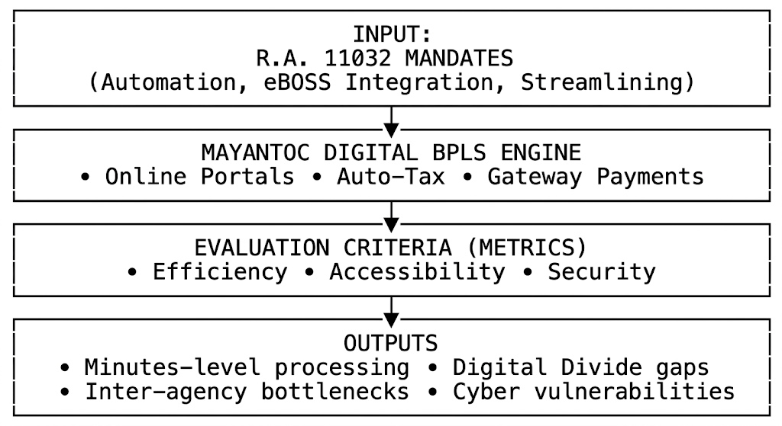
This study is grounded in the principles of New Public Management (NPM) and technological readiness frameworks in public administration. NPM advocates for the integration of private-sector efficiencies, results-oriented metrics, and customer-centric service delivery models into government operations. Within this study, the business applicant is analyzed not merely as a passive subject of state regulation, but as a valued public stakeholder entitled to rapid, transparent, and friction-free corporate onboarding.
Research Design and Data Collection
A descriptive, qualitative technology assessment design was deployed to analyze Mayantoc's digital BPLS. Data collection relied heavily on internal administrative data sources, including transactional processing logs, system timestamp audits, and institutional registration metrics across seasonal cycles.
To map real-world accessibility and performance, these metrics were analyzed alongside localized infrastructure capacity markers, including regional internet speed fluctuations, computing equipment availability, and staff technical troubleshooting logs.
Operational Assessment Metrics
The system’s operational health was scrutinized using three distinct qualitative and quantitative parameters:
- Efficiency: Measured by total end-to-end processing velocity (the time elapsed from initial document submission to final permit generation) and the reduction of mathematical errors during fee assessment.
- Accessibility: Assessed by evaluating the availability of the system (24/7 server uptime) and the ease with which users across different demographic and geographic spectrums navigate the interface.
- Security: Evaluated based on the system’s capacity to protect sensitive merchant financial disclosures, maintain structural data integrity, and prevent the introduction of fraudulent documentation.

3. Results
System Architecture and Components
The digital BPLS framework in Mayantoc is built on four core, interconnected technical components:
System Component | Core Technical Function | Primary Public Interface
Online Registration Portal | Cloud-based interface hosting digital document intake workflows. | Web Browser / Merchant Portal
Automated Tax Engine | Programmatic calculation of local taxes and regulatory fees. | Internal LGU Backend Server
Integrated e-Payment Link | Clearinghouse linking transactions directly to digital banking networks. | LandBank / GCash / Maya API
QR Code Generator | Cryptographic generation of unique, verifiable permit signatures. | Printed/Electronic Business Permit
Efficiency Findings
The transition from a physical, multi-layered layout to an automated backend produced massive shifts in processing capability. Processing speeds for basic business permit renewals dropped from a baseline of three to five business days down to minutes, provided all mandatory clearances were uploaded properly.
MANUAL SYSTEM (Pre-Automation)
[Queue at Window 1: Zoning] ──> [Queue at Window 2: Engineering] ──> [Queue at Window 3: Fire] ──> [Manual Math Assessment] ──> [Cashier Line]
Total Processing Time: 3 to 5 Business Days
AUTOMATED eBOSS (Current System)
[Single Cloud Upload] ──> [Automated Tax Calculation Engine] ──> [Instant Digital Gateway Payment] ──> [QR Code Permit Generation]
Total Processing Time: 15 to 30 Minutes
Automated fee assessment algorithms completely eliminated manual math errors, which previously caused lengthy reconciliation delays. However, a significant efficiency bottleneck remains: when an application flags a requirement needing manual evaluation from separate municipal units (such as specific on-site environmental health checks or spatial zoning inspections), processing stalls. Because these secondary offices run on distinct, non-integrated internal filing systems, applications are often delayed as staff shift back to manual tracking.
Accessibility Findings
The cloud-hosted infrastructure successfully expanded the operational window of local governance, allowing tech-literate entrepreneurs to complete filings 24/7 without spending money on transport or losing a day of storefront business.
However, this digital transition highlighted a deep technological divide within the municipality. In rural and mountainous upland barangays, unstable internet connections frequently cause application timeouts during document uploads. Furthermore, smaller micro-retailers who lack specialized computer equipment or digital literacy are often overwhelmed by the online interface, meaning they still rely heavily on the physical municipal hall for hands-on guidance.
Security Findings
From a security standpoint, the automated system has proven highly effective at preventing document fraud. Historically, physical permits were vulnerable to manual forgery and replication by unauthorized actors. The introduction of dynamic QR code generation allows field inspectors to scan any business license and instantly verify its authenticity against the active municipal database.
Despite this strength, moving large amounts of sensitive merchant corporate records and financial statements to online servers has increased the LGU's exposure to web-based security threats. Maintaining data privacy requires a continuous investment in server firewalls and robust backup systems to prevent unauthorized access and data loss.
4. Discussion
Interpretation of Results
The deployment of the digital BPLS in Mayantoc confirms the core value of New Public Management: adopting automated workflows can drastically improve speed and reduce friction in public services. By shifting away from rigid, multi-window checkpoints, the eBOSS model has dismantled traditional red tape, accelerated processing times, and eliminated the operational gaps that unauthorized third-party "fixers" historically exploited.
However, the findings show that technology cannot completely fix administrative flaws if the surrounding infrastructure is uneven. The system's primary vulnerabilities are institutional fragmentation and structural inequality. When secondary municipal offices fail to fully digitize their internal processes, it creates a fragmented system where a high-speed frontend is constantly slowed down by a manual backend. Furthermore, the digital divide across rural barangays demonstrates that aggressive automation can inadvertently exclude vulnerable, less-connected small businesses if offline alternatives are not properly maintained.
Comparative Policy Analysis
Mayantoc's experiences align closely with broader national trends in digital governance across the Philippines. Research from the Philippine Institute for Development Studies (PIDS) highlights that while fully automated business permitting systems consistently boost local revenue and drive formal business registrations, many lower-class municipalities face severe implementation barriers due to limited ICT infrastructure and strained local budgets.
Similar studies across rural regions confirm that while urban centers transition smoothly to advanced digital governance, rural areas are frequently held back by unstable power grids, lack of specialized IT personnel, and poor local network connectivity. Mayantoc's operational challenges reflect this national reality, demonstrating that local government units must balance automated goals with local infrastructural limitations.
Structural Recommendations
To maximize the impact of the digital BPLS in Mayantoc, the following systemic upgrades should be implemented:
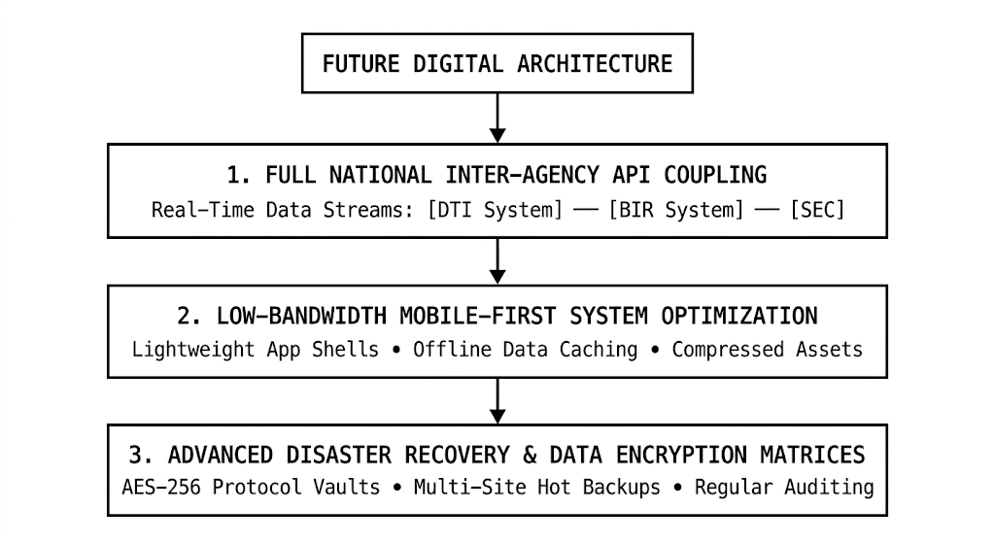
- Full National Inter-Agency API Coupling: The local system should link directly via secure APIs to national databases like the Department of Trade and Industry (DTI), the Securities and Exchange Commission (SEC), and the Bureau of Internal Revenue (BIR). This cross-platform link would allow the software to instantly verify a business's legal standing in real time, removing the need for manual document uploads entirely.
- Low-Bandwidth Mobile-First System Optimization: The merchant portal should be redesigned into a lightweight, mobile-responsive web application. Optimizing images, reducing script sizes, and supporting offline data caching will allow rural entrepreneurs to submit permit updates using basic smartphones, even on weak mobile networks.
- Advanced Disaster Recovery and Data Encryption Matrices: To safeguard sensitive business records and ensure compliance with national data privacy laws, the LGU must implement advanced server security measures. This includes applying AES-256 data encryption for stored files, enforcing multi-factor authentication for administrative users, and setting up off-site cloud backups to protect against server failures or cyber threats.
5. Conclusion
The implementation of the Electronic Business One-Stop Shop (eBOSS) in the Local Government Unit of Mayantoc proves that modern digital tools can transform rural public administration. By automating tax assessments and moving payments online, the municipality has turned a slow, bureaucratic task into a fast, transparent, and professional service.
However, the transition also highlights that technology depends heavily on infrastructure. To prevent rural businesses from being left behind and to eliminate remaining processing delays, the local government must invest in full cross-department integration, optimize systems for low-bandwidth mobile environments, and enforce rigorous data security measures. Moving forward, true administrative modernization requires building a resilient digital system that is both highly efficient and accessible to every entrepreneur in the community.

References
Anti-Red Tape Authority. (2023). Revisiting LGU compliance metrics for eBOSS automation: Annual report on ease of doing business. ARTA Governance Review.
Arzagon, S. B. (2025). Business One Stop Shop (BOSS) program and the level of clients' satisfaction in the City of Tacurong. International Journal of Advanced Studies in Agricultural Sciences and Technology, 2(5), 36–48.
Ballesteros, M. M., & Ramos, T. P. (2026). Relevance of e-governance in revenue generation among Philippine cities (Discussion Paper No. DP 2026-09). Philippine Institute for Development Studies. https://doi.org/10.62986/dp2026.09
Brillantes, A. B., & Fernandez, M. T. (2011). Restructuring the Philippine bureaucracy for governance: Ongoing reinvigoration. Philippine Journal of Public Administration, 55(1-2), 115–141.
Department of Information and Communications Technology, Department of Trade and Industry, & Department of the Interior and Local Government. (2021). Joint Memorandum Circular No. 2021-01: Guidelines for implementing the Electronic Business One-Stop Shop (eBOSS) compliance with R.A. No. 11032.
Gonzales, M. R. P. (2023). The implementation of the Ease of Doing Business Act in selected municipalities in the Province of Sorsogon. Unique International Journal of Research and Technology, 5(8), 21–34.
Mora, J. P. B., & Gianan, N. (2021). Philippine Competitiveness 4.0: Reimagining local economic development (LED) in the digital revolution. Department of Trade and Industry Bureau Report.
Osborne, D., & Gaebler, T. (1992). Reinventing government: How the entrepreneurial spirit is transforming the public sector. Addison-Wesley Publishing Co.
Perry, J. L. (1996). Measuring public service motivation: An assessment of construct reliability and validity. Journal of Public Administration Research and Theory, 6(1), 5–22.
Quimba, F. M., Serafica, R., Bayudan-Dacuycuy, C., Andrada, A., & Moreno, N. I. (2023). Green and digital: Managing the twin transition toward sustainable development (Discussion Paper No. DP 2023-21). Philippine Institute for Development Studies. https://doi.org/10.62986/dp2023.21
Republic Act No. 10173. (2012). An Act protecting individual personal information in information and communications systems in the government and the private sector, creating for this purpose a National Privacy Commission, and for other purposes (Data Privacy Act of 2012). Official Gazette, Republic of the Philippines.
Republic Act No. 11032. (2018). An Act promoting ease of doing business and efficient delivery of government services, amending for the purpose Republic Act No. 9485, otherwise known as the Anti-Red Tape Act of 2007, and for other purposes. Official Gazette, Republic of the Philippines.
Villegas, M. B. (2025). Assessing the digitization readiness of local government units in remote regions. ISRG Journal of Economics, Business & Management, 3(9), 102–115.

