Grace Oluwadunni Ayorinde¹*, Fausat Olubusola Afolami², Israel Ajibola¹, Oluwadurotimi Olutosin Akintade¹.
¹Department of Applied and Basic Sciences, Faculty of Applied Sciences, KolaDaisi University, Ibadan, Nigeria.
²Department of Chemical Sciences, Lagos State University of Science and Technology, Ikorodu, Lagos. Nigeria.
Corresponding author*
Corresponding email: ayorindegrace2@gmail
Mechanical Performance of Sugarcane Bagasse Fibre Reinforced Meta-Kaolinite Geopolymer Composites for Sustainable Construction Applications
Abstract
The increasing demand for sustainable and environmentally friendly construction materials has intensified research into alternatives to conventional cement-based systems. Geopolymer composites, synthesized from natural or industrial aluminosilicate sources, have gained significant attention due to their low carbon footprint, high durability, and superior chemical resistance. In this study, sugarcane bagasse fibre was explored as a natural reinforcement for meta-kaolinite based geopolymer composites in order to enhance mechanical performance while promoting agricultural waste valorisation.
Sugarcane bagasse fibres were obtained after juice extraction, sun-dried for one week, milled, and sieved into particle sizes of 0.425 mm and 1.00 mm. The fibres were incorporated into calcined kaolinite clay at varying contents of 1, 2.5, 5, 7.5, and 10 wt%, using equal volume of sodium silicate solutions (37.5%) and sodium hydroxide (10%) as alkaline activators. The functional group of the lignocellulose bagasse were investigated using Fourier Transform Infrared Spectroscopy (FTIR), which revealed the formation of hydrogen bonding and alcohol-related functional groups that contribute to improved interfacial adhesion between the fibre and the Geopolymer matrix.
The mechanical behaviour of the composites was evaluated through compressive strength testing. Pure meta-kaolinite Geopolymer exhibited compressive strengths ranging from 3.20 to 10.93 N/m² depending on NaOH concentration. In contrast, fibre-reinforced composites demonstrated a marked improvement in strength with increasing fibre content. Composites reinforced with 1.00 mm sugarcane fibres achieved the highest compressive strength of 28.78 N/m² at 10 wt% fibre loading, outperforming those reinforced with 0.425 mm fibres.
The results confirm that sugarcane bagasse fibre significantly enhances the mechanical properties of meta-kaolinite Geopolymer composites, with larger fibre sizes showing superior reinforcement efficiency. This study demonstrates the potential of sugarcane fibre–reinforced Geopolymer as a sustainable and eco-friendly material for construction applications.

Keywords: Geopolymer composites, Sugarcane bagasse fibre, Meta-kaolinite

Introduction

The global construction industry is one of the largest contributors to carbon dioxide emissions and environmental degradation, largely due to the extensive use of Portland cement–based materials. This has driven increasing research interest toward sustainable construction alternatives that minimize environmental impact while maintaining adequate mechanical performance. Among these alternatives, geopolymer materials, synthesized from aluminosilicate-rich sources activated by alkaline solutions, have emerged as viable low-carbon binders with superior durability, chemical resistance, and thermal stability compared to conventional cementitious systems (Davidovits, 2011; Provis and van Deventer, 2014). Kaolin, which is the Geopolymer adopted in this study, is an essential geopolymer precursor because of its high aluminosilicate content. When calcined at 600–800 °C, kaolin (Al₂Si₂O₅(OH)₄) transforms into reactive metakaolin (Al₂Si₂O₇) through dehydroxylation. The amorphous metakaolin readily reacts with alkaline activators to form a strong aluminosilicate (N–A–S–H) geopolymer network.
Despite their advantages, geopolymers often exhibit brittle behavior, which limits their structural performance. To address this limitation, natural fibre reinforcement has gained significant attention as an eco-friendly and cost-effective strategy to improve toughness, crack resistance, and mechanical strength. Several natural fibres have been successfully incorporated into geopolymer and cementitious matrices, including bamboo, sisal, jute, coir, flax, hemp, and banana fibres, all of which have demonstrated varying degrees of improvement in compressive, flexural, and tensile properties (Ramakrishna and Sundararajan, 2005; Asim et al., 2016; Ramesh et al., 2017). The advantages of these fibres include low density, renewability, biodegradability, and wide availability, making them attractive alternatives to synthetic reinforcements such as glass and carbon fibres.
Among agricultural residues, sugarcane bagasse fibre stands out due to its abundance and underutilization. Sugarcane (Saccharum officinarum) is one of the most widely cultivated crops globally, particularly in tropical and subtropical regions, producing large volumes of bagasse as a by-product of sugar extraction. Traditionally, sugarcane bagasse has been disposed of through open burning or used inefficiently as low-grade fuel, contributing to environmental pollution (Pandey et al., 2000). However, bagasse fibres possess favorable physicochemical characteristics, including low density, high cellulose content, and good interfacial bonding potential, which make them suitable for composite reinforcement applications (Ferreira et al., 2017).
Consequently, the incorporation of sugarcane bagasse fibre into geopolymer matrices not only enhances mechanical performance but also promotes agricultural waste valorisation and sustainable material development. This study therefore investigates the reinforcement of meta-kaolinite–based geopolymer composites with sugarcane bagasse fibre to produce an eco-friendly construction material with improved compressive strength and sustainability credentials.
Materials and Methods:
Sample Collection and Preparation
Sugarcane used in this study was obtained from a market in Ibadan, Akinyele Local Government Area, Oyo State, Nigeria. The bagasse was manually extracted using a knife and transported to the laboratory for further processing. Kaolin was collected at Mile 7, Abeokuta, Ogun State, Nigeria, and used as received.

The kaolin was dried and ground into a fine powder using a milling process to achieve uniform particle size and increased surface area. The powdered kaolin was then placed in a furnace and gradually heated to a temperature of 600 °C. This temperature was maintained for 7 hours to allow the required chemical transformations to occur. After the holding period, the heat source was switched off and the furnace was allowed to cool naturally to room temperature. The resulting metakaolin was collected and stored in a dry, airtight container.
During calcination, two key processes occurred: continuous dehydration involving the removal of free water at approximately 100-140°C, and dehydroxylation, characterized by the loss of structural hydroxyl groups from the kaolin lattice which occurred between 500-600 °C.

Preparation of Sugarcane Fibre
The sugarcane samples were cut into smaller segments to facilitate processing, and sugarcane bagasse was obtained after juice extraction. Sugarcane primarily contains sugars, carbohydrates, and water (Perez et al., 1997), while bagasse consists mainly of cellulose, hemicellulose, lignin, and wax. Bagasse fibres originate from the outer rind and inner pith, with rind fibres exhibiting longer length and superior mechanical properties compared to pith fibres (Collier et al., 1992). To obtain fibres suitable for reinforcement, the bagasse was manually cut into smaller pieces using a clean knife, sun-dried, and subsequently ground using an electric grinder. The resulting material was labeled as sugarcane fibre.
Moisture content of sugar cane fibre
2 g of air-dry sugar cane fibre of 0.425 mm mesh size was placed in an already weighed glass petri dish and placed in an oven set at 100ºC for 2 hours. After 2 hours it is removed and placed in a desiccator to cool after which it was then weighed. The sample of sugarcane fibre was put back in the oven for 1 hour, then weighed once more using the same method until a constant weight was achieved.
The moisture content in percentage was by the equation below.
$$Moisture content \%=\left(\frac{W1-W2}{W1}\right) x 100$$
Where:
W1=Weight of air-free specimen used, (2gram) and:
W2=Weight of moisture-free specimen obtained (gram); which is = (weight of petri dish + weight of air –free specimen used)–constant weight acquired
Alcohol-benzene solubility of sugar cane fibre
The standard procedure used for extractive content determination of alcohol benzene solubility of fiber is ASTM designated D1107. 2g of moisture free sugarcane fiber sample was weighed. The sample that has been dried in an oven for two hours at 100⁰C, then placed in a crucible, cooled in desiccators and weighed until constant weight is observed. These three samples were placed in a Soxhlet extraction apparatus and extracted with 150ml of ethyl alcohol-benzene solution in ratio 1:2 for 8 hours, keeping the liquid boiling briskly, providing four to six siphoning per hour. After evaporating the solvent from the extraction flask, the content was dried for 1 hour at 100⁰C, cooled in desiccators and weighed. This was continued until there was no further loss in weight. The alcohol-benzene can be calculated as follows:
$$Alcohol-Benzene solubility \%=\left(\frac{W2}{W1}\right) x 100$$
Where:
W₂=Weight of Extract
W₁=Proportion of moisture free fiber in air dried specimens.
FTIR analysis of sugar cane fibre
FTIR spectroscopy was employed to identify the functional groups present in the sugarcane fibre. The dried sugarcane was ground into a fine powder using an electric grinder to enhance surface area and ensure sample homogeneity. For analysis, approximately 5 mg of the sugarcane powder was thoroughly mixed with 100 mg of potassium bromide (KBr) and compressed under high pressure to form a transparent pellet suitable for spectral transmission. The prepared pellet was analyzed using an FTIR spectrometer over a wavenumber range of 450–4000 cm⁻¹ to determine the functional groups present.

Fabrication of Sugarcane Fibre–Reinforced Meta-Kaolinite Geopolymer Composites
Meta-kaolinite–based geopolymer composites reinforced with sugarcane fibres were prepared using two fibre particle sizes: 0.425 mm and 1 mm. For all formulations, meta-kaolinite was first dry-mixed to ensure homogeneity and then activated using a combination of sodium hydroxide (12 M) and sodium silicate solution, maintained at a fixed ratio of 4 mL to 40 mL, respectively. The activated paste was mechanically mixed until a uniform geopolymer slurry was obtained.
Sugarcane fibres were incorporated into the geopolymer matrix at fibre loadings of 1, 2.5, 5, 7.5, and 10 wt%, based on a total solid mass of 160 g per batch. For each formulation, the required mass of fibre was added to the corresponding reduced mass of meta-kaolinite and thoroughly mixed prior to the addition of the alkaline activators to ensure uniform fibre dispersion within the matrix.
The fresh composite mixtures were cast into moulds and compacted to remove entrapped air. The specimens were left in the moulds for 48 h at ambient conditions, after which they were demoulded and cured at room temperature for 10 days. During curing, the specimens were weighed at 24 h intervals to monitor moisture loss and dimensional stability, following the procedure reported by Ribeiro et al. (2016).
The same fabrication procedure, activator composition, fibre loading levels, and curing conditions were applied to both fibre sizes, with the only variable being the particle size of the sugarcane fibre (0.425 mm and 1 mm). This approach enabled a direct evaluation of the influence of fibre size and content on the mechanical performance of the geopolymer composites.
Compression testing was conducted to evaluate the mechanical behavior of the fibre-reinforced composites. Specimens were placed between two platens and subjected to a compressive load until failure. The applied load and resulting deformation were recorded to generate stress–strain curves, from which the compressive strength and modulus of the composites were determined.
Result and Discussion
Moisture Content and Alcohol–Benzene Solubility
The sugarcane fibres used in this study exhibited a moisture content of 12.53% and an alcohol–benzene solubility of 24.75%. The relatively low moisture content indicates that the fibres have been adequately dried, which is essential for preventing excess water in the geopolymer matrix that could interfere with alkali activation and reduce mechanical performance (Sanyang et al., 2015). High moisture levels in natural fibres can lead to poor fibre–matrix bonding and void formation, negatively affecting compressive strength and durability (Pickering et al., 2016).
The alcohol–benzene solubility reflects the amount of extractives, including waxes, fats, and resins, present in the fibre. A value of 24.75% suggests a moderate presence of these compounds, which may influence the interfacial adhesion between the fibre and the geopolymer matrix. While some extractives can act as a natural coupling agent, excessive amounts may reduce bonding and mechanical strength (Bledzki & Gassan, 1999). Therefore, pre-treatment or optimization of fibre content may enhance compatibility and maximize the reinforcing potential of sugarcane fibres in geopolymer composites.
The measured fibre properties indicate that sugarcane bagasse is a promising candidate for reinforcement, offering adequate dryness and manageable extractive content, which are key factors for achieving strong fibre–geopolymer interaction and improved compressive performance.

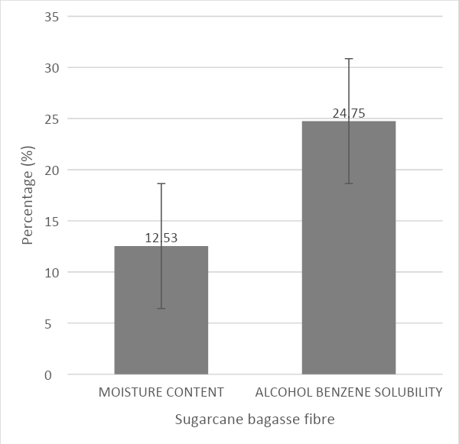
Figure 1: Graph showing the physical properties of Sugarcane bagasse fibre
Result of FTIR analysis of Sugar cane fibre
Figure 2 presents the FTIR spectrum of the modified sugarcane fiber, showing ten distinct absorption peaks ranging from 3792 cm⁻¹ to 696.42 cm⁻¹. The peak at 1637.20 cm⁻¹ corresponds to the C=C stretching of alkenes, while the band at 1508.8 cm⁻¹ indicates the N–O stretching of nitro compounds (Socrates, 2004). A broad, intense band observed at 3205.65 cm⁻¹ is attributed to O–H stretching, suggesting the presence of alcohol groups. The peak at 1162.3 cm⁻¹ is indicative of S=O stretching in sulfone groups, and the absorption at 1428 cm⁻¹ suggests C–H bending of alkanes. The peak at 1116.1 cm⁻¹ corresponds to C–H stretching in alkyl aryl ether compounds, while the 1031.4 cm⁻¹ band is assigned to C–O stretching in the presence of sulfoxide. The signal at 896.64 cm⁻¹ denotes C=C bending of alkenes, and the weak absorption at 696.42 cm⁻¹ is attributed to C–Br stretching, indicating the presence of halo compounds (Coates, 2000).

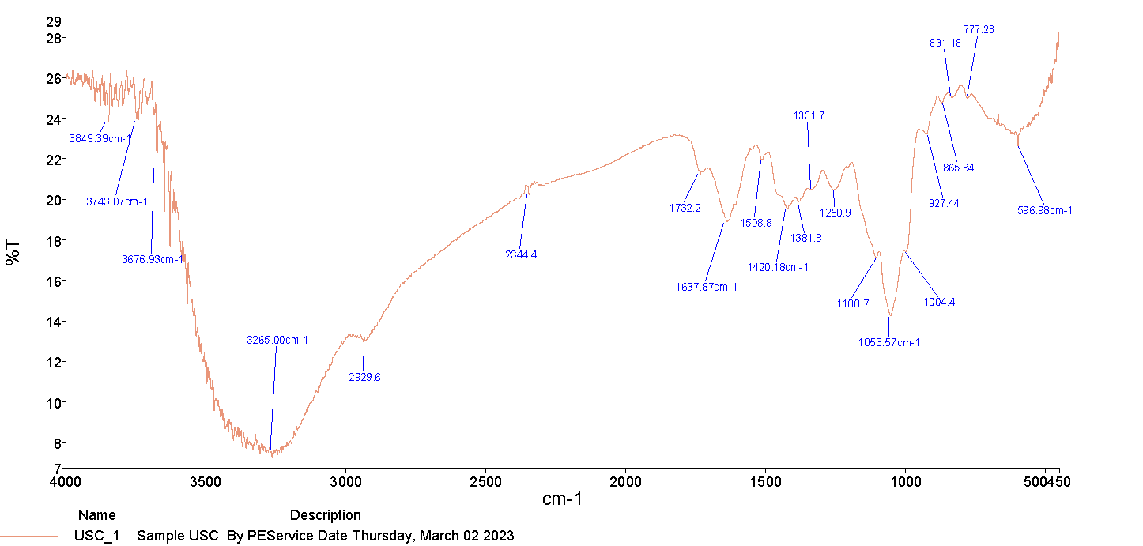
Figure 2: Fourier transform infrared (FTIR) Spectra of sugarcane fiber

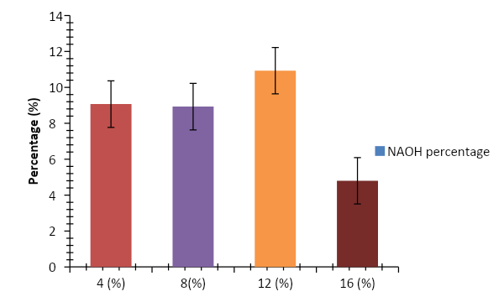
Figure 4.2: Compression strength for pure geopolymer

Result of compression strength for geopolymer composite with Sugarcane bagasse
The data presented illustrate the effect of fibre volume fraction and fibre size on the measured property (likely tensile strength, modulus, or similar composite characteristic). For the smaller fibre size (0.425 mm), the property increased steadily from 5.14 ± 1.81 at 1% fibre volume to 22.52 ± 0.69 at 10% fibre volume. Similarly, for the larger fibre size (1.00 mm), the values increased from 14.51 ± 2.33 at 1% to 28.78 ± 2.27 at 10%. This indicates that both increasing the fibre volume fraction and using larger fibres significantly enhance the composite’s performance.
The trend demonstrates a direct relationship between fibre content and composite strength, consistent with classical fibre-reinforced composite theory, where higher fibre volume fractions provide more load-bearing pathways, thus improving mechanical properties (Mallick, 2007). Additionally, larger fibres (1.00 mm) consistently outperformed smaller fibres (0.425 mm) at the same volume fractions, which can be attributed to the higher aspect ratio and better stress transfer efficiency of longer fibres (Hull & Clyne, 1996).
Statistical significance, as denoted by the letter superscripts (a–d), suggests that differences between the fibre contents and sizes are meaningful. Notably, at lower fibre volumes (1–2.5%), the difference between fibre sizes is more pronounced, indicating that fibre length plays a crucial role when reinforcement content is minimal. At higher fibre volumes (7.5–10%), both fibre sizes yield high performance, but longer fibres still offer superior results. This supports the principle that both fibre size and volume fraction must be optimized for the design of high-performance composites.
Table 1: Mean values for compression strength for geopolymer composite with Sugarcane bagasse
 | FIBRE VOLUME
FIBRE SIZE | 1% | 2.50% | 5% | 7.50% | 10%
0.425MM | 5.14±1.81d | 5.3±0.27d | 14.76±2.73c | 19.71±1.41b | 22.52±0.69a
1.00MM | 14.51±2.33d | 17.96±0.86d | 19.67±0.72c | 22.79±2.58b | 28.78±2.27a

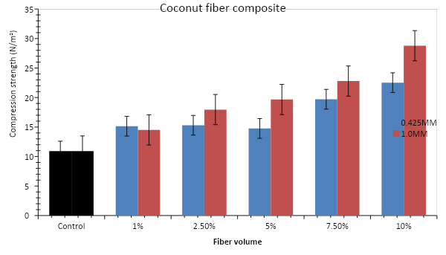Figure 3: Mean values obtained for compression strength for Sugarcane bagasse

Conclusion
The study demonstrates that sugarcane bagasse is a promising reinforcement for geopolymer composites. Its moderate moisture content (12.53%) and manageable alcohol–benzene solubility (24.75%) indicate good fibre dryness and extractive levels, which are crucial for effective fibre–matrix bonding. FTIR analysis confirmed the presence of functional groups such as O–H, C=C, C–O, and S=O, which may enhance interfacial interactions. Compression tests showed that increasing both fibre volume fraction and fibre size significantly improved composite strength, with longer fibres (1.00 mm) consistently outperforming shorter ones (0.425 mm). Overall, optimizing fibre size and content can maximize the reinforcing potential of sugarcane bagasse, supporting its use in high-performance geopolymer composites.

References (APA Style)
Asim, M., Abdan, K., Jawaid, M., Nasir, M., Dashtizadeh, Z., Ishak, M. R., & Hoque, M. E. (2016). A review on pineapple leaves fibre and its composites. International Journal of Polymer Science, 2016, 1–16. https://doi.org/10.1155/2016/9505678
Davidovits, J. (2011). Geopolymer chemistry and applications (3rd ed.). Institut Géopolymère.
Ferreira, S. R., Silva, F. A., & Toledo Filho, R. D. (2017). Effect of fibre treatments on the mechanical properties of sugarcane bagasse fibre-reinforced cement-based composites. Construction and Building Materials, 133, 612–621. https://doi.org/10.1016/j.conbuildmat.2016.12.078
Pandey, A., Soccol, C. R., Nigam, P., & Soccol, V. T. (2000). Biotechnological potential of agro-industrial residues. Bioresource Technology, 74(1), 69–80. https://doi.org/10.1016/S0960-8524(99)00142-X
Provis, J. L., & van Deventer, J. S. J. (2014). Alkali-activated materials: State-of-the-art report. Springer.
Ramakrishna, G., & Sundararajan, T. (2005). Studies on the durability of natural fibres and the effect of corroded fibres on the strength of mortar. Cement and Concrete Composites, 27(5), 575–582. https://doi.org/10.1016/j.cemconcomp.2004.09.008
Collier, J. R., Collier, B. J., & Rucker, J. W. (1992). Morphological and mechanical characteristics of sugarcane bagasse fibres. Journal of Materials Science, 27(20), 5451–5456. https://doi.org/10.1007/BF01105386
Pérez, J., Muñoz-Dorado, J., de la Rubia, T., & Martínez, J. (1997). Biodegradation and biological treatments of cellulose, hemicellulose and lignin: An overview. International Microbiology, 1(2), 53–63.
Bledzki, A. K., & Gassan, J. (1999). Composites reinforced with cellulose-based fibres. Progress in Polymer Science, 24(2), 221–274. https://doi.org/10.1016/S0079-6700(98)00018-4
Pickering, K. L., Aruan Efendy, M. G., & Le, T. M. (2016). A review of recent developments in natural fibre composites and their mechanical performance. Composites Part A: Applied Science and Manufacturing, 83, 98–112. https://doi.org/10.1016/j.compositesa.2015.08.038
Sanyang, M. L., Sapuan, S. M., Jawaid, M., Ishak, M. R., & Sahari, J. (2015). Chemical treatment of natural fibre for polymer composites: A review. Polymer Reviews, 55(4), 678–705. https://doi.org/10.1080/15583724.2015.1065910
Hull, D., & Clyne, T. W. (1996). An introduction to composite materials (2nd ed.). Cambridge University Press.
Mallick, P. K. (2007). Fiber-reinforced composites: Materials, manufacturing, and design (3rd ed.). CRC Press.
Coates, J. (2000). Interpretation of infrared spectra, a practical approach. In R. A. Meyers (Ed.), Encyclopedia of Analytical Chemistry (pp. 10815–10837). John Wiley & Sons.
Socrates, G. (2004). Infrared and Raman characteristic group frequencies: Tables and charts (3rd ed.). John Wiley & Sons.

