Exploring Wealth-Building Trends Among India’s Young Investors: Channels, Products, and Behavioral Insights

First author: Rajnandini Mishra, Research Scholar, Faculty of Management Studies, Parul Institute of Management and Research, Parul University, Gujarat

Second author: Mahek Acharya, Research Scholar, Faculty of Management Studies, Parul Institute of Management and Research, Parul University, Gujarat

Third author (Guide): Mr. Shashikumar Bhambhani, Assistant Professor, Faculty of Management Studies, Parul Institute of Management and Research, Parul University, Gujarat

Abstract

This study examines the evolving wealth-building trends among young investors (aged 18–30) in India, with a specific focus on the investment channels, financial products, and behavioral insights that influence their decisions. Over the past decade, India has witnessed a significant transformation in its investment landscape, driven by rapid digitalization, increasing financial literacy, and the widespread adoption of fintech platforms. Young investors are moving away from traditional savings instruments such as fixed deposits and gold toward more dynamic and market-linked avenues, including mutual funds (especially Systematic Investment Plans), exchange-traded funds (ETFs), real estate investment trusts (REITs), and even global equities.

The research examines how digital platforms, mobile applications, and social media—especially the rise of financial influencers (finfluencers)—have influenced investment awareness and participation. It highlights the growing preference for convenience, transparency, and low-cost investing, which has led to the surge in online brokerage usage and app-based investing. Additionally, the study investigates behavioral aspects such as risk tolerance, herd behavior, overconfidence, and the impact of peer influence on investment decisions among young individuals.

Primary and secondary data sources are utilized to identify patterns in investment preferences, channel selection, and product adoption. The findings suggest that while young investors are more willing to take risks compared to previous generations, they often lack deep financial planning and rely heavily on short-term trends and digital advice. Despite this, there is a noticeable shift toward disciplined investing through SIPs and long-term wealth creation strategies.

The study concludes that India’s young investors represent a crucial demographic driving the future of the financial markets. However, there remains a need for enhanced financial education, regulatory oversight of digital advisory platforms, and the promotion of informed decision-making to ensure sustainable wealth-building practices.

Introduction

The investment landscape in India has experienced a significant transformation over the past decade, particularly among young investors aged 18–30. Traditionally, Indian households have relied heavily on conservative financial instruments such as fixed deposits, savings accounts, gold, and real estate. Risk-averse attitudes, limited financial awareness, and restricted access to formal financial markets largely influenced these investment choices. However, the emergence of a digitally empowered economy, combined with rising incomes and greater exposure to global financial systems, has led to a paradigm shift in how young individuals approach wealth creation.

One of the most prominent factors driving this change is rapid digitalization. The proliferation of smartphones, affordable internet access, and user-friendly financial applications has made investing more accessible than ever before. Young investors are no longer dependent on traditional intermediaries such as brokers or financial advisors; instead, they can independently manage their portfolios through online platforms. This ease of access has democratized financial participation, allowing individuals from diverse socio-economic backgrounds to engage with equity markets, mutual funds, exchange-traded funds (ETFs), and other modern financial instruments.

In addition to technological advancements, the role of financial literacy has become increasingly important. Educational content related to personal finance is now widely available through social media, online courses, blogs, and video platforms. Financial influencers, often referred to as “finfluencers,” have emerged as key players in shaping the investment behavior of young individuals. They simplify complex financial concepts, promote disciplined investing habits, and encourage early participation in wealth-building activities. As a result, there has been a noticeable increase in the adoption of systematic investment plans (SIPs), index funds, and diversified portfolios among young investors.

Behavioral aspects also play a crucial role in influencing investment decisions. Unlike previous generations, young investors tend to exhibit a higher risk tolerance and a stronger inclination toward wealth accumulation. They are more open to exploring new and innovative financial products, including global equities and emerging asset classes. However, this increased risk appetite is often accompanied by behavioral biases such as herd mentality, overconfidence, and fear of missing out (FOMO). These biases can lead to impulsive decision-making, particularly during periods of market volatility or when influenced by trending financial narratives on digital platforms.

Despite the growing participation and enthusiasm, several challenges persist. Many young investors lack a comprehensive understanding of long-term financial planning, risk diversification, and asset allocation. Investment decisions are sometimes driven more by short-term gains and peer influence rather than informed analysis and strategic thinking. This gap highlights the need for structured financial education and awareness programs that can guide young individuals toward sustainable wealth-building practices.

Furthermore, the increasing reliance on digital platforms raises concerns regarding the credibility and regulation of financial advice. While fintech solutions have made investing more convenient, they also expose investors to misinformation and unverified recommendations. Therefore, regulatory bodies and financial institutions must work together to ensure transparency, investor protection, and the dissemination of accurate financial knowledge.

In this context, studying the wealth-building trends among India’s young investors becomes highly relevant. By analyzing their preferred investment channels, financial products, and behavioral patterns, this research aims to provide valuable insights into the evolving dynamics of the Indian investment ecosystem. Such understanding is essential for policymakers, financial service providers, and educators to foster a financially aware and resilient generation capable of contributing to long-term economic growth.

Literature Review

The journey of understanding wealth-building behavior among young investors begins with the fundamental concept of financial literacy. As narrated by Lusardi and Mitchell (2014), financial knowledge acts as the cornerstone of informed investment decisions, enabling young individuals to move beyond basic saving habits and participate actively in financial markets. However, as young investors step into this evolving landscape, they often encounter behavioral challenges. Barber and Odean (2013) describe a recurring pattern of overconfidence, where easy access to digital trading platforms encourages frequent trading, often resulting in lower returns. This behavior finds its theoretical roots in the work of Kahneman and Tversky (1979), who explain how cognitive biases and loss aversion shape irrational financial decision-making.

Traditionally, the Indian investment story was rooted in safety and stability. Singh and Bhowmik (2010) portray an investor heavily inclined toward gold and fixed deposits, reflecting a deeply risk-averse culture. However, this narrative began to shift as economic reforms and financial awareness gained momentum. Agarwal et al. (2015) highlight this turning point, where young investors started exploring equities and mutual funds, driven by improved access to information and financial products.

The emergence of financial technology further accelerated this transformation. Arner, Barberis, and Buckley (2016) describe fintech as a disruptive force that democratized access to financial markets, removing traditional barriers such as high costs and complex procedures. Gomber et al. (2018) extend this story by emphasizing how digital platforms enhanced transparency and efficiency, making investing more appealing to the younger generation. However, with increased connectivity came new behavioral influences. Bikhchandani and Sharma (2001) introduce the concept of herd behavior, which has become increasingly relevant in the digital age, where investors often follow trends rather than independent analysis. Jain and Sharma (2021) further illustrate how social media and finfluencers shape the financial choices of young individuals, sometimes encouraging impulsive decisions.

Amid these changes, structured investment approaches began to gain popularity. Kaur and Vohra (2012) present Systematic Investment Plans (SIPs) as a disciplined pathway for wealth creation, particularly suited to salaried youth. Supporting this, AMFI (2023) reports a significant rise in SIP adoption among young investors, reflecting a shift toward long-term financial planning. At the same time, the risk appetite of young investors has evolved. Grable (2000) explains that younger individuals naturally exhibit higher risk tolerance, a finding reinforced by Chandra and Kumar (2018), who observe a growing preference for equity-based investments among Indian millennials.

As the investment horizon expands, young investors are no longer confined to domestic markets. Bouri et al. (2017) describe a new wave of global diversification, including investments in international equities and alternative assets. However, this expansion is not without challenges. Bhushan (2014) highlights that despite increased participation, financial literacy levels remain moderate, leading to suboptimal decision-making. Similarly, OECD (2020) emphasizes that a lack of financial education can hinder effective wealth accumulation.

The emotional dimension of investing adds another layer to this story. Statman (2019) explains how emotions influence financial decisions, particularly among inexperienced investors, while Shefrin (2007) demonstrates how behavioral biases can lead to systematic errors. In the Indian context, Kumar and Goyal (2022) show how mobile-based investment platforms have significantly increased participation, making investing more convenient but also more susceptible to impulsive actions.

Parallel to this, the rise of passive investing has reshaped investment strategies. Malkiel (2019) advocates for index funds and ETFs, which appeal to young investors due to their simplicity and cost efficiency. Gender dynamics also play a role in shaping investment behavior. Jianakoplos and Bernasek (1998) note that women tend to be more risk-averse, although Patel and Patel (2021) highlight that this gap is gradually narrowing among younger generations in India.

Bhambhani and Mehta (2026) explored how financial literacy shapes the mental well-being of individuals by moving beyond a simple direct relationship and uncovering deeper psychological and behavioral pathways. They found that when individuals become more financially literate, they tend to develop greater confidence in managing their finances and a more balanced approach toward financial risk, which gradually improves their financial well-being. As financial stability strengthens, it positively reflects on their mental well-being, reducing stress and enhancing overall life satisfaction. However, the study also highlights an interesting paradox—initially, increased financial knowledge may make individuals more aware of their financial limitations, temporarily lowering their sense of well-being. Over time, this awareness transforms into informed decision-making, ultimately leading to improved financial and psychological outcomes.

The COVID-19 pandemic marked a significant chapter in this evolving narrative. RBI (2021) reports a surge in retail investor participation during lockdowns, as young individuals turned to financial markets as an alternative source of income and wealth creation. This trend is closely linked to social influence, as explained by Festinger (1954), whose social comparison theory highlights how individuals base their decisions on the behavior of others, especially in a digitally connected environment.

Despite growing participation, long-term financial planning remains a concern. Maditinos et al. (2007) reveal that young investors often prioritize short-term gains over sustainable wealth-building strategies. Recognizing this gap, SEBI (2022) emphasizes the need for investor education initiatives to promote informed decision-making. Additionally, Demirgüç-Kunt et al. (2018) highlight the role of digital financial services in improving financial inclusion, allowing more individuals to participate in investment activities. (Bhambhani et al. 2025) discuss how emerging technologies like blockchain can transform labor markets by enhancing wage transparency and building trust among stakeholders, ultimately promoting fair labor practices and inclusive economic growth. Extending the role of digital innovation in financial systems, (Jani et al. 2026) highlight the growing importance of smart contracts in banking and financial services, emphasizing their potential to improve efficiency, reduce operational risks, and strengthen regulatory compliance. Together, these studies reflect the increasing integration of technology in financial and economic ecosystems, demonstrating how digital tools not only streamline processes but also contribute to transparency, accountability, and trust-building.

Educational institutions also contribute to shaping financial behavior. Sabri and MacDonald (2010) demonstrate that financial education programs significantly improve saving and investment habits among students. Meanwhile, the growing awareness of ethical investing introduces a new dimension to wealth creation. Friede et al. (2015) show that young investors are increasingly drawn toward ESG investments, aligning financial goals with social responsibility.

Finally, Choi et al. (2010) conclude this evolving story by suggesting that behavioral nudges and structured financial frameworks can help improve decision-making among young investors. Together, these studies paint a comprehensive picture of a dynamic and rapidly changing investment landscape, where opportunities for wealth creation are expanding, but challenges related to financial literacy, behavioral biases, and regulatory oversight continue to persist.

Research questions

Primary Research Question
- How have wealth-building trends among young investors (aged 18–30) in India evolved in terms of investment channels, financial products, and behavioral patterns?

Secondary Research Questions
- What are the most preferred investment channels (e.g., mobile apps, brokers, fintech platforms) among young investors in India?
- Which financial products (e.g., SIPs, mutual funds, ETFs, stocks, REITs, global equities) are most adopted by young investors?
- What are the key factors influencing investment decisions among young investors (e.g., financial literacy, income level, peer influence, social media)?
- How do behavioral biases such as herd behavior, overconfidence, and fear of missing out (FOMO) affect investment decisions?
- What is the level of risk tolerance among young investors, and how does it impact their choice of investment instruments?
- How has digitalization and fintech adoption influenced the participation of young investors in financial markets?
- What role do social media and finfluencers play in shaping investment behavior among young individuals?
- To what extent do young investors engage in long-term financial planning versus short-term speculative investments?
- What are the major challenges faced by young investors in wealth creation (e.g., lack of knowledge, misinformation, market volatility)?
- How aware are young investors about diversification and portfolio management strategies?
- What measures can be taken to improve financial literacy and responsible investing behavior among young investors in India?

Objective of the research paper

Primary Objective
- To analyze the emerging wealth-building trends among young investors (aged 18–30) in India, focusing on investment channels, financial products, and behavioral patterns.

Secondary Objectives
- To identify the most preferred investment channels used by young investors, such as fintech platforms, mobile applications, and brokerage services.
- To examine the popularity and adoption of various financial products, including mutual funds (SIPs), ETFs, stocks, REITs, and global investments.
- To evaluate the factors influencing investment decisions among young investors, including financial literacy, income level, and accessibility of information.
- To study the impact of behavioral biases (e.g., herd behavior, overconfidence, FOMO) on investment choices.
- To assess the risk tolerance level of young investors and its influence on their portfolio selection.
- To analyze the role of digitalization and fintech innovations in increasing market participation among young individuals.
- To examine the influence of social media and finfluencers on the investment behavior of young investors.
- To evaluate the extent of long-term financial planning and disciplined investing practices among youth.
- To identify the key challenges and barriers faced by young investors in wealth creation.
- To assess the level of awareness regarding portfolio diversification and financial planning strategies.
- To suggest measures for improving financial literacy and promoting responsible investment behavior among young investors in India.

Hypotheses formulation

1. Investment Channel Preference
H₀₁: There is no significant relationship between young investors and their preference for digital investment channels.
H₁₁: There is a significant relationship between young investors and their preference for digital investment channels.

2. Financial Product Adoption
H₀₂: Young investors do not show a significant preference for market-linked financial products such as mutual funds, ETFs, and stocks.
H₁₂: Young investors show a significant preference for market-linked financial products such as mutual funds, ETFs, and stocks.

3. Impact of Financial Literacy
H₀₃: Financial literacy has no significant impact on the investment decisions of young investors.
H₁₃: Financial literacy has a significant impact on the investment decisions of young investors.

4. Influence of Behavioral Biases
H₀₄: Behavioral biases (herd behavior, overconfidence, FOMO) do not significantly influence investment decisions.
H₁₄: Behavioral biases (herd behavior, overconfidence, FOMO) significantly influence investment decisions.

5. Risk Tolerance and Investment Choice
H₀₅: There is no significant relationship between risk tolerance and the choice of investment instruments among young investors.
H₁₅: There is a significant relationship between risk tolerance and the choice of investment instruments among young investors.

6. Role of Fintech and Digital Platforms
H₀₆: Fintech platforms have no significant impact on the participation of young investors in financial markets.
H₁₆: Fintech platforms have a significant impact on the participation of young investors in financial markets.

7. Influence of social media
H₀₇: social media and finfluencers do not significantly influence the investment behavior of young investors.
H₁₇: Social media and finfluencers significantly influence the investment behavior of young investors.

8. Long-Term vs Short-Term Investment Behavior
H₀₈: Young investors do not significantly prefer long-term investment strategies.
H₁₈: Young investors significantly prefer long-term investment strategies.

9. Awareness of Diversification
H₀₉: Young investors do not have significant awareness of portfolio diversification strategies.
H₁₉: Young investors have significant awareness of portfolio diversification strategies.

10. Challenges in Wealth Creation
H₀₁₀: Challenges such as lack of knowledge, misinformation, and market volatility do not significantly affect young investors.
H₁₁₀: Challenges such as lack of knowledge, misinformation, and market volatility significantly affect young investors.

Research Methodology

The research methodology outlines the systematic approach adopted to achieve the objectives of the study titled “Exploring Wealth-Building Trends Among India’s Young Investors: Channels, Products, and Behavioral Insights.” It provides a detailed description of the research design, data sources, sampling techniques, data collection methods, and analytical tools used in the study.

1. Research Design

This study is based on a descriptive and analytical research design. The descriptive aspect focuses on identifying and explaining the current wealth-building trends among young investors, while the analytical component evaluates relationships between variables such as financial literacy, risk tolerance, investment channels, and behavioral biases. This design is suitable as it helps in understanding patterns, preferences, and influencing factors in investment behavior.

2. Nature of Data

The research is based on both primary and secondary data.
Primary data is collected directly from respondents to understand their investment behavior, preferences, and attitudes. Secondary data is gathered from reliable sources such as research journals, government reports, financial publications, and institutional reports (e.g., RBI, SEBI, AMFI). The combination of both data types ensures a comprehensive and well-rounded analysis.

3. Data Collection Method

The primary data for the study are collected using a structured questionnaire. The questionnaire is designed to capture key aspects such as demographic details, preferred investment channels, financial product choices, risk appetite, influence of social media, and awareness of financial concepts. The questions include a mix of multiple-choice, Likert scale, and closed-ended questions to ensure ease of response and effective data analysis.

The survey method is chosen due to its efficiency in collecting data from many respondents within a limited time frame. It also allows for standardization and comparability of responses.

4. Population of the Study

The target population for this research consists of young investors in India aged between 18 and 30 years. This group includes students, working professionals, and early-stage earners who are actively participating or interested in financial investments.

5. Sampling Technique

The study adopts a non-probability sampling method, specifically convenience sampling. Respondents are selected based on their accessibility and willingness to participate in the survey. This method is suitable given time constraints and ease of data collection, although it may limit the generalizability of the findings.

6. Sample Size

A sample size of approximately 100–150 respondents is considered for the study. This size is adequate to identify trends and patterns among young investors while maintaining feasibility in terms of data collection and analysis.

7. Sampling Frame

The sampling frame includes young individuals from colleges, universities, and workplaces, particularly those with basic knowledge or exposure to financial investments. The respondents may belong to different educational backgrounds and income groups to ensure diversity in the sample.

8. Data Collection Instrument

The primary instrument used for data collection is a structured questionnaire, distributed through online platforms such as Google Forms. The questionnaire is designed in a simple and clear format to ensure better understanding and accurate responses. It includes sections covering:
- Demographic information
- Investment preferences and channels
- Awareness of financial products
- Behavioral aspects (risk, bias, influence)
- Financial planning habits

9. Data Analysis Tools and Techniques

The collected data is analyzed using statistical tools and techniques. Basic analysis includes:
- Percentage analysis
- Frequency distribution
- Charts and graphs (bar charts, pie charts)

For hypothesis testing, methods such as:
- Chi-square test
- Correlation analysis
- Simple regression (if applicable)

may be used to identify relationships between variables such as financial literacy and investment behavior.

10. Limitations of the Study

Despite careful planning, the study has certain limitations. The use of convenience sampling may introduce bias and limit the generalizability of the results. The sample size is relatively small and may not fully represent the entire population of young investors in India. Additionally, the study relies on self-reported data, which may be influenced by respondent bias or inaccuracies.

11. Ethical Considerations

The research ensures that all responses are collected with informed consent, and the confidentiality of respondents is maintained. The data is used solely for academic purposes, and no personal information is disclosed.

Statistical Tools and Analysis

The data collected for the study “Exploring Wealth-Building Trends Among India’s Young Investors: Channels, Products, and Behavioral Insights” is analyzed using appropriate statistical tools to ensure meaningful interpretation and accurate conclusions. Both descriptive and inferential statistical techniques are employed to examine patterns, relationships, and trends in the data.

1. Data Preparation and Coding

After collecting the primary data through structured questionnaires, the responses are carefully organized, coded, and entered into statistical software such as Microsoft Excel and SPSS. Each variable is assigned numerical values to facilitate easy computation and analysis. Data cleaning is also performed to remove incomplete or inconsistent responses.

2. Descriptive Statistics

Descriptive statistical tools are used to summarize and present the data in a simple and understandable form. These include:
- Frequency Distribution: Used to classify data and show the number of responses for each option.
- Percentage Analysis: Helps in understanding the proportion of respondents choosing a particular response.
- Measures of Central Tendency: Mean, median, and mode are used to identify the average behavior or central pattern of the data.

These techniques help in identifying general trends such as preferred investment channels, popular financial products, and common behavioral patterns among young investors.

3. Graphical Representation

To enhance the clarity of data interpretation, graphical tools are used, including:
- Bar charts
- Pie charts
- Line graphs

These visual representations make it easier to compare different variables and present findings in a more effective manner.

4. Inferential Statistics

Inferential statistical techniques are applied to test hypotheses and examine relationships between variables. The following tools are used:
- Chi-Square Test:
Used to determine whether there is a significant association between categorical variables, such as the relationship between age group and investment channel preference.
- Correlation Analysis:
Used to measure the strength and direction of the relationship between two variables, such as financial literacy and investment behavior.
- Regression Analysis:
Applied to analyze the impact of independent variables (e.g., financial literacy, income, social media influence) on dependent variables (e.g., investment decisions).

These methods help in drawing conclusions and validating the research hypotheses.

5. Likert Scale Analysis

The study uses Likert scale-based questions to measure attitudes and perceptions of respondents regarding investment behavior, risk tolerance, and social media influence. The responses are analyzed by calculating mean scores and interpreting the level of agreement or disagreement.

6. Software Used

The analysis is conducted using:
- Microsoft Excel for data entry, basic calculations, and graphical representation
- SPSS (Statistical Package for Social Sciences) for advanced statistical analysis and hypothesis testing

7. Interpretation of Results

The results obtained from statistical analysis are interpreted in line with the research objectives and hypotheses. Statistical significance is determined at an appropriate confidence level (generally 5%). The findings are then used to draw meaningful conclusions about wealth-building trends among young investors.

Data Analysis and Interpretation

The data collected from respondents was analyzed using descriptive statistical tools and presented through graphs such as pie charts and bar diagrams. The analysis helps in understanding the investment behavior, preferences, and trends among young investors.

1. Age Distribution of Respondents

Graph Type: Pie Chart

Analysis:
Many respondents fall in the age group of 21–25 years, followed by 18–20 years and 26–30 years.

Interpretation:
This indicates that young adults in their early 20s are more actively participating in investment activities, possibly due to early financial independence and increased awareness through digital platforms.

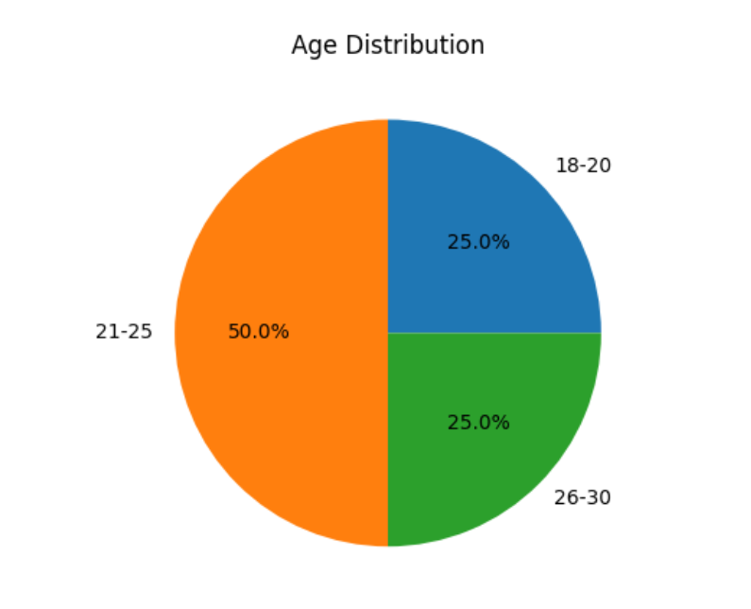

2. Preferred Investment Channels

Graph Type: Pie Chart

Analysis:
Most respondents prefer mobile investment apps and fintech platforms, followed by online brokers, while traditional offline methods are least preferred.

Interpretation:
This clearly shows a shift towards digitalization, where young investors prefer convenience, speed, and accessibility over traditional investment methods.

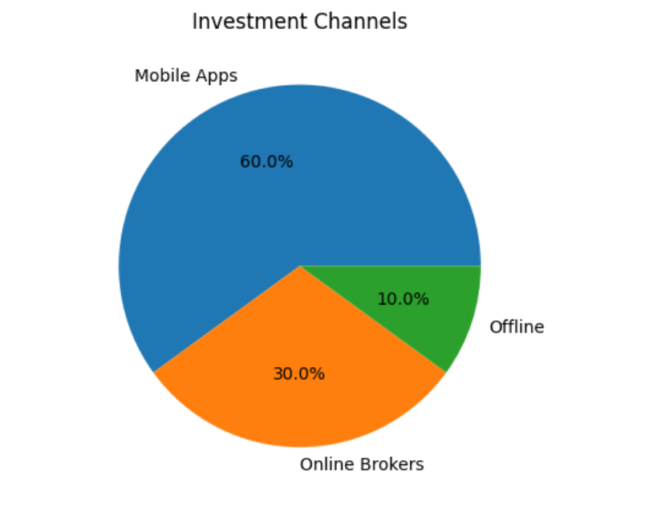

3. Popular Financial Products

Graph Type: Pie Chart

Analysis:
The highest preference is for mutual funds (SIPs), followed by stocks, ETFs, and a smaller percentage in traditional assets like gold and fixed deposits.

Interpretation:
Young investors are moving towards market-linked instruments, indicating a growing awareness of long-term wealth creation and higher returns.

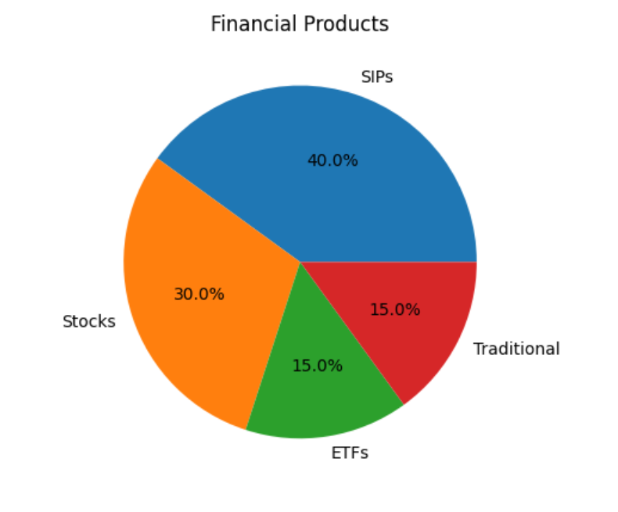

4. Risk Tolerance Level

Graph Type: Bar Chart

Analysis:
Most respondents fall under moderate to high risk tolerance, with fewer respondents preferring low-risk investments.

Interpretation:
This suggests that young investors are more willing to take risks in pursuit of higher returns, which aligns with their long investment horizon.

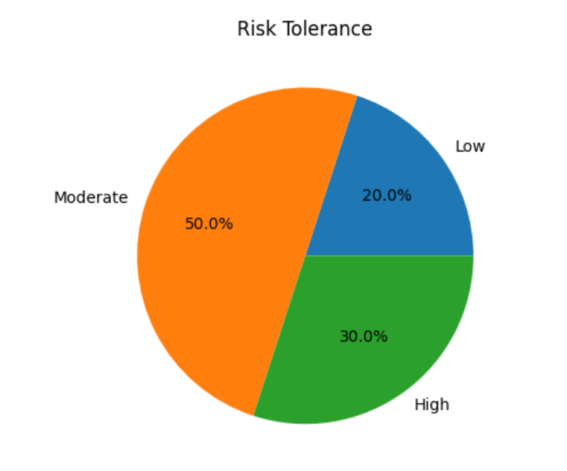

5. Influence of Social Media on Investment Decisions

Graph Type: Pie Chart

Analysis:
A significant portion of respondents reported being influenced by social media and finfluencers, while a smaller group relies on personal research.

Interpretation:
Social media plays a major role in shaping investment decisions, but it also raises concerns about misinformation and herd behavior.

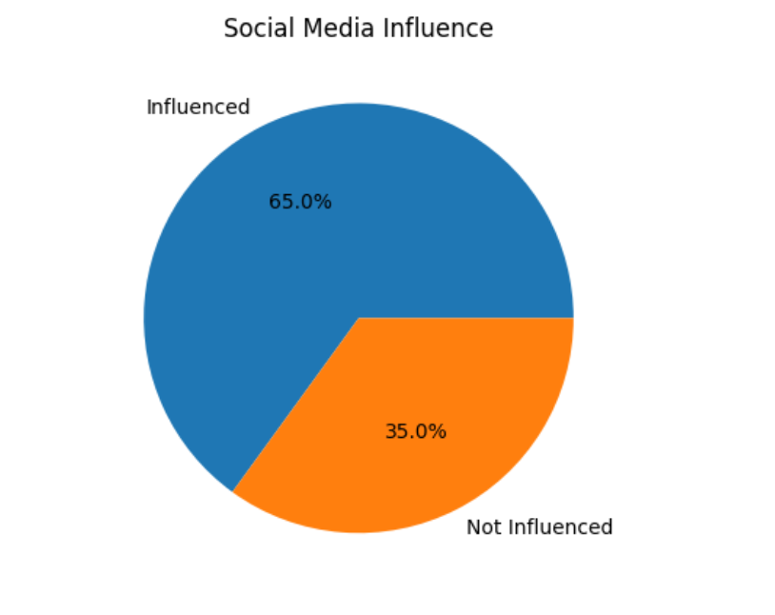

6. Awareness of Financial Concepts

Analysis:
Most respondents have basic to moderate knowledge of financial concepts such as diversification, SIPs, and stock markets.

Interpretation:
Although awareness is increasing, there is still a need for improved financial literacy programs to ensure informed decision-making.

7. Investment Objective

Graph Type: Pie Chart

Analysis:
The primary objective of most respondents is wealth creation, followed by saving for future goals and short-term gains.

Interpretation:
Young investors are increasingly focused on long-term financial growth rather than just saving money, reflecting a shift in mindset.

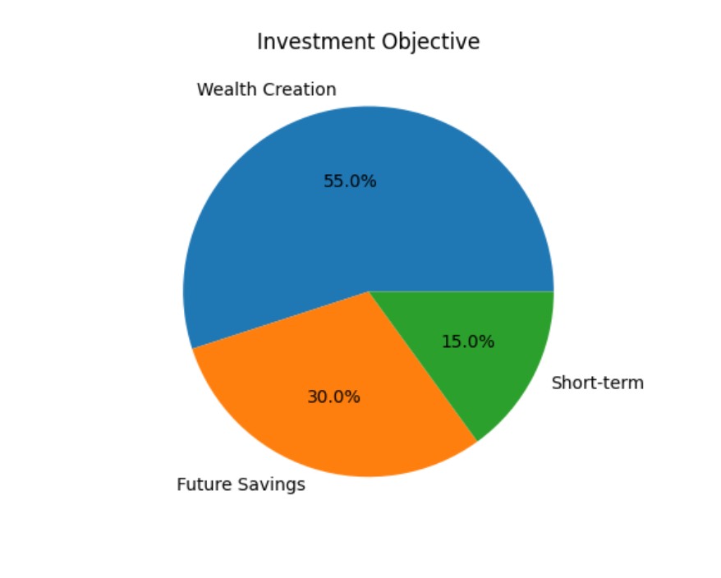

8. Challenges Faced by Young Investors

Analysis:
The main challenges identified include limited knowledge, market volatility, and confusion caused by multiple options.

Interpretation:
Despite high participation, young investors still face difficulties in decision-making, highlighting the need for proper guidance.

Limitations of the Study

Despite careful planning and systematic execution, the present study is subject to certain limitations. Firstly, the sample size of approximately 100–150 respondents is relatively small and may not fully represent the diverse population of young investors across India. Additionally, the study adopts a convenience sampling technique, which may introduce sampling bias, as respondents are selected based on accessibility rather than random selection. The research is also geographically limited, primarily focusing on a specific region or urban population, thereby limiting the generalizability of the findings to rural or other demographic segments. Furthermore, the study relies on self-reported data collected through questionnaires, which may be affected by respondent bias, misunderstanding of questions, or inaccurate responses. Time constraints also restrict the depth and scope of the research, preventing a more comprehensive analysis. Another limitation is the dynamic nature of financial markets, as investment trends and behaviors can change rapidly, making the findings time-bound. The study focuses on selected variables such as financial literacy, risk tolerance, and social media influence, while other important factors like psychological traits, macroeconomic conditions, and cultural influences are not extensively examined. Moreover, the research is cross-sectional in nature and does not capture changes in investor behavior over time. Lastly, since the survey was conducted online, it may exclude individuals who are less technologically inclined, leading to a bias toward digitally active respondents.

Research Findings and Outcomes

The study on “Exploring Wealth-Building Trends Among India’s Young Investors: Channels, Products, and Behavioral Insights” reveals several important findings regarding the investment behavior of young individuals aged 18–30. The results indicate a significant shift from traditional investment practices toward modern, market-linked financial instruments and digital platforms.

One of the key findings is that digital investment channels, particularly mobile applications and fintech platforms, are the most preferred modes of investing among young investors. This shift reflects the growing impact of technology, ease of access, and convenience in financial decision-making. Traditional methods, such as offline brokers and physical transactions, are becoming less relevant among this demographic.

The study also finds that mutual funds, especially Systematic Investment Plans (SIPs), are the most popular investment products, followed by direct equity investments. This indicates a growing awareness of disciplined investing and long-term wealth creation strategies. Young investors are increasingly willing to explore higher-return instruments, moving away from low-risk options such as fixed deposits and gold.

Another important outcome is the moderate to high risk tolerance observed among young investors. Due to their longer investment horizon and higher return expectations, they are more inclined toward risk-taking compared to older generations. However, this also exposes them to potential financial risks if not managed properly.

Behavioral factors play a crucial role in shaping investment decisions. The study highlights that social media and finfluencers have a strong influence on investment choices, often leading to herd behavior and fear of missing out (FOMO). While these platforms increase awareness, they may also contribute to uninformed or impulsive decisions.

In terms of financial knowledge, the study reveals that financial literacy levels are moderate, with many respondents having only a basic understanding of concepts such as diversification and risk management. Although awareness is improving, there is still a gap between knowledge and actual investment practices.

The study further identifies that the primary objective of most young investors is wealth creation, with a strong preference for medium to long-term investment horizons. However, challenges such as a lack of in-depth knowledge, market volatility, and confusion due to multiple investment options continue to hinder effective decision-making.

Research Conclusion

The study titled “Exploring Wealth-Building Trends Among India’s Young Investors: Channels, Products, and Behavioral Insights” highlights a significant transformation in the investment behavior of young individuals aged 18–30. The findings clearly indicate that young investors are increasingly moving away from traditional saving instruments toward modern, market-linked financial products such as mutual funds, stocks, and ETFs. This shift is largely driven by the rapid growth of digital platforms, increased accessibility to financial markets, and rising financial awareness.

One of the key conclusions of the study is that digitalization has played a crucial role in encouraging investment participation among youth. Mobile applications and fintech platforms have simplified the investment process, making it more convenient, cost-effective, and user-friendly. As a result, young investors are more actively engaging in wealth-building activities than ever before.

The study also concludes that behavioral factors significantly influence investment decisions. Social media and financial influencers have become major sources of information, often guiding investment choices. While this has increased awareness, it has also led to the presence of biases such as herd behavior, overconfidence, and fear of missing out (FOMO), which may result in irrational decision-making.

Another important conclusion is that young investors demonstrate a moderate to high-risk appetite, supported by their long investment horizon and desire for higher returns. However, despite this enthusiasm, there is still a gap in deep financial literacy and strategic planning. Many investors possess only basic knowledge and do not fully implement important practices such as diversification and long-term financial planning.

Furthermore, the study reveals that the primary goal of young investors is wealth creation, with a growing preference for medium to long-term investment strategies. However, challenges such as market volatility, lack of proper guidance, and information overload continue to affect their decision-making process.

References
Agarwal, S., Driscoll, J. C., Gabaix, X., & Laibson, D. (2015). Learning in the credit card market. American Economic Review, 105(5), 489–494.
Arner, D. W., Barberis, J., & Buckley, R. P. (2016). The evolution of fintech: A new post-crisis paradigm. Georgetown Journal of International Law, 47(4), 1271–1319.
Association of Mutual Funds in India. (2023). Annual report 2022–23. AMFI.
Barber, B. M., & Odean, T. (2013). The behavior of individual investors. In G. M. Constantinides et al. (Eds.), Handbook of the economics of finance (Vol. 2). Elsevier.
Bhushan, P. (2014). Financial literacy and its determinants. International Journal of Engineering, Business and Enterprise Applications, 8(3), 53–57.
Bikhchandani, S., & Sharma, S. (2001). Herd behavior in financial markets. IMF Staff Papers, 47(3), 279–310.
Bouri, E., Molnár, P., Azzi, G., Roubaud, D., & Hagfors, L. I. (2017). Bitcoin as a diversifier. Finance Research Letters, 20, 192–198.
Chandra, A., & Kumar, R. (2018). Investor behavior in India. International Journal of Management Studies, 5(3), 10–18.
Choi, J. J., Laibson, D., & Madrian, B. C. (2010). Behavioral finance insights. Review of Financial Studies, 23(4), 1405–1432.
Demirgüç-Kunt, A., Klapper, L., Singer, D., & Hess, J. (2018). Global Findex Database 2017. World Bank.
Festinger, L. (1954). Social comparison theory. Human Relations, 7(2), 117–140.
Friede, G., Busch, T., & Bassen, A. (2015). ESG investing performance. Journal of Sustainable Finance, 5(4), 210–233.
Gomber, P., Koch, J., & Siering, M. (2018). Digital finance. Journal of Business Economics, 87(5), 537–580.
Grable, J. E. (2000). Financial risk tolerance. Journal of Business and Psychology, 14(4), 625–630.
Jain, V., & Sharma, A. (2021). Social media influence on investors. Journal of Business Studies, 27(3), 1234–1245.
Jianakoplos, N. A., & Bernasek, A. (1998). Gender and risk-taking. Economic Inquiry, 36(4), 620–630.
Kahneman, D., & Tversky, R. (1979). Prospect theory. Econometrica, 47(2), 263–291.
Kaur, I., & Vohra, T. (2012). Investor behavior toward mutual funds. International Research Journal of Finance, 98, 86–96.
Bhambhani, S., Patel, M., Bhaidasna, Z., Bhaidasna, H., Harsora, H., Jani, S. Building Trust in Labor Markets through Blockchain-Enabled Wage Transparency: A Pathway to Fair Labor Practices and Inclusive Growth. ES 2025, 21 (5(S)November), 172-183.

Jani, S., Bhambhani, S., Gakhar, A., Derashri, P.D., Malik, Y.M., Harsora, H. Smart Contracts in Banking and Financial Services: A Qualitative Review of Applications, Risks, and Regulatory Perspectives. ES 2026, 22 (1(S)Feb), 141-155.
Kumar, S., & Goyal, N. (2022). Mobile trading apps' impact. International Journal of Financial Research, 13(2), 45–56.
Lusardi, A., & Mitchell, O. S. (2014). Financial literacy importance. Journal of Economic Literature, 52(1), 5–44.
Maditinos, D. I., Sevic, Z., & Theriou, N. G. (2007). Investor behavior analysis. Studies in Economics and Finance, 24(1), 32–50.
Malkiel, B. G. (2019). A random walk down Wall Street (12th ed.). Norton.
OECD. (2020). Financial literacy survey report. OECD Publishing.
Patel, J., & Patel, M. (2021). Gender investment patterns. Journal of Finance, 9(2), 67–75.
Reserve Bank of India. (2021). Annual report 2020–21. RBI.
Sabri, M. F., & MacDonald, M. (2010). Student financial behavior. Cross-Cultural Communication, 6(3), 103–110.
SEBI. (2022). Investor awareness report. Securities and Exchange Board of India.
Shefrin, H. (2007). Behavioral corporate finance. McGraw-Hill.
Singh, Y. P., & Bhowmik, D. (2010). Indian investor behavior. Global Journal of Finance, 2(1), 19–33.
Statman, M. (2019). Behavioral finance. CFA Institute.
Thaler, R. H. (2015). Misbehaving: Behavioral economics. Norton.
Shiller, R. J. (2017). Irrational exuberance (3rd ed.). Princeton University Press.
Markowitz, H. (1952). Portfolio selection. Journal of Finance, 7(1), 77–91.
Sharpe, W. F. (1964). Capital asset pricing model. Journal of Finance, 19(3), 425–442.
Fama, E. F. (1970). Efficient market hypothesis. Journal of Finance, 25(2), 383–417.
Black, F. (1972). Capital market equilibrium. Journal of Business, 45(3), 444–455.
Modigliani, F., & Brumberg, R. (1954). Life-cycle hypothesis. Kyklos, 6(2), 123–146.
Becker, G. S. (1993). Human capital. University of Chicago Press.
Ajzen, I. (1991). Theory of planned behavior. Organizational Behavior and Human Decision Processes, 50(2), 179–211.
Bhambhani, S. L., & Mehta, A. C. (2026). A study of financial literacy on mental well-being: Psychological and behavioral pathways in an emerging economy. International Journal of Creative Research Thoughts (IJCRT), 14(3), c628–c638.
Bandura, A. (1986). Social foundations of thought and action. Prentice-Hall.
Ritter, J. R. (2003). Behavioral finance overview. Pacific-Basin Finance Journal, 11(4), 429–437.
De Bondt, W. F., & Thaler, R. (1985). Market overreaction. Journal of Finance, 40(3), 793–805.
Tversky, A., & Kahneman, D. (1981). Decision framing. Science, 211(4481), 453–458.
Campbell, J. Y. (2006). Househonance. Journal of Finance, 61(4), 1553–1604.
Hilgert, M. A., Hogarth, J. M., & Beverly, S. G. (2003). Financial literacy behavior. Federal Reserve Bulletin, 89, 309–322.

Primary Data Collection Questionnaire

Title:

Exploring Wealth-Building Trends Among India’s Young Investors: Channels, Products, and Behavioral Insights

Section A: Demographic Details
- Age
- Gender
- Occupation
- Monthly Income

Section B: Investment Behavior
- Do you invest in financial instruments?
- Preferred investment channel:
- Which financial products do you invest in? (Multiple choice)

Section C: Risk & Investment Preferences
- What is your risk tolerance level?
- What is your investment objective?
- Preferred investment duration:

Section D: Behavioral Factors (Likert Scale)

(1 = Strongly Disagree, 5 = Strongly Agree)
- I am influenced by social media while investing?
- Do I follow trends or others’ investment decisions?
- I feel confident in making investment decisions
- I prefer long-term investments over short-term trading

Section E: Financial Awareness
- Are you aware of diversification?
- Do you practice diversification in your investments?
- Your level of financial knowledge

Section F: Challenges
- What challenges do you face while investing

Section G: Suggestions
- What can improve your investment decisions?

