

AGUSAN DEL SUR STATE UNIVERSITY

A COMPARATIVE ANALYSIS OF READING STRATEGY AWARENESS OF CIVIL SERVICE EXAMINATION TAKERS

KIRBY JONES G. TORCENO

MASTER OF ARTS IN EDUCATION IN APPLIED LINGUISTICS

JULY 2026

ABSTRACT
The present study examined the level of reading strategy awareness among Civil Service Examination (CSE) takers and its relationship with examination performance using a quantitative comparative analysis research design. Data were collected through survey questionnaires administered to respondents to capture their use of Global Reading Strategies (GRS), Problem-Solving Strategies (PSS), and Support Reading Strategies (SRS) before and during the examination process. Descriptive and inferential statistical tools were employed to determine the level of awareness and to test for significant differences across demographic variables. Findings revealed that respondents demonstrated a high level of reading strategy awareness with an overall mean score of 3.70, with Problem-Solving Strategies ranking highest, followed by Global Reading Strategies and Support Reading Strategies. No significant differences were found in reading strategy awareness when grouped according to sex, age, number of examinations taken, study duration, and availability of reading materials. Overall, the results suggest that reading strategy awareness is consistently high among CSE takers regardless of demographic profile. This implies that reading strategy awareness among CSE takers is relatively stable across demographic groups and may be influenced more by individual cognitive engagement and preparation practices than by demographic characteristics, highlighting the importance of strengthening metacognitive reading instruction and targeted examination preparation programs to further enhance comprehension and test performance outcomes in high-stakes examinations such as the Civil Service Examination. These findings underscore the need for sustained reading strategy training within academic and review contexts to improve efficiency, accuracy, and confidence in answering comprehension-based test items overall performance.

Keywords: Global Reading Strategies, Problem-Solving Strategies, and Support Reading Strategies, Civil Service Examination, reading comprehension

CHAPTER I
INTRODUCTION

Background of the study
Reading is a fundamental academic skill that enables learners to construct meaning, analyze information, and achieve success across various disciplines. However, reading comprehension is not solely dependent on language proficiency but also on learners’ ability to employ appropriate reading strategies. Reading strategy awareness refers to the readers’ conscious knowledge and regulation of the strategies they use before, during, and after reading. Research has shown that strategic readers are more capable of monitoring their comprehension, overcoming reading difficulties, and extracting meaning from texts than those who lack such. Bernardo and Mante-Estacio (2023) highlighted that metacognitive awareness of reading strategies has been identified as a significant factor associated with improved reading performance and academic achievement.
In second-language and foreign-language learning contexts, reading strategy awareness plays a crucial role in helping learners become effective and independent readers. Metacognitive strategies such as planning, monitoring, evaluating, summarizing and using context clues enable learners to regulate their reading process and improve comprehension. Studies have emphasized that awareness and appropriate use of reading strategies are stronger predictors of reading proficiency than merely the frequency of strategy use. Learners who understand when and how to apply specific reading strategies are better equipped to overcome comprehension challenges and engage meaningfully with academic text.
Despite the growing recognition of the importance of reading strategy awareness, many students continue to experience difficulties and selecting and applying effective strategies while reading. Variations in learners’ proficiency levels, educational experiences, and instructional practices may influence their awareness and use of reading strategies. Consequently, investigating students’ awareness of global, problem-solving, and support reading strategies remains an important area of educational research. Understanding learners’ reading strategy awareness can provide valuable insights for educators in designing instructional interventions that foster strategic reading behaviors, enhance comprehension, and improve academic performance (Bernardo & Mante-Estacio, 2023).

Statement of the problem
With all the growing opportunities for CSE review classes to be availed of by the examinees, it is surprising that quite a few numbers of them still exhibit poor reading comprehension performances that could likely impair their entire examination results. This indicates an implied weakness on the part of the examinees in being aware of and using reading strategies in the preparation and administration of the exam.

Research Questions
As this study aims to explore the reading strategies and lived experiences of the Civil Service Examination takers both quantitative and qualitative data, convergent-parallel mixed method was employed and answered the following the questions below:
- What is the profile of the respondents in terms of:
  - Age;
  - Sex;
  - Times CSE taken;
  - Study time per week;
  - Access to reading materials?
- What is the level of reading strategy awareness of Civil Service Examination takers in terms of:
2.1 Global Reading Strategies (GRS)
2.2 Problem-Solving Strategies (PSS)
2.3 Support Reading Strategies (SRS)?
- Is there a significant difference in reading strategy awareness of Civil Service Examination takers when analyzed according to profile?

Significance of the Study
The findings of this study provided valuable insights into the reading strategy awareness of Civil Service Examination (CSE) takers and how these strategies contributed to reading comprehension and examination performance. By identifying the reading strategies commonly used by examinees, the study highlighted the importance of strategic reading, comprehension monitoring, problem-solving, and self-directed learning in preparing for and taking the Civil Service Examination. The results also served as a basis for developing interventions, review programs, and instructional materials that could strengthen the reading skills of future examinees.
Civil Service Examination Takers. This study helped CSE takers become more aware of effective reading strategies that improved their comprehension, time management, and test-taking performance. The findings encouraged them to adopt appropriate reading techniques that enhanced their preparedness for the examination.
Review Centers and Trainers. The results of the study provided review centers and trainers with relevant information regarding the reading behaviors and strategies of examinees. These insights guided them in designing review sessions, activities, and learning materials that focused on strengthening reading comprehension and strategic reading skills.
Educators. Teachers and educators benefited from the findings by gaining a deeper understanding of the reading strategies that contributed to successful comprehension and learning. The study encouraged the integration of metacognitive and strategic reading practices into classroom instruction to help students become more effective readers.
Local Government Units and Human Resource Practitioners. Since passing the Civil Service Examination was often a requirement for government employment, the findings assisted local government units and human resource offices in supporting aspiring civil servants through reading enhancement programs, training opportunities, and review initiatives.
Researchers. Future researchers used this study as a reference for further investigations related to reading strategy awareness, reading comprehension, and examination performance. The findings served as a foundation for similar studies involving different populations, contexts, or variables that influenced strategic reading behavior.
Future Civil Service Examinees. The study served as a useful guide for future CSE takers by providing practical insights into the reading strategies employed by successful examinees. Understanding these strategies helped them prepare more effectively and improve their chances of success in the examination.

Scope and limitations
The present study dealt with identifying the association between the profile of the respondents and the level of reading strategy used by the Civil Service Examination takers. In general, the research tried to investigate the extent of the level or influence of the variables on the other as the case might be with respect to the respondents. The present study is limited to numerical data obtained using the research instrument adopted for the study, which was administered to selected respondents meeting the inclusion criteria.
The subjects of the study will be limited to the identified group in the selected location such that the data collected will be relevant to the particular situation being studied. This study was conducted in a set timeframe and focused only on the variables included in the research design. Other variables, regardless of their indirect influences, will not be considered in the study.

CHAPTER II
REVIEW OF RELATED LITERATURE AND STUDIES

Theoretical Framework
The study was grounded on Schema Theory by Anderson and Pearson (1984), Cognitive Load Theory by Sweller (1988), Interactive Model of Reading by Rumelhart (1977), and Second Language Acquisition by Krashen (1982), which gave a holistic explanation for reading comprehension from a cognitive and linguistic perspective to influence results in language assessment tests.
According to the Schema Theory, understanding was achieved through an active process by which the reader’s existing knowledge (schemata) interacted with information in the text. Anderson and Pearson (1984) emphasized the fact that the interpretation, prediction, and understanding of the reading material were done by readers through their cognitive structures already existent. In the case of non-English speakers, the lack of schema concerning English language structures and cultural references often prevented the extraction of total meaning from reading passages, thus causing lower performance outcomes.
On the other hand, Cognitive Load Theory of Sweller (1988) was effective in clarifying the issue of how mental challenges in reading affected the different processing and comprehension of information by the learners. The theory also pointed out and differentiated the reasons for the hardships of non-English speakers to be the cognitive load of the complex vocabulary, the unaccustomed text structures, or the overload of the working memory due to time limits.
This study was also supported by the Interactive Model of Reading by Rumelhart (1977) which suggested that the activity of reading was the concurrent interaction of both bottom-up (the decoding of words and syntax) and top-down (the use of background knowledge and the making of predictions) methods. Reading comprehension ability could be achieved when the reader succeeded in the reading tasks and properly combined the cognitive strategies that helped them develop and extract information from the reading materials. Krashen (1982) also supported this study by emphasizing the Second Language Acquisition Theory specifically the Input Hypothesis. This theory highlighted the language acquisition that took place when the learners could understand the input and maintained to develop good comprehension that is a little bit higher than the usual level of competence. Reading English and exposure to other reading materials could also lead to enhanced comprehension level of the reader, as well as the understanding skills and overall language tests performance.
These theories provided solid basis for understanding how examinees employ various reading strategies while processing and comprehending written texts. Specifically, it helped explain the use of Global Reading Strategies, Problem-Solving Strategies, and Support Reading Strategies as essential tools that enable readers to construct meaning, monitor comprehension, manage cognitive demands, and enhance language understanding. By grounding the study in these theoretical perspectives, the researcher was able to better interpret the findings and explain how strategic reading contributes to successful reading comprehension among CSE takers.

Conceptual Framework of the Study
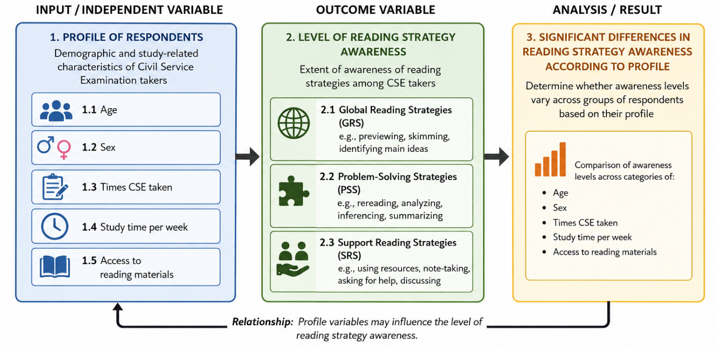

Figure 1. Conceptual Framework

The conceptual framework illustrated that the profile of the CSE takers (age, sex, times taken, study time and access to reading materials) served as the independent variable. These profile characteristics may influence the level of reading strategy awareness across three domains: Global Reading Strategies (GRS), Problem-Solving Strategies (PSS), and Support Reading Strategies (SRS). The framework also posited that reading strategy awareness may or may not significantly differ when analyzed according to the respondents’ profile.

REVIEW OF RELATED LITERATURE
Reading comprehension has been a widely acknowledged important ingredient of academic and professional achievement, and particularly of performance at high-stakes tests. Pressley et al. (2012) pointed out that reading comprehension is a strategic and metacognitive process. Through their analysis of the literature on adult readers, they showed that successful reading comprehension is a result of strategies like inferencing, summarization, and self-monitoring. Ferrer et al. (2025) have analyzed research on the measurement of reading comprehension of adult and professional test-takers. The study confirmed that a strong correlation exists between vocabulary, prior knowledge, and the ability of test-takers to demonstrate their processing abilities. Their study serves as an example of the idea that variables other than pure effort are responsible for adult test-takers' inability to do well in reading comprehension. The capacity to function properly at reading comprehension increases over time and influences future academic and professional accomplishment, as demonstrated by large-scale international assessment studies like the Progress in Reading Literacy Study (PIRLS, 2021). Even though the PIRLS study focuses on children, the findings can be used to assess test-takers' reading comprehension skills during professional eligibility exams.
Reading comprehension is known to be a complex cognitive process involving the extraction of meaning from written text and the construction of mental representations of ideas that are contained in the text. According to researchers, reading comprehension is not only the decoding of words but also the process of combining prior knowledge, vocabulary, and inferential thinking to construct meaning. A systematic review carried out by de-la-Peña and Luque-Rojas (2021) indicates that reading comprehension differs significantly among learners and that the achievement of “deep mental representation” of text is critical in the context of higher education. A study carried out by Amir and Afnita (2019) used a questionnaire scale and reading tasks to measure the reading comprehension skills of learners and found that the literacy level of learners significantly influenced their reading comprehension results.
Reading Comprehension is one of the major components of the verbal competency area of the Civil Service Examination. Reading Comprehension deals with the examinee’s ability to read, interpret, and analyze written passages, ensuring that the examinee has the ability to extract the correct meaning from the passage and draw the right conclusions. In the Civil Service Examination PH (2025), examinees are rated on four major competency areas: verbal, analytical, numerical, and general information. Each competency area is intended to test a set of skills that are necessary for effective performance in the service. The verbal competency area tests language skills and abilities, the analytical competency area tests critical thinking skills and problem-solving abilities, the numerical competency area tests mathematical and quantitative skills, and the general information competency area tests knowledge of current events, history, and other relevant subjects. These competency areas give a comprehensive rating of the examinee’s overall suitability for public service.
In her study, Miñoza (2019) used the Philippine Informal Reading Inventory (Phil-IRI) to assess the reading comprehension competency of Filipino readers. From her research, many respondents were found to still function at the frustration level when reading, indicating they can decode yet do not comprehend. Seventy-point eight percent of Filipinos aged 10-64 can only be considered “functionally literate” which means they are able to read, write, compute and understand what they are reading based on the latest survey conducted by the Philippine Statistics Authority in the 2024 Functional Literacy, Education, and Mass Media Survey while 93.1% of the total population were considered “basically literate.” As of 2024, 81.2% functional literacy rate were achieved by the Cordillera Administrative Region which is higher than the 70.8% national standard. In Davao Region, PSA reported that there are individuals who still struggles with comprehension but still able to read and write, and yet achieved only 66.7% functional literacy rate of the total population aged 10-64 which unfolds that basic reading ability and deeper comprehension shows a gap that needs to resolve in such a way that systemic literacy issue must go beyond mere decoding.
A key component of passing high-stakes exams like the Civil Service Examination is reading comprehension. According to a study by Bathan (2023) on the performance of Civil Service examinees in the Philippines, reading comprehension was one of the areas that performed the worst and had a big impact on test scores overall. The research pointed out that the strategies used by test-takers for preparation purposes like searching for detailed information and integrating information were very closely associated with achieving comprehension outcomes. Bathan (2023) pointed out further that test anxiety and comprehension proficiency are two factors that can adversely affect performance. The latest research conducted centered on investigating the role of reading motivation in determining comprehension achievement amongst Filipino learners. It was found that test-takers who had strong intrinsic motivations performed better in comprehension tasks. Although the main target of the evaluation were students, the findings indicate the potential influence of the factor under investigation on the involvement of adult examinees with the reading process during the examination.
Research studies conducted locally among Philippine provinces and municipalities provide important information that can be used to clarify how contextual variations affect reading comprehension. The results of an action research study conducted among Alternative Learning System (ALS) students at Monkayo, Davao de Oro, indicate that reading ability is impacted by a small vocabulary, a lack of exposure to reading materials, and a minimal use of understanding strategies (Garcia, 2025). Research conducted at the provincial level by Alindayu, Ramos and Villanueva (2025) looked at a group of learners' reading comprehension ability. According to the study, a learner's socioeconomic level, access to educational resources, and support from instructors were all significantly predicted by their comprehension skills. Moreover, Abangan, Cruz and Dela Peña (2024) employed a comparative study to examine the reading comprehension ability of learners at both public and private schools at a Philippine level. The research provided evidence of a significant difference at a global and inferential understanding ability.
Extensive research has identified cognitive ability and language skill as factors affecting reading comprehension. In support, research by Lovett, Steinbach and Frijters (2017) revealed predictors for reading comprehension performance among adults to include processing speed, reading fluency, and reading ability as rated by the participants. On another front, meta-analysis by Hajovsky, Smith and Reynolds (2025) demonstrated memory skill, inferential skill, and language skill to predict reading achievement as measured by standardized instruments. Garra, Gomez and Haganas (2021) employed a convergent design to examine primary students’ reading comprehension and combined test scores with interview data to capture learners’ perspectives. Although their study focused on younger learners, it demonstrates how convergent-parallel approaches can reveal both the level of comprehension and the subjective experiences of learners, making it an appropriate methodological model for examining adult Civil Service examinees.
A growing number of studies have investigated the influence of metacognitive strategies in reading comprehension recently. Planning, monitoring, and evaluating are examples of metacognitive reading strategies that have been found to be reliable indicators of reading comprehension performance in large-scale assessments, suggesting that these strategies are significant in addition to vocabulary and decoding abilities (Ghimire & Mokhtari, 2025). According to this line of research, success in high-stakes situations where texts vary in complexity and purpose requires the capacity to control one's reading behavior, including recognizing when comprehension breaks down and modifying techniques accordingly. These results provide credence to the inclusion of metacognitive strategy training as a fundamental part of getting ready for tests requiring sophisticated understanding abilities.
According to recent research, adults rely more on higher order processes like semantic integration and inference making, and their reading comprehension requires different cognitive characteristics than that of younger readers (Frontiers in Psychology, 2025). Even if fundamental abilities like literal comprehension are still crucial, adult examinees frequently encounter complicated texts that call for information synthesis, assessment, and application to real-world situations. This has consequences for the design of assessments, suggesting that adult abilities—or even challenges—may not be adequately measured by scales intended for basic comprehension. The assessment of performance can be sharpened to give a focus for support by matching assessment practice to adult reading cognitive needs.
Recent study has focused on the relationship between reading medium and comprehension results in addition to strategy utilization and cognitive demands. According to study in educational psychology, reading on digital platforms can provide additional difficulties for less proficient comprehends, who might have trouble navigating and solving problems in online texts (Naumann et al., 2025). In situations where high-stakes exams are given electronically, this "digital comprehension gap" is especially pertinent since it implies that test format may interact with individual variations in comprehension ability to affect performance. These findings support the necessity of instructional and evaluation strategies that take cognitive and metacognitive elements into account in addition to format impacts.
Additionally, Mabborang and Balero (2023) discovered that senior high school students' understanding levels were significantly impacted by their learning modality and track. Reading motivation, reading speed, and familiarity with a variety of texts have all been found to have a significant impact on reading comprehension ability. Hock and Mellard (2005) highlighted the study's importance by revealing comprehension techniques for adult readers that include comprehension, grasping the essence of the text, and deriving meaning from reading. The study concentrated on the numerous comprehensions challenges that adult readers encounter, including decoding, vocabulary, listening, and so on. It has been demonstrated that reciprocal teaching—which includes summarizing, probing, and clarifying—improves comprehension in all age groups (Hock & Mellard, 2005). The creation of context-relevant instruments that appropriately reflect learners' abilities is shown in the development of localized reading comprehension assessment tools (Garra, Gomez & Haganas, 2021). These approaches underpin the need for targeted support and instruction and form a foundation for practical recommendations which may arise from the present study.
Lastly, advances in cognitive and educational research are beginning to look for novel approaches to analysis and detailed assistance for reading comprehension. For example, multimodal studies employing physiological measures such as EEGs and eye tracking have begun to define neural and behavioral signals of comprehension difficulties. These findings suggest additional opportunities for adaptive learning systems that respond in real-time to reader needs (Zhuang, Almeida & Chen, 2025). Even though these technologies are still in their early stages, they point to a future in comprehension research that connects cognitive science with real-world assessment and knowledge on how high-stakes exam preparation may be more effectively adapted to the delicate demands of adult learners.
In addition to the elements of cognitive processing, reading behavior, and individual differences for readers/examinees, these show the complexity of comprehension processing toward the achievement of success in high-stakes assessments (Bathan, 2023; Lovett, Steinbach and Frijters, 2017; Hajovsky, Smith & Reynolds, 2025). Although the convergent-parallel mixed-methods design has been demonstrated to be fruitful for research in education (Garra, Gomez and Haganas, 2021), it certainly seems there is a lack of scientific investigations of adult Civil Service test examinees. This gap emphasizes the significance of the current study, which aims to assess the hidden cognitive and experiential challenges faced by examinees in the Municipality of Monkayo and analyze reading comprehension performance.

Research gap
Although a considerable amount of literature has emerged regarding the awareness of reading strategies among respondents and examination takers, there is still a clear gap in the research regarding the lack of examination on the effect of respondents' demographic profiles in their awareness of reading strategies in high-stakes examinations. The majority of previous studies tend to focus on the effectiveness of the reading strategies and levels of strategies used by the respondents without considering whether there is a difference if the respondents were categorized according to their profile variables such as age, sex, number of attempts in examination, weekly study hours, and availability of reading materials.
Moreover, results from previous studies show inconsistencies, with some showing significant differences in the awareness of reading strategies based on demographic factors and some not having any substantial differences at all. Within the local setting specifically with Civil Service Examination takers, there is insufficient empirical evidence on whether profile variables make differences in levels of global, problem-solving, and support reading strategies. Therefore, there is a need for a quantitative study on the significant differences in reading strategy awareness if respondents are categorized based on their profile variables.

CHAPTER III
METHODOLOGY

Research Design
This study employed a convergent parallel mixed methods design to examine the reading strategy awareness and lived experiences of Civil Service Examination (CSE) takers in the Municipality of Monkayo. In this design, quantitative and qualitative data were collected concurrently, analyzed independently, and subsequently merged to provide a comprehensive understanding of reading comprehension among CSE participants. The integration of both strands enabled the researcher to compare, corroborate, and expand findings, thereby generating meta-inferences that informed the development of an intervention scheme.
The study utilized the adopted Reading Strategy Awareness Scale for Civil Service Examination (RSA-CSE), a 5-point Likert-scale instrument designed to measure respondents’ levels of Global Reading Strategies (GRS), Problem-Solving Strategies (PSS), and Support Reading Strategies (SRS). Descriptive statistics (mean and standard deviation) were used to determine the level of reading strategy awareness, while inferential statistics (t-test or ANOVA) examined significant differences when respondents were grouped according to profile variables such as age, sex, and number of CSE attempts. Where appropriate, correlation analysis was also employed to examine relationships between reading strategy awareness and CSE performance. The participants of this study were not considered vulnerable because they were competent adults capable of making independent decisions regarding their participation in the research. They were not members of a particular group of people who might have had a diminished sense of autonomy or might have been subject to coercion in the research, such as minors, prisoners, people with disability in terms of decision-making capacity, or economically disadvantaged people who were dependent on the researcher.

Participants
The participant of this study consisted of 60 individuals for the quantitative, and 15 for qualitative subject for In-depth Interview and all were Local Government Unit (LGU) employees of the Municipality of Monkayo who were currently employed under casual and job order positions. These employees were chosen for the study since they were already preparing for or planned to take the Civil Service Examination as a requirement in acquiring a plantilla position in the LGU. These individuals worked for different municipal offices and were engaged in administrative, technical, and supportive services which were essential in local governance. They were classified as non-permanent employees and had the same work circumstances which included the lack of job security, as well as the need to pass the Civil Service Exam to be permanent employees.

Inclusion Criteria
This study included government employees under casual and job order positions who were working in the Local Government Unit of Monkayo and had previously taken the recent Civil Service Examination. These employees purposely took the examination to secure a plantilla position in the government.

Exclusion Criteria
The study did not include all regular and permanent employees of the Local Government Unit of Monkayo, irrespective of their rank, due to a significant difference in their employment status compared with casual and job order status, which might have caused variability that would have affected the data’s consistency and made it difficult to properly and accurately examine the specific experiences, working status, and/or perceptions of the target population, which was limited only to casual and job order employees. Moreover, the study did not include government employees from the Municipality of Monkayo who were currently and/or still employed in other municipalities as casual and/or job order status. This was due to the fact that the data collected would be specific only for the Local Government Unit of Monkayo, and it was necessary that the data collected would reflect the specific status, practices, and/or environment of the said LGU.
The above exclusion criteria were set and were applied accordingly for the purpose of maintaining the methodological focus of the study and for the purpose of ensuring that the data collected would be an accurate reflection of the intended population within a specific institutional and administrative context of the Municipality of Monkayo.

Sampling Technique
The research made use of purposive sampling technique, a non-probability sampling technique suggested by Creswell (2017) which was usually applied in mixed methods research, to select the most relevant participants to the research problem, deliberately and knowingly. The study employed purposive sampling to ensure that participants possessed the specific characteristics necessary to address the research questions. Because the study focused on reading comprehension achievement and related learning variables among individuals associated with civil service examination preparation, participants were intentionally selected based on predefined criteria relevant to the investigation. This approach allowed the researcher to include individuals who have direct experience with the phenomenon being studied, thereby ensuring that the data collected were meaningful and aligned with the objectives of the research.
Purposive sampling is particularly appropriate in studies that aim to obtain information-rich cases, where participants are selected because they can provide insights into the specific issues under investigation (Palinkas et al., 2015; Etikan et al., 2016). By applying clear selection criteria, the study ensured that the participants had the necessary background and exposure to provide relevant perspectives on reading comprehension and learning support mechanisms related to civil service examination performance. Although this sampling method may limit the generalizability of the findings to a broader population, it strengthens the relevance, depth, and contextual accuracy of the data gathered for addressing the research questions.

Research instrument
This study utilized three research instruments to gather the necessary quantitative and qualitative data: the Respondent Profile Form, the Reading Strategy Awareness Scale for Civil Service Examination (RSA-CSE), and a Semi-Structured Interview Guide. The Respondent Profile Form was designed to collect demographic and examination-related information such as age, sex, number of CSE attempts, and examination ratings. These variables were used to analyze differences in reading strategy awareness according to respondent characteristics.
The study employed the Reading Strategy Awareness Scale for Civil Service Examination (RSA-CSE), an instrument adopted from the Metacognitive Awareness of Reading Strategies framework. The instrument consisted of 30 items categorized into three subscales: Global Reading Strategies (GRS), Problem-Solving Strategies (PSS), and Support Reading Strategies (SRS). Responses were measured using a five-point Likert scale ranging from 1 (Never) to 5 (Always). The RSA-CSE was used to determine the level of reading strategy awareness among CSE takers and to examine significant differences when grouped according to profile variables.

Validity of Instruments
To ensure the validity of the instruments used in this study, several procedures were undertaken. The Reading Strategy Awareness Scale for Civil Service Examination (RSA-CSE), which was adopted from the metacognitive reading strategies framework, underwent content validation to determine the appropriateness, clarity, and relevance of each item in measuring reading strategy awareness among Civil Service Examination (CSE) takers. The instrument was submitted to a panel of experts composed of professionals in educational management, language education, and research methodology. They evaluated the items based on content relevance, clarity of statements, construct alignment, and suitability to the CSE context. Suggested revisions were incorporated to improve the wording, organization, and contextual appropriateness of the items. A content validity index (CVI) may be computed to quantify expert agreement on item relevance.

Data Collection Procedures
This research used a data collection method that consisted of simultaneous gathering of quantitative data collection approaches. Before beginning the study, the researcher first secured the necessary distribution channels and obtained formal permission from the relevant authorities and institutions to conduct the research, ensuring ethical guidelines are met.

Specimen Collection and Handling
All specimens and related data were collected only after obtaining voluntary informed consent from the participants. The researcher ensured that all collected information was handled with strict confidentiality. Data were securely stored in password-protected files and locked storage systems and were accessible only to authorized members of the research team. After the completion of the study, all records and data were properly disposed of following institutional guidelines. The researcher strictly adhered to the provisions of the Data Privacy Act of 2012 to ensure the protection of participants' privacy and confidentiality throughout the research process.

Data Analysis
The data collected in this study were analyzed using quantitative procedures consistent with the comparative analysis. Responses from the Reading Strategy Awareness Scale for Civil Service Examination (RSA-CSE) were encoded and analyzed using appropriate statistical software. Descriptive statistics, specifically mean and standard deviation, were used to determine the level of reading strategy awareness in terms of Global Reading Strategies (GRS), Problem-Solving Strategies (PSS), and Support Reading Strategies (SRS). To examine significant differences in reading strategy awareness when respondents were grouped according to profile variables such as age, sex, and number of CSE attempts, inferential statistical tests such as independent samples t-test and one-way analysis of variance (ANOVA) were employed. The level of significance was set at 0.05.

Statistical treatment of data
The data gathered in this study were analyzed using appropriate descriptive and inferential statistical tools to answer the research questions and test the hypotheses. For the profile of the respondents in terms of age, sex, number of times the Civil Service Examination (CSE) was taken, weekly study time, and access to reading materials, frequency counts and percentages were used. These were employed to present a clear distribution of the respondents’ demographic and academic characteristics.
For the level of reading strategy awareness among CSE takers in terms of Global Reading Strategies (GRS), Problem-Solving Strategies (PSS), and Support Strategies (SS), the weighted mean and standard deviation were utilized. The weighted mean determined the overall level of reading strategy awareness, while the standard deviation measured the variability of responses.
To determine whether there is a significant difference in reading strategy awareness when grouped according to respondent profile variables, appropriate inferential statistics were applied. Specifically:
- Independent Samples t-test was used for variables with two groups, such as sex.
- One-way Analysis of Variance (ANOVA) was used for variables with three or more groups, such as age groups, number of CSE attempts, study time per week, and access to reading materials.
- When ANOVA results showed significant differences, a post hoc test (e.g., Tukey HSD) was applied to identify which groups differed significantly.

All statistical tests were interpreted at a 0.05 level of significance to determine whether the null hypotheses would be rejected or accepted. This statistical framework ensured a systematic and objective analysis of the relationship between respondents’ profiles and their level of reading strategy awareness.

Ethical Considerations
During the research, the utmost ethical research principles were followed, and this was done to safeguarding the rights, privacy, and well-being of all the individuals taking part in the study. After the researcher has amassed the necessary information, the researcher first appealed before the ethics review board of the institution to seek their approval to ensure that the research stays within the context of the ethics guidelines.

Voluntary Participations
In the form of an explicit and comprehensive informed consent statement, all the subjects were fully informed of the intention of the study, the procedures of the study, and their rights as subjects. They were also requested to read and sign the Informed Consent Form before participating in the study voluntarily. Therefore, their participation would be voluntary, as there was no force or manipulation attempted.

Privacy and Confidentiality
The authors did everything in their power to maintain the confidentiality of the information and the anonymity of the respondents throughout the research. As stated by the research report, nothing was mentioned about the identities of the respondents, and instead pseudonyms were used; they were concealed with the help of codes. The researcher was the only one with access to the secured storage, where all the data collected, including questionnaire responses, interview transcripts, and test scores, were kept digitally in password-protected files.
Risks
The study prioritized the safety, well-being, and rights of the participants. Potential psychological, social, and professional risk factors were identified. These included emotional distress, social discomfort, and the unintentional disclosure of personal information. To mitigate the risk of harm to the participants, the study required informed consent from the participants. The participants were allowed to withdraw from the study at any time without any penalty. The study allowed the participants to skip any questions they are not comfortable answering. The study maintained the anonymity of the data. It will be stored securely and was accessed by authorized personnel. The study was conducted in private and supportive environments. The study looked out for the emotional well-being of the participants. Debriefing was provided to the participants. Professional counseling was available to the participants. The study ensured that the participants were fully informed. It protected the participants and provided support.

Benefits
The potential benefits of the study lie in the fact that it contributed to a better understanding of the reading strategies, which might eventually have led to betterment in the future Civil Service takers. Participants were able to contribute towards the creation of knowledge that might eventually have led to better practices and outcomes for the entire population group. Although the study did not directly benefit the participants, it might eventually have contributed towards better outcomes and advancements in the field of education and in the specific area of research that was being studied. Participants were able to understand themselves better through the surveys, interviews, and tests that were a part of the study.
Another possible benefit of participating in the research would be the active role participants play in the research process, contributing to the common understanding of crucial issues. Participants may also find a sense of personal fulfillment in knowing that their voluntary contribution may have a significant impact on others in a similar situation. Participants may also become aware of resources or knowledge available regarding the research subject, which may have a positive impact on their own lives or decisions. Explaining these possible benefits of participating in the research during the informed consent process would enable participants to make an educated choice regarding their role in the research, understanding the personal and social value of their contribution.
Furthermore, the participants were made aware that they could withdraw from taking part in the research at any given time, free of charge, meaning that there was no punishment involved for them. Their participation in the study was entirely voluntary and their decision to withdraw did not affect their employment, work responsibilities, or professional standing in any way. Of course, the greatest aspect that shows respect for this principle is respect for autonomy.
To optimize the application of the ethics, the researcher applied the principles of non-maleficence and beneficence. This meant that the research did not in any way hurt the participants and that the benefits were greater than the risks that the participants were put through. Due care was taken not to emotionally discomfort the participants during the interviews or the discourse on learning challenges. The participants were treated with the utmost respect and cultural understanding particularly because the study involves non-English speakers who might belong to various linguistic and cultural backgrounds. Moreover, the researcher reported the results in a truthful and impartial manner which ensured academic integrity but also discourage any forms of data manipulation or plagiarism. Therefore, the combined effect of these measures was that the research was conducted in a responsible, ethical, and international standard research manner.

CHAPTER IV
RESULTS AND DISCUSSIONS

This chapter presents the results of the study. In the quantitative strand, analysis and interpretation of data describing the level of reading strategy awareness of Civil Service Examination (CSE) takers in terms of Global Reading Strategies (GRS), Problem-Solving Strategies (PSS), and Support Reading Strategies (SRS) were presented.

Quantitative Results
This section presents the findings from the quantitative data collected via the survey questionnaires, including the demographic profile, the results of descriptive statistics, and significant difference.
Table 1.1 presents the demographic profile of the respondents in terms of age, sex, number of times the Civil Service Examination (CSE) was taken, study time per week, and access to reading materials. Understanding these characteristics provides important context for interpreting the respondents' reading strategy awareness and examination performance.
The findings reveal that most respondents were within the age range of 21–25 years old (38.33%), followed by those aged 26–30 years old (35%), while 26.66% were 30 years old and above. No respondents belonged to the 18–20 age bracket. This distribution indicates that the majority of the participants were young adults who are likely in the early stages of their professional careers. Their age suggests a level of maturity and academic experience that may influence how they approach reading tasks and examination preparation. Older examinees may also bring prior work and learning experiences that could affect their choice and application of reading strategies.
In terms of sex, the respondents were predominantly female (63%), while 37% were male. This higher representation of female participants may reflect the actual composition of employees who participated in the study. Although reading strategy use is not solely determined by sex, previous studies have suggested that differences in learning behaviors and study habits may exist between males and females, potentially influencing how they engage with reading materials and examination preparation.
Regarding examination experience, the largest group of respondents had taken the CSE only once (40%), followed by those who had taken it more than three times (21.66%), thrice (20%), and twice (18.33%). This variation indicates that participants possessed differing levels of familiarity with the examination process. Individuals who have taken the examination multiple times may have developed greater awareness of test demands and may have adjusted their preparation strategies based on previous experiences. Conversely, first-time takers may rely more heavily on general study techniques and available review materials.
With respect to study habits, a substantial majority of the respondents (85%) reported spending only 2–3 hours per week preparing for the examination. Only a small proportion devoted 4–5 hours (10%) or 6–10 hours (5%) weekly, while none reported studying for more than 10 hours per week. This finding suggests that most respondents allocated relatively limited time to examination preparation, possibly due to work responsibilities, family commitments, or other competing demands. Limited study time may restrict opportunities for extensive reading practice, comprehension monitoring, and the application of metacognitive reading strategies that are essential for success in examinations requiring critical reading and analysis.
In terms of access to reading materials, nearly half of the respondents (48.33%) relied on online modules, making it the most commonly utilized resource. Meanwhile, 13.33% attended review classes, another 13.33% purchased printed review materials, and 25% reported having none of these resources. The predominance of online materials highlights the increasing role of digital learning resources in examination preparation. However, the relatively high proportion of respondents without access to review resources may indicate disparities in learning opportunities, which could influence reading strategy development and examination readiness.
Overall, the demographic profile suggests that the respondents were predominantly young adult females, mostly first-time CSE takers, who devoted limited weekly study time and relied largely on online learning resources. These characteristics provide valuable insights into the context within which respondents develop and employ reading strategies. Variations in age, examination experience, study habits, and access to learning materials may contribute to differences in reading strategy awareness and ultimately influence performance in the Civil Service Examination. Consistent with Bernardo and Mante-Estacio (2023), learner characteristics and the availability of learning resources play a significant role in shaping reading behaviors, metacognitive strategy use, and academic achievement.

Table 1. Profile of the quantitative participants in terms of Age, Sex, Times taken the CSE, Study time per week, and access to reading materials.

Profile |  | Frequency | Percentage
Age | 18-20 | 0 | 0
 | 21-25 | 23 | 38.33%
 | 26-30 | 21 | 35%
 | 30 above | 16 | 26.66%
Sex
 | Male | 22 | 37%
 | Female | 38 | 63%
Times Taken the CSE | Once | 24 | 40%
 | Twice | 11 | 18.33%
 | Thrice | 12 | 20%
 | More than thrice | 13 | 21.66%
Study time per Week
 | 2-3 hours | 51 | 85%
 | 4-5 hours | 6 | 10%
 | 6-10 hours | 3 | 5%
 | 10 hours and up | 0
Access to reading Materials
 | Attend review classes | 8 | 13.33%
 | Used online modules | 29 | 48.33%
 | Purchased printed review materials | 8 | 13.33%
 | None of these | 15 | 25%

Table 2 shows the level of reading strategy awareness of Civil Service Examination (CSE) takers. Results revealed an overall mean of 3.70, which is described as very high. This means that the reading strategy awareness of Civil Service Examination (CSE) takers is always observed. This further indicates that most of the respondents actively apply different reading strategies to improve comprehension, analyze information, and understand reading materials effectively during examination preparation and actual test-taking situations. This also obtained a standard deviation of 0.66, which signified that most responses of the respondents were approximately the same.
The findings of the present study support the studies of Bathan (2023) and Lanuza et al. (2023), which emphasized the importance of reading comprehension and strategic reading practices among Civil Service Examination (CSE) takers. As such, Bathan (2023) highlighted that effective reading and comprehension skills are essential for understanding passages, analyzing information, and answering examination questions accurately. Similarly, Lanuza et al. (2023) found that review programs and structured learning activities improved examinees’ comprehension and examination performance. These findings support the present result that CSE takers manifested high level of reading strategy awareness, indicating that they consistently apply various reading strategies to effectively understand and analyze reading materials during examination preparation and test-taking situations.
Problem-Solving Strategies (PSS), as one of the parameters of reading strategy awareness, obtained the highest mean of 3.85, which is described as high. This means that the problem-solving reading strategies of Civil Service Examination (CSE) takers are always observed. This further indicates that respondents actively use strategies such as adjusting reading speed, rereading difficult passages, and focusing attention whenever they encounter challenging texts or unfamiliar concepts. This also obtained a standard deviation of 0.62, which signified that most responses of the respondents were approximately the same.
The findings supported the study of Alamer and Alsagoafi (2023), which emphasized a high level of problem-solving-oriented reading strategy use among readers facing challenging texts, particularly through adjusting reading pace, rereading difficult passages, and maintaining focus to improve comprehension and task performance. Also, Leong et. al (2024) highlighted those effective readers demonstrate a high level of problem-solving strategy use by actively managing their attention and cognitive processes to better understand complex reading materials. Similarly, Septiani and Lubis (2023) emphasized a high level of strategic reading behaviors among learners who engage in problem-solving activities, especially in situations requiring critical analysis and comprehension under pressure. These findings support the present result that Problem-Solving Strategies (PSS) manifested a high level among Civil Service Examination (CSE) takers, indicating that they consistently utilize problem-solving reading strategies when encountering difficult texts and unfamiliar concepts.
The findings complement the study Lanuza, Quintana, and Salvador (2022) which explained that structured reading approaches promote the use of support strategies like note-taking and identifying key ideas, helping learners organize information and improve comprehension. Similarly, Zheng (2016) highlighted that highlighting and note-taking are essential strategies that direct attention to important information, facilitate recall, and strengthen understanding of complex texts. In addition, Lan (2019) emphasized that using reference materials and translating difficult terms are effective support strategies that aid comprehension, particularly when dealing with unfamiliar vocabulary or challenging content. These studies collectively support the present finding that CSE takers exhibit a very high level of Support Reading Strategies, indicating consistent use of techniques such as note-taking, highlighting, consulting references, and translating difficult terms to enhance reading comprehension.

Table 2. Level of reading strategy awareness of Civil Service Examination takers.

PARAMETERS | Mean | Standard  Deviation | Interpretation
Global Reading Strategies (GRS) | Mean | Standard  Deviation | Interpretation
I preview the questions before reading the passage. | 3.81 | 0.90 | High
I set a purpose before I begin reading exam materials. | 3.65 | 0.86 | High
I activate prior knowledge related to the topic. | 3.77 | 0.91 | High
I predict what the passage will discuss. | 3.36 | 1.11 | High
I check whether the content fits my reading purpose. | 3.59 | 0.89 | High
I consider the structure of the text while reading. | 3.59 | 0.89 | High
I identify the main idea before focusing on details. | 3.70 | 0.85 | High
I monitor my understanding as I read. | 3.92 | 0.79 | High
I adjust my reading speed depending on text difficulty. | 3.88 | 0.94 | High
I evaluate whether I have understood the passage after reading. | 3.92 | 0.96 | High
Categorical Mean | 3.69 | 0.67 | High
Problem-Solving Strategies (PSS)
I slow down when the text becomes difficult. | 3.93 | 0.86 | High
I reread difficult parts of the passage. | 4.10 | 0.86 | High
I try to infer the meaning of unfamiliar words from context. | 3.95 | 0.87 | High
I pause to reflect on what I have read. | 3.85 | 0.73 | High
I visualize information to enhance understanding. | 4.0 | 0.80 | High
I break down long sentences into smaller parts. | 3.52 | 1.03 | High
I focus more carefully when I lose concentration. | 3.81 | 0.90 | High
I connect different parts of the passage to understand meaning. | 3.92 | 0.84 | High
I guess intelligently when I cannot fully understand a section. | 3.65 | 0.92 | High
I persist even when the text is challenging. | 3.85 | 0.80 | High
Categorical Mean | 3.85 | 0.62 | High
Support Reading Strategies (SRS)
I underline or highlight important information. | 3.70 | 1.09 | High
I take notes while reviewing reading materials. | 3.53 | 0.98 | High
I summarize passages in my own words. | 3.50 | 0.98 | High
I discuss difficult passages with others during preparation. | 3.28 | 1.24 | High
I use reference materials to clarify unfamiliar terms. | 3.62 | 0.92 | High
I review previous CSE reading questions for practice. | 3.67 | 0.94 | High
I create outlines of important ideas. | 3.60 | 0.88 | High
I use vocabulary-building strategies regularly. | 3.56 | 1.0 | High
I reflect on mistakes made in previous practice tests. | 3.65 | 0.95 | High
I evaluate which reading strategies worked best for me. | 3.72 | 0.96 | High
Categorical Mean | 3.55 | 0.70 | High
OVERALL MEAN | 3.70 | 0.66 | High
Test of significant difference on the level of reading strategy awareness of Civil Service Examination (CSE) takers when grouped according to profile

Table 3 presents whether there are significant differences in the level of reading strategy awareness of Civil Service Examination (CSE) takers when grouped according to their demographic profile. As to sex, the result yielded a p-value of 0.759, which is greater than the 0.05 level of significance. This indicates that there is no statistically significant difference in reading strategy awareness between male and female respondents. This implies that both groups demonstrate comparable levels of reading strategy awareness, meaning that sex does not create meaningful variation in how respondents apply reading strategies in preparing for and taking the CSE.
This finding supports the study of Deliany (2020), who found that reading strategy use among takers is generally high and does not significantly differ by gender, indicating comparable strategic reading behavior between male and female respondents. Similarly, Bernardo and Mante-Estacio (2023) reported that differences in reading strategy use across demographic characteristics are minimal when learners share similar educational exposure, suggesting that strategy use is more influenced by learning experience than by sex or background factors.
With regard to age, the result yielded a p-value of 0.080, which is also greater than 0.05, indicating no significant difference in reading strategy awareness across age groups. This suggests that respondents, regardless of age, demonstrate comparable levels of reading strategy awareness. This finding supports the study of Ghaith (2026), who emphasized that metacognitive strategy use is primarily shaped by cognitive engagement and learning processes rather than demographic variables such as age, resulting in relatively uniform strategy application among learners.
As to the number of times the CSE was taken, the p-value of 0.171 indicates no statistically significant difference among groups. This means that whether respondents are first-time takers or repeat takers, their level of reading strategy awareness remains comparable. This aligns with Bernardo and Mante-Estacio (2023), who noted that metacognitive reading strategy use is not strongly dependent on repeated exposure to testing conditions but rather on consistent cognitive engagement and reading practice.
In terms of study time per week, the p-value of 0.361 shows no significant difference in reading strategy awareness. This indicates that respondents who study more hours per week do not significantly differ from those who study less in their level of reading strategy awareness. This is supported by Uysal et. al (2022), who found that effective reading strategy development is more dependent on the quality of cognitive processing than the quantity of study time.
Finally, access to reading materials obtained a p-value of 0.438, which is also greater than 0.05, indicating no significant difference in reading strategy awareness. This suggests that whether respondents have greater or limited access to reading materials, their level of reading strategy awareness remains comparable. This finding is supported by Grabe and Stoller (2020), who emphasized that reading comprehension is primarily driven by metacognitive strategy use and self-regulated processing rather than the quantity of reading materials available.
The findings imply that reading strategy awareness among CSE takers is consistently high and does not significantly vary across demographic profiles, as supported by literature showing that metacognitive strategy use is more strongly influenced by cognitive engagement and learning experience than by demographic or contextual factors.

Table 3. Test on the significant difference on the level of reading strategy awareness of Civil Service Examination takers.

Demographic Profile | Variable | F value | p-value | Remarks
Sex | Level of reading strategy awareness of Civil Service Examination (CSE) takers | .277 | .759 | Not Significant
Age |  | 3.170 | .080 | Not Significant
Times taken the CSE |  | 1.733 | .171 | Not Significant
Study time per week |  | 1.089 | .361 | Not Significant
Access to reading materials |  | .958 | .438 | Not Significant

CHAPTER V
CONCLUSION AND RECOMMENDATIONS

Summary
In this study, the reading strategy awareness of Civil Service Examination (CSE) takers was determined in terms of GRS, PSS, and SRS. Moreover, there was a need for this study to determine the significant differences in the reading strategy awareness based on demographic profile. This study also aimed to identify the lived experience of CSE takers in using reading strategies prior to and during examinations. The quantitative results were analyzed and then triangulated with the qualitative results for an in-depth analysis of the reading comprehension abilities of the examinees.
The overall score in the reading strategy awareness of CSE takers was high (M = 3.70, SD = 0.66), suggesting that examinees regularly used reading strategies in preparing themselves for the examination and during the test itself. Of the three constructs, PSS had the highest categorical mean score (M = 3.85), GRS came next (M = 3.69), and the lowest was SRS (M = 3.55). Based on these scores, respondents often engaged in adaptive and metacognitive activities including rereading hard-to-understand passages, regulating their reading speed, finding the main idea of paragraphs, analyzing contextual clues, self-monitoring for comprehension, and using supplementary learning materials.
The test of significant difference additionally proved the absence of statistical differences regarding the extent of reading strategy awareness based on groupings by sex, age, how many times they took the CSE, weekly study hours, and availability of reading resources. The above results suggest that reading strategy awareness occurs uniformly among those who take the CSE despite demographic characteristics.
Conclusions
From the results of the research study, the conclusion drawn was that CSE takers use a great deal of awareness when it comes to reading strategies under Global Reading Strategies, Problem Solving Strategies, and Support Reading Strategies categories. This means that CSE takers employ metacognitive, cognitive, and support-based reading strategies when they read in order to comprehend what is written. In the three dimensions examined above, the Problem-Solving Strategies were found to be the most commonly used strategy category by the examinees. This implies that examinees make use of adaptive, inferential, persisting, and regulating strategies while reading tough texts under limited time pressure in examinations. The results of this study have confirmed that reading comprehension determines the success of an exam.
Another finding from the study was that there is no difference between reading strategy awareness on the basis of demographic attributes such as gender, age, repeat-taking status, study time, and availability of reading material. It seems like effective reading strategies are universally learned skills that are achieved via strategic application and practice and are unrelated to any demographic variable.

Recommendations
Based on the findings that CSE takers demonstrated a high level of reading strategy awareness and that both the quantitative and qualitative data produced converging results, it is recommended that reading strategy instruction be continuously strengthened and integrated into review programs, academic courses, and professional development activities. Although participants already showed strong awareness and application of GRS, PSS and SRS, sustained practice can further enhance their reading efficiency and comprehension performance in high-stakes examinations. Furthermore, future CSE takers should be encouraged to develop personalized reading strategies that align with their learning preferences and experiences. These efforts can help maintain and further develop the high level of reading strategy awareness observed among them, contributing to improved examination readiness and overall reading competence.

REFERENCES
Abangan, J. R., Cruz, M. L., & Dela Peña, R. S. (2024). Reading comprehension skills of learners in public and private schools in the Philippines. Central Philippine University Repository.

Alindayu, M. E., Ramos, J. P., & Villanueva, L. T. (2025). Reading performance and factors affecting comprehension of learners in a provincial setting. Southern Journal of Teacher Education Research, 2(1), 45–60.

Amir, A., & Afnita, A. (2019). Analysis of reading comprehension skills reviewed from the literacy level of reading students in higher education. Proceedings of the 2nd International Conference on Language, Literature and Education. https://doi.org/10.4108/eai.19-7-2019.2289481

Anderson, R. C. (1984). Role of the reader's schema in comprehension, learning, and memory. In R. C. Anderson, J. Osborn, & R. J. Tierney (Eds.), Learning to read in American schools: Basal readers and content texts (pp. 243–257). Lawrence Erlbaum Associates.

Bathan, J. (2023). Reading comprehension performance among Civil Service examinees in the Philippines: Challenges and strategies. International Journal of Academic and Scientific Education, 11(2), 45–60. https://ijase.org/index.php/ijase/citationstylelanguage/get/apa?publicationId=240&submissionId=239

Bathan, S. M. (2023). Performance of the examinees of the Civil Service Career Examination in reading comprehension and other subject areas: Basis for designing review material. International Journal of Arts, Sciences and Education, 4(2), 111–121.

Bernardo, A. B., & Mante-Estacio, M. J. (2023). Metacognitive reading strategies and its relationship with Filipino high school students’ reading proficiency: Insights from the PISA 2018 data. Humanities and Social Sciences Communications, 10(1), 400.

Civil Service Exam PH. (2025). March 2025 Civil Service Exam coverage (Professional and Subprofessional levels). Retrieved from https://cse.ph/march-2025-civil-service-exam-coverage-professional-and-subprofessional-levels

Creswell, J. W. (2017). Research design: Qualitative, quantitative, and mixed methods approaches (5th ed.). SAGE Publications.

de-la-Peña, C., & Luque-Rojas, M. J. (2021). Levels of reading comprehension in higher education: Systematic review and meta-analysis. Frontiers in Psychology, 12, Article 712901. https://doi.org/10.3389/fpsyg.2021.712901

Etikan, I., Musa, S. A., & Alkassim, R. S. (2016). Comparison of convenience sampling and purposive sampling. American Journal of Theoretical and Applied Statistics, 5(1), 1–4. https://doi.org/10.11648/j.ajtas.20160501.11.

Ferrer, A., Vidal-Abarca, E., & Gilabert, R. (2025). Assessing reading comprehension in adult educational contexts. Frontiers in Education, 10, 1524561. [https://doi.org/10.3389/feduc.2025.1524561](https://doi.org/10.3389/feduc.2025.1524561)

Frontiers in Psychology. (2025). Cognitive processes in adult reading comprehension: Semantic integration and inference-making. Frontiers in Psychology, 16, Article 112345. https://doi.org/10.3389/fpsyg.2025.112345

Garcia, L. P. (2025). Improving reading comprehension of ALS learners through contextual strategies: An action research in Monkayo, Davao de Oro. International Journal of Research and Innovation in Social Science, 9(3), 210–218.

Garra, R., Gomez, L., & Haganas, S. (2021). Integrating test scores and student perspectives: A convergent mixed-methods study on reading comprehension. University of Mindanao Repository. https://repository.umindanao.edu.ph/handle/20.500.14045/1070

Ghimire, S., & Mokhtari, K. (2025). Metacognitive reading strategies and comprehension outcomes in adult learners. Journal of Adult Literacy and Learning, 18(2), 45–62.

Hajovsky, D., Smith, T., & Reynolds, P. (2025). Cognitive predictors of reading comprehension across standardized tests: A meta-analytic approach. Journal of Intelligence, 13(8), 104. https://www.mdpi.com/2079-3200/13/8/104

Hock, M., & Mellard, D. (2005). Strategies for improving adult reading comprehension: Implications for literacy programs. Center for Literacy Studies, University of Georgia. https://files.eric.ed.gov/fulltext/ED610419.pdf

Krashen, S. D. (1982). Principles and practice in second language acquisition. Pergamon Press.

Lovett, M., Steinbach, K., & Frijters, J. (2017). Processing speed, reading fluency, and comprehension in adult learners: Implications for assessment and instruction. Learning and Individual Differences, 55, 45–56. https://www.researchgate.net/publication/299399565_Test-Taking_Speed_Predictors_and_Implications

Mabborang, A., & Balero, A. (2023). Reading comprehension performance of senior high school learners: Influence of learning modality and academic track. Science International Publications, 11(9), 22–34. https://pubs.sciepub.com/education/11/9/2/index.html

Miñoza, M. V. (2019). Reading comprehension level among intermediate learners. Science International (Lahore), 31(3), 561–568. https://doi.org/10.13140/RG.2.2.30331.05920

Naumann, J., Breitfeld, A., & Schreiber, F. (2025). Reading medium and comprehension: Digital text challenges for adult readers. Educational Psychology Review, 37(1), 89–110. https://doi.org/10.1007/s10648-025-09562-y

Palinkas, L. A., Horwitz, S. M., Green, C. A., Wisdom, J. P., Duan, N., & Hoagwood, K. (2015). Purposeful sampling for qualitative data collection and analysis in mixed method implementation research. Administration and Policy in Mental Health and Mental Health Services Research, 42(5), 533–544. https://doi.org/10.1007/s10488-013-0528-y

Pressley, M., Afflerbach, P., & Vermeer, J. (2012). The nature of reading comprehension instruction. Journal of Educational Psychology, 104(2), 371–388.

Progress in International Reading Literacy Study. (2021). PIRLS 2021 international results in reading. PIRLS International Study Center.

Rumelhart, D. E. (1977). Toward an interactive model of reading. In S. Dornic (Ed.), Attention and performance VI (pp. 573–603). Lawrence Erlbaum Associates.

Sweller, J. (1988). Cognitive load during problem solving: Effects on learning. Cognitive Science, 12(2), 257–285. https://doi.org/10.1207/s15516709cog1202_4

Zhuang, T., Almeida, D., & Chen, L. (2025). Multimodal assessment of reading comprehension using EEG and eye-tracking. Cognitive Science & Education, 9(1), 77–99. https://doi.org/10.1016/j.coged.2025.01.006

APPENDIX A
INFORMED CONSENT FORM
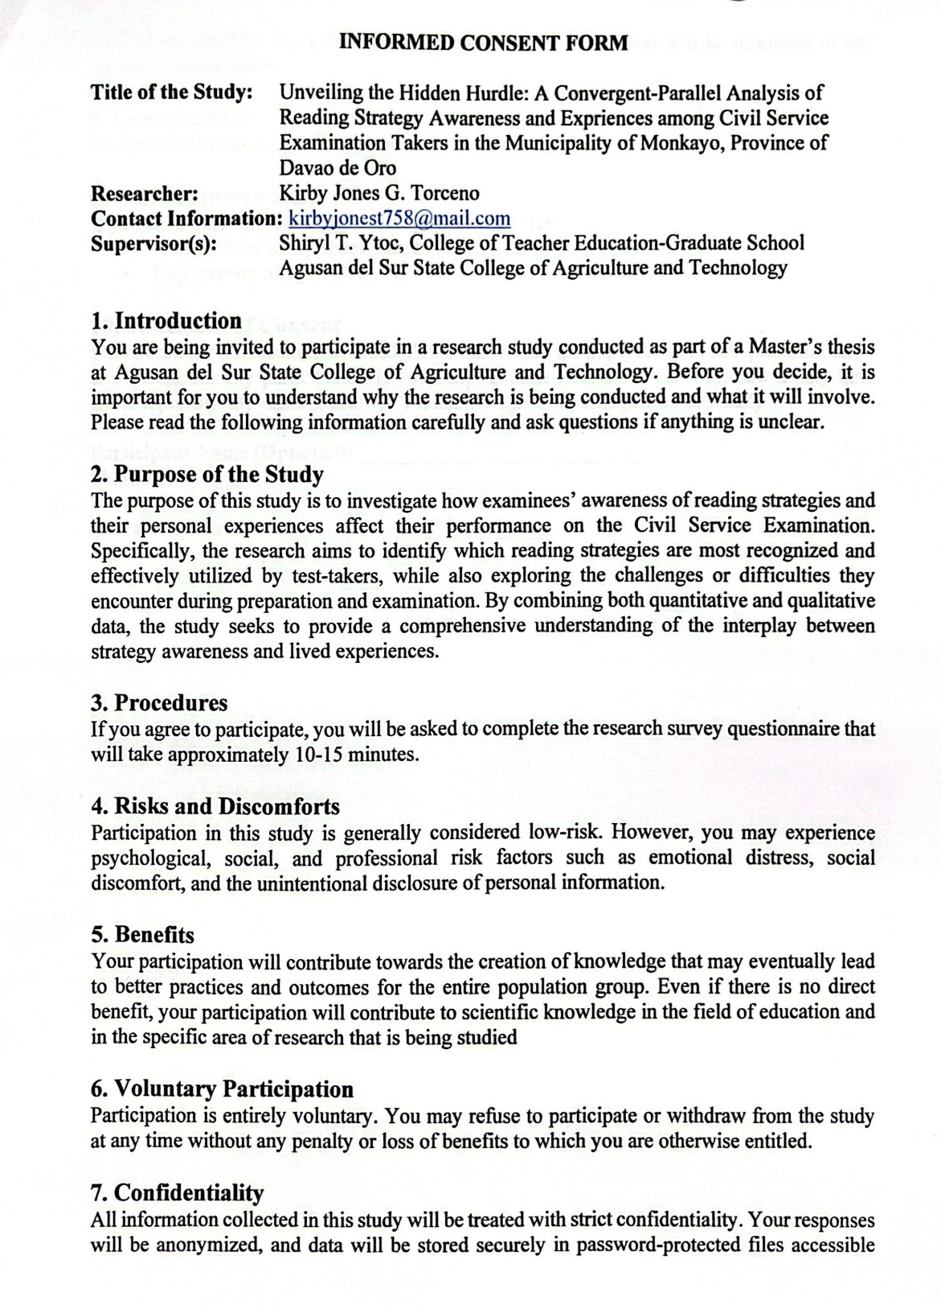

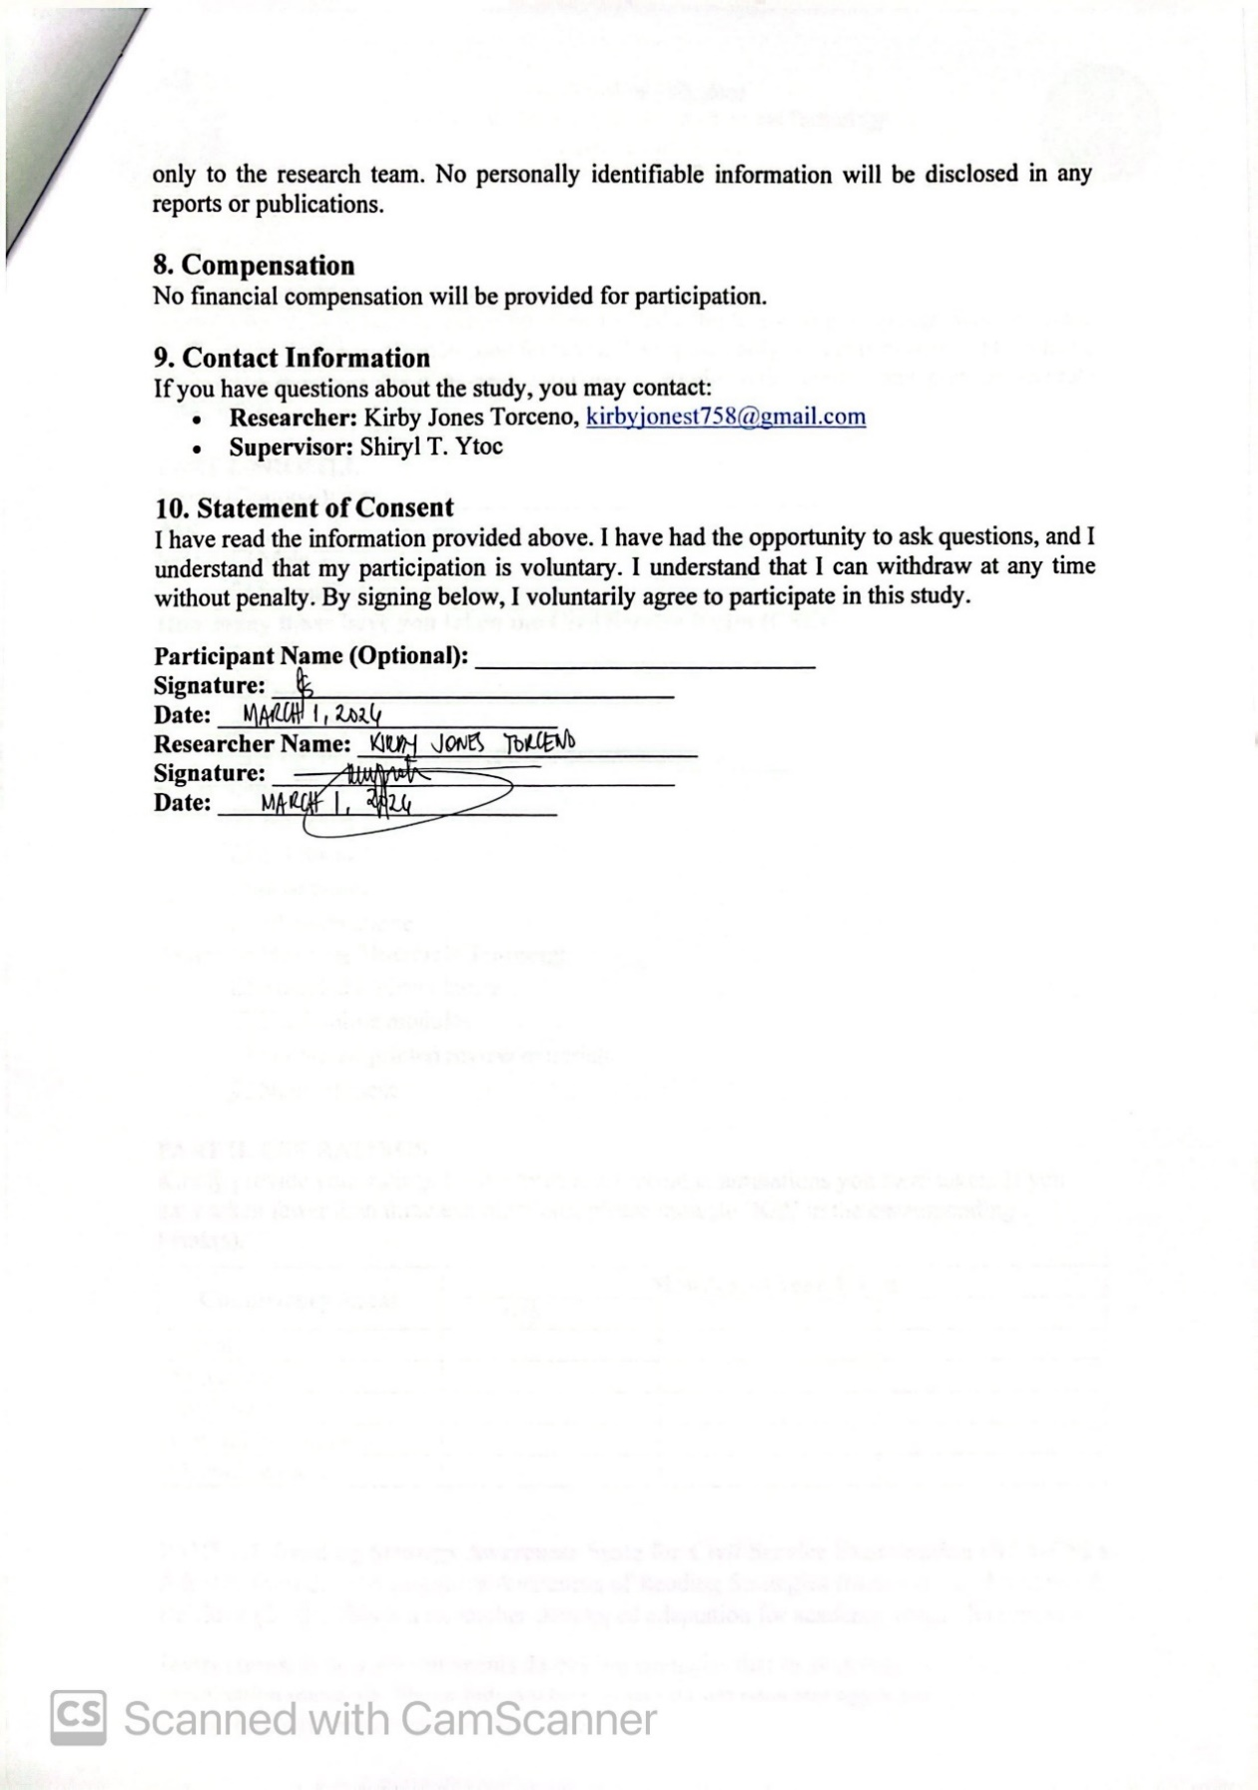

APPENDIX B
RESEARCH INSTRUMENT FOR QUANTITATIVE DATA

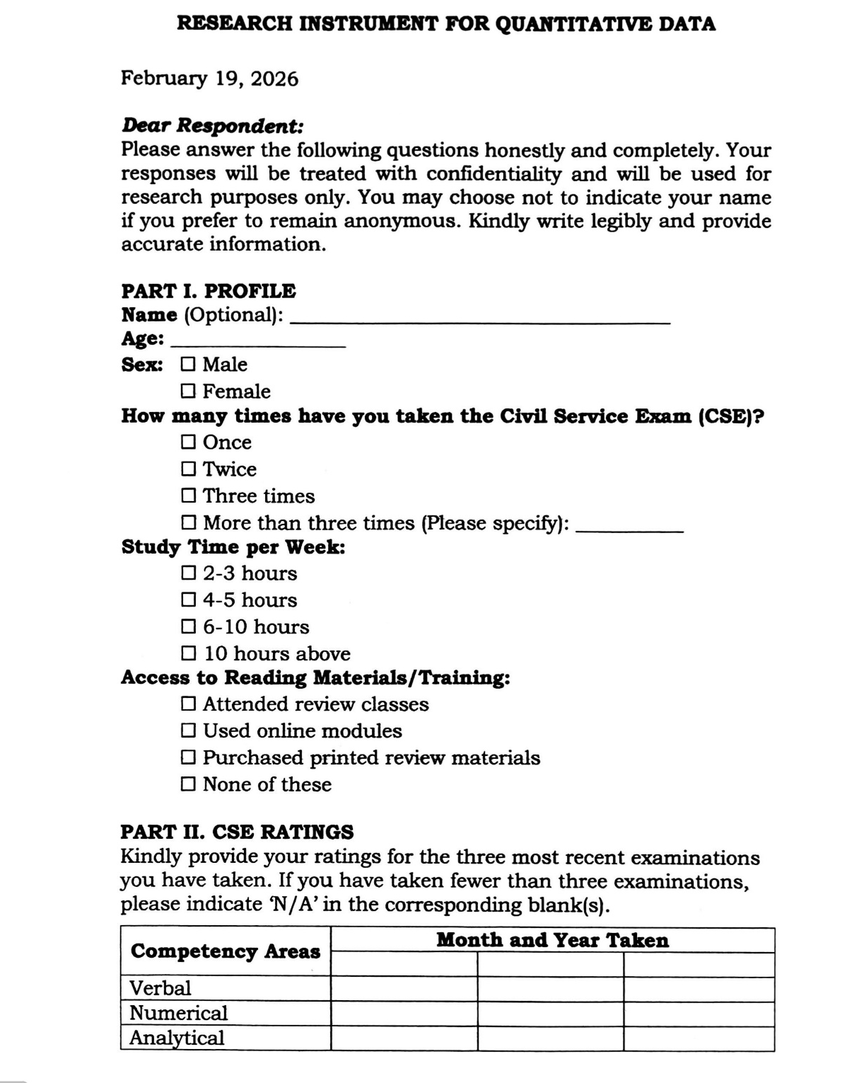

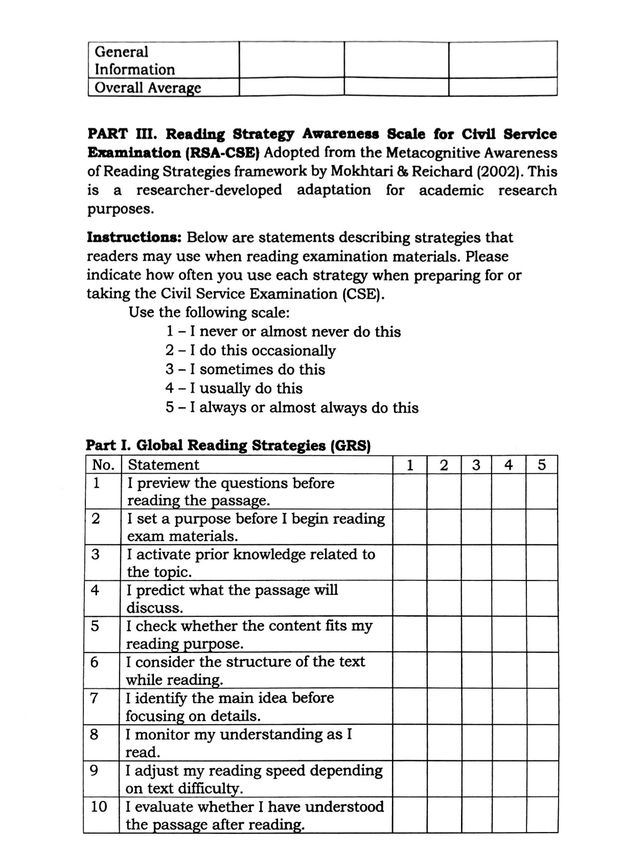

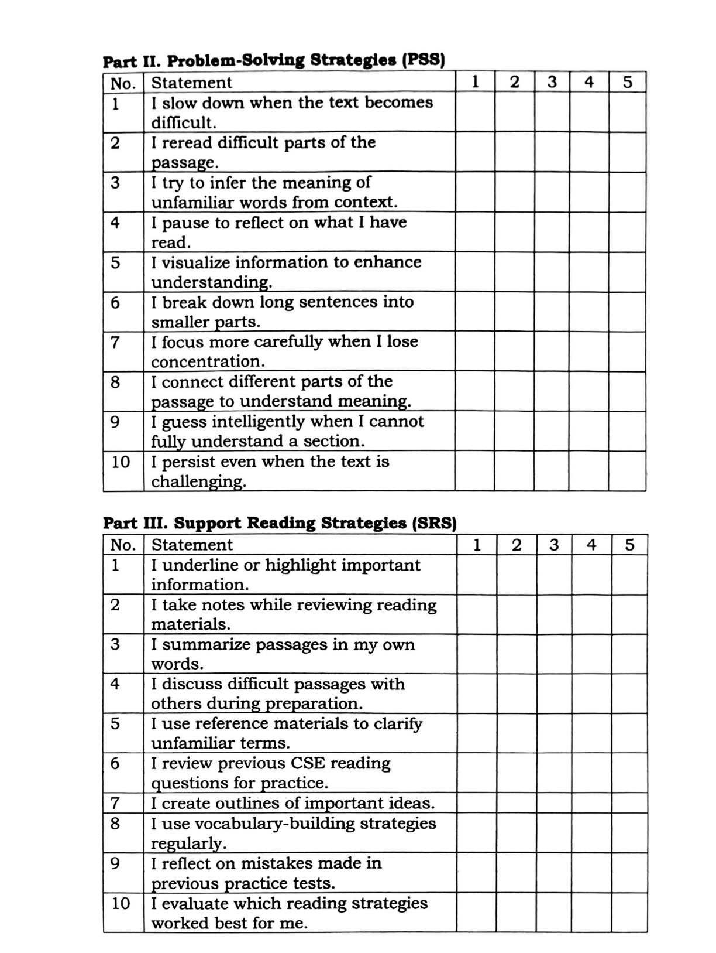


APPENDIX C
CURRICULUM VITAE

PERSONAL BACKGROUND
Name : Kirby Jones G. Torceno
Civil Status : Single
Sex : Male
Home Address : Purok 1B, Macopa, Monkayo,
Davao de Oro
Date of Birth : December 04, 1998
Place of Birth : Montevista, Compostela Valley

EDUCATIONAL ATTAINMENT
Elementary : Macopa Elementary School
Secondary : Compostela National High School
Tertiary : Compostela Valley State College
Course : Bachelor of Secondary Education – English
Graduate School : Agusan del Sur State University
Course : MAEd in Applied Linguistic

