A Real -Time Centralized Dashboard Framework for District-Level Administrative Monitoring and Decision Support

M. Arun Kumar Assistant Professor, Department of
Information Technology, PSNA College of Engineering and
Technology,
Dindigul, India arunkumarm@psnacet.edu.in
Dhilip S
UG Student, Department of Information Technology,
PSNA College of Engineering and Technology,
Dindigul, India dhilips22it@psnacet.edu.in
Gokul S
UG Student, Department of Information Technology,
PSNA College of Engineering and Technology,
Dindigul, India gokuls22it@psnacet.edu.in

Abstract—This project analyses 38 districts, covering four key government departments: Health, Education, Transport, and Revenue. For instance, in a typical district, 25% of tasks remain pending, 50% of educational initiatives are completed, 95% progress is observed in transport, and 75% performance is achieved in revenue. On average, across all four departments, 35% of tasks remain pending. The dashboard provides a comprehensive district-wise comparison, highlighting that Chennai ranks highest in overall performance. The system enables real-time tracking of monthly improvements, pending tasks, and completed projects. By integrating Java for the backend and Angular for the frontend, the project delivers a practical, data-driven tool for district administrators to monitor performance and make informed decisions. This system ensures that the progress of every district is transparently accessible through a unified dashboard.
Keywords— Real-time Government Analytics, Public Sector Progress Tracking, Data-driven Decision Support, Revenue Analytics.
- Introduction
In today’s rapidly evolving administrative landscape, district governance frequently encounters challenges such as data fragmentation and a lack of real-time insights. To address this critical gap, this project proposes a centralized real-time dashboard that integrates the activities of multiple departments—particularly Education, Transport, and Healthcare—by providing timely and unified data. This project serves as a real-time monitoring solution, enabling district authorities to compare progress across various districts and clearly identify which districts have advanced and where stagnation exists.
By leveraging powerful technologies such as Angular for the front end and Java for the back end, the solution is designed to be fast, reliable, and scalable. It allows district officials to directly monitor each department, take necessary actions, and evaluate which districts are outperforming others. In future expansions, the system can incorporate additional sectors—such as Agriculture, Employment, and Environmental Management—to create a comprehensive real-time oversight platform across multiple districts. As a result, the government can make timely decisions, respond to delays, and accurately track progress.
The primary benefit of this project lies in providing district administrators with clear data, real-time monitoring, and the ability to compare disparities across departments. This ensures that public services are delivered efficiently and equitably at every stage. Consequently, citizens, administrators, and policymakers can easily identify bottlenecks and make informed decisions. Thus, this project aims to become a robust, reliable, and impactful solution for district-level governance in the future.

- Related Works
K. Jaspin et al. proposed a secure digital reporting framework that prioritizes privacy, accessibility, and timely action on sensitive complaints [1] Q. Zou, Z. Mao, R. Yan, S. Liu, and Z. Duan, “Vision and reality of e-government for governance improvement: Evidence from global cross-country panel data,” Technological Forecasting and Social Change, vol. 193, 2023, Art. no. 122667. [2] A. Odeshina, O. Reis, F. Okpeke, V. Attipoe, O. Orien o, and A. Pub, “Business intelligence dashboard optimization model for real-time performance tracking and forecasting accuracy, ”International Journal of Social Science Exceptional Research
,vol. 3, pp. 334–342, 2024 [3] B. Payne, L. O. Ling, and A. Gorod, “Towards a governance dashboard for smart cities initiatives: A system of systems approach,” in Proc. 2020 IEEE 15th International Conference on System of Systems Engineering (SoSE), 2020, pp. 587–592 [4] S. Priyadharshini,
P. Ajith, R. Dharani, C. Brindha, B. Mohanapriya, and S. Dharaneesh, “Centralized Dashboard for District Administration to Monitor and Track,” in Proc. 2025 IEEE International Conference on Communication Networks and Computing (CNC), 2025, pp. 413–418. [5] Adam, I.O., 2020.
Examining E-government development effects on corruption in Africa: the mediating effects of ICT development and institutional quality. Technol. Soc. 61, 101245 https://doi.org/10.1016/j.techsoc.2020.101245. [6] Ahn, M.J., Bretschneider, S., 2011. Politics of E-government: E-government and the political control of bureaucracy. Public Adm. Rev. 71 (3), 414–424. https://doi.org/ 10.1111/j.1540-6210.2011.02225.x.[7] Amosun, T.S., Chu, J., Rufai, O.H.,
Muhideen, S., Shahani, R., Gonlepa, M.K., 2021. Does e-government help shape citizens’ engagement during the COVID-19 crisis? A study of mediational effects of how citizens perceive the government. Online. Inform. Rev.

XXX-X-XXXX-XXXX-X/XX/$XX.00 ©20XX IEEE

https://doi.org/10.1108/OIR-10-2020-0478 ahead-of-print. [8]. Achumie GO, Bakare OA, Okeke NI. Post-project financial auditing as a continuous improvement tool for SMEs. 2024. [9]. Adepoju AH, Eweje A, Collins A, Austin-Gabriel B. Automated offer creation pipelines: An innovative approach to improving publishing timelines in digital media platforms. Int J Multidiscip Res Growth Eval. 2024;5(6):1475-1489. [10]. Adepoju AH, Eweje A, Collins A, Austin-Gabriel B. Framework for migrating legacy systems to next generation data architectures while ensuring seamless integration and scalability. Int J Multidiscip Res Growth Eval. 2024;5(6):1462-1474. [11]. J. Gandhi, B. Sauser, and A.
Gorod, "A case study: The New York City yellow cab System of Systems," presented at the 2011 6th International Conference on System of Systems Engineering, Albuquerque, NM, USA, 30 June 2011, 2011. [12] M. Luciano. "Top 10
Smartest Cities In The World." DesignWorld.https://www.designworldonline.com/top-10-smartest-cities-in-the world/ (accessed). [13]. E. Woods. "Data analytics: The key to delivering smart cities." Navigant. https://www.smart-energy.com/magazine-article/data analytics-the-key-to-delivering-smart-cities/ (accessed 2020).
[14] Sharma, A., & Kumar, S. (2019). "E-Governance and Public Administration: A Review of Information Systems in Government." Journal of Public Administration Research, 55(2), 128-135. [15] Patel, R., & Desai, P. (2020).
"Developing Real-Time Administrative Dashboards for Smart Governance." Journal of Governance Technology, 37(4), 220-
235. [16] Lee, H., & Choi, T. (2018). "Performance Analysis of Real-Time Government Data Visualization Systems." Journal of Data Analytics, 23(6), 95-110.
- Proposed Work
The proposed system focuses on developing a real-time, multi-sector district analytics dashboard that enables efficient monitoring, analysis, and decision-making across various public administration domains. The methodology is structured into multiple stages to ensure accuracy, scalability, and performance.

System Archite
-cture

MySQL
Web Dashboar
Backend
Server
District Admin

- Data Collection:
In this phase, data is gathered from multiple heterogeneous sources to ensure comprehensive coverage across all sectors. The system collects both real-time and historical data from education systems, healthcare facilities, transport networks, and administrative records. Data sources include IoT devices, government open data platforms, and user-generated inputs. This multi-source approach ensures that the collected data is dynamic, up-to-date, and reflective of real-world conditions across districts.
- Data Preprocessing:
The collected data is often inconsistent and requires preprocessing before analysis. This phase involves data cleaning, handling missing values, and removing noise. Missing values are addressed using statistical techniques such as mean imputation or district-level averages. Outliers are identified and treated using methods such as standard deviation and interquartile range. Additionally, data normalization and transformation are performed to ensure all features are in a consistent format, enabling compatibility across different datasets.
- Model Architecture:
The system adopts a modular and scalable architecture that integrates data processing, analytics, and visualization components. A centralized backend processes incoming data streams, while machine learning models are incorporated for predictive analysis and anomaly detection. The architecture supports real-time data flow and ensures efficient communication between modules such as data ingestion, the processing engine, and the dashboard interface.
- Model Training:
In this stage, machine learning models are trained using preprocessed historical data. Various algorithms, including regression models, classification techniques, and clustering methods, are applied depending on the use case. The dataset is divided into training and validation sets to ensure effective learning. Hyperparameter tuning and optimization techniques are employed to improve model performance and accuracy.
- Model Evaluation:
The trained models are evaluated using standard performance metrics such as accuracy, precision, recall, F1-score, and mean squared error. Cross-validation techniques are applied to ensure robustness and to prevent overfitting. This evaluation process helps in selecting the best-performing model for deployment and ensures that the system provides reliable predictions and insights.
- Implementation
The proposed governance system is developed as a web-based platform aimed at enabling centralized monitoring of district-level administrative operations. The implementation adopts a modular architecture, combining frontend, backend, and database components to ensure efficient data management and real-time system responsiveness. The user interface is designed using HTML, CSS, and JavaScript to provide a simple, interactive, and responsive dashboard experience. Through this interface, administrators can access departmental information, monitor the status of ongoing projects, and interpret performance metrics using visual elements such as charts and summaries. On the server side, the system is built using the Flask framework in Python, which manages the core application logic and handles user authentication, request processing, and data validation. The backend acts as a bridge between the client interface and the database, enabling secure data exchange and the execution of operations such as insertion, retrieval, and updating of records.

For data storage, a MySQL database is utilized to maintain a centralized repository of all system information, including user credentials, departmental data, and progress updates. The database ensures data integrity and supports dynamic updates, allowing the system to reflect changes instantly on the dashboard. The operational workflow of the system begins with user authentication, followed by data entry from the respective departments. Once the data is validated and stored, the backend processes it and updates the dashboard in real time. This integrated approach ensures smooth interaction between system components and enhances the overall efficiency and transparency of governance activities.

- Proposed Algorithms
- User Authentication Algorithm:
The user authentication algorithm ensures secure access to the centralized governance system by validating user credentials. Initially, the user enters login details such as a username and password through the login interface. The system then verifies these credentials by comparing them with records stored in the database. If the credentials are valid, access to the dashboard is granted. Otherwise, access is denied, and an appropriate error message is displayed. This mechanism ensures that only authorized users can access the system and helps maintain data security.
- Data Entry Algorithm:
The data entry algorithm facilitates the accurate input of departmental work details into the centralized system. Authorized users from various departments enter project-related data through the interface. The system performs validation checks to ensure data accuracy and completeness. Once validated, the data is stored in the centralized database. The dashboard is then automatically updated to reflect the newly entered data in real time, ensuring consistency and up-to-date information across the system.
- Progress Monitoring Algorithm:
The progress monitoring algorithm is responsible for evaluating the status of ongoing projects. The system retrieves work progress data from the database and compares it with predefined targets or expected milestones. Based on this comparison, the system generates status indicators such as pending, in progress, or completed. These indicators help administrators identify delays, monitor performance, and take necessary corrective actions. The results are displayed on the dashboard for easy tracking.
- Dashboard Visualization Algorithm:
The dashboard visualization algorithm converts raw data into meaningful visual representations. The system retrieves relevant data from the database and processes it to compute statistical insights. Based on this processed data, visual elements such as charts, graphs, and reports are dynamically generated. These visualizations are displayed on the dashboard, enabling administrators to quickly understand system performance and make informed decisions.

- Module Description
The proposed system is designed using a modular architecture to ensure scalability, maintainability, and
efficient functionality. The system is divided into five major modules, each responsible for handling specific operations within the centralized governance dashboard.
- User Authentication Module:
The User Authentication Module is responsible for ensuring secure access to the system. It validates user credentials, such as username and password, by comparing them with data stored in the database. Only authorized users are granted access to the dashboard, while unauthorized users are denied access. This module plays a critical role in maintaining system security and protecting sensitive administrative data.
- Department Management Module:
The Department Management Module handles the management of multiple government departments within the system. It allows administrators to add, update, and maintain departmental details and activities. Each department can input and modify its respective work data, which is stored in a centralized database. This module ensures structured data organization and effective coordination among departments.
- Monitoring Module:
The Monitoring Module is designed to track the progress of ongoing projects across various departments. It collects real-time data and evaluates the status of work, categorizing it as pending, in progress, or completed. This module enables administrators to monitor departmental performance, identify delays, and take timely corrective actions, thereby improving overall efficiency.
- Dashboard Module:
The Dashboard Module provides a centralized interface for visualizing all departmental data. It presents information through charts, graphs, and summary reports, making it easier for administrators to analyze system performance. The dashboard is dynamically updated in real time, allowing users to quickly understand the current status of district-level activities.
- Reporting Module:
The Reporting Module generates comprehensive reports based on departmental data and project progress. It analyzes performance metrics and produces structured outputs that help administrators evaluate efficiency and identify trends. These reports support data-driven decision-making and enhance transparency in governance.

- Results and Applications:
The final system generates real-time insights through interactive dashboards, enabling administrators to monitor district-level performance efficiently. The results include predictive analytics, trend analysis, and anomaly detection across multiple sectors. This system can be applied in smart governance, resource allocation, emergency response management, and policy planning. Ultimately, it enhances transparency, improves operational efficiency, and supports data-driven decision-making.
- Login output:
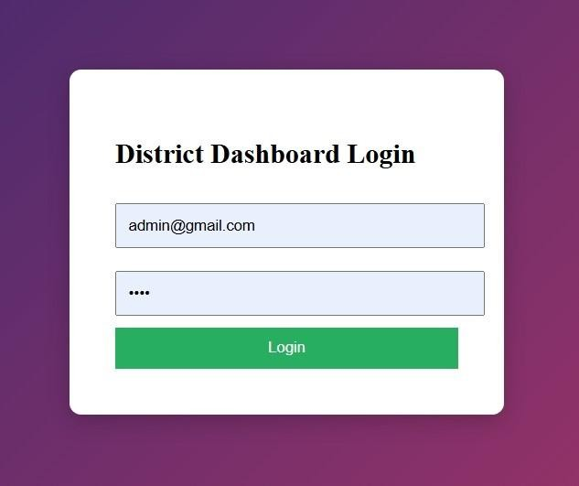

- Project Progress Dashboard Output:

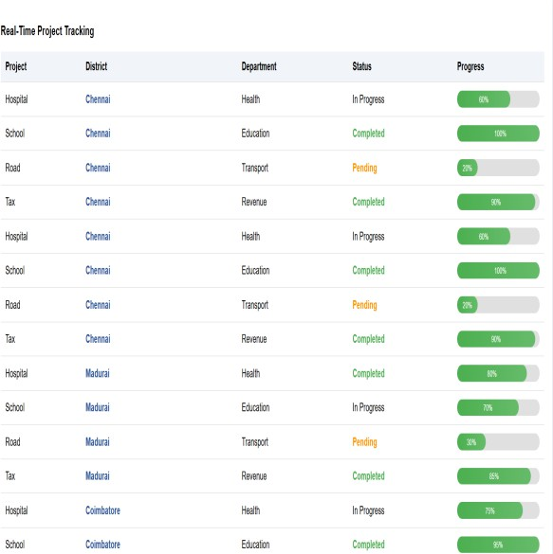

- Department Work Progress Charts output:

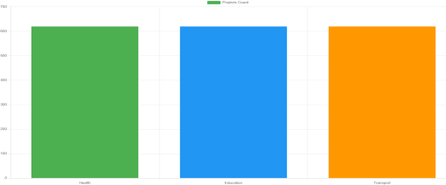
- District Analytics output:

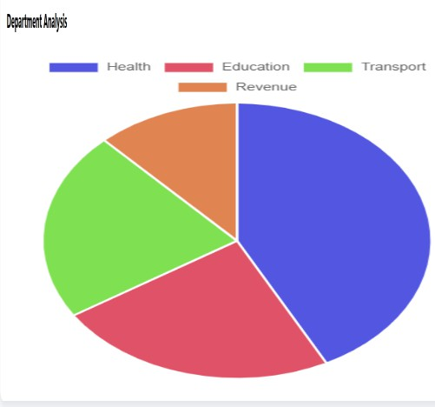
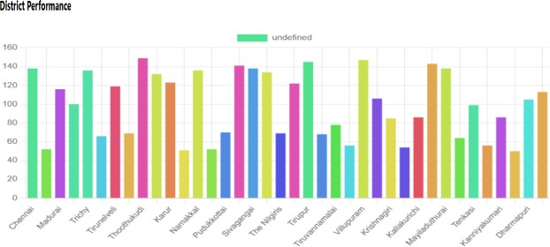
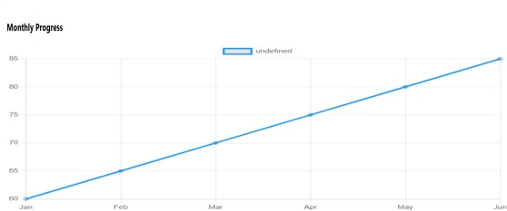

- AI Chatbot Intraction Output:
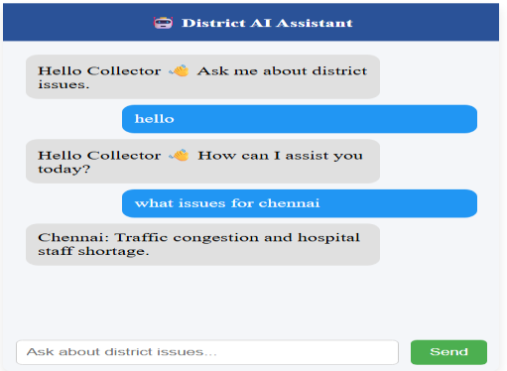

- Result Analysis:
The developed system was analyzed to evaluate its effectiveness in improving district-level administrative monitoring. The analysis focuses on system performance, data handling efficiency, and usability from an administrative perspective. The centralized dashboard successfully integrates data from multiple departments into a single

platform, eliminating the need for manual consolidation of reports. This significantly reduces time delays and minimizes inconsistencies commonly observed in traditional systems. The real-time data update mechanism ensures that the latest project information is always available to administrators, enabling quicker and more accurate decision-making. From a performance standpoint, the system efficiently handles data retrieval and updates through optimized backend processing using Flask and MySQL. The response time for fetching and displaying project data remains minimal, even when handling multiple departmental records. This ensures smooth interaction between the user interface and the database without noticeable delays.
The visualization component of the system enhances usability by presenting complex data in a simplified format. Through the use of progress indicators, tables, and structured layouts, administrators can easily interpret the status of projects across districts and departments. This reduces cognitive load and improves monitoring efficiency. Additionally, the system improves transparency and accountability by clearly displaying project statuses such as pending, in progress, and completed. This allows authorities to identify delays and take corrective actions promptly. Compared to traditional methods, the proposed system provides a more structured, reliable, and scalable solution for governance monitoring. Overall, the analysis indicates that the proposed dashboard effectively addresses the limitations of existing systems by providing centralized access, real-time updates, and enhanced visualization, thereby improving administrative efficiency and decision-making processes.

- Comparison with Existing System:
The existing approach used in district-level administration primarily relies on manual data collection and decentralized reporting mechanisms. Each department maintains its own records, often using spreadsheets or paper-based documentation. As a result, data is scattered across multiple sources, making it difficult to obtain a unified view of overall progress. Additionally, updates are not provided in real time, leading to delays in identifying issues and taking corrective actions. In contrast, the proposed system introduces a centralized dashboard that integrates data from all departments into a single platform. This eliminates the need for manual consolidation and ensures that all information is accessible in one place. The system provides real-time updates, allowing administrators to monitor project progress instantly and respond to delays without waiting for periodic reports.
Another key difference lies in data visualization. Traditional systems present data in textual or tabular formats, which require additional effort to interpret. The proposed system enhances usability by presenting information through structured tables, progress indicators, and intuitive layouts, enabling a quick understanding of project status. Furthermore, the proposed system improves transparency and accountability by clearly displaying the status of each project, such as pending, in progress, or completed. This allows administrators to track responsibilities and identify bottlenecks efficiently. The centralized nature of the system
also improves coordination among departments, which is often lacking in existing methods. Overall, the proposed system provides a more efficient, reliable, and scalable solution compared to existing approaches by enabling centralized monitoring, real-time data updates, and improved visualization of administrative activities.
- Advantages:
The proposed centralized governance dashboard offers several advantages over traditional administrative methods by improving efficiency, transparency, and data accessibility in district-level operations. The system provides a unified platform where data from multiple departments is consolidated into a single dashboard. This eliminates the need to collect and verify information from different sources, thereby reducing administrative effort and minimizing inconsistencies. As all departmental data is stored centrally, administrators can access the required information instantly without depending on individual departments.

Another major advantage of the system is its ability to provide real-time updates. Unlike conventional methods that rely on periodic reporting, the proposed system reflects changes immediately after data entry. This enables authorities to continuously monitor project progress and take timely corrective actions when delays or issues are identified. The system also enhances transparency and accountability in governance. By clearly displaying the status of each project along with progress indicators, it becomes easier to track responsibilities and ensure that departments adhere to timelines. This visibility helps improve overall performance and reduces the chances of data manipulation or reporting delays. In addition, the dashboard interface improves usability by presenting information in a structured and easily understandable format. The use of progress bars, status labels, and organized tables reduces the complexity of data interpretation and allows administrators to quickly analyze system performance without requiring technical expertise.
Furthermore, the modular design of the system makes it scalable and adaptable. New departments, additional data fields, or advanced analytical features can be integrated into the system without affecting existing functionality. This ensures that the system can evolve with changing administrative requirements. Overall, the proposed system significantly improves operational efficiency, reduces manual workload, and supports effective decision-making through centralized, real-time data monitoring.

- Future Work:

The proposed system can be further enhanced by integrating advanced features such as mobile application support for remote access by field officers. Future improvements may include the use of artificial intelligence for predictive analysis of project delays and performance trends. Integration with government databases and APIs can also be implemented to automate data collection and reduce manual input. Additionally, incorporating alert systems and notifications can help administrators respond more quickly to critical issues.

XIII. Conclusion:
The developed system successfully provides a centralized platform for monitoring district-level administrative activities. It enables real-time tracking of departmental work progress and improves transparency and efficiency in governance. By reducing manual processes and providing structured data visualization, the system supports better decision-making. Overall, the proposed solution offers an effective and scalable approach to modernizing district administration.

References

- Q. Zou, Z. Mao, R. Yan, S. Liu, and Z. Duan, “Vision and reality of e-government for governance improvement: Evidence from global cross-country panel data,” Technological Forecasting and Social Change, vol. 193, 2023, Art. no. 122667.

- A. Odeshina, O. Reis, F. Okpeke, V. Attipoe, O. Orieno, and A. Pub, “Business intelligence dashboard optimization model for real-time performance tracking and forecasting accuracy,” International Journal of Social Science Exceptional Research, vol. 3, pp. 334–342, 2024.

- B. Payne, L. O. Ling, and A. Gorod, “Towards a governance dashboard for smart cities initiatives: A system of systems approach,” in Proc. 2020 IEEE 15th International Conference on System of Systems Engineering (SoSE), 2020, pp. 587–592.

- S. Priyadharshini, P. Ajith, R. Dharani, C. Brindha, B. Mohanapriya, and S. Dharaneesh, “Centralized Dashboard for District Administration to Monitor and Track,” in Proc. 2025 IEEE International Conference on Communication Networks and Computing (CNC), 2025, pp. 413–418.

- I. O. Adam, “Examining E-government development effects on corruption in Africa: The mediating effects of ICT development and institutional quality,” Technology in Society, vol. 61, Art. no. 101245, 2020. doi: 10.1016/j.techsoc.2020.101245.

- M. J. Ahn and S. Bretschneider, “Politics of E-government: E-government and the political control of bureaucracy,” Public Administration Review, vol. 71, no. 3, pp. 414–424, 2011. doi: 10.1111/j.1540-6210.2011.02225.x.

- T. S. Amosun, J. Chu, O. H. Rufai, S. Muhideen, R. Shahani, and M.
K. Gonlepa, “Does e-government help shape citizens’ engagement during the COVID-19 crisis? A study of mediational effects of how citizens perceive the government,” Online Information Review, 2021. doi: 10.1108/OIR-10-2020-0478.

- G. O. Achumie, O. A. Bakare, and N. I. Okeke, “Post-project financial auditing as a continuous improvement tool for SMEs,” 2024.

- A. H. Adepoju, A. Eweje, A. Collins, and B. Austin-Gabriel, “Automated offer creation pipelines: An innovative approach to
improving publishing timelines in digital media platforms,” International Journal of Multidisciplinary Research and Growth Evaluation, vol. 5, no. 6, pp. 1475–1489, 2024.

- A. H. Adepoju, A. Eweje, A. Collins, and B. Austin-Gabriel, “Framework for migrating legacy systems to next generation data architectures while ensuring seamless integration and scalability,” International Journal of Multidisciplinary Research and Growth Evaluation, vol. 5, no. 6, pp. 1462–1474, 2024.

- J. Gandhi, B. Sauser, and A. Gorod, “A case study: The New York City yellow cab System of Systems,” presented at the 2011 6th International Conference on System of Systems Engineering, Albuquerque, NM, USA, Jun. 30, 2011.

- M. Luciano, “Top 10 Smartest Cities in the World,” DesignWorld.[Online].Available:https://www.designworldonline.co m/top-10-smartest-cities-in-the-world/

- E. Woods, “Data analytics: The key to delivering smart cities,” Navigant. [Online]. Available: https://www.smart-energy.com/magazine-article/data-analytics-the-key-to-delivering-smart-cities/

- A. Sharma and S. Kumar, “E-Governance and Public Administration: A review of information systems in government,” Journal of Public Administration Research, vol. 55, no. 2, pp. 128–135, 2019.

- R. Patel and P. Desai, “Developing real-time administrative dashboards for smart governance,” Journal of Governance Technology, vol. 37, no. 4, pp. 220–235, 2020.

- H. Lee and T. Choi, “Performance analysis of real-time government data visualization systems,” Journal of Data Analytics, vol. 23, no. 6,
pp. 95–110, 2018.

- A. Kumar and R. Singh, "Design of a Web-Based Governance Dashboard for Administrative Monitoring," International Journal of Advanced Computer Applications, vol. 12, no. 4, pp. 45–52, 2022.

- S. Mehta and P. Sharma, "Real-Time Data Monitoring Systems Using Web Technologies," in Proceedings of the International Conference on Smart Computing and Informatics, pp. 210–215, 2021.

- R. Verma and K. Patel, "Centralized Information Systems for Government Applications," Journal of E-Governance Systems, vol. 8, no. 2,
pp. 78–85, 2023.

- M. Rao and S. Reddy, "Web-Based Dashboard Design for Data Visualization and Decision Support," International Journal of Computer Science and Engineering, vol. 10, no. 6, pp. 112–118, 2022.

- T. Joseph and A. Mathew, "Implementation of Real-Time Monitoring Systems Using Flask and MySQL," in Proceedings of the International Conference on Emerging Technologies in Computing, pp. 95–100, 2023.

- Government of India, "Digital Governance and Administrative Monitoring Framework," Ministry of Electronics and Information Technology, Tech. Rep., 2022..

