Predictive Analytics for Disease Risk Assessment Using Machine Learning

Abstract
Data science is the newest technological breakthrough in the fourth industrial revolution, which is currently underway due to the widespread use of machine learning. As time goes on, it gets harder to use conventional methods to examine voluminous amount of data. As a result, machine learning has emerged to mimic human learning and increase accuracy. Even in the medical sciences, data interpretation is used to create new, optimal models combined with AI, machine learning, and data engineering to improve the performance of the models . These techniques are supposed to work well in the current paper where we have vast amounts of data, or "Big Data," and little or no past experience with data. The goal of machine learning models is to use datasets related to a certain disease to construct a network model for disease prediction. The main goal of this work is to anticipate and analyze symptoms in COVID-19 patients using two non-parametric algorithms: random forests and decision trees where observed accuracy of foremost is 95% and that of latter is 94%. These algorithms will undoubtedly verify the degree of accuracy that the machine learning model predicts. The wisdom of the crowd, which states that a group of results yields better and optimal solutions than each individual result so, is the foundation of the random forest algorithm. Decision trees, on the other hand, create predictions about each and every data point.
Keywords: Machine learning, Decision tree, Random forest, Fatal disease, COVID-19.

Introduction
Pathogens of all kinds have been discovered in the contemporary era, and they mostly contribute to vectorborne and zoonotic infectious agents that have steadily put human existence in grave danger and sparked a lethal outbreak that has raised concerns for the public and the entire world. These days, the phrase "Emerging Infectious Disease" is used to highlight the past occurrence of diseases, known or unknown, that have the potential to trigger significant global outbreaks [1]. Furthermore, a WHO report states that these newly emerging zoonotic diseases, which are caused by pathogens, are already present in the environment and did not cause any harm in the beginning. However, over time, they became unmanageable and detrimental, giving rise to a new host species that is unidentified and contagious [2][23][27].
The formation of novel infectious illnesses is caused by a number of important causes, the most prominent of which are changes in human demography and behavior, environmental factors such as temperature and ecological change, and abrupt increases in human and animal movement [3][24][28].
The research primarily focuses on the advent of RNA bacteria like corona virus and severe respiratory syndrome in this noteworthy case, "Prediction of fatal diseases using machine learning." CoV-2 SARS[4]. The disease known as COVID-19 is highly contagious and was first identified in Wuhan, China in December 2019. The World Health Organization (WHO) proclaimed the outbreak to be a pandemic on January 30, 2020, raising concerns among the majority of the people at the time. Normal temperature, cough, respiratory illness, loss of taste and smell, and other symptoms are associated with the corona virus. About 80% of patients recover without any care or access to medical facilities, but symptoms typically appear one to fourteen days after virus exposure [5].Only 5% of patients experience catastrophic symptoms including multi organ failure and respiratory failure, while 14% of patients experience severe symptoms like dyspnea and hypoxia [6][29]. Individuals in the 65–80 age range are most susceptible to the severe symptoms. Numerous long-term side effects and months of recuperation are experienced by a wide variety of patients [7][30]. Various symptons of Covid-19 are depicted in Table 1.

Table 1: Symptoms of Covid-19 [4][8][9]
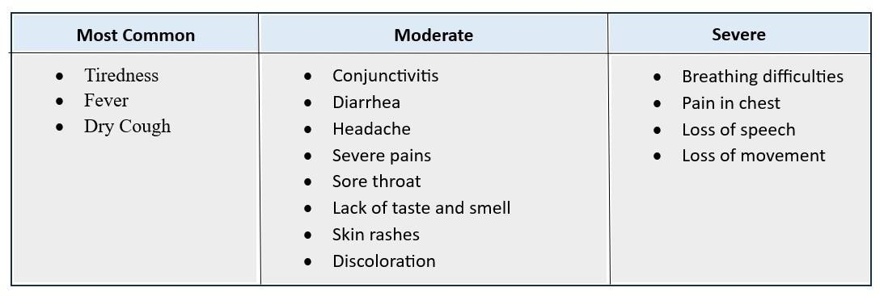

Objective
The primary goal is to develop a machine learning model that will evaluate the medical history, current symptoms, and status of Covid-19 patients in order to determine whether or not they are at high risk of contracting the virus [10][25].This will undoubtedly forecast the future results for individuals who are highly susceptible to contracting a virus or who fail to consider the full range of their symptoms. In order to prevent these kinds of infections, automatic detection methods are necessary because hospitals have very few test kits accessible. In the fight against such a terrible disaster, artificial intelligence is crucial [11][21][26].
This work uses the COVID-19 dataset, which includes a large number of dangerous diseases, to provide a model for disease prediction. Machine learning techniques can then be applied to any other deadly, common illnesses. Additionally, two non-parametric algorithms that aid in enhancing the ultimate quality of the data and aid in future prediction are explained.

In this paper, out of many fatal diseases, COVID-19 dataset is taken to set an example for predicting diseases and can be used for any other deadly widespread ailments using machine learning algorithms. Also, two non-parametric algorithms are explained that assists in making the data of more supreme quality which helps in predicting the future.
2.1 Random Forest Classifier – Random forest is based on ensemble learning where combining the results give better optimum results than the individual result. It relies on multiple decision trees and makes results on the basis of predictions we made in our progress [14].
2.2 Decision Tree Classifier- Decision Tree is basically used for data analysis and machine learning which is depicted by a flow-chart structure having internal nodes which specifically represents ‘test’ which gives outcome of the classification [15].
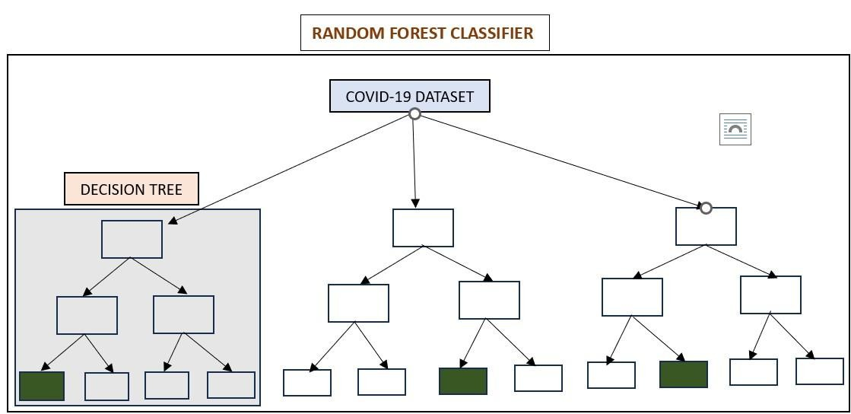
Figure 1: Random Forest and Decision Tree Classifier

Literature Review
Table 2: Paper published year, Author, Topic, Dataset, Evaluation and Contribution
Year | Author | Topic | Dataset | Evaluation | Contribution
2019  [12] | J. A.  Sidey-  Gibbons and C.  J.  SideyGibbons | Machine  Learning in  Medicine: a  practical introduction | Three predictive models for cancer diagnosis | The algorithms which were trained were able to distinguish cell nuclei with high accuracy(.94-.96) | This paper provides a pragmatic examples using supervised ML techniques to derive classification from a dataset containing multiple inputs. Finally, introduced ANN. The dataset used in this work is the breast  cancerWisconsin diagnostic dataset using R language.
2019  [23] | M. Soni and S. Varma | Diabetes prediction using machine learning techniques | Two diabetes datasets for prediction of various factors | Outof various algorithms used logistic regression gave the highest accuracy of 96%. | In this paper, diabetes prediction model is used for classification of diabetes that include factors like glucose, BMI, age and insulin.
2020  [10] | K. B.  Prakash,  S. S.  Imambi,  M. Ismail,  T. P.  Kumar, and Y.  N. Pawan | Analysis, Prediction and evaluation of COVID-19  datasets using  Machine  Learning | Two  COVID-  19 datasets for  building  ML models | Various algorithms were used to  predict the  accuracy of covid19 disease with highest accuracy of  SVM  classifier(.96667) | Machine Learning  techniques, which can selflearn from data by using COVID-19 dataset.
2020  [24] | M. Alazab,  A.  Awajan, A. Mesleh, and  S.  Alhyari | COVID-19  prediction  and  detection using deep learning | Chest  XRays are used to examine the disease. | The prediction evaluation gave accuracy of 94.80%  in  Australia and that of  Japan is 88.43% | This paper significantly studies about identification of most infected cities where coastal regions are more affected than that of noncoastal regions.
2020  [20] | B. A. Jnr | Use of  Telemedicine and Virtual care for Remote Treatment in  response to  COVID-19  Pandemic | Literature review |  | In this paper, the relevant studies are retrieved from well-organized scientific databases and digital libraries selected and had been observed that China has been able to control and manage the COVID-  19 by using telemedicine.
2020  [25] | R. Sadik,  M. L.  Reza, A.  Al  Noman, S.  Al Mamun, M. S.  Kaiser, | Covid-19 pandemic: a comparative prediction using machine learning | The  dataset used is about reported dengue cases and also  the  rainfall in | The accuracy predicted was about 86.84% which is better than neural network model whose accuracy was  65.58%. | This paper represents predictive analysis of Covid-19 in Bangladesh with the help of comparative studies based on Machine Learning.
 | and M. A. Rahman |  | five districts.
2020  [7] | D.  Calandra  and M.  Favareto | Artificial  Intelligence to fight COVID-19 outbreak impact an overview | Overview |  | This paper provides indepth analysis of international best practices for tracking contact and social distance applications.
2021  [21] | D. Painuli, D. Mishra,  S.  Bhardwaj,  and M.  Aggarwal | Forecast and prediction of COVID-19 using  machine learning. | Covid-19 dataset is  used for building future  forecasting cased with the help of  machine learning | Two classifiers, random forest and extra tree  classifiers are selected with accuracy more than 90% and that of extra tree classifier is  93.62%. | This paper gives the information about the methods for forecasting future cases based on the pre-existing data.
2021  [22] | K.  Chadaga, S.  Prabhu, S.  Umakanth,  K. Bhat,  N. Sampathil a, and R. Chadaga | "COVID-19  mortality prediction among  patients using epidemiological parameters: an ensemble machine learning approach" | The dataset which is used gives details of both positive and negative Covid-19 cases from Mexico. | Extreme Gradient Booster gave the highest accuracy with 96% among all algorithms. | This research paper goals at finding the important predictive parameters that are used to find the patients who are at highest risk of death taking into account their overall health and symptoms.
2022  [14] | J. Kaur H. Kaur and | Literature review on nonparametric algorithms on  Big Data | Literature  Review |  | This paper delineates how huge amount of unstructured data can be analyzed with the use of two non-parametric algorithms of machine learning.

Implementation

About Dataset
The Mexican government provides the dataset that will be used, which is obtained via Kaggle[16]. Numerous patient records, including pre-conditions, are included in this dataset. It is estimated that there are 21 unique traits and 1,048,576 unique patients in the pre-existing dataset[17]. Taking into account the patient's symptoms, machine learning algorithms will precisely diagnose the illness ahead of time and notify the patient that they have a high chance of contracting the virus[18]. Pneumonia, diabetes, COVID19, asthma, hypertension, cardiovascular, chronic renal disease, and obesity are among the illnesses that are taken into account. Before the model produces correct findings, a number of other parameters are also closely monitored, including whether or not a patient is pregnant, intubated, admitted to an intensive care unit, and has any prior knowledge of tobacco use [20][22].

Observations and Result sets
- Various techniques which are used in Machine Learning are implemented to understand the demographics of this infectious and detrimental disease. Figure 2 depicts the distribution of COVID-19 with respect to the Age group. It is clearly noticeable that age group between 36 to 50 shows most signs of having the disease in near future and also are most vulnerable to the infections in the environment and surroundings whereas, the least signs are shown by the age group 0 to 7 with only 2.2%.

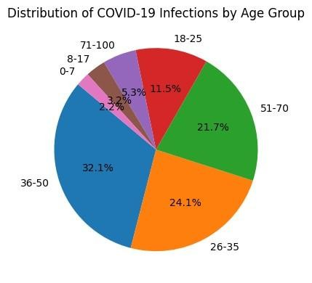
Figure 2: Percentage of Covid-19 Infections by Age Group
- Further analysis shows the correlation matrices between the diseases and the data perceived. Figure 3 heat map shows that Darker colours indicate negative correlation whereas, lighter colours indicate positive correlation. -0.98 represents highest negative correlation while 1 represents highest positive correlation. This correlation is used to pairwise compute the correlation of columns of data and returns correlation matrix which represents correlation coefficients between columns.

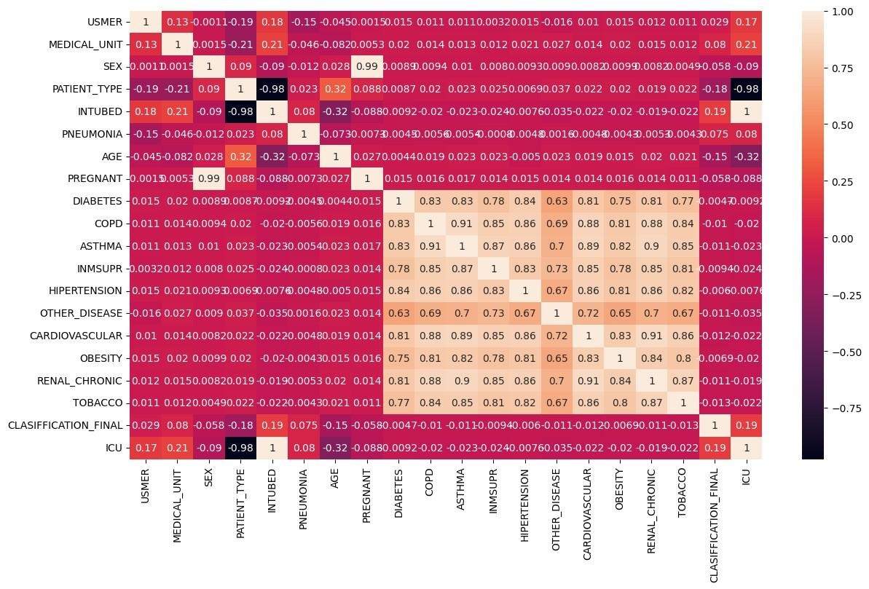
Figure 3: Heat Map

- On further observations, analysis on Mortality rate was done. Figure 4, clearly depicts that obesity patients are more likely to die due to COVID-19 as compared to the non-obese once and in Figure 5, one more analysis was done based on the gender which clearly stated that Male patients have more mortality rate than that of Females.

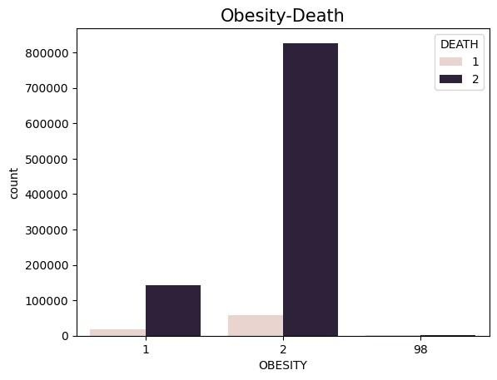
Figure 4: Obese Patients are more likely to Die due to COVID-19

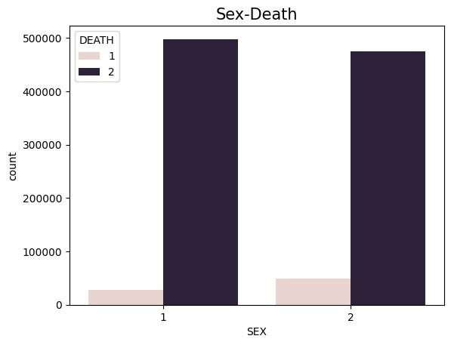
Figure 5: Male Patients are more likely to die due to COVID-19

- Upon analyzing and cleaning the data which had null values and Outliers, classification was done based on the data subjected to testing. In this paper, Machine Learning models based on the algorithms like Random Forest and Decision Tree are built using this dataset. The output of both the algorithms is written as follows:

Decision Tree Classifier
The decision tree classifier is a machine learning algorithm which is used for both regression and classification tasks. This model basically predicts the target variable inferring from the input features by simple decision rules and techniques.
It calculates accuracy, confusion matrix and the classification report and the result for COVID-19 dataset is given as follows:

Accuracy- 0.9503890623506959
Confusion Matrix- [[187545 6211]
[12999 180458]]

Classification report for the Decision trees is depicted in table 3.

Table 3: Decision Tree Classification report
 | Precision | Recall | F1-score | Support
1 | 0.94 | 0.97 | 0.95 | 193756
2 | 0.97 | 0.93 | 0.95 | 193457
accuracy |  |  | 0.95 | 387213
Macro avg | 0.95 | 0.95 | 0.95 | 387213
Weighted avg | 0.95 | 0.95 | 0.95 | 387213

Random Forest Classifier

Random Forest Classifier uses ensemble machine learning techniques and algorithms that joins multiple decision trees to make predictions and analysis. This algorithm is known for handling complex data and robustness.
It calculates accuracy, confusion matrix and the classification report and the result for COVID-19 dataset is given as follows:

Accuracy- 0.9413397793979025
Confusion Matrix- [[185474 8282]
[ 14432 179025]]

Classification report for the random forest algorithm is given in the table 4.

Table 4: Random Forest Classification report
 | Precision | Recall | F1-score | Support
1 | 0.93 | 0.96 | 0.94 | 193756
2 | 0.96 | 0.93 | 0.94 | 193457
accuracy |  |  | 0.94 | 387213
Macro avg | 0.94 | 0.94 | 0.94 | 387213
Weighted avg | 0.94 | 0.94 | 0.94 | 387213

Conclusion and Future work
Two machine learning models—random forest and decision tree classifiers—are used to predict above 90% of accuracy when predicting deadly diseases like Covid-19. The accuracy of the random forest classifier was almost 94% and a decision tree classifier provided accuracy of almost 95%. In the future work, more machine learning models will be considered in the medical field.

References
- C. R. Howard and N. F. Fletcher, "Emerging virus diseases: can we ever expect the unexpected?," Emerg. Microbes Infect., vol. 1, pp. 1–9, 2012.
- World Health Organization, "Report of the WHO/FAO/OIE joint consultation on emerging zoonotic diseases," World Health Organization, 2004.
- S. T. Nichol, J. Arikawa, and Y. Kawaoka, "Emerging viral diseases," Proc. Natl. Acad. Sci. USA, vol. 97, pp. 12411–12412, 2000. doi: 10.1073/pnas.210382297.
- R. Alfred and J. H. Obit, "The roles of machine learning methods in limiting the spread of deadly diseases: A systematic review," Heliyon, vol. 7, no. 6, 2021.
- World Health Organization, "What are the symptoms of COVID-19?," [Online]. Available:
https://www.who.int/emergencies/diseases/novelcoronavirus-2019/question-and-answers-
hub/qadetail/q-a-coronaviruses#:~:text=symptoms.
- T. W. Lew et al., "Acute respiratory distress syndrome in critically ill patients with severe acute respiratory syndrome," JAMA, vol. 290, pp. 374–380, 2003. [Online]. Available: https://doi.org/10.1001/jama.290.3.374
- D. Calandra and M. Favareto, "Artificial Intelligence to fight COVID-19 outbreak impact: an overview," European Journal of Social Impact and Circular Economy, vol. 1, no. 3, pp. 84-104, 2020
- Mollarasouli, F., Zare-Shehneh, N., & Ghaedi, M. (2022). A review on corona virus disease 2019 (COVID-19): current progress, clinical features and bioanalytical diagnostic methods. Microchimica Acta, 189(3), 103.
- Rajendran, D. K., Rajagopal, V., Alagumanian, S., Santhosh Kumar, T., Sathiya Prabhakaran, S. P., & Kasilingam, D. (2020). Systematic literature review on novel corona virus SARS-CoV-2: a threat to human era. Virusdisease, 31, 161-173.
- K. B. Prakash, S. S. Imambi, M. Ismail, T. P. Kumar, and Y. N. Pawan, "Analysis, prediction and evaluation of COVID-19 datasets using machine learning algorithms," International Journal, vol. 8, no. 5, pp. 2199-2204, 2020.
- A. Kopka and D. Fornahl, "Artificial intelligence and firm growth—catch-up processes of SMEs through integrating AI into their knowledge bases," Small Business Economics, vol. 62, no. 1, pp. 6385, 2024.
- J. A. Sidey-Gibbons and C. J. Sidey-Gibbons, "Machine learning in medicine: a practical introduction," BMC Medical Research Methodology, vol. 19, pp. 1-18, 2019.
- V. Štuikys and R. Burbaitė, "Introduction to Artificial Neural Networks and Machine Learning," in Evolution of STEM-Driven Computer Science Education: The Perspective of Big Concepts, pp. 311346, Cham, Springer Nature Switzerland, 2024.
- H. Kaur and J. Kaur, "Literature Review on Non-Parametric Algorithms in Big Data," in Proceedings of Two Days International Conference Sponsored by DST-SERB On ICRASRT, 2022.
- Q. Yu, "Performance assessment and fitness analysis of athletes using decision tree and data mining techniques," Soft Computing, vol. 28, no. 2, pp. 1055-1072, 2024.
- Gobierno de México, "Información referente a casos COVID-19 en México," Datos Abiertos México, [Online]. Available: https://datos.gob.mx/busca/dataset/informacion-referente-a-casoscovid-19-enmexico.
- https://www.kaggle.com/datasets/meirnizri/covid19-dataset/data
- D. D. Solomon, K. Sonia, K. Kumar, S. Iyer, and M. Kumar, "Extensive review on the role of machine learning for multifactorial genetic disorders prediction," Archives of Computational Methods in Engineering, vol. 31, no. 2, pp. 623-640, 2024.
- S. S. Morse, "Factors in the emergence of infectious diseases," in Plagues and Politics: Infectious Disease and International Policy, pp. 8-26, 2001.
- B. A. Jnr, "Use of telemedicine and virtual care for remote treatment in response to COVID-19 pandemic," Journal of Medical Systems, vol. 44, no. 7, p. 132, 2020.
- D. Painuli, D. Mishra, S. Bhardwaj, M. Aggarwal, “Forecast and prediction of COVID-19 using machine learning”. Data Science for COVID-19. 2021:381–97. doi: 10.1016/B978-0-12-824536-
1.00027-7. Epub 2021 May 21. PMCID: PMC8138040.
- K. Chadaga, S. Prabhu, S. Umakanth, K. Bhat, N. Sampathila, and R. Chadaga, "COVID-19 mortality prediction among patients using epidemiological parameters: an ensemble machine learning approach," Engineered Science, vol. 16, pp. 221-233, 2021.
- M. Soni and S. Varma, "Diabetes prediction using machine learning techniques," International Journal of Engineering Research & Technology (IJERT), vol. 9, no. 9, pp. 921-925, 2020.
- M. Alazab, A. Awajan, A. Mesleh, and S. Alhyari, "COVID-19 prediction and detection using deep learning," International Journal of Computer Information Systems and Industrial Management Applications, vol. 12, pp. 14-14, 2020.
- R. Sadik, M. L. Reza, A. Al Noman, S. Al Mamun, M. S. Kaiser, and M. A. Rahman, "Covid-19 pandemic: a comparative prediction using machine learning," International Journal of Automation, Artificial Intelligence and Machine Learning, vol. 1, no. 1, pp. 1-16, 2020.
- Ahmad, Z., Rahim, S., Zubair, M., & Abdul-Ghafar, J. (2023). Artificial Intelligence in Healthcare: Applications of Machine Learning for Disease Prediction. Healthcare Analytics, 3, 100120.
- Topol, E. J. (2023). High-Performance Medicine: The Convergence of Human and Artificial Intelligence. Nature Medicine, 29(1), 44–56.
- Zhang, Y., Wang, J., & Li, H. (2024). Explainable Artificial Intelligence for Clinical Decision Support Systems. Artificial Intelligence in Medicine, 146, 102673.
- Kumar, P., Sharma, R., & Singh, A. (2024). Ensemble Learning Techniques for Medical Diagnosis: A Comparative Study. Journal of Healthcare Engineering, 2024.
- World Health Organization. Global Health Statistics Report. WHO, 2024.

