The Role of Artificial Intelligence in Modernizing Academic Library Services
¹Mrs. Prangya Prachi Samantaray, Ph.D. scholar of CSE Department (Vikrant University,Gwalior)
²Dr. Sanmati Jain, Associate Prof. CSE Department (Vikrant University)
³Dr. Arati Pradhan, Assistant professor of Computer Science Department, Udayanath Autonomous college of Science and Technology, Odisha, India
¹prangyaprachi1996@gmail.com,² sanmati@vitmindore.com,³ aratipradhancompsc@gmail.com
Abstract:
Artificial Intelligence (AI) has been identified as a revolutionary technology that has the potential to improve the efficiency and effectiveness of academic library services. This paper examines the use of AI in the modernization of academic libraries by incorporating intelligent systems such as chatbots, recommendation systems, automated cataloguing, and data analytics. These technologies help in the optimization of information retrieval, personalized user services, and automating the routine tasks of the library. The paper discusses how AI-based systems can help librarians in handling massive digital information while allowing them to concentrate on advanced research support services. The results of this paper indicate that the efficient use of AI can help in the transformation of conventional libraries into intelligent knowledge repositories to cater to the changing demands of researchers, students, and academic organizations.
Keywords: Artificial Intelligence, Academic Libraries, Digital Libraries, Library Automation, Smart Libraries, Information Retrieval
1.Introduction:
The academic libraries have been considered to be the core centers of knowledge storage, research, and information dissemination. However, with the rapid development of digital information and technology, academic libraries face new challenges in managing vast amounts of information. In this regard, academic libraries have started to use advanced technology, especially Artificial Intelligence, to update their services and operations. Artificial Intelligence can be defined as the development of computer systems that can perform tasks that require human intelligence, i.e., learning, problem-solving, language understanding, and decision-making. In the case of academic libraries, the use of Artificial Intelligence can update their services and operations. Academic libraries can update their services and operations by integrating Artificial Intelligence tools into their management systems.[5]Artificial intelligence (AI) is one of the latest digital transformations (DT) technological trends the university library can use to provide library users with alternative educational services. AI can foster intelligent decisions for retrieving and sharing information for learning and research. However, extant literature confirms a low adoption rate by the university libraries in using AI to provide innovative alternative services, as this is missing in their strategic plan.
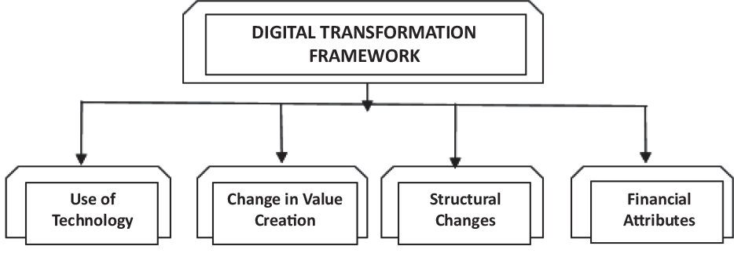
[5] Fig:1 Digital Transformation Framework
Fig:1 shows conceptual Digital Transformation Framework that outlines the key dimensions involved in the transformation of contemporary organizations, including academic libraries. The framework outlines four key elements that are critical to the success of digital transformation: the role of technology, the role of value creation, structural transformation, and financial dimensions. The role of technology involves the application of cutting-edge technology such as artificial intelligence, cloud technology, data analytics, and automation technology to improve efficiency and effectiveness in service delivery; in academic libraries, this would include AI-powered search engines, digital repositories, and automated cataloguing systems. The role of value creation involves the shift from traditional service delivery models to more innovative and user-centric models, where the library transforms from a physical repository of information to a digital knowledge service provider. Structural changes involve changes in structure, workflow, and skills, which often create new positions such as digital librarians, data specialists, and IT professionals who manage complex information systems. Financial attributes focus on the economic aspects of digital transformation, such as investments in digital infrastructure, cost optimization through automation, and sustainability of technology-driven services. In conclusion, this framework highlights that digital transformation is not just about adopting technology but involves various aspects such as service value, structure, and financial aspects in order to improve service delivery and user experience.
2. Literature Review:
The use of Artificial Intelligence (AI) in academic libraries has gained momentum in recent years. Research studies have shown that the use of AI technologies significantly improves information accessibility. Babayi et al. (2025) [1] presented the prospects and challenges of AI in library services, underlining its ability to improve service efficiency and user satisfaction. Similarly, Lakho et al. (2025) [2] investigated the modernization of library services using AI in Pakistan and concluded that AI tools facilitate digital transformation and enhance information retrieval systems. Ogungbenro et al. (2025) [3] presented the effect of AI on cataloging and information accessibility in Nigerian academic libraries, proving the efficiency of AI in improved metadata management and search results. Barsha and Munshi (2024) [4] presented a review on AI adoption in developing nations, underlining opportunities as well as challenges. Okunlaya et al. (2022) [5] have proposed an AI conceptual framework for digital transformation in university libraries. In addition, Jha (2023) [6] and Suganth (2022) [7] have discussed the applications and future of AI, whereas Echedom and Okuonghae (2021) [10] have examined the opportunities and challenges of AI adoption in African academic libraries.
The literature reviewed suggests that the application of Artificial Intelligence (AI) is an important factor in the current transformation of academic library services. The authors discuss that AI technologies are used to improve information retrieval, cataloging, and user service systems, making library services more efficient and easily accessible. Many authors discuss the advantages of AI tools like chatbots, automated cataloging, and intelligent recommendation systems, which improve user experience and research support services. Moreover, AI is also helping in the digital transformation of libraries by facilitating smart information management and personalized services. However, the literature also discusses many challenges faced in the application of AI, including high costs of implementation, lack of technical knowledge, and infrastructural constraints, especially in developing nations. In summary, the current literature suggests that although AI has vast potential for transforming academic libraries and improving knowledge access, its successful implementation requires appropriate technological infrastructure, technical knowledge, and organizational support. While the previous studies have emphasized the potential of AI in enhancing the services of libraries, many educational institutions are still struggling to implement these technologies because of their limited financial resources, lack of technical knowledge, and poor information technology infrastructure. Hence, there is a need for further research in this area.
3. Need for Artificial Intelligence in Academic Libraries:
The integration of AI in academic libraries serves as a transformative force that addresses various challenges such as resource constraints, improves information retrieval, streamlines knowledge organisation, personalises user services and enhances resource management, thereby significantly improving library services. The diverse capabilities of AI, ranging from natural language processing to classifying books to enriching metadata, are redefining traditional library operations.
Artificial Intelligence (AI) has emerged as a significant factor in contemporary libraries because of the exponential rise in digital information and the evolving needs of library users. Libraries are dealing with massive digital collections of e-books, journals, research articles, and multimedia content, and AI tools help in organizing, analyzing, and extracting this information more efficiently (Jha, 2023 [6]; Suganth, 2022 [7]).
One of the most significant requirements of AI in libraries is the need to enhance information retrieval systems. AI-powered search engines employ methods like natural language processing to better comprehend user queries and yield more precise search results (Cox & Mazumdar, 2022 [8]). AI also facilitates automated cataloging and classification, which minimizes manual effort and enhances the management of library resources (Ogungbenro et al., 2025 [3]).
In addition, AI is important in improving user services. AI chatbots and virtual assistants will offer support services to users by answering their questions and assisting them in finding information (Babayi et al., 2025 [1]; Lakho et al., 2025 [2]). Finally, AI is important in digital transformation and smart library services. AI will assist libraries in providing innovative knowledge services (Okunlaya et al., 2022 [5]; Barsha & Munshi, 2024 [4]; Echedom & Okuonghae, 2021 [10]).
[12] Traditional libraries require several manual steps for borrowing books, such as searching for materials, visiting the circulation desk, verifying identification, and completing the borrowing process. In many cases, readers may find that the required books are already borrowed or located in another branch, which increases the time and effort required to access resources. With the development of Smart Libraries, technologies such as Artificial Intelligence (AI) and the Internet of Things (IoT) have significantly improved library services. Users can search, reserve, and schedule book borrowing through smart devices before visiting the library. AI systems analyze user data and circulation records to recommend the most suitable branch and optimal borrowing time. At the same time, IoT technologies such as Radio Frequency Identification (RFID) systems and Wi-Fi-based positioning help users quickly locate books within the library and complete borrowing through self-service machines. These technologies reduce human intervention, improve efficiency, and enhance user experience. Overall, AI and IoT enable libraries to provide smart services, improved sustainability, and enhanced security, creating a modern and user-centered information environment.
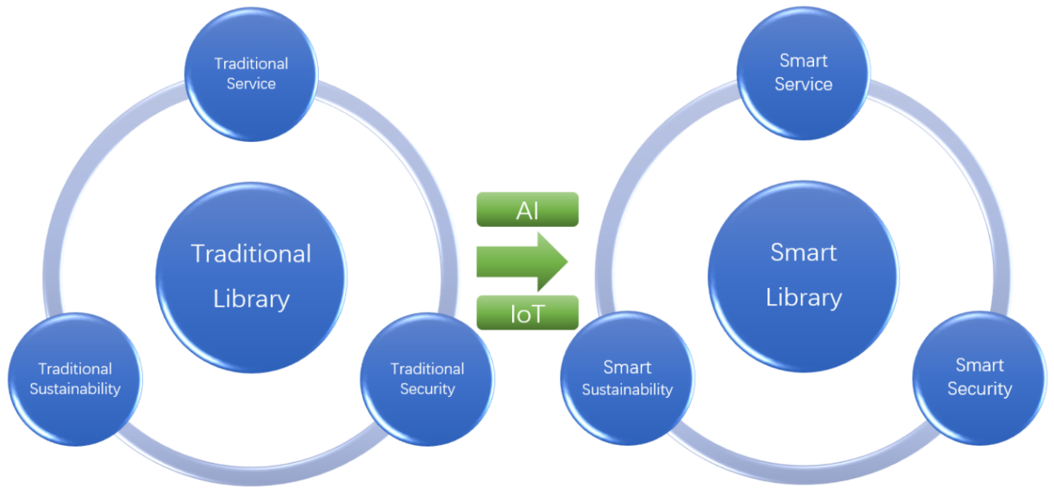
[12] Fig:2 Transition from Traditional to Smart Libraries Using AI and IoT

4. Applications and Benefits of AI in Libraries
Artificial Intelligence (AI) is a significant factor in enhancing library services and improving access to information resources. AI-based search engines have the ability to comprehend complex search queries and deliver more precise and relevant results, making it easier for users to search through massive digital collections (Cox & Mazumdar, 2022 [8]). AI-based algorithms also have the ability to analyze user behavior to provide personalized recommendations, which can introduce users to relevant books, journals, and research materials (Okunlaya et al., 2022 [5]; Suganth, 2022 [7]).

Moreover, AI also assists in automating mundane tasks such as cataloging, classification, and data processing, allowing library professionals to engage in more advanced and value-added tasks (Ogungbenro et al., 2025 [3]; Jha, 2023 [6]). AI-based chatbots and virtual reference services can also assist users continuously by responding to their queries and helping them access library resources (Babayi et al., 2025 [1]; Lakho et al., 2025 [2]).
Furthermore, AI technologies help in the preservation and conservation of library materials by examining images and identifying symptoms of deterioration (Barsha & Munshi, 2024 [4]). Nevertheless, it is important to note that the use of AI technologies in libraries entails a number of ethical issues such as data privacy and access to information resources (Echedom & Okuonghae, 2021 [10]).
5. Challenges of AI Adoption in Libraries
Table:1 presents the major challenges faced by libraries in adopting Artificial Intelligence technologies. Data quality issues are the most significant challenge, accounting for about 60% of the institutions, followed by privacy concerns and ethical issues. All these challenges point to the need for good data governance, enhanced privacy, and staff training for the effective implementation of AI systems in libraries.
[13] Table:1Challenges of AI Adoption in Libraries
Challenge | Percentage (%)
Data Quality Issues | 60%
Privacy Concerns | 55%
Ethical Considerations | 50%
Lack of Staff Training | 45%
High Implementation Costs | 40%
Artificial Intelligence (AI) offers immense opportunities for improving academic library services; but there are certain challenges that impede its widespread use. The first challenge is the high cost of implementation, which includes the cost of advanced infrastructure, specialized software, and system maintenance. Many libraries, especially in developing nations, are constrained by financial resources that make it difficult to implement such technologies. The second challenge is the absence of specialized technical knowledge among library personnel, who need to have knowledge in areas such as data analysis, machine learning, and digital system management. Ethical issues, such as data privacy, bias, and transparency in processing user data, also impede the adoption process. In addition, obsolescence of technological infrastructure and resistance to technological change among library personnel also impede the adoption process.
Conclusion:
Artificial Intelligence is revolutionizing academic libraries by upgrading their services and ensuring better access to knowledge resources. Technologies like intelligent search engines, chatbots, automated cataloging, and recommendation engines help libraries deliver services faster, more efficiently, and in a more personalized manner. Despite challenges like high costs of implementation, lack of technical know-how, and data protection issues, the long-term advantages of implementing AI in academic libraries are immense. With adequate investment in infrastructure and planning, academic libraries can be developed into intelligent knowledge centers to aid research, innovation, and e-learning in the new academic setting.Future studies can be conducted on how to leverage advanced AI tools like machine learning, predictive analytics, and intelligent digital assistants to further improve the services of academic libraries.
References:
- Babayi, B. U., Ahmed, H. M., Yahya, A. A., & Makintami, A. I. (2025). The Role of Artificial Intelligence in Providing Library Services: The Prospects and Challenges
- Lakho, G. A., Memon, S. G., Janat, F., & Iqbal, N. (2025). Exploring the Impact of Artificial Intelligence on the Modernization of Library Services in Pakistan. Research Journal for Social Affairs, 3(6), 981-990.
- Ogungbenro, O. D., Esse, U. C., Olowoporoku, I., & Christopher, A. (2025). Revolutionizing library services: The impact of artificial intelligence on cataloguing and access to information in Nigeria academic libraries. Journal of Library Metadata, 25(2), 99-118.
- Barsha, S., & Munshi, S. A. (2024). Implementing artificial intelligence in library services: A review of current prospects and challenges of developing countries. Library Hi Tech News, 41(1), 7-10.
- Okunlaya, R. O., Syed Abdullah, N., & Alias, R. A. (2022). Artificial intelligence (AI) library services innovative conceptual framework for the digital transformation of university education. Library hi tech, 40(6), 1869-1892.
- Jha, S. K. (2023). Application of artificial intelligence in libraries and information centers services: prospects and challenges. Library hi tech news, 40(7), 1-5.
- Suganth, M. S. (2022). Revolutionizing library services: The role of AI in shaping the future. International Research Journal of Education and Technology, 4(6), 254-260.
- Cox A.M.Mazumdar S.2022 "Defining artificial intelligence for librarians" Journal of Librarianship and Information Science 000111
- Owolabi K.Abayomi A. O.Aderibigbe N.Kemdi O.M.Oluwaseun O.A.Okorie C.2022 "Awareness and readiness of Nigerian polytechnic students towards adopting artificial intelligence in libraries" Journal of Information and Knowledge 5911524
- Echedom, A. U., & Okuonghae, O. (2021). Transforming academic library operations in Africa with artificial intelligence: Opportunities and challenges: A review paper. New Review of Academic Librarianship, 27(2), 243-255.
- Cardon, A. (2018). Beyond artificial intelligence: From human consciousness to artificial consciousness. London, UK: John Wiley & Sons.
- https://doi.org/10.3390/s22082991
- https://www.researchgate.net/publication/383157291_Artificial_Intelligence_in_Libraries_Benefits_Challenges_and_Ethical_Considerations

