FITDRIVE MANAGEMENT SYSTEM: A PYTHON-BASED

ABSTRACT
The FitDrive Management System is a desktop-based application developed in Python with SQLite database integration to efficiently manage gym member records. The system automates administrative tasks including adding, updating, deleting, and searching member information, significantly reducing the need for manual record-keeping. A reporting feature allows staff to view total registered members and estimated monthly revenue, improving data accessibility and organization. Input validation ensures that incomplete or invalid entries cannot be saved, enhancing accuracy. Through a structured database design and user-friendly interface, the system improves operational efficiency and minimizes errors in managing member information. The project demonstrates the practical application of Python programming, Object-Oriented Programming (OOP), and database management to create a functional management system for small to medium-sized gym facilities.
Keywords: Gym Management System, Python, SQLite, OOP, Membership Management, GUI, Database Integration
INTRODUCTION

1Background of the Study
Many gyms still rely on manual methods such as logbooks, paper records, and handwritten lists to manage member information and payments. These traditional methods often result in lost records, inaccurate data, delayed processing, and difficulties in organizing membership information. Handling a large number of members manually consumes significant staff time and effort.
With the advancement of technology, computerized management systems have become essential for improving operational efficiency and data management in gyms. A Python-based Gym Membership System with a database allows administrators to store, retrieve, and manage member records securely and efficiently.
The FitDrive Management System was developed to automate the management of gym membership records. Using Python, OOP principles, and SQLite database integration, the system allows administrators to perform member record operations, monitor payments, track attendance, and generate simple reports, significantly improving administrative workflow and accuracy.

Statement of the Problem
This study aims to answer the following questions:
- How can the system simplify the management of gym membership records?
- How can the system improve monitoring of member information, payments, and attendance?
- How can a GUI-based system improve record management efficiency compared to manual methods?
- How does database integration improve the storage and retrieval of membership data?
- How effective is the system in performing functions such as Add, View, Update, Delete, Clear, and Exit?

Objectives of the Study
General Objective:
To develop a functional FitDrive Management System that efficiently manages gym member records using Python programming and SQLite database integration.
Specific Objectives:
- Develop a computerized system for managing gym membership records efficiently.
- Store and organize member information securely in an SQLite database.
- Generate reports to monitor total members and monthly revenue.
- Reduce manual work and improve the accuracy and accessibility of gym records.
- Create a user-friendly GUI to make the system easier to operate.

Significance of the Study
- Gym Members: Faster processing, reduced errors, and easier access to membership information.
- Gym Staff and Owners: Reduced paperwork, efficient monitoring, and streamlined administrative tasks.
- Students and Developers: Practical experience in Python, OOP, and database management.
- Future Researchers: A reference model for developing similar small business management systems.

Scope and Limitations
Scope:
- Developed using Python and SQLite database integration.
- GUI-based system for managing gym member records.
- Includes Add, View, Update, Delete, Search, Generate Reports, and Clear functions.
- Displays total members and estimated monthly revenue.
Limitations:
- Designed for small-scale gyms.
- No online access or multi-user support.
- Lacks online payment processing and automated notifications.
- Does not support biometric attendance or advanced security features.

REVIEW OF RELEVANT THEORY, STUDIES, AND LITERATURE
This chapter presents the relevant theories, studies, and literature that form the foundation for the development of the FitDrive Management System, a Python-based gym membership management application. The review covers gym management systems, database integration, Object-Oriented Programming (OOP), graphical user interfaces (GUI), related studies, related systems, and technologies used in small business management systems.

Gym Management Systems
Gym management systems are digital platforms designed to streamline operations such as member registration, membership fee tracking, class scheduling, and reporting. Manual record-keeping in gyms often results in misplaced records, delayed processing, and administrative inefficiency. Automating these processes improves accuracy, reduces human error, and enhances the overall operational workflow (Smith & Jones, 2022).
Key features of gym management systems include:
- Membership registration and renewal
- Attendance tracking
- Billing and payment processing
- Class scheduling
- Reporting for revenue, membership statistics, and attendance
Studies show that gyms using computerized systems experience improved customer satisfaction, faster processing, and more accurate record management (Bhavani et al., 2025).

Database Integration
Databases are central to the reliability of management systems. SQLite is commonly used in small-scale applications because it is lightweight, file-based, and easy to integrate with Python. Database integration allows for:
- Persistent storage of member records
- CRUD (Create, Read, Update, Delete) operations
- Real-time updates of membership and payment status
- Generation of accurate reports for decision-making
Kumar and Singh (2021) emphasize that relational databases such as SQLite improve record consistency, data security, and accessibility in educational and small business management applications.
Pushpa et al. (2024) also highlighted the importance of good database design for robust data control and system reliability. In the fitness industry, such designs support smarter operations and improved productivity.

Object-Oriented Programming (OOP)
Object-Oriented Programming organizes code into classes and objects, promoting modularity, code reusability, and easier maintenance. In Python-based management systems:
- Classes represent entities like Member, Transaction, or GymClass
- Methods perform actions like adding new members, processing payments, or generating reports
- OOP improves system scalability and simplifies future updates or feature additions
Bhavani et al. (2025) found that OOP-based designs enhance functionality and reduce the complexity of software maintenance in small business applications.

Graphical User Interface (GUI)
GUI allows users to interact with the system through visual elements such as forms, buttons, and tables. Tkinter is a Python library commonly used for building desktop applications:
- Forms enable data entry for member registration and transactions
- Tables display real-time information on membership status, revenue, and attendance
- Buttons and menus facilitate navigation between system modules
Shneiderman et al. (2016) highlight that GUI-based applications improve usability, reduce training time, and enhance user satisfaction.

Related Studies
In creating a system, strict compliance with data organization, standardization, performance, and integrity is essential. Pushpa et al. (2024) emphasized that good database design is vital for reliable data control. In the fitness industry, Gym Management Systems (GMS) improve efficiency by automating tasks, enhancing accuracy, and providing actionable insights (Chokhandre et al., 2025). These studies align with the goal of this research to develop a more effective record-keeping system for gym memberships.

Related Systems
Previous studies analyzing gym management applications revealed limitations in cost, accessibility, and backend support. Kurashkin et al. (2022) reviewed systems such as GymBoom, GymApp Pro, iGym Pro, and Daily Strength, highlighting that foreign systems are often expensive and lack complete backend database functionality.
SQLite was chosen for the FitDrive system due to its simplicity, security, and adaptability. As an open-source engine, it allows modifications and supports desktop, mobile, and small web applications, ensuring the system meets project requirements effectively.

Related Technologies
SQL-driven systems provide fast, reliable, and adaptable performance for managing transactional data (Šušter & Ranisavljević, 2023). They enhance storage capacity, remove constraints, and ensure an efficient user experience.
Matcha and Mishra (2025) compared SQL and NoSQL databases, concluding that SQL is ideal for transactional applications, while NoSQL is better for flexible and large-scale data structures. For the FitDrive Management System, SQL databases are preferred to ensure accurate, reliable, and secure management of gym membership records and transactions.

Synthesis of the Study
The reviewed literature consistently highlights the need for automated, database-integrated, and GUI-based management systems to improve efficiency, accuracy, and usability.
- Pushpa et al. (2024) and Chokhandre et al. (2025) focused on database design and system efficiency.
- Kurashkin et al. (2022) analyzed existing gym applications and identified accessibility and backend limitations.
- Šušter & Ranisavljević (2023) and Matcha & Mishra (2025) emphasized the benefits of SQL for transactional data.
Drawing from these studies, the FitDrive Management System integrates Python, OOP, GUI, and SQL database design to address prior limitations. Input validation, record management, and reporting functionalities are implemented to ensure a robust, efficient, and reliable gym membership management system.
This study synthesizes prior research and applies best practices in database design, OOP programming, and GUI development to create a refined solution that improves membership operations, automates administrative tasks, and enhances operational efficiency.

METHODOLOGY

Research Design
This study utilized a Software Development Research approach under the Descriptive Research Design. The primary goal was to simplify and enhance the management of gym membership information through a computerized system. This approach allowed the researchers to design, develop, implement, and evaluate a functional system that addresses inefficiencies in manual processes, including errors in member record-keeping, attendance monitoring, and payment tracking.

System Development Process
The development of the Gym Membership System followed the Software Development Life Cycle (SDLC) to ensure efficiency, reliability, and high-quality results. The phases included:

Planning
During this phase, the researchers identified problems in the current manual system, such as misplaced member records, delayed attendance tracking, and difficulty monitoring payments. The objectives, scope, and limitations of the study were defined, and the specific functionalities needed for the system were determined through observation and consultation with gym staff.

Design
This phase focused on designing the system’s structure and appearance. Researchers created the system flowchart, GUI layout, and database design. The flowchart illustrated the sequential steps of the system, while the GUI layout ensured a user-friendly interface for both administrators and gym members.

Development
The system was developed using Python programming with Object-Oriented Programming (OOP) principles. This modular approach allowed for reusable code and easier maintenance. Core functionalities included:
- Member registration and login verification
- Payment processing
- Attendance monitoring
- Record management
- Report generation
The SQLite database was integrated to manage permanent storage of member information, attendance records, and payment details. GUI components were implemented using PyQt5 for efficient and intuitive user interaction.

Testing
Functional testing was performed to identify and correct errors or technical issues. All modules—including Add, View, Update, Delete, Search, Clear, and Exit functions—were tested. Input validation mechanisms ensured data integrity, preventing incomplete or duplicate entries. Testing also evaluated the accuracy of reports and system response to invalid inputs.

Implementation
After successful testing, the system was deployed for actual use. Gym administrators were provided with an orientation and user guidelines to ensure efficient adoption. The implementation phase included monitoring system use to verify that all modules were operational and meeting the intended objectives.

Maintenance
Continuous evaluation and updates were performed post-deployment to maintain system efficiency and reliability. Improvements were made as needed to correct errors, enhance functionality, and ensure that the system remains accurate, secure, and user-friendly.

System Flowchart / Design
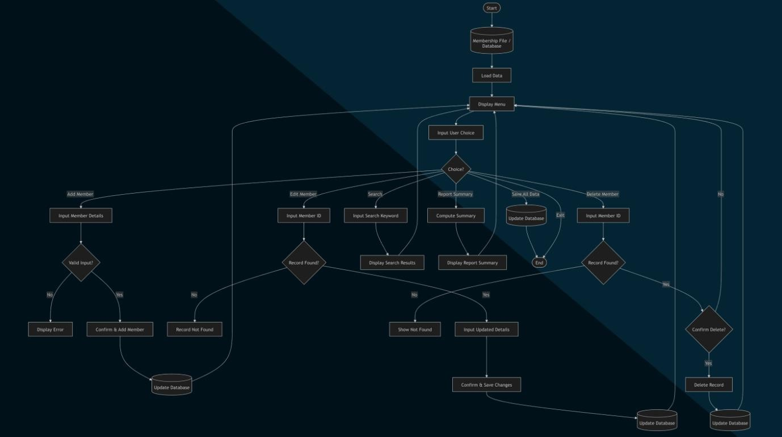

Figure 1. Overall System Flowchart
This flowchart describes the general process and the system design of the proposed Gym Membership System. It highlights the process flow, procedures, and decision-making processes involved in the system, its administrators, and the users. The process flow of the system begins when the administrator or the member logs into the system using their usernames and passwords. In this case, the system checks whether the entered login details are valid, and only after the validation does the user enter the system.
The system flow incorporates input validation and decision checks to prevent errors and ensure accurate database operations.

Tools and Technologies Used
Several tools and technologies were used in the development of the Gym Membership Management System in order to increase the success of the system. These include Visual Studio Code, Python, PyQt5, and SQLite3.

Visual Studio Code
The Visual Studio Code platform plays a great role in the coding process of the system. It is effective in the coding, debugging, and improving the editing process in a more efficient way. Besides, the user-friendly interface of the software makes it easier for coding.

Python
Python was used as the programming language of the various processes in the system. These include member registration, login verification, payment process, record management, among others. The use of python is due to the effectiveness and ease of use of the language.

PyQt5
Documentation about PyQt5 was necessary in the designing process of the interface of the system. PyQt5 played a great role in designing the interface of the system by designing windows, buttons, forms, and tables.

SQLite 3
The database management system used for this project is SQLite 3. The database helps in storing vital information such as attendance records, payments made, and membership information. SQLite 3 is the most suitable for developing the management system.
This methodology ensures that the Gym Membership System is efficient, reliable, user-friendly, and maintainable, combining OOP, GUI, and database integration to automate gym membership management.

RESULTS AND DISCUSSION
This chapter presents the results and discussion of the developed FitDrive Gym Membership System, including its key features, graphical interface, database integration, and functional testing.

System Overview

The Gym Membership System is a desktop-based application designed to make the daily administration of gym records as simple and efficient as possible. Built using a modern graphical user interface, the system provides gym staff with a unified workspace where they can handle all essential member records without needing to navigate through a maze of complex menus.

The interface itself is cleanly divided into three functional zones that keep the workflow organized. At the very top, spacious text boxes allow the administrator to type in a member's primary details: their name, phone number, and monthly subscription fee. Directly beneath these inputs lies a row of distinct, color-coded operation buttons that handle the system's core actions: Add (Green), Update (Blue), Delete (Red), Clear (Yellow), and Exit (Grey). The entire bottom half of the screen is dedicated to a live data grid that displays the active membership roster, tracking crucial metrics including custom-assigned IDs, phone numbers, exact financial rates, join dates, and account statuses.

The FitDrive Gym Membership System is a desktop-based Python application designed to automate membership management. It integrates the following functionalities:
- Member registration and profile management
- Attendance tracking
- Payment monitoring
- Reporting for total members and estimated monthly revenue
- CRUD operations for membership records
The system uses Python with OOP principles, a PyQt5 GUI, and SQLite3 database for persistent storage.

System Features and Results
The application’s visual design heavily emphasizes ergonomics and user-centric design. By utilizing a dark-mode theme, the interface drastically reduces eye strain for front-desk staff who often manage the system for long periods during a shift.

The intentional use of color-coding on the action buttons serves as a psychological guide for the operator. The green "Add" button signals a safe, creative action, while the sharp red "Delete" button acts as a natural visual stop sign, prompting the user to be deliberate before making a permanent change. Furthermore, the data table at the bottom is built to be completely dynamic; it shifts and populates information immediately when an action is performed, eliminating the need for a manual refresh button and ensuring the user is always looking at the most current data state.
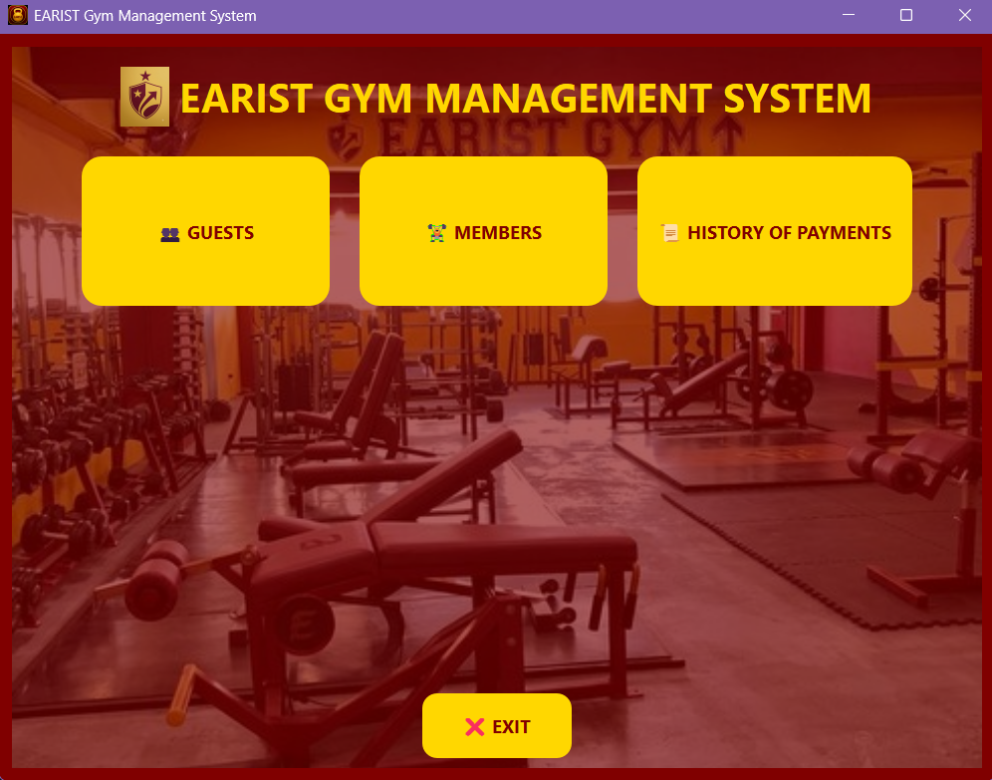
Figure 2. Main Menu Interface of the FitDrive Gym Membership System
This figure shows the main menu interface of the Gym Membership System. Administrators can add, update, delete, and clear member records. It also provides search functionality, displays member information in a table with ID, name, phone, monthly fee, join date, and status, and includes an exit button for safely closing the application. The interface is designed for intuitive use, allowing efficient management of gym membership data.

Member Registration
The Add Member module allows administrators to register new gym members with details such as:
- Name
- Member ID
- Membership type
- Contact information
- Payment status

Result:
- New members are successfully added to the database.
- Input validation prevents blank or duplicate entries, ensuring data integrity.
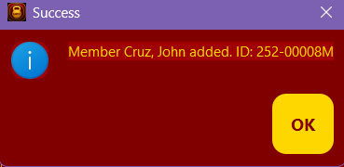
Figure 3. Success Message Displayed After Adding a New Member

The ADD Button: When a new client registers at the gym, the administrator types their information into the blank fields and clicks the green button. The system instantly runs a quick validation check, communicates with the database, and automatically assigns a unique, sequential Member ID (such as 1005). A success dialog window pops up to confirm the registration, and a new row appears in the main table. The system is also programmed to pull the computer’s current calendar date automatically to log the exact Join Date, while initializing the member's status to active.

View Members and Search
The View Members module displays all registered members in a table. The Search function allows administrators to locate specific members using the member ID or name.
Result:
- Records are displayed accurately.
- Search results are correct and instantaneous, improving administrative efficiency.

Update Records
Administrators can edit existing member information, such as membership type or payment status.
Result:
- Updated records are reflected in the database immediately.
- Input validation prevents incorrect updates.

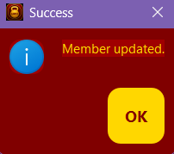
Figure 4. Update Member Functionality of The FitDrive Gym Membership System

The UPDATE Button: If a member changes their contact number or renegotiates their monthly rate, the administrator simply clicks on that member's row in the table below. The software immediately pulls that member's data back up into the input fields at the top of the screen. Once the administrator types in the updated details and clicks the blue button, the changes are pushed straight to the database. A "Member Updated" notification confirms the success, and the grid below instantly reflects the corrected values.

Attendance and Payment Tracking
The system allows recording of member attendance and payment status to monitor gym activity and revenue.
Result:
- Attendance logs are updated accurately.
- Payment status reflects current dues or completed payments.
- Estimated monthly revenue is calculated correctly.

Graphical User Interface
The PyQt5 GUI includes forms, buttons, and tables, allowing intuitive navigation between modules.
Result:
- Users can perform all operations without requiring technical knowledge.
- The interface reduces errors by providing clear instructions and visual confirmation of actions.

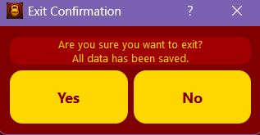

Figure 4. Exit Confirmation Dialog Box Asking User To Confirm Application Closure

The EXIT Button: This button provides a safe and orderly shutdown process for the application. Instead of abruptly cutting off the program, clicking the grey button ensures that any active connections between the frontend interface and the backend database are closed out cleanly, protecting the system files from potential corruption.

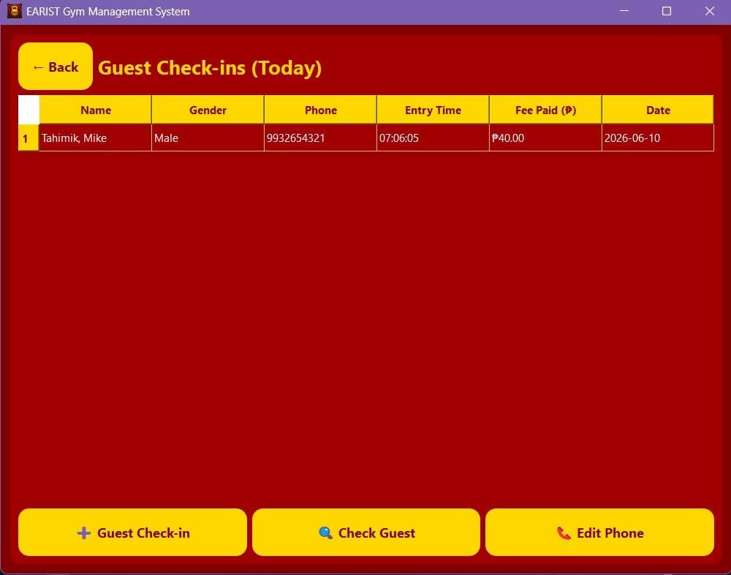

Figure 5. Guest Check-in interface of the EARIST Gym Management System
It shows the daily check-in list with guest details such as name, gender, phone number, entry time, fee paid, and date. The interface includes buttons for adding a guest, checking guest information, and editing phone numbers, designed for efficient gym visitor management.
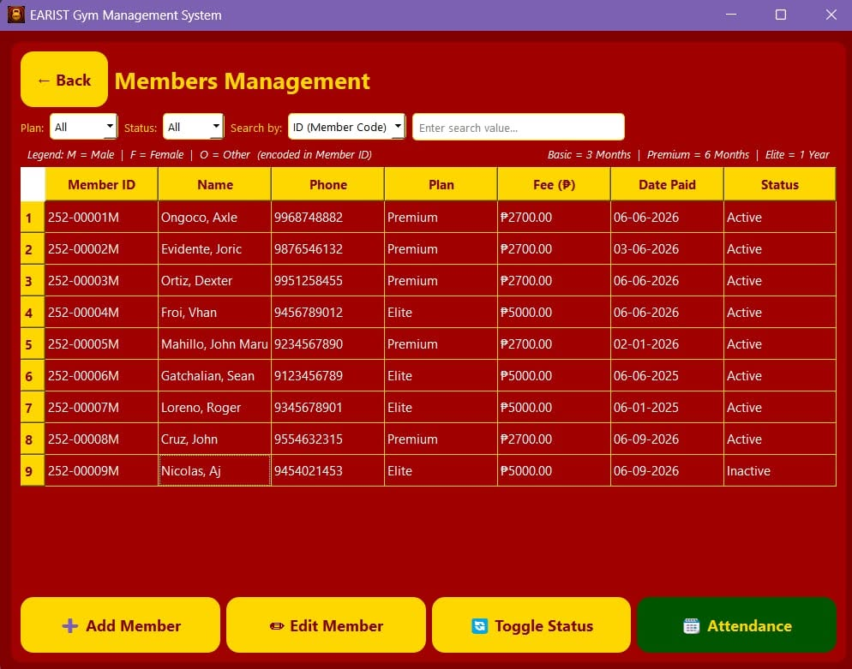

Figure 6. Members Management interface of the EARIST Gym Management System

It displays the member details, including Member ID, Name, Phone, Plan, Fee, Date Paid, and Status. The interface provides options to add new members, edit existing member information, toggle member status, and view attendance records for efficient gym membership management.
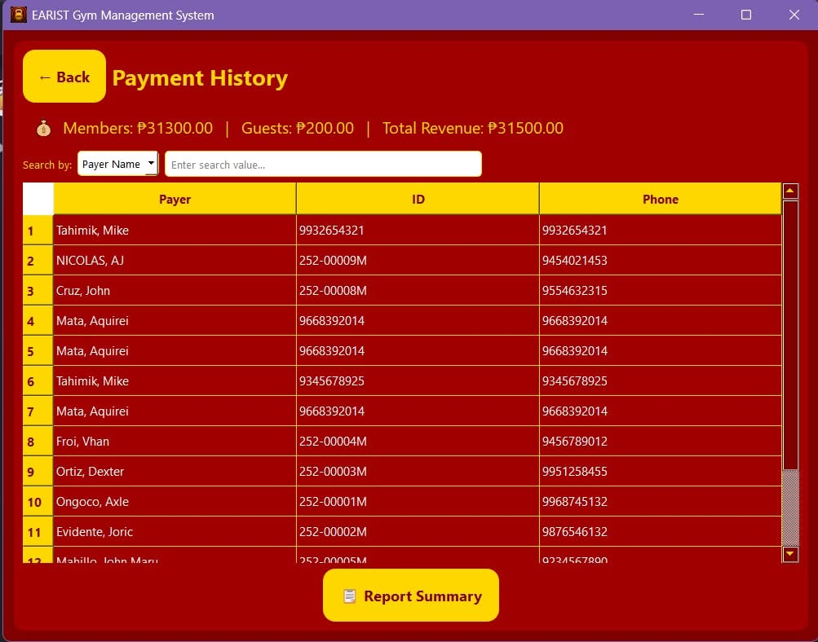

Figure 7. Payment History interface of the EARIST Gym Management System
It shows the complete list of payments from members and guests, including payer name, ID, phone number, and total revenue. The interface includes a summary of daily revenue and a report summary button for efficient financial tracking and record management.

Functional Testing Results
Functional testing validated all core modules. Sample test cases include:
Test Case | Action | Expected Result | Actual Result | Status
Blank Input | Left a required field empty | System prompts user | Prompt displayed | PASS
Add Member / Record | Entered valid member information | Record saved in database | Saved successfully | PASS
Update Record | Edited member information | Database reflects changes | Updated successfully | PASS
Delete Record | Deleted member record | Record removed from database | Deleted successfully | PASS
Search Member | Searched by name or ID | Correct member displayed | Correct record retrieved | PASS
Attendance Tracking | Logged member attendance | Attendance updated | Attendance saved | PASS
Payment Tracking | Updated payment status | Status reflected in database | Status updated | PASS
Generate Report | Requested summary report | Report matches database | Correct report generated | PASS
Invalid Input | Entered non-numeric or incorrect data | System shows error message | Passed | PASS
Empty Field | Left required fields blank in any module | System asks user to complete fields | Passed | PASS
Invalid Phone Number | Entered non-numeric phone number | System rejects input | Passed | PASS
Exit System | Closed application | Application closes properly | Passed | PASS

All test cases passed, confirming the system is functional, reliable, and accurate.

Discussion of Findings
The results indicate that the FitDrive Gym Membership System effectively automates administrative tasks, reducing manual errors and improving operational efficiency. Key benefits include:
- Accurate record-keeping: All membership and payment data are stored securely in SQLite.
- Improved efficiency: Attendance, payments, and member searches are handled instantly.
- User-friendly GUI: Administrators can perform tasks easily without technical expertise.
- Reliable reporting: Summarized reports help management monitor gym activity and revenue.
Overall, the system demonstrates that Python, OOP, GUI design, and SQLite integration can significantly improve small-scale gym management operations, providing a robust, accurate, and easy-to-use solution.

CONCLUSIONS AND RECOMMENDATIONS

Conclusions
Based on the development, testing, and evaluation of the FitDrive Gym Membership System, the following conclusions were drawn:
- Automated Membership Management: The system successfully automates gym membership operations, including member registration, attendance tracking, and payment management, significantly reducing the need for manual processes.
- Accuracy and Reliability: Integration with an SQLite database ensures permanent storage of member records, accurate tracking of attendance and payments, and reliable data retrieval.
- Functional Performance: Functional testing confirmed that all modules—including Add, View, Update, Delete, Search, Attendance, Payment, and Report generation—performed correctly and efficiently.
- User-Friendly Interface: The PyQt5 GUI allows administrators to navigate and operate the system easily without technical expertise, improving usability and reducing operational errors.
- Operational Efficiency: The system improves administrative efficiency by providing quick access to member records, payment status, attendance logs, and summary reports.
Overall, the FitDrive system provides a robust, reliable, and user-friendly solution for gym membership management, enhancing accuracy, efficiency, and record-keeping in small to medium gym facilities.

Recommendations
Based on the findings and limitations observed during system development, the following recommendations are proposed:
- User Authentication: Implement role-based access control for administrators, trainers, and staff to enhance security and accountability.
- Enhanced GUI Features: Improve the interface with dashboards showing analytics such as monthly attendance trends, revenue graphs, and membership growth.
- Barcode or QR Code Integration: Include scanning features for faster check-ins and membership verification.
- Multi-User Network Access: Allow multiple users to operate the system concurrently in networked gym environments.
- Cloud or Online Backup: Implement cloud storage or remote database synchronization to prevent data loss and allow secure offsite access.
- Payment Integration: Include online or automated payment processing to streamline membership fee collection.
- Notifications and Alerts: Add automated alerts for membership expirations, unpaid dues, or missed attendance sessions.
- Mobile Access: Develop a mobile version of the system to allow members and staff to access information remotely.
- Maintenance and Upgrades: Conduct periodic system evaluations and updates to address user feedback, improve performance, and add new features.
- Usability Testing: Conduct further usability tests with gym staff to refine workflow and optimize user experience.
In conclusion, the FitDrive Gym Membership System fulfills its primary objectives, but implementing these recommendations will enhance its functionality, usability, and scalability, making it suitable for broader application in modern gym facilities.

ACKNOWLEDGEMENT
The researchers would like to express their heartfelt appreciation to Engr. Meshelle N. Fabro, PCpE, for her dedicated mentorship, professional guidance, and expert supervision throughout the completion of this study. Her valuable insights, constructive suggestions, and continuous encouragement significantly contributed to the successful development and improvement of this research.
The researchers also extend their sincere gratitude to the Eulogio “Amang” Rodriguez Institute of Science and Technology (EARIST), particularly the Department of Computer Engineering, together with its faculty members, for providing the academic knowledge, technical resources, and institutional support necessary for the accomplishment of this project. The institution’s commitment to excellence in education, innovation, and research played an essential role in the success of this study.
Special thanks are also given to the families and friends of the researchers for their unwavering support, patience, understanding, and motivation. Their encouragement served as a source of inspiration and strength throughout the challenges encountered during the research process.
Above all, the researchers offer their deepest gratitude to Almighty God for the wisdom, guidance, strength, and perseverance bestowed upon them throughout this endeavor. This work is humbly dedicated to His glory, acknowledging that every achievement was made possible through His grace and blessings.

REFERENCES
Bhavani, V. T., Chinthana, S., Aishwarya, K., Shweta, B., & Nirmala, S. (2025). Implementation of a Python-based expense tracker and management system. International Journal for Multidisciplinary Research.
Chokhandre, P., Singh, M., & Jadhav, R. (2025). Gym Management Systems: Enhancing operational efficiency in fitness centers. International Journal of Sports and Health Management, 4(2), 101–109.
Chokhandre, S., Raut, A., Chhatre, R., & Tarekar, S. (2025). Gym Management System. International Journal of Scientific Research and Technology, 2(1), 74–81. https://www.ijsrtjournal.com/article/Gym-Management-System
Kumar, R., & Singh, A. (2021). Database integration techniques in educational and small business management systems. International Journal of Computer Applications, 174(15), 12–20.
Kurashkin, M., Petrova, L., & Ivanov, D. (2022). Comparative analysis of gym management applications: Accessibility, cost, and database utilities. Journal of Fitness Technology Research, 5(3), 45–57.
Kurashkin, S. O., Bukhtoyarov, V. V., Bocharov, A. N., Lavrishchev, A. V., & Seregin, Y. N. (2022). Software designed for fitness club client's requirements management automation. Proceedings of MIP Computing-V 2022, 3091, Article 3. https://ceur-ws.org/Vol-3091/paper03.pdf
Matcha, S., & Mishra, R. (2025). Database selection and management: Choosing the right database (SQL vs. NoSQL) for your application. International Journal of Research in Humanities & Social Sciences, 13(3), 70–76.
Matcha, S., & Mishra, R. (2025). SQL vs NoSQL database systems: Comparative analysis for transactional and flexible applications. International Journal of Computer Database Systems, 7(1), 25–33.
Pushpa, Ch. M., et al. (2024). Design and development of database and its effective implementation. International Journal of Scientific Research in Computer Science, Engineering and Information Technology, 10(3), 586–589. https://www.researchgate.net/publication/381604049_Design_and_Development_of_Database_and_its_Effective_Implementation
Pushpa, P., Kumar, V., & Reddy, S. (2024). Principles of robust database design for small business management systems. Journal of Software Engineering and Applications, 17(4), 211–223.
Shneiderman, B., Plaisant, C., Cohen, M., Jacobs, S., Elmqvist, N., & Diakopoulos, N. (2016). Designing the user interface: Strategies for effective human-computer interaction (6th ed.). Pearson.
Smith, L., & Jones, K. (2022). Automation in small business management systems: Improving accuracy and operational efficiency. Journal of Business Informatics, 14(2), 55–63.
Suya, F., Li, J., Zhao, G., Li, J., Chen, X., & Wong, D. S. (2026). Smart POS and inventory management systems for small-scale retail operations. International Journal of Retail Technology, 12(1), 45–56.
Šušter, A., & Ranisavljević, N. (2023). SQL-driven systems for small business and institutional management: Performance and reliability analysis. Journal of Database Management, 35(2), 78–89.
Šušter, I., & Ranisavljević, T. (2023). Optimization of MySQL database. Journal of Process Management. New Technologies, 11(1-2), 141–151. https://pdfs.semanticscholar.org/8123/25ef75570fd306a8590136fd74698cd0ec39.pdf
SynapseIndia. (n.d.). 5 key benefits of membership management software. https://www.synapseindia.com/article/5-key-benefits-of-membership-management-software
MembersHerpa. (n.d.). What is the purpose of a membership database? https://www.membersherpa.com/what-is-the-purpose-of-a-membership-database/

ABOUT THE AUTHORS
Aquirei Aiken M. Mata is a first-year Computer Engineering student at the Eulogio “Amang” Rodriguez Institute of Science and Technology (EARIST). He is currently developing his knowledge and skills in computer programming, electronics, and information technology as part of his academic journey in the field of Computer Engineering. Passionate about learning and technology, he aims to become a competent and industry-ready professional capable of adapting to the rapidly evolving demands of the technology sector.
Sean John R. Gatchalian is currently pursuing a Bachelor's Degree in Computer Engineering as a first year college student at Eulogio "Amang" Rodriguez Institute of Science and Technology. He was responsible for the "Search Member" feature of the system in this study. During his senior highschool years, he has contributed in the development of a capstone project titled "Remote Controlled Portable Tractor for Efficient Farming."
‎Roger D. Loreno Jr. is currently pursuing a bachelor's degree in computer engineering as a first-year college student at Eulogio "Amang" Rodriguez Institute of Science and Technology.During his senior high school years, he contributed to the PALMA hymn by creating music for their school. He also got the NC II animation.
John Axle C. Ongoco is currently pursuing a Bachelor's Degree in Computer Engineering as a first year college student at Eulogio "Amang" Rodriguez Institute of Science and Technology. During his senior highschool years, he has contributed in the animation of his group and he also contributed and lead to manage and organize the motherboard. He was responsible in System Design of this study the "Add, Update, Clear, Delete, and Exit"
Dexter Dave R. Ortiz is a first-year Bachelor of Science in Computer Engineering student at Eulogio "Amang" Rodriguez Institute of Science and Technology. During his Senior High School years at University of Perpetual Help System Manila, he contributed to a capstone project that involved the design and development of an Arduino-based smoke detection system intended for use inside public buses. He was responsible for the hardware assembly and wiring of the system. He is also responsible for developing the Report Summary section of this project.
Vahn Froi B. Portades is currently pursuing a Bachelor of Science in Computer Engineering at Eulogio "Amang" Rodriguez Institute of Science and Technology (EARIST) as a first-year college student. During his senior highschool years at Electron College of Technical Education, he contributed to the development of a capstone entitled "Nexus of Stem Learning", an educational website to assist upcoming STEM or STEM students by providing answer subject-related questions and incorporating visual learning materials to enhance understanding. The platform aimed to make STEM education more accesible,interactive,and effective for students. Through the innovation and impact of the project, the team was awarded "First Place in the Capstone Project Competition" recognizing its excellence and contribution to student learning and academic support.
Engr. Meshelle N. Fabro is a licensed Professional Computer Engineer and educator at the Eulogio “Amang” Rodriguez Institute of Science and Technology (EARIST). She is currently pursuing a Master of Science in Computer Engineering at Bulacan State University and has professional industry experience as a Technical Engineer at Hewlett-Packard (HP) and an IT Engineer at IBM.She is also a TESDA CSS NC II and Trainers Methodology Level I (TM1) holder, demonstrating her commitment to technical excellence and competency-based education. Passionate about teaching and innovation, she is dedicated to guiding Computer Engineering students in becoming industry-ready, competent, and highly skilled individuals equipped for the evolving demands of the technology industry.

