DEEP ECOLOGY MOVEMENT:

ABSTRACT

The environment is a massive space for everything. It is where the necessities of living and nonliving things ought to come from. For us people to survive, we need food, shelter, and water. Such, the importance of keeping a deep connection and movement with the environment is the significant action we need to do. Because in the end, we still are the ones who will live and will benefit from it. That is, keeping our perspective capable of seeing what is good and bad for the environment. On the other hand, we shall seek attention to the injustices that man is doing to nature. For example, the results of tree poaching as these actions were illegal under jurisprudence as it has no permission to use certain areas for agricultural lands can harm the habitat of living organisms and may be the primary factor in the destruction of lives and properties during floods because of improper storage of logs. Typhoon Washi, or what was locally called Bagyong Sendong, causes a tremendous effect that involves the environment, victims, and the local and national government. These effects are visible as to how actions of different authorities have been expressed towards community involvement and legal matters. According to DENR-CENRO Iligan, the contributing factor to the floods caused by the typhoon was the logs that came from the mountain boundaries of Lanao del Sur, Iligan City, and Bukidnon. Traumatic as it seems, but due to environmental degradation, the result was evidence to show the injustices that man is doing in his environment can cause as huge as they can be.

Furthermore, Arne Naess, a Norwegian philosopher produced the term Deep Ecology Movement to claim environmental actions be a perception that many people shall inherit. Aldo Leopold, an American ecologist claims in his The Sand County Almanac, that thinking like a mountain is accepting our place in the biosphere (as the global ecosystem composed of living and nonliving things from which they acquire their needs) and accepting our duties to all life forms. As a result, we must consider the environment's long-term values as a whole (Leopold, 1949). The latter claim was then supported by Naess in his many works.

Fundamentally, the claims refer to the goal of the special project that centers on rehabilitating the Sendong Memorial Park from a dilapidated and messy to a verdant and clean place. Thus, it can be used as a park for recreational activities, academic purposes, and a tourist spot. Just as it aims to trigger the attention of the public on why the park was built. As it was built to commemorate the lives that were claimed during the Typhoon Sendong, and how the causes of man-made abuses in our environment can result in massive destruction to man itself. Also, it was built to give most people an environmental reflection of how they can change the negativities they have brought towards natural resources. As illegal poaching of trees is a major reason why logs from highland areas of Lanao del Sur, Iligan City, and Bukidnon were brought by heavy rains and floods towards the city and caused the destruction of properties and lives during Typhoon Sendong. By that means, the sculpture that was made by Julie Lluch of a girl (Annalou Lapuerta) riding a log with a snake on the back, which was displayed in the park, projects the catastrophic happening of Typhoon Sendong. Lastly, the park will be an avenue of history and academic approach to environmental philosophy and ethics to the community and the visitors of the park, projecting the Deep Ecology Movement of Arne Naess.

Keywords: Deep Ecology Movement, Bagyong Sendong, Arne Naess, Sendong Memorial Park, Environment

CHAPTER 1: INTRODUCTION

Iligan City was one of the major cities in Mindanao, the Philippines, that was hit by the Tropical Storm Washi or locally known as Bagyong Sendong, on December 17, 2011. It had claimed many lives that almost swept out a community. In Bayug Island, Iligan City was the ground zero of the tropical storm with an aftermath of a devastating impact brought by floods and massive logs caused by strong winds and heavy rains. As a result, many properties were damaged, and everything that was left was debris from houses, vehicles, and corpses of victims and animals. "The disaster resulted in 1,292 deaths, 1,049 missings, and 2,002 injured and affected 695,195 people (110,806 families)." The disaster was an effect of environmental degradation that man had made. These issues on ecological degradation, such as illegal logging, illegal poaching of trees, or unwanted pollutants, are significant contributions to why there are effects that we can not foresee its destruction towards us and the environment itself. The aftermath of Bagyong Sendong is just one out of many deadly disasters that happened worldwide that can be analyzed and claimed because of environmental degradation.
Anthropocentrism, a worldview that includes an instrumentalist view of nature and sees humanity as the conqueror of nature, and one of the two divisions of environmental ethics, has resulted in environmental degradation around the world (Madsen, 2016); seeing the nature as non-intrinsically valuable makes it look disposable—threatening the value of the environment (property) based on the contribution it can give you economically and politically is an example of an anthropocentric worldview. The destruction Typhoon Sendong brought is not only seen physically; the tragedy has targeted the emotional and psychological aspects of the victim that years can't just make them forget how hard and painful that experience is. The Sendong Memorial Park is a park built to commemorate the lives that have been lost and are still missing during Typhoon Sendong. The proponents have noticed that after almost eleven (11) years after the tragedy, the park has been abandoned and is not well maintained. This situation is seen as a misunderstanding of meaning between the government and the victims. Nevertheless, the memorial and environmental awareness aspect is the enveloping point the visitors of the place will have in their perspective. The more profound thought of the latter claim will take on the community's involvement and the citizens of Iligan, not to mention the local government unit.

  - Statement of the Problem

The dispirited situation of Sendong Memorial Park is a depiction of a problem of understanding its meaning and the kind of worldview of the people involved. Typhoon Sendong is one of the major catastrophes in the Philippines that have destroyed properties, families, and lives. This tragedy has reminded the people of Iligan, and Cagayan de Oro how destroyed our environment is, as it becomes incapable of absorbing rainwater. The logs that have been stored in the mountain boundaries of “Iligan, Lanao del Sur, and Bukidnon” (CENRO-Iligan, DENR) lead to worsen the effect of Typhoon Sendong.
Hence, rehabilitating the park would cause the people involved to inherit knowledge and awareness of how the Sendong Memorial Park’s presence triggers the social spectrum of Iligan City, that the cause of an environmental tragedy has an effect that massively involves the local and national government, victims, environment, and media; especially during the aftermath of Typhoon Sendong that happened way back on December 17, 2011. Thus, the study problematizes on how a memorial park, environmental destructions, and governmental actions will identify man’s relationship towards the environment and whether man’s perspective settles on an anthropocentric worldview or biocentric worldview, connecting Arne Naess' Deep Ecology Movement.

  - Background

The Philippines' geographical location along the route of tropical storms forming in the western Pacific and along the Pacific Ring of Fire has provided ample justification for the Philippine Government to treat environmental deterioration as a severe issue. The Sendong memorial park is one of the initiatives of the Government to remember and commemorate Typhoon Sendong. The park is where the list of the missing and fatalities is placed and is also decorated by the artwork of Julie Lluch, of a girl (Annalou Lapuerta) riding a log with a snake on the back as a symbol of bravery, courage, kindness, human survival, and resilience. The log that this child is riding is one of the logs that have been washed out from the mountains within the boundaries of Iligan City, Bukidnon, and Lanao del Sur, from illegal poaching of trees. "Typhoon Sendong was allegedly worsened by illegal logging, mining, and quarrying (Inquirer Mindanao, 2014)." However, as of today, these allegations are still issues debatable to the congress, as they suspected illegal poaching of trees in between the boundaries of Iligan City, Bukidnon, and Lanao del Sur (CENRO-Iligan, DENR). These illegal poaching of trees allegedly is caused by poverty, demand, and expansion of agricultural lands of the hinterlands due to the increase in the demand for crops caused by the increase in their population.

Typhoon Sendong has caused damage not just to the demographic aspect of Iligan but also to the socio-economic and geographical aspects of the city. As seen in the image below, the before image of Bayug Island, Hinaplanon, Iligan City is very different from the after image. The number of trees found in the areas has decreased, the reason why the Government has amended lots of projects on the restoration of the watershed and eco shed in the area. Projects like National Greening Program, Enhanced National Greening Program, and primarily the UDP or the Upland Development Program.
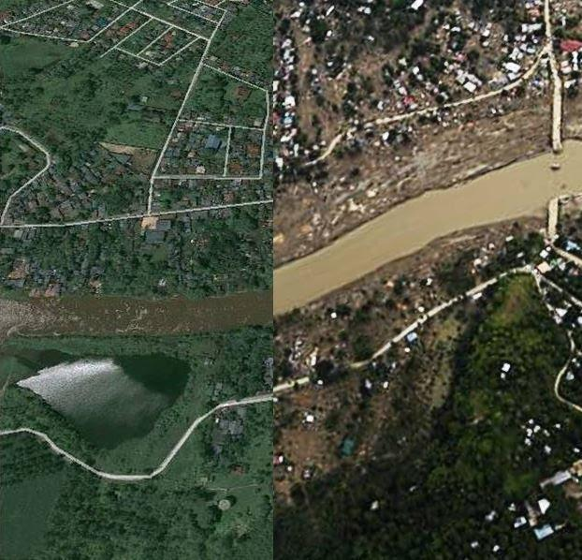

Figure 1.1. The photo on the left displays a Google map view of Iligan City's Hinaplanon area prior to "Sendong," while the one on the right depicts the town's environment after the typhoon hit. (Courtesy of UP-NIGS) Retrieved from: https://www.tinigngplaridel.net/2012/up-geologist-residents-warned-of-sendong-disaster-in-2009/

According to the CENRO-Iligan, DENR, the aftermath of Typhoon Sendong has caused the people in Iligan City to lessen illegal environmental practices, as the security and the implementation of the policies concerning Illegal environmental activities have heightened. Typhoon Sendong has also given light and ideas to refocus the restoration program of the government, and they switch their full attention to restoring the ecological balance, especially the trees, in the landslide and high-risk areas.

Number of Family members died and missing During Typhoon Sendong:

- Bayug Island. 16 (37%) out of 43 respondents have family missing and 10(23%) out of 43 respondents have family died
- Prk. 9 Riverside. 15(13%) out of 114 respondents have family missing and 9(8%) out of 114 respondents have family died
- Deus Caritas. 27(50%) out of 54 respondents have family missing and 12(22%) out of 54 respondents have family died
- Bayanihan Village. 7(29%) Out of 24 respondents have family missing and 1(4%) out of 24 respondents have family died
- Online Respondents. None.

  - Purpose

The long-term goal of this Special Project is to establish a well-rehabilitated Sendong Memorial Park as a reminder of how destructive Typhoon Sendong and environmental degradation are, as well as to commemorate the lives that the said typhoon has lost. The objective is to provide a comprehensive review of literature connected to Environmental Ethics. Deep Ecology Movement, value-oriented environmental ethics, and relation-oriented environmental ethics would complement the project in its philosophical aspect. Remarkably, the study has the following sub-objectives:
- To provide a better memorial park for the relatives of the people who died in Typhoon Sendong;
- To trigger the attention of the public and the local government, which would lead to other possible plans for the Sendong Memorial Park, especially the environmental aspect in Iligan City;
- To give significance to the current symbolism of Julie Lluch's art piece (the girl that rides the log with a snake at her back); and
- To identify the kind of environmental relationship the former residents of Purok 9 Riverside and Bayug Island, Hinaplanon, Iligan City have.
The result of this Special Project will be valuable in terms of environmental ethics. This paper will also tackle the ethical dilemma involving environmental practices and the value of the people's relationship with the environment. The project will be valuable to the family and relatives of the Typhoon Sendong victims. It would also be valuable to the residents of Iligan as it would serve to be a landmark that displays how brave, courageous, kind, and resilient people in Iligan are. However, this landmark would also serve as a reminder of how people have abused the environment (illegal poaching and quarrying), making it incapable of absorbing enough rainwater that leads to worsening the catastrophic effect of Typhoon Sendong, leaving a traumatic thought to many victims.

  - Scope and Limitations

This study focuses on how the Sendong Memorial Park can be an avenue for environmental ethics, academe, and the local government response to the environmental degradation happening in Iligan City. This park would also represent the direct connection humans have with the environment, a basis of the human-nature relationship. The latter will then be the basis of how the Deep Ecology Movement of Arne Naess makes sense of how the locals value the environment; anthropocentric or biocentric.

CHAPTER 2: THEORETICAL FRAMEWORK

Deep Ecology Movement

Deep ecology, environmental philosophy, and a social movement founded on the conviction that people must fundamentally alter their connection with nature from one that values nature simply for its use to humans to one that acknowledges nature's intrinsic value. Deep ecology, often known as "ecosophy," is a social movement with theological and metaphysical elements that gives a different definition of the self than traditional concepts. The concept was coined in 1972 by Norwegian philosopher Arne Naess, who devised a platform of eight organizational principles for the deep ecology social movement with American environmentalist George Sessions. Deep ecology differs from other varieties of environmentalism as it makes larger and more fundamental philosophical statements concerning metaphysics, epistemology, and social justice (Madsen, 2016).
The deep ecology movement stands here as a point wherein it basically judges the implication of what should be the application needs to be done by the person in the community and the environment. By that means, human beings need to have a connection with the environment, and that points out the notion of ‘biosphere’ which is a global ecological system that points on to take relationship with all the living things and the consideration on the aspect of other natural elements, such as the atmosphere, lithosphere, etc. Organisms, modes of life, and interactions in the biosphere in general demonstrate such a high level of complexity that it colors ecologists' overall view. Because of this, thinking in terms of large systems is unavoidable. It also allows for a clear, consistent view of humanity's abysmal misunderstanding of biospheric linkages and, as a result, the impact of disruptions (Naess, 1973).”
Some of the primary components of the political and ethical movement of environmentalism include conservationism, protectionism, ecological science, and deep ecology. Deep ecologists frequently contrast their own stance with what they refer to as other environmentalists' "shallow ecology." They argue that the mainstream ecological movement is only concerned with different environmental concerns (such as pollution, overcrowding, and conservation) when they have a detrimental impact on an area's ecology and disturb human interests. They contend that anthropocentrism, a worldview that includes an instrumentalist view of nature and a view of humanity as the conqueror of nature, has resulted in environmental degradation around the world and should be replaced with ecocentric (ecology-centered) or biocentric (life-centered) worldviews, where the biosphere is the primary subject of attention (Madsen, 2016).
In relation to environmental ethics, Arne Naess' perspective in his Deep Ecology Movement is one of the key factors that would lead to the project's essence. It goes by the emphasis on the perceptions and works, or in short, the approach of man, in relation with the environment, specifically nature. The notion in his position stands on the moral and ethical standards or obligations that should be applied by humans not just in the shallow manner, which is the action of man towards the environment. But in the deeper sense, it tracks the application of moral implication from the action taken of keeping the environment in place and in a good position. All these claims will still evolve on the point of disciplinary actions – that must be taken under control in this certain issue of natural disasters since it seems that some people are not anymore taking it seriously when it comes to natural disasters – where it should be developed and given importance for the benefit of the people.
Deep Ecology, on the other hand, is such a vast concept. Given that Deep Ecology is concerned with the intrinsic value of nature and its relationship to humans, it would be a significant undertaking. Discussing the intrinsic value of nature and human-nature relation all together may require a great deal of information and insight, which might make this research complex. This study required narrowing the notion down to two related concepts called Value-Oriented and Relation-Oriented Environmental ethics, which separately discussed the two main notions discussed in Deep Ecology, the intrinsic value of nature and the human relationship towards nature. Value-Oriented environmental ethics focuses on the value of the environment; does the value of non-human nature only instrumental or it also has intrinsic value? Relation-Oriented Environmental ethics focuses on human beings' relationships with nature through their experiences.

Value-Oriented Environmental Ethics

Value-oriented environmental ethics is an environmental ethical conceptual framework developed by David O. Kronlid and Johan Öhman that talks about the intrinsic value of the environment. This ethical framework focuses on extending the moral relevance to the environment. It argues that non-human nature or non-human entities are also a moral agent and have intrinsic value beyond their instrumental value. Value-oriented environmental ethics has three central moral considerations “(a) who or what is considered as an amoral object, (b) the human–nature relationship and (c) definitions of nature’s value” (Kronlid and Ohman 2012). Moreover, Value-oriented environmental ethics argues that there are specific instances where human and nature are integrated and separated and as a result, human-nature relationship should not be understood as a unified environmental ethic, understood to be anthropocentric or non-anthropocentric.
However, according to relation-oriented environmental philosophy, revolving only on the “so-called moral extensionism philosophy, i.e., relies on philosophical arguments for or against extending the circle of moral relevance. Thus, Value-oriented environmental ethics is accused of disregarding moral aspects of the environmental crisis associated with e.g., psychological, gender, institutional, religious and spiritual phenomena” (Merchant 1992,1996; Zimmerman 1993; Oelschlaeger 1995; Callicott 2002 as cited in Kronlid and Ohman 2012). Among the three central moral considerations of value-oriented environmental ethics points b and c are what this study would focus on. These points are believed to help this study understand the relationship of human and nature, on whether they are integrated or separated. This would also help the study understand how Typhoon Sendong victims value nature based on the relationship they have with it.
Furthermore, even if value-oriented environmental ethics has previously addressed the concept of human-nature relationships, the aspects that value-oriented environmental ethics ignore are the factors that are the subject of this study. The purpose of this study, which is to explore the connection between the environmental relationship and the experience of Typhoon Sendong victims during and after the typhoon, necessitated a greater attention on the relational part of Deep Ecology.

Relation-Oriented Environmental Ethics

Relation-Oriented Environmental Ethics is a one of the two environmental ethical conceptual frameworks that is developed by David O. Kronlid and Johan Öhman. Relation-oriented environmental ethics suggests that we need to look into how environmental values and the actions associated with those values are created and maintained in various contexts of humans relating to other humans, to nature and to technology. Relation-oriented environmental ethics are coined from different environmental theories like Deep ecology, ecofeminism, and social ecology. Relation-oriented environmental ethics focuses on the relationship of our values, our relationship with other people, the environment we belong and the technology we are associated with; and on how we value the environment and our action towards the environment.
Moreover, relational theories like relation-oriented environmental Philosophy are mostly to position their difficulties in situated relational space, such as environmental and developmental crisis experiences and the practical implications of such experiences. Hence, relation-oriented environmental ethics seeks answers to questions about how we ought to live our everyday life in this modern world. Hence, people's interactions and experiences of and within the world are relevant settings for environmental ethical contemplation in relation-oriented environmental ethics because there is no other way to understand one’s position towards a certain idea but through relational space.
Furthermore, relation-oriented environmental ethics is seen to target both the idea of biocentrism (the idea suggested by deep ecology) and environmental education. Environmental education is targeted as this study aims to know the environmental consciousness of the victims of Bagyong Sendong. Do they have the same environmental perspective? Do they have the same understanding on what caused Bagyong Sendong? And how they apply this understanding to their everyday life. Relation-oriented environmental ethics would also help in understanding the importance of environmental experience to the kind of relationship humans have with nature. Does experiencing natural disasters caused by negative environmental practices can lead them to have a good relationship with nature? Or is there any chance that even with the same experience people could still have different environmental relationship outcomes?

CHAPTER 3: METHODOLOGY AND ETHICAL CONSIDERATION

3.1. Methodologies

The Special Project would be an ‘Analytical Philosophical Research’ as we would try to analyze the connection of the Deep ecology movement to the overall environmental consciousness and Environmental relationship of the Sendong victims. On how they see themselves in connection to the environment. What was their relationship with the environment after they experienced Typhoon Sendong? Furthermore, it is achievable by following our theoretical framework.
The target population of this study is the Typhoon Sendong Victim in Barangay Hinaplanon; this population is the most affected people of the Typhoon Sendong as Bayug Hinaplanon, Iligan City, is considered the ‘Ground Zero’ of the Typhoon. However, the proponents have narrowed it down, identifying the former residents of Bayug Island, Hinaplanon, and Purok 9 Riverside Bayug as the sampling frame. The former Bayug Island Residents are currently residing at Bayanihan Village, Sta. Elena and Deus Caritas, Luinab, and some stay at Bayug Island and Purok 9 Riverside Bayug.

The total number of families affected by Typhoon Sendong in Hinaplanon as identified by the City Social Works and Development (CSWD) in Iligan City is 3,951 from that population; the proponents only identified respondents as 280. This number of respondents would constitute 7. 09 percent of the overall population. These respondents come from the following location:
- Bayug Island, Hinaplanon- constitute 15.36% (43 respondents) of the overall Sampling Frame and 1.09% of the population.
- Purok 9 Riverside Bayug, Hinaplanon- constitute 40.71 % (114 respondents) of the Sampling Frame and 2.89% of the overall population.
- Deus Caritas, Luinab - constitute 19.29 % (54 respondents) of the overall Sampling Frame and 1.37% of the population.
- Bayanihan Village, Sta. Elena- constitutes 8.57 % (24 respondents) of the overall Sampling Frame, which is 0.61% of the overall population.
- Online Respondents- constitute 16.07 % (45 respondents) of the overall Sampling Frame, which is 1.14% of the overall population.

Location | Number of respondents | Percentage it constitutes in the overall Sample. | Percentage it constitutes in the overall Population
Bayug Island, Hinaplanon | 43 | 15.36 % | 1.09%
Purok 9 Riverside Bayug, Hinaplanon | 114 | 40.71 % | 2.89%
Deus Caritas, Luinab | 54 | 19.29 % | 1.37%
Bayanihan Village, Sta. Elena | 24 | 8.57 % | 0.61%
Online Respondents | 45 | 16.07 % | 1.14%
Total | 280 | 100 % | 100 %
Table 1.1. Population of the survey respondents

And as per the data collection in terms of the background of the project and Typhoon Sendong the proponents have properly requested the collection of data to the authoritative office that is connected to the park environmental issues relation to Typhoon Sendong and the Typhoon Sendong itself, namely:
- Department of Environment and Natural Resources, CENRO-Iligan.
- City Social Works Department
- Iligan City Tourism
- Local Government of Barangay Hinaplanon
- Sangguniang Panlungsod
The proponents will use questionnaires and interviews to gather data in this study. The proponents have a structured questionnaire distributed through Google Forms and to the selected location, namely, Bayug Island, Purok 9 Riverside Bayug, Deus Caritas, and Bayanihan Village. They will answer six (6) questions relating to the relationship between "Sendong, Environment, and Memorial." While answering the survey questionnaires, the proponents would then be asking the question as a sort of interview, questions like "how many times did they go to the memorial park?" and "what particular time or event did they usually go to the Memorial Park?" and if they have not gone to the place the proponents would ask "if where do they celebrate the anniversary of Typhoon Sendong?" and "if by any chance that this place will be rehabilitated, would they visit it and decide to celebrate the occasion there?" The proponents have also included asking the number of family members that are declared deceased and missing to see if there is any relationship between the number of casualties a victim of Typhoon and their involvement and relationship to the park and the topic relating to Typhoon Sendong. The proponents have also included a black space in the survey form intended for the comments and suggestions of the respondents relating to the memorial park. With the use of this method, the researchers can collect data and construct an accurate result that will meet the study's objective.

3.2. Ethical Considerations
According to Pritha Bhandari, “Understanding real-life occurrences, exploring successful therapies, analyzing habits, and enhancing lives in various ways are all common aims of human research. Choosing to investigate and perform are both ethically important concerns.” The following are the ethical issues and considerations identified by the proponents upon conducting the particular project:

Informed consent. The ‘informed consent’ are the survey and interview participants which are the Typhoon Sendong victims and the agencies that have participated in giving initial data concerning Typhoon sendong and sendong memorial park. The ‘informed consent’ are well-informed on how, where, and when the provided data will be used. This study makes sure that the notion of 'informed' is clear. The ‘informed consent’ should know who the proponents are, what are the intentions of the Special project, what data will be collected from the participants, what level of commitment is required from participants, and what the potential risks of participating in the research are.

Voluntary participation. The participants have voluntarily participated in the survey, interview and events organized by the proponents. Participants have the option to opt in or out of the events connected with the Special Project at any time. There is also no money given to compensate for the participants' efforts and presence.

Confidentiality. The participants are known to the proponents, but the rest of the group is not. Proponents have anonymized personally identifying data so that it cannot be linked to other data.

Potential for harm. Participants in this Special Project are not harmed and are kept safe from potential harm, whether physical, emotional, or psychological.

Conflict of interests was well-managed. Given that the Special project has taken place during the election, conflict of interest such as political publicity of the political candidates have been well-avoided. The proponents do not want the Special project to be conflicted with any political issues. The proponents have made sure that the participants of every event have understood and are informed that the event is not a political event or politically related.

Results communication. The survey results were used as identifiers to what are the participant’s pulse in the act of rehabilitating the Sendong Memorial Park. Hence, it is used as data for what the majority wants to happen upon rehabilitating. On the other hand, the survey also identifies how the proponents would start the rehabilitation plan. Also, the results from the survey present the environmental concerns and realizations of the respondents, especially during and after Bagyong Sendong.

CHAPTER 4: REVIEW OF LITERATURE

The literature review will present how environmental degradation, environmental exploitation, and anthropocentrism have affected humanity, especially Filipinos, throughout history. This literature review would also present the importance of representation to showcase a deeper meaning and understanding of a particular tragedy or phenomenon.

Deep Ecology Movement

Ecology, as the prior basis of the Deep Ecology Movement, develops such significance on the notions as it is to cover the development in the broader sense of understanding nature and its connection to the living beings. For Stephan Harding, he pointed out: “Ecology is a biological term that describes how living organisms interact with one another and their respective environment. Arne Naess believes that ecological science, which is solely concerned with facts and reasoning, is incapable of answering ethical problems concerning how we should live. We'll need ecological wisdom for this. Profound ecology focuses on deep experience, inquiry, and dedication in order to achieve this. They form a system that is interrelated. Each feeds and supports the other, while the whole system is an ecosophy, as defined by Naess: a changing but consistent philosophy of being, thinking, and acting in the environment that exemplifies ecological wisdom and harmony.”

Naess simplifies the idea of ecological knowledge on the understanding of the issues brought towards the natural environment. This remarks that a person should not only deal with the underlying thought of how an environmental issue can be done through this or through that. However, we must dwell on the fundamental root causes of the issue being brought to nature. It stands with the point or idea in which man must develop his intuitive knowledge about the role of nature and man to one another, not just by allowing a cause to develop an effect that produces something negative in the natural resources perhaps.

The Deep Ecology Movement now develops the idea of man's relationship towards the environment, that as a person who knows what to do with the issues regarding the rampant cases that affect its life and the lives of many. Through this, he must focus on these issues and take part in thinking of ways to manage such in order not to develop at risk. Furthermore, the movement suggests that we should take part in taking care with a commitment to the environment.
Peter Madsen, in "A Focus on The Biosphere," states that anthropocentrism, a worldview that includes an instrumentalist view of nature and sees humanity as the conqueror of nature, has resulted in environmental degradation around the world and that it should be replaced with ecocentric (ecology-centered) or biocentric (life-centered) worldviews, in which the biosphere is the primary concern.

Environmental harm: An eco-justice perspective

Environmental degradation results from the damages caused by human activities that are compromising the natural environment in many ways. Alongside these results is reducing the scope of health in the environment, and much more is biological diversity. Thus, the implications of environmental degradation result in different aspects, especially when it comes to tree poaching or illegal logging. The organisms and other animals’ habitats and resources are at risk, and they too can be victims of these unwanted actions by humans. According to General Multilingual Environmental Thesaurus, “Environmental degradation is a process in which the natural environment is harmed somehow, resulting in a reduction in biological variety and environmental health. This process can be fully natural, or it can be expedited or triggered by human actions.”

As stated by Rob White, “the survival of the human species is dependent on how they connect and interact with the environment. Environmental degradation and climate change are outcomes whose causes may be inferred from the interests that individuals deal with in terms of business.”
Sendong Memorial Park

A place of peace and contemplation is the natural foundation of a memorial park. This place is where a memory of something or someone had happened. It is where many people visit to honor their loved ones that were affected by any events, such as natural death, accidents, tragic events, or historical wars. The park may be composed of dead people buried underground with gravestones inscribed with the name of the dead. On the other hand, a memorial park can have a structure or a symbol of an event that connects with a tragedy that claimed lives and left several victims. People left dead may either be missing or burned to ashes (after a bombing or fire tragedy).

With the latter claim, memorial parks that consist of monuments tend to let visitors connect with the art they convey. Many memorial parks were established with monuments or statues that displayed intense historical sensations, such as heroes, wars, natural disasters, or even well-known personalities that left a great legacy to the community. This might be owing to their building material, structures, colors, performances, and sizes, or it could be due to the emotive, thought-provoking, and empathy-inducing qualities they feature. According to Sunstar, “The impact on the background of why the park was established was how it greatly affected the people and the environment. Nevertheless, memorial parks are designed to symbolize significant values that will let people know how the cause of an event creates a tremendous effect.”

The Sendong Memorial Park is said to be where it pays tribute to individuals who have passed away. It is a memorial to individuals who faced nature's relentless wrath and displayed amazing bravery, courage, and kindness. According to Aware: Women Artists, "Julie Lluch is a Filipino sculptor who earned a degree in Philosophy at University of Santo Tomas." She sculpted the girl that rides the log with a snake on her back using a bronze material. The statue was placed in the memorial park, which strongly symbolizes the environmental aspect. As stated on the memorial plate:

“The sculpture depicts an actual experience of a young girl who was washed out to the sea, but stayed alive by clinging to a trunk of a tree until she was rescued by fisherman. The girl astride a log is a symbol of human survival and resilience, giving us a message of hope and new beginnings. Environmentally, it is a reminder of man’s intimate stewardship over nature, and of the terrible consequences when he reneges on this sacred trust. It is also a call to take action against climate change.”

The symbolism of the memorial park not just gives remembrance to the lives claimed during the Typhoon Sendong. However, it also stands as a philosophical reminder of how the cruel acts of man in the environment can be destructive to its nature. That is to say that the environmental philosophy between man and nature examines our philosophical perspective and relationship with nature and ourselves. It investigates how humans are to live with nature's worth and rights.

The impact of the deep ecology movement then results in how the Sendong Memorial Park conveys the message of how environmental degradation causes devastating effects. These effects reflected the park's monument, memorial wall (of those who are dead and missing), and the site where it was located, being said that it was ground zero during Bagyong Sendong. In such cases, Arne Naess simplified the idea of ecological knowledge on the understanding of the issues brought towards the natural environment. The latter remarks that a person should not only deal with the underlying thought of how an environmental issue can be done through this or through that. However, we must dwell on the fundamental root causes of the issue being brought to nature. It stands with the point or idea in which man must develop his intuitive knowledge about the role of nature and man to one another, not just by allowing a cause to develop an effect that produces something negative in the natural resources perhaps.

Related Memorial Parks

The Sendong Memorial Park is similar to other memorial sites that have been constructed to honor the fatalities of unfortunate occurrences. First, at the international level, which created a tremendous and alarming impact on the global economy and security, is the terror attack on the World Trade Center on September 11, 2001. Though this may be a manufactured tragedy, its result still endures pain to the family members that had lost their father, mother, brother or sister, child, or even a friend up until today. The bereavement of their loved ones was engraved in what is now called Reflecting Absence, where the memorial site was established and designed by architect Michael Arad and landscape architect Peter Walker. The site's location was where the World Trade Center was established, thus creating a foundation for the park's idea to be created and opened to the public on September 11, 2011, ten (10) years after the 9/11 attack. The presence of this memorial site aims to pay tribute to the 2,983 victims, address the needs of bereaved families, and provide a safe space for healing and contemplation (National September 11 Memorial & Museum, 2021).

The second significant or related to this special project is the Sendong Memorial Park in Cagayan de Oro, Philippines. Together with the efforts of the JCI Bai Lawanen led by Gean T. Cesar and Gigi Go, in cooperation with the City Government of Cagayan de Oro, constructed a memorial wall on December 17, 2012, exactly one (1) year after the catastrophic event happened. The wall was inscribed with names of the lives claimed and missing during the Bagyong Sendong event. The memorial wall was built in Gaston Park, Cagayan de Oro, fronting the Saint Augustine Church. Each year, the Memorial Wall was visited, and a mass was held to commemorate the lives claimed during the typhoon (CDODev Admin, 2012).

Related Rehabilitation Projects

The related project connected with this special project is the rehabilitation of Leyte's MacArthur Park on October 19, 2019. This restoration was carried out to inaugurate the historical message of support sent by the country's leaders during the Battle of Leyte Gulf, which the United States conducted during World War II. Landscape improvements, the building of a view deck and visitor center across the park, upgrades to the lighting and sound system, and the addition of a dancing fountain, treehouse, and amphitheater are all part of the PHP Sixty nine-million (P69,000,000) project. Governor Leopoldo Dominico Petilla asked to "Never forget the heroism of our warriors; this park is dedicated to our soldiers who have given their lives in service to our nation, and we reward them by loving it (Amazona, 2019)."

Another memorial site that was rehabilitated and improvised was the Cebu Pacific Flight 387 memorial site in Gingoog City, Philippines, which was established to commemorate the lives lost because of a plane crash that happened on February 2, 1998. The Cebu Pacific Flight 387 memorial was created years ago to honor more than one hundred four (104) crew and passengers who died when the jet crashed on Mount Sumagaya at an altitude of six thousand (6,000) feet above sea level. Today, the memorial park is visited by different visitors or tourists from different places. Furthermore, the memorial site turned into a tourist attraction because of the improvements made by the local government unit. There is a botanical garden, fish pond, and other beautifications or improvements for the betterment of the site (Gomez & Albasin, 2022).

Though there may be a difference between the proponent’s special project and the latter rehabilitated historical sites because it was established, the proponent’s special project is to rehabilitate a memorial site that results from an environmental tragedy. At the same time, the historical site results from man versus man war or tragic accidents. The intention seems to be contrasting as it was rehabilitated for remembrance and a reminder of the historical happenings of the people around them. According to Knollwood Memorial Park (2022), “The importance of memorial parks goes back to the idea of a place for contemplation and remembrance. It is where most people who have lost their loved ones reestablish a memory and the emotional sensation of respect and reverence. To give visitors an ambiance of beautiful nature.”

CHAPTER 5: THE MATERIAL OUTPUT

The proponents would like to begin this chapter by presenting the actions that have occurred in conjunction with the completion of the material output. According to Ronalie Llaguno, one of the volunteers of the activities held in the park, “The project was definitely in action. Environmental issues are rampant today. Aside from the fact that this project will contribute to minimizing climate change and serve as a one-stop solution to the crisis, it is also a way for volunteers to share their interests. The project was relevant, and the plan for the project was concise. I have been glad for the opportunity that the Initiators have given us to share our endeavors for environmental change. It is not easy to develop a concrete plan, but kudos to the initiators who opened the window for others to begin with, a step.”

The 3D Plan
Figures 5.1-5.6. are created by Mea Ann Magdadaro, a 4th year -BTVTED-DT (Bachelor of Technical Vocational Teacher Education- Major in Drafting Technology) student.

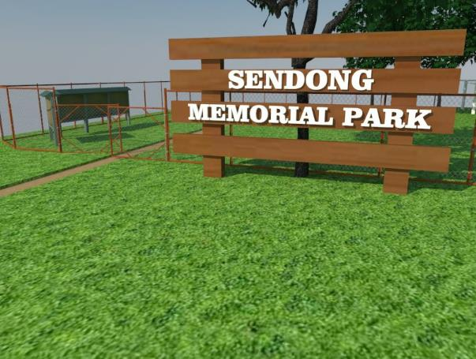
Figure 5.1. The Signage was made of wood. To represent the logs (or locally known as troso) from Bagyong Sendong. The wood that has been used was from a century old house who encountered the catastrophic event

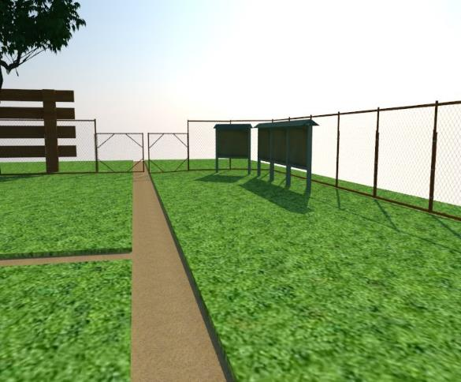
Figure 5.2. Bulletin Board, to put information on the said event and stories of the people. (Maximized view)
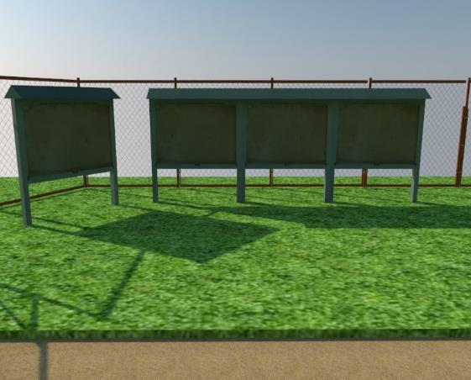
Figure 5.3. Bulletin Board, to put information on the said event and stories of the people (Minimized view)

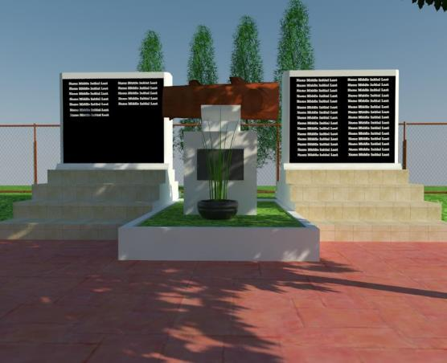
Figure 5.4. The Memorial Wall (Minimized view)

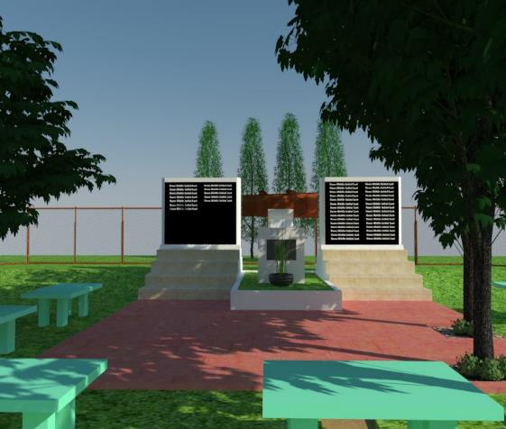
Figure 5.5.The Memorial Wall (Maximized view)

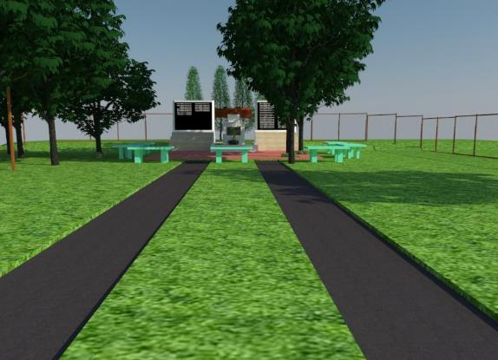
Figure 5.6. Pathway

The Volunteers

One of the goals of the rehabilitation plan of Sendong Memorial Park is to have volunteerism from the community to participate in any activities that they want to be part of. Two activities were documented to have volunteers that participated in the activities that the proponents looked into: the clean-up drive and the tree planting activity. The proponents reached out to these volunteers by posting an invitation and details on the Facebook page. By joining the event, the volunteer must fill up a Google Form that has a consent form, volunteer’s details (name, contact number, email address, etc.), and a survey to determine whether they knew the Sendong Memorial Park considering its location and its features.

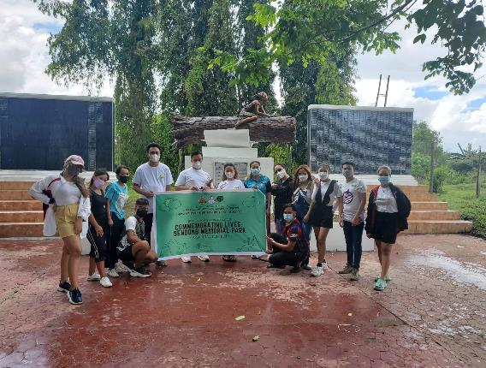
Figure 5.7. The volunteers during the April 2, 2022 Clean-up Drive

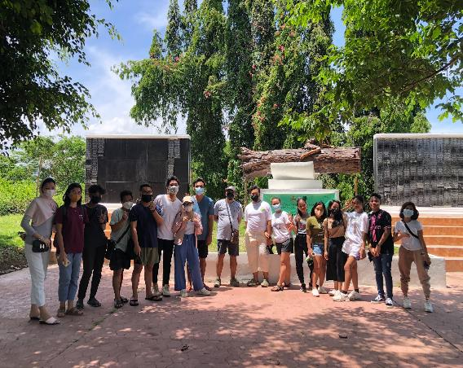
Figure 5.8. The volunteers during the April 23, 2022 Tree planting activity

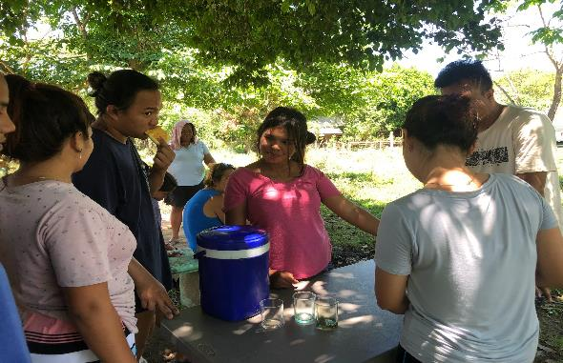
Figure 5.9. Volunteers (people from the community) during the March 23, 2022 Clean-up Drive

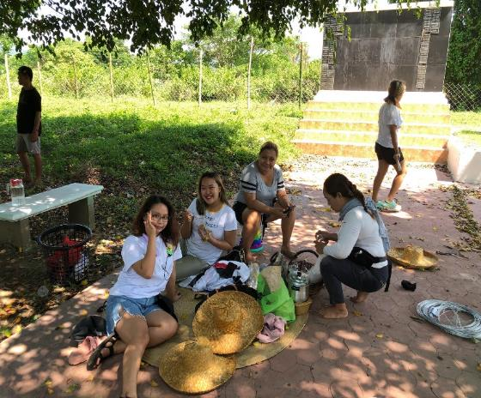
Figure 5.10. Volunteers (proponents relatives) during the April 17, 2022 Clean-up Drive

Clean-up drives

Clean-up drives are the inception of the whole project. Without these activities, the goal of the project will not be accomplished. The first clean-up drive was participated by the local community of Bayug Island, Brgy. Hinaplanon, Iligan City. Their volunteerism in cleaning the memorial park shows their interest and desire to rehabilitate the said memorial park.

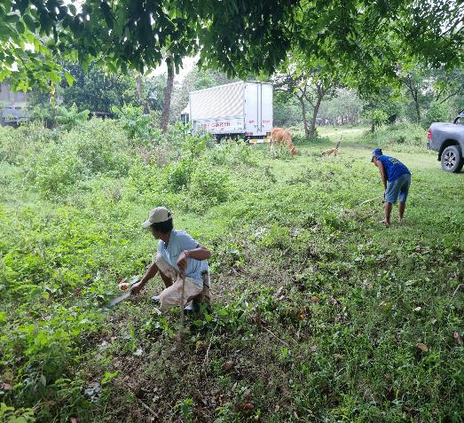
Figure 5.11. Bayug Farmers Association helped in the initial clean-up drive.
Photo taken: March 23, 2022

According to the volunteers, the impact of this clean-up drive on the community is that it can help develop the place they once created as a place for livelihood. Mr. Rogelio Torregosa, the Purok President of Purok Bayug Island, said that the initiative of rehabilitating the place (including the activities on clean-up drives and tree planting) is an excellent plan since it has the goal of making the park a better place, especially when there are events that are to be held in the place. Such as birthdays, all soul’s day, and the anniversary of Bagyong Sendong that also indicate the commemoration of those lives who were claimed during the typhoon.

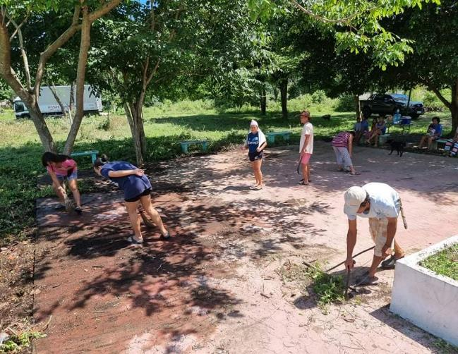
Figure 5.12. The volunteers from the community near the Sendong Memorial Park helped in the initial clean-up drive. Photo taken: March 23, 2022
Next, students from MSU-IIT (from various courses) and the proponents' families clean the memorial wall, re-paint the areas of the memorial wall that were previously painted white, and clear some shrubs surrounding the memorial wall. It happened on April 2, 2022, Saturday with 28 volunteers. It was a half-day event from 7:00 AM - 12:00 NN. Everyone is helping, from cleaning up to painting the untidy walls and borders of the park. Other people from the community are putting up bamboo trunks around the park to support the fence that will soon be built. Its final results were proof of the sincere efforts and participation that everyone is pouring into.
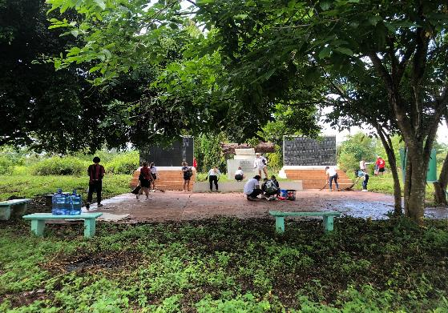
Figure 5.13. The volunteers are cleaning the Sendong Memorial Park grounds
Photo taken: April 2, 2022

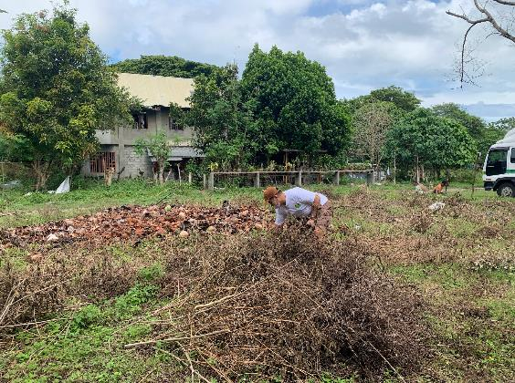
Figure 5.14. Stephen Gabriel Zamora (one of the proponents) gathering the dried bushes
Photo taken: April 2, 2022

The impact on the volunteer’s participation on the clean-up drive settles on the idea that they see this activity as an opportunity to help in cleaning the place with their kind and sincere efforts. Thus, the results are evidence of their participation in achieving a cleaner Sendong Memorial Park. According to Deborah Torres, one of the volunteers, “The clean-up drive on the Sendong Memorial was a great initiative. I didn't know there was a memorial for a typhoon that affected my family and me. As a Typhoon Sendong victim and helping clean the memorial park was like addressing something that I haven't before; it was addressing a traumatic experience in a place where I still live and experience minors na pagbabaha that everyday in our barangay face. The experience was not only about cleaning. It was also about respecting those affected by the typhoon, like paying our respects to those who passed away and appreciating life more than ever. Moreover, it is still a park, still a place where people can muni-muni, stay for a while, and relax. It is a place for everyone, and helping at cleaning it makes me feel proud, knowing that someday someone will be thankful that someone cleaned that place where that person can sit and rest.” Lastly, would be the gradual clean-up drives participated by the proponents' relatives and friends every time there is a particular action taken place inside the memorial park. Like of:

1. Clean -up and fencing
As requested by most people from the community of Purok Bayug Island, a fence would be a great help for the livestock not to enter the premises of the Sendong Memorial Park, which may cause damage and pollution of animal wastes. In this minor activity, the proponents and their families build a fence in the park using a cyclone wire and bamboo trunks for three days.
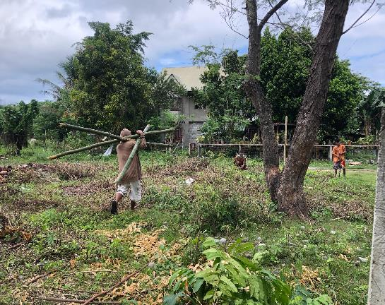
Figure 5.15. The labors that helped in setting up the bamboo foundation of the fence.
Photo taken: April 2, 2022

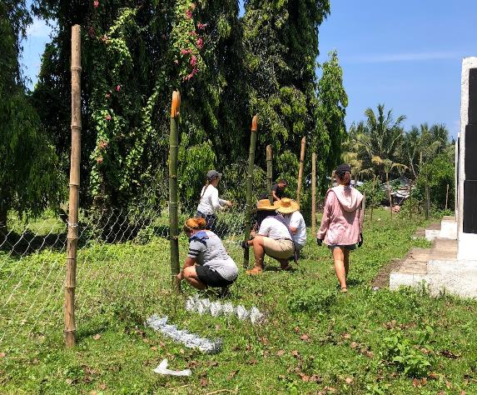
Figure 5.16. The volunteers that helped in setting up the cyclone wire fence.
Photo taken: April 16, 2022

The idea of putting up the fences around the park and with it being actualized is another achievement for one of the goals of this project. The fences may not be that easy to put up as it requires patience, proper materials, and a workforce. As it took a week to set it up, the result is still an achievement for the park and the expectation of the people. According to Mrs. Joan Gamos, “Ang akong maingon sa pag butang ug koral sa park, kay maayo jud labaw na nga makatabang ni para ma pa nindot ang lugar. Kaso lang dili jud ma kontrol ang pag sulod sa mga hayop kay guba-on jud nila. Pero at least nalang na gamay ra ang maka sulod kompara sa una nga mapuno jud sa ilang mga hugaw ang park.” Her claim is the fact that the fence is not that effective in terms of blocking the entry of livestock on the premises of the park. The proponents have seen a few incidents where there are animals that enter the place and pollute it with their body wastes. According to Mr. Rogelio Torregosa, the entry of animals into the place cannot be prevented. Sadly, some parts of the fence were damaged, but the proponents looked into it and resolved as much as they could.

- Clean-up and planting

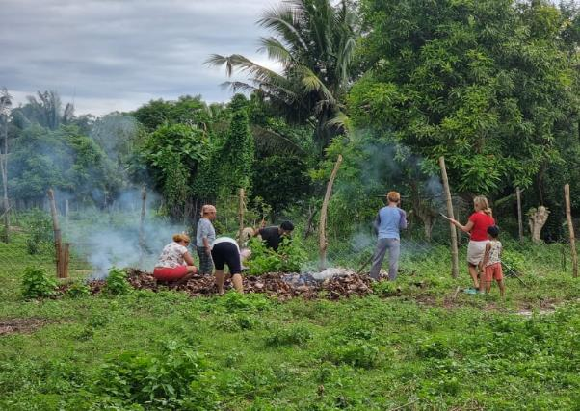
Figure 5.17. The volunteers that helped in clearing the area where the ornamental plants are to be planted.
Photo taken: May 1, 2022

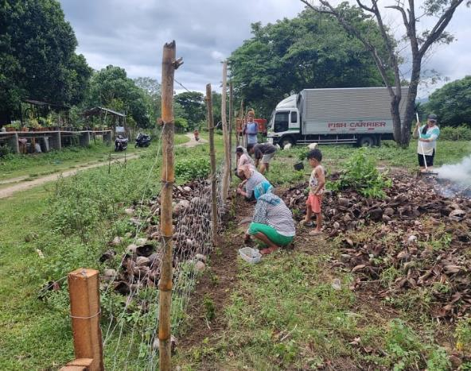

Figure 5.18. The volunteers planted the ornamental plants.
Photo taken: May 1, 2022

Planting ornamental plants alongside the fence in Sendong Memorial Park is suggested by the community. These ornamental plants are believed to help park’s beautification. The santan and other plants planted are donated by the community and Atty. Demosthenes "Demy" R. Plando. Unfortunately, some of the plants did not survive but we have replaced them with marigold seedlings. According to Mrs. Rosaline Ragasajo “ako jud ning gipaningkamotan na matanum og tarung para mutubo siya kay may na lang ni pampadungag kanindot sa park.” Her claim is a proof of sincere participation and contribution towards the park’s development.

Tree Planting Activity

The tree planting activity is thought to aid the environment and beautify the park, involve the public, and promote the fact that there is a memorial park created in this specific location here in Iligan to commemorate the fatalities from Typhoon Sendong. Earth Day is on April 22; the proponents celebrated the event through a Tree Planting Activity on April 23, 2022, Saturday, with 17 volunteers gathered. It was a half-day event from 8:00 AM to 11:30 AM. With 25 Narra tree seedlings given by the Department of Environment and Natural Resources (CENRO-Iligan, DENR), Iligan City, everyone is helping each other in planting the seedlings from making a hole in the ground using a trowel or garden bolo, up to building a tree guard using bamboo sticks and rope. In the end, everyone is making sure that the seedlings are watered.

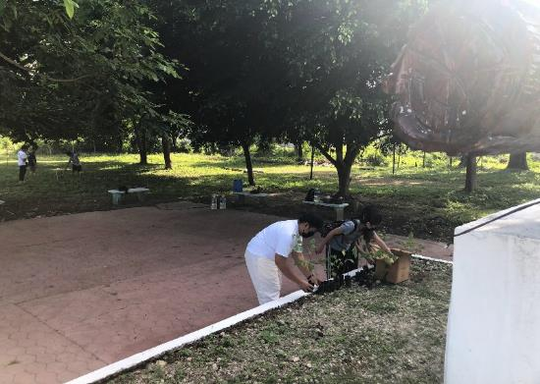

Figure 5.19. The volunteers arranged the Narra seedlings that are to be planted

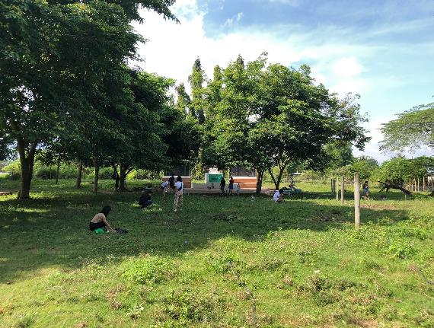
Figure 5.20. The volunteers planted their seedlings in the designated area

The impact of this activity, according to Aivae Tabuclin, one of the volunteers, “As someone who has been a victim of the typhoon Sendong, planting trees has been an essential task in our community, but of course, as I observed, not everyone in our community has been consistently participating in it, maybe they already moved on from the disaster, or they do not want themselves to engage in something that would remind them of the disaster. In encouraging people to engage themselves with such activities, we have to ask ourselves, How is this best promoted? Moreover, I think this special project is a fundamental way to do this. Last April 23, during the Earth Day, I joined the tree planting, and personally, as I planted a tree, I told myself that I was not planting a tree not just because I have been a victim of the disaster but because I believe in this one single seed, the next generations will reap the harvest and children will have a smile on their faces.”

Another sentiment from Ronalie Llaguno, still one of the volunteers, said, "Tree planting was a great opportunity for us – volunteers, to help save our most precious planet in simple ways. Through tree planting, we can help to minimize the effect of floods. Thus, trees are designed to absorb the rainwater that may cause floods in a community, combat climate change, and improve our environment. In particular, Bayug was one of those places with worse conditions during Typhoon Sendong. Sendong Memorial Park is considered the sentimental park in Iligan, and it serves as a place to commemorate those who were victims of the tragic event. Through such activity, we can help improve the park not only to "save the earth" but also make the park more pleasant so that more people may visit and appreciate its value and beauty. As a volunteer, it was indeed a great experience to be part of such a tree-planting activity that may greatly impact both relatives of the victims and the community."

The setting of the Signages

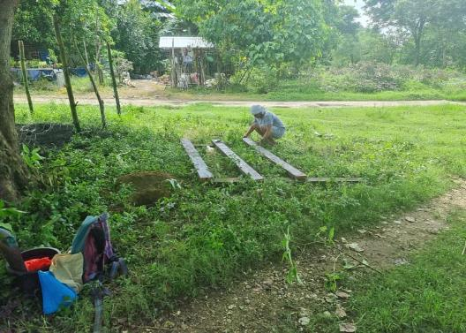
Figure 5.21. The assembling of the signage in the Sendong Memorial Park
Photo taken: May 11, 2022
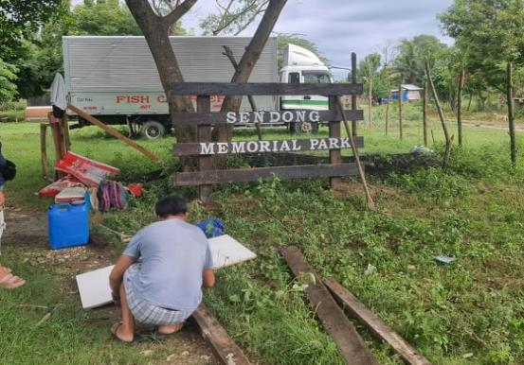
Figure 5.22. The setting up of the signage in the Sendong Memorial Park
Photo taken: May 11, 2022

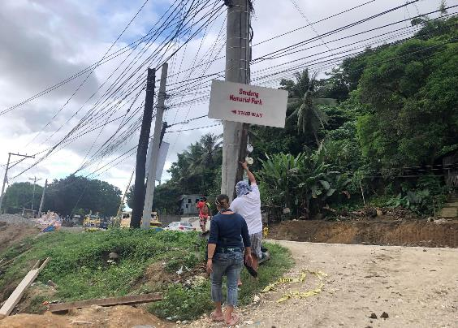
Figure 5.23. The setting up of the signage of the Sendong Memorial Park along the Sta. Filomena, Iligan City highway.
Photo taken: May 11, 2022

Sendong Memorial Park Facebook Page

The Sendong Memorial Park Facebook page, namely Commemorating Lives: Sendong Memorial Park, was made in order to make a connection with the general public, not just in Iligan City, but the whole world, that there is this particular park that was built in order to commemorate the lives that had been claimed during Bagyong Sendong. It was intended to be made for an awareness that the proponents saw the rehabilitation of Sendong Memorial Park as an opportunity to amplify environmental awareness and ethics. In this small way, with a growing community on the media, the proponents can express their intentions that a once nearly-abandoned memorial park was changed because of the special project on rehabilitating the premises.

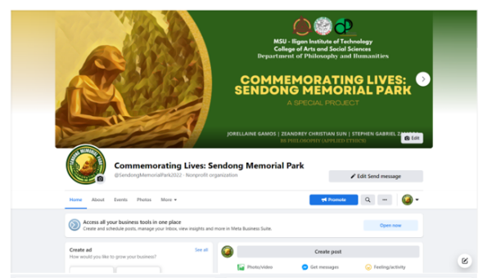
Figure 5.24. The Sendong Memorial Park Facebook Page
(Commemorating Lives: Sendong Memorial Park)


Figure 5. 25. The Sendong Memorial Park Facebook Page: About and Insights
(Commemorating Lives: Sendong Memorial Park)

With enough reactions and shares on the posts, the proponents believed that these small steps would bring a perception of change to the environmental concerns in the community. The page will also be used for invitations to any activities in the park. As such, these activities needed to have volunteers that wanted to participate. The number of engagements, reactions, and participation on this Facebook page has displayed a positive result in Parks promotion. The park visitors are also a positive indicator that the goal of this page: to promote and publicize the Sendong Memorial Park, is achieved.

Before and after photos of the Sendong Memorial Park

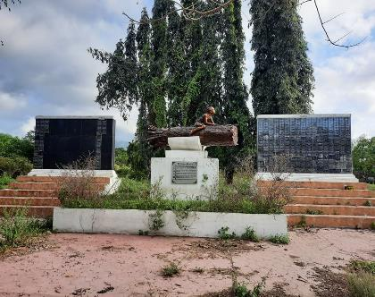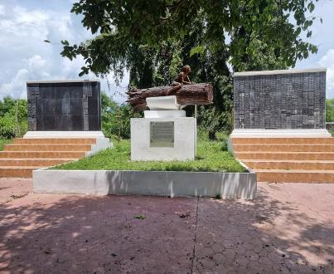
Figure 5.26. The Sendong Memorial Park memorial wall (Before) Figure 5.27. The Sendong Memorial Park memorial wall (After)

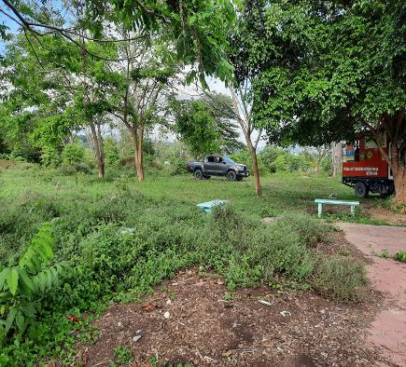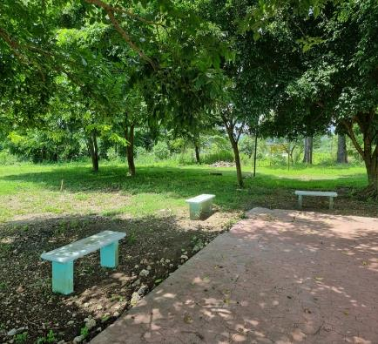
Figure 5.28. The benches on the Sendong Memorial Park (Before) Figure 5.29. The benches on the Sendong Memorial Park (After)

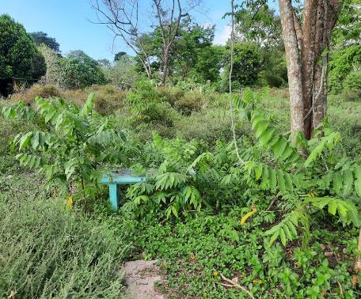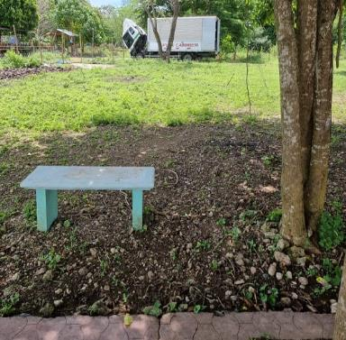
Figure 5.30. The bench on the Sendong Memorial Park (Before) Figure 5.31. The bench on the Sendong Memorial Park (After)

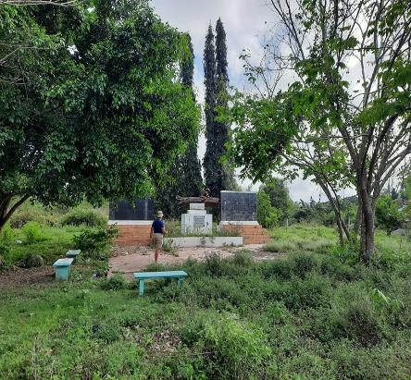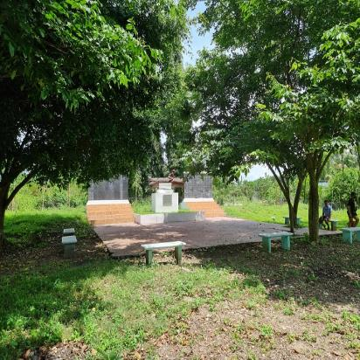
Figure 33. The Sendong Memorial Park memorial ground (Before) Figure 5.33. The Sendong Memorial Park memorial ground (After)

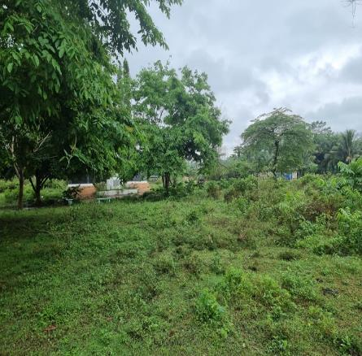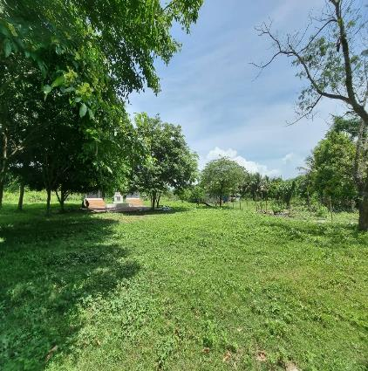
Figure 5.34. The Sendong Memorial Park (Before) Figure 5.35. The Sendong Memorial Park (After)

CHAPTER 6: PHILOSOPHICAL REFLECTIONS ON THE SPECIAL PROJECT

The Sendong Memorial Park is the representation that helps this study identify the connection and the kind of human-nature relationship the victims of Sendong had. The tragic event (Sendong), the experience of the victims, the environmental destruction, and unexpected government and victims actions towards the memorial park are facets to identify the relationship with the environment and the kind of perspective of the Typhoon Sendong victims. Being a victim during Typhoon Sendong is the common denominator of the respondents of this study. All of them are victims, but not all share the same experience and responses. Some have lost all their families; some do not. Some of them had already recovered, some of them still grieving. “What experience suggests about itself is a genuinely objective world which enters into the actions and sufferings of men and undergoes modifications through their responses.”
In line with the goal of this study; is to identify the connection between the experience and the relationship the victims of Typhoon Sendong have with the environment. The proponents would like to showcase the data of findings, analysis, and interpretation of data gathered during the survey and interview conducted. This data is connected to the environment, Sendong Memorial Park and Typhoon Sendong in Bayug Island, Hinaplanon; Deus Caritas, Luinab; Prk. 9 Riverside Bayug, Hinaplanon; and Bayanihan Village, Sta. Elena.

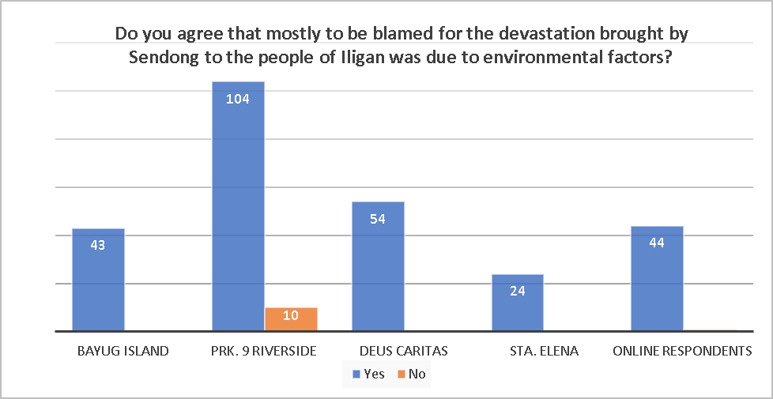
Graph 6.1. Question 1: Do you agree that mostly to be blamed for the devastation brought by Sendong to the people of Iligan was due to environmental factors? Mouyon ba ka na ang buot na ma basol sa epekto sa Sendong sa syudad sa Iligan kaniadto kay mahitungod sa mga pag daot sa atong kinaiyahan?

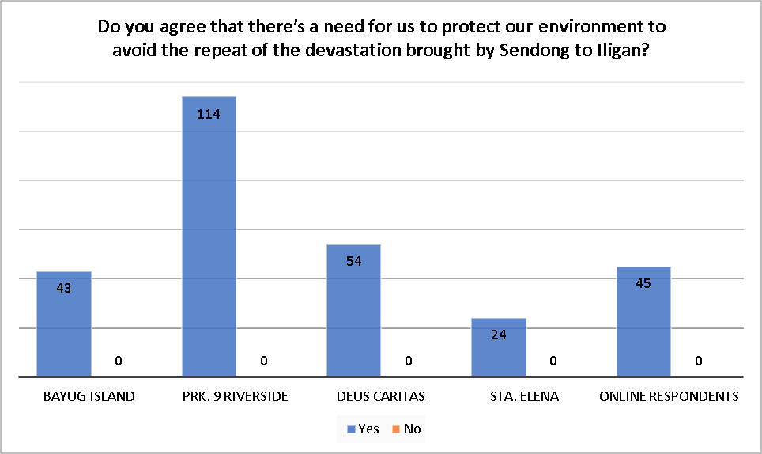
Graph 6.2. Question 2: Do you agree that there’s a need for us to protect our environment to avoid the repeat of the devastation brought by Sendong to Iligan? Mouyon ba ka na adunay kinahanglan na buhaton para sa pag panalipod sa atong kinaiyahan aron nga dili na ma usab pa ang daotan nga panghitabo sa Sendong sa syudad sa Iligan?

Graph 1 presents the awareness of the victims of Typhoon Sendong that one of the significant factors that made the effects of Typhoon Sendong worse and more damaging is the environmental degradation caused by the adverse environmental practices. However, the victims of Typhoon Sendong do not solely blame other people; they have claimed that all of us contribute to the environmental degradation that is happening right now. These are the statements that we want to highlight in regards to the claim stated above, “wala tay lain ma blame sa mga panghitabo na atong nadangatan karon kung dili kita ra sad mga tao, maski sa mga gamay na mga butang na atong gibuhat na makadaut sa kinaiyahan kay sala nana”; “tanan binuhatan nato, mubalik rana sa atoa” and “wala koy lain gibasol gang kung di akong kaugalingon”. These statements are drawn from the small interview during the survey.
Furthermore, Graph 2 indicates that the victims of Typhoon Sendong agreed that there is a need to protect our environment to avoid another catastrophe brought by environmental degradation. However, statements like “dapat lang protektahan kay para dili na magbaha”,”dapat protektahan para mapuslan pa sa sunod na mga henerasyon” and “dapat protektahan para dili na mumahal ang panaliton" showcase an anthropocentric view or treating the environment. This data showcases that some of the victims of Typhoon Sendong have only seen the instrumental value of the environment; “the concept of 'instrumental value' (or extrinsic value) refers to things/people that are valuable because they are the means to what is or is perceived as being good in itself.”
On the other hand, statements like “protektahan sa gobyerno og sa mga katawhan ang kinaiyahan kay kita uban niini”, “ang kinaiyahan gang kung sultihan taka kay kita kana…” and “part man ta sa kinaiyahan gang, maong lisod palandungon na dili ta sama sa uban na mananap na mabuhi na wala nagguba niini”, are statements that are favorable to the view of Deep Ecology, the statements showcase a view that gives intrinsic value to the environment and biocentric worldview. The different outcome of these questions has just proven the claim of Kronlid and Ohman (2012) that the “human-nature relationship should not be understood as a unified environmental ethic and that there should not be a dichotomy in terms of worldview in the environment.” Although most critics view anthropocentrism as a short-sighted dualistic ethic that loves nature only because it meets urgent human needs, anthropocentrism should not be discarded as an environmentally harmful dualistic perspective (Kronlid and Ohman,2012). People may sound biocentric; they may tell us that we are one with nature and value the intrinsic value of the environment, but there are possibilities that the perceptions of the intrinsic value of nature are different from each other. Here are some examples of the different perspectives in valuing the intrinsic value of nature, as cited by Kronlid and Ohman (2012).
Inherent worth. Non-human nature has an objective value of its own
Inherent value. Non-human nature has a socially constructed induced value of their own
Systemic or emergent value. Systems have transactional value of their own that emerges in encounters between the parts of the system
On the other hand, here are the different perspectives of valuing the environment based on its instrumental value, as cited by Kronlid and Ohman (2012).
Demand Value. Natural resources are valued because they satisfy our felt preferences.
Transformative value. Natural resources are valued because our experiences of nature may change our preferences, moral outlooks, and world views.
Constitutive value. Natural resources are valued because the conception of nature is constitutive of being human.
Need Value. Natural resources are valued because humankind is dependent on nature for its essential well-being and survival.
The concept that one environmental worldview is more beneficial to the environment than the other is thought to be incorrect. An anthropocentric viewpoint toward the environment does not always imply being unfriendly to the environment or engaging in harmful environmental practices. Similarly, a biocentric worldview regarding the environment does not necessarily necessitate being more environmentally conscientious and causing more environmental good than individuals with anthropocentric worldviews. Both worldviews have their pros and cons. Let us see, for example, people with an anthropocentric worldview see nature as property; they have a sense of ownership of the environment; a person having property often takes good care of that particular property as this property is helpful to them, and they do not want to damage this property. The example can be contextualized that even if other people see the environment as a mere means to an end, a property does not necessarily entail that the person's goal is to harm the environment. On the other hand, a person whose environmental worldview is biocentric treats the environment as part of the body; it is one with them, or they are part of it; a person sometimes tends to be abusive even to their own body; unintentional or intentionally; a person tend to abuse the body to work for survival. This example means that even if we treat ourselves as part of the environment does not always guarantee a good action toward the environment; we may love it and take care of it, but there is an excellent possibility that we may abuse it.
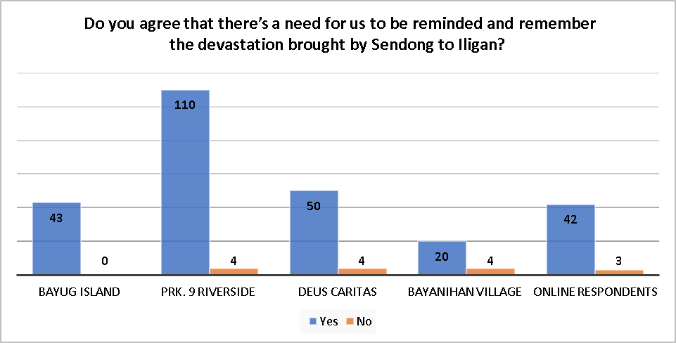

Graph 6.3. Question 3: Do you agree that there’s a need for us to be reminded and remember the devastation brought by Sendong to Iligan? Mouyon ba ka na adunay kinahanglan sa atoa nga paghalandom ug paghinumdom sa panghitabong dili maayo atong sa Sendong?

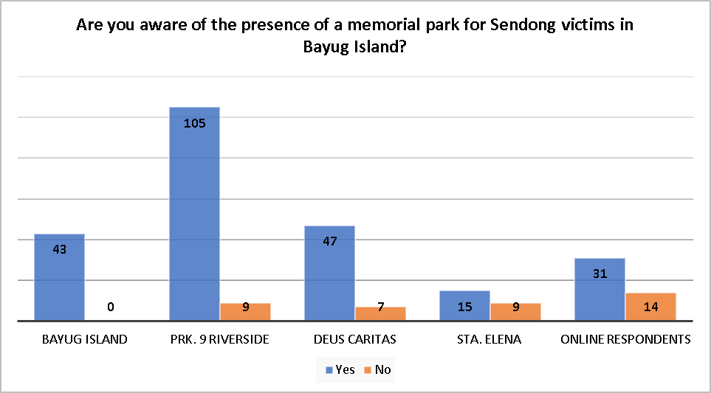
Graph 6.4. Question 4: Are you aware of the presence of a memorial park for Sendong victims in Bayug Island? Nakahibalo ba ka ug presensya sa usa ka memorial park para sa mga na biktima sa Sendong didto sa Bayug Island?

Sendong Memorial Park has not been publicized or endorsed to the Public. The conclusion was drawn out from the statements of the some Sendong Victims that “wala man mi kabalo ana gang kay wala mi giignan ana'‘, “nangita gani mig lugar na macelebrate ang anniversary sa sendong” and “ay naa diay nna gang kanusa sad na gitukod?”. And that even without the knowledge of the existence of the Memorial Park the victims of Typhoon Sendong want something; a representation; that would help them be reminded of the tragic experience. Statements like “bahalag sakit tong Sendong gang, gusto ko makahinumdom ato kay kato ang usa sa mga kaagi na nagpaka-unsa ko karon” and “gusto ko naay memorial park gang kay para didto nako maduaw akong mga anak na na missing pa hangtud karon”.

The data below is believed to identify the connection of the experience, particularly the number of fatalities in the family and how they experienced the Sendong Park. Are they informed of the existence of the park? Do they visit regularly or occasionally in the Memorial Park? Although the connection is not directly proportional and is not uniform to all the respondents, this data would somehow help identify the factors affecting the victims' relationship, information, and knowledge of the Memorial Park.

Informed about the existence of Memorial Park and have gone to the Memorial on every occasion that the family member (who died and went missing) is involved, e.g., anniversaries and birthdays. | They have known the memorial park ever since it was built because they always visit Bayug Island, and some live on Bayug Island.  Treat the Memorial as a place where they can commemorate the lives and memories they have with them before Typhoon Sendong.
Informed about the existence of Memorial Park and have gone to the Memorial once or twice. | They have known the existence of the memorial park ever since it was built  They have been relocated to a place far from Bayug Island and are busy with the new life they are living at the moment  They have found other places to commemorate the lives of the family member (who died and went missing) Typhoon Sendong) every occasion like anniversaries and birthdays.
Informed about the existence of Memorial Park and have not gone to the Memorial even once or twice. | They have known the existence of the memorial park ever since it was built  They have been relocated to a place that is far from the Bayug Island and are busy with the new life they are living at the moment  They Have found other places to commemorate the family member (who died and went missing during Typhoon Sendong) every occasion, like anniversaries and birthdays  Some do not want to treat the family member missing as they do not see them as someone who died.  They do not want to revisit Bayug Island as it would strike emotions that they do not want.
Was not informed of the existence of Memorial Park and is willing to visit the memorial park upon knowing | They have been relocated to a place far from Bayug Island and are busy with the new life they are living.  They have found other places to commemorate the family member (who died and went missing during Typhoon Sendong) every occasion, like anniversaries and birthdays. Some want to commemorate it in the place where the tragedy takes place.  They want to revisit Bayug Island. Although the place would make them strike lots of emotion and memories, they still want to be reminded, especially of the happy memories before Typhoon Sendong
.  We are not informed about the existence of Memorial Park and are not willing to visit the memorial park upon knowing. | They have been relocated to a place far from Bayug Island and are busy with the new life they are living at the moment.  They have found other places to commemorate the family member (who died and went missing during Typhoon Sendong) every occasion, like anniversaries and birthdays.  Some do not want to treat the family member missing as they do not see them as someone who died.  They do not want to revisit Bayug Island as it would strike emotions that they do not want
Table 6.1. The different connections on the existence of Sendong Memorial Park identified by the proponents from the perspective of the respondents
We cannot deny that there is a minority of the respondents who, after almost more than a decade after Typhoon Sendong hit Iligan, they have still not moved on. The word "Sendong" still gives them goosebumps and would always trigger emotions they have long buried. Such information consisting of the knowledge about "Typhoon Sendong" has created its truth. This truth was created because of experience. The word “Sendong” is hurtful to remember as the truths and facts connotated with this word reflect suffering and bad events. The emotion they have felt during Typhoon Sendong is like a demon lurking deep inside them, waiting for a small trigger to eat them up again. They may smile, but their eyes speak a thousand words of longing, guilt, love, and suffering. The tragedy has not just killed a family member but has changed who they are, what they believe, and the way they live.

Experience, according to John Dewey, includes both the idea of the experienced (Typhoon Sendong) and the experiencing (the current life). John Dewey argues that our experiences are connected, related, and continuing. The experience (Typhoon Sendong) that have been experienced by the victims of bagyong sendong is not just a one time experience it is an experience that is continuing, processing this experience (subjectively) still continues up until this moment. Experience is either a reference to differentiate the experience and future experience or dubious the future experience as a mere byproduct of the past experience. “An experience that is undergoing an environment and a striving for its control in new directions is pregnant with connections.” Our experience is intertwined with each other; its connection cannot be identified as a mere connection but as a connection with a connection; however, each experience has its own intrinsic integrity.
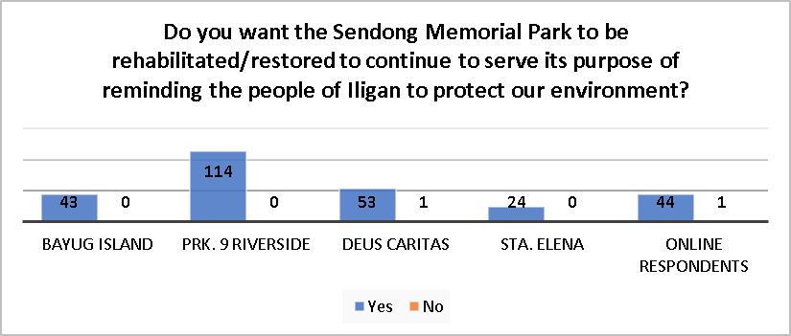
Graph 6.5. Question 5: Do you want the Sendong Memorial Park to be rehabilitated/restored to continue to serve its purpose of reminding the people of Iligan to protect our environment? Gusto ba ka na ma ipatukod pag-usab o ang pag rehabilitasyon ni ini para ma padayon ang pag-alagad sa katuyoan nga paghinumdom sa mga tawo sa syudad sa Iligan nga dapat panalipdan and atong kinaiyahan?
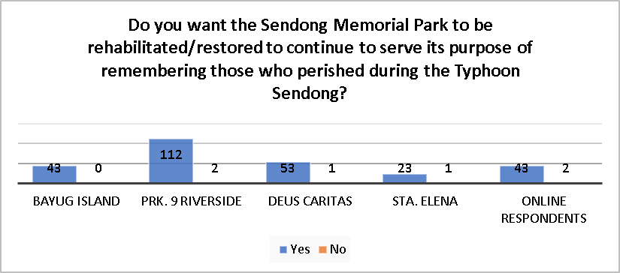
Graph 6.6. Question 6: Do you want the Sendong Memorial Park to be rehabilitated/restored to continue to serve its purpose of remembering those who perished during the Typhoon Sendong? Gusto ba ka na ma ipatukod pag-usab o ang pag rehabilitasyon sa Sendong Memorial Park, para ma padayon ang pag alagad sa katuyoan nga paghalandom sa mga nangamatay ug mga nangawala na biktima sa Bagyong Sendong?

Graph 6.5 and 6.6 indicates that the majority of the Sendong Victim population wants the Sendong Memorial Park to be rehabilitated/restored to continue to serve its purpose of reminding the people of Iligan to protect our environment and of remembering those who perished during the Typhoon Sendong. Additionally, the minority of the respondents that have answered “no” to the question have reasons such as they have lost their hopes that the government and the people would take environmental issues and problems seriously. Hence, they still believe that protecting the environment would help decrease the risk and danger a calamity caused by environmental degradation can cause but have lost hope that; with the current environmental situation the world is facing; people can still save the mother earth. Additionally, respondents have answered “no” because after all these years they still haven’t accept the fact that one of their family members have been missing and dead because of the Typhoon, they can’t still face this reality and being on a place that reminds them of the lives that have been perish is something that they can’t bear.
Hence, the way people have treated Sendong memorial park upon knowing its existence and its history; the hidden meaning behind the park, the history of the place, and the experiences of the name listed on the memorial wall, have showcased how massive the contribution can information and experience brought to realize meanings of a significant phenomenon and structure. Our knowledge, experience, and how we process it are facets of building connections and relationships with other people and nature. Our worldview in terms of our connection to the environment, anthropocentric or biocentric, is seen to not hinder us in participating in the fight against environmental degradation. The war had just begun. A war which we must fight in order to have a future for the next generation (transgenerational anthropocentrism), to fulfill our intuitive inclinations (Demand Value), and to encounters with nature that alters our tastes and moral outlooks, and world views (Transformative value). To fight because the notion of nature is essential to being human (Constitutive value), because humans rely on nature for their essential well-being and survival (Need value), because non-human nature has its objective worth (inherent worth), because non-human nature has its own socially manufactured induced worth (inherent value) and because Systems have a transactional value that derives from interactions between system components. (systemic or emergent value).
Lessons Learned
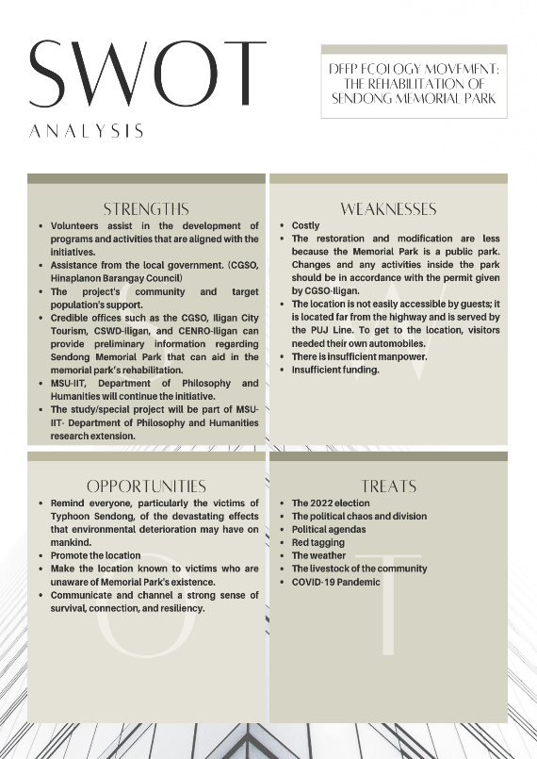
Figure 6.7. SWOT Analysis

There is a lot to learn, even just by doing simple activities. Rehabilitating a dispirited park with a lot of meaning and history has made us reflect, decide and learn many things. We learned:
Little is big.
There is complexity and simplicity. Our project's output may be perceived to be simple, and the changes may not be drastic, but to come up with that simple change takes a lot of effort, brainstorming, consideration, and patience. This narrative of a simple change that needs more extensive effort is applied to the victims of Sendong. We may look at them and question why haven't they moved on? Why do they still suffer from the aftermath of the Typhoon Sendong? When it has already been a decade. The metamorphosis of a particular being does not need to be prominent, noticeable, and grandiose. A slight chance that every being partakes in is a significant change and an important step to rise again after they fall.
Appreciation.
Appreciation of the plan, of the perceived project, of the aim, and of the efforts spent in every modification that has occurred is critical to the success of a project. The beauty of a project cannot be seen if the people seeing it are uninterested, if one's mind is too close to notice everything, and if the person viewing it does not appreciate anything about it. People tend to forget "meanings." They forget that each thing carries meaning, and it takes a creative mind to notice and understand it, and its meaning varies depending on how one perceives it. The Sendong Memorial's state was appalling. It was so sad to think that this piece of land full of meaning, art, and memory had been here, not being recognized and celebrated.

CHAPTER 7: SUGGESTIONS AND RECOMMENDATION

Fence. The fence that has been established in Sendong Memorial Park is not strong enough to handle the livestock from coming in. We suggest that if there is a plan of re-fencing the area, please do use complex and robust materials.

Promotion. The Sendong Memorial Facebook page is a venue to promote and discuss matters involving the memorial park. We suggest constantly updating the Facebook page so that the people engaging the page will not think that the page is inactive.

Paying attention to ethical dilemmas happening on environmental practices. There are lots of ethical dilemmas concerning environmental practices. The morality of whether a practice is considered to be morally immoral. What would be the basis in saying an environmental practice is negative not?. Illegal poaching of trees in between the boundaries of Iligan City, Bukidnon, and Lanao del Sur (CENRO-Iligan, DENR), is allegedly caused by poverty, demand, and expansion of agricultural lands of the hinterlands because of the increase in the demand for crops caused by the increase in their population, is one of an adverse environmental practice that is burden with an ethical and legal dilemma. Illegal poaching of trees has allegedly worsened the effect of Typhoon Sendong; the logs that have been stored have been washed out together with the floodwater. Pouching of trees do not use heavy equipment to cut trees; the intention is not to destroy the environment but to survive; they value the intrinsic value of nature (Demand Value and Need Value); this is the point where questions like “Are they ethically condemnable of this action?” is to be raised.

Paying attention to the notion of representation, symbolism and aesthetics in the Sendong Memorial Park. The notion of representation seems to be very critical in finding how the Sendong Victims perceive the meaning of the park. The proponents have failed to discuss this notion as the study is only limited in identifying the kind of human-nature relationship of the Typhoon Sendong Victims. The study only focuses on the experience of the Sendong Victim (the Typhoon Sendong).

BIBLIOGRAPHY

Amazona, R. (2019). Gov't completes rehab of Leyte's MacArthur Park. Philippine News Agency. Retrieved March 2022, from https://www.pna.gov.ph/articles/1083086
Bhandari, P. (2022, May 7). Ethical considerations in research: Types & examples. Scribbr. Retrieved May 16, 2022, from https://www.scribbr.com/methodology/research-ethics/#:~:text=What%20are%20ethical%20considerations%20in,for%20harm%2C%20and%20results%20communication
Carrey, T. (2019). The Fight to End Illegal Logging. Freethink. Retrieved March 2022, from https://www.freethink.com/environment/illegal-logging.
CDODev (2012). Sendong Memorial Wall unveiled. CDODev.Com. Retrieved March 2022, from http://www.cdodev.com/2012/12/17/sendong-memorial-wall-unveiled/
Dalupang, J.M. (2012). UP geologist: Residents warned of ‘SENDONG’ disaster in 2009. Tinigngplaridel.net. Retrieved March 2022, from https://www.tinigngplaridel.net/2012/up-geologist-residents-warned-of-sendong-disaster-in-2009/
Dewey, J. (n.d.). The Need for A Recovery of Philosophy. classes.matthewjbrown.net. Retrieved March 2022, from http://classes.matthewjbrown.net/teaching-files/american/Dewey-Recovery.pdf
Drengson, A. and Devall, B. (2008). The Long-Range Deep Ecology Movement. The Ecology of Wisdom. Berkeley CA. Counterpoint Press. pp. 97-141

Drengson, A. (n.d.). ‘The Deep Ecology Movement.’ The Trumpeter. Retrieved April 2022. from http://trumpeter.athabascau.ca/index.php/trumpet/article/view/313/1249 .1995

Drengson, A. (n.d.). Some Thought on the Deep Ecology Movement. Retrieved April 2022. from http://environment-ecology.com/deep-ecology/786-some-thought-on-the-deep-ecology-movement.html. 2012
Encyclopædia Britannica, Inc. (n.d.). Deep ecology. Encyclopædia Britannica. Retrieved March 2022, from https://www.britannica.com/topic/deep-ecology
Frey, R. and Wellman C. (2003). Environmental Ethics. A Companion to Applied Ethics. United Kingdom. Blackwell Publishing Ltd.. 2003. pp. 633-649
Gomez, H. and Albasin, G. (2022). Misamis Oriental turns Cebu Pacific 387 crash site into tourism hub 24 years later. Rappler. Retrieved March 2022, from https://www.rappler.com/nation/misamis-oriental-turns-cebu-pacific-387-crash-site-tourism-hub-2022/
Harding, S. (nd). ‘What is Deep Ecology?’. Retrieved March 2022, from https://www.schumachercollege.org.uk/learning-resources/what-is-deep-ecology . n.d.
Huang, L. and Chen, S. (2019). What makes tree poachers give up? A case study of forestry law enforcement in Taiwan. Environmental conservation. Cambridge Core. Retrieved March 2022, from https://www.cambridge.org/core/journals/environmental-conservation/article/what-makes-tree-poachers-give-up-a-case-study-of-forestry-law-enforcement-in-taiwan/4460A7B3AF50F60625A8458555638B6C
Knollwood Memorial (2015). What is a Memorial Park? Retrieved March 2022, from https://knollwoodmemorial.com/about/what-is-a-memorial-park/#:~:text=The%20concept%20of%20a%20memorial,the%20memory%20of%20loved%20ones.
Kronlid, D. and Ohman, J. (2012). An environmental ethical conceptual framework for research on sustainability and environmental education. Environmental Education Research. Retrieved March 2022, from https://www.researchgate.net/publication/254250910_An_environmental_ethical_conceptual_framework_for_research_on_sustainability_and_environmental_education.
Law Insider (n.d.). Memorial Park definition. Retrieved March 2022, from https://www.lawinsider.com/dictionary/memorial-park
Madsen, P. (2016). A Focus on The Biosphere. Deep Ecology: Environmental Philosophy. Encyclopedia Britannica Inc.. Retrieved March 2022, from https://www.britannica.com/topic/deep-ecology
Martorano, J. (2018). Think like a mountain. Retrieved March 2022, from https://www.tapinto.net/towns/yorktown/articles/think-like-a-mountain
Mindanao, Inquirer (2014). What Went before: Tropical Storm 'Sendong'. INQUIRER.net. Retrieved March 2022, from https://newsinfo.inquirer.net/659878/what-went-before-tropical-storm-sendong.
Mindanaoan, I. (2012). Sendong Memorial in Iligan City. Mindanaoan. Retrieved March 2022, from https://www.mindanaoan.com/2012/12/sendong-memorial-in-iligan-city/
Næss, A. (1973). 'The Shallow and the Deep, Long-Range Ecology Movement.' Inquiry 16. pp. 95-100.
Naess, A. and Rothenberg, D. (1989). Fact and value; basic norms. Ecology, Community and Lifestyle: Outline of An Ecosophy. United Kingdom. Cambridge University Press. pp. 68-86
Naess, A. and Haukeland, P. (2008). A Feeling for All Living Beings. Life's Philosophy: Reason and Feeling in a Deeper World. Athens, Georgia. Georgia University Press. pp. 108-111
Piechowiak, M. (2019). Countries Using Vertical Farming. Vertical Farming Planet. Retrieved January 2022, from https://verticalfarmingplanet.com/countries-using-vertical-farming/#:~:text=Currently%2C%20the%20country%20with%20the,%2C%20UK%2C%20and%20the%20Netherlands.
Porro, K. (n.d). Julie Lluch Dalena. AWARE Women artists / Femmes artistes. Retrieved March 2022, from https://awarewomenartists.com/en/artiste/julie-lluch-dalena/.
Rasquinho, O., Liu, J., and Leong, D. (2013). Assessment on Disaster Risk Reduction of Tropical Storm Washi. Tropical Cyclone Research and Review. Retrieved February 2022, from https://www.sciencedirect.com/science/article/pii/S2225603218300808.
Stenmark, M. (2016). Environmental ethics and policy-making. Routledge, Taylor & Francis Group.
Sunstar (2014). Of cemeteries and Memorial Parks. SUNSTAR. Retrieved March 2022, from https://www.sunstar.com.ph/article/361603/of-cemeteries-and-memorial-parks
The Memorial | National September 11 Memorial & Museum (n.d.). The Memorial. Retrieved March 2022, from https://www.911memorial.org/visit/memorial
Ward, L. (2010). John Dewey: The Need for A Recovery of Philosophy. The Mead Project. Retrieved March 2022, from https://brocku.ca/MeadProject/Dewey/Dewey_1917b.html.
White, R. D. (2014). Environmental harm: An eco-justice perspective. The Policy Pres

“Assessment on Disaster Risk Reduction of Tropical Storm Washi”, ScienceDirect, Las Modified September 2013, https://www.sciencedirect.com/science/article/pii/S2225603218300808
“A Focus on The Biosphere”, Deep Ecology: Environmental Philosophy, Encyclopedia Britannica Inc., Retrieved March 2022, from https://www.britannica.com/topic/deep-ecology
“Illegal poaching”,CENRO-Iligan, Department of Environment and Natural Resources (DENR)
"WHAT WENT BEFORE: Tropical Storm ‘Sendong’”, Inquirer.Net, Accessed May 2022, https://newsinfo.inquirer.net/659878/what-went-before-tropical-storm-sendong
Ibid.
Ibid.
Madsen, Peter (2016). A Focus on The Biosphere. Deep Ecology: Environmental Philosophy. Encyclopedia Britannica Inc.. Retrieved March 2022, from https://www.britannica.com/topic/deep-ecology
Næss, Arne (1973). 'The Shallow and the Deep, Long-Range Ecology Movement.' Inquiry 16. pp. 95-100.
Ibid.
“What is Deep Ecology?”, Schumacher College, Retrieved March 2022, https://www.schumachercollege.org.uk/learning-resources/what-is-deep-ecology
“An environmental ethical conceptual framework for research on sustainability and environmental education”, Environmental Education Research, Accessed February 2022, https://www.researchgate.net/publication/254250910_An_environmental_ethical_conceptual_framework_for_research_on_sustainability_and_environmental_education
Ibid.
Ibid.
“Ethical Considerations in Research | Types & Examples”, Scribbr, Accessed May 2022, https://www.scribbr.com/methodology/research-ethics/#:~:text=What%20are%20ethical%20considerations%20in,for%20harm%2C%20and%20results%20communication
“Deep Ecology”, Environment And Ecology, accessed May 2022, http://environment-ecology.com/deep-ecology/74-deep-ecology.html
“Deep Ecology”, Britanicca, accessed May 2022, https://www.britannica.com/topic/deep-ecology
“Environmental Degradation” General Multilingual Environmental Thesaurus, accessed May 16, 2022, https://www.eionet.europa.eu/gemet/en/concept/15154#:~:text=Environmental%20degradation%20is%20a%20process,or%20caused%20by%20human%20activities.
White, R. D. (2014). Environmental harm: An eco-justice perspective. The Policy Press. pp. 56
“Of cemeteries and Memorial Parks”, Sunstar, Retrieved March 2022, https://www.sunstar.com.ph/article/361603/of-cemeteries-and-memorial-parks
“Julie Lluch Dalena”, Aware, Accessed May 16, 2022, https://awarewomenartists.com/en/artiste/julie-lluch-dalena/
“TS Sendong Memorial''. Sendong Memorial Park. Julie Lluch’s Sculpture on the girl that rides the log with a snake at her back using a bronze material, Established December 11, 2012
“The Shallow and the Deep, Long-Range Ecology Movement”, Inquiry 16, pp. 95-100, Næss, Arne (1973).
“The Memorial”, The Memorial | National September 11 Memorial & Museum, Retrieved March 2022, https://www.911memorial.org/visit/memorial
“Sendong Memorial Wall unveiled”, CDODev.Com, Retrieved March 2022, http://www.cdodev.com/2012/12/17/sendong-memorial-wall-unveiled/
“Gov't completes rehab of Leyte's MacArthur Park”, Philippine News Agency, Retrieved March 2022, from https://www.pna.gov.ph/articles/1083086
“Misamis Oriental turns Cebu Pacific 387 crash site into tourism hub 24 years later”, Rappler, Retrieved March 2022, https://www.rappler.com/nation/misamis-oriental-turns-cebu-pacific-387-crash-site-tourism-hub-2022/
“What is a Memorial Park?”, Knollwood Memorial, Retrieved March 2022, https://knollwoodmemorial.com/about/what-is-a-memorial-park/#:~:text=The%20concept%20of%20a%20memorial,the%20memory%20of%20loved%20ones
Rosaline Ragasajo, interview by proponents, Iligan City, May 12, 2022
Rogelio Torregosa, interview by proponents, Iligan City, May 12, 2022
Deborah Trixie Torres, interview by proponents, Iligan City, May 17, 2022
Rosaline Ragasajo, interview by proponents, Iligan City, May 12, 2022
Aivae Tabuclin, interview by proponents, Iligan City, May 17, 2022
Ronalie Llaguno, interview by proponents, Iligan City, May 17, 2022
John Dewey, “The Need for a Recovery of Philosophy”, in Bernstein (1960), p. 23.
“An environmental ethical conceptual framework for research on sustainability and environmental education”, Environmental Education Research, Accessed February 2022, https://www.researchgate.net/publication/254250910_An_environmental_ethical_conceptual_framework_for_research_on_sustainability_and_environmental_education
“An environmental ethical conceptual framework for research on sustainability and environmental education”, Environmental Education Research, Accessed February 2022, https://www.researchgate.net/publication/254250910_An_environmental_ethical_conceptual_framework_for_research_on_sustainability_and_environmental_education
Ibid.
Dewey, “The Need for a Recovery of Philosophy”, in Bernstein (1960), p. 23

