ParallelEarthDAO: An AI-Powered Digital

Abstract
Governance systems are becoming more complex due to rapid urbanization and changing socio-economic conditions. Traditional methods depend on historical data and expert judgment, which makes it tough to predict the long-term effects of policy decisions. While technologies like Digital Twins, Multi-Agent Systems, DAOs, and Large Language Models show promise on their own, their use together for governance simulation is still limited. This paper introduces ParallelEarthDAO, an AI-powered Digital Twin framework. It combines Multi-Agent Systems, DAO-based governance, and Explainable AI into one decision-support platform. This framework allows for the simulation of policy scenarios, collaborative evaluation by intelligent agents, and clear recommendations before decentralized voting. Explainable AI provides transparency in decision-making, while the Digital Twin illustrates policy impacts in an interactive way. ParallelEarthDAO brings these technologies together in one framework for simulating governance scenarios. It supports informed and transparent decision-making, laying the groundwork for future intelligent governance systems.

Keywords: Digital Twin, Multi-Agent Systems, DAO Governance, eXplainable Artificial Intelligence, Large Language Models, Governance Simulation, Decision Support Systems, Blockchain.

1 Introduction
The rapid growth of urban populations, increasing policy complexity, and rising public expectations have significantly changed modern governance systems [11]. Governments must consider many factors, such as economic growth, environmental sustainability, public welfare, healthcare, education, and resource management, when making decisions [11]. Traditional governance methods rely on historical data, statistical analysis, and expert judgment [2],[11], but they often struggle to evaluate multiple policy options and predict long-term outcomes effectively [2]. Recent advancements in artificial intelligence (AI), Digital Twin technology, Multi-Agent Systems (MAS), blockchain, and Large Language Models (LLMs) have opened new doors for smart governance [1],[9],[13]. Digital Twins create virtual representations of realworld systems for simulation and predictive analysis [1],[3] ,but current uses mainly focus on infrastructure instead of governance [4].[5], Multi-Agent Systems model stakeholders as independent agents, allowing for more realistic simulations of governance interactions [9],[10]. Blockchain and Decentralized
Autonomous Organizations (DAOs) bring transparency and decentralized decision-making, although most research targets finance and voting systems [6][7]. At the same time, LLM-based Explainable AI improves decision support by analyzing policies and offering clear recommendations [11][12][15]. Despite these advancements, many of these technologies are developed separately [10][13]. Few studies combine Digital Twins, Multi-Agent Systems, DAO governance, and Explainable AI into a single framework for policy simulation and evaluation [10][14][15]. To fill this gap, this paper proposes ParallelEarthDAO, an AI-powered Governance Digital Twin framework that merges these technologies into one decision-support platform . The framework allows for the simulation of governance scenarios, collaborative evaluation by intelligent agents, and clear policy recommendations before realworld application. The main contributions of this work are:
- A unified Governance Digital Twin framework that combines Digital Twins, Multi-Agent Systems, DAO governance, Explainable AI, and policy simulation • A Multi-Agent architecture that represents diverse governance stakeholde.
- An Explainable AI module for clear policy analysis and prediction.
- A simulation engine for assessing multiple policy scenarios.
- A scalable framework for future smart governance systems.
The rest of this paper is organized as follows. Section II reviews related work. Section III presents the ParallelEarthDAO framework. Section IV describes the methodology. Section V discusses system components, followed by future work and conclusions in Sections VI and VII.

2 Literature Review
Recent trends in smart governance are found in the area of Digital Twins, Multi-Agent Systems, governance through (for) blockchain, and Explainable AI [1][9][13]. Although all have potential, their links are currently weak [10]. This section summarizes landmark work relevant to our background.
- Digital Twin : Digital Twin is a digital replica of physical assets to monitor the system and simulate how it will behave [3]. They help with smart city management through data, sensor and simulation tool integration [1][4]. However, most applications are infrastructure-focused rather than governance-focused [2][5].
- Multi-Agent Systems for Governance DecisionMaking : Multi-Agent Systems treat stakeholders as fully autonomous agents, allowing for more realistic simulation of social and governance processes [10]. Recent work combines reasoning and coordination LLMs [9][12] but does not link these with Digital Twins nor decentralized governance systems [9][13].
- Governance and Blockchain-Based Decision Making for DAOs : DAOs allow secure and transparent decision-making with the help of blockchain [13]. Some studies highlight progress on voting systems [6][7] but mostly concentrates on security rather than exploring policy simulation governance results [8][14][15].
- Explainable Artificial Intelligence for Decision Support : Interpretable insights improve decisionmaking by explainable AI and large language models (LLMs) [11][12]. Although our technology is extensive for multi-tasking, its sample applications in governance simulation and integrated systems are still novel [11][12].
Existing studies treat these technologies in isolation or with limited integration into a unified governance framework [10][14]. This gap can be filled with the proposed ParallelEarthDAO framework, which combines Digital Twins, Multi-Agent Systems to govern them with DAO and Explainable AI to provide support for transparent and data-driven policy evaluation.

3 Proposed Framework
This paper presents ParallelEarthDAO, an AIpowered Governance Digital Twin framework. It combines Digital Twin technology[3], Multi-Agent
Systems (MAS)[9], Explainable Artificial Intelligence
(XAI)[12], and DAO-inspired governance methods[13] into one decision-support platform.
This framework allows policymakers to assess governance proposals in a virtual space before putting them into action. It helps reduce uncertainty and improve decision quality. Unlike typical Digital Twin systems that mainly monitor infrastructure or visualize urban areas[2], ParallelEarthDAO models governance entities as smart autonomous agents[10]. These agents can interact, think, and work together to evaluate policy proposals. The framework constantly simulates the impacts of governance decisions across various societal sectors while offering clear recommendations using Large Language Models[12]. The main goal of the proposed framework is to support intelligent governance through simulation-driven policy evaluation, decentralized decision support, and transparent AI reasoning.

3.1 Overall Framework Architecture
The proposed framework consists of 6 major layers. Let’s understand each one of them.
- Governance Proposal Layer : Proposals of different kinds of initiatives like healthcare, infrastructural developments, educational bills or public welfare programs, are given by administrators or decentralized authorities.
- Explainable AI Analysis Layer : The given proposals are analyzed by Large Language Model[12] to understand and identify objectives, affected shareholders, expected results, possible limitations and implementation risks. The AI also describes the policy in natural words.
- Multi-Agent Simulation Layer : Specialized autonomous agents that represent different Governance shareholders take part in the simulation[9]. Agents like Citizen Agents, Economic Agents, Environmental Agents, Healthcare Agents, Education Agents, and Government Administration Agents. Each agent analyses the objectives and constraints and hence concludes while interacting with other agents.
- Governance Digital Twin Layer : In this layer, the virtual representation of aspects like citizen satisfaction, environmental sustainability, healthcare, etc., results are simulated and updated.
- DAO Governance Layer : Here decentralized decision-making process inspired by DAO governance[13] is followed. Outcomes are determined based on shareholders responses and predefined decision rules.
- Visualization and Decision Support Layer : In this layer, dashboards, governance indicators, and Digital Twin visualization of cities are upgraded and degraded depending upon the outcome of the vote.
3.2 Framework Workflow The proposed framework's sequential steps are :
Step 1: Submission of a governance proposal.
Step 2: AI-based proposal understanding and policy summarization.
Step 3: Distribution of the proposal to multiple autonomous governance agents.
Step 4: Independent evaluation and interaction among agents.
Step 5: Digital Twin simulation of governance outcomes.
Step 6: Governance score calculation and impact assessment.
Step 7: Explainable AI generates policy recommendations.
Step 8: DAO-inspired voting and governance decision.
Step 9: Visualization of simulation outcomes through the Governance Digital Twin.
This flow enables governance to have a new vision about the implementation of any new policy. Experimenting with policies in a digital environment before the real-world environment.
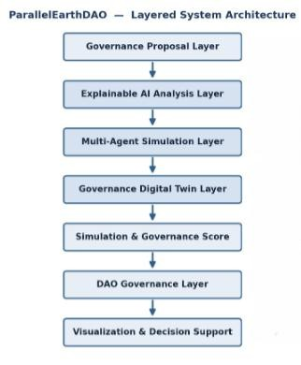
Figure 1: Overall Layered system architecture

4 Research Methodology
This research adopts a simulation driven methodology, where it combines - Digital Twin Technology[3], DAO principles[13], Explainable AI, and MultiAgent Systems[9]. The proposals are introduced in the Digital Twin phase, where Explainable AI analyzes each objective and affected sectors. Then these proposals are distributed among different specialized agents which represnt different shareholders.
Now each agent evaluates the objectives depending upon their character (pre-defined rules) leading to realistic governance behaviour. Now these are converted into different governance indicators which reflect education sector, healthcare, environmental and administrative impacts. Explainable AI interprets these results and provides with recommendations before DAO-inspired voting begins. This will help governments to test multiple policy alternatives in a virtual environment without affecting real environment.
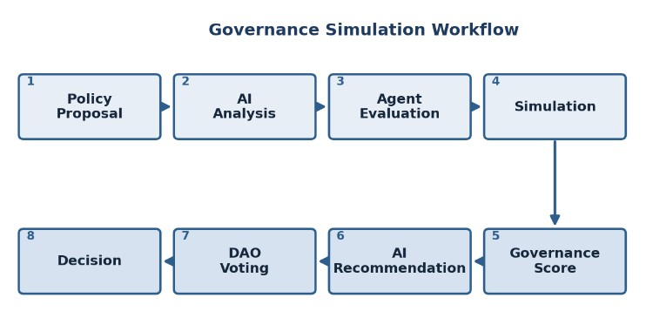
Figure 2 Sequential workflow of ParallelEarthDAO

4.1 Governance Score Model
To quantitatively evaluate governance performance, a Governance Score (GS) is introduced. That is: GS = αE + βS + γEnv + ΔH + δC where,
- E = Economic Impact
- S = Social Impact
- Env = Environmental Sustainability
- H = Healthcare and Public Services
Performance
- C = Citizen Satisfaction
Description | Weig  ht
Fiscal cost, growth and budgetary | α
Effect on citizens and social equity | β
Ecological sustainablity affect | γ
Effect on healthcare and public service | Δ
Overall public satisfaction | δ
Table 1 : Parameters and public scores
The weight coefficients α + β + γ + Δ + δ = 1 allow policymakers to prioritise different governance objectives depending on the application scenario. A higher governance score indicates a better outcome. 4.2 Experimental Methodology
The proposed objective will be validated through a simulation-based evaluation system.
Governance scenarios like - Health care expansion, Budget allocation for education, Industrial development, Public transport improvement, Green energy investing.
Each scenario will be evaluated using the proposed Governance Score and also with additional performance indicators, which include - Citizen Satisfaction, Economic Stability, Environmental Sustainability, Policy Success Rate, Efficient Administration, AI Recommendation Confidence Level
The simulation results generated by ParallelEarthDAO will be compared across different policy alternatives to determine their expected governance effectiveness. 5 Proposed System Components
ParallelEarthDAO consists of 5 core functional components. They work collaboratively for an efficient output. Briefing about each one : 5.1 Governance Digital Twin
Virtual representation of governance ecosystem, which actually calculates all kinds of changes possible in real world and finally present a digital visual representation, it represents the state of multiple governance indicators, with visual affects on shareholders and policy evolution[1].

5.2 Multi-Agent Simulation System
Multi-Agent simulation engine represents various characters, also known as shareholders. Each of them has their pre-defined policies, decision-making capabilities, and certain behavioural rules, hence the agents continuously cooperate and simulate real-time governance dynamics[10].

5.3 Explainable AI Decision Support
Explainable AI modules, Large Language Models, and hence analyze governance objectives, summarize the responses of the shareholders, predict the outcomes, and provide recommendations.
It also starts a debate between different shareholders and hence concludes in the end. Along with recommendations[12], it also justifies why it took a particular decision.
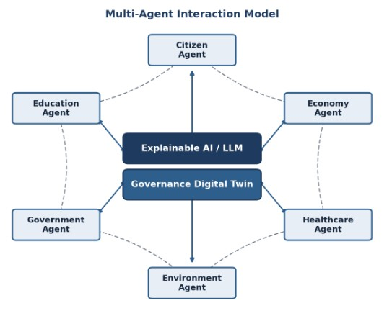
Figure 3 : Multi-Agent interaction within Governance Digital Twin

5.4 DAO Governance Module
The DAO Governance Module introduces decentralized policies through proposal and objective management along with voting mechanisms[13]. Governance proposals are evaluated using stakeholder responses and Governance Scores before entering the voting phase. This promotes transparency and collaborative decision-making.

5.5 Visualization and Analytics Dashboard
This Layer presents governance indicators, simulation outputs, success rate scores, objective comparisons, and shareholder interaction through a dashboard.

6 Future Work
Future work includes integrating real-time smart city data streams and heterogeneous governmental datasets to improve simulations, applying advanced multiagent learning techniques such as reinforcement learning, evolutionary learning, collaborative decision-making, and adaptive behavior.
Implementing blockchain-based smart contracts, strengthening decentralized governance, ensuring transparency, traceability, and automated execution, enhancing Explainable AI through the integration of Retrieval-Augmented Generation (RAG), connecting to external knowledge bases, and incorporating citizen sentiment feedback, inclusiveness, and real-time applicability.

7 Conclusion
ParallelEarthDAO framework, which is based on Digital Twin, Multi-Agent Systems, DAOs, and Explainable Artificial Intelligence, was discussed in this paper. ParallelEarthDAO framework was created to help the government make the right decisions regarding governance by providing simulations and evaluations of governance scenarios, along with AIgenerated suggestions on how to manage situations.
Many different approaches were worked on and researched, but the combination of exploring the unified framework of all 4 technology was never proposed before. It means that ParallelEarthDAO can be viewed as the first attempt to build such a framework with the help of intelligent stakeholder modeling, decentralized policy evaluation, explainable reasoning, and Digital Twin visualization.
The creation of the proposed framework allows laying the groundwork for future intelligent governance systems, which would help policymakers in evaluating different governance scenarios and making decisions without any uncertainty. Though the current study offers only a theoretical framework for future work, it has already provided a basis for implementing, testing, and deploying this framework in smart governance systems.

References
- L. Adreani, P. Bellini, M. Fanfani, P. Nesi, et al., "Smart City Digital Twin Framework for Real-Time Multi-Data Integration and Wide Public Distribution," 2024. - https://doi.org/10.1109/access.2024.3406795
- M. A. Fuller, A. Fan, C. Day, and C. Barlow, "Challenges of Urban Digital Twins: A Systematic Review and a Delphi Expert Survey," 2023. - https://doi.org/10.1016/j.autcon.2022.104716

- Y. Liu, X. Zhang, J. Wang, et al., "Digital Twins: Past, Present and Future," 2026. - https://doi.org/10.1038/s41598-026-45272-z
- M. M. H. Khan, M. R. Islam, and M. A. Rahman, "Management of Climate Resilience: Exploring the Potential of Digital Twin Technology, 3D City Modelling, and Early Warning Systems," 2023. - https://doi.org/10.3390/s23052659
- G. D'Amico, F. Petrucci, A. Pollini, and M. Pristeri, "Digital Twin for Urban Planning in the Green Deal Era: State of the Art and Future Perspectives," 2022. - https://doi.org/10.3390/su14106263
- G. O. Karayel and E. Yıldırım, "Implementation and Early Adoption of an Ethereum-Based Electronic Voting System for the
Prevention of Fraudulent Voting," 2022. -
https://doi.org/10.3390/su14052917
- M. A. A. Khan, M. M. H. Onik, S. M. Miraz, J. Kim, and C. S.
Hong, "Analysis of Blockchain Solutions for E-Voting: A
Systematic Literature Review," 2022. - https://doi.org/10.1109/access.2022.3187688
- A. M. H. Ho, "Decentralised Finance's Timocratic Governance: The Distribution and Exercise of Tokenised Voting Rights," 2023. - https://doi.org/10.1016/j.techsoc.2023.102251
- Y. Zhang, Z. Wang, H. Li, et al., "LLM-Based Multi-Agent Systems for Software Engineering: Literature Review, Vision and the Road Ahead," 2025. - https://doi.org/10.1145/3712003
- C. M. Guerrero, M. Bodin, and G. Sandström, "Governance in Social-Ecological Agent-Based Models: A Review," 2021. - https://doi.org/10.5751/ES-12440-260238
- M. A. Wirtz, W. Weyerer, and C. Geyer, "AI Adoption and Diffusion in Public Administration: A Systematic Literature Review and Future Research Agenda," 2023. -
https://doi.org/10.1016/j.giq.2022.101774
- Y. Qiao, Z. Li, X. Wang, et al., "From System 1 to System 2: A Survey of Reasoning Large Language Models," 2025. - https://doi.org/10.1109/tpami.2025.3637037
- Y. Liu, X. Wang, Z. Zheng, and X. Yi, "Web3-Based Decentralized Autonomous Organizations and Operations: Architectures, Models, and Mechanisms," IEEE Transactions on
Systems, Man, and Cybernetics, 2023. - https://doi.org/10.1109/tsmc.2022.3228530
- P. Fridgen, S. Lockl, M. Radszuwill, and M. Urbach, "Understanding Decentralization of Decision-Making Power in Proof-of-Stake Blockchains: An Agent-Based Simulation Approach," European Journal of Information Systems, 2022. - https://doi.org/10.1080/0960085X.2022.2125840
- A. Capponi, A. Gliozzo, C. Han, and J. Lee, "DAO-AI: Evaluating Collective Decision-Making through Agentic AI in
Decentralized Governance," 2025. -
https://arxiv.org/abs/2510.21117

