Bearing Failure Analysis and Reliability Improvement of Centrifugal Pumps in Nigeria’s Oil and Gas Processing Facilities

Abstract
Bearing-related issues continue to be a significant cause of downtime for centrifugal pumps in oil and gas processing plants, especially in developing countries where harsh operating conditions, aging equipment, and mainly reactive maintenance strategies prevail. This research provides a thorough analysis of bearing failures and reliability evaluation for centrifugal pumps in selected oil and gas facilities in Nigeria. A mixed-method strategy was employed, which combined the analysis of historical maintenance data, physical examination of failed bearings, Failure Mode and Effects Analysis (FMEA), Root Cause Analysis (RCA), and reliability modeling through Weibull distribution and Mean Time Between Failures (MTBF). The findings suggest that the main causes of unplanned pump failures are lubrication degradation, contamination ingress, and shaft misalignment, which together make up many of these outages. Reliability analysis shows that the mean time between failures (MTBF) is considerably less than what the manufacturer anticipates, while Weibull shape parameters reveal a prevalence of early-life and random failure patterns. Considering these results, a practical framework for improving reliability is proposed, which includes condition-based monitoring, structured lubrication management, better installation practices, and reliability-centered maintenance (RCM). This study offers component-level insights tailored to specific contexts to improve the reliability and availability of centrifugal pumps in Nigerian and similar oil and gas processing settings.
Keywords:
Centrifugal pumps; Bearing failure; Reliability analysis; Oil and gas; Nigeria; Maintenance engineering

1.0 Introduction
Centrifugal pumps are among the most widely deployed rotating equipment in oil and gas processing facilities due to their operational simplicity, flexibility, and capacity to handle large flow rates across diverse operating conditions [1]. In Nigerian oil and gas facilities, centrifugal pumps perform critical services including crude oil transfer, produced water handling, cooling water circulation, chemical injection, firewater service, and general utility operations [6]. The reliable operation of these pumps is therefore essential for production continuity, safety assurance, environmental protection, and cost optimization [2].
Despite their extensive application, centrifugal pumps are susceptible to operational failures, with bearings consistently identified as one of the most failure-prone components [3], [4]. Bearings support the rotating shaft, maintain alignment, and transmit loads during operation. Degradation in bearing condition can rapidly escalate into severe pump damage, leading to extended downtime, secondary component failure, and increased maintenance expenditure [5].
In Nigeria’s oil and gas sector, bearing failures are intensified by adverse operating conditions such as high ambient temperatures, humidity, dust, process fluid contamination, inconsistent power supply, and variable operating loads [6], [7]. Furthermore, maintenance strategies in many facilities remain largely reactive, with limited adoption of predictive or condition-based maintenance technologies [8]. Consequently, bearing replacements are often executed after catastrophic failure rather than guided by early fault detection [9].
Although several studies have investigated pump reliability and maintenance optimization, many adopt system-level perspectives without sufficiently addressing component-level failure mechanisms [10], [11]. A clear gap exists in detailed, bearing-focused failure analysis that reflects the environmental, operational, and organizational realities of Nigerian oil and gas processing facilities. This study addresses this gap by conducting a comprehensive bearing failure analysis and reliability assessment of centrifugal pumps in selected Nigerian oil and gas facilities.

2.0 Literature Review
2.1 Centrifugal Pump Reliability in Oil and Gas Facilities
The reliability of centrifugal pumps has been widely investigated due to their critical role in continuous processing industries [12]. Previous studies consistently identify bearings, mechanical seals, and impellers as the most frequent contributors to pump failure and unplanned downtime [13], [14]. Investigations conducted in offshore platforms, refineries, and petrochemical plants demonstrate that bearing-related failures account for a significant proportion of maintenance costs and production losses [15].
System-level reliability modeling techniques such as fault tree analysis, reliability block diagrams, and Markov models have been applied to pump systems [16]. However, these approaches often treat bearings as generic components, with limited exploration of specific degradation mechanisms or failure precursors under real operating conditions [17].
2.2 Bearing Types and Operating Conditions in Centrifugal Pumps
Centrifugal pumps typically employ rolling element bearings, including deep groove ball bearings, angular contact ball bearings, cylindrical roller bearings, and spherical roller bearings [4], [18]. Bearing selection is influenced by load capacity, speed, axial thrust requirements, and installation constraints [19].
Operating conditions in oil and gas facilities impose severe stresses on pump bearings, including continuous operation, fluctuating loads, thermal gradients, misalignment induced by piping strain, and exposure to contaminants such as water, sand, and hydrocarbons [6], [20]. Inadequate consideration of these conditions during bearing selection and maintenance significantly reduces bearing service life [21].
2.3 Bearing Failure Modes and Mechanisms
Bearing failure modes are comprehensively documented in international standards and technical literature [4]. ISO 15243 classifies bearing damage into fatigue, wear, corrosion, electrical erosion, plastic deformation, fracture, and thermal damage [4]. Common mechanisms in centrifugal pumps include rolling contact fatigue, lubrication starvation, contamination-induced abrasion, fretting corrosion, electrical fluting, misalignment, and overheating [22], [23].
Empirical studies emphasize that bearing failures rarely result from a single cause; instead, they arise from interacting factors such as poor lubrication, excessive vibration, and inadequate sealing effectiveness [24].
2.4 Bearing Failure Analysis Techniques
Bearing failure analysis involves both condition monitoring and post-failure investigation techniques [25]. Common approaches include vibration analysis, temperature monitoring, oil analysis, acoustic emission, and visual inspection [26]. Vibration analysis remains one of the most effective tools for early detection of bearing defects in rotating machinery [27].
Post-failure investigations often involve macroscopic inspection, microscopic examination, hardness testing, and metallurgical analysis to identify damage patterns and root causes [28]. Integrating condition monitoring data with physical inspection provides a comprehensive understanding of bearing degradation processes [29].
2.5 Reliability Improvement and Maintenance Strategies
Reliability improvement strategies range from time-based preventive maintenance to predictive maintenance and reliability-centered maintenance (RCM) [10]. RCM focuses on understanding functional failures, failure modes, and consequences in order to select appropriate maintenance tasks [9]. Studies show that integrating condition-based monitoring with structured maintenance frameworks significantly improves bearing life and reduces unplanned downtime [30].
3.0 Methodology
3.1 Research Design
A mixed-method research design was adopted, combining quantitative reliability analysis with qualitative failure investigation [31]. This approach enables statistical evaluation of bearing performance while providing an in-depth understanding of underlying failure mechanisms.
3.2 Data Collection
Maintenance data were collected from centrifugal pumps operating in selected Nigerian oil and gas facilities over five years, including operating hours, bearing replacement records, and failure descriptions [32], lubrication history, and downtime duration. Supplementary qualitative data were obtained through physical inspection of failed bearings and structured interviews with maintenance engineers and technicians.
3.3 Failure Analysis Methods
Failure Mode and Effects Analysis (FMEA) and Root Cause Analysis (RCA) were applied to systematically identify failure modes, causes, and consequences [33]. Root Cause Analysis (RCA), supported by cause-and-effect diagrams, was employed to trace observed failures to underlying systemic issues such as inadequate procedures, training gaps, or organizational constraints.
3.4 Reliability Analysis Techniques
Reliability indices such as MTBF and failure rate were computed using historical data, while bearing life characteristics were modeled using the two-parameter Weibull distribution [11], [34] due to its flexibility in representing early-life, random, and wear-out failure behavior. As shown in Fig. 1, Weibull shape (β) and scale (η) parameters were estimated using probability plotting and maximum likelihood estimation methods.

Fig. 1. Weibull probability plot for centrifugal pump bearing failure

4.0 Results and Discussion
4.1 Bearing Failure Mode Distribution
Analysis of five years of maintenance and failure records enabled classification of bearing failures according to dominant mechanisms. As shown in Fig. 2, lubrication-related failures were the most prevalent, followed by contamination ingress and misalignment-induced damage [5], [22]. Fatigue-related failures were relatively infrequent, indicating that many bearings failed prematurely before reaching their calculated fatigue life [18].
Table 1. Bearing Failure Mode Ranking
Rank | Failure Mode | Occurrence (%) | Description
1 | Lubrication degradation | 45 | Inadequate lubrication quantity or incorrect viscosity leading to overheating and wear
2 | Contamination ingress | 30 | Dirt, water, and process fluid ingress causing abrasive wear
3 | Misalignment/imbalance | 15 | Excessive radial and axial loads due to poor installation
4 | Rolling contact fatigue | 5 | Spalling and pitting on raceways and rolling elements
5 | Other (overload, vibration) | 5 | Operational upsets and transient conditions

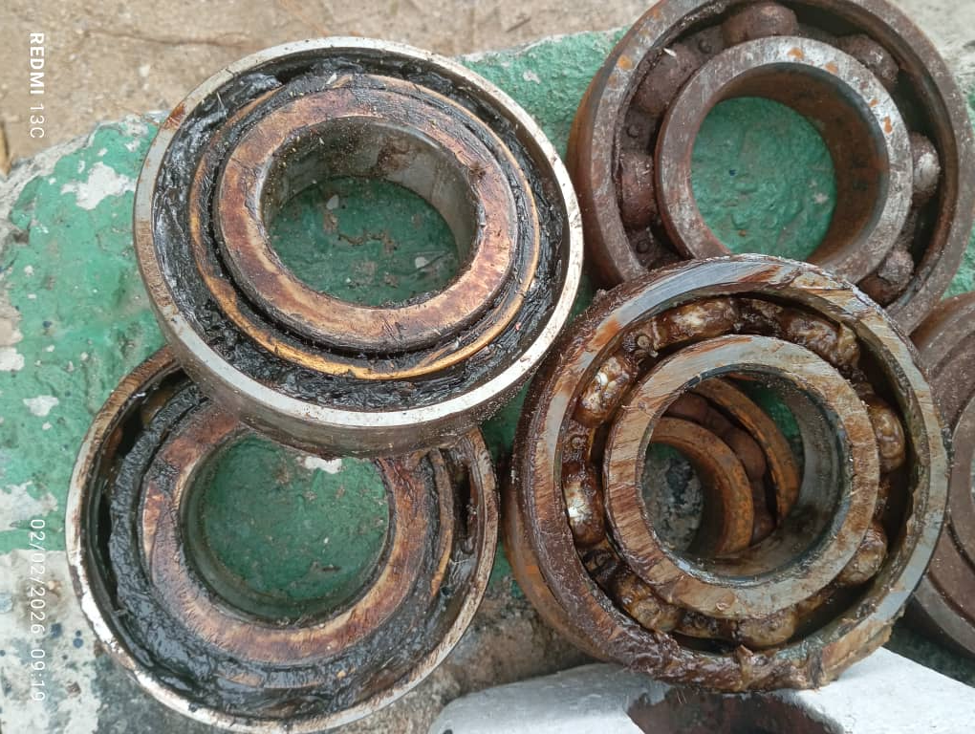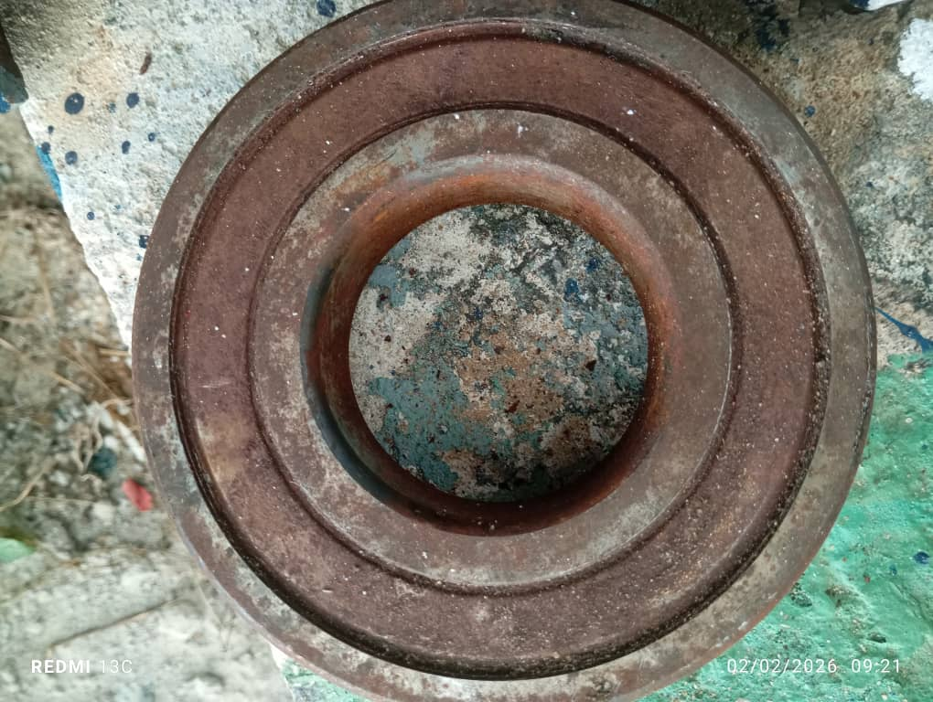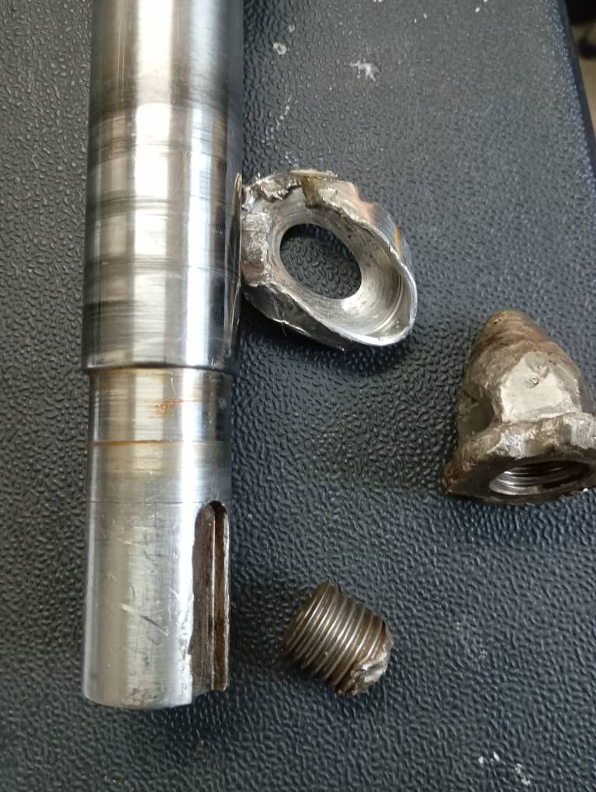
- (b) (c)
Fig. 2. Lubrication-related failures, contamination ingress and misalignment-induced damage

4.2 Vibration and Temperature Analysis of “31-P-01” Equipment.
Unit: UFC.
Equipment rpm: 2989
Table 2. Motor and Pump Vibration Summary (mm/s)
Equipment | H (Horizontal)  1st & 2nd Readings |  | V (Vertical)  1st & 2nd Readings |  | A (Axial)  1st & 2nd Readings
Motor A | 2.67 | (2.77) | 3.92 | (4.22) | 4.07 | (4.28)
Motor B | 3.97 | (3.88) | 5.61 | (5.75) | 4.51 | (4.66)
Pump C | 22.3 | (22.8) | 13.2 | (12.8) | 8.18 | (7.88)
Pump D | 20.3 | (19.8) | 7.79 | (8.05) | 5.02 | (4.98)

Observation:
- Pump C has a very high vibration on horizontal, vertical and axial direction. Hence it requires immediate inspection.
- Pump D also has a very high vibration on horizontal, vertical and slightly on axial axis. Hence it requires immediate inspection.
- Motors A and B show moderate-to-high vibration in vertical and axial directions, suggesting alignment.
- The FFT spectrum pattern indicates bearing looseness for motor and pump bearings.

Fig 3. Motor and Pump Temperature Readings

Observation: Motor and pump bearings are within normal operating temperature range.
4.2.1 Vibration Analysis (1st and 2nd Readings)
Vibration measurements were recorded in horizontal, vertical, and axial directions and expressed in mm/s RMS. Comparison of the first and second readings shows that the vibration levels are persistent, indicating an underlying mechanical problem rather than temporary operational effects.
Motor A shows moderate vibration levels, particularly in vertical and axial directions, with a slight increase between the first and second readings. This vibration pattern is commonly associated with coupling misalignment, soft foot conditions, or early-stage bearing looseness.
Motor B exhibits elevated vertical and axial vibration, remaining consistently high across both readings. Such vibration behavior typically indicates angular misalignment, structural looseness, or deterioration of bearing internal clearances.
Pump C presents extremely high vibration levels in all directions, with horizontal vibration exceeding 22 mm/s in both readings. These values are far above acceptable limits and clearly indicate a severe mechanical fault. Possible contributors include advanced bearing damage, shaft misalignment, mechanical looseness, hydraulic imbalance, or internal pump defects.
Pump D also records very high vibration levels, particularly in horizontal and vertical directions, with axial vibration approaching critical limits. The consistency of these readings suggests progressive degradation and possible foundation or causing looseness.
4.2.2 Temperature Analysis
Motor and pump temperature measurements were evaluated to support the vibration findings. Motor A (30.6°C) and Motor B (38.7°C) operate within normal thermal limits. Similarly, Pump C (37.0°C) and Pump D (33.5°C) do not currently show abnormal temperature rise.
Although temperatures are within acceptable ranges, this does not eliminate the presence of bearing defects. Early-stage looseness and mechanical clearance issues often manifest as high vibration before a noticeable temperature increase occurs.
4.2.3 Relationship Between High Vibration and Bearing Damage
High vibration levels have a direct and detrimental effect on bearing life. Excessive vibration induces cyclic dynamic loads on rolling elements and raceways, leading to accelerated fatigue, surface distress, and micro-cracking.
As vibration amplitude increases, bearing internal clearances enlarge, causing looseness and instability. This results in metal-to-metal contact, lubricant film breakdown, and uneven load distribution. Over time, these conditions progress to spalling, cage damage, and eventual bearing failure.
The FFT spectrum characteristics observed for this equipment indicate bearing looseness, confirming that the vibration energy is being generated and amplified within the bearing system.
4.2.4 Root Causes of High Vibration in 31-P-01
High vibration in equipment 31-P-01 is most likely caused by progressive mechanical faults, including severe bearing wear or looseness, motor-pump shaft misalignment, mechanical looseness at the base or bearing housings, and possible hydraulic instability or internal pump defects. The consistently high vibration levels indicate these issues are ongoing and worsening. Root cause analysis points to systemic maintenance deficiencies such as poor lubrication practices, inadequate sealing, insufficient alignment control during installation, limited use of predictive condition monitoring, and gaps in maintenance standardization and technical training. Vibration analysis results further confirm bearing looseness and misalignment as key contributors to excessive dynamic loading [27].

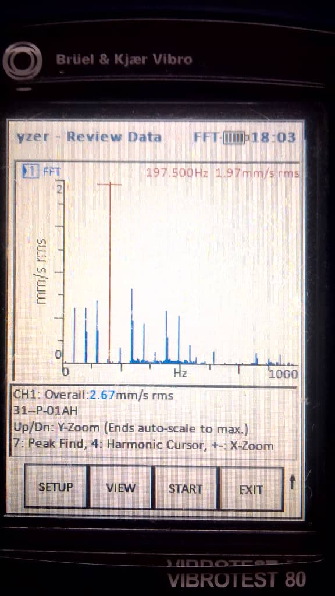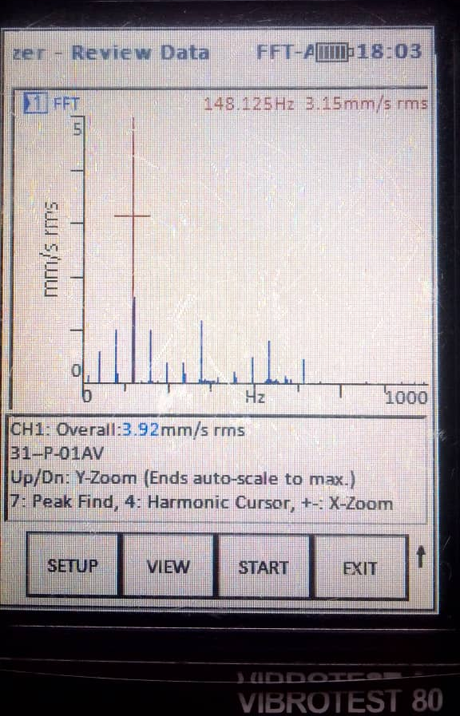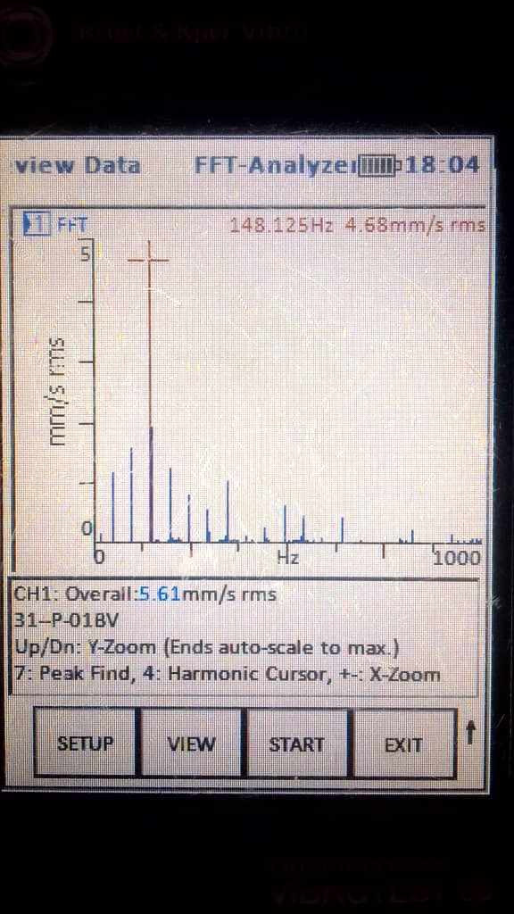
- (b) (c)
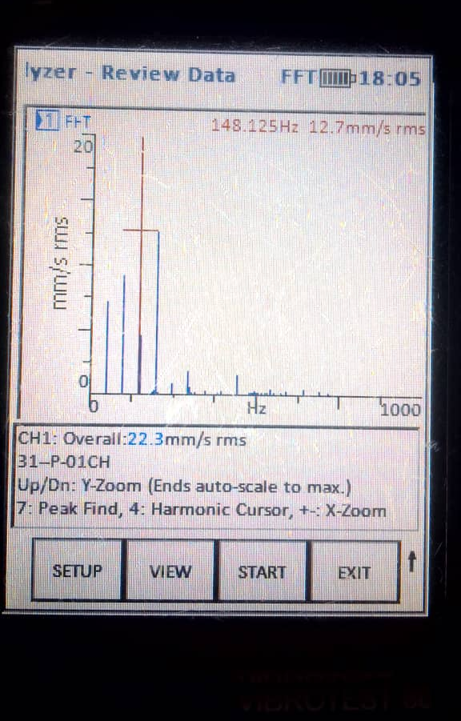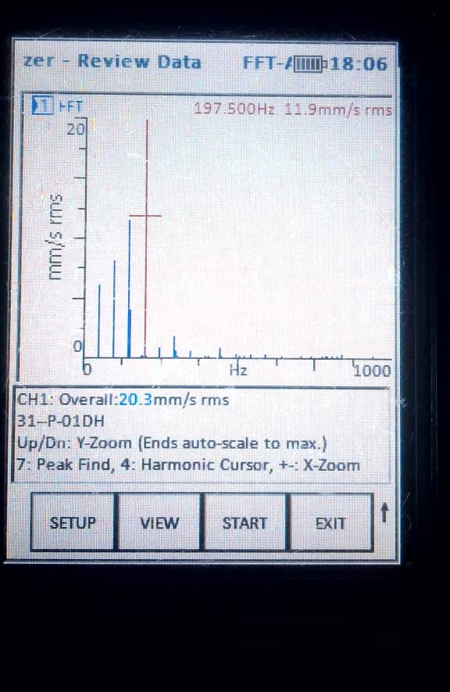
(d) (e)
Fig 4. FFT Vibration Spectrum for Dominant Frequency Vibration.

4.3 Reliability Assessment and MTBF Analysis
Reliability assessment reveals MTBF values significantly below manufacturer expectations, highlighting deficiencies in installation practices, lubrication management, and early fault detection [21], [30].
Table 3. Bearing Reliability Indices
Pump ID | Bearing Type | Operating Hours | Failures | MTBF (h)
P-014 | Deep groove ball | 32,000 | 6 | 5,333
P-007 | Angular contact ball | 28,500 | 5 | 5,700
P-001 | Cylindrical roller | 35,200 | 7 | 5,029
P-015 | Deep groove ball | 30,100 | 6 | 5,017

The low MTBF values reflect premature degradation primarily linked to lubrication and contamination-related issues.
4.4 Weibull Reliability Modeling
Bearing life data were analyzed using the two-parameter Weibull distribution. The cumulative distribution function is given by:
$$F(t)=1-exp⁡\left[ − {\left(\frac{t}{η}\right)}^{β}\right]$$
For a bearing population with $β=0.72$and $η=6100$h, the probability of failure at 4000 h is approximately 0.41, indicating that 41% of bearings are expected to fail before this operating duration.
Table 4. Weibull Parameters for Bearing Populations
Population | Shape parameter (β) | Scale parameter (η) (h) | Failure behavior
A | 0.72 | 6,100 | Early-life dominant
B | 0.98 | 6,800 | Random
C | 1.35 | 8,200 | Wear-out dominant

4.5 Availability Analysis
Assuming a mean repair time (MTTR) of 12 h, pump availability was estimated using:
$$A=\frac{MTBF}{MTBF+MTTR}$$
For Pump P-101, availability was approximately 99.77%, indicating that modest improvements in MTBF could yield substantial availability gains.
4.6 Engineering Implications
Weibull analysis shows shape parameter values below or near unity, indicating early-life and random failure behavior [11], [34], rather than wear-out mechanisms. This means the equipment is failing not because it has reached its expected service life, but because defects are being introduced during installation, assembly, or early operation.
Accordingly, preventive strategies should focus on improving installation quality and early-life controls, as illustrated in Fig. 3. Critical actions include measuring pump shaft runout and inspecting for bent shaft conditions prior to installation, since these defects can immediately induce high vibration, uneven loading, and premature bearing damage.
Proper bearing installation is equally important. Bearings should be installed using controlled methods such as cold mounting with mechanical fitting tool kits, thermal installation using an oil bath, or induction heating. These methods ensure correct interference fit while avoiding impact loading or surface damage that can significantly shorten bearing life.
Shaft alignment is another key preventive measure. Initial alignment can be performed using a straight edge; however, final alignment should be carried out using a properly calibrated dial gauge indicator or, preferably, a laser alignment machine. As shown in Fig. 4, misalignment correction results for horizontal centrifugal pumps using a laser alignment machine demonstrate superior accuracy, ease of use, and repeatability, significantly reducing residual misalignment and associated vibration.
In addition, effective contamination control preventing the ingress of dirt, moisture, and debris into bearings and lubrication systems is essential to reduce random failure occurrence. Finally, early fault detection through continuous condition monitoring, such as vibration analysis, enables timely identification and correction of developing defects before they progress into functional failures.
Overall, the prevalence of low Weibull shape parameters clearly indicates that strengthening installation practices, alignment precision, cleanliness, and early condition monitoring will deliver the greatest improvements in equipment reliability.
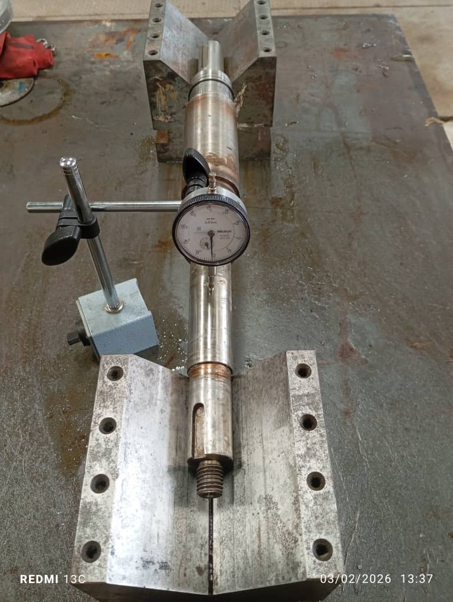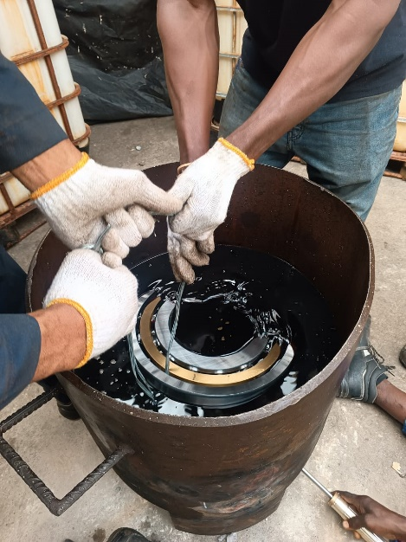
Bath
Oil
Bearing
Magnetic stand
Dial guage
Indicator
Shaft
V-Block
- Pump shaft run out (b) thermal installation method
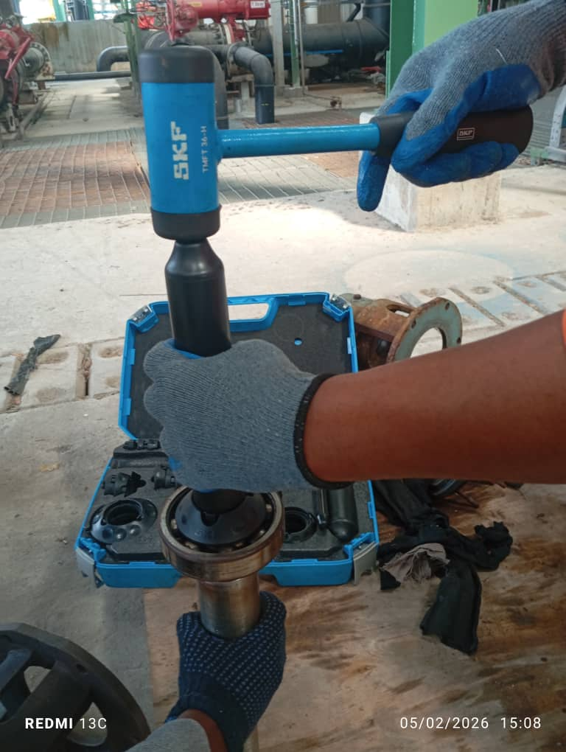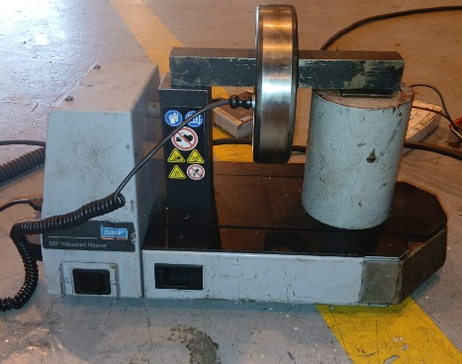
Bearing
(c) Cold mounting method (d) Induction heater
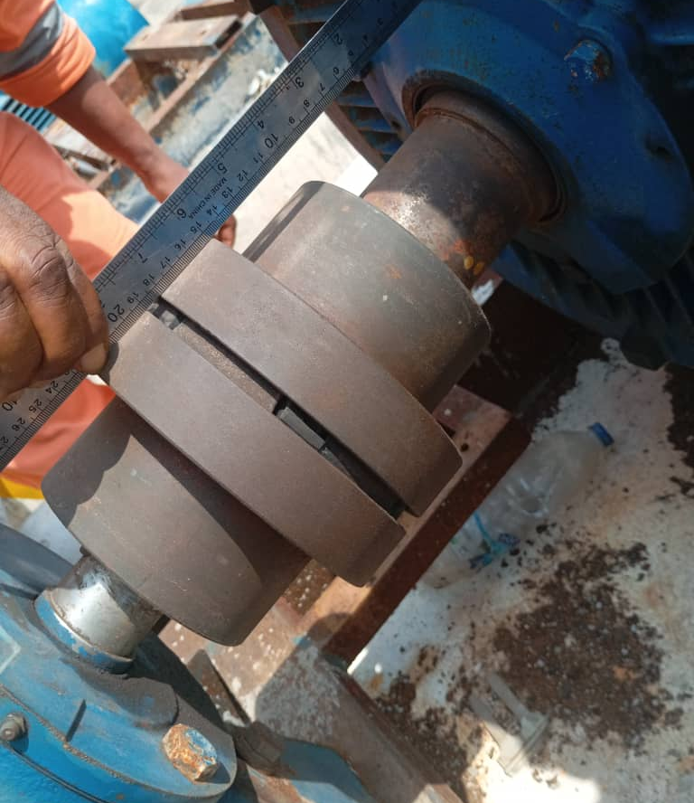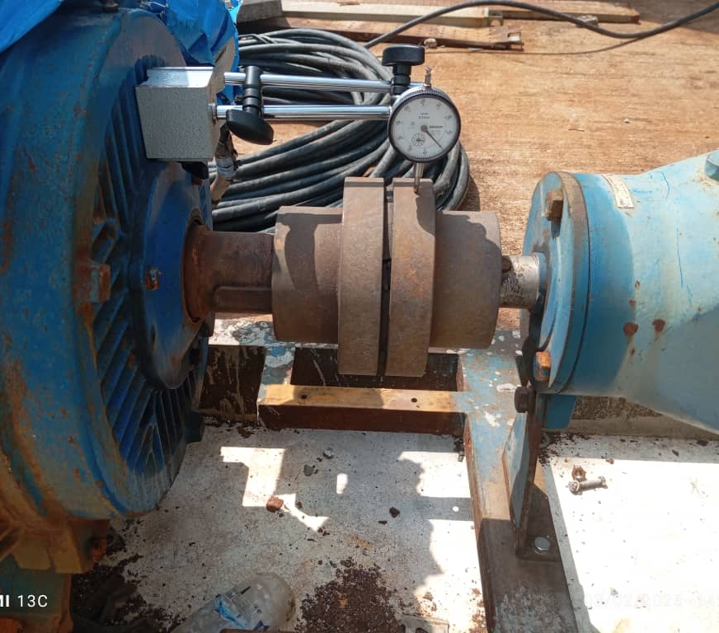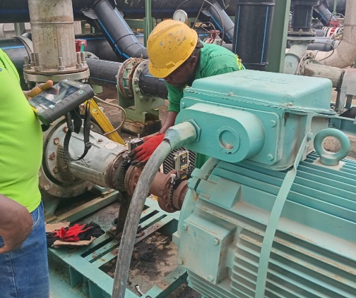
Laser machine
Straight edge
- (f) (g)
Fig 5. Improved installation practices

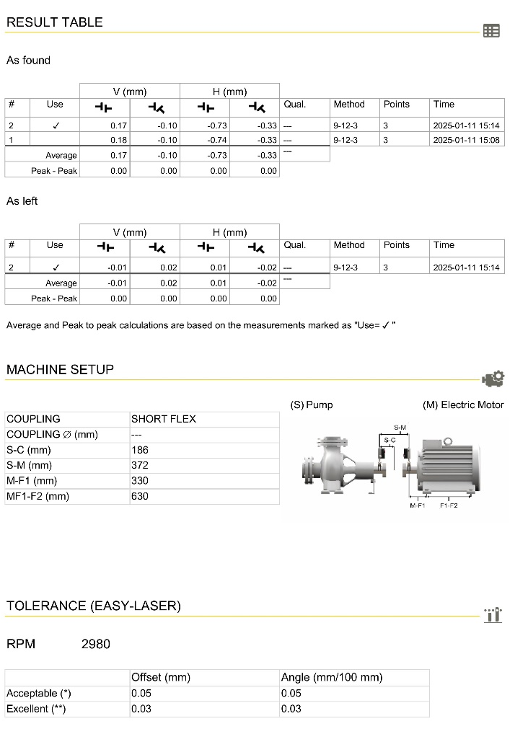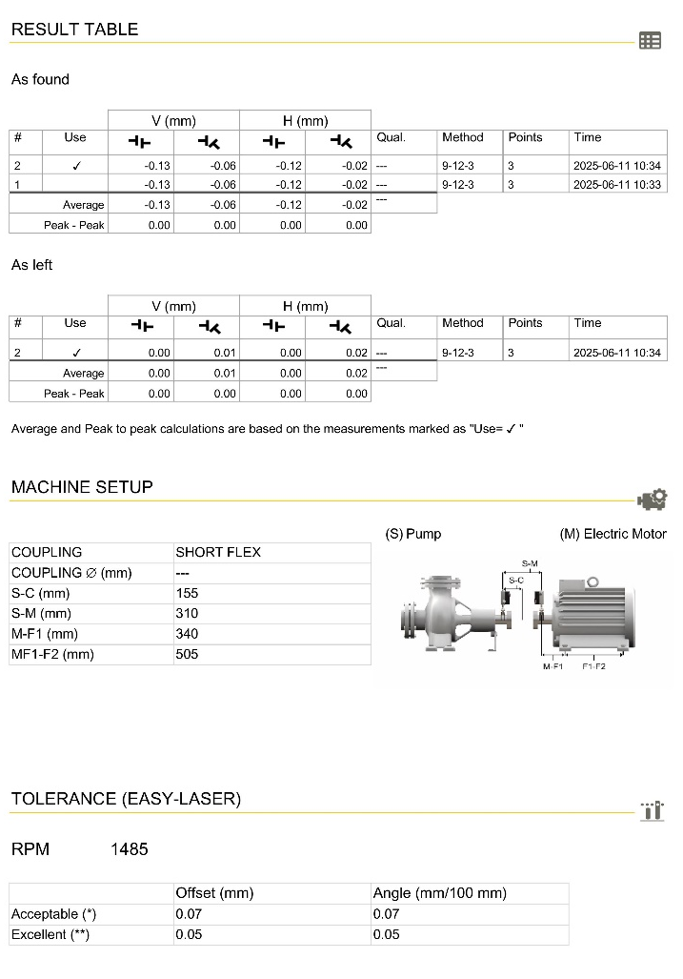
(a) (b)
Fig 6. Misalignment correction results for horizontal centrifugal pumps using laser alignment machine

5.0 Reliability Improvement Framework
A structured reliability improvement framework was developed based on identified failure mechanisms and reliability assessment outcomes. The framework integrates condition-based monitoring, optimized lubrication management, improved installation standards, and RCM principles was developed [9], [10]. FMEA results highlight lubrication starvation and contamination ingress as the highest-risk failure modes [33].
Table 5. FMEA Summary for Pump Bearings
Failure Mode | Primary Cause | Effect | Severity | Occurrence | Detection | RPN
Lubrication starvation | Inadequate relubrication | Overheating, seizure | 8 | 7 | 5 | 280
Contamination ingress | Poor sealing | Abrasive wear | 7 | 6 | 4 | 168
Misalignment | Poor installation | Excessive vibration | 6 | 5 | 4 | 120
Fatigue spalling | Prolonged service | Noise, failure | 5 | 3 | 3 | 45

6.0 Practical Implementation Considerations
Implementation of the proposed framework within Nigerian oil and gas facilities requires careful consideration of resource constraints, workforce competency, and organizational culture. A phased deployment approach, targeted training programs, and sustained management commitment are critical to successful adoption.

7.0 Limitations of the Study
The study relies primarily on historical maintenance records, which may contain incomplete or inconsistent documentation [32]. Advanced metallurgical and real-time sensor data were limited due to practical constraints [28].

8.0 Future Research Directions
Future studies should integrate continuous condition-monitoring data and advanced signal-processing techniques to enable early fault detection. Development of remaining useful life (RUL) prediction models [35] using data-driven and hybrid approaches is recommended. Comparative studies across different pump standards and operating environments would further strengthen insights into reliability.

9.0 Conclusion
Bearing failures have a considerable adverse effect on the reliability and operational availability of centrifugal pumps in the oil and gas processing plants located in Nigeria. The results indicate that merging comprehensive analysis of bearing failures with maintenance strategies based on reliability can significantly enhance pump efficiency, minimize downtime, and decrease lifecycle expenses.

10.0 Recommendations
Operators in the oil and gas sector should give priority to condition monitoring that focuses on bearings, establish systematic lubrication management programs, uphold installation and alignment standards, and implement reliability-centered maintenance approaches. Future research should investigate digital condition monitoring technologies and sophisticated models for predicting the remaining useful life of pump bearings.

References
- Bloch, H. P., & Geitner, F. K. (2019). Machinery Failure Analysis and Troubleshooting. Elsevier, Oxford.
- Mobley, R. K. (2020). An Introduction to Predictive Maintenance (3rd ed.). Butterworth-Heinemann, Oxford.
- SKF Group. (2018). Rolling Bearing Damage and Failures. SKF Publication, Gothenburg.
- ISO 15243. (2017). Rolling Bearings—Damage and Failures—Terms, Characteristics and Causes. International Organization for Standardization, Geneva.
- Budris, A. R. (2014). Centrifugal pump bearings: Tips for improving reliability and reducing failure. Water Technology Online, 39(6), 1–6.
- Petrashko, M. (2011). Proactive bearing maintenance. Pumps & Systems, 18(5), 34–39.
- Funmilayo, A. T., & Saturday, E. G. (2023). Cost-effective maintenance strategy for centrifugal pumps using reliability-centered maintenance. International Journal of Frontiers in Engineering and Technology Research, 5(2), 1–11.
- Jardine, A. K. S., Lin, D., & Banjevic, D. (2006). A review on machinery diagnostics and prognostics. Mechanical Systems and Signal Processing, 20(7), 1483–1510.
https://doi.org/10.1016/j.ymssp.2005.09.012
- Moubray, J. (1997). Reliability-Centered Maintenance. Butterworth-Heinemann, Oxford.
- Mobley, R. K., & Keith, R. (2002). Maintenance Engineering Handbook (6th ed.). McGraw-Hill, New York.
- Raj, K. K., Kumar, S., & Kumar, R. R. (2025). Systematic review of bearing component failure: Strategies for diagnosis and prognosis in rotating machinery. Arabian Journal for Science and Engineering, 50, 5353–5375.
https://doi.org/10.1007/s13369-024-09866-x
- Palit, P., Sri, P., Gokarn, P., Kumar, A., & Das, S. (2025). Rolling contact fatigue failure analysis of ball bearing in gearbox. Journal of Failure Analysis and Prevention, 25, 62–69.
https://doi.org/10.1007/s11668-025-02109-7
- Li, R., Zhang, Y., Wang, J., & Liu, H. (2024). Failure analysis of a needle roller bearing in a megawatt reciprocating pump. Journal of Failure Analysis and Prevention, 24, 108–115.
https://doi.org/10.1007/s11668-023-01821-6
- Yang, Z., Hong, J., Wang, D., Ma, Y., & Cheng, R. (2023). Failure analysis of an aero-engine inter-shaft bearing due to clearance between the outer ring and its housing. Engineering Failure Analysis, 150, 107298.
https://doi.org/10.1016/j.engfailanal.2023.107298
- Hong, J., Liu, F., Ma, Y., Chen, X., & Wang, Y. (2024). Composite failure analysis of an aero-engine inter-shaft bearing inner ring. Engineering Failure Analysis, 165, 108707.
https://doi.org/10.1016/j.engfailanal.2024.108707
- Lu, G., Zhang, Y., Li, H., Wang, X., & Zhou, J. (2023). Micro-morphological analysis and wear failure mechanisms of propeller hub bearings in marine environments. Wear, 530–531, 205047.
https://doi.org/10.1016/j.wear.2023.205047
- Chang, Z., Jia, Q., Yuan, X., & Chen, Y. (2017). Main failure mode of oil-air lubricated rolling bearing installed in high-speed machining. Tribology International, 112, 68–74.
https://doi.org/10.1016/j.triboint.2017.03.024
- Jakobsen, M. O., Hansen, J. H., & Larsen, R. (2021). Vibration signatures in ball bearings as a function of lubricant viscosity ratio under alternating lubrication conditions. Tribology International, 156, 106840.
https://doi.org/10.1016/j.triboint.2020.106840
- Sousa, A. M., Pereira, M. J., & Matos, H. A. (2022). Oil-in-water and water-in-oil emulsions formation and demulsification. Journal of Petroleum Science and Engineering, 210, 110041.
https://doi.org/10.1016/j.petrol.2021.110041
- Dai, L., Guo, J., Wan, J. L., Wang, J., & Zan, X. (2022). A reliability evaluation model of rolling bearings based on WKN-BiGRU and Wiener process. Reliability Engineering & System Safety, 225, 108646.
https://doi.org/10.1016/j.ress.2022.108646
- Kong, W., & Li, H. (2022). Remaining useful life prediction of rolling bearing under limited data. Applied Soft Computing, 129, 109630.
https://doi.org/10.1016/j.asoc.2022.109630
- Wang, Y., Zhao, J., Yang, C., Xu, D., & Ge, J. (2022). Remaining useful life prediction of rolling bearings based on multi-feature fusion. Measurement, 201, 111572.
https://doi.org/10.1016/j.measurement.2022.111572
- Schmidt, S., Heyns, P. S., & Gryllias, K. C. (2019). Discrepancy analysis methodology for rolling element bearing diagnostics under variable speed conditions. Mechanical Systems and Signal Processing, 116, 40–61.
https://doi.org/10.1016/j.ymssp.2018.06.026
- Salunkhe, V. G., & Desavale, R. G. (2021). Intelligent prediction for detecting bearing vibration characteristics using machine learning. Journal of Nondestructive Evaluation, Diagnostics and Prognostics of Engineering Systems, 4.
https://doi.org/10.1115/1.4049938
- Salunkhe, V. G., Khot, S. M., Desavale, R. G., & Yelve, N. P. (2023). Incipient fault detection for roller bearings using deep independent component analysis. Journal of Tribology, 145.
https://doi.org/10.1115/1.4056899
- Salunkhe, V. G., Khot, S. M., Yelve, N. P., Jagadeesha, T., & Desavale, R. G. (2025). Rolling element bearing fault diagnosis using Elman neural networks with LSTM strategy. Journal of Tribology, 147.
https://doi.org/10.1115/1.4067382
- Failure analysis of ball bearing in centrifugal pump using envelope and demodulation techniques. (2022). Materials Today: Proceedings.
- Reliability estimation using EM algorithm with censored data: A case study on centrifugal pumps. (2024). Applied Sciences.
- Salunkhe, V. G., & Desavale, R. G. (2021). Intelligent prediction for detecting bearing vibration characteristics using machine learning. Journal of Nondestructive Evaluation, Diagnostics and Prognostics of Engineering Systems, 4.
https://doi.org/10.1115/1.4049938
- Salunkhe, V. G., Khot, S. M., Desavale, R. G., & Yelve, N. P. (2023). Incipient fault detection for roller bearings using deep independent component analysis. Journal of Tribology, 145.
https://doi.org/10.1115/1.4056899
- Salunkhe, V. G., Khot, S. M., Yelve, N. P., Jagadeesha, T., & Desavale, R. G. (2025). Rolling element bearing fault diagnosis using Elman neural networks with LSTM strategy. Journal of Tribology, 147.
https://doi.org/10.1115/1.4067382
- Failure analysis of ball bearing in centrifugal pump using envelope and demodulation techniques. (2022). Materials Today: Proceedings.
- Reliability estimation using EM algorithm with censored data: A case study on centrifugal pumps. (2024). Applied Sciences.

