Deep Learning Framework for Multistage Diabetic Retinopathy Detection and Integrated Patient Monitoring
Ms. K. Ragavi¹, M. Piramu², R. Poovika^{3,}, R. Pooveesh⁴
¹Assistant Professor, Department of AI&DS, Erode Sengunthar Engineering
College, Perundurai, Erode-638052, Email- sriragaviesec.ac@gmail.com
^{2,3&4}Research Scholar, Department of AI&DS, Erode Sengunthar Engineering College,
Email- prema36063@gmail.com, poovikarajamani@gmail.com, pooveeshr@gmail.com

Abstract— Diabetic Retinopathy (DR) stands as one of the main reasons which diabetes patients to lose their ability to see. The risk of severe vision impairment needs continuous monitoring, which requires early diagnosis, especially in rural areas that lack access to specialized eye care facilities. This research establishes a deep learning system which detects Diabetic Retinopathy in different stages through the analysis of retinal fundus images. The Convolutional Neural Network (CNN) system classifies retinal images into five different severity levels which include No DR Mild Moderate Severe and Proliferative DR. The system provides automated classification functions together with healthcare support modules which include dietary guidance for different stages and eye exercise recommendations and hospital location services for users who need eye care facilities. The web-based platform provides organized patient record systems which allow continuous tracking of patient health and disease development. The experimental results show that the system achieves dependable multi-class classification results which were measured through accuracy and precision and recall and F1-score metrics. The proposed framework offers a scalable and cost-effective solution for early DR screening and integrated patient monitoring.
Keywords— Diabetic Retinopathy, Convolutional Neural Network, Retinal Fundus Images, Multistage Classification, Medical Image Analysis, Patient Monitoring, Geolocation Services.

I.INTRODUCTION

Diabetic Retinopathy is a retinal disorder caused by diabetes which ranks among the top preventable blindness disorders in the world. The early detection of eye diseases becomes critical for stopping severe vision impairment which people in remote areas face because they cannot reach specialized vision treatment centers. The traditional screening process requires ophthalmologists to manually review retinal fundus images, which results in a slow process that cannot handle tests for big populations.

Deep learning research has created automated systems which analyze retinal images to identify DR cases. Convolutional Neural Networks (CNNs) have demonstrated strong performance in multistage DR classification tasks [1], [2]. Attention-based and hybrid deep learning models have further improved detection accuracy and lesion localization [3], [4]. Transfer learning approaches have also been widely applied to enhance classification performance, especially when labeled datasets are limited [5], [6]. Recent research studies have introduced large, automated screening systems.
This paper presents a deep learning framework which detects multiple stages of Diabetic Retinopathy through retinal fundus images. The system combines CNN-based classification with patient record management and healthcare support modules to create an enhanced DR screening system which can be used for both initial screening and ongoing patient evaluation.

II.LITERATURE REVIEW

Research on artificial intelligence and deep learning for Diabetic Retinopathy (DR) detection has become popular during the last few years. Zhang et al. [1] and Sharma and Gupta [2] showed that Convolutional Neural Networks (CNNs) achieve accurate classification of DR severity stages through retinal fundus image analysis. Their studies confirmed that automated systems can assist ophthalmologists in large-scale screening. The models developed by researchers only focused on classification accuracy, which excluded methods for tracking patients over extended periods.

The medical imaging field uses transfer learning to solve problems that arise when there are not enough labeled datasets. Ahmed and Rahman [5] utilized pretrained convolutional networks for multistage DR classification, achieving improved generalization through fine-tuning. Patel and Shah [6] demonstrated that organizations need to understand their systems through deep learning methods which design interpretable solutions that deliver better clinical understanding. Research progress has been made, yet researchers still face difficulties with overfitting problems and class imbalance and inconsistent stage-wise accuracy.

Researchers developed architectural improvements through attention mechanisms and hybrid deep learning models to achieve better detection capabilities. Liu et al. [3] developed an attention-based framework which enhanced both lesion localization and classification accuracy. Kumar et al. [4] created a hybrid deep learning model which combines multiple architectural elements to achieve better multistage grading results. The approaches succeeded in enhancing accuracy, but they resulted in higher computational demands which needed extensive training data to reach maximum performance.
Recent research shows various methods for deploying systems at large scales. Verma and Mehta [7] created a practical deep learning system for DR screening which uses automated processes, while Abbasi et al. [8] developed an adaptive deep convolutional neural network that protects against different levels of image quality. The existing systems mainly focus on detection accuracy while they lack the ability to manage structured patient records and track disease progression over time and provide healthcare support through dietary guidance and eye exercises and geolocation-based hospital identification.

Research has shown that previous studies developed better automatic systems for detecting DR but those systems still need improved capabilities for monitoring systems that track patients and their medical records and for deploying systems on web platforms. The proposed framework addresses these gaps by combining multistage CNN-based classification with patient record management, disease progression tracking, dietary guidance, guided eye exercises, and geolocation- based hospital services within a unified platform

III.PROPOSED METHODOLOGY

The system has been constructed as a complete deep learning framework which detects multiple stages of Diabetic Retinopathy and monitors patients through its organized medical system. The methodology consists of six major components: image acquisition, preprocessing and augmentation, CNN-based classification, stage-wise decision processing, report generation, and deployment of supportive healthcare modules.

Image Acquistion

The system supports two modes of retinal image input. First, users can upload pre-captured retinal fundus images through the web interface. Second, the system allows users to directly capture images through a camera interface which enables them to conduct immediate analysis. The system provides two input methods which enhance accessibility while enabling users to conduct screenings in both offline and real-time modes.

Image Preprocessing and Augmentation

The retinal images need preprocessing, which helps to improve feature detection and better model results after their acquisition. The preprocessing pipeline processes images through multiple steps which begin with dimensional reduction to 224 × 224-pixel size and proceed to pixel intensity normalization and contrast enhancement for retinal lesion detection and finally end with noise reduction. The training process uses data augmentation techniques which include random rotation and horizontal and vertical flipping and zoom transformation and brightness variation to improve model generalization and solve class imbalance. The established steps create defense systems which enable systems to function properly during different lighting conditions and visual quality transformations.

CNN-Based Multistage Classification

Convolutional Neural Network performs multistage diabetes retinopathy (DR) classification through its implementation. The system uses convolutional layers to extract features while pooling layers reduce dimensions and fully connected layers handle classification with Softmax activation producing five output classes. The model classifies retinal images into five severity levels: No DR, Mild, Moderate, Severe, and Proliferative DR. The network uses the Adam optimizer to train with categorical cross-entropy loss while dropout regularization helps prevent overfitting.
Stage Prediction and Decision Logic

Stage Prediction and Decision Logic

The system uses a stage prediction module to process output probabilities which calculate the final DR severity level after the classification step. The system activates guidance modules based on the predicted stage. For No DR and Mild cases, preventive ca re advice and monitoring suggestions are provided. The system provides structured dietary guidance and guided eye exercise recommendations for Moderate and Severe stages. This decision mechanism ensures stage-specific intervention and personalized support.

Report Generation and Patient History Storage

The system produces a structured diagnostic report which contains the predicted DR stage, confidence score, and analysis timestamp after prediction. The results are stored in a secure database to maintain patient history. This enables longitudinal tracking of disease progression and supports comparative analysis across multiple patient visits.

Integrated Support Modules

The system includes extra support features which help patients to access medical services while their conditions can be monitored. The hospital locator system uses geolocation to find nearby eye care centers which users can access through their current location. Multilingual support improves usability across diverse user groups by providing translated outputs. The progress tracking system displays past prediction results which allow users to monitor disease development through specific time periods.

System Workflow

The proposed system starts with retinal image input through upload or real-time capture. The image undergoes preprocessing before it reaches the CNN model which performs multistage DR classification. The system uses predicted stage results to deliver guidance and create a report while it stores results to monitor patient progress. A. Dataset Description

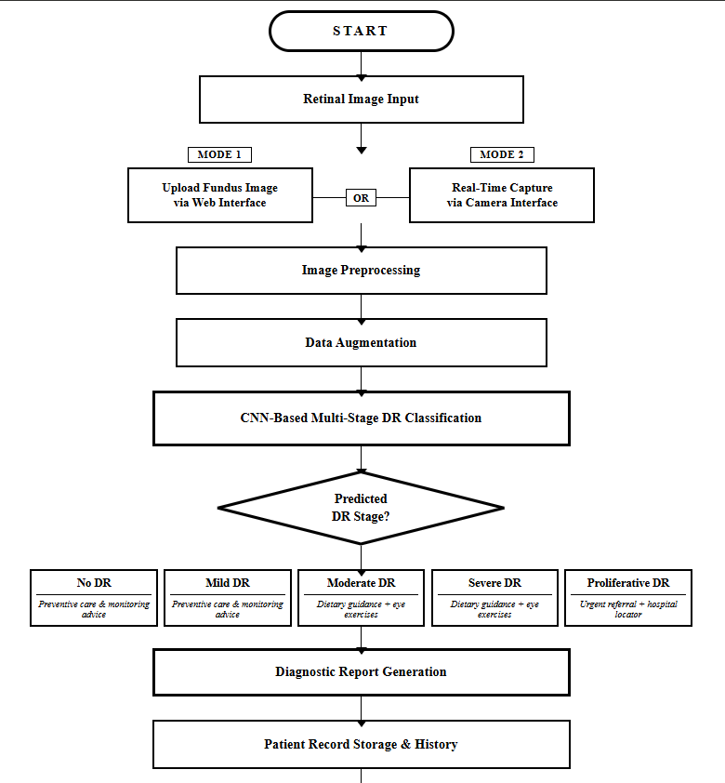
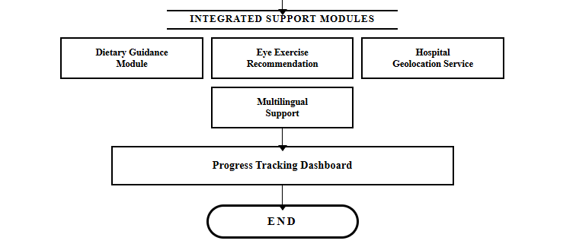
Fig 1: Flow of Proposed System

IV. EXPERIMENTAL SETUP

This section describes the experimental framework adopted to evaluate the proposed deep learning-based Diabetic Retinopathy detection system. The research used dataset preparation, training configuration, data splitting strategy, evaluation methodology, and computational environment to achieve objective validation and reproducibility testing.

Dataset Description

The testing process used both the APTOS 2019 Blindness Detection dataset and the IDRiD dataset for their evaluation. The two datasets contain high-resolution retinal fundus images which researchers categorized into five severity levels: No DR, Mild, Moderate, Severe, and Proliferative DR.

The APTOS dataset contains images which were taken under various lighting conditions and focus accuracy, and background interference elements. The IDRiD dataset contains clinically annotated retinal images which were gathered from Indian patients who show various demographic and pathological characteristics. The combined use of these datasets improves model performance because it enables testing in multiple real-world conditions.

Data Splitting and Validation Strategy

The combined dataset was organized to ensure balanced representation of all five DR severity stages. The data were divided into training, validation, and testing subsets to enable dependable model development and impartial performance assessment. The training set provided data for model parameter optimization while the validation set allowed trainers to track model effectiveness throughout training while preventing overfitting. The testing set served as the only means for conducting the final assessment. Stratified sampling established class distribution across all subsets while maintaining proportional representation of each severity level during training and evaluation.

Model Training Configuration

The developers built the deep learning model through Python programming by utilizing both TensorFlow and Keras software frameworks. The system applied a Convolutional Neural Network architecture to complete multi-class classification tasks. The model used the Adam optimizer for training which operated at a learning rate of 0.001 and applied categorical cross-entropy as its loss function.

The network's hidden layers employed ReLU activation to generate non-linear transformations while the SoftMax activation function produced probability scores which represented five separate DR classes. The training process used mini-batch gradient descent with a batch size of 32. The model training continued until it achieved convergence which showed through continuous validation accuracy improvements and decreasing validation loss. The system applied Dropout regularization to reduce overfitting tendencies while improving the model's capability to generalize.

Hardware and Software Environment

The experiments were performed using a computing system that had Intel Core i5 and i7 processors and 8 to 16 GB of RAM installed. The research used GPU acceleration whenever it was accessible to improve computing performance and decrease training duration.

The trained model was integrated into a Django-based web application to enable real-time prediction, automated report generation, and patient history management. SQLite served as the database system which structured the storage of prediction results and patient records.

Evaluation Metrics

The proposed model evaluation used standard multi-class classification metrics which included accuracy and precision and recall and F1-score. The five severity stages classification system uses these metrics to measure its ability to classify cases correctly.

The analysis used a confusion matrix to measure prediction accuracy for each class while detecting misclassification patterns that occurred between neighboring DR severity levels. The evaluation framework provides detailed information about the system's performance in detecting multiple stages of Diabetic Retinopathy.

V.EXPERIMENTAL RESULTS AND DISCUSSION

This section presents the performance evaluation of the proposed Diabetic Retinopathy detection system and demonstrates the functionality of the developed web-based healthcare support platform. The evaluation includes both classification performance of the CNN model and the effectiveness of the integrated modules such as detection interface, recommendation system, patient monitoring dashboard, and location services.

- Model Performance Evaluation

The DR classification model was developed using the Convolutional Neural Network architecture based on MobileNetV2. Being a lightweight structure was one of the reasons that got it chosen by the developer since this would have facilitated real-time integration with a webcam appliance.

DR  Severity | Accuracy  (%) | Precision  (%) | Recall  (%) | F!-  Score  (%)
No DR | 94.8 | 95.5 | 94.0 | 94.8
Mild DR | 91.7 | 92.1 | 91.3 | 91.7
Moderate  DR | 89.4 | 90.2 | 88.7 | 89.5
Severe DR | 87.5 | 88.1 | 86.9 | 87.5
Proliferative DR | 86.2 | 86.7 | 85.6 | 86.1

Table I: Performance Metrics of DR Severity Classification
− That is the system's overall accuracy: about 89.9%.
− In terms of inference speed and real-time webcam deployment, MobileNetV2 beats ResNet-50 and other heavier models, although it has similar accuracy.
− Again, the very low resolution of the webcam images made confusion possible for visually similar classes (e.g., Severe vs Proliferative DR).

- Detection Interface and Model Prediction

The system provides a user-friendly detection interface that allows users to upload retinal fundus images or capture images for analysis. Once an image is uploaded, the trained CNN model processes the image and predicts the severity stage of Diabetic Retinopathy. The system also displays the prediction confidence score, which represents the probability associated with the predicted class.

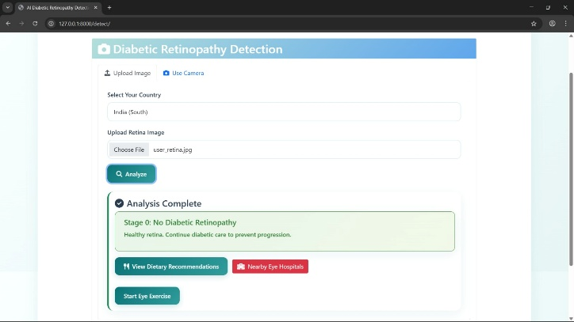

Fig. 2. Detection page showing retinal image upload

- Model Confidence Score Visualization

The system displays the prediction confidence score for the detected DR stage. This feature provides transparency to the prediction process by allowing users and healthcare professionals to understand the certainty level of the model's decision.
Higher confidence values indicate stronger classification certainty, while lower confidence values may require further medical verification.

- Patient Dashboard and Diagnostic Logs

The developed system includes a patient dashboard that provides users with access to their diagnostic history, as well as their disease progression over time. Each prediction result is stored in the database and can be accessed through the dashboard.

The logs of the diagnostic tests provide records of previous predictions, including their timestamps, as well as the stages of DR and their corresponding confidence scores. This feature allows healthcare providers to monitor disease progression.
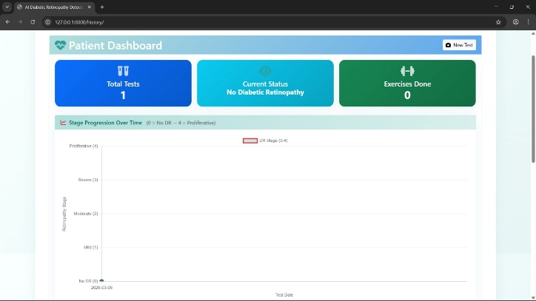

Fig. 3. Patient dashboard displaying diagnostic history and disease progression.

- Dietary Recommendation Module

In addition to disease detection, the system provides personalized dietary recommendations based on the predicted DR severity stage. The recommendation module suggests appropriate nutritional guidance to help manage diabetic conditions and support eye health.
This feature extends the functionality of the system beyond diagnosis by providing preventive healthcare support to patients
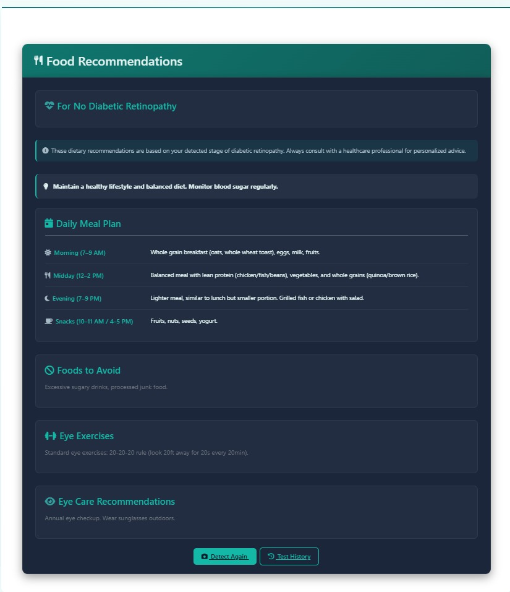
Fig. 4. Food recommendation module providing stage-specific dietary guidance.

F. Hospital Locator Using Geolocation

This proposed system includes a geolocation-based hospital locator that allows users to find eye care facilities near them. This is achieved by utilizing the location services feature, which allows the system to find the nearest hospital or clinic to the user.

This feature will aid patients in seeking prompt medical attention after a diagnosis of DR.

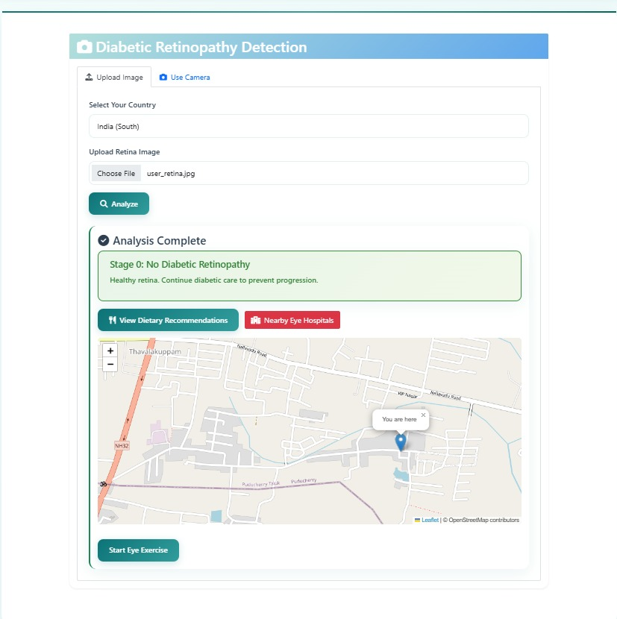
Fig. 6. Geolocation-based hospital locator showing nearby eye care centers

G. Comparative Analysis
The proposed CNN-based Diabetic Retinopathy detection model proves its competitiveness in terms of performance in comparison to the existing traditional machine learning and deep learning approaches. Moreover, the proposed model does not require the extraction of features using the traditional approach, as the CNN model is capable of learning the relevant features from the retinal fundus images and hence proves its reliability in the classification of the images into different classes. Additionally, the proposed model also offers supportive healthcare-related features such as dietary plans, hospital locations, and patient monitoring.

Model | Validation  Accuracy | Interference Time | Multilingual | Food recommendation | Suitable for Real-Time
Simple  CNN | 25.4 | 5.2 | No | No | No
Efficient  Net | 68.7 | 3.9 | Limit ed | No | Limited
ResNet-50 | 89.2 | 4.8 | Limit  ed | No | Limited
VGG-  16 | 87.5 | 6.0 | No | No | No
Inception V3 | 85.8 | 5.1 | No | No | Limited
Dense Net121 | 90.1 | 3.5 | Limit ed | No | Limited
Mobile NetV2 | 91.5 | 2.8 | Yes | Yes | Yes

Table II: Comparative Analysis of DR Detection Models
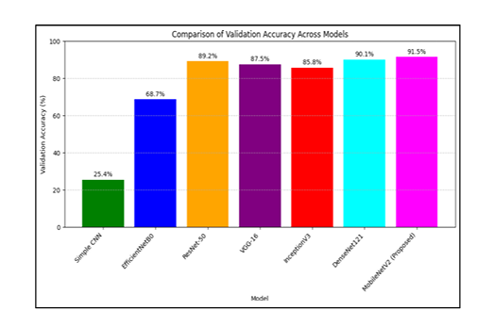
Fig 7. Bar Graph Comparing Accuracy Across Different Models
V. CONCLUSION

The early detection of Diabetic Retinopathy (DR) is extremely important in preventing visual impairment in those suffering from diabetes. A novel method employing a deep learning architecture has been developed for automatically diagnosing and classifying retinal images. The classification of a retinal image into the category of No DR, Mild, Moderate, Severe or Proliferative DR will be accomplished through the use of Convolutional Neural Networks . This application of deep learning will allow for rapid and accurate diagnosis by automatically extracting feature sets from retinal images used for detecting DR.

The experiment confirmed that the proposed model provides reliable multi-class classification. The datasets used to train the model were retinal images . Evaluation metrics included accuracy, precision, recall and F1-score to determine the system’s effectiveness. The results indicate that the proposed model is able to successfully identify different stages of Diabetic Retinopathy; thus, early diagnosis of Diabetic Retinopathy can be achieved and would aid in the decision making process for healthcare professionals.

Along with disease detection capability, this system also has multiple types of support modules available to increase patient engagement and usability. There are several additional features included in the system that will help improve patient care and support, such as: the ability to detect eye disease from one retinal image; display a confidence score for the model used in predicting eye disease; provide dietary recommendations; locate hospitals based on patient location; and create a holistic dashboard for tracking past diagnostic data and future follow-up appointments. By adding these additional support modules to the system, we have created a complete environment that will allow us to provide patients with guidance and support when they are diagnosed with DR, as well as allowing them to track their diagnostic history over time.

Overall, the proposed framework provides a scalable and cost-effective solution for early DR screening and patient monitoring. The integration of deep learning with web-based healthcare services can significantly improve accessibility to DR screening, particularly in rural or resource-limited areas. The system has the potential to assist both patients and medical practitioners in improving disease management and enabling timely medical intervention to prevent vision loss.

VI. REFERENCE

[1] L. Zhang, Y. Chen, and H. Wang, “Automated diabetic retinopathy detection using deep learning techniques,” IEEE Access, vol. 10, pp. 87521–87534, 2022.

[2] A. Sharma and P. Gupta, “Deep learning-based screening of diabetic retinopathy,” Computers in Biology and Medicine, vol. 145, p. 105454, 2022.

[3] C. Liu, Z. Wu, and Y. Sun, “Attention-based deep learning for diabetic retinopathy detection,” Biomedical Signal Processing and Control, vol. 84, p. 104823, 2023.

[4] R. Kumar, S. Singh, and P. Verma, “Hybrid deep learning model for diabetic retinopathy classification,” Expert Systems with Applications, vol. 213, p. 119032, 2023.

[5] M. Ahmed and K. Rahman, “Transfer learning approach for multi-stage diabetic retinopathy classification,” Applied Sciences, vol. 14, no. 2, p. 845, 2024.

[6] J. Patel and S. Shah, “Explainable deep learning for diabetic retinopathy diagnosis,” Artificial Intelligence in Medicine, vol. 147, p. 102672, 2024.

[7] S. Verma and A. Mehta, “Deep learning-based automated screening system for diabetic retinopathy,” Healthcare Analytics, vol. 5, p. 100287, 2025.

[8] R. Abbasi, M. Alhaisoni, and T. Khan, “Diabetic retinopathy detection using adaptive deep convolutional neural network,” Scientific Reports, vol. 15, p. 11234, 2025.

