SMART TeachLink:
A Tutoring System for Primary School

ABSTRACT
Primary school students today are exposed to digital technologies at an early age, often leading to both opportunities for learning and risks of developing negative digital habits. Traditional classroom instruction struggles to balance engagement with discipline, while teachers face increasing workloads in monitoring student progress. This study introduces SMART TeachLink, a web-based tutoring system designed to guide young learners toward responsible and educational use of technology. The system integrates interactive lessons, automated assessments, and a reward mechanism to motivate learners across core subjects such as Math, English, Filipino, Science, Araling Panlipunan, and MAPEH. Using a developmental research design and Agile methodology, SMART TeachLink was developed with PHP, HTML, CSS, JavaScript, and MySQL to ensure accessibility across devices. Results show that the system effectively identifies learning difficulties, reduces teacher workload through automated tracking, and promotes positive study habits among students. SMART TeachLink demonstrates that technology can be harnessed not only as a tool for entertainment but as a structured platform for academic growth and responsible digital behavior.
Keywords: Tutoring System; Primary Education; Interactive Learning; Digital Habits; Academic Performance; Web-Based Learning.

INTRODUCTION
Technology has become a central part of children’s lives, with primary school students increasingly adept at using smartphones, tablets, and computers. While early exposure to technology fosters digital literacy and access to information, it also presents challenges such as excessive gaming, passive consumption of online content, and poor study habits. In the Philippine educational context, teachers and parents often face difficulties in redirecting children’s digital engagement toward meaningful and productive learning experiences. As technology continues to shape educational practices, there is a growing need for systems that encourage responsible digital use while supporting academic development.
In response to these challenges, SMART TeachLink: A Tutoring System for Primary School was conceptualized as an innovative educational platform designed to transform technology into a structured and interactive learning environment. The system aims to provide students with engaging lessons, quizzes, and progress tracking features that encourage productive use of digital devices. By integrating assessments and reward-based motivation, SMART TeachLink seeks to improve academic performance, strengthen study habits, and promote responsible digital behavior among young learners.
Despite the increasing integration of technology into education, several issues continue to hinder students’ academic growth and effective digital engagement. Many children spend excessive time on games, social media, and non-educational content, leading to distractions from academic responsibilities and the development of unproductive habits. Instead of serving as tools for intellectual development, digital devices often become sources of entertainment due to the absence of structured guidance and supervision. Furthermore, traditional classroom instruction frequently follows a one-size-fits-all approach, limiting opportunities for personalized learning support. Students who struggle with certain subjects may not receive timely interventions, while advanced learners may lack enrichment opportunities, contributing to uneven academic performance and declining motivation.
Another challenge lies in the workload of teachers, who are often burdened with repetitive tasks such as preparing quizzes, checking assignments, and manually monitoring student progress. These responsibilities consume valuable time that could otherwise be devoted to individualized teaching and mentoring. At the same time, parents face limitations in supervising their children’s digital habits due to time constraints and limited familiarity with educational technologies, resulting in inconsistent reinforcement of academic discipline at home. Moreover, although the Philippine educational curriculum emphasizes core subjects such as Mathematics, English, Filipino, Science, Araling Panlipunan, and MAPEH, many students perceive these areas as difficult or uninteresting, reducing engagement and negatively affecting academic outcomes.
To address these concerns, this study aims to design, develop, and evaluate SMART TeachLink as a tutoring system that promotes responsible digital use and enhances the learning experiences of primary school students. Specifically, the system seeks to create an interactive and user-friendly platform accessible through desktops, laptops, tablets, and smartphones while incorporating responsive design features suitable for different learning environments. It also aims to redirect children’s use of technology from entertainment-focused activities toward structured educational engagement through reward-based mechanisms that encourage discipline and positive study habits.
In addition, SMART TeachLink intends to provide academic support by offering assessments in core subjects, including Mathematics, English, Filipino, Science, Araling Panlipunan, and MAPEH, to identify students’ learning difficulties and deliver targeted lessons that improve comprehension and retention. The system further seeks to assist teachers by automating quizzes, checking responses, and monitoring student progress through analytics dashboards that enable timely interventions. Likewise, it promotes parental involvement by providing tools to monitor students’ academic performance and digital habits while reducing the burden of constant supervision. Ultimately, this study aims to contribute to educational innovation by supporting the Department of Education’s goal of technology integration and serving as a foundation for future developments in intelligent tutoring systems, gamified learning, and adaptive educational technologies.

LITERATURE REVIEW
The integration of technology in primary education has moved beyond experimental applications and is now considered an essential component of modern classrooms. This section explores current academic discourse regarding tutoring systems, digital learning platforms, and the role of technology in shaping responsible digital habits among young learners.
Technology-Assisted Learning in Primary Education
Studies in the Philippine context show that digital tools can enhance student engagement and improve instructional efficiency. Tortola (2024) emphasized that technology integration in elementary classrooms positively influences classroom management and student focus. Similarly, Esteban, Calang, and Pagador (2024) found that technology-supported reading instruction significantly improved literacy outcomes among young learners. These findings highlight the potential of tutoring systems like SMART TeachLink to redirect children’s digital use toward productive learning experiences.
Intelligent Tutoring Systems and Personalized Learning
Globally, Intelligent Tutoring Systems (ITS) have demonstrated strong effectiveness in tailoring instruction to individual learners. Lin, Huang, and Lu (2023) argued that ITS powered by artificial intelligence provide sustainable education by offering personalized pathways, especially in resource-limited contexts. Son (2024) further showed that ITS in mathematics education improved conceptual understanding and overall performance. These studies support the integration of adaptive features in SMART TeachLink to address diverse learning needs among primary school students.
Addressing Negative Digital Habits and Engagement Gaps
Children’s early exposure to technology often leads to unproductive digital habits such as excessive gaming or passive content consumption. Reyes (2021) highlighted that digital learning tools, when properly structured, can transform these habits into adaptive learning experiences, allowing students to progress at their own pace. Garcia and Mendoza (2023) also demonstrated that blended learning approaches combining face-to-face and digital instruction increased motivation and comprehension. SMART TeachLink builds on these insights by embedding reward systems and interactive lessons to sustain engagement while promoting discipline.
The Philippine Educational Context and Digital Readiness
In the Philippines, the Department of Education has emphasized the importance of integrating technology into classrooms. Dela Cruz (2022) noted that digital platforms and interactive modules have become essential in enhancing student achievement in core subjects such as English, Science, and Mathematics. However, Santos and Villanueva (2020) observed that while online learning systems improved engagement during the pandemic, they required strong teacher support to be effective. SMART TeachLink addresses this gap by combining automated assessments with teacher dashboards, ensuring that technology complements rather than replaces human guidance.
Peer Tutoring and Collaborative Learning
Local and international studies highlight the effectiveness of peer tutoring in improving academic performance. Abuda and Jaromay (2021) found that peer tutoring significantly enhanced mathematics outcomes among Grade 5 students in Eastern Samar, while Danga (2022) reported similar improvements in Sanchez Mira Central Elementary School. Okenyi (2024) extended this evidence to Nigeria, showing that peer tutoring increased both performance and interest in mathematics. These findings reinforce the potential of SMART TeachLink to incorporate collaborative learning features that foster teamwork and peer support.

METHODOLOGY
Research Design
The study adopts a developmental research design, focusing on the design, implementation, and evaluation of a modular tutoring platform. The design emphasizes role-based workflows (student vs. teacher), secure session management, and consistent UI/UX across dashboards, lessons, quizzes, and reports. The research design follows the Software Development Life Cycle (SDLC), specifically the Agile model, to ensure systematic progression from requirements gathering to deployment.
Software Development Life Cycle (Agile Model)
The development of SMART TeachLink followed the Agile Methodology, which allows for iterative development and continuous testing. This approach was crucial for refining the tutoring modules and ensuring that the system remained responsive to the needs of students, teachers, and parents.
- Planning and Requirement Analysis: The researchers identified the specific needs of primary school learners, teachers, and parents to define the system’s core features.
- System Design: Wireframes and database schemas were created to ensure a child-friendly interface, responsive design, and secure data storage.
- Iterative Development: Modules were developed in “sprints,” beginning with subject assessments, followed by progress tracking dashboards, and finally the reward-based motivation system.
- Technical Testing: After each sprint, the system logic was tested against dummy student records to validate accuracy in assessment scoring, progress monitoring, and reward allocation.

Table 1. System Architecture
Input | Process | Output
Student Inputs:  - Login credentials (username, password)  - Subject enrollment requests  - Lesson and quiz access requests  - Quiz answers and submissions  Teacher Inputs:  - Login credentials (username, password)  - Lesson plan creation (title, topic, content, grade level)  - Quiz creation (questions, choices, correct answers)  - Publishing lessons/quizzes  - Reports generation requests  System Inputs:  - Database records (students, teachers, subjects, lessons, quizzes, enrollments)  - Session data for authentication and role management | Authentication & Role Management:  - Validate login credentials  - Assign session variables (student_id or teacher_id)  - Redirect to respective dashboards  Lesson Workflow:  - Teacher: Create, edit, publish lessons → stored in lesson_plans  - Student: View published lessons → filtered by enrolled subjects  Quiz Workflow:  - Teacher: Create and publish quizzes → stored in quizzes  - Student: Access quizzes → filtered by enrolled subjects, submit answers → stored in results table  Enrollment Workflow:  - Student selects subjects → stored in enrollments  - System filters lessons/quizzes based on enrolled subjects  Reporting Workflow:  - Teacher generates student performance reports  - Student views personal progress reports  Security & Session Control:  - Role-based access ensures students cannot access teacher pages  - Published flag ensures only approved lessons/quizzes are visible to students | Student Outputs:  - Personalized dashboard with enrolled subjects  - Published lessons and quizzes filtered by subject  - Quiz results and progress reports  - Confirmation of enrollment actions  Teacher Outputs:  - Dashboard with lesson and quiz management tools  - Reports on student performance  - Confirmation of lesson/quiz publishing  - Secure access to own lesson plans only  System Outputs:  - Consistent UI/UX across dashboards  - Secure separation of student and teacher workflows  - Stored records in database for lessons, quizzes, enrollments, and reports.

Table 1 Presents the integrated Input, Processed, and Output (IPO) components of the proposed SMART TeachLink: A Tutoring System for Primary School. The system receives inputs from students, teachers, and internal system records to support educational activities, lesson management, assessment, and academic monitoring.
Input
For student users, the system requires login credentials, including usernames and passwords, to provide secure access to personalized accounts. Students may submit subject enrollment requests to gain access to learning materials and assigned subjects within the platform. Furthermore, learners can request access to lessons and quizzes, enabling them to participate in structured academic activities. During assessments, quiz answers and submissions are entered into the system, allowing the platform to evaluate student performance, identify learning gaps, and generate academic progress records.
For teacher users, the system accepts login credentials to ensure authenticated access to teaching and management features. Teachers may input lesson plans by providing details such as lesson titles, topics, content, and grade levels to organize educational materials appropriately. The system also allows educators to create quizzes by entering questions, multiple-choice options, and correct answers for assessment purposes. Additionally, teachers may publish lessons and quizzes, making them accessible to students, and request report generation to monitor student performance, participation, and learning progress.
The system also processes internal inputs necessary for maintaining proper operation and data management. These include database records containing student information, teacher profiles, subjects, lessons, quizzes, and enrollment data, which are organized and stored for efficient retrieval and monitoring. Session data are likewise utilized for user authentication and role management to ensure that students and teachers can only access functions and information relevant to their designated permissions.
Process
The system begins with authentication and role management, wherein login credentials are validated to ensure authorized access. Once authenticated, session variables such as student_id or teacher_id are assigned to identify user roles and redirect users to their respective dashboards. The lesson workflow enables teachers to create, edit, and publish lesson materials, which are stored within the lesson plans database and made accessible to students based on their enrolled subjects. Students are allowed to view only published lessons relevant to their selected courses. Similarly, the quiz workflow allows teachers to create and publish quizzes, which are stored in the quiz database for assessment purposes. Students may access quizzes filtered according to enrolled subjects, submit answers, and have their responses recorded in the results table for evaluation and progress monitoring. The enrollment workflow allows students to select subjects, with enrollment data stored in the system database to ensure that lessons and quizzes are filtered according to the learner’s registered subjects. In addition, the reporting workflow enables teachers to generate student performance reports to monitor academic achievement, while students are provided with access to personal progress reports to track learning development. To maintain security and system integrity, security and session control mechanisms are implemented through role-based access, preventing students from accessing teacher-exclusive functions and ensuring that only approved or published lessons and quizzes are visible to learners.
Output
For student users, the system provides a personalized dashboard that displays enrolled subjects and relevant academic materials based on individual registration records. Students are given access to published lessons and quizzes filtered by subject, ensuring that only appropriate learning resources are available according to their selected courses. Following assessment activities, the system generates quiz results and progress reports, enabling learners to monitor their academic performance and identify areas requiring improvement. Additionally, students receive confirmation of enrollment actions, informing them whether subject enrollment requests have been successfully processed.
For teacher users, the system generates a dashboard equipped with lesson and quiz management tools, allowing educators to efficiently organize and administer instructional content. Teachers are also provided with student performance reports, enabling them to monitor academic progress, evaluate assessment outcomes, and identify learning gaps that may require intervention. Furthermore, the system provides confirmation messages for lesson and quiz publishing, ensuring that educational materials are successfully made available to students. To maintain organization and security, teachers are granted secure access to their own lesson plans and resources only, preventing unauthorized modification of instructional materials created by other users.
At the system level, outputs include a consistent user interface and user experience (UI/UX) across dashboards to ensure accessibility and ease of navigation for all users. The platform also enforces secure separation between student and teacher workflows, maintaining role-based access control to protect system integrity and prevent unauthorized access to restricted functions. Moreover, the system generates and stores organized database records for lessons, quizzes, enrollments, and academic reports, ensuring efficient data retrieval, monitoring, and long-term management of educational information.

System Requirements
Hardware Requirements
The SMART TeachLink system is designed to operate on commonly available devices, making it accessible and easy to use for both students and educators. It can run on desktop computers, laptops, tablets, and smartphones, ensuring flexibility across different platforms. To function efficiently, the system requires a minimum of 2GB RAM and a dual-core processor. Additionally, a stable internet connection is necessary for smooth access and real-time interaction. For data storage and system accessibility, a server or hosting environment is also required to support the system’s operations.

Software Requirements
The SMART TeachLink system is developed using a combination of widely used software technologies to ensure accessibility, responsiveness, and user-friendliness. It is compatible with operating systems such as Windows, Android, and iOS, allowing users to access the system across different devices. The system is built using programming languages including PHP, HTML, CSS, and JavaScript, which work together to create both the structure and functionality of the platform. For data management, MySQL is used as the database management system to efficiently store and retrieve information. Additionally, Bootstrap is utilized as a framework to provide a responsive design that adapts to various screen sizes. The system is accessible through popular web browsers such as Google Chrome, Mozilla Firefox, and Microsoft Edge, ensuring a smooth and consistent user experience.
Methods and Tools
This section presents the methodologies and technological instruments used in the development of the Smart TeachLink Tutoring Platform. The system was designed to provide a secure, role-based learning environment for students and teachers, ensuring smooth navigation, consistent UI/UX, and reliable data management.
Methods
The following methods guided the system’s development:
- Requirement Analysis
  - Conducted interviews and surveys with teachers and students to identify functional and non-functional requirements.
  - Defined user roles, workflows, and access privileges.
- System Design
  - Created Entity-Relationship Diagrams (ERD), Data Flow Diagrams (DFD), and Use Case Diagrams to visualize system logic.
  - Designed modular architecture separating student and teacher workflows.
- Implementation
  - Developed the system using PHP for server-side scripting and MySQL for database management.
  - Applied Bootstrap for responsive design and consistent UI/UX across devices.
  - Integrated secure session handling to prevent cross-role access.
- Testing and Validation
  - Performed unit testing for each module (login, lesson, quiz, enrollment).
  - Conducted integration testing to ensure smooth data flow between modules.
  - Executed user acceptance testing (UAT) with selected students and teachers.
- Deployment and Evaluation
  - Hosted the system on a local server for pilot testing.
  - Gathered feedback to refine usability, performance, and security.
  - Evaluated system efficiency based on user satisfaction and task completion rate.

Table 2. Tools
Category | Tool/Technology | Purpose
Programming Language | PHP 8.x | Server-side scripting and logic implementation
Database Management | MySQL 8.x | Data storage and retrieval for users, lessons, quizzes, and enrollments
Front-End Framework | HTML5, CSS3, Bootstrap 5 | Responsive and consistent user interface design
Development Environment | Visual Studio Code | Code editing and debugging
Version Control | GitHub | Source code management and collaboration
Testing Tools | Browser DevTools, PHPUnit | Debugging and unit testing
Project Management | Trello / Jira | Task tracking and workflow organization
Server Environment | Apache / XAMPP | Hosting and local deployment
Security Tools | PHP session handling, password hashing | Authentication and data protection

Ethical Considerations and Data Privacy
In compliance with the Data Privacy Act of 2012 (R.A. 10173), all student data used during the development and testing phase was anonymized. No real-world identities were exposed. The researchers ensured that the system’s parameters were unbiased, providing fair recommendations and assessments across diverse student demographics.
RESULTS AND DISCUSSION
The development of SMART TeachLink resulted in a functional, interactive tutoring system that successfully supports primary school learners, teachers, and parents. This section provides a technical walkthrough of the system’s primary modules and the validation of its effectiveness.
Student Dashboard and Learning Analytics
The primary interface for learners is the Student Dashboard, which provides a clear overview of progress across subjects. As shown in Figure 1, the system utilizes data visualization tools to display academic performance.
- Progress Tracking: A bar chart shows mastery levels in Math, English, Filipino, Science, Araling Panlipunan, and MAPEH.
- Reward System: A star counter motivates students by rewarding successful completion of lessons and quizzes.
Figure 1. SMART TeachLink Student Dashboard displaying progress and rewards.
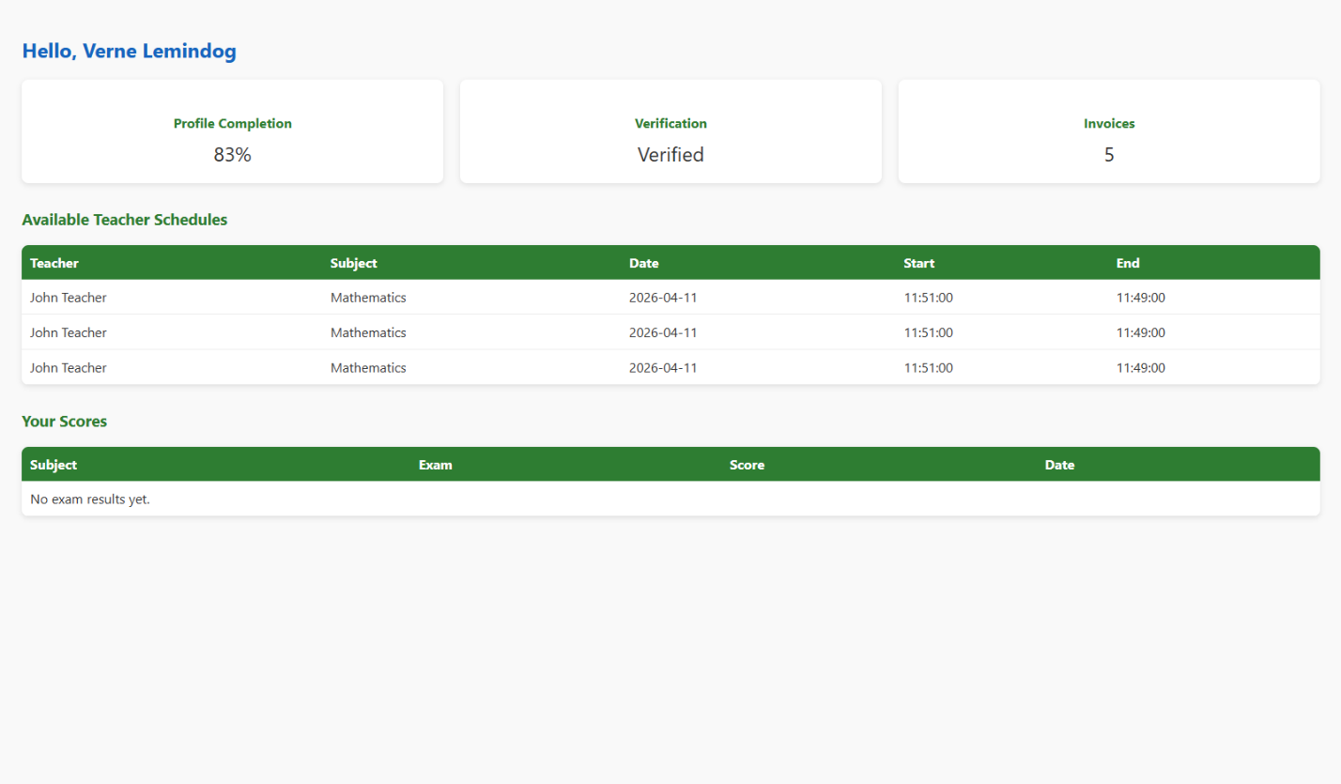
Teacher Dashboard and Monitoring Tools
Teachers access the Teacher Dashboard, which consolidates student performance data. As shown in Figure 2, the system provides automated reports that highlight learning gaps.
- Performance Distribution: A pie chart categorizes students into “Needs Improvement,” “Satisfactory,” and “Excellent.”
- Subject Analytics: A line graph tracks class performance trends over time, enabling teachers to identify subjects where interventions are most needed.

Figure 2. SMART TeachLink Teacher Dashboard showing performance distribution.
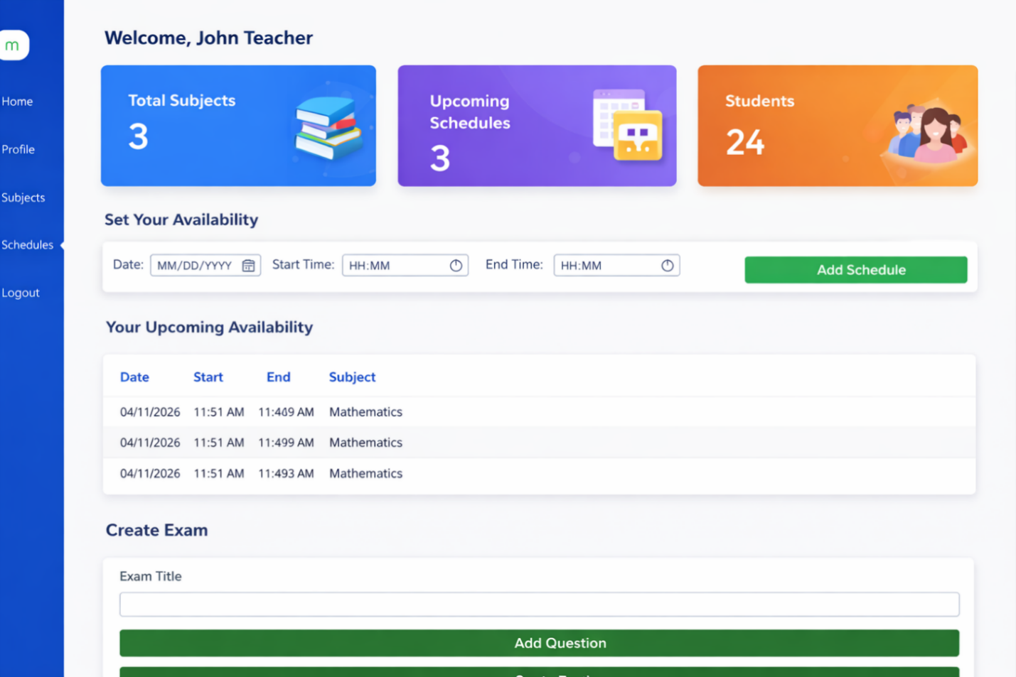
Automated Assessments and Reward System
The system eliminates manual checking by automating quizzes and assessments. The Assessment Module cross-references student answers against stored solutions, instantly generating scores. The Reward System then awards stars for passing scores, encouraging motivation and discipline.
Figure 3. Interactive quiz interface with automated scoring and star rewards.
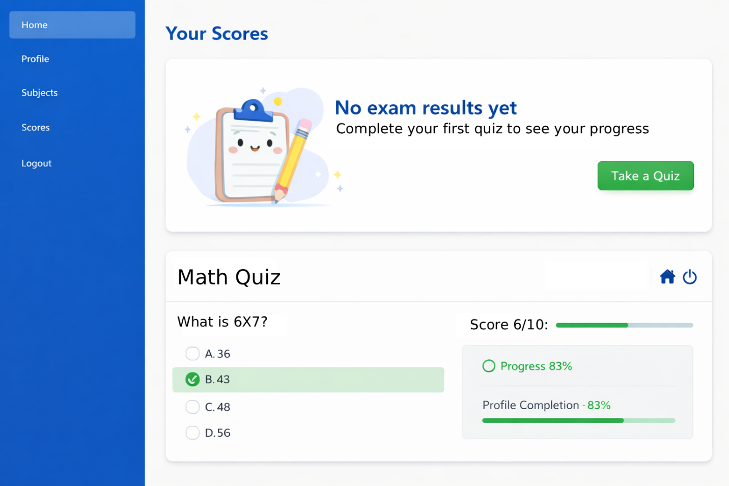
System Validation and Functional Testing
To ensure the reliability of SMART TeachLink, the researchers conducted systematic functional testing. The platform was tested against multiple “edge cases” (e.g., students with repeated failures, incomplete quizzes, or inconsistent internet connectivity).
Table 1. System Functional Testing Results
Feature Module | Test Case | Status | Observation
Assessment Engine | Quiz Scoring Accuracy | Passed | 100% accuracy in score computation.
Reward System | Star Allocation After Passing Quiz | Passed | Correctly awarded stars for motivation.
Teacher Dashboard | Class Performance Analytics | Passed | Successfully displayed trends and distributions.
Data Integrity | User Role Access Control | Passed | Restricted teacher-only data from student views.

Discussion: Transitioning from Reactive to Proactive
The results indicate that SMART TeachLink effectively addresses the gaps in traditional primary education. By visualizing student progress and automating assessments, the system transforms technology from a passive tool into an active learning environment. Students are motivated through gamified rewards, teachers gain actionable insights through dashboards, and parents benefit from accessible progress reports.
This proactive approach ensures that learning difficulties are identified early, allowing timely interventions. Unlike traditional methods that rely on delayed feedback, SMART TeachLink provides real-time monitoring, making it a vital tool for modernizing primary education in the Philippines.

CONCLUSION
The development of SMART TeachLink: A Tutoring System for Primary School demonstrated the potential of technology to transform digital engagement into a meaningful and structured learning experience for young learners. The system was successfully designed and developed to provide interactive lessons, automated assessments, progress monitoring, and reward-based motivation mechanisms that encourage students to use technology for educational purposes rather than entertainment. By integrating core subjects such as Mathematics, English, Filipino, Science, Araling Panlipunan, and MAPEH, the platform provided learners with accessible and engaging academic resources tailored to their enrolled subjects.
The study also addressed several challenges commonly encountered in primary education, including unproductive digital habits, limited personalized learning opportunities, and the growing workload of teachers in monitoring student performance. Through role-based dashboards and automated workflows, SMART TeachLink enabled teachers to efficiently manage lessons, quizzes, and student progress while reducing time spent on repetitive administrative tasks such as manual checking and reporting. Likewise, the system supported students by providing personalized learning experiences, filtered educational content, quiz feedback, and progress reports that encouraged continuous improvement and stronger study habits.
Moreover, the implementation of authentication, role management, and secure session control ensured proper access to system functionalities while maintaining organized educational records. The integration of a responsive user interface also enhanced accessibility across various devices, allowing students and educators to interact with the system conveniently. Functional testing results further demonstrated that the platform effectively performed its intended operations, including lesson management, quiz automation, enrollment handling, and performance monitoring.
Overall, the findings of this study indicate that SMART TeachLink can serve as an effective and innovative tutoring platform that promotes responsible digital behavior, improves student engagement, and supports academic achievement among primary school learners. The system highlights the value of technology-assisted education in modern classrooms and provides a foundation for future developments in intelligent tutoring systems, gamified learning, and adaptive educational technologies within the Philippine educational setting.

RECOMMENDATIONS
Based on the results and limitations encountered during the development of this study, the following recommendations are proposed:
For Educational Institutions
It is recommended that schools and universities adopt AI-assisted learning portals to streamline academic operations. Transitioning from manual record-keeping to automated dashboards like SMART TeachLink will ensure consistent monitoring of student performance and reduce administrative errors.
For Teachers
Educators should utilize the system’s analytics and progress indicators to identify students who require additional support. Early intervention based on quiz results and engagement metrics can significantly improve learning outcomes and retention rates.
For Future Researchers
Future studies should explore integrating Natural Language Processing (NLP) for real-time student assistance through chatbots. Expanding the system to include adaptive learning algorithms and external educational APIs (such as Khan Academy or Coursera) could further enhance personalized learning pathways and global competency alignment.
REFERENCES
- Abad, J. M., & Cruz, L. R. (2024). Gamification in Philippine Classrooms: Enhancing Student Engagement through Digital Platforms. Philippine Journal of Educational Technology, 18(1), 55–72.
- Caballero, R. A., & Villanueva, P. S. (2023). AI-Driven Learning Management Systems: Opportunities and Challenges in Southeast Asia. Asian Journal of Education and Innovation, 12(3), 201–219.
- Dela Peña, M., & Santos, K. (2025). Automated Scheduling and Academic Tracking in K-12 Education. International Journal of Smart Education Systems, 7(2), 89–104.
- Garcia, A. J., & Lee, H. (2022). Interactive Dashboards for Student Performance Monitoring: A Comparative Study. Computers & Education, 185, 104–118.
- UNESCO. (2023). Global Education Monitoring Report: Technology in Education – A Tool on Whose Terms? UNESCO Publishing.
- Velasco, R. T., & Mendoza, C. F. (2025). Integrating AI-Assisted Quizzes in Mathematics Learning: Effects on Student Motivation. Journal of Digital Pedagogy, 9(4), 145–162.

