VISION BASED ROAD LANE DETECTION SYSTEM FOR VEHICLE GUIDANCE OPENCV

Dr.G.Dhanalakshmi
Dept of Information Technology Panimalar Engineering College Chennai, India gdhanalakshmipecit@gmail.com
Aparna.V
Dept of Information Technology Panimalar Engineering College Chennai, India
aparnaswathi17@gmail.com

Lakshaya.A
Dept of Information Technology Panimalar Engineering College Chennai,India
lakshaya1828@gmail.com
Yuvasree.V
Dept of Information Technology
Panimalar Engineering College Chennai, India yuvasreevelayudham2004@gmail.com

Abstract— The basic need that is conditioned by the lane awareness is safe and dependable steering of a vehicle in a current driver assistance system. This project presents a vision-based road lane recognition system created on the framework of OpenCV and classical computer vision algorithms to identify the lane markers and track them on the real-time images and video streams of the road. The system is aimed at the high quality lane extraction in variable illumination and road conditions through the pipeline of color space filtering (HSL/HSV), edge detection, region of interest masking and Hough transform line detection, slope-intercept based lane estimation. As the framework is aimed at enhancing the perception of the scene, and maintaining the focus on the main goal, the road surface segmentation and object detection are included with the aid of YOLOv8. The segmentation of the road, helps in justification of the driveable space and the object detection (vehicles, pedestrians, traffic lights, obstacles) provides the background information to the lanes identified. These auxiliary modules make the process of lane detection easier, by increasing precision in the setting where similar roads are located in cities. The entire system is implemented as an interactive Streamlit application that is capable of processing both images and video as well as displaying real- time performance, which may be applied to intelligent transportation and Advanced Driver Assistance Systems (ADAS). Since the outcomes of the experiment have revealed, the suggested solution will be able to discover the boundaries of the lanes with high accuracy, and provide substantial road context, that is why it could be considered an effective solution to the issue of vehicle guidance based primarily on the lane perception, which is driven by the computer vision.

Keywords— Lane Detection, OpenCV, Hough Transform, Vehicle Guidance, Road Segmentation, YOLOv8, ADAS, Computer Vision.

- Introduction
The future development of smart transportation systems and autonomous driving technologies has posed an immediate need of highly sophisticated perception systems that can comprehend intricate road conditions with high and dependable precision. To move safely and effectively one of the requirements is that a vehicle is able to continuously scan the environment around it, understand road features, determine safe areas to drive in, and the dangers that might occur on the road surface. The vision-based perception with cameras has turned out to be one of the most effective and
cost-efficient methods of implementing this environmental awareness. Nonetheless, most of the current systems are designed to complete major perception opportunities, including lane estimation, semantic road segmentation, and surface anomaly detection, leading to duplicated computation, loose interpretation of the scenes, and complexity of the systems. In this project, the proposed problem is to have a single vision pipeline that will incorporate these three critical tasks of perception as one single unit so that the visual input can analyze road structure, road context, and the state of the road simultaneously.
Lane estimation is an essential part of advanced driver assistance systems and autonomous cars, as it allows the car to stay within the limits of a road and perform safe motor actions like lane keeping and lane changing. Correct lane identification guarantees the good alignment and helps a great deal towards the driving safety, especially in highways and in constructed city roads. However, the problem of estimating lanes in real-life situation is not that simple because of such issues like the disappearance or destruction of lane markings, shadows in the surrounding objects, other vehicle occlusions, lighting variations, and bad weather (rain and fog). An effective system should then be able to find significant features in complicated scenes and decode lane structures even when visual cues are meager or even incomplete. The addition of lane estimation into a larger perception pipeline enables other tasks to provide contextual information to aid in achieving a higher level of accuracy in lane detection. Semantic road segmentation is a supplement to lane estimation, which gives pixel-wise classification of the scene as a whole. Semantic segmentation does not merely identify and mark lines in a lane, but rather recognizes all other pertinent road environment features, including the areas that should be traversed by vehicles, footways, vehicles, pedestrians, vegetation, and the background. This fine knowledge enables the system to dissimilarize safe and unsafe areas in which to navigate. Semantic segmentation allows greater awareness of the perception system by establishing the spatial context of lanes to guide the better understanding of the lane boundaries and greatly diminishes false detections. With knowledge of the general road environment, the system is able to maintain the lane estimation to be confined to the plausible regions and can accommodate more complex city structures where lanes are not necessarily clearly defined. Another dimension of critical dimension to road perception is introduced by surface anomaly detection which deals with the physical condition of the road surface. Potholes, cracks, debris, bumps and uneven

pavements are hazards that are very dangerous to the stability of the cars and the comfort of the passengers. These things are not always considered in traditional perception pipelines, which are more focused on navigation and not safety concerning surface conditions. By integrating the concept of anomaly detection in the same vision pipeline, the system will be able to determine not only where a vehicle needs to drive, but also check whether the surface is safe to drive on. On-the-fly detection of anomalies occurring on the surface can be used to respond proactively e.g. to reduce speed or to change the path and improve the riding experience and overall safety.
- Litearture review
Y. Liu (2020) [1] suggested fused front-lane trajectory estimation algorithm that is specific to existing ADAS sensor designs to promote functions ACC and automated lane change. The algorithm comprises lane markings, front car paths, and host vehicle dynamics, based on a clothoid lane model the parameters of which are estimated through a Kalman Filter. The method considers predicted and real state measurements to generate a healthy lane path instead of using vision lane markers only.
I. Fakhari (2022) [2] proposed a hybrid lane detector that is based on Multiple Model Adaptive Estimation (MMAE) to fuse a group of vision-based lane detectors. Since it was noted that different models work differently in different conditions, the study involved the use of both front and rear cameras in the AirSim environment, with the rear camera serving as an estimator of the model uncertainty. The MMAE framework is dynamic to change the models in case of failures, which improves their reliability and solves the problem of generalization that is typical of deep learning methods.
As T. Yuan (2023) [3] showed, even current Surround View Systems (SVS) that are designed to aid in parking can be reused to detect lanes and estimate them without changing hardware. Because of the depth ambiguity and distortion of mono-cameras, a multi-stage pipeline was suggested, which consists of neural network classification, truncated Gaussian random field spatial filtering, fading memory temporal filtering, and polynomial fitting. Experimental results in the real world indicated that statistically processed SVS data could result in meaningful lane orientation information that would allow the automation to a higher degree.
J. Alexander (2025) [4] had a computationally cheap lane-keeping system on a 1:10 scale vehicle based on traditional lane detection, inverse perspective mapping and Stanley controller in Jetson Nano. At 12 FPS, the system had a stable lane keeping and the lateral correction was smooth. The findings proved that cost-effective hardware and classical controllers can be used to provide dependable lane- keeping behavior, which can provide a safe and cost- effective testing setup prior to real-world implementation of full-size vehicles.
Z. Zhang (2022) [5] enhanced the power of deep learning lane detector by using an encoder/decoder structure with a Feature Shift Aggregator and adding data augmentation/filtering methods. The technique dealt with lane-change glitches in datasets like TuSimple and obtained the state of the art accuracy. Filter stage was essential in predictive stability with time, hence the significance of time consistency in the lane detection networks.
K. Cheng (2025) [6] suggested UR-SAM, a road semantic segmentation system that is based on the Segment Anything Model with LoRA-based urban domain adaptation. The model introduced Road Semantic Priors-Guided prompts, which rely on structural and color prompts, and the model created adaptive prompts to enhance the segmentation of the objects on the road. Cityscapes evaluations had better generalization and finer-grained segmentation in complicated lighting and weather conditions.
L. Du (2023) [7] upgraded BiSeNet to optimize the urban road segmentation process by adding supervised blocks to the context path to alleviate the problem of loss of information due to continuous downsampling. This change saved more contextual information on layers and has been shown to yield significant mIoU gains on datasets of Cityscapes and CamVid. The paper focused on continuing features in the real-time segmentation networks.
H. Lin (2023) [8] introduced TDRNet, which is a trilateral dual-resolution real-time segmentation network that enhances the fusion of features at different stages but not just the end of branches. The third branch is selective in the use of weight-based fusion mechanisms. The network delivered a high FPS and high mIoU on conventional road datasets, which shows that it achieved a good balance between accuracy and real-time.
I. Liu (2024) [9] made DeeplabV3+ more effective with road marking segmentation with the structured road markings by substituting the backbone with MobileNetV3 and the ACMix module which is used to extract hybrid convolution-attention features. The enhancements resulted in a significant mIoU increase and real-time inference rate and are robust to occlusion and uneven illumination, so it is applicable to resource-limited ADAS systems.
E. Caceres (2024) [10] focused on satellite imagery as the input of multilabel road segmentation with the help of U- shaped CNN architectures. The sample generation process was developed as a custom one because of the dataset limits. Its performance metrics were very high and the models showed good generalization even performing better than certain ground truth annotations, which points to the prospects of satellite-based road understanding in the monitoring of extensive infrastructure.
D. Liang (2025) [11] proposed a thermal aberration projection technique in terms of Landsat 8 land surface temperature information that costs the development and establishment of fit-reference and genuine reference temperature models. The analysis of differences between observed and reference temperatures allowed the method to identify both high- and low-temperature changes including fires, deforestation, and river drying with high F1-scores at various spatial levels and demonstrating the ability to monitor anomalies in space.
- Methodology

A. Input Acquisition and Pre-Processing.
The solution records the video feed of a forward facing camera attached to the vehicle. Frame processing is done in advance to increase visibility and minimize noise. The image obtained is transformed into various color space like RGB, HSV and HSL to enhance feature identification in varying illumination and weather conditions. Gaussian

smoothing is used to reduce the noise in the high- frequency and ready the frame to undergo additional processing.
B Lane Detection with Vision Methods.
The process of lane detection is performed with the help of effective traditional image processing. Canny edge detector is used to extract high intensity gradient as in fig:1 which represents lane markings. An ROI mask is then applied to the processing region to limit the
processing to the road part of the frame. Hough Transform is used to identify straight line segments that show the edges of lanes. The average of these detected lines is computed to get left and right lane boundaries that are stable using a slope-intercept method. The continuity and strength of lane estimation are guaranteed by the application of the temporal smoothing method between the successive frames.

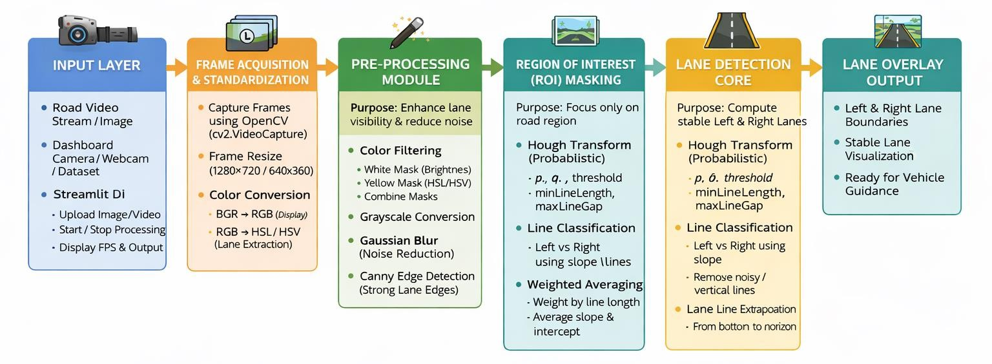
Fig:1 lane detection flow diagram using vision

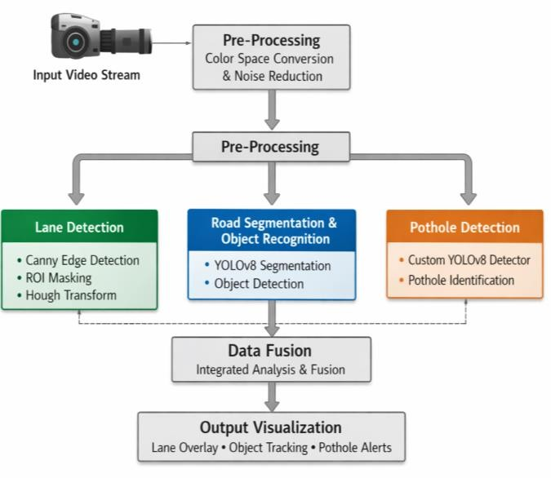
C. Segmentation and Object Recognition of a Road with . YOLOv8 Segmentation.
The YOLOv8 segmentation model is applied in order to gain semantic comprehension of the road scene. The model is used to segment the area of the road that can be driven upon on a pixel-by-pixel basis and at the same time identify any dynamic and stationary objects like vehicles, pedestrians, and obstacles. The segmentation output gives an accurate road mask whereas the detection component determines entities around it. The combination of this information makes possible a more profound analysis of the driving environment that is required in intelligent transportation systems.
D. Pothole Detection YOLOv8 Detector Trained Custom.
To identify potholes and irregularities of the surface on the road, a custom-trained YOLOv8 object detection model is used. The model is trained using annotated datasets that consist of all kinds of road damage, which allows the model to identify potholes, cracks, and surface defects. The module helps to monitor the road condition automatically and can be used in the infrastructure

Fig:2 System Architecture

maintenance and safety systems.
E. Fusion of Integration and Fusion of the Output.
The results of the lane detection, road segmentation, object detection and pothole detection modules are combined to form a complete image of the road scene. The boundary of lanes is overlapped with the segmented road areas, the detected objects, and the locations of potholes to make a complete representation. This merged output enables real-time decision making on applications in the advanced driver assistant systems, robotic cars, and smart city traffic monitoring.
F. System Architecture
The proposed system as in fig:2 is built in terms of a single pipeline that receives the real-time video input and processes it using a number of vision modules and combines their results into one analytical framework. This works by having a forward facing camera which records an ongoing video of the road surroundings. The first stage is pre-processing where the color space conversion and noise reduction schemes are used to increase the image quality and ensure the safety of the feature extraction. Following pre-processing, the frame is shared among three parallel modules, namely lane detection, road segmentation including object recognition and pothole detection. The lane detector module is based on classical

computer vision methods which include edge detection, region of interest masking and Hough Transform to estimate lane boundaries effectively. At the same time, the road segmentation and object recognition module uses the YOLOv8 segmentation model, which accomplishes extraction of the road area (pixels location) and detection of the nearby vehicles, pedestrians and objects. Simultaneously, the pothole detection module is based on the custom-trained YOLOv8 detector that identifies irregularities on the road surface in the form of potholes. The products of each of the three modules are then sent through a data fusion phase where the lane overlays, part segments of the roads, detected objects, and pothole alerts are integrated to give the complete picture of the scene. Lastly, the integrated output is displayed in real time, which gives actionable data on driver assistance, autonomous navigation, and intelligent road surveillance systems
- Result And Discussion
- Original Road Scene Frames to be used in Lane Detection.
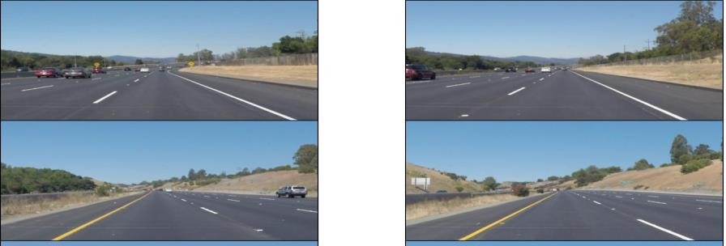
Fig. 3. Sample input road frames taken by the front-viewing camera at different conditions on the highway.
Figure 3 presents the initial frames that were obtained out of the input video prior to any preprocessing or lane detection processes being performed. These frames depict various highway conditions such as straight roads, slight curves, and vehicles on the road, roadside plants, shadows and changes in the visibility of lane marking. This diversity is necessary to test the strength of the suggested lane detection pipeline in the real-life driving conditions. One can see that markings along the lane are contrasting and less clear under the light conditions, the road and the perspective distortion. These difficulties render direct edge detection unreliable unless it has been preceded by color filtering, smooth and region-of- interest detection. Therefore, these input frames support the significance of multi-stage preprocessing steps embraced in the proposed system in obtaining precise and consistent estimation of the lane.
- Lane Highlighting filtering via color space.
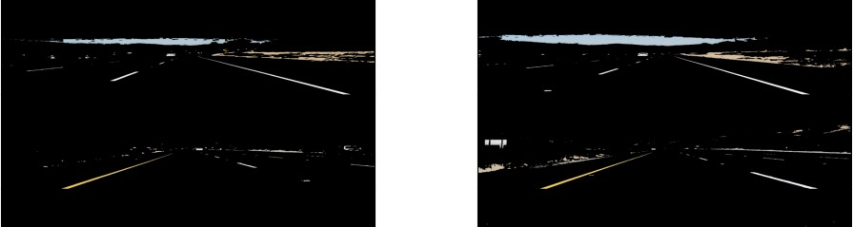
Fig. 4. Result obtained following the application of the HSL/HSV color space thresholding to extract the lane markings in the road scene.
Figure 4 shows how the original road frames are filtered after using the color space-based filtering methods. The lane markings are effectively brought out by converting the image to HSL and HSV color space and using carefully chosen ranges of threshold values of white and yellow colors to make the lane markings visible and subdue most of the background information of the image. The dark areas are the elimination of the irrelevant pixels on the road, a car, trees, and shadows and forms the bright pixels of the lane.This is critical since in direct edge detection of raw images, too much gradients that are not needed by road texture, shadows, and nearby objects are usually captured. The masking based on color greatly works to minimize noise and prepares the image so that more elucidate edge detection is done. The white and yellow lane markings, as in the figure, are quite visible in a variety of road conditions, and this proves how effective color space filtering is to various illumination levels and perspective distortions. Such preprocessing step is the basis of reliable extraction of edges in the further steps of the lane detection pipeline.

- Feature Enhancement in Multi Color Space Transformation.
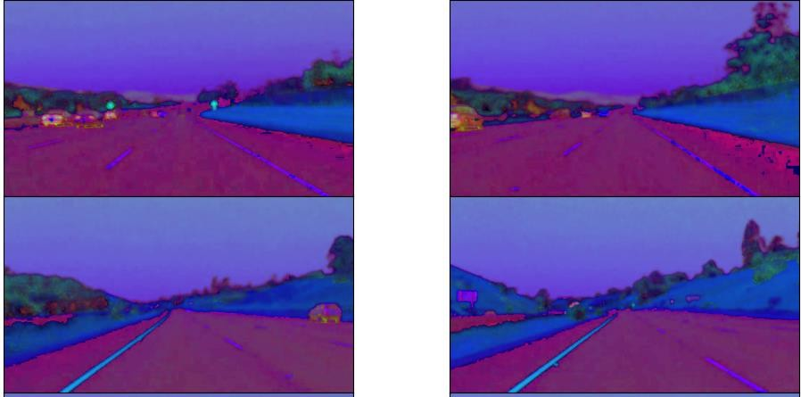
Fig. 5. Road processes the conversion of HSV/HSL color spaces on the conversion to road frame to make lane feature visible in different lighting conditions.
Figure 5 represents how the original road frames are converted to other color space like HSV and HSL. These color models do not intermix intensity information with color components unlike in the RGB representation and, as such, lane markings can be better differentiated against the road surface and the surrounding environment. The differences in color tones observed in the picture are not the side effects but the consequences of the increase of contrast between the pixels on the lane, asphalt texture, vegetation, and sky areas.This transformation is critical in enhancing the strength of the lane detection pipeline particularly in varying surroundings of light, shadows and distortions of perspective. The system is able to use more effective thresholding with white and yellow lane markings by isolating luminance and chromatic components. The lane boundaries as it can be seen are clear and simpler to isolate than the original frames. This makes the further preprocessing steps like smoothing, edge detection, and ROI masking more reliable thus helping to achieve stable and accurate lane estimates.

- HSV Colour Space Conversion to Intense Lane Feature Isolation.

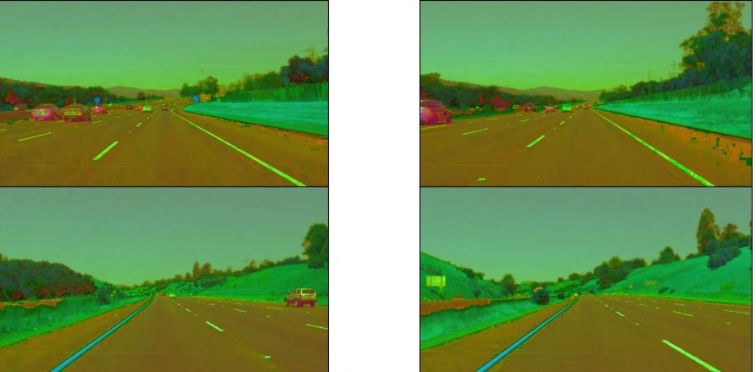
Fig. 6. Road frames were modeled in the HSV color space in order to further distinguish between the lane markings and the background.
Figure 6 shows the road scenes in the HSV (Hue, Saturation, Value) color space as the RGB model was converted to HSV. In this rendering, the brightness (Value) element is detached as well as color data to enable the lane markings to be more clearly distinguished between the asphalt surface and the rest of the environment. These differences in the green, blue and yellow color also represent the redistribution of the various parts of the picture in hue and saturation channel.This transformation comes in handy specifically in dealing with changes in lighting, shadows as well as reflective roads. The white and yellow lane markings are more prominent as they are more distinguishable because they have unique hues and the high value components whereas the irrelevant background textures are suppressed.
- Final Lane Boundary Estimation based on Hough Transform and Slope Averaging.

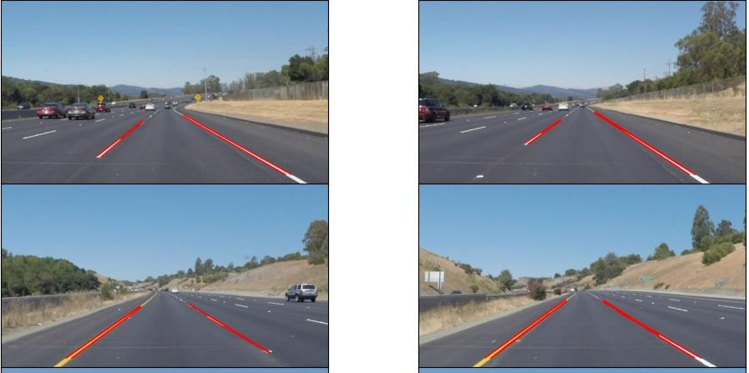
Fig. 7. After Hough Transform and slopeintercept averaging, found lane boundaries were superimposed on original road frames.
Figure 7 represents the end product of the lane detecting pipeline in which the approximated right and left edges of lanes are overlaid onto the original road pictures. Once edge detection and masking of regions-of-interest is performed, the Hough Transform is used to determine several line segments that are shorter than the length of the lane. The segments are then grouped into left and right lanes depending on slopes orientation and united with weighted slope- intercept averaging method to form continuous and stable lane edges. The red lines are clear evidence that the system is effective in the detection of lane positions in straight roads, curved routes, and scenarios that have vehicles and shadows. These findings indicate that geometric constraints in conjunction with a color-based preprocessing system and line averaging yield the correct lane estimates in the event that the markings of lanes are partially erased or have been influenced by lighting conditions. This last overlay proves the usefulness of classical computer vision methodology that
is used in the proposed unified vision pipeline to provide trusted real-time lane detection.
- Road Segmentation with Object Detection Image
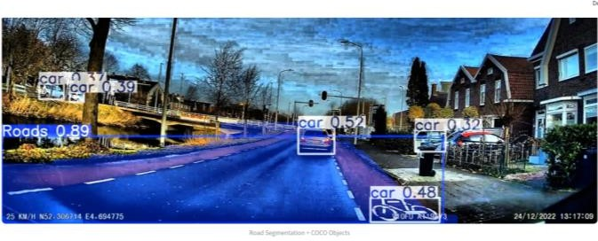

Figure 8: Road Segmentation and Object Detection Output Showing Drivable Area and Surrounding Objects

The image in fig:8 shows the output of the road segmentation and object detection module. The blue highlighted region represents the drivable road area identified at the pixel level by the segmentation model. This clearly separates the road surface from sidewalks, buildings, and other non-drivable regions. In addition to segmentation, multiple objects such as vehicles and pedestrians are detected using bounding boxes with confidence scores. The system successfully identifies these objects in relation to the road region, demonstrating accurate environmental perception. The segmentation ensures that the detected lane boundaries belong to the actual road surface, while object detection provides awareness of dynamic obstacles. The clear separation of road and non-road regions indicates reliable performance under real-world urban conditions.

- Pothole Detection Image
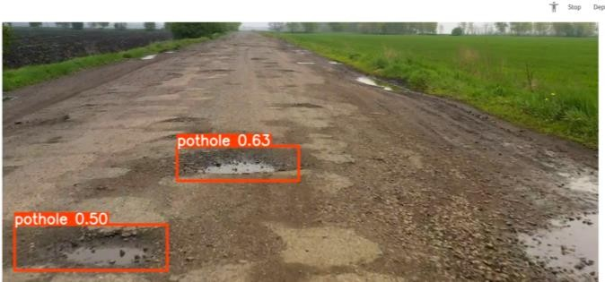
Figure 9: Pothole Detection Output Using Custom YOLOv8 Model Showing Road Surface Defects

The image in fig:9 shows the output of the custom-trained YOLOv8 pothole detection model. The red bounding boxes labeled “pothole” with confidence values indicate successful identification of damaged road surfaces. The model accurately detects potholes even on an uneven mud road where lane markings are absent. This demonstrates the robustness of the model in recognizing surface irregularities based on texture and shape features rather than relying on lane cues. Such detection can be used to warn drivers and support road maintenance systems. The consistent detection of potholes with meaningful confidence scores indicates good model performance in challenging road environments.

V1.Conclusion
This paper offered a single vision-based system to real- time understand the road scene through the unification of the lane segmentation, road segmentation, object recognition, and pothole detection into one system. To make use of the advantages of both methodologies, the offered approach integrated classical image processing methods with the most developed deep learning models. The computer vision was used to provide computationally efficient and stable lane detection, whereas the YOLOv8-based segmentation and detection models could be used to obtain detailed semantic knowledge of the road environment. Experimental testing has established that the system has a good performance in various lighting, traffic densities, and varying road surfaces. Data fusion of various modules was used to facilitate a total visualization of lane boundaries, road regions, and surrounding objects as well as surface anomalies in real-time. This integrated architecture has better situational awareness than traditional ADAS functionalities, as it is able to monitor the road conditions as well as perceiving the scene. The findings suggest that the supplied system should be applied to the development of advanced driver assistance systems, autonomous vehicles, and smart city road monitoring systems. Future work could involve optimization in low-light and poor weather environments, and scaling of the pothole database to allow more generalization, as well as implementation on embedded systems to use in a large-scale field environment.
VII .References

- Y. Liu, H. Cheng and Z. Li, “Fused Front Lane Trajectory Estimation Based on Current ADAS Sensor Configuration,” 2020 4th CAA International Conference on Vehicular Control and Intelligence (CVCI), Hangzhou, China, 2020, pp. 124–129, doi:10.1109/CVCI51460.2020.9338470.

- I. Fakhari and S. Anwar, “A Multiple Model Estimation Approach to Robust Lane Detection via Computer Vision Based Models,” 2022 IEEE 31st International Symposium on Industrial Electronics (ISIE), Anchorage, AK, USA, 2022, pp. 576–581, doi:10.1109/ISIE51582.2022.9831692.

- T. Yuan, W. Cao, S. Zhang, K. Yang, M. Schoen and B. Duraisamy, “Lane Detection and Estimation from Surround View Camera Sensing Systems,” 2023 IEEE SENSORS, Vienna, Austria, 2023, pp. 1–4, doi:10.1109/SENSORS56945.2023.10324877.

- J. Alexander, F. Sutanto and S. Tan, “Performance Evaluation of Conventional Lane Detection and Stanley Controller on Jetson Nano for Lane Keeping Application in a Miniature Vehicle,” 2025 9th International Conference On Electrical, Electronics And Information Engineering (ICEEIE), Mataram, Indonesia, 2025, pp. 1–6, doi:10.1109/ICEEIE66203.2025.11252372.

- Z. Zhang, S. Lin, T. Chou, S. Jhong and Y. Chen, “Robust Lane Detection via Filter Estimator and Data Augmentation,” 2022 IEEE International Conference on Consumer Electronics - Taiwan (ICCE-Taiwan), Taipei,
Taiwan, 2022, pp. 291–292, doi:10.1109/ICCE- Taiwan55306.2022.9869116.

- K. Cheng, “UR-SAM: Urban Road Segmentation in Autonomous Driving Scenes Based on SAM,” 2025 3rd International Conference on Algorithm, Image Processing and Machine Vision (AIPMV), Zhenjiang, China, 2025, pp. 126–130, doi:10.1109/AIPMV67185.2025.11290629.

- L. Du, Y. Zhang, B. Liu and H. Yan, “An Urban Road Semantic Segmentation Method Based on Bilateral Segmentation Network,” 2023 3rd International Conference on Neural Networks, Information and Communication Engineering (NNICE), Guangzhou, China, 2023, pp. 503– 507, doi:10.1109/NNICE58320.2023.10105801.

- H. Lin, J. Qiu, Y. Tong and Y. Tang, “Trilateral Dual- Resolution Real-Time Semantic Segmentation Network for Road Scenes,” 2023 IEEE 18th Conference on Industrial Electronics and Applications (ICIEA), Ningbo, China, 2023,
pp. 135–140, doi:10.1109/ICIEA58696.2023.10241797.

- I. Liu, Z. Haizhe, Y. Li and C. Siyuan, “Research on Structured Road Segmentation Algorithm Based on Improved Deeplabv3+,” 2024 6th International Academic Exchange Conference on Science and Technology Innovation (IAECST), Guangzhou, China, 2024, pp. 2107– 2111, doi:10.1109/IAECST64597.2024.11117254.

- E. Cáceres, C. Beltrán and F. Pineda, “Road Multilabel Semantic Segmentation from Satellite Images Using Convolutional Neural Networks,” 2024 IEEE ANDESCON, Cusco, Peru, 2024, pp. 1–5, doi:10.1109/ANDESCON61840.2024.10755732.

- D. Liang et al., “A New Detection Method for Land Surface Anomalies From the Perspective of Thermal Infrared Remote Sensing,” IEEE Transactions on Geoscience and Remote Sensing, vol. 63, 2025, Art. no. 5007216, doi:10.1109/TGRS.2025.3605164.

- E. Lin, Y. Chen, K. Tan, Y. Zhou, Y. Xu and Y. Zhai, “Evaluation of Fine-Grained Anomaly Detection Methods on a Novel Battery Surface Defect Dataset,” 2024 5th International Symposium on Computer Engineering and Intelligent Communications (ISCEIC), Wuhan, China, 2024,
pp. 277–280, doi:10.1109/ISCEIC63613.2024.10810185.

- J.-A. Wang, Z. Gao, Z. Liao, S. Xia, M. Cao and Q. Wang, “ESAD-GPT: Earth’s Surface Anomaly Detection Using Large Vision-Language Models,” IGARSS 2025 - 2025 IEEE International Geoscience and Remote Sensing Symposium, Brisbane, Australia, 2025, pp. 1007–1011, doi:10.1109/IGARSS55030.2025.11243288.

- J. Luo, J. Lin, Z. Yang and H. Liu, “SMD Anomaly Detection: A Self-Supervised Texture–Structure Anomaly Detection Framework,” IEEE Transactions on Instrumentation and Measurement, vol. 71, 2022, Art. no. 5017611, doi:10.1109/TIM.2022.3194920.

