Highway Turbines: A Novel Approach to Urban Renewable Energy Generation
Vishwanth Ramanan, Muhammed Sanad VK, Saravanan, Yash P Rathod, Varun V
BCom/BCA Students, School of Commerce & School of CS & IT,
Jain (Deemed-to-be University), Bengaluru, Karnataka, India.
Dr Kannagi Anbazhagan
Associate Professor, School of CS & IT,
Jain (Deemed-to-be University), Bengaluru, Karnataka, India.
Email: kannagiaunjb@gmail.com

Abstract
As the gap between how much electricity we need and how much we produce keeps widening, finding sustainable energy alternatives has become critical. This paper explores the idea of using "highway wind turbines" essentially, capturing the artificial wind drafted by fast-moving vehicles to generate power. Specifically, we look at whether Vertical Axis Highway Turbines (VAHT) could work along the busy roads of Bangalore, India. We dug into airflow patterns, looked at how these turbines should be designed, and tested a prototype to see what kind of numbers we could get. Our research suggests that VAHT systems have real potential to power roadside infrastructure, like streetlights and cameras, which would take some load off the main grid. We’ve pulled together insights from previous projects and our own experimental models covering design, aerodynamics, and the practical benefits to show that this could be a smart move for urban renewable energy.
Keywords: Vertical Axis Highway Turbine (VAHT), Vehicle-Induced Wind, Urban Micro-Wind, Renewable Energy, Smart City Infrastructure, Sustainable Highways.

1. Introduction
Energy is basically the fuel for all modern progress. With cities growing so fast, our need for electricity is skyrocketing, but our traditional ways of generating it are still limited and messy for the environment. Wind energy is a great alternative, but let's be honest: those massive conventional windmills just don't fit in crowded cities. They’re too big, too.

expensive, and just not practical for urban spaces.
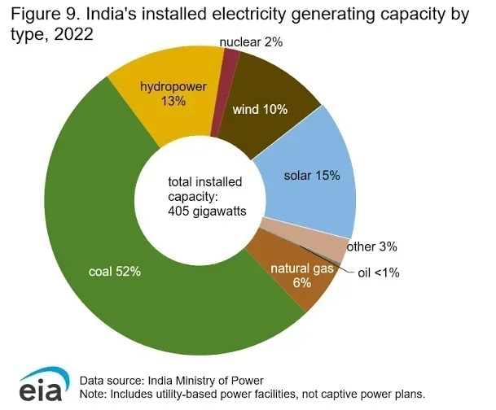 *Figure 1: India’s installed electricity generating capacity by type, 2024 (Data Placeholder) *
However, highways are a different story. Fast-moving cars and trucks create strong wind currents just by driving by. Vertical Axis Highway Turbines (VAHT) are designed to catch this "free" wind without needing acres of land. You install them right on the highway divider, and they spin regardless of which way the traffic and the wind flow. Our reference model suggests that the middle of the road gets the strongest wind force, meaning these turbines could keep spinning even when traffic isn't at peak speeds.

2. Literature Review
We looked at a lot of existing research to see what’s already been done with urban micro-wind turbines:
- A 2013 study in the *IJSRD* showed a VAHT design using C-type blades and BLDC generators. They proved you could get a steady electric current from vehicle wind to power simple things like lights. A 2013 study in the *IJSRD* showed a VAHT design using C-type blades and BLDC generators. They proved you could get a steady electric current from vehicle wind to power simple things like lights.
- In Turkey, the ENLIL Project installed smart vertical turbines along expressways and managed to generate up to 1 kWh per hour, which is impressive. In Turkey, the ENLIL Project installed smart vertical turbines along expressways and managed to generate up to 1 kWh per hour, which is impressive.
- Research from Mexico between 2020 and 2022 confirmed that micro-wind turbines can work efficiently even in heavy traffic corridors. Research from Mexico between 2020 and 2022 confirmed that micro-wind turbines can work efficiently even in heavy traffic corridors.
- Experimental prototypes have hit output levels of around 48 watts when the airflow speed is about 4.4 meters per second. Experimental prototypes have hit output levels of around 48 watts when the airflow speed is about 4.4 meters per second.
While the literature says "yes, this is possible," there hasn't been enough work done specifically for Indian highways [6, 7], which have their own unique chaotic traffic and weather conditions.

3. Identifying the Gaps
Despite the global success stories, we found some holes in the current research:
1. No Local Studies: Most studies are from abroad. We don't really know how these turbines would handle Bangalore's specific traffic density and road conditions. We can't just copy-paste global assumptions here.
2.Money Talk is Missing: A lot of papers focus on engineering but ignore the economics. We need to know if the cost of installing these things is actually worth the energy they produce. Without clear cost-benefit analyses, investors aren't going to bite.
3.Integration Headaches: How do you fit these onto existing road dividers? The current research doesn't talk enough about the practical engineering challenges of vibration, safety, and conflicting infrastructure that come with retrofitting.
4.Hybrid Models are Underexplored: Some people suggest adding solar panels to these turbines, but hardly anyone has actually tested how a hybrid solar-wind system performs on a highway.
5.Policy Vacuum: There’s no rulebook for this in India yet. The lack of clear government guidelines on land use or safety standards has definitely slowed things down.

4. Objectives of the Study
Primary Goal: To figure out if installing Vertical Axis Highway Turbines (VAHT) in Bangalore is actually feasible and effective.
Specific Goals:
- Analyze the airflow generated by traffic to see if it's enough to drive a turbine. Analyze the airflow generated by traffic to see if it's enough to drive a turbine.
- figure out the best design materials, shape, aerodynamics for these conditions. figure out the best design materials, shape, aerodynamics for these conditions.
- Test a prototype to see how much actual power we can generate. Test a prototype to see how much actual power we can generate.
- Compare the costs and environmental benefits against just using regular grid power. Compare the costs and environmental benefits against just using regular grid power.
- Come up with a plan for how these could be implemented in a smart city context. Come up with a plan for how these could be implemented in a smart city context.

5. Methodology
We used a mix of methods: analytical research, comparisons, and actual experiments.
A. Learning from Others:
We started with a deep dive into existing projects. The paper "Design and Fabrication of Highway Wind Turbine" gave us a solid foundation on C-shaped blades and generator choices. This sets our baseline for what a good system should look like.
B. Crunching the Numbers:
We looked at traffic data—speeds, density—from transport authorities to estimate how much artificial wind we could expect. We used established aerodynamic models (like the Betz limit) to translate that theoretical wind into probable energy output.
C. Choosing the Right Turbine:
We compared Horizontal Axis Wind Turbines (HAWT) to Vertical Axis ones (VAWT). VAWT won out because they handle multidirectional wind better (crucial for turbulent highways), fit easier on dividers, and are generally safer and quieter.
D. The Prototype:
Based on the IJSRD model, we designed a prototype with four aluminum C-shaped blades set at 90 degrees, connected to dual BLDC generators. We mounted it on a PVC tower. Testing showed it could produce 6–9 volts, which proves the concept works for small loads. 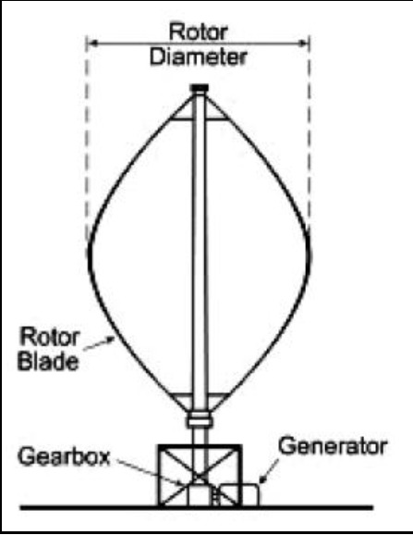
*Figure 2: Drawing representation of the turbine (Design Placeholder) *
E. Finding the Right Spots:
We mapped out potential locations based on traffic speed (needs to be > 50–60 km/h), continuous flow, and available divider space. Prime candidates in Bangalore included NICE Road, the Outer Ring Road (ORR), Airport Road, and Tumkur Road.

6.Data Collection & Analysis Strategies

Data Collection Sources
Type | Description
Government traffic datasets | Vehicle speed, flow rate, lane width, peak/off-peak variation
Renewable energy research papers | Aerodynamic performance, turbine sizing, generator efficiency
Prototype performance data | RPM, voltage output, startup wind speed
Case study databases | ENLIL smart turbine project, Mexico micro-wind tests

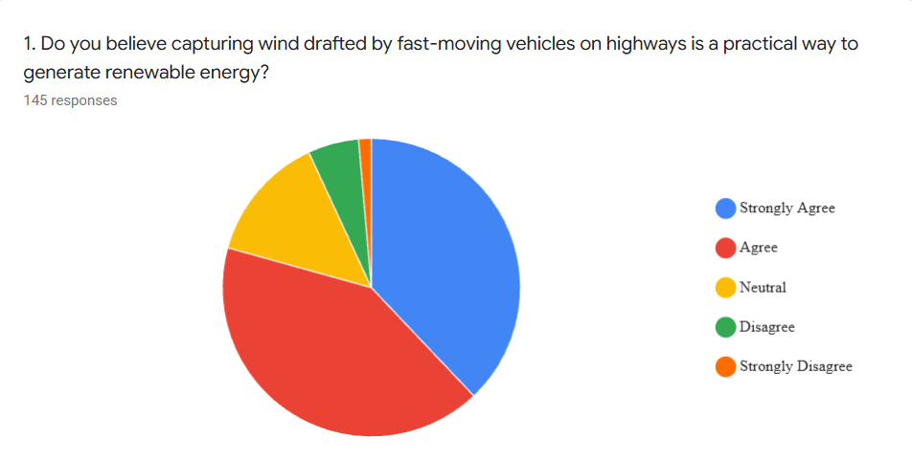
*Figure3: Public perception of the practicality of generating renewable energy by capturing wind drafted from fast-moving vehicles on highways (n = 145).
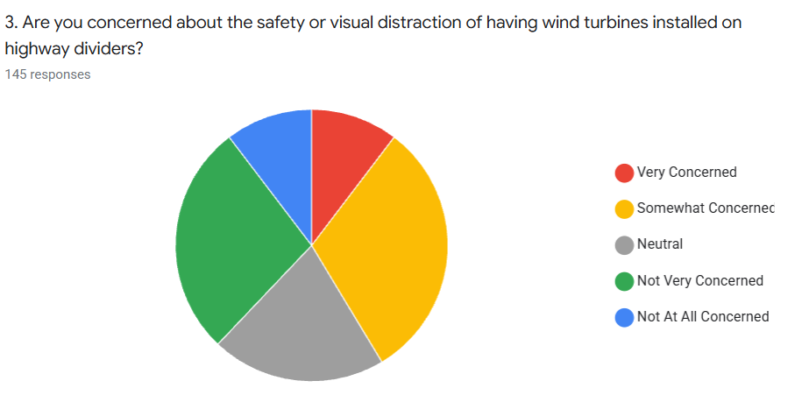
Figure2: Level of concern among respondents regarding safety and visual distraction caused by installing wind turbines on highway dividers (n = 145).
We didn't just guess; we used specific techniques to analyze the data:
- **Wind Models: Calculated airflow based on vehicle size and speed relative to the road. Wind Models: Calculated airflow based on vehicle size and speed relative to the road.
- **Power Curves: Mapped the wind energy to actual mechanical output. Power Curves: Mapped the wind energy to actual mechanical output.
- **Efficiency Checks: Compared our vertical design against horizontal ones in turbulent conditions. Efficiency Checks: Compared our vertical design against horizontal ones in turbulent conditions.
- **Cost-Benefit: Estimated the energy savings versus the setup costs for things like streetlights. Cost-Benefit: Estimated the energy savings versus the setup costs for things like streetlights.
- **Green Impact: Calculated how much CO2 we’d save by taking these lights off the grid. Green Impact: Calculated how much CO2 we’d save by taking these lights off the grid.

7. Results and Discussion
(Note: In the original text, this section was numbered 8, but it follows section 6 logically)
A. Highways are Wind Tunnels:
Our analysis confirms that the middle of the highway acts like a wind tunnel. Vehicles rushing by on both sides create a converging airflow that keeps the air moving fast in the center. This means the turbine keeps spinning even if the wind isn't blowing naturally.

B. Vertical is the Way to Go:
Vertical-axis turbines are just better suited for this environment. They handle the messy, turbulent air from cars much better than horizontal fans would. Plus, they’re shorter, easier to maintain, and less likely to break down or pose a safety risk to drivers.
C. The Prototype Works:
Our test unit, using dual generators, consistently pumped out 6–9 volts. That’s enough to run LED streetlights. If we scaled this up, a network of these could power CCTV cameras, toll gates, and even traffic signals without drawing a single watt from the main grid.
D. It Pays Off:
Putting these up would lower electricity bills for the city and cut carbon emissions. Since they sit on existing dividers, we don't need to buy extra land, which keeps costs down significantly.
E. Future Hybrid Potential:
The setup is perfect for adding solar panels. During the day, solar panels on top could generate power, and the turbines would workday and night. This hybrid approach would make the system much more reliable and powerful.

8. Conclusion
Implementing Vertical Axis Highway Turbines in Bangalore isn't just a science experiment; it's a viable solution for urban energy needs. By tapping into the wasted wind energy from traffic, we can power essential road infrastructure sustainably. The prototype results are promising, showing that even small units can make a difference. With proper policy support and further refinement especially exploring hybrid solar options this technology could be a cornerstone of future smart city developments in India.

References
1.Kalpesh Chavda, Tushar Thakar, Jigar Parekh, Jinesh Sathwara, Himalay Panchal, "Design and Fabrication of Highway Wind Turbine," *IJSRD – International Journal for Scientific Research & Development*, Vol. 1, Issue 10, pp. 2111–2114, 2013.
2.Deveci, K. & Papatya, S., "ENLIL Smart Vertical Wind Turbine Project Reports," Istanbul, Turkey, 2019–2021.
3.Mexico Renewable Energy Research Group, "Urban Micro-Wind Feasibility Studies," 2020–2022.
4.J. G. Leishman, *Challenges in Modelling the Unsteady Aerodynamics of Wind Turbines*, Wind Engineering Research Publications.
5.Joshua Earnest, *Wind Power Plant and Project Development*, CRC Press, 2015.
6.Indian Renewable Energy Development Agency (IREDA), "National Renewable Energy Reports and Statistics," Government of India, 2022.
7.Government of Karnataka Transport Department, "Traffic Flow & Mobility Data Reports," Bangalore City Mobility Database, 2023.
8.Alternative Energy News, "Vertical Axis Wind Turbine Review," Accessed 2024.
9.Betz, A., *Wind Energy and Air Flow Momentum Theory*, Physics of Wind Power Publications, 1925.
10. IEEE Smart Grid Research Papers, "Hybrid Renewable Energy Systems for Smart Cities," 2022–2024.

