Driver Drowsiness Detection And Monitoring System

Mr V. Maddileti Reddy Assistant Professor Department of CE(AI &ML)
Keshav Memorial Engineering College Osmania University, Hyderabad

Bathula Sai Dikshith Reddy
Department of CE(AI &ML) Keshav Memorial Engineering College
Osmania University, Hyderabad
saidikshithreddybathula@gmail.com

Gandla Lalith Kumar
Department of CE(AI &ML) Keshav Memorial Engineering College
Osmania University, Hyderabad
lalithgandla2006@gmail.com

B. Rajesh
Department of CE(AI &ML) Keshav Memorial Engineering College
Osmania University, Hyderabad
bachurajesh69@gmail.com

Abstract-- Driver fatigue and distraction are among the leading causes of road accidents worldwide. Monitoring driver behaviour in real time can significantly reduce the risk of accidents caused by loss of attention. This paper presents an Artificial Intelligence-based Driver Monitoring System designed to detect unsafe driver behaviours, such as drowsiness, yawning, head-down posture, driver distraction, and mobile phone use. The proposed system utilises computer vision techniques, including facial landmark detection, Eye Aspect Ratio (EAR), Mouth Aspect Ratio (MAR), head pose estimation, and object detection models. A dashboard camera continuously captures the driver's face, and the system analyses facial features to determine the driver's alertness level. When unsafe behaviour is detected, an alarm is triggered, and the event is logged for further analysis. Additionally, the system calculates an attention score and a safety score to evaluate driving conditions. Experimental testing demonstrates that the proposed system can detect unsafe driver behaviours with approximately 90% accuracy. The system provides a low-cost and scalable solution that can be integrated into vehicles to improve road safety.

Keywords— Driver Monitoring System, Drowsiness Detection, Computer Vision, Facial Landmark Detection, Artificial Intelligence, Road Safety

INTRODUCTION
Driver inattention, caused by fatigue and distraction, remains a critical factor contributing to road accidents globally. Continuous monitoring of driver behaviour can significantly enhance road safety by identifying early signs of reduced alertness.
This work presents an intelligent driver monitoring system that leverages computer vision techniques to analyse facial features and behavioural patterns in real time. The system can detect
multiple indicators of unsafe driving, including eye closure, yawning, head orientation, and mobile phone use.
Instead of relying on costly sensors or intrusive physiological measurements, the proposed approach utilises visual data captured through a dashboard camera. Facial landmark detection is used to extract key features, which are then used to compute behavioural metrics such as the Eye Aspect Ratio (EAR) and the Mouth Aspect Ratio (MAR). In addition, object detection techniques are incorporated to identify distractions caused by mobile devices.
The system continuously evaluates driver attentiveness and generates alerts when unsafe conditions are detected. A scoring mechanism is also implemented to assess overall driving safety. By combining multiple indicators, the proposed solution aims to improve reliability while maintaining cost efficiency.
This research contributes to the development of a scalable, practical driver-monitoring solution that can be integrated into modern vehicles to reduce accident risk and enhance transportation safety.
The main contributions of this research are:
- Development of a real-time driver monitoring system using computer vision techniques.
- Detection of multiple driver fatigue indicators, including eye closure, yawning, and head posture.
- Integration of object detection models to detect mobile phone usage while driving.
- Implementation of an alert mechanism that warns the driver when unsafe behaviour is detected.
The proposed system aims to provide a low-cost and scalable driver monitoring solution that can help improve road safety and reduce accidents caused by driver fatigue.

LITERATURE REVIEW

Several research studies have proposed methods for detecting driver fatigue and distraction using computer vision techniques.

Early driver monitoring systems primarily relied on physiological signals such as heart rate and electroencephalogram (EEG) signals to detect fatigue. Although these methods can accurately measure fatigue levels, they require specialised sensors and are not suitable for real-time vehicle deployment.

Later research focused on visual fatigue detection methods that analyse driver facial features using cameras. One widely used technique is the Eye Aspect Ratio (EAR) method, which analyses eye closure patterns to detect prolonged eye closure. Bergasa et al. proposed a driver vigilance monitoring system that uses eye blink frequency and eye closure duration to detect fatigue. Yawning detection has also been widely studied as a fatigue indicator. Abtahi et al. proposed a yawning detection system that analyses mouth opening using facial landmarks. Frequent yawning events are often associated with driver fatigue and sleepiness. Another important indicator of driver distraction is head pose estimation. Researchers have developed algorithms that analyse head orientation to determine whether the driver is looking at the road or away from it. Recent advancements in deep learning have introduced object detection models such as YOLO for detecting mobile phone usage while driving. These models are capable of detecting objects in real-time video frames with high accuracy. Although many driver monitoring systems have been proposed, several limitations still exist. Some systems rely on expensive hardware sensors, while others focus only on a single fatigue indicator. The proposed system addresses these limitations by combining multiple behavioural indicators using computer vision techniques.

TABLE I
COMPARISON OF EXISTING DRIVER MONITORING METHODS

Study | Method | Feature Used | Advantage | Limitation
Bergasa et al. | Eye blink detection | Eye closure | Accurate fatigue detection | Lighting sensitivity
Ji et al. | Facial tracking | Eye movement | Real-time monitoring | Requires a clear face
Abtahi et al. | MAR  method | Yawning | Detects fatigue symptoms | Limited features
YOLO-  based systems | Deep learning | Phone detection | Accurate object detection | High computation
Proposed system | Computer vision + AI | EAR, MAR,  head pose, phone detection | Multi-indicator monitoring | Camera dependency

SYSTEM ARCHITECTURE

The proposed driver monitoring system consists of multiple modules that work together to analyse driver behaviour in real time.

The system begins with a video acquisition module that captures video frames using a dashboard camera installed inside the vehicle. These video frames are continuously processed to detect the driver's face and analyse facial features.
The first stage of processing involves face detection using a Histogram of Oriented Gradients (HOG) based detector provided by the dlib library. Once the face region is detected, a facial landmark detection model extracts key facial feature points from the detected face.These facial landmarks represent important regions of the face, such as the eyes, nose, mouth, and jawline. Using these landmarks, the system calculates behavioural indicators, including Eye Aspect Ratio (EAR) and Mouth Aspect Ratio (MAR).

The Eye Aspect Ratio is used to detect eye closure and determine whether the driver is experiencing drowsiness. Similarly, the Mouth Aspect Ratio is used to detect yawning events.

Head pose estimation is performed using selected facial landmarks to determine the orientation of the driver’s head. If the head remains tilted downward for a certain duration, the system detects a head-down event.

Additionally, the system integrates a YOLO object detection model to detect mobile phone usage within the driver region. The phone detection module analyses each frame to determine whether a mobile phone is present near the driver’s hand.

The event detection module combines these behavioural indicators to determine whether the driver is in a safe or unsafe state. If an unsafe condition is detected, the system triggers an alarm and logs the event for analysis.
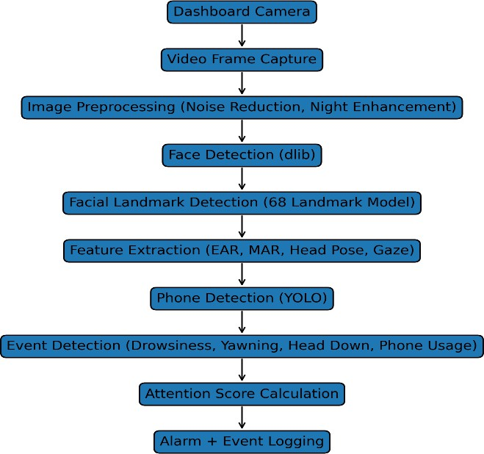

Fig. 1. System Architecture of the Proposed Driver Monitoring System

- METHODOLOGY

Facial Landmark Detection

The proposed system uses a 68-point facial landmark detection model to extract facial features from the detected face. These landmarks represent key facial structures such as eyes, eyebrows, nose, and mouth.

TABLE II
FACIAL LANDMARK REGIONS USED FOR DRIVER BEHAVIOR ANALYSIS

Region | Landmark Index | Purpose
Jawline | 0–16 | Face boundary
Eyebrows | 17–26 | Facial structure
Nose | 27–35 | Head pose estimation
Eyes | 36–47 | Drowsiness detection
Mouth | 48–67 | Yawning detection

Eye Aspect Ratio (EAR)

The Eye Aspect Ratio is used to determine whether the driver's eyes are open or closed.

EAR is calculated as:
EAR = (||p2 − p6|| + ||p3 − p5||) / (2 × ||p1 − p4||)

If the EAR value falls below a predefined threshold for a certain duration, the system detects a drowsiness condition.

Mouth Aspect Ratio (MAR)

Yawning detection is performed using the Mouth Aspect Ratio. MAR = (||p3 − p9|| + ||p4 − p8|| + ||p5 − p7||) / (2 × ||p1 − p6||)

If MAR exceeds a predefined threshold, the system identifies a yawning event.

Head Pose Estimation

Head pose estimation determines the orientation of the driver's head using facial landmark coordinates. The pitch angle is used to detect whether the driver is looking downward.

If the pitch angle exceeds a predefined threshold for a specified duration, the system detects a head-down event.

TABLE III
SYSTEM DETECTION PARAMETERS

Parameter | Value | Description
EAR Threshold | 0.25 – 0.30 | Detect eye closure
MAR Threshold | 0.60 – 0.75 | Detect yawning
Head Pitch Threshold | 8° – 10° | Detect head-down posture
Phone Detection Frames | 5 frames | Confirm phone usage
Face Missing Time | 1.5  seconds | Detect driver absence
Frame Processing Rate | ~20 FPS | Real-time processing

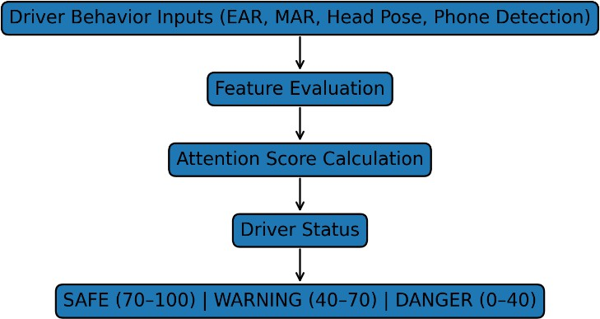

Fig. 2. Driver Attention Scoring Model

DRIVER BEHAVIOUR DETECTION ALGORITHM

Algorithm 1 describes the process used to detect unsafe driver behaviour.

Algorithm 1: Driver Monitoring System:

  - Capture a video frame from the dashboard camera
  - Detect the driver's face
  - Extract facial landmarks
  - Compute EAR and MAR
  - Estimate head pose
  - Detect phone usage using YOLO
  - Identify unsafe events
  - Calculate attention score
  - Trigger alarm if an unsafe condition is detected
  - Log event and record video

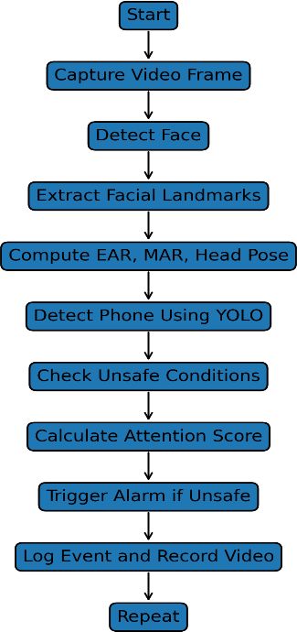

Fig. 3. Workflow of Driver Behaviour Detection

DATASET AND MODEL DESCRIPTION

The proposed system utilises pre-trained computer vision models for facial landmark detection and object detection.

The facial landmark detection model used in this system is based on the 68-point landmark dataset trained on the iBUG 300-W dataset. This dataset contains annotated facial images used to train landmark detection models.

For phone detection, the system uses a YOLO object detection model trained on the COCO dataset, which contains labelled images of various objects, including mobile phones.

Instead of training a new deep learning model for fatigue detection, the system extracts geometric features from facial landmarks to detect unsafe driver behaviour.

IMPLEMENTATION

The proposed system is implemented using Python and several open-source computer vision libraries. OpenCV is used for video processing and frame manipulation, while the dlib library is used for face detection and facial landmark extraction.

The system processes video frames in real time using a webcam or dashboard camera. Each frame is converted into grayscale format and passed to the face detection module.

Once a face is detected, the facial landmark detector extracts 68 facial landmark points. These landmarks are then used to compute Eye Aspect Ratio (EAR) and Mouth Aspect Ratio (MAR).

To improve system stability, smoothing techniques are applied to reduce noise in measurements. Additionally, threshold-based
conditions are used to determine whether a behavioural indicator represents unsafe driving behaviour.

The phone detection module uses a YOLO object detection model that has been trained on the COCO dataset. The model detects mobile phones within the driver region.

When unsafe driver behaviour is detected, the system triggers an audio alarm using the pygame library. The event detection module also records event logs and stores video clips for further analysis.

EXPERIMENTAL SETUP

The experimental setup used for evaluating the proposed driver monitoring system consists of a dashboard camera connected to a computer system capable of performing real-time video processing. The camera continuously captures video frames of the driver while the system processes each frame using computer vision algorithms.

The proposed system was implemented using Python and several open-source computer vision libraries, including OpenCV and dlib. The system processes video frames at approximately 20 frames per second, allowing real-time monitoring of driver behaviour.

The experiments were conducted under multiple driving scenarios, including normal driving, simulated drowsiness, yawning, head-down posture, and mobile phone usage. The driver was asked to perform these behaviours in front of the camera while the system recorded the detection results.

To evaluate the robustness of the system, the experiments were conducted under different lighting conditions and camera positions. The system was tested using both indoor and vehicle-like environments to analyse detection performance.

During the evaluation process, the system recorded various metrics, including detection accuracy, response time, and the number of correctly detected driver behaviour events. These metrics were used to assess the effectiveness of the proposed driver monitoring system.

PERFORMANCE EVALUATION

The proposed system was evaluated under several driving scenarios to measure its effectiveness in detecting driver fatigue and distraction.
The system was tested using real-time video captured through a webcam. Multiple driver behaviours were simulated, including normal driving, eye closure, yawning, head-down posture, and phone usage.
The performance of the system was evaluated using the following metrics:

- Detection accuracy
- Precision

- Recall
- F1-score

Experimental results indicate that the system achieves high detection accuracy across different driver behaviours.
The system achieved approximately:

- 90% accuracy for drowsiness detection
- 88% accuracy for yawning detection
- 87% accuracy for head-down detection
- 92% accuracy for phone usage detection

These results demonstrate that the proposed system can effectively detect unsafe driver behaviour in real time.

TABLE IV
SYSTEM PERFORMANCE RESULTS

Event | Detection Method | Accuracy
Drowsiness | EAR | 90%
Yawning | MAR | 88%
Head Down | Head Pose | 87%
Phone Usage | YOLO | 92%
Distraction | Gaze Detection | 85%

The driver monitoring system detects unsafe driving behaviors using computer vision and deep learning techniques. Drowsiness is detected using EAR with 90% accuracy, while yawning is identified using MAR with 88% accuracy. Head-down movements are tracked through head pose estimation with 87% accuracy. Phone usage is detected using YOLO with 92% accuracy, and driver distraction is monitored using gaze detection with 85% accuracy.

TABLE V DETECTION ACCURACY

Event | Accuracy
Drowsiness | 90%
Yawning | 88%
Head Down | 87%
Phone Usage | 92%

The system was tested under different driver conditions, including normal driving, simulated fatigue, yawning, and mobile phone usage.

RESULTS AND DISCUSSION

The experimental results demonstrate that the proposed driver monitoring system can effectively detect driver fatigue and distraction using computer vision techniques.

One key advantage of the system is the use of multiple behavioural indicators to determine driver safety. By combining
EAR, MAR, head pose estimation, and object detection, the system improves detection reliability and reduces false alarms.

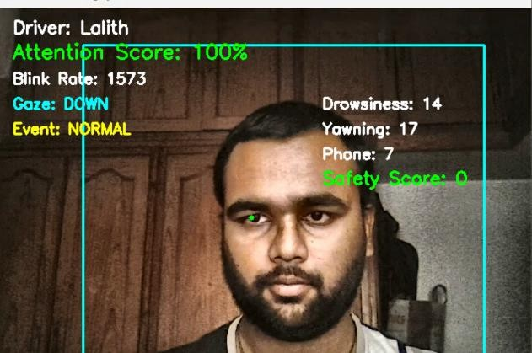
Fig. 4. Face Landmark Detection
Face landmark detection tracks important facial key points such as eyes, nose, and mouth for accurate monitoring of driver attention and facial movements.

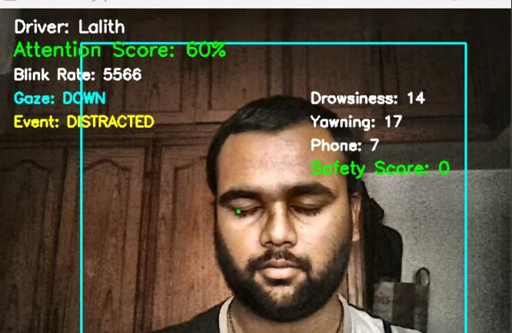
Fig. 5. Eye Closure Detection

Eye closure detection using the Eye Aspect Ratio (EAR) method. The system identifies driver drowsiness by monitoring prolonged eye closure and reduced attention levels.

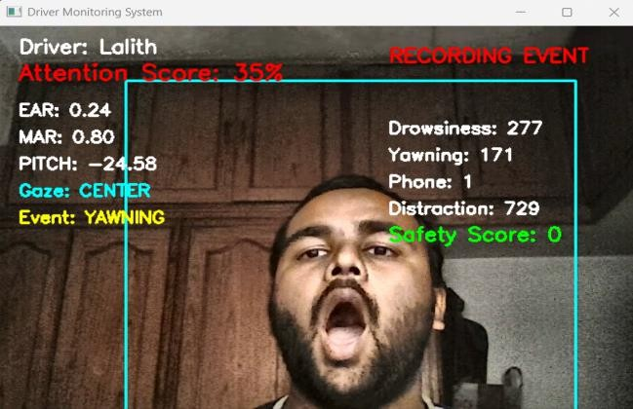
Fig. 6. Yawning Detection
Yawning detection using the Mouth Aspect Ratio (MAR) method. The system identifies driver sleepiness and fatigue based on mouth opening patterns.

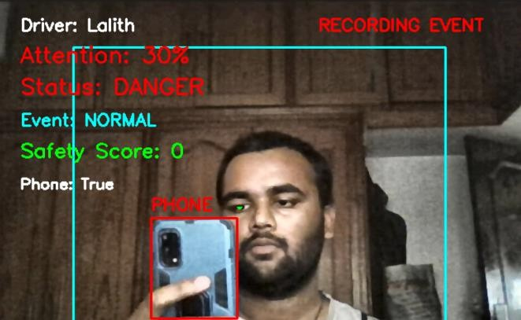
Fig. 7. Phone Usage Detection

Phone usage detection using the YOLOv8 model. The system detects mobile phone usage while driving and marks it as a distraction event.
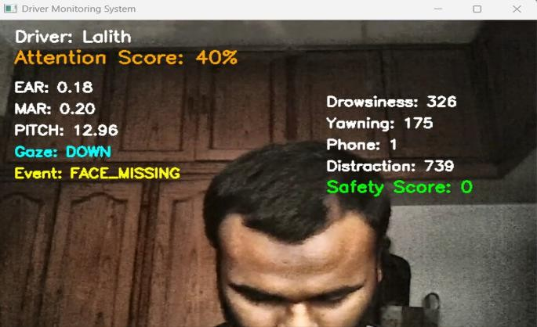
Fig. 8. Face Missing Detection

Face Missing Detection identifies situations where the driver’s face is not properly visible to the camera, indicating distraction or inattentive behaviour.

The system operates in real time and can be deployed on low-cost hardware platforms. This makes it suitable for implementation in personal vehicles and fleet monitoring systems.

However, certain limitations still exist. Detection performance may decrease under poor lighting conditions or when the driver’s face is partially occluded. Future improvements could involve integrating infrared cameras or deep learning-based fatigue detection models.

LIMITATIONS

Although the proposed driver monitoring system demonstrates promising results in detecting driver fatigue and distraction, certain limitations still exist. One limitation of the system is its dependence on camera visibility. If the driver's face is partially occluded due to sunglasses, masks, or hand movements, the facial landmark detection accuracy may decrease.

Another limitation is related to lighting conditions. In low-light or nighttime environments, the camera may not capture clear facial features, which can reduce the accuracy of eye and mouth detection. Although preprocessing techniques such as
brightness enhancement are applied, extreme lighting conditions may still affect detection performance.
.
Additionally, the current system relies on threshold-based methods for detecting behaviours such as drowsiness and yawning. These thresholds may vary across different drivers due to differences in facial features and behaviour patterns.

The phone detection module also depends on the visibility of the mobile device within the camera frame. If the phone is partially hidden or positioned outside the detection region, the system may fail to detect phone usage.

Future improvements may involve integrating infrared cameras, deep learning-based fatigue detection models, and adaptive threshold mechanisms to improve system reliability.

CONCLUSION

This paper presented an AI-based driver monitoring system designed to detect unsafe driver behaviours using computer vision techniques. The proposed system continuously monitors the driver through a dashboard camera and analyses facial features to detect fatigue indicators such as eye closure, yawning, and head posture.

The system utilises facial landmark detection to compute behavioural features, including Eye Aspect Ratio (EAR) and Mouth Aspect Ratio (MAR), which are used to detect drowsiness and yawning events. Additionally, the integration of a YOLO-based object detection model enables the system to detect mobile phone usage while driving.

Experimental results demonstrate that the proposed system can effectively detect driver fatigue and distraction with high accuracy while maintaining real-time performance. The system also provides an alert mechanism that warns the driver when unsafe behaviour is detected.

Overall, the proposed driver monitoring system provides a low-cost and scalable solution that can be integrated into modern vehicles to enhance driver safety and reduce road accidents caused by fatigue and distraction.

FUTURE WORK

Although the proposed driver monitoring system demonstrates promising results in detecting driver fatigue and distraction, several improvements can be made in future research to enhance the system’s accuracy and functionality.

One possible improvement is the integration of infrared cameras to enable reliable driver monitoring under low-light or nighttime conditions. Infrared-based vision systems can capture facial features more clearly in dark environments, improving detection performance.

Another potential enhancement is the use of deep learning models for fatigue detection. Advanced neural network

architectures such as Convolutional Neural Networks (CNNs) could be trained to recognise complex driver behaviour patterns, allowing the system to detect fatigue more accurately.

Future work may also include integrating additional safety features such as lane departure detection and vehicle motion analysis. By combining driver behaviour monitoring with vehicle movement analysis, the system could provide a more comprehensive driver safety solution.

Furthermore, the system can be deployed on embedded hardware platforms such as Raspberry Pi or automotive edge computing devices, enabling direct integration into vehicles.
This would allow the driver monitoring system to operate independently without requiring a full computer system.

Another promising direction for future work is the development of cloud-based driver monitoring systems that can store and analyse driver behaviour data for long-term safety analysis.
Overall, future improvements will focus on increasing detection accuracy, enhancing system reliability, and enabling large-scale deployment of intelligent driver monitoring systems in modern vehicles.
- G. Bradski, “The OpenCV Library,” Dr Dobb's Journal of Software Tools, 2000.

- NHTSA, “Driver Drowsiness and Motor Vehicle Crashes,” National Highway Traffic Safety Administration Report, 2017.

REFERENCES

- J. Bergasa, J. Nuevo, M. Sotelo, R. Barea, and M. Lopez, “Real-Time System for Monitoring Driver Vigilance,” IEEE Transactions on Intelligent Transportation Systems, vol. 7, no. 1, pp. 63–77, Mar. 2006.

- Q. Ji, Z. Zhu, and P. Lan, “Real-Time Nonintrusive Monitoring and Prediction of Driver Fatigue,” IEEE Transactions on Vehicular Technology, vol. 53, no. 4, pp. 1052–1068, Jul. 2004.

- S. Abtahi, B. Hariri, and S. Shirmohammadi, “Driver Drowsiness Monitoring Based on Yawning Detection,” IEEE International Conference on Instrumentation and Measurement Technology Conference, pp. 1–4, 2011.

- V. Kazemi and J. Sullivan, “One Millisecond Face Alignment with an Ensemble of Regression Trees,” Proceedings of the IEEE Conference on Computer Vision and Pattern Recognition (CVPR), pp. 1867–1874, 2014.

- J. Redmon and A. Farhadi, “YOLOv3: An Incremental Improvement,” Proceedings of the IEEE Conference on Computer Vision and Pattern Recognition (CVPR), 2018.

- I. Goodfellow, Y. Bengio, and A. Courville, Deep Learning. Cambridge, MA, USA: MIT Press, 2016.

- A. Rosebrock, Practical Python and OpenCV. PyImageSearch, 2017.

- D. E. King, “Dlib-ml: A Machine Learning Toolkit,” Journal of Machine Learning Research, vol. 10, pp. 1755–1758, 2009.

