Clinical and Radiological Presentation of Adult Brainstem Glioma Managed with Stereotactic Radiotherapy: A Case Report
Korlakunta Deva Harshini¹, Samana Surya Iswaryambica Pooja²
Doctor of Pharmacy (Pharm-D)
Aditya College of Pharmacy, Surampalem, Andhra Pradesh, India

ABSTRACT:
A 42-year-old male diagnosed with brainstem glioma who presented with neurological symptoms. MRI revealed a heterogeneously enhancing lesion in the midbrain region. The patient underwent external beam radiotherapy (EBRT) using Stereotactic Radiotherapy (SRT) technique with a total dose of 54 Gy in 27 fractions over four weeks. He tolerated treatment well with minimal side effects. This case emphasizes the importance of early imaging, accurate localization, and targeted radiotherapy in the management of brainstem glioma.
KEYWORDS:
Brainstem glioma, Stereotactic radiotherapy, Magnetic resonance radiotherapy, High grade glioma, Neuro-oncology.
INTRODUCTION:
Brainstem gliomas are Rare infiltrative glial tumours that originate in the medulla, pons, or midbrain. They are less prevalent in adults but make up for 10–15% of brain tumours in children ^{[1,2]}. They are the most prevalent malignant primary brain tumours, with 4.3% of cases occurring in the brain stem ^{[3]}.
Gliomas in the brainstem grow rapidly. Because the clinical signs and symptoms are directly related to the tumour’s location, symptoms may manifest over a few days or weeks.
These tumours may disrupt normal brainstem function, leading to common symptoms such as deviations from normal eye movement, paralysis on one side of the face, numbness or weakness in the extremities, not being able to keep equilibrium Headache, sickness ^{[4-6]}.
Typically, a combination of cranial nerve dysfunction and long-tract signs is considered suggestive of a brainstem lesion. Patients may present with a long history of facial palsy sometimes associated with facial myokymia or hemifacial spasm ^{[7]}. Pyramidal weakness, cerebellar signs, or involvement of other cranial nerves (V, VI, VIII, palatal palsy) have also been commonly found during medical examinations.
Due to their critical anatomical location, surgical resection or biopsy is often not feasible and is associated with high morbidity ^{[8,9]}. Hence, radiotherapy remains the mainstay of treatment, particularly stereotactic techniques that deliver targeted doses with minimal injury to surrounding neural tissue ^{[10,11]}.
CASE PRESENTATION:
A 42 years old male patient presented to hospital with complaints of gradually progressive facial weakness, slurring of speech and difficulty in maintaining balance while walking. The symptoms had developed insidiously over a period of several weeks and were associated with intermittent headaches and occasional nausea. There were no history of seizures, trauma or loss of consciousness. On clinical examination the patient was conscious, oriented and cooperative. Cranial nerve examination revealed left-sided upper motor neuron type seventh cranial nerve palsy. Motor and sensory examinations were within normal limits. No signs of raised intracranial pressure were noted. The eastern cooperative oncology group (ECOG) performance status was 1. Routine laboratory investigations, including complete blood count and serum creatinine levels were within normal limits.
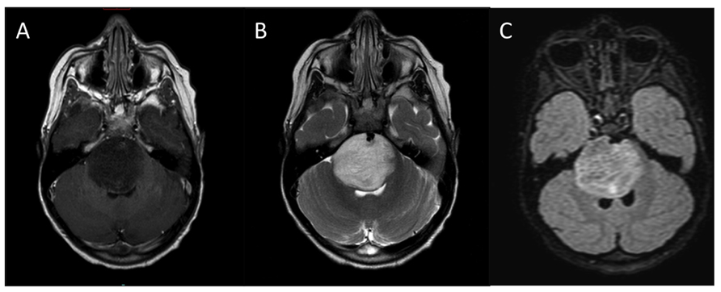
Magnetic resonance imaging (MRI) of the brain revealed a relatively well-defined, non-homogeneous lesion predominantly involving the pons (Figure 1). The lesion appeared hyperintense on T₂ -weighted and FLAIR images and hypointense on T₁-weighted sequences. It measured approximately 64mm in craniocaudal dimension, 29mm in anteroposterior dimension and 36mm in transverse dimension. The lesion extended superiorly into the mid-brain and inferiorly into the medulla, involving the right half of the mid-brain and left cerebral peduncle with effacement of the right cerebellopontine angle cistern and mild mass effect on the 4thventricle. Post-contrast imaging demonstrated mild patchy enhancement within the lesion (Figure 2). Diffusion-weighted imaging did not show significant restriction and no blooming was noted on susceptibility-weighted imaging. MR spectroscopy revealed an elevated choline peak with reduced N-acetylaspartate (NAA) and reversal of the choline-NAA ratio, suggestive of a high-grade gliomatous lesion.

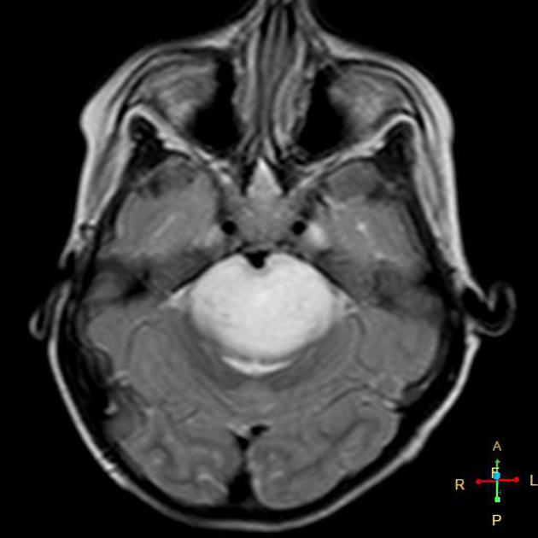
Figure 1: Representative axial T₂-weighted MRI of brainstem glioma showing hyperintense signs in the pons and midbrain. Image obtained from Wikimedia commons: “Typical MRI appearance of diffuse intrinsic pontine glioma (DIPG)” (CC BY 4.0).

Figure 2: Axial T1-weighted post-contrast MRI demonstrating mild patchy enhancement within a brainstem glioma. Image obtained from Radiopaedia.org (CC BY-NC-ND 4.0).
Based on the clinical and radiological findings, a diagnosis of brain stem glioma was considered. Due to the deep-seated location of the tumor and proximity to vital neurological structures, surgical intervention was not considered feasible. The patient was therefore planned for definitive radiotherapy along with adjuvant chemotherapy. He underwent external beam radiotherapy using stereotactic technique with a linear accelerator, receiving a total dose of 54Gy in 27 fractions over a period of approximately 6 weeks using 6MV photons. Following completion of radiotherapy, the patient was initiated on chemotherapy and received a 2-month treatment cycle as per institutional protocol. The chemotherapy was well tolerated, and no major haematological or systemic adverse effects were observed during the treatment period.
The patient was monitored regularly through out the course of treatment. Supportive medications, including corticosteroids and gastric protection agents, were prescribed to manage treatment-related symptoms. He showed clinical improvement with reduction in neurological symptoms and maintained stable general condition. At the time of discharge, the patient was advised regular follow-up with clinical evaluation and periodic MRI scans to asses tumor response and detect disease progression.
In the present case, a multimodal treatment approach involving stereotactic radiotherapy and chemotherapy was adapted, as surgical resection was not feasible due to the critical anatomical location of the lesion. Radiotherapy combined with chemotherapy remains the standard treatment modality for adult brainstem gliomas. Long-term management requires close surveillance with regular neuro imaging and neurological assessment. The patient was advised regular follow-up with clinical and radiological assessment to monitor disease progression.
DISCUSSION:
Brainstem gliomas in adults differ significantly from paediatric forms — they are often focal and slower growing but carry a poor prognosis when high-grade ^{[12,13]}. Because of the critical location near vital centre (respiratory, cardiovascular nuclei), biopsy or resection is risky ^{[14,15]}, making radiotherapy the standard of care.
In this case, Stereotactic Radiotherapy (SRT) was chosen to deliver conformal high-dose radiation precisely to the tumour while sparing surrounding normal brain tissue ^{[16,17]}. The patient received 54 Gy in 27 fractions. It is the standard regimen for high-grade gliomas involving the brainstem^{[18,19]}. He tolerated the treatment well with minimal acute toxicities.
Radiation-induced side effects such as fatigue, mild headache, and nausea are common but usually reversible. Long-term complications may include radiation necrosis or neurocognitive decline, which require monitoring.
This case highlights the multidisciplinary approach—involving oncologists, radiologists, pharmacists, and nutritionists—necessary for optimal management ^{[20,21]}.
CONCLUSION:
This case demonstrates that stereotactic radiotherapy (SRT) is an effective and well-tolerated way for the management of brainstem glioma in adults. Through Early diagnosis, appropriate imaging, precise radiotherapy, and supportive pharmacological management the proper symptom control and better quality of life can be achieved. Further research into molecular profiling may enhance personalized treatment strategies for better prognosis.

REFERENCES:
- Louis DN, Perry A, Wesseling P, et al. The 2021 WHO Classification of Tumors of the Central Nervous System. Acta Neuropathologic. 2021;142(4):577-592.
- Fisher PG, Breiter SN, Carson BS, et al. A clinicopathologic reappraisal of brainstem tumor classification. Cancer. 2000;89(7):1569-1576.
- Ostrom QT, Patil N, Cioffi G, Waite K, Kruchko C, Barnholtz-Sloan JS. Cbtrus Statistical Report: Primary Brain and Other Central Nervous System Tumors Diagnosed in the United States in 2013-2017. Neuro-Oncology (2020) 22:iv1–96. 10.1093/neuonc/noaa200.
- Guillamo JS, Monjour A, Taillandier L, et al. Brainstem gliomas in adults: Prognostic factors and classification. Brain. 2001;124(12):2528-2539. doi: 10.1093/brain/124.12.2528.
- Salmaggi A, Fariselli L, Milanesi I, et al. Natural history and management of brainstem gliomas in adults: a retrospective Italian study. J Neurol. 2008;255:171–177. doi: 10.1007/s00415-008-0589-0.
- Kesari S, Kim RS, Markos V, et al. Prognostic factors in adult brainstem gliomas: a multicenter, retrospective analysis of 101 cases. J Neurooncol. 2008;88:175–183. doi: 10.1007/s11060-008-9545-1.
- Selvapandian S, Rajshekhar V, Chandy MJ. Brainstem glioma: comparative study of clinico-radiological presentation, pathology and outcome in children and adults. Acta Neurochir (Wien) 1999;141:721–726. doi: 10.1007/s007010050367. discussion 726–727.
- Guillamo JS, Monjour A, Taillandier L, et al. Brainstem gliomas in adults: Prognostic factors and classification. Brain. 2001;124(12):2528-2539. doi: 10.1093/brain/124.12.2528.
- Albright AL, Packer RJ, Zimmerman R, et al. Magnetic resonance scans should replace biopsies for the diagnosis of diffuse brainstem gliomas. Neurosurgery. 1993;33(6):1026-1030.
- Chang EL, Allen P, Wu C, et al. Stereotactic radiotherapy for brainstem lesions. International Journal of Radiation Oncology Biology Physics. 2002;54(2):487-496.
- Yen CP, Sheehan J, Steiner L. Gamma Knife radiosurgery for brainstem tumors. Journal of Neurosurgery. 2007;107 (4):768-777.
- Kesari S, Kim RS, Markos V, et al. Prognostic factors in adult brainstem gliomas: a multicenter, retrospective analysis of 101 cases. J Neurooncol. 2008;88:175–183. doi: 10.1007/s11060-008-9545-1.
- Reithmeier T, Kuzeawu A, Hentschel B, et al. Long-term survival of adult patients with brainstem gliomas. Journal of Clinical Neuroscience. 2014;21(3):432–437.
- Barkovich AJ, Krischer J, Kun LE, et al. Brainstem gliomas: A classification system based on magnetic resonance imaging. Paediatric Neurosurgery. 1990;16(2):73–83.
- Law M, Yang S, Wang H, et al. Glioma grading: sensitivity, specificity, and predictive values of perfusion MR imaging and proton MR spectroscopy. Radiology. 2003;227(2):540–547.
- Combs SE, Thilmann C, Huber P, et al. Efficacy of fractionated stereotactic radiotherapy in patients with brainstem gliomas. Radiotherapy and Oncology. 2005;75(2):161–168.
- Minniti G, Clarke E, Lanzetta G, et al. Stereotactic radiosurgery for brainstem metastases. Journal of Neuro-Oncology. 2011;102(2):251–260.
- National Comprehensive Cancer Network (NCCN). Central Nervous System Cancers – Clinical Practice Guidelines. Latest version.
- Prados MD, Scott C, Rotman M, et al. Influence of radiation dose on survival in patients with high-grade gliomas. International Journal of Radiation Oncology Biology Physics. 2001;50(2):305–311.
- Bond CA, Raehl CL, Franke T. Clinical pharmacy services, pharmacy staffing, and hospital mortality rates. Pharmacotherapy. 1999;19(10):1219–1225.
- Dalton K, Byrne S. Role of the pharmacist in reducing healthcare costs. Integrated Pharmacy Research & Practice. 2017; 6:37–46.

