Diagnostic Evaluation of Pancytopenia: A Retrospective Analysis

Dr. Saroj Kumari Meena | Assistant professor, Dept of Pathology, Government Medical College & Hospital, Sawai Madhopur, Rajasthan, India
Dr. Pooja Saini | Assistant professor, Dept of Pathology, Government Medical College & Hospital, Hanumangarh, Rajasthan, India
Dr. Hrishikesh Sharma | Senior Resident, Dept of Pathology, Government Medical College & Hospital, Sawai Madhopur, Rajasthan, India  E-Mail – drhs1011@gmail.com

ABSTRACT
Background: Pancytopenia is a hematological condition characterized by a reduction in all three cellular components of blood—erythrocytes, leukocytes, and platelets. It encompasses a wide range of etiologies, from nutritional deficiencies to bone marrow disorders. Aim: To analyze the clinical, hematological, and etiological profile of pancytopenia in patients presenting to a tertiary care center. Materials and Methods: This retrospective study was conducted at Government Medical College and Hospital, Sawai Madhopur, Rajasthan, over a period of one year (February 2025–January 2026). A total of 410 patients fulfilling diagnostic criteria for pancytopenia were included. Clinical data, laboratory investigations, and bone marrow findings were evaluated. Results: Among 410 patients, females (55.1%) slightly outnumbered males (44.9%). The most commonly affected age group was 41–60 years (34.6%). Megaloblastic anemia was the leading cause (39.5%), followed by aplastic anemia (15.9%), infections (15.1%), hematological malignancies (12.2%), chronic diseases (10.2%), and miscellaneous causes (7.1%). Conclusion: Megaloblastic anemia remains the predominant and reversible cause of pancytopenia. Bone marrow examination plays a crucial role in diagnosis, and early identification of etiology is essential for effective management.
Keywords: Pancytopenia, Megaloblastic anemia, Bone marrow, Hematological malignancies, varied etiologies

INTRODUCTION
Pancytopenia is a commonly encountered hematological abnormality defined by the simultaneous decrease in hemoglobin concentration, total leukocyte count, and platelet count. It is not a disease entity but a manifestation of various underlying pathological conditions affecting bone marrow function or peripheral blood cell survival.
The etiological spectrum includes nutritional deficiencies, bone marrow failure syndromes, infections, malignancies, and chronic systemic illnesses. The pattern of these causes varies depending on geographic region, socio-economic status, and healthcare access.
Bone marrow aspiration and biopsy remain indispensable tools in the evaluation of pancytopenia, providing valuable insights into marrow cellularity and pathology.
This study was undertaken to evaluate the etiological spectrum and clinicopathological features of pancytopenia in our Government district hospital in Rajasthan.

MATERIALS AND METHODS
Study Design:
Retrospective observational study
Study Location:
Government Medical College and Hospital, Sawai Madhopur, Rajasthan, India
Study Duration:
February 2025 – January 2026
Sample Size:
410 cases
Inclusion Criteria:
- Patients aged >10 years
- Hemoglobin <9 g/dL
- Total leukocyte count <4000/mm³
- Platelet count <100,000/mm³
Exclusion Criteria:
- Patients on chemotherapy
- Previously diagnosed hematological malignancies under treatment
Data Collection:
Data were retrieved from hospital records including:
- Demographic details
- Clinical presentation
- Hematological parameters
- Peripheral smear examination
- Bone marrow findings
RESULTS

Demographic Profile:
Out of the 410 cases, 226 patients (55.1%) were females and 184 (44.9%) were males, showing a slight female predominance with a female-to-male ratio of approximately 1.2:1.
The age of the patients ranged from 10 to over 80 years. The highest number of cases was observed in the 41–60 years age group, accounting for 142 cases (34.6%), followed by the 61–80 years group with 109 cases (26.6%). Younger age groups contributed comparatively fewer cases, with 10% in the 10–20 years category and 22.9% in the 21–40 years group. Patients above 80 years constituted the smallest proportion (5.9%).
Gender | Cases | Percentage
Male | 184 | 44.9%
Female | 226 | 55.1%
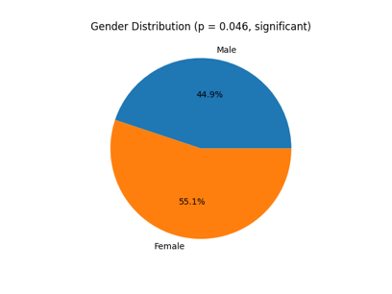

Age-wise Distribution:

Age groups | Cases | Percentage
10–20 | 41 | 10.0%
21–40 | 94 | 22.9%
41–60 | 142 | 34.6%
61–80 | 109 | 26.6%
>80 | 24 | 5.9%
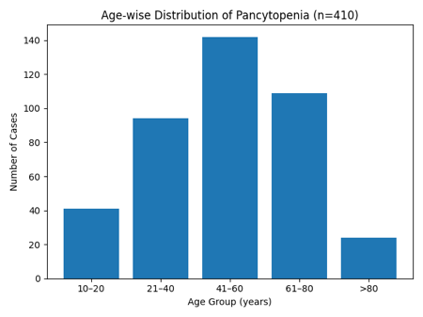
Etiological Spectrum:
The etiological analysis revealed that megaloblastic anemia was the most common cause of pancytopenia, identified in 162 cases (39.5%). Aplastic anemia was the second most frequent etiology, seen in 65 cases (15.9%).
Infectious causes, including sepsis, tuberculosis, and viral infections, accounted for 62 cases (15.1%). Hematological malignancies such as leukemia and lymphoma were observed in 50 patients (12.2%).
Chronic diseases, including chronic liver disease and autoimmune disorders, were responsible for pancytopenia in 42 cases (10.2%). Miscellaneous causes, comprising hypersplenism and other less common conditions, accounted for 29 cases (7.1%). There was a statistically significant association between gender and etiology (p < 0.05), indicating that certain causes like megaloblastic anemia and chronic diseases were more prevalent in females.
Etiology | Male | Female
Megaloblastic anemia | 70 | 92
Aplastic anemia | 34 | 31
Infections | 33 | 29
Malignancies | 28 | 22
Chronic diseases | 11 | 31
Miscellaneous | 8 | 21
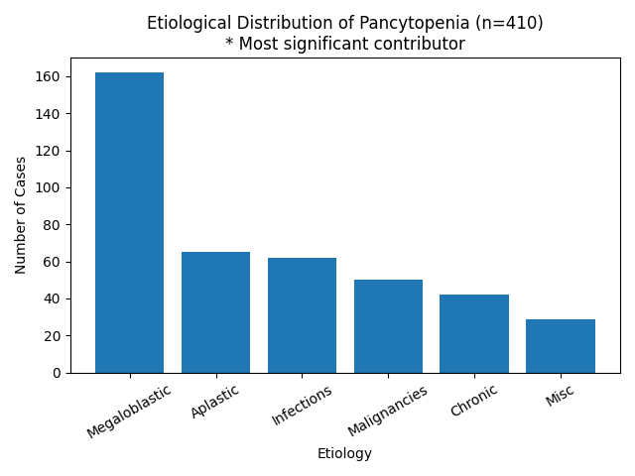

Bone Marrow Findings
Bone marrow examination findings showed that hypercellular marrow was the most common pattern, observed in 204 cases (49.8%). This pattern was predominantly associated with megaloblastic anemia.
Normocellular marrow was noted in 131 cases (32.0%), while hypocellular marrow was seen in 75 cases (18.2%), primarily in patients diagnosed with aplastic anemia.
Marrow Cellularity | Cases | Percentage
Hypercellular | 204 | 49.8%
Normocellular | 131 | 32.0%
Hypocellular | 75 | 18.2%
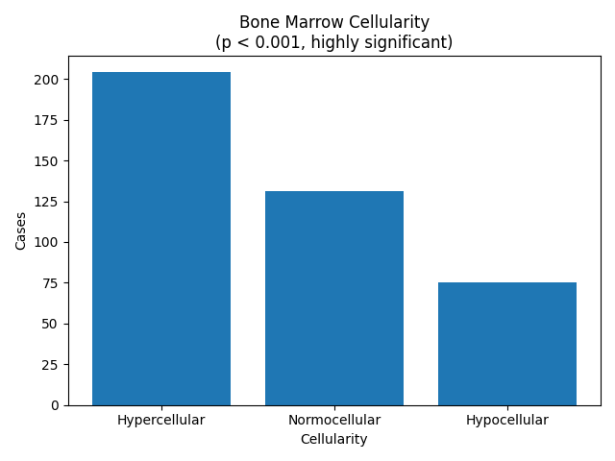
- Hypercellular marrow predominantly seen in megaloblastic anemia
- Hypocellular marrow associated with aplastic anemia
Chi-square analysis demonstrated a statistically significant association between gender and etiology (p=0.046) and a highly significant association between bone marrow cellularity and underlying cause (p<0.001), while age-wise distribution did not show statistical significance (p>0.05).

CONCLUSION
Pancytopenia is a significant hematological condition with varied etiologies. Megaloblastic anemia continues to be the most common and reversible cause in this region. Importantly, a large proportion of cases identified in this study were potentially reversible or manageable with timely intervention. This emphasizes the need for a systematic and stepwise diagnostic approach, including clinical assessment, hematological investigations, and bone marrow evaluation where indicated.
Pancytopenia should be approached as a clinical indicator of underlying disease rather than a standalone diagnosis. Early detection, appropriate etiological classification, and targeted management are essential to improve patient outcomes. Strengthening nutritional awareness, improving diagnostic facilities, and ensuring timely referral to specialized centres can significantly reduce morbidity and mortality associated with pancytopenia.
- REFERENCES
- Kumar DB, Raghupathi AR. Clinicohematologic analysis of pancytopenia: Study in a tertiary care centre. Basic Applied Pathol. 2012;5(1):19-21.
- Kar M, Ghosh A. Pancytopenia. J Indian AcadClin Med. 2002;3:29 34.
- Khodke K, Marwah S, Buxi G, Yadav RB, Chaturvedi NK. Bone marrow examination in cases of pancytopenia. J Indian Academy Clin Med. 2001;2:1-2. 4. Niazi M, Raziq F. The incidence of underlying pathology in pancytopenia. J Postgrad Med Inst. 2004;18:76 9.
- Williams WJ, Bentkr E, Erskv AJ. Hematology.third edition. Singapore, McGraw hill book company; 1986:161-184.
- Jha A, Sayami G, Adhikari RC, Panta AD, Jha R. Bone marrow examination in cases of pancytopenia. J Nepal Med Assoc. 2008;47(169):12-7.
- Tilak V, Jain R. Pancytopenia-a clinico-hematologic analysis of 77 cases. Indian J PatholMicrobiol. 1992;42:399-404.
- Kumar R, Kalra SP, Kumar H, Anand AC, Madan M. Pancytopenia-a six-years study. J Assoc Physicians India. 2001;49:1079-81.
- AkshathaSavith, Rama Mishra R. “Pancytopenia: A clinical and etiological study.” Scholars Journal of Applied Medical Sciences 3.5B (2015): 1926-1928.
- Sankepally, Kondal Reddy, and Saikrishna, K. “Etiological prole of pancytopenia.” International Journal of Innovative Research and Development ISSN 2278-0211 4.3 (2015).
- Thakkar, Bhaskar B., et al. “A study of pancytopenia in adult patients more than 12 years of age in North West region of saurashtra.” National Journal of Medical Research 3.1 (2013): 48-52.
- Kumar, Deepak B., and Raghupathi, A. R. “Clinicohematologic analysis of pancytopenia: Study in a tertiary care centre.” Basic and Applied Pathology 5.1 (2012): 19-21.
- Lakhey, A., et al. “Clinico-hematological study of pancytopenia.” Journal of Pathology of Nepal 2.3 (2012): 207-210.

