PANDA: Paper Allocation and Neatness Detection Automation –



ABSTRACT

Classroom cleanliness and paper distribution are routine tasks that often add to teachers’ workload. This study developed PANDA: Paper Allocation and Neatness Detection Automation, an intelligent dual-purpose robot designed to assist in waste collection and paper distribution within classroom environments. The project aims to support school cleanliness while providing teachers with assistance during daily activities and examination periods. A descriptive research design combined with a developmental approach was employed. The PANDA robot was designed, constructed, and programmed to operate autonomously using a microcontroller, sensors, a camera module, and motor-driven mechanisms. System performance was evaluated through pilot testing and a survey questionnaire administered to thirty (30) respondents. The evaluation focused on functionality, accuracy and efficiency, mobility, environmental impact, and user satisfaction. Data were analyzed using weighted mean computation. Results indicate that the PANDA robot effectively performed its intended functions, with the highest ratings observed in environmental impact and waste collection. Other performance areas were rated satisfactory, although limitations in navigation and response speed were identified. The study concludes that the PANDA robot is a feasible assistive system for classroom settings and has potential for further improvement and application in educational environments.

DEDICATION

This study is devoted to the almighty God, the creator and parent of all things.
This research is also dedicated to the Researchers, Parents, Advisors, and Friends with their support during the entirety of the research process.
They gave the investigators the fortitude, drive, and confidence to keep going despite the numerous challenges, long nights, and trials they had to overcome in order to analyze the outcome of the study.
This Capstone Project is also dedicated to the investigation' instructors and mentors, who have generously shared their knowledge and experience with the researchers.
Lastly, this research is dedicated to future researchers who will utilize it as a guide for their own research.

TABLE OF CONTENTS
Title page i.
Abstract ii.
Dedication iii.
Table of Contents v.
Page
I. INTRODUCTION
Overview 1-2
Features and Specifications 3-5
Marking Trends and Opportunities 6-7
Statement of the Problem
II. MARKET AND METHODS 8-12
III. RESULTS & DISCUSSIONS 13-19
IV. CONCLUSION 20-22
V. ACKNOWLEDGEMENT 23
VI. REFERENCES 24
VII. APPENDIXES
Validation Sheet 25-28
Questionnaire 29- 33
Documentation of Project Development 34-35

Introduction
1
Overview
Maintaining classroom neatness while ensuring efficient distribution of learning materials are two essential but time-consuming responsibilities commonly handled by teachers. Waste management has remained our big but unsolved problem, especially in our learning facilities. Unfortunately, the Waste Cost Solutions (2022) reported improper responses to this issue, leading to plenty of unnecessary waste within school ground. Along with this, the workloads of teachers are already heavy delivering the learning competencies to the students, having less labor during class would be such a big help. Thus, this research aims to give a solution by offering a robot that cleans (garbage collecting) and serves (sheet collecting).
As Artificial Intelligence upgrades, it is now possible for robots to detect garbage accurately and autonomously by installing a deep neural network for garbage recognition (Bai et al., 2018). Students are getting harder and harder to control regarding the proper waste disposal due to laziness and lack of consideration, thus, it is important to have alternative and innovative ways until discipline can strongly hold the youth's growth. There is research using this innovation by Bai et al. (2008), wherein it focuses the use of neural network in robots to garbage collecting in grass fields. It serves as a reference for this study, however, the researchers aim to solve two problems at the same time but in a classroom setting. ‎
‎Teachers jobs are mainly centered in educating students. Fortunately, in other countries, power points and learning materials are provided by the school and teachers only need to worry about partaking the lessons just like in Japan (Yamasaki, 2016). However, in some country like Philippines where the education system has no strong foundation, teachers are obligated to create and provide for their own learning materials aside from textbooks (Chan & Walker, 2025). With plenty of tasks and expenses, they still need to do physical labour during class which drains them mentally and physically. Thus, relieving them of the smallest task could be a small step but can be the start for various inventions that aim to assist educators.
2
‎Given all these data’s, the researchers aim to solve the problem faced by nature and another by the educators' workloads. Using Arduino, robotics can be accessible for students and proved to be easier to program. The researchers aim to create a robot with a neural network programmed to have two modes: Garbage collecting mode that picks up light trash inside the classroom; and sheet serving mode that sims to assist teachers in distributing learning materials easier and hassle free. This robot will serve a dual purpose which would be maintaining cleanliness inside the classrooms (cleaning) and assisting educators on their light works (serving) with the help of arduino and technology.

Features and Specifications
3
Main Features of PANDA
Paper Distribution Module
PANDA includes a built-in paper tray designed to securely hold multiple sheets of paper. It uses a controlled dispensing mechanism that releases one sheet at a time to support organized paper distribution within classroom environments.
Trash Detection System
The robot is equipped with an ESP32-CAM that enables visual detection of trash on the floor. This allows the system to identify visible waste within its operational area and initiate the appropriate collection process.
Waste Collection Bin
A detachable trash bin is attached to PANDA and serves as the container for collected waste. The bin can be easily removed and emptied, making cleaning more convenient and efficient for users.
Mobility System
PANDA moves using durable wheels powered by DC motors. This mobility system allows the robot to navigate through classrooms and perform its tasks within designated areas.
Operation Mode
PANDA operates in autonomous mode, meaning it can perform paper distribution and waste collection by following programmed instructions without requiring manual control.
Basic Specifications
4
- Microcontroller: Arduino Mega
- Sensors: Ultrasonic sensors for distance detection and an ESP32-CAM for trash recognition.
- Motors: Four DC motors for movement and one servo motor for paper dispensing and assistance in trash collection
- Power Source: 18950 rechargeable battery
- Body Material: Constructed with plywood and multi-purpose board for a sturdy and durable build

Non-Functional Specifications
- Performance: The system is designed to dispense paper one sheet at a time and collect light waste within a reasonable response time suitable for classroom use.
- Reliability: The system is expected to operate continuously during short classroom sessions on a single battery charge.
- Safety: The robot operates at a controlled speed appropriate for indoor school environments to minimize the risk of accidents.
- Maintainability: Components such as the trash bin and battery are designed to be accessible for easy cleaning, charging, and basic maintenance.

Operating Environment
5
- Indoor classrooms and school hallways
- Flat and level flooring
- Normal classroom lighting conditions

Intended Users
- Teachers, for assistance in paper distribution
- School maintenance staff, for support in waste collection
- Students, as indirect beneficiaries of cleaner and more organized learning spaces

System Constraints
- The system is intended for indoor use only.
- Trash detection is limited to visible and lightweight waste.
- Obstacle detection relies on ultrasonic sensors, which have limited precision.
- Battery capacity limits the duration of continuous operation.

Marking Trends and Opportunities
6

1. Expansion of Service Robots in Non-Industrial Settings
Service robots are increasingly deployed beyond industrial, hospitality, and restaurant contexts, extending into schools and other public institutions for cleaning, delivery, and support tasks (Wirtz et al., 2018). Observations from our study indicate that multifunctional robots, capable of handling both waste collection and material delivery, are well-received in educational settings. This suggests that integrating such systems into classrooms can enhance efficiency without disrupting daily routines.
2. Growing Demand for Automation in Education
Educational institutions are adopting automation and smart technologies to reduce teacher workload and improve operational efficiency. Routine tasks such as distributing materials and managing classroom order often limit instructional time. Insights from our research highlight that assistive robots can effectively support these tasks, allowing educators to focus on teaching while maintaining classroom organization.
3. Emphasis on Clean, Healthy, and Safe Learning Environments
Schools are placing greater emphasis on hygiene, cleanliness, and safe learning environments, particularly in response to heightened health concerns (WHO & UNICEF, 2020). Feedback from stakeholders shows that robotic systems supporting waste management and sanitation are perceived as valuable tools for maintaining clean indoor spaces, making them a relevant and practical addition to school operations.
7
4. Market Opportunities for the PANDA System
These trends present a strong market potential for the PANDA system. The growing acceptance of service robots in non-industrial environments, combined with the demand for automation in education and the priority on hygiene, underscores the relevance of PANDA’s dual functions. Identified areas for improvement, such as navigation and operational speed, provide clear avenues for refinement, positioning PANDA as a viable prototype for assistive robotics in educational institutions.

Market and Methods
8

Market
This section discusses the market relevance of the PANDA system and identifies environments where the project is most valuable, appreciated, and has potential for adoption or future development.
Target Market
The primary market for the PANDA system includes educational institutions, particularly public and private secondary schools. These environments face recurring challenges related to classroom cleanliness and the distribution of learning materials, especially during examination periods. Teachers often handle these tasks manually, adding to their workload.
PANDA is designed to assist in these routine yet time-consuming activities by providing automated waste collection and paper distribution. This dual-purpose functionality makes the system suitable for classrooms where efficiency, cleanliness, and time management are important.

Market Value and Application
The PANDA robot is most valuable in settings where:
- Classroom cleanliness is a recurring concern
- Teachers are responsible for distributing printed learning materials
- School staff seek low-cost, assistive technological solutions
The system’s ability to collect even small pieces of trash supports school cleanliness initiatives, while its paper distribution function provides teachers with practical assistance during daily lessons and examinations. These features make PANDA appealing not only as a prototype but also as a potential assistive tool for schools with limited manpower.
9

Opportunities for Adoption and Repurposing
Beyond classrooms, the PANDA system may be repurposed or adapted for:
- School libraries
- Faculty rooms
- Training centers and learning laboratories
The growing acceptance of service robots in non-industrial environments, combined with increased emphasis on automation and hygiene in schools, presents opportunities for further development and refinement of PANDA. With improvements in navigation and speed control, the system has potential for wider application within educational settings.

Methods
This section describes the research design, development process, data collection tools, and analysis techniques used in the study. It serves as a roadmap that allows other researchers to replicate the project.

Research Design
The study employed a descriptive research design combined with a developmental approach. The developmental aspect focused on the design, construction, and testing of the PANDA robot, while the descriptive approach was used to evaluate its performance based on user feedback.
10

System Development Procedure
The development of the PANDA system followed a systematic process consisting of the following stages:
1. Design and Planning
The researchers conceptualized the robot’s dual-purpose functionality, focusing on waste collection and paper distribution. Hardware components, sensors, and materials were selected based on availability and suitability for classroom use.
2. Hardware Assembly
The robot was constructed using a microcontroller, sensors, motors, and a waste bin. The body was built using pile wood and multi-purpose board to ensure stability while keeping the structure lightweight.
3. Programming and Integration
The Arduino Mega was programmed to control movement, sensor input, and task execution. The ESP32-CAM was integrated for trash detection, while ultrasonic sensors were used for distance detection and obstacle awareness.

4. Pilot Testing
Initial testing was conducted to observe the robot’s movement, trash detection, waste collection, and paper dispensing capabilities. Identified issues such as navigation errors and camera transmission delays were noted for evaluation.
11

Respondents of the Study
The study involved thirty (30) respondents, composed of grade 12 STEM Students familiar with classroom environments. The respondents were selected to evaluate the system’s functionality, efficiency, mobility, environmental impact, and overall user satisfaction.

Data Collection Instrument
A survey questionnaire using a 5-point Likert scale was employed as the primary data collection tool. The questionnaire assessed the following categories:
- Functionality
- Accuracy and efficiency
- Mobility
- Environmental impact
- User satisfaction
Each statement was rated from Strongly Disagree (1) to Strongly Agree (5).

Data Gathering Procedure
12
After pilot testing, the PANDA robot was demonstrated to the respondents. The participants were then asked to observe the robot’s performance and accomplish the survey questionnaire based on their evaluation and experience.

Data Analysis Technique
The collected data were analyzed using weighted mean computation. Each response was assigned a numerical value based on the Likert scale. The weighted mean for each statement and category was calculated to determine the level of agreement and overall evaluation of the PANDA system.

Results and Discussion
13
Likert Scale
Scale | Description
5 | Strongly Agree
4 | Agree
3 | Neutral
2 | Disagree
1 | Strongly Disagree

Table 1
Functionality of the PANDA Robot
Statement | 5 | 4 | 3 | 2 | 1 | Weighted Mean | Intrepretation
The robot successfully performs trash collection | 14 | 11 | 4 | 1 | 0 | 4.27 | Strongly Agree
The robot effectively distributes paper | 10 | 12 | 6 | 2 | 0 | 4.00 | Agree
Overall Mean |  |  |  |  |  | 4.12 | Agree

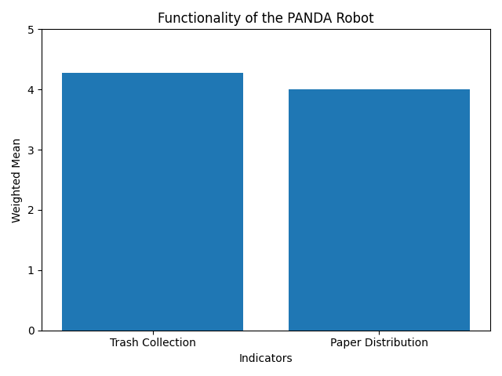
The overall weighted mean of 4.14 indicates that respondest generally agree that the PANDA robot functions effectively. Trash collection received a higher rating than paper distribution, showing stronger performance in waste-related tasks.
14

Table 2
Accuracy and Efficiency
Statement | 5 | 4 | 3 | 2 | 1 | Weighted Mean | Interpretation
The Robot detects trash accurately | 12 | 12 | 4 | 2 | 0 | 4.13 | Agree
The robot collects trash effectively | 11 | 11 | 6 | 2 | 0 | 4.03 | Agree
The robot distributes paper efficiently | 9 | 12 | 7 | 2 | 0 | 3.93 | Agree
The robot responds quickly when trash is detected | 8 | 11 | 8 | 3 | 0 | 3.80 | Agree
The robot is easy to operate | 7 | 11 | 9 | 3 | 0 | 3.73 | Agree
Overall Mean |  |  |  |  |  | 3.92 | Agree
15
The overall mean of 3.92 shows that respondents agree with the robot’s accuracy and efficiency. Detection and trash collection scored higher, while response speed and ease of operation received lover ratings, reflecting system delays and operational challenges.
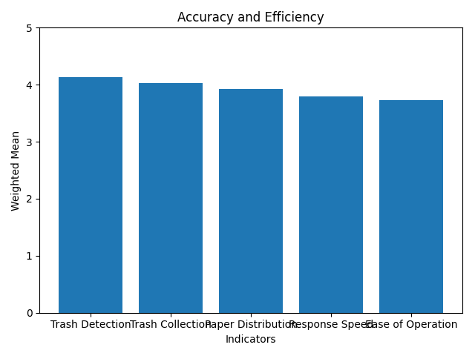

Table 3
16
Mobility
Statement | 5 | 4 | 3 | 2 | 1 | Weighted Mean | Interpretation
The robot moves smoothly within the area | 7 | 11 | 9 | 3 | 0 | 3.73 | Agree
The robot successfully avoids obstacles during operation | 6 | 11 | 10 | 3 | 0 | 3.67 | Agree
Overall Mean |  |  |  |  |  | 3.70 | Agree

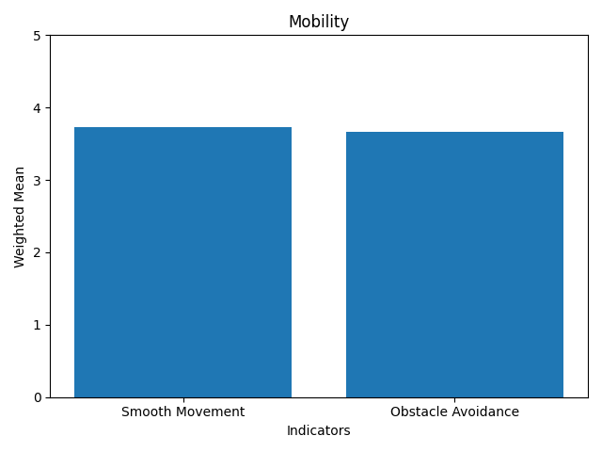
Mobility obtained an overall mean of 3.70, indicating moderate agreement. While the robot can move within the area, obstacle avoidance and navigation issues affected consistent performance.

Table 4
17
Environmental Impact
Statement | 5 | 4 | 3 | 2 | 1 | Weighted Mean | Interpretation
The robot contributes to maintaining cleanliness in the area | 17 | 9 | 3 | 1 | 0 | 4.40 | Strongly Agree
Overall mean |  |  |  |  |  | 4.40 | Strongly Agree

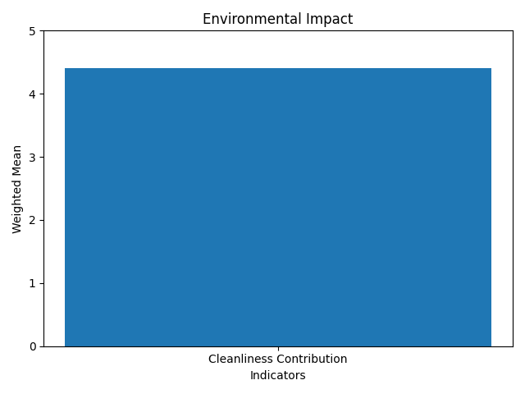
The environmental impact category received the highest mean score. This shows strong agreement that the PANDA robot helps maintain cleanliness, supporting its purpose in waste management.

Table 5
18
User Satisfaction
Statement | 5 | 4 | 3 | 2 | 1 | Weighted Mean | Interpretation
The robot improves convenience in waste disposal | 12 | 11 | 5 | 2 | 0 | 4.10 | Agree
The robot improves convenience in paper distribution | 9 | 12 | 7 | 2 | 0 | 3.93 | Agree
The robot meets user expectations in performance | 8 | 11 | 8 | 3 | 0 | 3.80 | Agree
I am satisfied with the overall operation of the robot | 9 | 10 | 8 | 3 | 0 | 3.83 | Agree
Overall Mean |  |  |  |  |  | 3.92 | Agree

The user satisfaction results indicate that respondents are generally satisfied with the PANDA robot. Higher satisfaction was observed in waste disposal convenience, while performance expectations were slightly lower due to technical limitations.

19

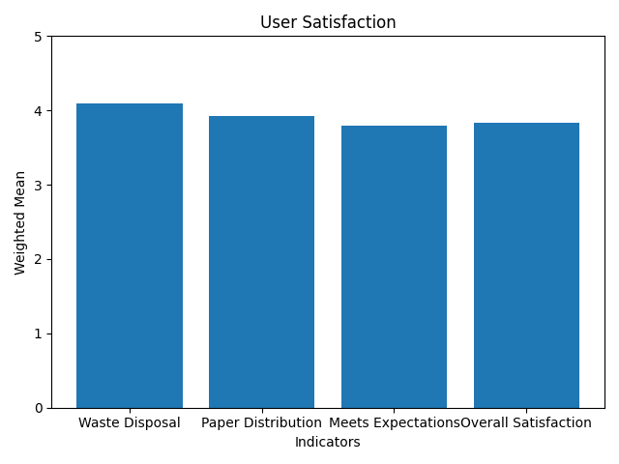

Identified Limitations
Despite positive evaluations, the robot did not fully functions as expected due to navigation failures, camera transmission issues, and inconsistent communication with the Arduino. These limitations affected accuracy, efficiency, and mobility ratings.

Summary of Findings, Conclusions, and Recommendations
20
5.1 Summary of Findings
This study aimed to alleviate school waste by automating the collection of even small pieces of trash, while also providing teachers with relief in paper distribution, particularly during examination days. The project introduced PANDA: Paper Allocation and Neatness Detection Automation, a dual-purpose robot designed for paper distribution and waste collection within a school environment.
The overall performance of the PANDA robot was examined through the results presented in the result and discussion part. Based on the responses of thirty (30) respondents using a survey questionnaire, the robot demonstrated positive performance across all evaluated categories, including functionality, accuracy and efficiency, mobility, environmental impact, and user satisfaction.
The findings showed that the robot was most effective in waste collection, with respondents strongly agreeing that PANDA contributes to maintaining cleanliness in the area. This highlights the robot’s strength in supporting proper waste management and reinforcing cleanliness within the school environment. Functionality results further showed that the robot successfully performed its intended tasks, with trash collection receiving higher ratings than paper distribution.
Accuracy and efficiency results indicated that PANDA was able to detect and collect trash accurately, though response speed and ease of operation received comparatively lower ratings. Mobility results reflected moderate agreement, suggesting that while the robot could move within the area, navigation and obstacle avoidance were not consistently reliable. User satisfaction results showed that respondents were generally satisfied with the robot, particularly in terms of waste disposal convenience, while expectations related to overall performance were influenced by observed technical limitations.
21

5.2 Conclusions
Based on the results presented in the result and discussion part, the study concludes that the project achieved its objectives. The findings, grounded in the validation and innovation survey questionnaire, confirm that the dual-purpose capability of the PANDA robot is feasible in terms of functionality.
The robot effectively performed waste collection, as supported by high respondent ratings and observations during several pilot tests. Its contribution to maintaining cleanliness was strongly affirmed, indicating that the system can assist in addressing waste management concerns within a school setting. Paper distribution was also achieved, although with slightly lower performance compared to waste collection.
While the robot demonstrated acceptable accuracy, efficiency, and user satisfaction, limitations in navigation, obstacle avoidance, and camera-to-Arduino communication prevented optimal performance. Despite these constraints, the overall results validate the practicality of the PANDA robot as an assistive system for waste collection and paper distribution. The study therefore concludes that the concept and implementation of the PANDA robot are viable, with identified areas requiring improvement for enhanced performance.
5.3 Recommendations
22

Based on the findings and identified limitations of the study, the following recommendations are proposed:

Technical Recommendations
Future improvements should focus on enhancing the robot’s obstacle avoidance and navigation system to ensure smoother and more reliable movement within the area. Adjusting or tuning down the speed of the DC motors is recommended to improve control and stability during operation. Additionally, the trash collection mechanism should be optimized, as the collection speed was observed to be slower than expected during testing.

Design Improvements
For succeeding versions of the project, the physical design of the robot should consider its height to ensure better reach, balance, and interaction with its environment. Proper adjustment of dimensions may improve both mobility and task efficiency.
Research Recommendations
Future researchers are encouraged to extend the testing duration and allot more time for system evaluation. A longer testing period would help identify potential issues that may not appear during short-term trials and allow for a more comprehensive assessment of the robot’s performance under varied conditions.
ACKNOWLEDGMENT
23

The investigators would like to express their sincere gratitude and deep appreciation to all the individuals who contributed to the successful completion of this research paper;
First and foremost, the researchers extend their heartfelt thanks to their families, friends, and loved ones for their constant support, encouragement, and understanding throughout the duration of this study. The investigators are also deeply grateful to all supporters and individuals who, in one way or another, offered assistance, motivation, time, and resources that helped sustain the researchers during the challenges of this project.
To the Capstone adviser, Mary Jane T. Mizell, MSC, PhD, MT-I for the guidance and knowledge given to the researchers.
To the Principal and Assistant Principal, ELLIN T. VICERA, P-II and ARLENE RAVELO, P-I. For their approval and permission to conduct this research among the grade 12 senior high school students.
The researchers also thank all the respondents for their cooperation, willingness, and consent to share their views, opinions, and knowledge, which were essential to the completion of this research.
Above all, the investigators give thanks to God Almighty for the wisdom, strength, guidance, and blessings bestowed upon them throughout the research process and up to its completion.
The Researchers
REFERENCES:
24

Alimisis, D. (2013). Educational robotics: Open questions and new challenges. Themes in Science and Technology Education, 6(1), 63–71.
Chan, J. & Walker, S. (2024). Filipino teachers need workload reform. Inquirer.Net. Retrieved from https://opinion.inquirer.net/179491/filipino-teachers-need-workload-reform.
‎Waste Management is a Problem at School (2019). Wastecostsolutions.com. Retrieved from https://www.wastecostsolutions.com/why-waste-management-is-a-problem-at-school.
Wirtz, J., Patterson, P. G., Kunz, W. H., Gruber, T., Lu, V. N., Paluch, S., & Martins, A. (2018). Brave new world: Service robots in the frontline. Journal of Service Management, 29(5), 907–931. https://doi.org/10.1108/JOSM-04-2018-0119.
World Health Organization & UNICEF. (2020). Water, sanitation, hygiene, and waste management for COVID-19: Technical brief. World Health Organization.
‎Yamasaki, H. (2016). Teachers and teacher education in Japan. Retrieved from https://scholar.google.com/scholar?hl=en&as_sdt=0%2C5&q=japan+education+system+for+the+teachers&btnG=#d=gs_qabs&t=1763876593337&u=%23p%3DP2oxl9i3NBQJ .

Appendix A
25

Validation Sheet

Appendix B
29

Questionnaire

Appendix C
34

Documentation of Project Development

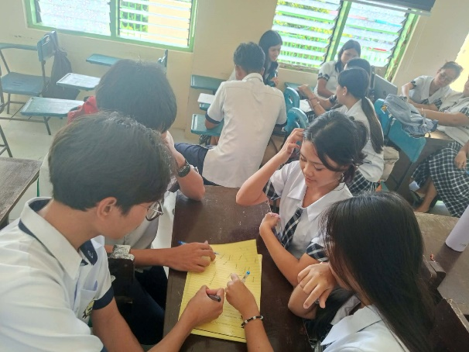
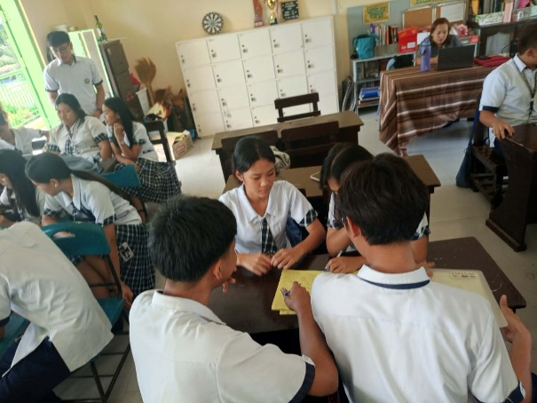

Figure 1: Brainstorming of Concept

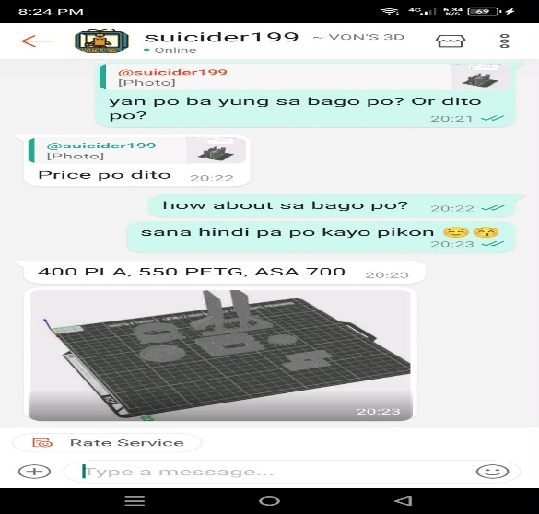
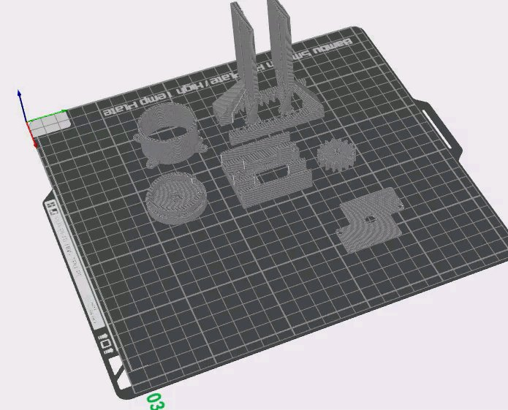

Figure 2: Materials Procurement
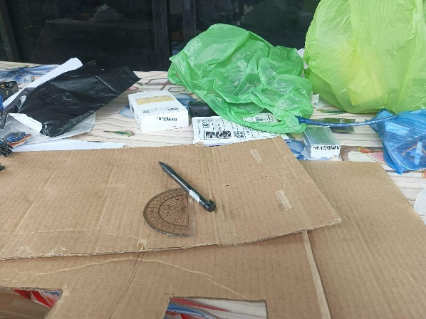
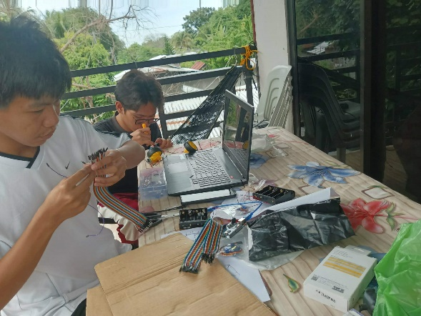
35

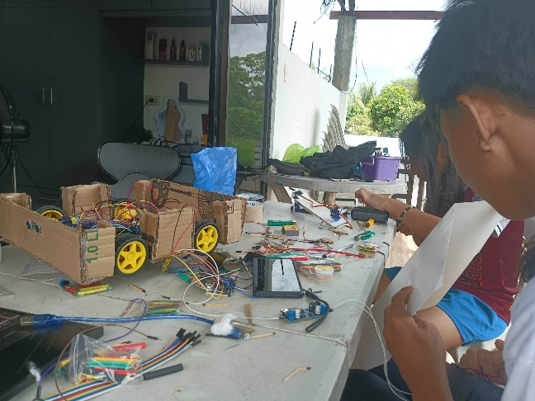
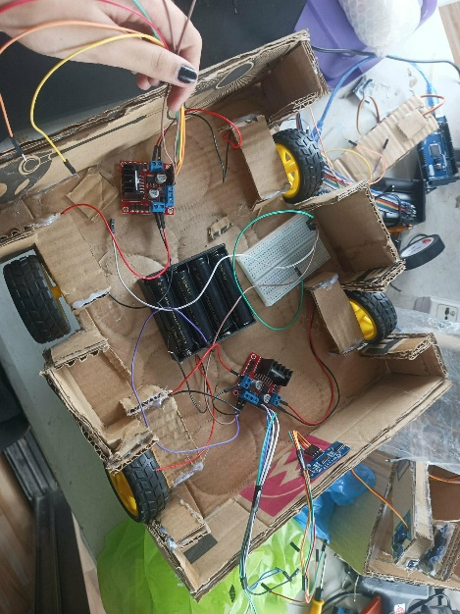
Figure 3: Design and Layout

Figure 3: Prototype Development
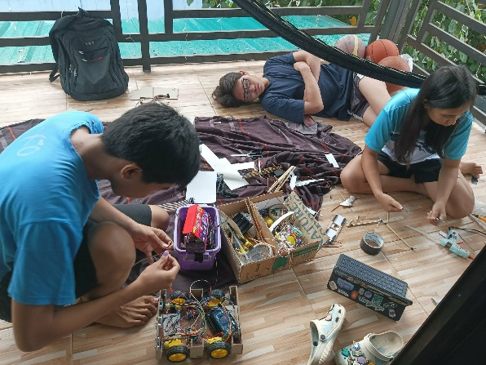
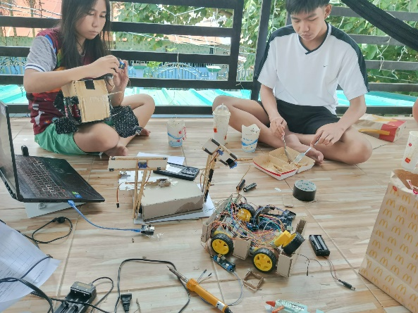
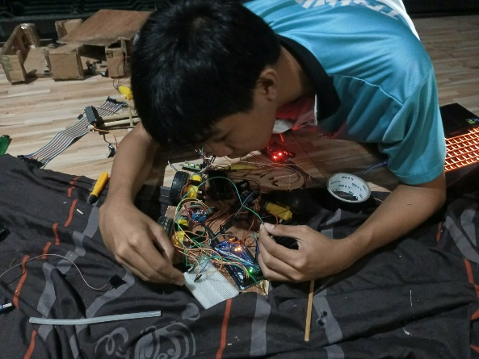

Figure 4: Actual product development

Statement of the Problem

This study aims to assess the effectiveness and functionality of the PANDA: Smart Waste Management System and Automated Paper Dispenser in promoting cleanliness and efficient waste disposal.
Specifically, this study seeks to answer the following questions:
1. How effective is PANDA in detecting the presence of waste using its sensors and ESP32-CAM in terms of:
a. Functionality
b. Accuracy and Efficiency
c. Mobility
d. Environmental Impact
e. User Satisfaction
2. How efficient is PANDA in terms of:
a. Waste Collection
b. Paper Distribution

