ENGAGING SENIOR HIGH SCHOOL STUDENTS IN CLIMATE CHANGE AND DISASTER RISK REDUCTION EDUCATION IN TINAMBAC, CAMARINES SUR: EVIDENCE FROM A QUASI-EXPERIMENTAL EXTENSION INTERVENTION

1. INTRODUCTION
Climate change has intensified the frequency and severity of hydro-meteorological hazards globally, disproportionately affecting developing countries such as the Philippines. The country’s geographic location and socio-economic vulnerabilities make it highly susceptible to typhoons, flooding, and sea-level rise (IPCC, 2014). These risks necessitate urgent and innovative approaches to disaster risk reduction (DRR), particularly through education.
Education is increasingly recognized as a critical pathway for enhancing adaptive capacity and reducing vulnerability (UNESCO, 2020). In particular, youth engagement plays a vital role in fostering long-term resilience. Senior high school students are strategically positioned as both learners and community actors who can influence household and community-level preparedness. Despite the integration of DRR in national policies, gaps remain in the practical understanding and application of climate knowledge among students. Traditional classroom-based approaches often fail to translate theoretical knowledge into actionable behaviors.
To address this gap, the College of Environmental Science and Design implemented an extension program aimed at enhancing climate and disaster risk reduction literacy and critical thinking among senior high school students in Tinambac, Camarines Sur. This research also aligns with the shared commitment between the Commission on Higher Education and the current Philippine administration to empowering youth as active partners creating more opportunities for the youth to learn, lead, and make a difference in building safer and more resilient communities,
This study aims to:
- Measure knowledge gains using pre-test and post-test analysis
- Evaluate participant perceptions of program effectiveness
- Examine the relationship between instructional delivery and perceived impact
- Provide policy recommendations for scaling climate education initiatives

Review of Literature
Theoretical and Conceptual Framework
This study is grounded in three complementary frameworks that collectively explain how learning interventions can enhance disaster risk reduction (DRR) knowledge, influence behavior, and contribute to resilience-building. These include Experiential Learning Theory, Kirkpatrick’s Training Evaluation Model, and the Sendai Framework for Disaster Risk Reduction. Together, these frameworks provide a robust foundation for understanding how interactive educational programs can produce meaningful cognitive, behavioral, and societal outcomes.
Experiential Learning Theory (ELT), developed by Kolb (1984), posits that learning is a dynamic process whereby knowledge is created through the transformation of experience. The theory emphasizes a cyclical model consisting of four stages: concrete experience, reflective observation, abstract conceptualization, and active experimentation. In the context of this study, the use of interactive seminars aligns with this cycle by engaging participants in hands-on activities (experience), encouraging reflection on these activities, facilitating the development of concepts related to DRR, and enabling participants to apply learned knowledge in practical contexts. This approach is particularly relevant in environmental and disaster education, where experiential engagement enhances understanding of complex socio-ecological systems and fosters deeper retention of knowledge.
To assess the effectiveness of the learning intervention, the study adopts Kirkpatrick’s Training Evaluation Model, a widely used framework for evaluating educational and training programs (Kirkpatrick & Kirkpatrick, 2006). The model’s first three levels are applied in this research. Level 1 (Reaction) measures participants’ satisfaction with the training, providing insights into engagement and perceived relevance. Level 2 (Learning) evaluates the extent of knowledge acquisition, often through pre- and post-test comparisons. Level 3 (Behavior) examines the degree to which participants apply what they have learned in real-world contexts, reflecting changes in attitudes and practices. By integrating these levels, the study ensures a comprehensive evaluation of both immediate learning outcomes and longer-term behavioral impacts, which are critical for effective DRR education. Furthermore, the study is aligned with the Sendai Framework for Disaster Risk Reduction 2015–2030, a global policy instrument that guides efforts to reduce disaster risks and enhance resilience (United Nations Office for Disaster Risk Reduction [UNDRR], 2015). Specifically, the study contributes to Priority 1, which emphasizes understanding disaster risk through knowledge dissemination and capacity-building, and Priority 3, which highlights the importance of investing in disaster risk reduction for resilience, including through education and awareness programs. By embedding DRR concepts within an experiential learning framework and evaluating outcomes using a structured model, the study operationalizes these global priorities at the local level.
Overall, the integration of these three frameworks provides a coherent conceptual structure for the study. Experiential Learning Theory explains how participants learn, Kirkpatrick’s Model evaluates what they learn and how they apply it, and the Sendai Framework situates the study within a broader policy context aimed at reducing disaster risks and strengthening community resilience. This triangulated approach ensures that the study not only contributes to academic understanding but also supports practical and policy-relevant outcomes in disaster risk reduction and environmental management (Figure 1).
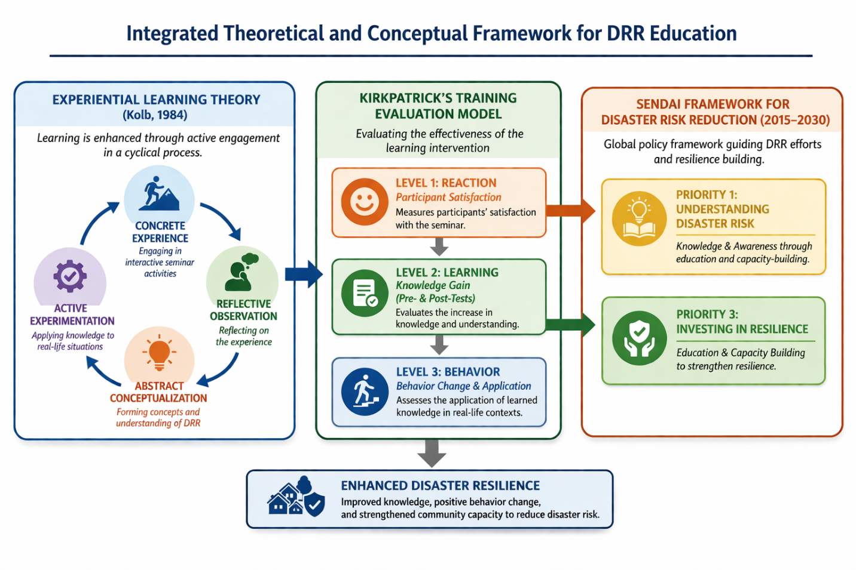Figure 1. Integrated theoretical and conceptual framework (Kolba 1984, Kirkpatrick et. Al 2006, UNDRR 2015)
METHODOLOGY
The methodological approach adopted in this study was designed to rigorously evaluate the effectiveness of a climate change and disaster risk reduction (DRR) education intervention among senior high school students. A quasi-experimental research design utilizing pre-test and post-test comparisons was employed, complemented by descriptive survey analysis. This design is widely used in educational and extension research where random assignment is not feasible, allowing for the assessment of intervention effects within naturally occurring groups (Creswell & Creswell, 2018). By comparing students’ knowledge before and after the intervention, the study was able to capture measurable learning gains attributable to the program.
The participation of 468 senior high school students across multiple schools provided a robust sample size, enhancing the generalizability and reliability of the findings. Large sample sizes are particularly important in educational research, as they increase statistical power and reduce the likelihood of Type II errors (Field, 2018). Moreover, involving multiple schools ensured diversity in student backgrounds, thereby improving the external validity of the results. Table 1 shows the breakdown of the participants in the four selected schools.
Table 1. Number of participants per school
NAME OF SCHOOL | NUMBER OF PARTICIPANTS
Sagrada National High School | 72
Tamban National High School | 290
Antipolo National High School | 56
San Ramon Provincial High School | 50
Total | 468

Two primary instruments were utilized in this study: a knowledge test and a client satisfaction survey. The knowledge test, scored on a 0–10 scale, was designed to assess students’ understanding of climate change and DRR concepts. Pre-test and post-test measures are commonly used to evaluate cognitive outcomes and are considered effective indicators of instructional impact (Fraenkel et al., 2019). Meanwhile, the client satisfaction survey, based on a 5-point Likert scale, captured participants’ perceptions of the program’s relevance, delivery, and overall effectiveness. Likert-scale instruments are widely recognized for their reliability in measuring attitudes and perceptions in social science research (Likert, 1932).
Statistical Analysis and Computation Procedures
The statistical analysis employed a combination of inferential and descriptive techniques to provide a comprehensive evaluation of the intervention. Given that the dataset consisted of grouped frequency distributions rather than raw individual scores, a weighted statistical approach was applied to compute the necessary parameters, which is a standard procedure in handling aggregated educational data (Field, 2018; Howell, 2013).
Computation of the Mean from Grouped Data
The mean scores for both pre-test and post-test were derived using weighted averages based on frequency distributions. The mean was computed using the following formula:
$$\overset{ˉ}{X}=\frac{∑(f⋅x)}{∑f}$$
where $f$represents the frequency of responses, $x$denotes the corresponding score, and $∑f$is the total number of respondents. This method ensures an accurate representation of central tendency when raw data are unavailable and is widely applied in statistical analyses involving grouped datasets (Bluman, 2018; Gravetter & Wallnau, 2017).

Computation of Variance
To estimate the dispersion of scores, the variance for each group was calculated using the weighted variance formula:
$$s^{2}=\frac{∑f(x-\overset{ˉ}{X})^{2}}{n-1}$$
This computation provides a measure of variability within each dataset, which is essential for inferential statistical testing. Variance estimation from grouped data is a recognized approach when individual-level observations are not accessible (Field, 2018; Howell, 2013).
t-Test Analysis (Welch’s Approximation)
To determine whether the difference between pre-test and post-test mean scores was statistically significant, a Welch’s independent t-test was employed. This approach was selected because: (1) the data were grouped and not paired at the individual level, and (2) the assumption of equal variances could not be guaranteed. Welch’s t-test is recommended under such conditions as it provides a more robust alternative to the standard Student’s t-test (Delacre et al., 2017; Field, 2018).
The test statistic was computed as follows:
$$t=\frac{{\overset{ˉ}{X}}_{post}-{\overset{ˉ}{X}}_{pre}}{\sqrt{\frac{s_{pre}^{2}}{n_{pre}}+\frac{s_{post}^{2}}{n_{post}}}}$$
The degrees of freedom were estimated using the Welch–Satterthwaite equation:
$$df=\frac{{\left(\frac{s_{pre}^{2}}{n_{pre}} + \frac{s_{post}^{2}}{n_{post}}\right)}^{2}}{\frac{\left(s_{pre}^{2}/n_{pre})^{2}\right.}{n_{pre}-1}+\frac{\left(s_{post}^{2}/n_{post})^{2}\right.}{n_{post}-1}}$$
Statistical significance was evaluated at the 0.05 level. In this study, results yielded p < 0.001, indicating a highly significant difference between pre-test and post-test scores (Field, 2018; Lakens, 2013).
Methodological Consideration
It is important to note that the study followed a pre-test–post-test design involving the same participants, for which a paired t-test would be the most appropriate method under ideal conditions. However, due to the absence of individual paired observations and the availability of only aggregated frequency data, the use of Welch’s t-test serves as a statistically acceptable approximation in grouped data analysis. This approach has been supported in methodological literature when dealing with secondary or summarized datasets (Field, 2018; Howell, 2013).
Effect Size (Cohen’s d)
Beyond statistical significance, the magnitude of the intervention’s effect was assessed using Cohen’s d, which provides a measure of practical significance. The effect size was computed as:
$$d=\frac{{\overset{ˉ}{X}}_{post}-{\overset{ˉ}{X}}_{pre}}{s_{pooled}}$$
where the pooled standard deviation is given by:
$$s_{pooled}=\sqrt{\frac{(n_{pre}-1)s_{pre}^{2}+(n_{post}-1)s_{post}^{2}}{n_{pre}+n_{post}-2}}$$
Effect size measures are essential in educational and social science research, as they complement hypothesis testing by indicating the magnitude of observed effects (Cohen, 1988; Lakens, 2013). Cohen’s d values were interpreted based on standard benchmarks: 0.20 (small), 0.50 (medium), and 0.80 or higher (large effect).
Furthermore, descriptive statistics, including mean scores, were used to summarize the data and provide a clear overview of trends in student performance and satisfaction. These combined statistical approaches ensured both the rigor and interpretability of the findings, allowing for a robust assessment of the intervention’s effectiveness.
Overall, the methodological framework of this study integrates both quantitative rigor and practical evaluation tools, ensuring a comprehensive assessment of the program’s effectiveness. By combining quasi-experimental design, validated instruments, and appropriate statistical analyses, the study provides credible evidence of the impact of climate change education on student knowledge and perceptions. However, future studies may benefit from incorporating true experimental designs or longitudinal approaches to further strengthen causal inferences and assess long-term behavioral outcomes.

The Methodological Framework of the Study
The study follows an Input–Process–Output (IPO) model, which provides a structured representation of the research design. The input consists of senior high school students who participated in the climate change and disaster risk reduction (DRR) education program, along with their baseline knowledge as measured through a pre-test.
The process involves the implementation of the educational intervention, specifically an interactive seminar designed to enhance students’ understanding of climate change and disaster preparedness. During this phase, data were collected through post-test assessments and a client satisfaction survey using a Likert scale. Statistical analyses, including t-test, Cohen’s d, and descriptive statistics, were then applied to evaluate the effectiveness of the intervention.
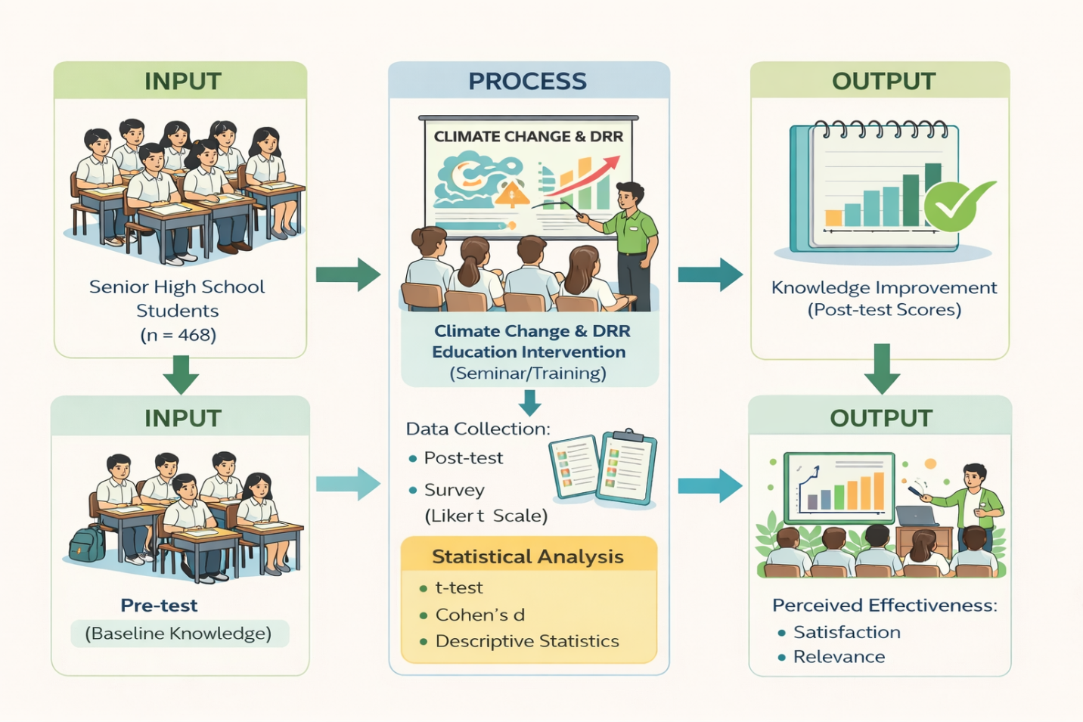
Figure 2. The methodologic framework of the study
The output includes the observed improvement in students’ knowledge, as reflected in post-test scores, as well as their perceived satisfaction, relevance of the program, and overall effectiveness. These outputs provide empirical evidence of the impact of the intervention on both cognitive and perceptual outcomes.
This conceptual framework illustrates the logical flow of the study, linking the intervention to measurable outcomes through systematic data collection and analysis. It also highlights the integration of quantitative methods in assessing educational effectiveness, ensuring that both learning gains and participant perceptions are captured.
4. RESULTS AND DISCUSSION
4.1 Knowledge Gains: Inferential Evidence
The findings of this study reveal a statistically significant improvement in students’ knowledge following the implementation of the climate change and disaster risk reduction (DRR) education program. The comparison between pre-test and post-test scores demonstrates a clear upward shift in performance levels. Pre-test scores were generally within the low to moderate range, indicating limited baseline knowledge among participants, while post-test scores moved into the moderate to high range, reflecting substantial learning gains after the intervention (Figure 3).
The inferential analysis confirms that the observed improvement is highly statistically significant (p < 0.001), indicating that the difference between pre-test and post-test scores is unlikely to have occurred by chance (Field, 2018). More importantly, the computed effect size (Cohen’s d = 1.43) indicates a large magnitude of impact, signifying that the intervention was not only statistically significant but also practically meaningful (Cohen, 1988). In educational research, effect size is considered a critical indicator because it reflects the real-world relevance and strength of an intervention beyond mere statistical significance (Lakens, 2013).
Taken together, these findings demonstrate both statistical and practical significance. The extremely low p-value (p < .001) provides strong evidence against the null hypothesis, while the large effect size confirms that the intervention produced a substantial and meaningful improvement in learning outcomes. This suggests that the educational strategy employed is highly effective and capable of generating significant cognitive gains among students, consistent with prior research emphasizing the impact of well-designed instructional interventions (Hattie, 2009).
From a theoretical perspective, these findings can be explained through Experiential Learning Theory, which emphasizes the importance of active engagement in knowledge acquisition (Kolb, 1984). The interactive seminar format allowed students to move through the stages of experience, reflection, conceptualization, and application, thereby facilitating deeper cognitive processing. This supports the assertion that experiential and participatory approaches enhance comprehension and retention of complex concepts.
Furthermore, the results are consistent with global findings that interactive and participatory climate education produces measurable learning gains (UNESCO, 2020). The integration of real-world examples and localized case studies likely enhanced students’ ability to relate theoretical concepts to practical realities. In the context of climate education, such contextualization is essential for transforming abstract knowledge into actionable understanding (Lasco et al., 2016).
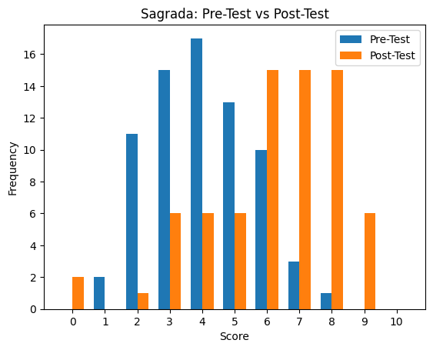
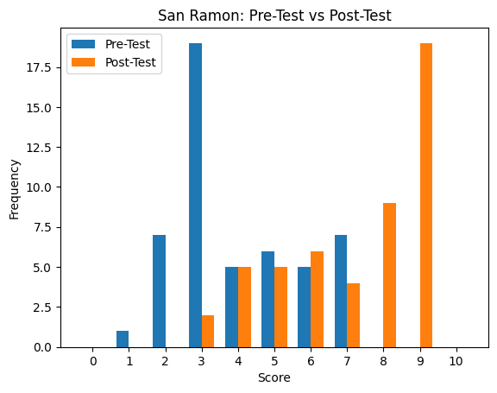
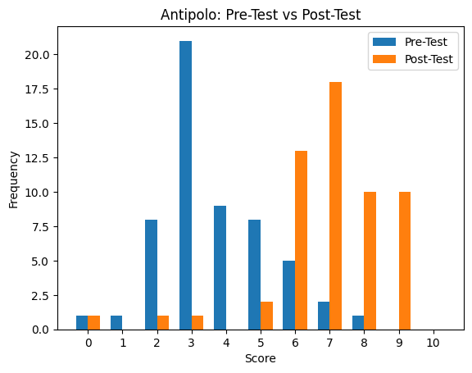
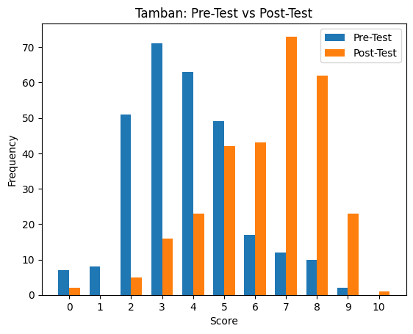
Figure 3. The pre and post test scores
4.2 Relevance and Contextualization
The high mean rating for relevance and usefulness (M = 4.26) indicates that students perceived the program as highly applicable to their needs and local context. Relevance is widely recognized as a key determinant of learning engagement and motivation (Creswell & Creswell, 2018). When learners perceive content as meaningful, they are more likely to actively participate and invest cognitive effort.
In this study, the use of localized examples—such as flooding risks and climate hazards specific to Tinambac—enhanced the relatability of the material. Students were able to connect abstract concepts to real-life situations, thereby deepening their understanding. This finding aligns with place-based education theory, which emphasizes the importance of situating learning within local contexts to promote deeper engagement and environmental awareness (Gruenewald, 2003).
Moreover, contextualized learning has been shown to improve both academic performance and environmental literacy, particularly in developing countries where local experiences strongly shape perceptions of risk (Lasco et al., 2016). The high relevance rating suggests that the program successfully addressed the informational needs of students by aligning content with their lived experiences.
4.3 Instructional Quality
Instructional quality received the highest rating among all domains (M = 4.37), reflecting the effectiveness of the program’s delivery. This result indicates that facilitators demonstrated strong teaching competencies, including clarity of explanation, effective communication, and the ability to engage students in meaningful discussions.
High instructional quality is a critical factor influencing learning outcomes, as effective teaching enhances both comprehension and retention (Fraenkel et al., 2019). The use of visual aids, interactive discussions, and real-life examples likely contributed to the positive evaluation of instructional delivery. These strategies are consistent with best practices in environmental education, which emphasize active learning and student-centered approaches (UNESCO, 2020).
However, the findings also suggest potential variability in instructional effectiveness across different schools or sessions. Such variability may be attributed to differences in facilitator experience, teaching style, or resource availability. This highlights the importance of standardizing instructional materials and training facilitators to ensure consistency in program delivery (Creswell & Creswell, 2018).
Ensuring pedagogical consistency is particularly important for extension programs that aim to scale across multiple locations. Without standardized approaches, variations in instructional quality may lead to uneven learning outcomes, thereby affecting the overall effectiveness of the program.
4.4 Impact Gap: Learning vs. Behavior
While the program demonstrated strong performance in terms of knowledge acquisition and satisfaction, the relatively lower rating for perceived impact (M = 4.13) highlights a critical issue—the knowledge-action gap. This refers to the disconnect between what individuals know and how they act upon that knowledge.
Despite significant learning gains, students may not immediately translate their understanding into behavioral changes. Several factors may explain this gap. First, the short duration of the intervention may not have been sufficient to influence long-term behavior. Behavioral change typically requires sustained exposure and reinforcement (Ajzen, 1991).
Second, the lack of follow-up activities or reinforcement mechanisms may have limited the program’s impact. Without continued engagement, students may struggle to retain and apply what they have learned. Third, students may face structural or environmental barriers, such as limited resources or lack of institutional support, which hinder the application of knowledge.
This finding is consistent with behavioral science literature, which emphasizes that knowledge alone is insufficient to drive behavior change (Ajzen, 1991). According to the Theory of Planned Behavior, behavior is influenced not only by knowledge but also by attitudes, social norms, and perceived behavioral control. Therefore, effective DRR education programs must address these factors to achieve meaningful behavioral outcomes.
To bridge this gap, future interventions should incorporate hands-on activities, simulations, and community-based projects, which provide opportunities for students to apply their knowledge in real-world contexts. Such approaches have been shown to enhance both learning and behavior in environmental education (UNESCO, 2020).
4.5 Overall Satisfaction
The high level of overall satisfaction (M = 4.08) indicates that the program was well-received by participants. Satisfaction is an important indicator of program success, as it reflects participants’ perceptions of quality, relevance, and usefulness (Kirkpatrick & Kirkpatrick, 2006).
High satisfaction levels suggest that the program was credible, engaging, and beneficial to students. It also indicates a positive emotional response, which can enhance motivation and learning outcomes. Furthermore, satisfied participants are more likely to recommend the program to others, thereby increasing its potential for replication and scaling.
From an implementation perspective, high satisfaction supports the feasibility of expanding the program to other schools and communities. However, maintaining quality during scaling requires careful planning, particularly in terms of instructional delivery and contextual adaptation.

4.6 Integrated Interpretation of Findings
Cohen’s d values were interpreted based on standard benchmarks: 0.20 (small), 0.50 (medium), and 0.80 or higher (large effect). The results of this study yielded d > 0.80, indicating a large effect size, which suggests that the intervention produced a substantial and meaningful improvement in student learning outcomes.
From an educational perspective, the findings demonstrate both statistical and practical significance, confirming that the observed improvements are not only unlikely due to chance but also have strong real-world implications. This aligns with existing literature emphasizing that high-impact instructional strategies can significantly enhance student learning outcomes (Cohen, 1988; Hattie, 2009).
Furthermore, the results of this study reveal a three-stage outcome pattern:
- Strong cognitive outcomes – Significant improvement in knowledge
- Strong affective outcomes – High levels of satisfaction and engagement
- Moderate behavioral outcomes – Presence of a knowledge-action gap
This pattern is consistent with Kirkpatrick’s Training Evaluation Model, which distinguishes between reaction, learning, and behavior outcomes (Kirkpatrick & Kirkpatrick, 2006). While the program successfully achieved positive results at the reaction and learning levels, its impact on behavior remains limited.
This highlights the need for multi-phase interventions that extend beyond initial training. Continuous engagement, reinforcement activities, and integration into school and community systems are essential for translating knowledge into sustained behavioral change. The findings also reinforce the importance of aligning educational interventions with broader policy frameworks, such as the Sendai Framework for Disaster Risk Reduction, which emphasizes the role of education in building resilience (UNDRR, 2015).
5. POLICY AND DEVELOPMENT IMPLICATIONS
The findings of this study have significant implications for policy and practice. The demonstrated effectiveness of the program supports its alignment with global frameworks such as the Sendai Framework for Disaster Risk Reduction, particularly in enhancing disaster risk awareness among youth (UNDRR, 2015).
The study also contributes to the achievement of Sustainable Development Goal (SDG) 13 (Climate Action) by promoting climate literacy and adaptive capacity (UN, 2015). Additionally, it supports SDG 4 (Quality Education) by improving the relevance and effectiveness of educational programs.
At the local level, the results highlight the importance of integrating climate and DRR education into school curricula and development planning. Collaboration among local government units (LGUs), educational institutions, and communities is essential for sustaining and scaling such initiatives.
6. CONCLUSION
The study demonstrates that the climate change and DRR education program was highly effective in improving students’ knowledge and awareness. The significant learning gains and high satisfaction ratings confirm the value of interactive, context-based educational approaches.
However, the presence of a knowledge-action gap underscores the need for sustained engagement and practical application. Addressing this gap requires a holistic approach that integrates education, community participation, and policy support.
7. RECOMMENDATIONS
The study recommends several strategies to enhance the effectiveness and sustainability of climate change and disaster risk reduction (DRR) education initiatives. First, it is essential to adopt multi-phase and continuous learning models that allow participants to build knowledge progressively and reinforce learning over time. Integrating climate change and DRR education into formal curricula is also crucial to institutionalize disaster awareness and preparedness among students. In addition, schools should develop DRR-related projects and simulation activities to provide practical and experiential learning opportunities. To better understand the long-term impacts of these interventions, conducting longitudinal studies is highly encouraged. Strengthening partnerships among local government units (LGUs), schools, and universities is likewise necessary to ensure coordinated efforts and resource sharing. Finally, the use of mixed-methods approaches is recommended to enable a more comprehensive evaluation of learning outcomes, combining both quantitative and qualitative insights.

References

Ajzen, I. (1991). The theory of planned behavior. Organizational Behavior and Human Decision Processes, 50(2), 179–211.
Bluman, A. G. (2018). Elementary statistics: A step-by-step approach (10th ed.). McGraw-Hill.
Cohen, J. (1988). Statistical power analysis for the behavioral sciences (2nd ed.). Lawrence Erlbaum Associates.
Creswell, J. W., & Creswell, J. D. (2018). Research design: Qualitative, quantitative, and mixed methods approaches (5th ed.). SAGE Publications.
Delacre, M., Lakens, D., & Leys, C. (2017). Why psychologists should by default use Welch’s t-test instead of Student’s t-test. International Review of Social Psychology, 30(1), 92–101.
Field, A. (2018). Discovering statistics using IBM SPSS statistics (5th ed.). SAGE Publications.
Fraenkel, J. R., Wallen, N. E., & Hyun, H. H. (2019). How to design and evaluate research in education (10th ed.). McGraw-Hill.
Gravetter, F. J., & Wallnau, L. B. (2017). Statistics for the behavioral sciences (10th ed.). Cengage.
Gruenewald, D. A. (2003). Foundations of place-based education. Educational Researcher, 32(4), 3–12.
Hattie, J. (2009). Visible learning: A synthesis of over 800 meta-analyses relating to achievement. Routledge.
Howell, D. C. (2013). Statistical methods for psychology (8th ed.). Cengage.
Kirkpatrick, D. L., & Kirkpatrick, J. D. (2006). Evaluating training programs: The four levels (3rd ed.). Berrett-Koehler.
Kolb, D. A. (1984). Experiential learning: Experience as the source of learning and development. Prentice-Hall.
Lakens, D. (2013). Calculating and reporting effect sizes to facilitate cumulative science: A practical primer for t-tests and ANOVAs. Frontiers in Psychology, 4, 863. https://doi.org/10.3389/fpsyg.2013.00863
Lasco, R. D., et al. (2016). Climate adaptation in the Philippines. Climate Policy.
Likert, R. (1932). A technique for the measurement of attitudes. Archives of Psychology, 140, 1–55.
UNESCO. (2020). Education for sustainable development. UNESCO.
United Nations (UN). (2015). Sustainable Development Goals. United Nations.
United Nations Office for Disaster Risk Reduction (UNDRR). (2015). Sendai framework for disaster risk reduction 2015–2030. United Nations.

