The Study of Research-Based Education and Technological Advancement in Nigeria: The Panacea of African Educational Quandary

Abel Simeon Igah, PhD

Faculty of Management Sciences, Corporate Institute of Strategic Research, Abuja, Nigeria.

ABSTRCT

This study examined the nexus between research-based education and technological advancement in Nigeria, situating it within Africa’s broader struggle to overcome colonial legacies of rote learning and underdevelopment. Drawing on a sample of 400 students across six federal universities. The overall purpose of this study was to investigate whether there existed a relationship between Research-Based Education and Technological Advancement, influenced positively by the implementation of the Research-Based Policy Implementation, and conversely influenced negatively by the Non-Policy Implementation.The study employed a cross-sectional survey design and Karl Pearson’s Product Movement Correlation Coefficient, with analyses conducted using SPSS (v.27) and EViews (v.10). The study explored five dimensions of research-based learning (Ontological, Epistemological, Methodological, Axiological, and Practical learning), and their influence on technological advancement, measured through automation and nanotechnology. The results demonstrated statistically significant positive relationships across all dimensions, with methodological and practical learning showing particularly strong predictive power. Policy implementation was found to enhance these relationships, while non-policy implementation weakened them, underscoring the critical role of institutional frameworks in sustaining educational reform. These findings provide empirical support for theoretical critiques of Africa’s colonial educational inheritance, which privileged memorization over inquiry and creativity. By validating the transformative potential of research-based, learner-centered pedagogy, the study contributes to ongoing debates on how African education systems can drive innovation and global competitiveness. The originality of this work lies in its integration of historical critique with empirical evidence, offering a comprehensive framework for understanding how educational reform can catalyze technological progress. The study concluded that research-based education is not only a pedagogical imperative but also a strategic pathway for Africa to achieve sustainable development, particularly in the context of automation and nanotechnology. The study warned that delay of Africa to embark on active research-based learning would place her on the defensive, rather than the offensive; thus lagging behind at the forthcoming UN’s Education 2030 Agenda for Africa.
Keywords: Technological Impact, Digital Transformation, Innovation, Capacity Development, African Development, African Education

- INTRODUCTION
First of all, before this point slips off the memory of the author, note that the European colonial powers, be they British, French, Portuguese, Germans, Italians and others, did not design colonial education to empower Africans, but to control and sustain the colonial system. At best, they offered us rote learning and obedience, rather than critical inquiry or creative reasoning style of education. All they were after was to produce low- and mid-level functionaries, like clerks, interpreters, messengers, and catechists through their hypocritical and utilitarian style of education, which would never make us, Africans critical thinkers to challenge their imperial authority - Rodney ¹, Ngũgĩ wa ² . By the way, Rote Learning is a memorization-based learning approach, which involves committing information to memory through repetition, without grasping the underlying concepts or relationships -Ausubel ³. This means that learners repeatedly rehearse facts, formulas or information without necessarily understanding their meaning or application. For instance, we were often asked by our teachers, back then in our primary schools days - “who discovered river Niger?” We would then respond “Mongo Park”. The teacher would respond - “brilliant boy!” In other words, the learner can recall information accurately but may not be able to explain, analyze, or apply it in new situations. This is the reason African has not grown and can not grow to be industrialized or technologically advanced except we change this useless and unprofitable system of learning.
The etymology of the word ‘Education’ is from the Latin word Educo - Dorina ⁴ or Educere - Peters ⁵. E (out) and ducere (to lead). This implies that education is to lead out the potential that is already within the same person involved in the process of educere (education), rather than an instruction coming from without (external). It is purely a hands-on thing, practical, creative thinking, problem solving, real life issues based, and such like. Even, if we try to water down the real quality meaning of education to mean the act of bringing up or training someone or instructing someone, the Oxford Latin Dictionary ⁶ declares that educere is not only to instruct, but also to lead forth that which lies dormant within the learner. This means that even, if there is an instructor or trainer, he or she does that to bring forth the potentials already resident in the trainee or instructee.

The question is, how can anyone lead out the potential in another person, if he/she (the leader) has not first searched out (research) or have no experience on the subject matter he/she is leading? Similarly, how can the learner truly understand without being practically involved in what is taught? According to the Boyer Commission on Educating Undergraduates in the Research University ⁷, chaired by Shirley Strum Kenny, learning is based on discovery, guided by mentoring rather than on the transmission of information. Their main idea about learning is that undergraduate education in research universities had become too focused on information delivery, with little attention to active engagement or discovery learning.

Africa, as matter of urgency, should desist from her current pedagogical pattern of imparting knowledge in schools - The Teacher-Centered method, which merely focuses on the transmission of knowledge through lecturing, recitation and verbal presentation of information to The Learner-Centered methods, which focuses on exploration, discovery, inquiry, trouble shooting, problem solving, real projects, critical thinking, creativity and innovation. African current style of educational is non-directional; leading us to nowhere. It is similar to what this author - Abel ⁸ refers as the vague definition of management. It is a fact as well as the truth that the world civilization sprang up from Africa. We Africans can regain our leadership role in civilization, once again by embracing the Learner-Centered style. This Learner-Centered approach can be broken down into: the Discussion Method,which involves in interactive dialogue between teacher and learners, the Demonstration Method, which involves in showing how to perform a task or process, the Inquiry or the Discovery Method, which involves in learners explore and find out things by themselves, the Project Method, which involves in learners work on real-life tasks or problems, the Problem-Solving Method, which involves in learners analyze and solve given challenges, the Collaborative or the Cooperative Learning, which involves in learners work in teams to achieve shared goals, the Experimental Method, which involves in learning by doing under controlled conditions, and the Activity Method, which involves in using games or physical activities for learning.

Africa should go back to her roots. There were universities in Africa before the advent of the Europeans. The University of Al-Qarawiyyin, located in Fez, Morocco, northern Africa was established in 859 AD by Fatima Al-Fihri, a woman of Tunisian origin, the Al-Azhar University in Cairo, Egypt was founded around 970 AD, the Sankoré University in the present day Mali, West Africa about the 13th - 16th Century.
What shall we say of the Neolithic Revolution of 1500 BC by the Bantu speaking people of the present day Eastern and Southern Africa, which led to the discovery of iron and its application, provided a better cutting edge than copper or bronze. Agriculture increased using iron hoes, domestication of animals, migration, population growth and trade were the outcome of the Neolithic Revolution. These African universities predated those of University of Bologna in Northern Italy was founded in 1088 and the University of Oxford founded in 1096. The University Bologna of 1088 AD was considered as the oldest University in the world. This is untrue. Why do Europeans want you to believe in a lie? They deliberately destroyed African history and records to make Africans reject themselves, their ability to govern themselves, their ideas, their scientific ways of solving their environmental challenges, and trust in European superiority. They want Africans to believe that learning was introduced to Africa by colonial powers. In fact, it was the opposite. Many European scholars came to Africa to study, especially during the Middle Ages - Fatima ⁹. Why did the Europeans talked much about Pythagoras, Thales of Miletus, Anaximander, Pherecydes of Syros, etc., but did not mention anything about the African teachers who mentored the Europens like Oenuphis of Heliopolis who taught Pythagoras geometry (Mathematics) - Iamblichus ¹⁰ , Plotinus, an Egyptian who taught St. Augustine and Porphry Phylosophy, Tertulial, a North African Theologian who taught St. Augustine theology and introduced the concept of Trinity - Rankin ¹¹ , Augustine of Hippo, an Algerian taught Thomas Aquinas, Martin Luther theology - Brown ¹². Manetho, an Egyptian astrologist, taught Eratosthenes and Hecataeus of Abdera astronomy in Egypt - Waddell ¹³. Amenemope, an Egyptian taught Hebrew scribes moral philosophy - Shupak ¹⁴ . Ptahhotep, an Egyptian whose work centered on moral conduct, leadership, humility, and justice influenced the much talked about Seven Sages Greece, including: Thales of Miletus, Solon of Athens, Chilon of Sparta, Bias of Priene, Pittacus of Mytilene, Cleobulus of Lindos and Periander of Corinth. According to Nunn ¹⁶ and Bard ¹⁷, the Seven Sages of Greece were a group of early Greek philosophers, lawgivers, and statesmen who lived between the 7th and 6th centuries BC. They were celebrated for their practical wisdom, ethical sayings, and guidance in governance, long before Socrates, Plato, and Aristotle appeared.
The works of Ptahhotep influenced Solon the Athens the most when he studied in Egypt (Africa) around 600 BC - Diogenes ¹⁵. Imhotep, an Egyptian physician, scribe and architect, who was a mentor to Roman and Greek priests, Hippocrates, a Greek (the so-called Father of Medicine), and Vitruvius Roman architect - Nunn ¹⁶ , Bard ¹⁷ . Augustine of Hippo, a philosopher, an Algerian teachings greatly influenced great European clergymen and philosophers like Thomas Aquinas, Martin Luther, and much of Western theology.

Understand that the wisdom of the Seven Sages, include moderation, justice and self-knowledge are all reflected in the moral ideas already established in African (Egyptian) teachings such as those of Ptahhotep and Amenemope, both of whom predated the Greek sages by over a thousand years. So, why the so much noise about educational supremacy? After all, precolonial African education was practical, moral, and community-based. It taught problem-solving, ethics, cooperation, and the Greek writers themselves, like Herodotus and Plato acknowledged that many of the early Greek sages visited Egypt to study under African priests and scholars. What the colonial masters did was to replace Africa rich educational system and culture with classroom-based, text-heavy education that glorified European culture while devaluing African systems. The colonial school became the instrument for cultural alienation; teaching the African child to look down on his own traditions and languages - Altbach & Kelly ¹⁸
Thomas Babington Macaulay, a British historian and member of the British Parliament understood the truth about European colonies, particularly India where he served, who advised the British Parliament on the 2nd of February 1835 thus: “We must at present do our best to form a class who may be interpreters between us and the millions whom we govern; a class of persons, Indian in blood and colour, but English in taste, in opinions, in morals, and in intellect.” - Macaulay ¹⁹. So, in 1885, on this advice and similar contextual advice, Africa was balkanised, and till the present day, we are to recover from that evil act of the Europeans, which sprang from the Berlin Conference.
Sir Frederick John Dealtry Lugard was a British representative like Thomas Babington Macaulay. In 1912, prior to the amalgamation of Nigeria in 1914, Sir Frederick John Dealtry Lugard advised the British Economically as thus: “The North is poor and has no access to the sea. It cannot pay for the cost of administration. The South has wealth and coastline… The two should be amalgamated so that the wealth of the South may be used to develop the North.”, Politically as thus: “The fusion of the two Protectorates under one Government would strengthen the position of Great Britain in West Africa and render administration more secure and harmonious.”. in 1813, he also advised the British government Administratively as thus: “It is essential that there should be one Government, and one Governor, for the two Protectorates, so that uniformity of policy and control may be secured.” Culturally and Racially as thus: “In dealing with the Mohammedan Emirates, the system of indirect rule must be maintained… In the South, where native institutions have been more disturbed, the same principle must gradually be developed.”
Another advice was given to the British government as thus: “I have traveled across the length and breadth of Africa and I have not seen one person who is a beggar, who is a thief. Such wealth I have seen in this country, such high moral values, people of such caliber, that I do not think we would ever conquer this country, unless we break the very backbone of this nation, which is her spiritual and cultural heritage So, I propose that we replace her old and ancient education system, her culture, for if the Africans think that all that is foreign and English is good and greater than their own, they will lose their self-esteem, their native culture and they will become what we want them — a truly dominated nation.” This statement has been labeled as fabrication. The truth remains that this penultimate quote, whether right or wrong has the same context and intent with the ones quoted by Sir Frederick John Dealtry Lugard and Thomas Babington Macaulay.
The bottom line is that Africans should change the present educational curriculum and embrace the research-based, the critical thinking and problem solving driven educational system and would find wanting at the UN’s Education 2030 Agenda for Africa. UN emphasized that Africa’s investment in research and education is crucial for resilience against future health crises - UNESCO²⁰, ACDCP²¹, Oxford University²², WHO²³.
2 RESEARCH OBJECTIVES
The main purpose of this study is to establish the relationship between Research-Based Education and Technological Advancement, influenced positively by the implementation of the Research-Based Policy Implementation and how it is influenced negatively by the Non-Policy Implementation. The sub-objectives for this study are tied to the relationship between the dimensions under the Predictor Variable and the measures under the Dependent Variable. On this assumption, therefore, this study specifically tries to:
- Ascertain the relationship that exists between Ontological Learning (OL) and Technological Advancement (TA)
- Ascertain the relationship that exists between Epistemological Learning (EL) and Technological Advancement (TA)
- Ascertain the relationship that exists between Methodological Learning (ML) and Technological Advancement (TA)
- Ascertain the relationship that exists between Axiological Learning (AL) and Technological Advancement (TA)
- Ascertain the relationship that exists between Practical Learning (PL) and Technological Advancement (TA)
- Ascertain the positive impact of Research-Based Policy Implementation (RBPI) in the relationship between Research-Based Education and Technological Advancement (TA)
- Ascertain the negative impact of Non-Policy Implementation (NPI) in the relationship between Research-Based Education and Technological Advancement (TA)

3. RESEARCH QUESTIONS
- What relationship that exists in the relationship between Ontological Learning (OL) and Technological Advancement (TA)
- What relationship that exists in the relationship between Epistemological Learning (EL) and Technological Advancement (TA)
- What relationship that exists in the relationship between Methodological Learning (ML) and Technological Advancement (TA)
- What relationship that exists in the relationship between Axiological Learning (AL) and Technological Advancement (TA)
- What relationship that exists in the relationship between Practical Learning (PL) and Technological Advancement (TA)
- What positive impact does Research-Based Policy Implementation (RBPI) have in the relationship between Research-Based Education and Technological Advancement (TA)
- What negative impact does Non-Policy Implementation (NPI) have in the relationship between Research-Based Education and Technological Advancement (TA)

4 METHODOLOGY
4.1 The Study Design
This study finger-pointedly adopted a cross-sectional design approach through the instrumentality of ‘Research-based Education’ questionnaire within a broader survey design. Due to the complexity in the accidental history innate in the faulty rote educational system, handed over to the African educationists by the Europeans, particularly the British, a correlational approach was employed in the content of the study instrument for the extraction of truth-based information from the study respondents. Thus, Research-Based Education (RBE) stood as a free factor independent variable, and Technological Advancement (TA) stood as the autonomous factor dependent variable.

4.2 The Population
The population of this study was 325, 240 students across the six geographical zones of Nigeria, spelt out as follows: University of Port Harcourt (Uniport) - 60, 000; University of Maiduguri (Unimaid) - 51, 000; Amadu Bello University, Zaria (ABU) - 49, 954; University of Lagos (Unilag) - 62, 215; University of Nigeria, Nsuka (UNN) - 48, 432; University of Jos (Unijos) - 53, 639. This information was sourced from the school websites as indicated below:
Uniport - (https://www.uniport.edu.ng/about-uniport/); Unimaid- (https://www.uni-hildesheim.de/sustainability/index.php/university-of-maiduguri/); ABU - (https://thenhef.org/partner-universities/ahmadu-bello-university/); Unilag -(https://unilag.edu.ng/wp-content/uploads/2024/02/UNILAG-Pocket-Statistics-2019_20-Infographics-Slides.pdf); Unijos - (https://vcoffice.unn.edu.ng/history/); (https://www.unijos.edu.ng/vacancy-post-bursar-university-jos), respectively.

5.2.1 Population Table

S/n | University | Number of Students
1 | University of Port Harcourt | 60,000
2 | University of Maiduguri | 51,000
3 | Amadu Bello University | 49,954
4 | University of Lagos | 52,215
5 | University of Nigeria, Nsuka | 48,432
6 | University of Jos | 53,639
7 | Total | 325,240
Source: Simeon (2025) Population Table

5.3 The Sample Size
The sample size of the study population was 400 students. This was determined using the Taro Yamane sample size determination technique - (Taro, 1967).

5.3.1 Study Sample Table
The study sample table was determined by using a simple percentage of the study sample to the study population. This means $sample/population×100\%=400/325,240×100=0.00123×100\%=1.122986102\%.$
$\text{N}\text{otet} \text{t}\text{hat} \text{3} \text{students} \text{were} \text{added} \text{to} \text{Uniport}\text{,} \text{1} \text{student} \text{to} \text{Unimaid}\text{,}$ $\text{1} \text{student} \text{to} \text{ABU}\text{,} \text{2} \text{students} \text{to} \text{Unilag}\text{,} \text{1} \text{student} \text{to} \text{UNN} \text{and} \text{2} \text{students} \text{to} \text{Unijos} \text{to}$
$$\text{make} \text{up} \text{for} \text{the} \text{sample} \text{siple} \text{size} \text{of}\text{ 400 }\text{students}$$

Table 5.3.1 Study Sample
S/n | University | Number of Students
1 | University of Port Harcourt | 77
2 | University of Maiduguri | 64
3 | Amadu Bello University | 63
4 | University of Lagos | 67
5 | University of Nigeria, Nsuka | 61
6 | University of Jos | 68
7 | Total | 400

Source: (Simeon, 2025) Sample Table

5.3.2 Mathematical Computation of the Sample Size
Taro Yamane sample size determination formula is as follows:
$$n = N/1 + N{(e)}^{2}$$
Where:
n = Sample Size
N = Population under study
e = Margin of error or Confidence Interval or Alpha Coefficient or Level of Precision
Error. Let the Alpha Coefficient be 0.05 (95% Confidence)

5.3.3 Application of (Taro, 1967) Formula
n = $325,240/1 + 325,240 {(0.05)}^{2}$
n = $325,240/1 + 325,240 (0.0025)$
n = $325,240/1 + 813.1$
n = $325,240/814.1$
$$n = 399.5$$
$n = 400$to the nearest descret number
Sample = 359
The sample of the population of this study = 400 students

6. Sampling Technique
In this study used the simple percentage approach to determine the number of student as study respondents in each university. That is, the percentage of the sample to the population was applied to the population in each university. Thus, a triangulation approach was adopted to select the study respondents, which include a simple random sampling, a purposive and convenient sampling techniques

7. Method of Data Collection
Utilization of questionnaire, telephone discussions, direct observation, eye-ball-to-eye-ball discussion and interviews were adopted in the extraction of Information extracted from the research respondents. The instrument used for collecting the study data was the 'Research Based Education' questionnaire, which constituted the primary data source from the representatives of the study population. The questionnaire was designed to get responses within the suggested order of responses from the respondents, contextually representing the general population target to achieve objective views. It is a six-point modified Likert rating scale with the following structured suggested opinions: (1) Very Great Extent (VGE), (2) Great Extent (GE), (3) Considerable Extent (CE), (4) Moderate Extent (ME), (5) Small Extent (SE) and (6) Not at All (NaA). Twelve (12) field workers were dispersed to the six regions to extract information from the students. With the simple random purposive and convenient sampling methods adopted, the respondents met the study's intent, which further widened the researcher's scope of trust in the instrument to produce a valid result. Thirty-six (36) sub-research questions were fielded to the respondents. Fourteen thousand, four hundred (14,400) responses from the four hundred (400) respondents were subjected to a scientific tests. Fourteen thousand, three hundred and eighty-eight (14,388) responses arrived at by multiplying the total sub-research questions by the complete retrieved questionnaires. From the responses of the respondents, data cleaning exercise was carried out, and the null hypotheses were formed, which were further subjected to some bivariate tests through the use of a parametric tool - Karl Pearson's Product Movement Correlation Coefficient (R). the six Likert scaling were added up, which summed up to twenty-one (21) and was divided by six (6), resulting to three and half (3.5). This stood as the basis for the decision rule, either accept or reject the overall opinions of the research respondents on a particular question.
- Content Validity
This explains the similarities between the study population and the study sample as evidence that the study sample can adequately represent the study population. The Line of Fitness shows the similarities in both the study population and the study sample.

Study Population
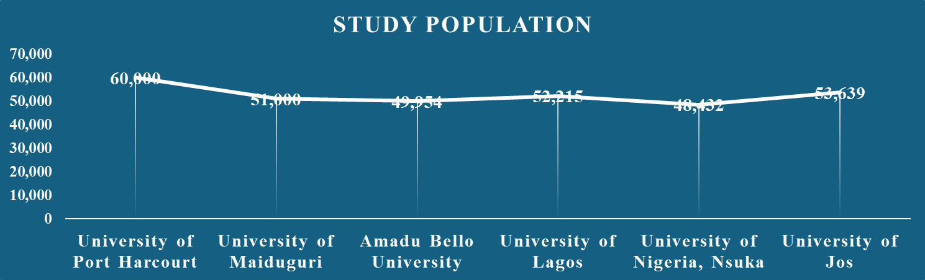
Source: Content Validity, Simeon, 2025
Figure 8.1

Study Sample
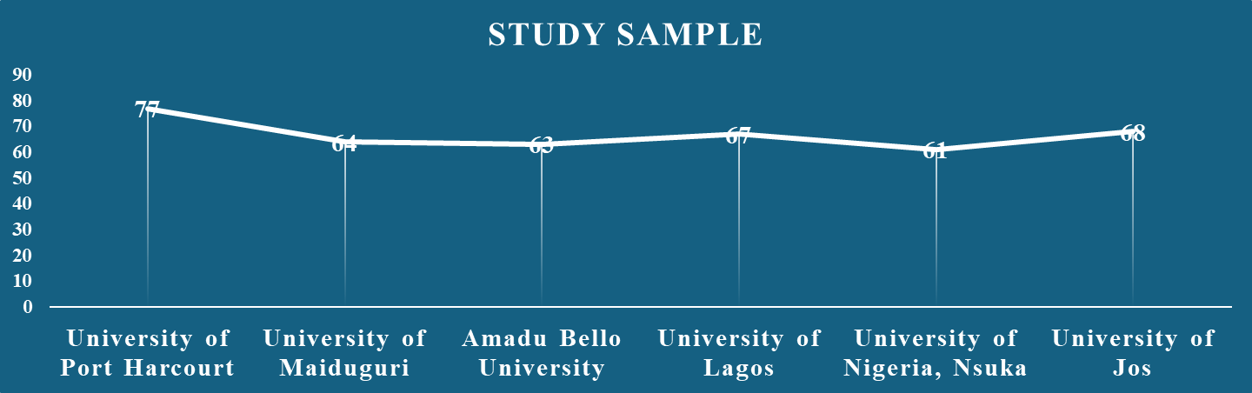

Source: Content Validity, Simeon, 2025
Figure 8.2

Study Population
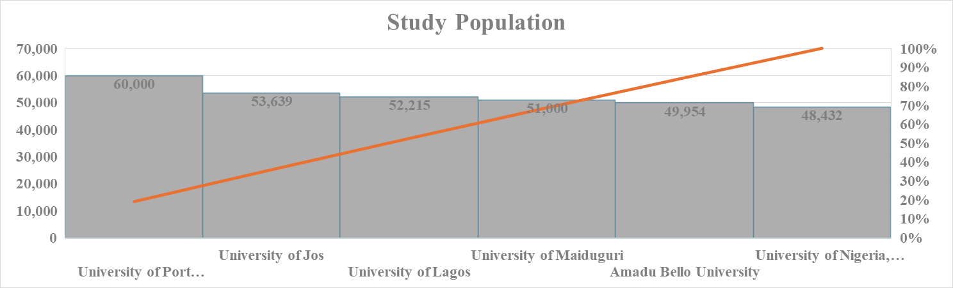
Source: Content Validity, Simeon, 2025
Figure 8.3

Study Sample
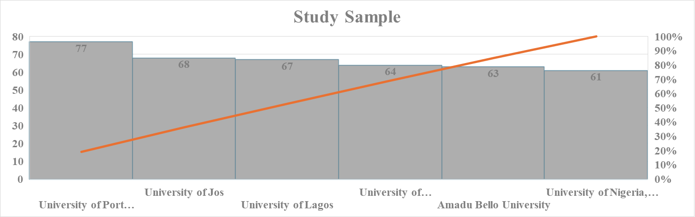
Source: Content Validity, Simeon, 2025
Figure 8.4

Table 9.1 Demography of the Research Respondents
 | Uniport | Unimaid | ABU | Unilag | UNN | Unijos | Total
B.Ed | 7 | 9 | 10 | 8 | 7 | 8 | 49
B.Sc. | 10 | 8 | 7 | 6 | 5 | 6 | 42
PGD | 17 | 14 | 15 | 15 | 14 | 15 | 90
MBA | 13 | 11 | 14 | 12 | 11 | 12 | 73
M.Sc. | 15 | 10 | 9 | 13 | 12 | 14 | 73
PhD | 15 | 12 | 8 | 13 | 12 | 13 | 73
Tpotal | 77 | 64 | 63 | 67 | 61 | 68 | 400

Source: Research Respondent Demography, (Simeon, 2025)

9.2 Research Respondents

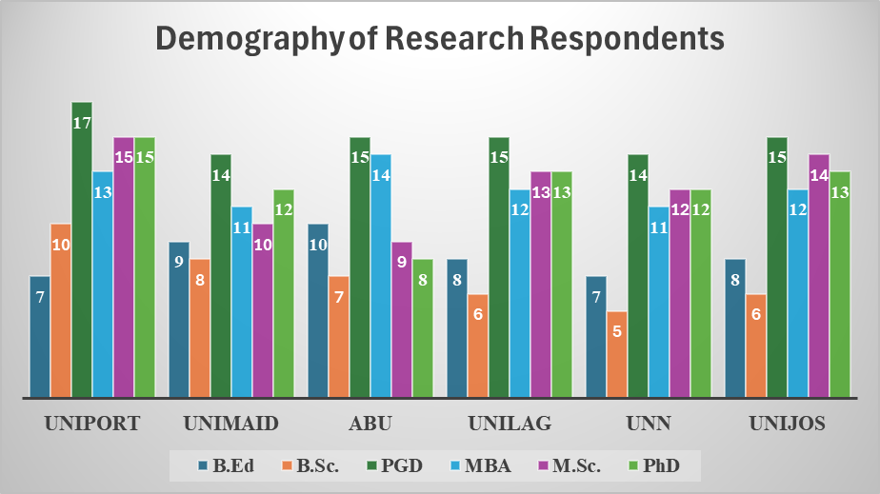

Source: Research-Based Education, (Simeon, 2025)

Figure 9.2

9.3 Uniport Demography

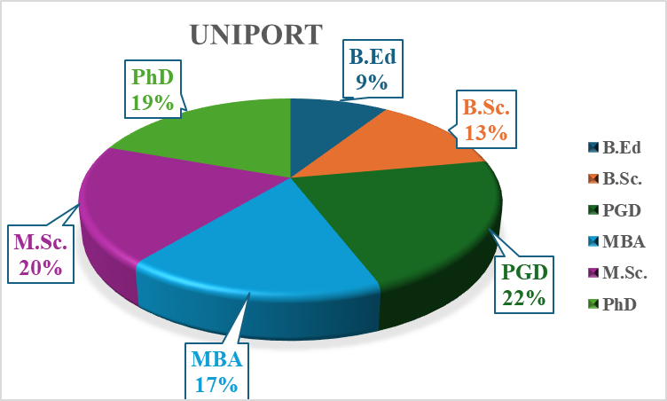

Source: Research-Based Education, (Simeon, 2025)

Figure 9.3

9.4 Unimaid Demography

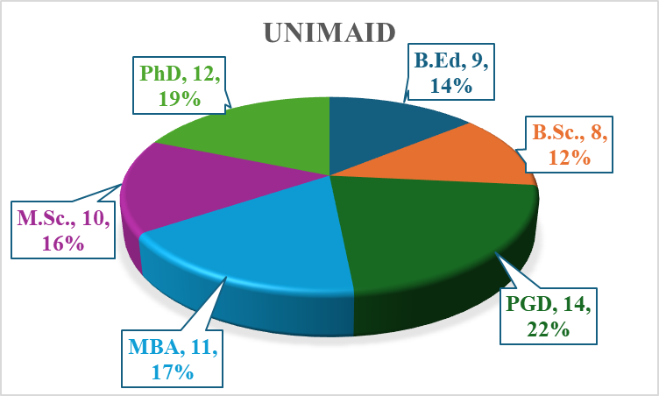

Source: Research-Based Education, (Simeon, 2025)

Figure 9.4

9.5 Unilag Demography

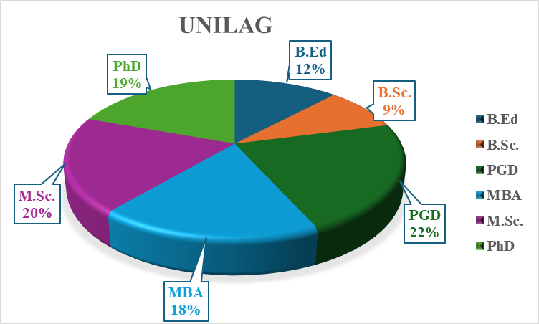

Source: Research-Based Education, (Simeon, 2025)

Figure 9.5

9.6 Unilag Demography

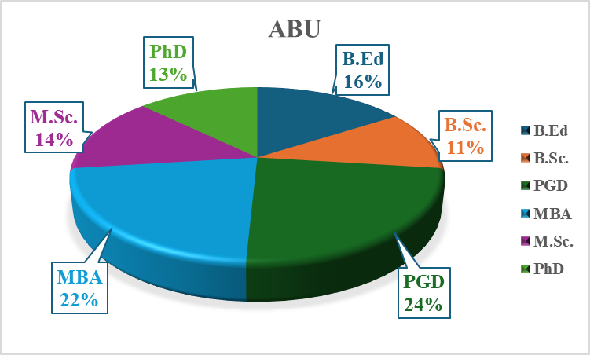

Source: Research-Based Education, (Simeon, 2025)

Figure 9.6

9.7 UNN Demography

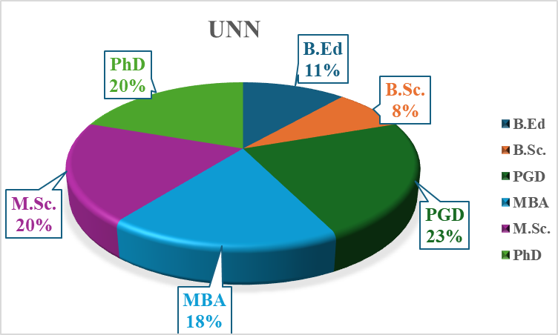

Source: Research-Based Education, (Simeon, 2025)

Figure 9.7

9.8 Unijos Demography

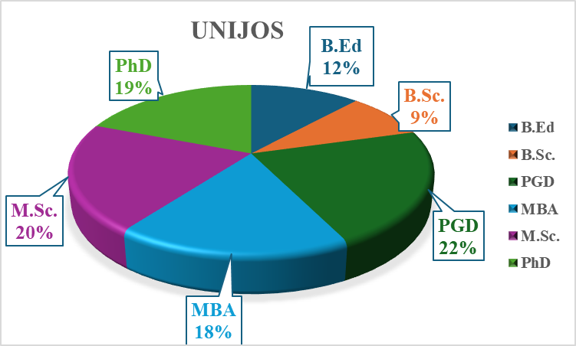

Source: Research-Based Education, (Simeon, 2025)

Figure 9.8

10. Assumption Tests

Assumption testing constitutes an important component of empirical research, providing evidence, though not definitive proof for the researcher’s claims. Without appropriate assumption tests, a scientific study lacks credibility and may be perceived as dogmatic or as merely projecting the researcher’s personal views onto others. According to Simeon (2022), the inclusion of assumption tests in scientific article functions as a validity check and serves as a prerequisite for conducting hypothesis testing on a regression line, particularly within correlational analyses. In this study, the reliability results, such as KMO of .768, Bartlett's test outcome of P-V < 0.01, Cronbach’s alpha values of .786 for total total items of further demonstrate the internal consistency of the measurement instruments. According to Simeon (2022), assumption testing is essential before performing factor analysis and before transforming study data into meaningful variables that adequately represent the constructs of interest.study population. He added that assumption testing is a pre-condition for the factor analysis of the study data and the 36 subsequent transformation of the data into variables. In assumption testing, as it relates to a correlational study, the dependent variable must meet certain criteria before the commencement of the correlation test between the variables. The clear display of this feat in a scientific work is a validity of the study, in itself. The whole essence of the Assumption tests is to increase the believeability of the reader, on account of the unbiased and scientific compliance in the whole process of the study

Table 10.1 Kaiser-Meyer-Olkin Measure of Sampling Adequacy and Bartlett's Test of Sphericity

KMO and Bartlett's Test
Kaiser-Meyer-Olkin Measure of Sampling Adequacy. |  | .768
Bartlett's Test of Sphericity | Approx. Chi-Square | 9606.171
Bartlett's Test of Sphericity | df | 630
Bartlett's Test of Sphericity | Sig. | .000
Source: Simeon (2025) test for KMO and Bartlett’s Test

The Kaiser-Meyer-Olkin and Maurice Stevenson Bartlett Tests have to be conducted, first before proper factor analysis can be carried out. Note that Kaiser-Meyer- Olkin (KMO) evaluates sampling adequacy by measuring the proportion of variance among the study variables that might be common variance. The closer it is to 1, the better. The KMO value (closer to 1) indicates that the data are suitable for factor analysis because the variables share enough common factors. Typically, a KMO value above 0.6 (60%) is considered acceptable, with values above 0.8 (80%) deemed excellent. Similarly, William Henry Golding Bartlett test is to ascertain whether the correlation matrix is significantly different from an identity matrix (which would indicate no correlations among variables). A significant Bartlett’s test of (p < 0.05) suggests that correlations between variables are sufficiently large for the Principal Factor Analysis (PFA) or Principal Component Analysis (PCA) and the supposed correlation matrix is assumed to be significantly different from identity matrix. In identity matrix, all diagonal elements are 1, that is perfect self-correlation and all off-diagonal elements are 0, that is no correlation between different variables.

In this study, the KMO is .786 (78.6%) and the Bartlett test result is P < .005, which indicate that data structure is suitable the extraction of variables. The Kaiser-Meyer-Olkin and Maurice Stevenson Bartlett Tests tests help to determine whether the data structure is suitable for factor extraction, ensuring that the factor analysis results will be meaningful and reliable. Bartlett’s test for Sphericity showed a statistically significant correlation matrix of Sphericity, signifying a multivariate normality in a set of distribution of the measures and the factorability of the correlation matrix – (Bartlett, 1954).

10.2 Scree Plot

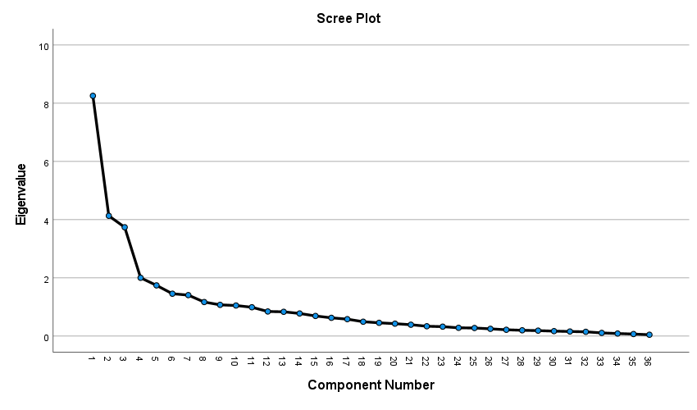

Source: Research-Based Education Scree Plot, (Simeon, 2025)
Figure 10.1
The scree plot is a graphical presentation of the factors (variables) within the study data extrapolated from the study instrument (Research Based Education) questionnaire retrieved from the study respondents for the general analysis of the study variables. The screes are the points on the graph showing the first ten screes that make up the 72.294% used for the analyses. There are seven ten factors on the graph representing the nine study variables.

Table 10.2 is a tabular presentation of the factors (variables) within the study data extrapolated from the study instrument (Research Based Education) questionnaire retrieved from the study respondents for the general analysis of the study variables. The screes translated to the numbering points on the table showing the first seven screes you saw on the scree plot, that make up the 72.294% used for the analyses. There are ten factors on the graph representing the nine study variables.

Table 10.3 Tabular Presentation the Total Variance in the Data Structure
Total Variance Explained
Component | Initial Eigenvalues |  |  | Extraction Sums of Squared Loadings
Component | Total | % of Variance | Cumulative % | Total | % of Variance | Cumulative %
1 | 8.255 | 22.930 | 22.930 | 8.255 | 22.930 | 22.930
2 | 4.132 | 11.477 | 34.408 | 4.132 | 11.477 | 34.408
3 | 3.739 | 10.387 | 44.794 | 3.739 | 10.387 | 44.794
4 | 2.002 | 5.562 | 50.356 | 2.002 | 5.562 | 50.356
5 | 1.742 | 4.839 | 55.196 | 1.742 | 4.839 | 55.196
6 | 1.455 | 4.043 | 59.238 | 1.455 | 4.043 | 59.238
7 | 1.407 | 3.909 | 63.147 | 1.407 | 3.909 | 63.147
8 | 1.170 | 3.249 | 66.396 | 1.170 | 3.249 | 66.396
9 | 1.073 | 2.981 | 69.377 | 1.073 | 2.981 | 69.377
10 | 1.050 | 2.918 | 72.294 | 1.050 | 2.918 | 72.294
11 | .990 | 2.750 | 75.045
12 | .845 | 2.347 | 77.392
13 | .834 | 2.317 | 79.709
14 | .777 | 2.158 | 81.867
15 | .691 | 1.920 | 83.787
16 | .627 | 1.742 | 85.530
17 | .581 | 1.615 | 87.144
18 | .493 | 1.371 | 88.515
19 | .456 | 1.266 | 89.781
20 | .426 | 1.184 | 90.965
21 | .390 | 1.084 | 92.049
22 | .338 | .939 | 92.988
23 | .324 | .899 | 93.887
24 | .284 | .789 | 94.676
25 | .278 | .771 | 95.447
26 | .249 | .692 | 96.139
27 | .217 | .602 | 96.740
28 | .199 | .552 | 97.292
29 | .187 | .520 | 97.813
30 | .170 | .473 | 98.286
31 | .158 | .438 | 98.724
32 | .147 | .408 | 99.131
33 | .109 | .302 | 99.433
34 | .088 | .244 | 99.677
35 | .070 | .194 | 99.871
36 | .046 | .129 | 100.000
Extraction Method: Principal Component Analysis.
Source: Principal Component Analysis, (Simeon, 2025)
10.4.1 Stationary Test for Research-Based Education (RBE), an Independent Variable

Source: Stationary Test for Research Variables, (Simeon, 2025)

Table 10.5 Test for Reliability of the Total 36 Item of the Study

Reliability Statistics
Cronbach's Alpha | Cronbach's Alpha Based on Standardized Items | N of Items
.786 | .792 | 36
Source: Simeon (2025) Test for Reliability of all 36 Study Item

Table 10.4.2 Stationary Test for Technological Advancement (TA), a Dependent Variable

Source: Stationary Test for Research Variables, (Simeon, 2025)

Table 10.6 Causality Test for the dependence of Advanced Technology (AT) on Research-Based Education (RBE)

Source: Causality Test Result for Independent and Dependent Variables, (Simeon, 2025)

Table 10.4.3 Stationary Test for Policy Implementation (PI), a Moderating Variable

Source: Stationary Test for Research Variables, (Simeon, 2025)
10.7 Cumulative Sum Test for Long Term Stability on Research-Based Education (RBE) and Technological Advancement (TA)
Figure 10.7 explains that the predictor variable, Research-Based Education (RBE) predicts the variation of the criterion variable, Technological Advancement (TA) by way of the blue line within the two red lines showing that RBE systematically and in stability with TA at 5% confidence interval, as represented by the two red lines. No variation by the TA in their relationship.

Tables 10.4.4 to 10.4.11 explain the non-stationarity of the study variables. In scientific research, carrying out a stationary or root test is not just a formality, it is a critical diagnostic step to ensure your results aren't "garbage.". The primary scientific reason is to avoid spurious regression, a situation where two variables appear to have a strong relationship only because they are both trending in the same direction over time, not because they actually influence each other. The tables under review show that the variables are not stationary.

Table 10.4.4 Stationary Test for Non-Policy Implementation, a Suppressor Variable

Source: Stationary Test for Research Variables, (Simeon, 2025)

10.4.5 Stationary Test for Nanotechnology (NAT), Measure for the Dependent Variable

Source: Stationary Test for Research Variables, (Simeon, 2025)
10.4.6 Stationary Test for Automation (AM), Measure for the Dependent Variable, Technological Advancement (TA)

Source: Stationary Test for Research Variables, (Simeon, 2025)

10.4.7 Stationary Test for Ontological Learning (OTL), Dimension for the Independent Variable, Research-Based Education (RBE)

Source: Stationary Test for Research Variables, (Simeon, 2025)
10.4.8 Stationary Test for Epistemological Learning (EPL), Dimension for the Independent Variable, Research-Based Education (RBE)

Source: Stationary Test for Research Variables, (Simeon, 2025)
10.4.9 Stationary Test for Methodological Learning (MTL), Dimension for the Independent Variable, Research-Based Education (RBE)

Source: Stationary Test for Research Variables, (Simeon, 2025)

10.4.10 Stationary Test for Anxiological Learning (AL), Dimension for the Independent Variable, Research-Based Education (RBE)

Source: Stationary Test for Research Variables, (Simeon, 2025)

10.4.11 Stationary Test for Practical Learning (PL), Dimension for the Independent Variable, Research-Based Education (RBE)

Source: Stationary Test for Research Variables, (Simeon, 2025)

Table 10.5 Test for Serial Correlation of the Study Variables
Source: Stationary Test for Research Variables, (Simeon, 2025)
Note: Computing serial correlation (Autocorrelation) is a scientific necessity because most statistical models assume that each piece of data is independent of the ones that came before it. In the real world, especially in fields like economics, finance, and climate science, this is rarely true. The scientific reason for this computation boils down to three core objectives: (1) Validating model assumptions (2) Ensuring the accuracy of predictions, and (3) Diagnosing model flaws. Serial correlation helps scientists determine if a pattern is a meaningful signal or just random noise. Positive Serial Correlation: If a value is high today, it is likely to be high tomorrow (stock prices or temperature). Negative Serial Correlation: If a value is high today, it is likely to be low tomorrow (a "rebound" effect). Identifying these patterns allows researchers to build more realistic simulations and forecasting models that reflect the "memory" of the data. The null hypothesis of serial correlation is that: There is no serial correlation in the residuals. This means that the error terms, after the model makes its prediction are independent of each other over time. In table 10.5, the p-value is 0.9323 (Greater than 0.05). so, there is a serial correlation among the variables.

11. Operational Framework Subsumed in Conceptual Framework
Default Variable Outcome Variable Mod Variable Supressor Variable
Non-Policy Implementation
Research-Based Education
Policy Implementation
Research-Based Education
Technological Advancement

Ontological Learning (OL)
Epistemological Learning (EL)
Methodological Learning (ML)
Axiological Learning (AL)
Practical Learning (PL)

Automation (AUT)

Policy Discontinuity (PI)

Policy Monitoring (PM)
Nanotechnology (NT)

Source: Researcher’s Operational Framework, 2025
The above operational framework has suggested the following hypotheses:
12. RESEARCH HYPOTHESES
H₀₁ - There is no significant relationship between Ontological Learning (OL) and Automation (AUT)
H₀₂ ₋ There is no significant relationship between Epistemological Learning (EL) and Automation (AUT)
H₀₃ ₋ There is no significant relationship between Methodological Learning (ML) and Automation (AUT)
H₀₄ ₋ There is no significant relationship between Axiological Learning (AL) and Automation (AUT)
H₀₅ ₋ There is no significant relationship between Practical Learning (PL) and Automation (AUT)
H₀₆ - There is no significant relationship between Ontological Learning (OL) and Nanotechnology (NT)
H₀₇ ₋ There is no significant relationship between Epistemological Learning (EL) and Nanotechnology (NT)
H₀₈ ₋ There is no significant relationship between Methodological Learning (ML) and Nanotechnology (NT)
H₀₉ ₋ There is no significant relationship between Axiological Learning (AL) and Nanotechnology (NT)
H₀₁₀ ₋ There is no significant relationship between Practical Learning (PL) and Nanotechnology (NT)
H₀₁₁ ₋ There is no positive impact of Research-Based Policy Implementation (RBPI) in the relationship between Research-Based Education and Technological Advancement (TA)
H₀₁₂ ₋ There is no negative impact of Non-Policy Implementation (NPI) in the relationship between Research-Based Education and Technological Advancement (TA)
12.1 Simple Hypotheses and Simple Regression on the Research Hypotheses

12.1.2 Hypotheses testing between Automation (AUT) and the Dimensions of Research-Based Learning, Ontological Learning (OL), Epistemological Learning (EL), Methodological Learning (ML), Axiological Learning (AL) and Practical Learning (PL)

12.1.3 Null Hypothesis - H01: There is no significant relationship between
Ontological Learning (OL) and Automation (AUT)
Table 12.1.3.1 Ontological Learning (OL) and Automation (AUT) Summary Table
Model Summary^{b}
Model | R | R Square | Adjusted R Square | Std. Error of the Estimate
1 | .943ª | .889 | .889 | 3.086
a. Predictors: (Constant), ONTOLOGICAL LEARNING (OL)
b. Dependent Variable: AUTOMATION (AUT)

Source: Researcher’s Summary Model Table, 2025) with SPSS Version 27 window
output
Table 12.1.3.2 Ontological Learning (OL) and Automation (AUT) ANOVA Table
ANOVAª
Model |  | Sum of Squares | df | Mean Square | F | Sig.
1 | Regression | 30220.430 | 1 | 30220.430 | 3173.126 | .000^{b}
1 | Residual | 3761.928 | 395 | 9.524
1 | Total | 33982.358 | 396
a. Dependent Variable: AUTOMATION (AUT)
b. Predictors: (Constant), ONTOLOGICAL LEARNING (OL)

Source: Researcher’s ANOVA Table, 2025) with SPSS Version 27 window
Output

Table 12.1.3.3 Ontological Learning (OL) and Automation (AUT) Coefficient Table

Coefficientsª
Model |  | Unstandardized Coefficients |  | Standardized Coefficients | t | Sig.
 |  | B | Std. Error | Beta | t | Sig.
1 | (Constant) | 4.512 | .442 |  | 10.206 | .000
1 | ONTOLOGICAL LEARNING (OL) | .292 | .005 | .943 | 56.331 | .000
a. Dependent Variable: AUTOMATION (AUT)

Source: Researcher’s Coefficient Table, 2025) with SPSS Version 27 window
Output

12.2.1 Null Hypothesis - H02: There is no significant relationship between
Epistemological Learning (EL) and Automation (AUT)

Table 12.2.1 Epistemological Learning (EL) and Automation (AUT) Summary Table

Model Summary^{b}
Model | R | R Square | Adjusted R Square | Std. Error of the Estimate
1 | .904ª | .817 | .817 | 3.968
a. Predictors: (Constant), EPISTEMOLOGICAL LEARNING (EL)
b. Dependent Variable: AUTOMATION (AUT)

Source: Researcher’s Summary Model Table, 2025) with SPSS Version 27 window
output
Table 12.2.2 Epistemological Learning (EL) and Automation (AUT) ANOVA Table

ANOVAª
Model |  | Sum of Squares | df | Mean Square | F | Sig.
1 | Regression | 27763.453 | 1 | 27763.453 | 1763.424 | .000^{b}
1 | Residual | 6218.905 | 395 | 15.744
1 | Total | 33982.358 | 396
a. Dependent Variable: AUTOMATION (AUT)
b. Predictors: (Constant), EPISTEMOLOGICAL LEARNING (EL)
Source: Researcher’s ANOVA Table, 2025) with SPSS Version 27 window
Output

Table 12.2.3 Epistemological Learning (EL) and Automation (AUT) Coefficient Table

Coefficientsª
Model |  | Unstandardized Coefficients |  | Standardized Coefficients | t | Sig.
 |  | B | Std. Error | Beta | t | Sig.
1 | (Constant) | 7.492 | .524 |  | 14.303 | .000
1 | EPISTEMOLOGICAL LEARNING (EL) | .737 | .018 | .904 | 41.993 | .000
a. Dependent Variable: AUTOMATION (AUT)
Source: Researcher’s Coefficient Table, 2025) with SPSS Version 27 window
Output

12.3.1 H₀₃ ₋ There is no significant relationship between Methodological Learning (ML) and Automation (AUT)

Table 12.3.1 Methodological Learning (ML) and Automation (AUT) Summary Table
Model Summary
Model | R | R Square | Adjusted R Square | Std. Error of the Estimate
1 | .927ª | .859 | .858 | 3.486
a. Predictors: (Constant), METHODOLOGICAL LEARNING (ML)

Source: Researcher’s Summary Model Table, 2025) with SPSS Version 27 window
Output
Table 12.3.2 Methodological Learning (ML) and Automation (AUT) ANOVA Table

ANOVAª
Model |  | Sum of Squares | df | Mean Square | F | Sig.
1 | Regression | 29182.930 | 1 | 29182.930 | 2401.798 | .000^{b}
1 | Residual | 4799.428 | 395 | 12.150
1 | Total | 33982.358 | 396
a. Dependent Variable: AUTOMATION (AUT)
b. Predictors: (Constant), METHODOLOGICAL LEARNING (ML)

Source: Researcher’s ANOVA Table, 2025) with SPSS Version 27 window
Output

Table 12.3.3 Methodological Learning (ML) and Automation (AUT) Coefficient Table

Coefficientsª
Model |  | Unstandardized Coefficients |  | Standardized Coefficients | t | Sig.
 |  | B | Std. Error | Beta | t | Sig.
1 | (Constant) | 4.340 | .510 |  | 8.505 | .000
1 | METHODOLOGICAL LEARNING (ML) | .601 | .012 | .927 | 49.008 | .000
a. Dependent Variable: AUTOMATION (AUT)

Source: Researcher’s Coefficient Table, 2025) with SPSS Version 27 window
Output

12.4.1 H₀₄ ₋ There is no significant relationship between Axiological Learning (AL) and Automation (AUT)

Table 12.4.1 Methodological Learning (ML) and Automation (AUT) Summary Table

Model Summary
Model | R | R Square | Adjusted R Square | Std. Error of the Estimate
1 | .943ª | .889 | .889 | 3.084
a. Predictors: (Constant), ANXIOLOGICAL LEARNING (AL)
Source: Researcher’s Summary Model Table, 2025) with SPSS Version 27 window
Output

Table 12.4.2 Axiological Learning (AL) and Automation (AUT) ANOVA Table

ANOVAª
Model |  | Sum of Squares | df | Mean Square | F | Sig.
1 | Regression | 30224.878 | 1 | 30224.878 | 3177.350 | .000^{b}
1 | Residual | 3757.479 | 395 | 9.513
1 | Total | 33982.358 | 396
a. Dependent Variable: AUTOMATION (AUT)
b. Predictors: (Constant), ANXIOLOGICAL LEARNING (AL)
Source: Researcher’s ANOVA Table, 2025) with SPSS Version 27 window
Output

Table 12.4.3 Axiological Learning (AL) and Automation (AUT) Coefficient Table

Coefficientsª
Model |  | Unstandardized Coefficients |  | Standardized Coefficients | t | Sig.
 |  | B | Std. Error | Beta | t | Sig.
1 | (Constant) | 4.873 | .436 |  | 11.183 | .000
1 | ANXIOLOGICAL LEARNING (AL) | .566 | .010 | .943 | 56.368 | .000
a. Dependent Variable: AUTOMATION (AUT)
Source: Researcher’s Coefficient Table, 2025) with SPSS Version 27 window
Output

12.5.1 H₀₅ ₋ There is no significant relationship between Practical Learning (PL) and Automation (AUT)
Table 12.5.1 Practical Learning (PL) and Automation (AUT) Summary Table

Model Summary
Model | R | R Square | Adjusted R Square | Std. Error of the Estimate
1 | .932ª | .869 | .869 | 3.352
a. Predictors: (Constant), PRACTICAL LEARNING (pl)

Source: Researcher’s Summary Model Table, 2025) with SPSS Version 27 window
Output

Table 12.5.2 Practical Learning (PL) and Automation (AUT) ANOVA Table

ANOVAª
Model |  | Sum of Squares | df | Mean Square | F | Sig.
1 | Regression | 29543.408 | 1 | 29543.408 | 2628.921 | .000^{b}
1 | Residual | 4438.950 | 395 | 11.238
1 | Total | 33982.358 | 396
a. Dependent Variable: AUTOMATION (AUT)
b. Predictors: (Constant), PRACTICAL LEARNING (pl)
Source: Researcher’s ANOVA Table, 2025) with SPSS Version 27 window
Output

Table 12.5.3 Practical Learning (PL) and Automation (AUT) Coefficient Table

Coefficientsª
Model |  | Unstandardized Coefficients |  | Standardized Coefficients | t | Sig.
 |  | B | Std. Error | Beta | t | Sig.
1 | (Constant) | 4.984 | .476 |  | 10.463 | .000
1 | PRACTICAL LEARNING (pl) | .343 | .007 | .932 | 51.273 | .000
a. Dependent Variable: AUTOMATION (AUT)
Source: Researcher’s Coefficient Table, 2025) with SPSS Version 27 window
Output

12.6.1 H₀₆ - There is no significant relationship between Ontological Learning (OL) and Nanotechnology (NT)

Table 12.6.1 Ontological Learning (OL) and Nanotechnology (NT) Summary Table

Model Summary
Model | R | R Square | Adjusted R Square | Std. Error of the Estimate
1 | .891ª | .793 | .793 | 3.444
a. Predictors: (Constant), ONTOLOGICAL LEARNING (OL)
Source: Researcher’s Summary Model Table, 2025) with SPSS Version 27 window
Output

Table 12.6.2 Ontological Learning (OL) and Nanotechnology (NT) ANOVA Table

ANOVAª
Model |  | Sum of Squares | df | Mean Square | F | Sig.
1 | Regression | 17957.991 | 1 | 17957.991 | 1514.162 | .000^{b}
1 | Residual | 4684.709 | 395 | 11.860
1 | Total | 22642.700 | 396
a. Dependent Variable: NANTECHNOLOGY (NT)
b. Predictors: (Constant), ONTOLOGICAL LEARNING (OL)
Source: Researcher’s ANOVA Table, 2025) with SPSS Version 27 window
Output

Table 12.6.3 Ontological Learning (OL) and Nanotechnology (NT) Coefficient Table

Coefficientsª
Model |  | Unstandardized Coefficients |  | Standardized Coefficients | t | Sig.
 |  | B | Std. Error | Beta | t | Sig.
1 | (Constant) | -1.587 | .493 |  | -3.217 | .001
1 | ONTOLOGICAL LEARNING (OL) | .225 | .006 | .891 | 38.912 | .000
a. Dependent Variable: NANTECHNOLOGY (NT)
Source: Researcher’s Coefficient Table, 2025) with SPSS Version 27 window
Output

12.7.1 H₀₇ ₋ There is no significant relationship between Epistemological Learning (EL) and Nanotechnology (NT)
Table 12.7.1 Epistemological Learning (EL) and Nanotechnology (NT) Summary Table

Model Summary
Model | R | R Square | Adjusted R Square | Std. Error of the Estimate
1 | .903ª | .815 | .815 | 3.256
a. Predictors: (Constant), EPISTEMOLOGICAL LEARNING (EL)
Source: Researcher’s Summary Model Table, 2025) with SPSS Version 27 window
Output

Table 12.7.2 Epistemological Learning (EL) and Nanotechnology (NT) ANOVA Table

ANOVAª
Model |  | Sum of Squares | df | Mean Square | F | Sig.
1 | Regression | 18455.102 | 1 | 18455.102 | 1740.799 | .000^{b}
1 | Residual | 4187.598 | 395 | 10.602
1 | Total | 22642.700 | 396
a. Dependent Variable: NANTECHNOLOGY (NT)
b. Predictors: (Constant), EPISTEMOLOGICAL LEARNING (EL)
Source: Researcher’s ANOVA Table, 2025) with SPSS Version 27 window
Output

Table 12.7.3 Epistemological Learning (EL) and Nanotechnology (NT) Coefficient Table

Coefficientsª
Model |  | Unstandardized Coefficients |  | Standardized Coefficients | t | Sig.
 |  | B | Std. Error | Beta | t | Sig.
1 | (Constant) | -.194 | .430 |  | -.451 | .652
1 | EPISTEMOLOGICAL LEARNING (EL) | .601 | .014 | .903 | 41.723 | .000
a. Dependent Variable: NANTECHNOLOGY (NT)
Source: Researcher’s Coefficient Table, 2025) with SPSS Version 27 window
Output

12.8.1 H₀₈ ₋ There is no significant relationship between Methodological Learning (ML) and Nanotechnology (NT)

Table 12.8.1 Methodological Learning (ML) and Nanotechnology (NT) Summary Table

Model Summary
Model | R | R Square | Adjusted R Square | Std. Error of the Estimate
1 | .861ª | .742 | .741 | 3.845
a. Predictors: (Constant), METHODOLOGICAL LEARNING (ML)
Source: Researcher’s Summary Model Table, 2025) with SPSS Version 27 window
Output

Table 12.8.2 Methodological Learning (ML) and Nanotechnology (NT) ANOVA Table

ANOVAª
Model |  | Sum of Squares | df | Mean Square | F | Sig.
1 | Regression | 16803.652 | 1 | 16803.652 | 1136.734 | .000^{b}
1 | Residual | 5839.048 | 395 | 14.782
1 | Total | 22642.700 | 396
a. Dependent Variable: NANTECHNOLOGY (NT)
b. Predictors: (Constant), METHODOLOGICAL LEARNING (ML)

Source: Researcher’s ANOVA Table, 2025) with SPSS Version 27 window
Output

Table 12.8.3 Methodological Learning (ML) and Nanotechnology (NT) Coefficient Table

Coefficientsª
Model |  | Unstandardized Coefficients |  | Standardized Coefficients | t | Sig.
 |  | B | Std. Error | Beta | t | Sig.
1 | (Constant) | -1.436 | .563 |  | -2.551 | .011
1 | METHODOLOGICAL LEARNING (ML) | .456 | .014 | .861 | 33.715 | .000
a. Dependent Variable: NANTECHNOLOGY (NT)

Source: Researcher’s Coefficient Table, 2025) with SPSS Version 27 window
Output

12.9.1 H₀₉ ₋ There is no significant relationship between Axiological Learning (AL) and Nanotechnology (NT)

Table 12.9.1 Axiological Learning (AL) and Nanotechnology (NT) Summary Table

Model Summary
Model | R | R Square | Adjusted R Square | Std. Error of the Estimate
1 | .887ª | .786 | .785 | 3.503
a. Predictors: (Constant), ANXIOLOGICAL LEARNING (AL)

Source: Researcher’s Summary Model Table, 2025) with SPSS Version 27 window Output

Table 12.9.2 Axiological Learning (AL) and Nanotechnology (NT) ANOVA Table

ANOVAª
Model |  | Sum of Squares | df | Mean Square | F | Sig.
1 | Regression | 17795.398 | 1 | 17795.398 | 1450.122 | .000^{b}
1 | Residual | 4847.303 | 395 | 12.272
1 | Total | 22642.700 | 396
a. Dependent Variable: NANTECHNOLOGY (NT)
b. Predictors: (Constant), ANXIOLOGICAL LEARNING (AL)

Source: Researcher’s ANOVA Table, 2025) with SPSS Version 27 window
Output

Table 12.9.3 Axiological Learning (AL) and Nanotechnology (NT) Coefficient Table

Coefficientsª
Model |  | Unstandardized Coefficients |  | Standardized Coefficients | t | Sig.
 |  | B | Std. Error | Beta | t | Sig.
1 | (Constant) | -1.227 | .495 |  | -2.478 | .014
1 | ANXIOLOGICAL LEARNING (AL) | .434 | .011 | .887 | 38.080 | .000
a. Dependent Variable: NANTECHNOLOGY (NT)

Source: Researcher’s ANOVA Table, 2025) with SPSS Version 27 window Output

12.12.1 H₀₁₀ ₋ There is no significant relationship between Practical Learning (PL) and Nanotechnology (NT)

Table 12.9.1 Practical Learning (PL) and Nanotechnology (NT) Summary Table

Model Summary
Model | R | R Square | Adjusted R Square | Std. Error of the Estimate
1 | .895ª | .801 | .800 | 3.378
a. Predictors: (Constant), PRACTICAL LEARNING (pl)
Source: Researcher’s Summary Model Table, 2025) with SPSS Version 27 window
Output

Table 12.9.2 Practical Learning (PL) and Nanotechnology (NT) ANOVA Table

ANOVAª
Model |  | Sum of Squares | df | Mean Square | F | Sig.
1 | Regression | 18136.207 | 1 | 18136.207 | 1589.662 | .000^{b}
1 | Residual | 4506.493 | 395 | 11.409
1 | Total | 22642.700 | 396
a. Dependent Variable: NANTECHNOLOGY (NT)
b. Predictors: (Constant), PRACTICAL LEARNING (pl)
Source: Researcher’s ANOVA Table, 2025) with SPSS Version 27 window
Output

Table 12.9.3 Practical Learning (PL) and Nanotechnology (NT) Coefficient Table

Coefficientsª
Model |  | Unstandardized Coefficients |  | Standardized Coefficients | t | Sig.
 |  | B | Std. Error | Beta | t | Sig.
1 | (Constant) | -1.512 | .480 |  | -3.149 | .002
1 | PRACTICAL LEARNING (pl) | .269 | .007 | .895 | 39.871 | .000
a. Dependent Variable: NANTECHNOLOGY (NT)

Source: Researcher’s Coefficient Table, 2025) with SPSS Version 27 window
Output

12.11.1 H₀₁₁ ₋ There is no positive impact of Research-Based Policy Implementation (RBPI) in the relationship between Research-Based Education (RBE) and Technological Advancement (TA)

12.11.2 Null Hypotheses - H₀₁₁: There is no positive impact of Research-Based Policy Implementation (RBPI) in the relationship between Research-Based Education (RBE) and Technological Advancement (TA)

Table 12.11.1 Research-Based Education (RBE), Technological Advancement (TA)
and Research-Based Policy Implementation (RBPI) Partial Correlation and Zero Order Correlation Descriptive Statistics

Descriptive Statistics
 | Mean | Std. Deviation | N
Research-Based Education (RBE) | 40.82 | 15.792 | 397
Technological Advancement (TA) | 13.65 | 7.005 | 397
RESEARCH-BASED POLICY IMPLEMENTATION (RBPI) | 26.00 | 10.135 | 397
Source: Researcher’s Descriptive Zero Order and Partial Correlation output window with SPSS Version 27 window output, 2025

Table 12.11.2 Research-Based Education (RBE), Technological Advancement (TA)
and Research-Based Policy Implementation (RBPI) Partial Correlation and Zero Order Correlation

Correlations
Control Variables |  |  | Research-Based Education (RBE) | Technological Advanacement (TA) | RESEARCH-BASED POLICY IMPLEMENTATION (RBPI)
-none-ª | Research-Based Education (RBE) | Correlation | 1.000 | .868 | .878
-none-ª | Research-Based Education (RBE) | Significance (2-tailed) | . | .000 | .000
-none-ª | Research-Based Education (RBE) | df | 0 | 395 | 395
-none-ª | Technological Advancement (TA) | Correlation | .868 | 1.000 | .613
-none-ª | Technological Advancement (TA) | Significance (2-tailed) | .000 | . | .000
-none-ª | Technological Advancement (TA) | df | 395 | 0 | 395
-none-ª | RESEARCH-BASED POLICY IMPLEMENTATION (RBPI) | Correlation | .878 | .613 | 1.000
-none-ª | RESEARCH-BASED POLICY IMPLEMENTATION (RBPI) | Significance (2-tailed) | .000 | .000 | .
-none-ª | RESEARCH-BASED POLICY IMPLEMENTATION (RBPI) | df | 395 | 395 | 0
RESEARCH-BASED POLICY IMPLEMENTATION (RBPI) | Research-Based Education (RBE) | Correlation | 1.000 | .872
RESEARCH-BASED POLICY IMPLEMENTATION (RBPI) | Research-Based Education (RBE) | Significance (2-tailed) | . | .000
RESEARCH-BASED POLICY IMPLEMENTATION (RBPI) | Research-Based Education (RBE) | df | 0 | 394
RESEARCH-BASED POLICY IMPLEMENTATION (RBPI) | Technological Advancement (TA) | Correlation | .872 | 1.000
RESEARCH-BASED POLICY IMPLEMENTATION (RBPI) | Technological Advancement (TA) | Significance (2-tailed) | .000 | .
RESEARCH-BASED POLICY IMPLEMENTATION (RBPI) | Technological Advancement (TA) | df | 394 | 0
a. Cells contain zero-order (Pearson) correlations.
Source: Researcher’s Zero Order and Partial Correlation output window with SPSS Version 27 window output, 2025

12.12.1 H₀₁₂ ₋ There is no negative impact of Non-Policy Implementation (NPI) in the relationship between Research-Based Education and Technological Advancement (TA)
12.12.2 Null Hypotheses - H₀₁₂: There is no negative impact of Non-Policy Implementation (NPI) in the relationship between Research-Based Education (RBE) and Technological Advancement (TA)

Table 12.12.1 Research-Based Education (RBE), Technological Advancement (TA)
and Non-Policy Implementation (NPI) Partial Correlation and Zero Order Correlation Descriptive Statistics
Descriptive Statistics
 | Mean | Std. Deviation | N
Research-Based Education (RBE) | 40.82 | 15.792 | 397
Technological Advancement (TA) | 13.65 | 7.005 | 397
NON-POLICY IMPLEMENTATION (NPI) | 36.01 | 14.738 | 397

Source: Researcher’s Descriptive Zero Order and Partial Correlation output window with SPSS Version 27 window output, 2025

Table 12.12.2 Research-Based Education (RBE), Technological Advancement (TA)
and Non-Policy Implementation (NPI) Partial Correlation and Zero Order Correlation

Correlations
Control Variables |  |  | Research-Based Education (RBE) | Technological Advancement (TA) | NON-POLICY IMPLEMENTATION (NPI)
-none-ª | Research-Based Education (RBE) | Correlation | 1.000 | .868 | .969
-none-ª | Research-Based Education (RBE) | Significance (2-tailed) | . | .000 | .000
-none-ª | Research-Based Education (RBE) | df | 0 | 395 | 395
-none-ª | Technological Advancement (TA) | Correlation | .868 | 1.000 | .895
-none-ª | Technological Advancement (TA) | Significance (2-tailed) | .000 | . | .000
-none-ª | Technological Advancement (TA) | df | 395 | 0 | 395
-none-ª | NON-POLICY IMPLEMENTATION (NPI) | Correlation | .969 | .895 | 1.000
-none-ª | NON-POLICY IMPLEMENTATION (NPI) | Significance (2-tailed) | .000 | .000 | .
-none-ª | NON-POLICY IMPLEMENTATION (NPI) | df | 395 | 395 | 0
NON-POLICY IMPLEMENTATION (NPI) | Research-Based Education (RBE) | Correlation | 1.000 | .004
NON-POLICY IMPLEMENTATION (NPI) | Research-Based Education (RBE) | Significance (2-tailed) | . | .940
NON-POLICY IMPLEMENTATION (NPI) | Research-Based Education (RBE) | df | 0 | 394
NON-POLICY IMPLEMENTATION (NPI) | Technological Advancement (TA) | Correlation | .004 | 1.000
NON-POLICY IMPLEMENTATION (NPI) | Technological Advancement (TA) | Significance (2-tailed) | .940 | .
NON-POLICY IMPLEMENTATION (NPI) | Technological Advancement (TA) | df | 394 | 0
a. Cells contain zero-order (Pearson) correlations.
Source: Researcher’s Zero Order and Partial Correlation output window with SPSS Version 27 window output, 2025

Findings from the Regression Analyses Tests of Hypotheses Ho₁ to Ho₁₂ in Tables 12.1.3.1 to 12.12.2
Source: Researcher’s Interpretation of Findings from Regression Analyses, 2025
Hypothesis | R Square | F-Ratio | B | Beta | T-Ratio | P-Value
Ho₁ | .889 | 3173.126 | 4.512/.292 | .943 | 10.206/56.331 | < .001
Ho₂ | .817 | 1763.424 | 7.492/.737 | .904 | 14.303/41.993 | < .001
Ho₃ | .589 | 2401.798 | 4.340/.610 | .927 | 8.505/49.008 | < .001
Ho₄ | .943 | 3177.300 | 4.873/.566 | .943 | 11.183/56.368 | < .001
Ho₅ | .932 | 2628.921 | 4.984/.343 | .932 | 10.463/51.273 | < .001
Ho₆ | .793 | 1514.162 | -.587/.225 | .891 | -3.217/38.812 | < .001
Ho₇ | .815 | 1740.799 | -.194/.601 | .903 | -451/41.723 | < .001
Ho₈ | .742 | 1136.734 | -.436/.456 | .861 | -2.551/33.715 | < .001
Ho₉ | .786 | 1450.122 | -1.227/.434 | .887 | -2.478/38.080 | < .001
Ho₁₀ | .801 | 1589.662 | -1.512 | .897 | -1.512/.269 | < .001
Research-Based Education (RBE), Technological Advancement (TA) and Research-Based Policy Implementation (RBPI) Partial Correlation and Zero Order Correlation and Descriptive Statistics

Ho₁₁ | Zero Order Correlation | Std Deviation | Total Item | Mean | Patial Correlation
RBE | .868 | 15.792 | 397 | 40.82 | .872 | <.001
TA | .868 | 7.005 | 397 | 13.65 | .872 | < .001
RBPI | .868 | 10.135 | 397 | 21.00 | .872 | < .001
Ho₁₂
RBE | .868 | 15.792 | 397 | 40.82 | .872 | <.001
TA | .868 | 7.005 | 397 | 13.65 | .872 | < .001
NPI | .868 | 14.735 | 397 | 36.01 | .004 | < .001

- Summary of Findings
S/n | Findings
1 | There is a statistically significant relationship between Ontological Learning (OL) and Automation (AUT)
2 | There is a statistically significant relationship between Epistemological Learning (EL) and Automation (AUT)
3 | There is a statistically significant relationship between Methodological Learning (ML) and Automation (AUT)
4 | There is a statistically significant relationship between Axiological Learning (AL) and Automation (AUT)
5 | There is a statistically significant relationship between Practical Learning (PL) and Automation (AUT)
6 | There is a statistically significant relationship between Ontological Learning (OL) and Nanotechnology (NT)
7 | There is a statistically significant relationship between Epistemological Learning (EL) and Nanotechnology (NT)
8 | There is a statistically significant relationship between Methodological Learning (ML) and Nanotechnology (NT)
9 | There is a statistically significant relationship between Axiological Learning (AL) and Nanotechnology (NT)
10 | There is a statistically significant relationship between Practical Learning (PL) and Nanotechnology (NT)
11 | There is a Significant Positive Influence of Research-Based Policy Implementation (RBPI) in the relationship between Research-Based Education (RBE) and Technological Advancement (TA)
12 | There is a Significant Negative Influence of Non-Policy Implementation (NPI) in the relationship between Research-Based Education (RBE)and Technological Advancement (TA)
Source: Researcher’s Summary of Findings Table, 2025
- Brief Discussion of the Study/Findings
The literature review situates African education within a historical trajectory shaped by colonial legacies. The study emphasizes that colonial education was designed for control, privileging rote memorization and obedience over inquiry, creativity, and problem-solving. This pedagogical inheritance, according to the study, has hindered Africa’s technological and industrial growth.
Learner-Centered vs. Teacher-Centered Approaches: The review highlights the need to shift from teacher-centered rote learning to learner-centered methods such as inquiry, project-based learning, and collaborative problem-solving. These approaches align with global best practices in research-based education, fostering innovation and adaptability.
Historical Precedents in Africa: The text underscores that Africa had thriving centers of learning (e.g., Al-Qarawiyyin, Al-Azhar, Sankoré) long before European universities, challenging the narrative of European educational supremacy.
Philosophical Foundations: Education is framed as “educere”, which to lead out inherent potentials, requiring research and discovery. This resonates with constructivist theories that stress active engagement and contextual learning.
In sum, the literature review argues that Africa’s educational quandary is not due to lack of Africans’ intellectual heritage but due to the persistence of colonial-era pedagogical models. Research-based education is presented as the corrective path toward technological advancement.

From the Regression Analysis Outcomes: The empirical findings strongly support the theoretical claims. Regression analyses reveal statistically significant relationships between all five dimensions of research-based learning and measures of technological advancement (automation and nanotechnology) in the following ways:
Ontological Learning (OL): Explains 88.9% of the variance in automation outcomes (R² = .889), showing that foundational understanding of existence and reality is critical for technological systems.
Epistemological Learning (EL): Accounts for 81.7% of automation variance and 81.5% of nanotechnology variance, highlighting the importance of knowledge structures in driving innovation.
Methodological Learning (ML): Explains 85.9% of automation variance and 74.2% of nanotechnology variance, confirming that systematic approaches to inquiry are essential for applied technology.
Axiological Learning (AL): Shows strong predictive power (R² = .889 for automation; R² = .786 for nanotechnology), suggesting that values and ethics underpin sustainable technological progress.
Practical Learning (PL): Explains 86.9% of automation variance and 80.1% of nanotechnology variance, reinforcing the role of hands-on, experiential learning in technological development.
Additionally: Policy Implementation (RBPI) has a positive moderating effect, strengthening the relationship between research-based education and technological advancement.
Non-Policy Implementation (NPI) exerts a negative suppressor effect, weakening this relationship.
Integrated Discussion: The findings of these analyses reinforce long-standing critiques of Africa’s colonial educational inheritance. The literature review highlighted that colonial education was designed to produce obedient clerks and catechists rather than innovators, privileging rote memorization over inquiry and creativity (Rodney, 1972; Ngũgĩ wa Thiong’o, 1986). This pedagogical model, still prevalent in many African institutions, has hindered technological progress by failing to cultivate critical thinking and problem-solving skills (Ausubel, 1968).
The regression analyses provide empirical validation of these claims. Each dimension of research-based education, be it ontological, epistemological, methodological, axiological, and practical learning was found to significantly predict technological advancement, particularly in automation and nanotechnology. For instance, methodological learning explained 85.9% of automation variance, while practical learning accounted for 80.1% of nanotechnology variance. These results suggest that technological innovation is not merely a function of material investment but is deeply tied to the epistemic and pedagogical foundations of education.
Policy implementation emerged as a decisive moderating factor. Research-Based Policy Implementation (RBPI) strengthened the positive relationship between education and technology, while Non-Policy Implementation (NPI) weakened it. This finding underscores the necessity of institutional and governmental support for research-based pedagogy. Without such frameworks, even strong educational practices risk being undermined by systemic inertia.
Taken together, the literature and empirical evidence converge on a central thesis: Africa’s technological future depends on abandoning rote learning and embracing research-based, learner-centered education supported by policy frameworks. This aligns with global calls for discovery-driven learning (Boyer Commission, 1998) and resonates with Africa’s own historical traditions of inquiry and innovation, as seen in precolonial universities such as Al-Qarawiyyin and Sankoré (Fatima, 2009).

Implications: For Theory: The study extends constructivist and learner-centered theories by empirically linking them to technological advancement outcomes.
For Practice: Universities should embed research-based learning across curricula, emphasizing inquiry, collaboration, and practical application.
For Policy: Governments must enact supportive policies to institutionalize research-based education, ensuring sustainability and scalability.
- Conclusion
This study has established that research-based education is a fundamental catalyst for technological advancement in Nigeria and across Africa. By empirically demonstrating significant relationships between the five dimensions of research-based learning, which included Ontological, Epistemological, Methodological, Axiological, and Practical, and measures of technological progress such as Automation and Nanotechnology. The findings confirm that inquiry-driven, learner-centered pedagogy is indispensable for innovation. Policy implementation emerged as a critical moderating factor, strengthening these relationships, while non-policy implementation weakened them, highlighting the decisive role of institutional frameworks in sustaining educational reform.
The broader implication is that Africa’s technological stagnation stems not from a lack of intellectual heritage but from the persistence of colonial-era rote learning models that suppress creativity and problem-solving. By embracing research-based education, African nations can reclaim their historical traditions of inquiry and innovation, positioning themselves as leaders in global technological development.
This conclusion resonates with international development agendas. The United Nations Sustainable Development Goals (SDG 4: Quality Education and SDG 9: Industry, Innovation, and Infrastructure) emphasize the need for inclusive, equitable, and innovation-driven education systems. Similarly, the African Union’s Agenda 2063 envisions “an Africa whose development is people-driven, relying on the potential of African people, especially women and youth, and caring for children.” Research-based education directly advances these goals by equipping learners with the skills to drive industrialization, digital transformation, and sustainable innovation.
Ultimately, the study contributes to both theory and practice by bridging historical critique with empirical evidence, offering a comprehensive framework for understanding how educational reform can catalyze technological progress. It calls for urgent policy action to embed research-based education into national curricula and development strategies. Without such reforms, Africa risks remaining on the defensive in the face of global technological transformations. With them, however, the continent can harness its intellectual capital to achieve sustainable innovation, industrialization, and competitiveness in the 21st century.
- References:

- Rodney, W. (1972). How Europe underdeveloped Africa. Bogle-L’Ouverture Publications.
2. Ngũgĩ wa Thiong’o. (1986). Decolonising the mind: The politics of language in African literature. Heinemann.
- Ausubel, D. P. (1968). Educational psychology: A cognitive view. New York: Holt, Rinehart & Winston.
- Dorina, M. (1995). Latin roots of education. Rome: Academic Press.
- Peters, R. S. (1967). The concept of education. London: Routledge & Kegan Paul.
- Oxford Latin Dictionary. (1982). Oxford Latin Dictionary. Oxford: Oxford University Press.
- Boyer Commission on Educating Undergraduates in the Research University. (1998).
Reinventing undergraduate education: A blueprint for America’s research universities. Stony Brook University.
8. Abel S. Igah (2022). The Need to Redefine Management from the View Point Of Scarcity: The Ontological and Epistemogical Consideration. International Journal for Science and Research 2(5). DOI: https://doi.org/10.54756/IJSAR.2022.V2.i5.4
9. Research-based education and technological advancement in Nigeria: The panacea of African educational quandary. Abuja: Corporate Institute of Strategic Research.
10. Fatima, A. (2009). The history of Al-Qarawiyyin University. Journal of North African Studies, 14(3), 345–360.
11. Iamblichus. (1989). The life of Pythagoras. Translated by T. Taylor. Rochester, VT: Inner Traditions.
12. Rankin, D. (1995). Tertullian and the church. Cambridge: Cambridge University Press.
13. Brown, P. (1967). Augustine of Hippo: A biography. Berkeley: University of California Press.
14. Waddell, W. G. (1940). Manetho. Cambridge, MA: Harvard University Press.
15. Shupak, N. (1993). Where can wisdom be found? The sage’s language in biblical and Egyptian texts. Göttingen: Vandenhoeck & Ruprecht.
16. Diogenes Laertius. (1925). Lives of eminent philosophers. Cambridge, MA: Harvard University Press.
17. Nunn, J. F. (1996). Ancient Egyptian medicine. London: British Museum Press.
18. Bard, K. A. (2008). An introduction to the archaeology of ancient Egypt. Oxford: Blackwell Publishing.
19. Altbach, P. G., & Kelly, G. P. (1978). Education and colonialism. Longman.
20. Macaulay, T. B. (1835). Minute on Indian education. British Parliament Records.
21. United Nations Educational, Scientific and Cultural Organization (2015). Education 2030: Incheon declaration and framework for action for the implementation of sustainable development goal for Africa. UNESCO.
22. Africa Centres for Disease Control and Prevention. (2021). The new public health order for Africa. Addis Ababa: Africa CDC.
23. Oxford University. (2022). Africa Pandemic sciences alliance launched to strengthen research and innovation capacity for pandemic preparedness. Oxford University.
24. World Health Organization. (2019). A world at risk: Annual report on global preparedness for health emergencies. Geneva: WHO, Global Preparedness Monitoring Board.


Figure 1
Source: The Al-Qarawliyi University in Fes, Morocco - https://www.africanleadershipmagazine.co.uk/dr-adesola-adeduntan-putting-innovation-at-the-drivers-seat/

