________________________________________________________________
Bio-process Scale-up to Protect and Commercialise Tribal Breweries in North East India- Examining Potential Adaptability of Japanese Sake Brewery Regulations

Abstract
The commercialisation of traditional fermented drinks poses a challenge in Northeast India. Furthermore, it opens up global market opportunities for the people of the Northeast; however, it also brings risks to local culture and knowledge. The study examines ways to improve indigenous brewing systems for the Boros 'jou', the Dimasas 'judima', and the Deoris 'sujen'. It does this by examining ethnobiology, chemical engineering, and liquor control. The study shows that Assamese starter cultures, such as Pitha, Humao, and Emao, are very effective in biotechnology. These starters help lower the Glycemic index through organic acids and support good health with probiotics. To reduce corporate dominance in the industry, the current study proposes a model based on the Japanese Koji and Korean Nuruk fermentation systems. The idea is to make the traditional production reliable. Alongside these technical improvements, the study also recommends flexible policy reforms based on Japan’s "Special Doburoku Zones," which support small-scale producers from the Northeast while maintaining regulatory oversight and sustainable livelihood. The government also wants to create rules to protect areas where food and drinks are made. This way of doing things helps the environment and the people who live there. It shows that companies can make money while also helping nature. This also helps to restore areas and supports the rights of local tribes. It also helps protect people's independence.
Keywords: Bioprocess Scale-Up, Japanese Sake Regulations, Special Doburoku Zones, Northeast India Tribal Breweries, Glycemic Index Suppression, Cyclic Restoration, Regenerative Bio-Economy Loop
Introduction
In the modern era, the commercialisation of traditional fermented drinks can bring social and ecological challenges. However, integration into the global market can bring economic improvement and sustainability to the indigenous tribal communities. However, the industrialisation of ethnic and cultural drinks might harm the biocultural systems that have been used (Nezine,2020). In the field of ethnobotanical starter cultures, the tribes of Northeast India have rich knowledge and have mastered the practice for millennia. For example: Bodo ‘Ankur’, Dimasa ‘Bakhor’ and Deori ‘Mod Pitha’ to ferment indigenous rice varieties for cultural festivals to serve as both sacred artefacts and probiotic nutraceuticals (Das et al., 2012). However, the Assam Excise Rules impose costly and strict requirements on producers. As a result, rural people are often excluded, while large companies can meet these rules and dominate the market (Nezine, 2020). To address this challenge, industrial bioprocessing must move away from linear extraction models and adopt a cyclic restoration approach.

Figure 1 Cyclic Restoration Framework

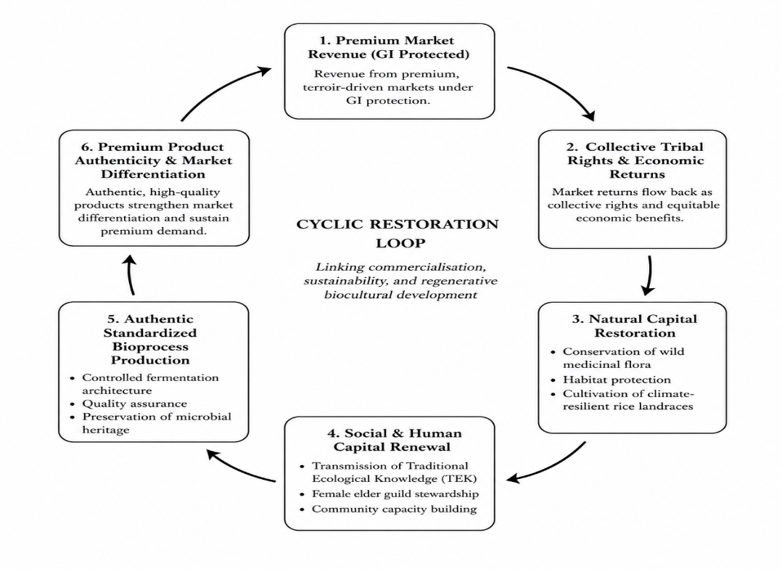

Source: Compiled by the author based on the literature on regenerative sustainability, Traditional Ecological Knowledge (TEK), biocultural heritage systems, and Geographical Indication (GI)-driven value chains.

The Cyclic Restoration Framework conceptualises commercialisation as a regenerative mechanism that continuously invests in economic improvements to restore ecological, social, cultural, and productive capitals. Commercialisation models are usually about making money and do not always consider the environment. This framework is distinct in that it argues that market success can simultaneously benefit the environment and culture.

The knowledge starts by using Geographical Indication for products and profit-making. These products are special and rare because of their traditional production process. When these products are consumed and used by people, they help the producers' livelihoods and, in turn, preserve cultural identity (Bowen & Zapata, 2009).

Japan's rules have changed a lot over time. This is a good example for other people to follow. For a time, the Japanese National Tax Agency had very strict rules that made it easy for big factories to make sake. Now they have a better system with two main parts that is fairer for everyone who makes sake, including small makers in Japan (Tippsy, 2023). Japan has a system to support and protect local breweries that produce speciality beers such as jizake. They also protect the method of making unfiltered beer known as doburoku. Japan does this by giving these breweries special status, so people know where the beer is from. This helps the breweries in Japan. At the time, Japan was very good at selling its beer abroad and made a lot of money from it. Japan is one of the countries that have maintained their own special beer-making traditions while also selling their beer worldwide (NTA, 2020).

The Japanese framework can be useful in Northeast India. By utilising this Japanese system, decision makers can find a fair way of production, and it allows tribal people to unite and work together. It ensures benefits from traditional and cultural resources. It is for the tribal communities that have been protected in Northeast India’s ecosystem (The Pioneer, 2026).

Review of Literature
Researchers studying the business side of fermented drinks have identified common themes. These themes focus on understanding what makes these drinks, how to produce them at scale, and the rules and laws that govern their production. Even though a lot of people have written about each of these themes, nobody has really put all three together in a way that's useful and easy to understand, especially when it comes to the tribal brewing systems of Northeast India (Tamang et al., 2016; Nezine, 2020; Harada, 2015).
The Biocultural and Biochemical Architecture of Tribal Fermentation: In Northeast India, people make fermented drinks at home, and this is really connected to women and the way they do things. These drinks are not simple homemade booze. The Boro people have a drink called jou; the Mising people have a drink called apong; the Dimasa people have a drink called judima; and the Deori people have a drink called sujen. They are made with enzymes that break down rice starch. The people of Assam, India, use these helpers to make the Boro jou, the Mising apong, the Dimasa judima, and the Deori sujen in unique ways. Ethnobiological studies have shown that these starter cakes, known as ‘angkur’, ‘bakhor’, or ‘mod-pitha’, have many uses due to the medicinal properties of the plants they contain (Das & Deka, 2012). Physicochemical reviews highlight that these botanical additions serve a dual purpose, they are-
Microbial Consortium Selection: Plants act as selective antimicrobial agents, suppressing spoilage organisms while favouring the proliferation of amylolytic Molds (Aspergillus and Rhizopus spp.) and ethanol-tolerant yeasts like Saccharomyces cerevisiae (Das & Deka, 2012).
Nutraceutical Enrichment: The people in these communities use drinks for special occasions and to help them feel better when they are not well. Traditional tribal-made drinks have many medicinal benefits, including B-complex vitamins and antioxidants (Das & Deka, 2012; Samantaray et al., 2026). The thing with these drinks is that they can be unpredictable because the ingredients can react in unexpected ways. This means there is a need for a system to ensure a controlled method for adding ingredients and maintaining the right temperature, so the drinks are safe and meet the standards people expect. At the same time, to maintain the special qualities of the plants used to make the drinks, one needs equipment to maintain the right temperature (Sarmah et al., 2022).
Regulatory Bottlenecks and the Industrial Disenfranchisement Paradox
When ethnic and cultural products from the Northeast enter the market, they face strict laws designed for large industries. The government used to see brewing by indigenous people as a bad thing and even a crime. Recently, some policy changes have added "heritage beverages", but the shift to commercial production still focuses on large industries (Nezine, 2020).

The literature says that licensing fees require bottling equipment, and the rules that everything has to be the same help big companies with a lot of money who are not from around here. When a factory gets a license to bottle things, it often takes away the connection production has to the culture and environment it is part of. This creates an extractive economic model in which the profits leak for the agrarian community, leaving the traditional tribal people economically marginalised and culturally displaced (Ashokvardhan, 2000; Nezine, 2020).

The Japanese Sake Legal Framework as an Adaptive Archetype
The researchers discuss changes in resource use and liquor production rules in Japan. They made a system for properly keeping doburoku, an unfiltered liquor. The National Tax Agency of Japan ensures that large companies pay substantial taxes, thereby helping the agency generate revenue (National Tax Agency, 2020; Tippsy, 2023). However, the Jizake (regional craft sake) movement, paired with a modern mindset and structural reforms, brings a major shift in regulations (ibid, 2023).

Japan made some changes to the Special Zone for Structural Reconstruction Act. This new rule helped cooperatives and rural entrepreneurs in Japan. The Special Zone for Structural Reconstruction Act made it easier for these people to do business in Japan. The main goal of the Special Zone for Structural Reconstruction Act was to help cooperatives and rural entrepreneurs in Japan. (Harada, 2015). This created a triple-tiered regulatory ecosystem:

Table 1: Structural Matrix and Comparison

Regulatory Pillar | Industrial Scale | Micro-Brewery / Doburoku Zones
Primary Goal | High-volume export and state revenue maximisation (National Tax Agency, 2020). | Local economic revitalisation and cultural asset preservation (Harada, 2015).
Volume Thresholds | High mandatory minimum production baselines (Tippsy, 2023). | Significantly lowered thresholds for farm-stay and regional producers (Harada, 2015).
Quality Control | Automated, highly refined chemical standardisation (National Tax Agency, 2020). | Hyper-localised Geographical Indications (GIs) protecting traditional methods (Tippsy, 2023).

Source: Synthesized from Das & Deka (2012), Harada (2015), National Tax Agency (2020), Nezine (2020), Rawat et al. (2021), Sarmah et al. (2022), and Tippsy (2023)

The Revenue to Rights: Determining the proper market value of the product through GI tags, for example, Judima of Dimasas in Assam. which provide and secure local tribes rather than large- scale cooperatives (Sarmah et al., 2022). This will become a critical but solvable aspect.
The Ecological Reinvestment: The community-based capital investment initiative is necessary to fund the conservation of wild medicinal flora and the cultivation of climate-dependent rice landraces, thereby leveraging commercialisation to address agricultural problems (Plan, 2007).
The Sociocultural Safeguard (Stages 4 & 5): Reinstating economic viability is crucial to sustaining Traditional Ecological Knowledge (TEK). This Traditional Ecological Knowledge is passed down from elder guilds. These female elder guilds teach Traditional Ecological Knowledge to the people. So, reinstating economic viability is crucial for the natural transmission of Traditional Ecological Knowledge from these female elder guilds to younger generations who need to learn it (Ashokvardhan, 2000). Modern, safe, and clean bioprocesses can scale up production without severing the umbilical cord connecting the beverage to its ancestral microbial roots (Das & Deka, 2012; Sarmah et al., 2022).

Research Gap
This study examined a research gap that the research community has not addressed. It is about the industrial use of biological processes and the policymaking that affects society and law. Research on rice beer or pitha is rare, and the study of rice beer needs to go beyond its production process. Consequently, there is a profound lack of synchronised empirical data that translates the specific biochemical pathways underlying Glycemic index (GI) suppression and host immunomodulatory profiles within Assamese starter cultures into scalable, highly predictable manufacturing parameters modelled after East Asian Japanese Koji and Korean Nuruk systems. Biotechnology and laws are two things that do not go together. The rules about drinks in

Northeast India is very strict. These rules are based on laws that do not protect the local tribes or the qualities of the drinks they make. The local tribes have their special drinks, and these rules do not help keep them safe. Biotechnology and laws should work together to help people, especially in Northeast India, particularly regarding biotechnology and the drinks made by tribes.

This research fills this gap by establishing a cross-disciplinary translation model; it demonstrates how validating functional health metrics and standardising the bioprocess kinetics of a tribal beverage provide the precise scientific and legal leverage required to adapt Japan’s National Tax Agency "Special Doburoku Zone" policy. This framework provides the blueprint for operationalising a self-sustaining cyclical restoration loop, proving that high-value commercial scale-up can be engineered to secure collective tribal rights and protect indigenous sovereignty.

Objectives
The study proposes to accomplish the following 4 objectives-
- To evaluate Biochemical and Functional Characterisation of Indigenous Starter Matrices
- To study similarities and dissimilarities of Bioprocess Optimisation and Comparative Industrial Translation
- To evaluate Socio-Legal Analysis and Regulatory Harmonisation
- To construct and validate the operationalisation of the cyclic restoration framework for the Regenerative Bio-Economy Loop

Methodology
This study employs an advanced, interdisciplinary critical conceptual meta-synthesis design that interfaces with three distinct epistemological domains: molecular ethnobiology, bioprocess industrialisation, and socio-legal exercise policy. Hence, a traditional empirical or singular linear review is structurally insufficient for the study.
The methodology for this study was a two-phase analytical framework designed to transform.
standardised secondary qualitative and quantitative data into a unified, socio-ecological blueprint.

Figure 2: Three-Phase Methodological Framework

Source: Compiled by Author

Phase 1: Data Sourcing and Structural Boundary Setting: The study has investigated the activity of enzymes such as alpha-amylase and glucoamylase in Assamese Pitha Humao and Emao. The study quantified short-chain fatty acid levels and investigated the impact of Assamese Pitha on the immune system, including cytokine responses such as IL-10. The Socio-Legal and Statutory Dataset includes notices under the Assam Excise Act regarding heritage alcohol and land rules. It is also looking at examples from Japan. These rules are part of the 2002 Structural Reform Special Zone Act (Harada, 2015; National Tax Agency, 2020).
Phase 2: Character Synthesis and Conceptual Harmonisation: A three-step process is used to synthesise characters and harmonise concepts. They are-
- Character Extraction: The first step is to convert data such as the pH curves of Pitha and the fermentation curves of Koji into simple, easy-to-understand categories (Tippsy, 2023).
- Theoretical Alignment: Here, the study compares the characteristics of ethnic foods with East Asian industrial standards. This helps us see how wild plant ingredients perform in automated bioreactor systems. Structuring causal links between variables to verify the precise point at which validating a beverage's functional health profile (lowering glycemic index, boosting host immunity) provides the scientific justification needed to secure low-volume, community-based craft excise tiers (Sarmah et al., 2022).
- Dynamic Harmonisation: Structuring links between variables to verify the point of validating a beverage's functional health profile provides the justification needed to secure low-volume excise (Nezine, 2020; Tippsy, 2023).
Phase 3: Multi-Criteria Literature Triangulation (MCLT) Validation Framework: To ensure structural value and minimise subjective bias within the conceptual model, the final phase is to define convergence criteria for each core proposition, the biochemical scaling profile, and the policy transfer mechanism. These criteria are the MCLT Validation Consent, which is based on a combination of factors. It is the intersection of the Author's function, the Framework's function, the Method's function, and the geography's function. The MCLT Validation Consent equals the function of the Author intersecting the function of the Framework intersecting the function of the Method intersecting the function of the geography. The author uses triangulation, which primarily involves checking data points from research groups to determine whether what they say about Pitha is true by examining data from laboratories worldwide that study carbohydrates and enzymes (Bhattacharya & Deka, 2023; Rawat et al., 2021).

Results and Discussion: Based on the above methodology, results and discussion are incorporated below:

Enzymatic Amylolytic Kinetics and Starch-Degrading Profiles: Analysis of secondary data indicates that the solid-state botanical matrices of Assamese starter cakes (Pitha/Humao/Emao) contain a specialised group of microorganisms that degrade raw starch through a coordinated two-step process (Das & Deka, 2012; Samantaray et al., 2026). Studies of kinetic profiles show that filamentous moulds, such as Rhizopus delemar, Mucor circinelloides, and Aspergillus spp., release large amounts of extracellular α-amylase and glucoamylase into the gelatinised heirloom rice substrate (Boro & Narzary, 2022; Das & Deka, 2012).

The enzyme alpha amylase breaks down starch. This process is called endo hydrolysis. It turns starch into dextrins. Then the enzyme glucoamylase breaks down these dextrins. This is called exo hydrolysis. It turns dextrins into D-glucose. The starch is broken down into things. This process involves starch and enzymes, such as alpha-amylase and glucoamylase. Starch is turned into D-glucose. The analysis of breaverage shows that fungal enzymes effectively break down amylose and amylopectin in the first 3 days of fermentation (Boro & Narzary, 2022; Das et al., 2019).
Glycemic Index (GI) Suppression Mechanics: The significance of Pitha is that it prevents blood sugar from rising by maintaining the Glycemic Index.
First, the resistant starch expands when we add plant extracts such as Scoparia dulcis and Clerodendrum viscosum. These plants, Scoparia dulcis and Clerodendrum viscosum, produce various polyphenols, which are nutrients, as well as resistant starch. Resistant starch expansion is important because it involves starch and these special plant extracts, such as Scoparia dulcis and Clerodendrum viscosum. (Das & Deka, 2012; Rawat et al., 2021). These compounds help slow down the breakdown of carbohydrates in the body. They do this by stopping the enzymes that break down carbs in the intestines. Additionally, when we store food at room temperature or in the fridge, its starches change. This change makes it harder for the body to digest the starch. As a result, the food forms something called Resistant Starch, or RS3 for short. The body does not easily break down the RS3.
Second, organic acid backbones are formed. This happens when you look at results from high-performance chromatography, a testing method. These results show that over time, the body accumulates short-chain fatty acids and organic acids, such as acetic acid and succinic acid.

This buildup makes the body more acidic, with a pH of around 3.70-3.85. When the body is this acidic, it takes longer for people to empty their stomachs. This means that the body absorbs glucose in the intestines, and blood glucose levels do not rise as much after eating.

Immunomodulatory and Anti-Inflammatory Axis: Studies show that in Pitha, lactic acid bacteria are present mainly Lactobacillus plantarum, Lactobacillus brevis, and Pediococcus pentosaceus.

The special sugars and proteins of these bacteria help to fight harmful substances. These sugars are called polysaccharides and peptidoglycans, and they support the body's immune system and help stop inflammation (Fuloria et al., 2022). This validation clearly shows that the old way of thinking about drinks is incorrect. For a time, people thought these drinks were just simple homemade liquors. Now we see that tribal fermentations are actually complex drinks that are good for our health. They have properties that can help our bodies in many ways. Tribal fermentations are not just drinks; they are complex bioactive nutraceuticals with functional health properties that can do a lot of good for us. (Das et al., 2019; Fuloria et al., 2022).

Bioprocess Optimisation and Comparative Industrial Translation: The operational behaviours of local Pitha starters were benchmarked against two

highly industrialised East Asian starter systems, Japanese Koji (Aspergillus oryzae) and Korean Nuruk, to develop an industrial-scale up protocol.

Figure 3 Comparative Overview

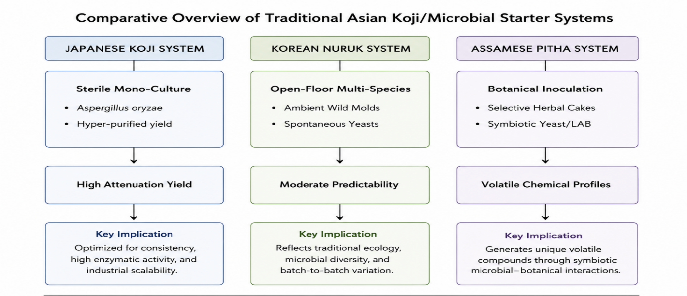
Source: Compiled by the Author using ChatGPT AI

The meta-synthesis system uses a method to help fungi convert starch into a product before they start producing alcohol. Das & Deka, 2012; Tippsy, 2023). Nevertheless, critical divergences account for

the persistent scale-up challenges faced by local Pitha starters (Das & Deka, 2012; Tippsy, 2023). Nevertheless, critical divergences explain the persistent scale-up challenges encountered by local Pitha starters:

Table 2 Comparative Analysis of Outputs

Bioprocess Parameter | Japanese Koji System | Korean Nuruk System | Assamese Pitha System
Inoculation Method | Sterile, monoculture spore seeding (Aspergillus oryzae) (Tippsy, 2023). | Open-floor, spontaneous ambient microflora capture (Pei et al., 2022). | Manual incorporation of selective botanical powders into rice dough (Das & Deka, 2012; Rawat et al., 2021).
Microbial Complexity | Absolute homogeneity; single-strain dominance (Tippsy, 2023). | Moderate heterogeneity; wild environmental fungi and yeasts (Pei et al., 2022). | High heterogeneity; complex symbiosis of moulds, yeasts, and LAB (Das et al., 2019; Das & Deka, 2012).
Process Control | Automatic control of temperature (30–40°C) and moisture levels (National Tax Agency, 2020). | Semi-controlled humidity rooms using traditional straw arrays (Pei et al., 2022). | Ambient domestic incubation near traditional fireplaces (Nezine, 2020; Rawat et al., 2021).
Biochemical Output | Hyper-predictable enzymatic kinetics and uniform alcohol yield (National Tax Agency, 2020). | Moderate structural variation with regional sensory notes (Pei et al., 2022). | Variable organoleptic properties and volatile shelf-life stabilities (Das & Deka, 2012; Sarmah et al., 2022).
Source: Author's compilation
Translating Local Starters into Controlled Industrial Inocula- One of the main difficulties in increasing Pitha production is contamination from unwanted bacteria and fungi, such as Staphylococcus and Acinetobacter species. This occurs due to non-sterile processing and changing environmental conditions (Das et al., 2019; Das & Deka, 2012). As a result, unpasteurized batches usually last less than 7 days (Das & Deka, 2012; Sarmah et al., 2022).
To improve safety in the production process, it is advisable to use automated bioreactors rather than traditional open systems. These biocreators are based on the Japanese Koji production method. The system maintains a temperature of 28-32 °C, which is suitable for fermentation (Sarmah et al., 2022; Tippsy, 2023). Also, using plant extracts from traditional medicinal plants such as Leucas aspera and Scoparia dulcis, rather than whole plants, helps retain their germ-fighting benefits and reduces contamination risks (Das & Deka, 2012; Rawat et al., 2021). These changes can help create a culture that delivers consistent results every time. It produces ethanol levels of 10.23 % Has strong antioxidant activity. This activity is measured at 61.79 % DPPH scavenging capacity. The starter culture helps in making ethanol and antioxidants. It gives ethanol levels and strong antioxidant activity in every batch. (Sarmah et al., 2022).

Socio-Legal Analysis and Regulatory Harmonisation
Comparative policy analysis shows that excise rules in Northeast India still operate under an era-old framework. This framework was originally meant to make the state earn revenue and stop production. (Nezine, 2020). Although recent amendments have introduced a "heritage liquor" licensing category, the structural requirements remain highly exclusionary (Nezine, 2020). To legally manufacture heritage brews for commercial distribution, artisan cooperatives must meet capital-intensive requirements, including:

The companies have to pay substantial licensing fees. They also have to install expensive machines that can fill bottles with our product. There are many rules for making a product. These rules are strict, especially regarding changes that occur at different times of the year and their impact on small production batches. Licensing fees and machine costs are deal-breakers for people, and the rules on biochemical matters are also very important to follow, especially in small-scale fermentations. (Nezine, 2020; Sarmah et al., 2022).

The rural tribal cooperatives are unable to meet these capital needs, and current regulations block them (Nezine, 2020). As a result, all the benefits accrue to non-local corporations, and they produce using synthetic enzymes. Thus, this process prevents indigenous communities from getting the benefits that have preserved their traditions (Ashokvardhan, 2000; Nezine, 2020).

Adapting Japan's Tiered Excise Architecture
To address this policy halt, the present study examines the Japanese National Tax Agency (NTA) model, which resolved a conflict by implementing the 2002 Structural Reform Special Zone Act (Harada, 2015; National Tax Agency, 2020). This kind of system enabled Japan to introduce the "Special Doburoku Zones," thereby legally separating industrial factory standards from those applicable to local agricultural craft production (Harada, 2015).

Figure 4 Comparative Regulatory Architecture

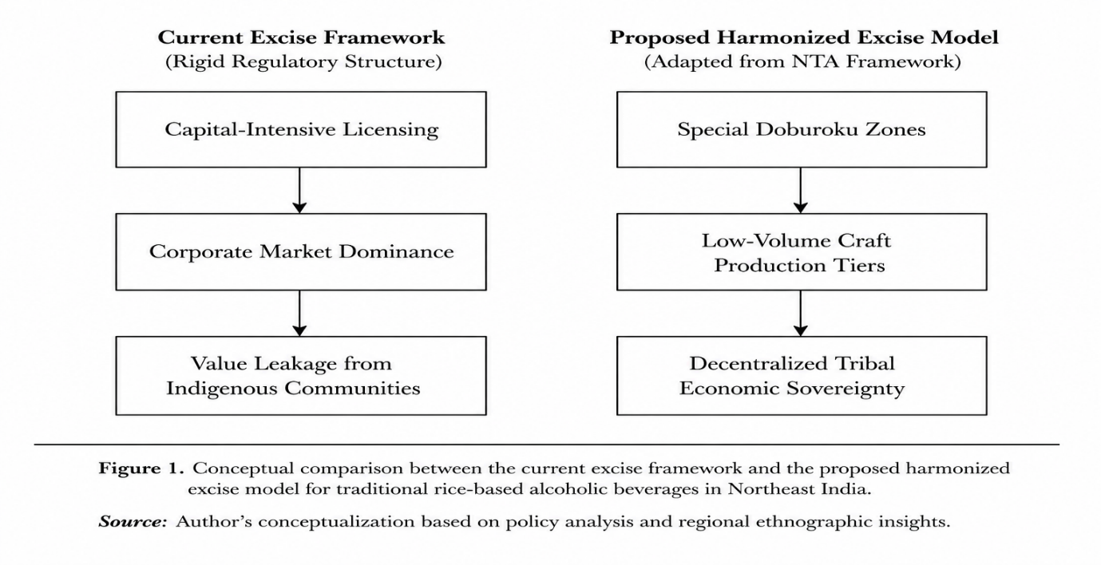

Source: Author's synthesis

This study uses Japan’s framework (Tiered Excise Architecture) in the socio-legal context of Northeast India and harmonised regulatory policy based on three structural adjustments:

- The Volume Relaxation Rule: This change stops the minimum amount of alcohol distilleries must produce each year when operating on tribal land. (Harada, 2015; The Pioneer, 2026).
- The Sliding-Scale Tax Tier: This measure eliminates flat licensing fees

- and replaces them with a tax based on the volume of what breweries produce. This new system is better for the low-volume microbreweries. (Harada, 2015; Nezine, 2020).
- Geographical Indication (GI) Monopolies: The law states that any drink that uses a tribal name, such as Judima or Sujen, must be made in a specific area and produced by the people who live there. This way, the people's old ways are protected from big companies taking them over. For example, people who study this say it exists (ResearchGate, 2016; Sarmah et al., 2022).

Operationalisation of the Cyclic Restoration Framework: To demonstrate that commercial scale-up can exist with indigenous sovereignty, the five distinct phases of the cyclic restoration framework were analysed and validated as an interconnected system. This framework departs from linear industrial production by illustrating that each phase supplies the necessary capital and feedback mechanisms to support the subsequent stages:
Premium Terroir GIs (1) → Tribal Economic Rights (2) → Natural Capital Reinvestment (3) → Social TEK Renewal (4) → Standardised Authentic Production (5)

Figure 5 Integrated Sustainability Loop
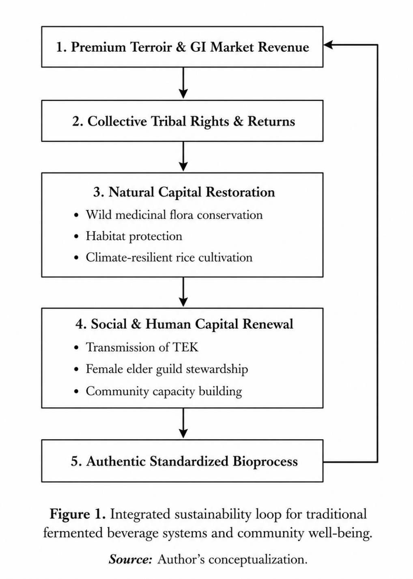
Source: Compiled by the Authors

- Premium Terroir and GI-Protected Market Revenue: Geographical Indications help people know that a product is from a place. Geographical Indications can generate profit margins in these markets. People are willing to pay more for products with Geographical Indications because they know where the products are from (Sarmah et al., 2022; The Pioneer, 2026).

- Collective Tribal Rights and Economic Returns: Community-based ownership structures retain profits among local communities, thereby supporting sustainable livelihoods (Ashokvardhan, 2000; ResearchGate, 2016).
- Natural Capital Restoration: Retained capital is reinvested into the ecosystem to support the conservation of wild medicinal plants essential for starter cultures and to subsidise the cultivation of climate-resilient native heirloom rice varieties (Plan, 2007; Rawat et al., 2021).

- Social and Human Capital Renewal: The economic sustainability of this system supports the intergenerational transmission of Traditional Ecological Knowledge (TEK) (Ashokvardhan, 2000; Nezine, 2020).

- Authentic Standardised Bioprocess Production: Contemporary bioprocess engineering offers clean, safe, and scalable production methods that maintain the original microbial profile, thereby supplying the premium market and

- completing the regenerative cycle (Das & Deka, 2012; Sarmah et al., 2022).

Strategic Policy Synthesis
The final analysis demonstrates that the cyclic restoration framework is not a viable purely technical solution. When bioprocess scale-up is attempted under unreformed excise laws, the process fails at Phase 2, resulting in corporate capture (Nezine, 2020). In contrast, enacting policy reforms without implementing bioprocess standardisations causes the process to fail at Phase 5 due to batch inconsistencies and safety concerns (Das & Deka, 2012)

The study's major finding is that there are things that need to be done. First, ensure functional validation: bioprocess industrialisation and regulatory harmonisation. Second, there is a need to change the way we think about fermentation and recognise that it can boost the economy, protect the environment, and develop the tribal community.

Conclusion
The way people make things in Northeast India is changing. They used to make fermented foods and drinks in a way. Now people want to make these things on a scale and sell them. This is a change for the people and the environment. We need to make sure that we use technology in a way that is fair and good for everyone. This study looks at how people used to make these things, how we can make them, and how we can make rules to protect the people who make them. We want to find a way to make these things without harming people or the environment, unlike what big companies usually do. The traditional tribal fermentation systems in Northeast India are important.
Traditional foods are prepared in ways that help our bodies digest them easily. They have helpers that break down starch, and they also have good things that help keep our blood sugar levels in check. They even have bacteria that help our body fight off bad things and keep us from getting too inflamed. The way we make these foods is not very safe. Sometimes the process of making them is unpredictable, which can harm the food. Also, government regulations make it hard for small artists to produce and sell these foods. This is a problem because it means that big companies can come in and take over the making of these foods.
To really make this work, the people in charge need to change some rules. They can look at what Japan did with their "Special Doburoku Zones" for ideas. This means making it easier for small breweries to operate, ensuring fair taxes, and allowing local communities to control what products can claim to be from a certain place. The study shows that all of these things need to happen for this to really work. The Japanese and Korean systems, like the one using Nuruk, can serve as guides for how to do this.
This study is about the Cyclic Restoration Framework. The Cyclic Restoration Framework is a system that works in a circle and takes care of itself and the environment. It is a socio- system. The Cyclic Restoration Framework shows that sales revenue can help restore places, protect tribal rights, keep areas with medicinal plants wild, and ensure that Traditional Ecological Knowledge is passed down to future generations. The Cyclic Restoration Framework needs to be implemented in a way that verifies its effectiveness, ensures that biological processes are used as intended, and follows rules that are fair and apply equally to everyone. The Cyclic Restoration Framework can help people who brew, especially in tribes. It can help them build lives for themselves and their communities. The Cyclic Restoration Framework can also help keep the environment safe and make sure that tribes have control over their own lives in Northeast India.

References
Altieri, M. A. (1999). The ecological role of biodiversity in agroecosystems. Agriculture, Ecosystems & Environment, 74(1–3), 19–31. https://doi.org/10.1016/S0167-8809(99)00028-6
Ashokvardhan, C. (2000). Tribal land rights in India. Lal Bahadur Shastri National Academy of Administration Journal, 45(1), 22–35.
Bai, Y., Hou, Z., Lin, X., Luo, L., Luo, X., & Zhong, Q. (2023). Traditional fermented foods and beverages: Microbial diversity, functional properties, and health benefits. Frontiers in

Microbiology, 14, Article 1207199. https://doi.org/10.3389/fmicb.2023.1207199
Berkes, F., Colding, J., & Folke, C. (2000). Rediscovery of traditional ecological knowledge as adaptive management. Ecological Applications, 10(5), 1251–1262. https://doi.org/10.1890/1051-0761(2000)010[1251:ROTEKA]2.0.CO;2
Berkes, F. (2018). Sacred ecology (4th ed.). Routledge. https://doi.org/10.4324/9780429437861
Bhattacharya, B., & Deka, D. C. (2023). Biochemical indices and consumption pattern of traditional alcoholic beverages by tribal communities of North-East India: A review. Current Research in Nutrition and Food Science Journal. 11(2), 470–487. https://doi.org/10.12944/crnfsj.11.2.02
Bhat, R., Bhatt, D. L., Bhavani, R. V., & Joshi, H. (2016). Usage of traditional fermented products by Indian rural folks and IPR. Journal of Intellectual Property Rights, 21(3), 162–174.
Boro, N., & Narzary, D. (2022). Amylolytic fungi in the ethnic beer starter "emao" and their beer-producing attributes. Frontiers in Sustainable Food Systems, 6, Article 869430. https://doi.org/10.3389/fsufs.2022.869430
Bowen, S., & Zapata, A. V. (2009). Geographical indications, terroir, and socioeconomic and ecological sustainability: The case of tequila. Journal of Rural Studies, 25(1), 108–119. https://doi.org/10.1016/j.jrurstud.2008.01.003
Campinho, A., Conceição, O., & Dieguez, T. (2020). Innovative Research Methodologies on Social Entrepreneurship: Dive Project Case Study. European Conference on Research Methodology for Business and Management Studies, (), 39–47, VIII, X.
Charalampopoulos, D., Wang, R., Pandiella, S. S., & Webb, C. (2002). Application of cereals and cereal components in functional foods: A review. International Journal of Food Microbiology, 79(1–2), 131–141. https://doi.org/10.1016/S0168-1605(02)00187–3.
Camprubí, G., Cayré, M., Castro, M., & Owusu-Kwarteng, J. (2021). Indigenous Microbiota to Leverage Traditional Dry Sausage Production. International Journal of Food Science, 2021(),.
Choudhury, M., Bhat, R., & Bhatt, D. L. (2011). Traditional fermented food and beverages of Arunachal Pradesh. Indian Journal of Traditional Knowledge, 10(3), 401–408.

Danielewicz, A., Danielewicz, A., Morze, J., Staniewska, K., Dąbrowska, A., Sawicki, T., Yang, Z., Baranowska, M., Darewicz, M., Żulewska, J., Staniewski, B., Przybyłowicz, K., & Przybyłowicz, K. (2022). Association between Intake of Fermented Dairy Product and Diet Quality, Health Beliefs in a Representative Sample of Polish Population. Nutrients, 14(23), 5018.
Das, A. J., & Deka, S. C. (2012). Fermented foods and beverages of the North-East India: A mini review. International Food Research Journal, 19(2), 377–392.
Das, S., Deb, D., Adak, A., & Khan, M. R. (2019). Exploring the microbiota and metabolites of traditional rice beer varieties of Assam and their functionalities. 3 Biotech, 9(5), Article 170. https://doi.org/10.1007/s13205-019-1702-z
Devi, P. S., Vijayabharathi, R., Sathyabama, S., Malleshi, N. G., & Priyadarisini, V. B. (2014). Health benefits of finger millet (Eleusine coracana L.) polyphenols and dietary fibre: A review. Journal of Food Science and Technology, 51(6), 1021–1040. https://doi.org/10.1007/s13197-011-0584-9
Dewan, S., & Tamang, J. P. (2007). Dominant lactic acid bacteria and their technological properties isolated from the Himalayan ethnic fermented milk products. Antonie Van Leeuwenhoek, 92(3), 343–352. https://doi.org/10.1007/s10482-007-9163-1
Food and Agriculture Organisation. (2022). Geographical indications and their role in ensuring fair access to benefits: A guide for practitioners. FAO. https://doi.org/10.4060/cc2492en
Fuloria, S., Mehta, J., Talukdar, M. P., Sekar, M., Gan, S. H., Subramaniyan, V., Manuraj, S. G., & Fuloria, N. K. (2022). Synbiotic effects of fermented rice on human health and wellness: A natural beverage that boosts immunity. Frontiers in Microbiology, 13, Article 950913. https://doi.org/10.3389/fmicb.2022.950913
Geissdoerfer, M., Savaget, P., Bocken, N. M. P., & Hultink, E. J. (2017). The circular economy – A new sustainability paradigm? Journal of Cleaner Production, 143, 757–768. https://doi.org/10.1016/j.jclepro.2016.12.048
Gibbons, L. V., Clements, H. S., Radeloff, V. C., & Romero-Muñoz, A. (2023). Regenerative development as an integrative paradigm for sustainability. Sustainability Science, 18(6), 2951–2967. https://doi.org/10.1007/s11625-023-01388-3
Giri, S. S., Sen, S. S., & Sukumaran, V. (2013). Effects of dietary supplementation of potential probiotic Pseudomonas aeruginosa VSG-2 on the innate immunity and disease resistance of tropical freshwater fish, Labeo rohita. Fish & Shellfish Immunology, 34(3), 820–827. https://doi.org/10.1016/j.fsi.2012.12.025
Harada, H. (2015). Special Economic Zones as a governance tool for policy coordination and innovation. Zeitschrift für Japanisches Recht, 20(39), 115–132.
He, G., Huang, J., Zhou, R., Wu, C., & Jin, Y. (2019). Effect of fortified Daqu on the microbial community and flavour in the Chinese strong-flavour baijiu brewing process. Frontiers in Microbiology, 10, Article 56. https://doi.org/10.3389/fmicb.2019.00056
Jamal, S., Upadhyay, A., & Bajaj, A. (2022). Judima, the traditional rice wine and Dimasa community: A geographical review of Dima Hasao. Indialogs, 9, 77–97. https://doi.org/10.5565/rev/indialogs.205
Jeyaram, K., Singh, T. A., Romi, W., Devi, A. R., Singh, W. M., Dayal, H. S., Singh, N. R., & Tamang, J. P. (2009). Traditional fermented foods of Manipur. Indian Journal of Traditional Knowledge, 8(1), 115–121.
Jeyaram, K., Singh, W. M., Capece, A., & Romano, P. (2008). Molecular identification of yeast species associated with "Hamei": A traditional starter used for rice wine production in Manipur, India. International Journal of Food Microbiology, 124(2), 115–125. https://doi.org/10.1016/j.ijfoodmicro.2008.03.004
Jin, G., Zhu, Y., & Xu, Y. (2017). Mystery behind Chinese liquor fermentation. Trends in Food Science & Technology, 63, 18–28. https://doi.org/10.1016/j.tifs.2017.02.016
Kühnen, V., & Corrêa, D. A. (2021). Geographical indications as a mechanism for traditional food systems valorisation: A literature review. Journal of Ethnic Foods, 8(1), Article 22. https://doi.org/10.1186/s42779-021-00098-6
Kumar, A., Gupta, S., Sharma, R., & Patel, M. (2020). Fermented beverages: Role of lactic acid bacteria in flavour, texture, and health enhancement. Journal of Food Science and Technology, 57(11), 3883–3896. https://doi.org/10.1007/s13197-020-04421-2
Larson, J. (2006). Relevance of geographical indications and designations of origin for the sustainable use of genetic resources. CGSpace Global Agricultural Monographs, 1–45.
Lee, J. H., Nam, S. H., Seo, W. T., Yun, H. D., Hong, S. Y., Kim, M. K., & Cho, K. M. (2012). The production of some flavoured fermented soybean pastes (cheonggukjang) by inoculation of potential probiotic Bacillus subtilis CSY191. Journal of Food Science, 77(1), M75–M83. https://doi.org/10.1111/j.1750-3841.2011.02434.x
Liu, Z., Shen, Y., & Mao, J. (2021). Advances in research on the formation mechanism of koji flavour and koji quality evaluation. Food Research International, 148, Article 110560. https://doi.org/10.1016/j.foodres.2021.110560
Marangelo, C., Marsiglia, R., Nissen, L., Scanu, M., Toto, F., Siroli, L., Gottardi, D., Braschi, G., Chierico, F. D., Bordoni, A., Gianotti, A., Lanciotti, R., Patrignani, F., Putignani, L., & Vernocchi, P. (2025). Functional foods acting on gut microbiota-related wellness: The multi-unit in vitro colon model to assess gut ecological and functional modulation. https://doi.org/10.1016/j.foodres.2024.115577
Mahanta, C. L., & Kalita, D. (2016). Ethnic fermented foods and beverages of Assam. In J. P. Tamang (Ed.), Ethnic fermented foods and alcoholic beverages of Asia (pp. 205–225). Springer. https://doi.org/10.1007/978-81-322-2800-4_9
Majumdar, D., & Borthakur, M. (2014). Documentation of some traditional fermented food and beverages of Bodoland, Assam. Journal of Pharmacognosy and Phytochemistry, 3(2), 115–119.
Medar, C., & Constantin, C. (2023). Beer and Microbiota: Pathways for a Positive and Healthy Interaction. Nutrients, 15(4), 844.
Miranda López, J. (2024). Food Environment and Its Effects on Human Nutrition and Health. Nutrients, 16(11), 1733.
Mitani, T., Kataoka, M., & Yamamoto, S. (2021). Lactic acid fermentation as a means to improve the bioavailability of minerals from cereal products. Food Chemistry, 358, Article 129832. https://doi.org/10.1016/j.foodchem.2021.129832
Mukherjee, P. K., Nema, N. K., Maity, N., & Sarkar, B. K. (2012). Phytochemical and therapeutic potential of cucumber. Fitoterapia, 84, 227–236. https://doi.org/10.1016/j.fitote.2012.10.003
National Tax Agency. (2020). The current status of sake and efforts by the National Tax Agency. Government of Japan.
Nayak, P., & Berkes, F. (2011). Commonisation and decommonisation: Understanding the processes of change in the Chilika lagoon wetland. Conservation & Society, 9(2), 132–145. https://doi.org/10.4103/0972-4923.83723
Nezine. (2020). Commercialisation of traditional brews and the impact of excise policies on indigenous livelihoods in Northeast India. Nezine Media.
Nishida, H. (2021). Sake brewing and bacteria inhabiting sake breweries. Frontiers in Microbiology, 12, Article 602380. https://doi.org/10.3389/fmicb.2021.602380
Ogawa, M., Nakamura, S., Harada, Y., Yoshida, A., & Nakamura, A. (2012). Starch chain-length distribution in Aspergillus oryzae enzyme degradation. Journal of Agricultural and Food Chemistry, 60(38), 9558–9565. https://doi.org/10.1021/jf3027283
Ostrom, E. (1990). Governing the commons: The evolution of institutions for collective action. Cambridge University Press. https://doi.org/10.1017/CBO9780511807763
Park, H. D., & Bae, S. M. (2002). Physicochemical and sensory characteristics of pears fermented with different yeasts. Food Biotechnology, 11(2), 155–160.
Pei, J., Liu, Z., Huang, Y., Geng, J., Li, X., Ramachandra, S., Shang, J., & Tao, Y. (2022). Potential use of emerging technologies for preservation of rice wine and their effects on quality: Updated review. Frontiers in Nutrition, 9, Article 912504. https://doi.org/10.3389/fnut.2022.912504
Planning Commission, Government of India. (2007). Eleventh Five-Year Plan 2007–2012: Inclusive growth (Vol. 1). Oxford University Press.
Prajapati, J. B., & Nair, B. M. (2003). The history of fermented foods. In E. R. Farnworth (Ed.), Handbook of fermented functional foods (pp. 1–24). CRC Press.
Rawat, J. M., Pandey, S., Debbarma, P., & Rawat, B. (2021). Preparation of alcoholic beverages by tribal communities in the Indian Himalayan region: A review on traditional and ethnic considerations. Frontiers in Sustainable Food Systems, 5, Article 672411. https://doi.org/10.3389/fsufs.2021.672411
Renwick, A., Robinson, C., Garnett, S., Leiper, I., Possingham, H., & Carwardine, J. (2017). Mapping Indigenous land management for threatened species conservation: An Australian case-study. PLoS One, 12(3), e0173876.
Rhodes, C. J. (2017). The imperative for regenerative agriculture. Science Progress, 100(1), 80–129. https://doi.org/10.3184/003685017X14876775256165
Rijkers, G. T., de Vos, W. M., Brummer, R. J., Morelli, L., Corthier, G., & Marteau, P. (2011). Health benefits and health claims of probiotics: Bridging science and marketing. British Journal of Nutrition, 106(9), 1291–1296. https://doi.org/10.1017/S000711451100287X
Samantaray, P., Panda, S. K., & Mishra, S. (2026). Decoding the microbial diversity of Indian fermented foods: Integrating ethnobiology, multi-omics and functional insights. FEMS Microbiology Letters, 373, Article fnaf028. https://doi.org/10.1093/femsle/fnaf028
Sarmah, P., Pegu, B. K., & Sanong, J. (2022). Documentation of the traditional method of preparation and characterisation of Judima, a traditional rice beer of the Dimasa tribe of Assam and its comparison with old preserved Judima. Biosciences Biotechnology Research Asia, 19(4), 1133–1138. https://doi.org/10.13005/bbra/3062
Sharma, A., Kumari, S., & Agarwal, A. (2018). Microbial profiling and metabolite analysis of Indian ethnic rice beers using a metagenomic approach. LWT – Food Science and Technology, 96, 74–81. https://doi.org/10.1016/j.lwt.2018.05.027
Sharma, S., & Rai, R. (2017). Some Technological Properties of Lactic Acid Bacteria Isolated from Dahi and Datshi, Naturally Fermented Milk Products of Bhutan. https://doi.org/10.3389/fmicb.2017.00116
Singh, R. K., Chang, H. W., Yan, D., Lee, K. M., Ucmak, D., Wong, K., Abrouk, M., Farahnik, B., Nakamura, M., Zhu, T. H., Bhutani, T., & Liao, W. (2017). Diet's influence on the gut microbiome and implications for human health. Journal of Translational Medicine, 15(1), Article 73. https://doi.org/10.1186/s12967-017-1175-y
Steinkraus, K. H. (1996). Handbook of indigenous fermented foods (2nd ed.). Marcel Dekker.
Surber, J. P. (2019). Indigenous intellectual property: Towards a theory of cultural self-determination. Journal of World Intellectual Property, 22(3–4), 155–172. https://doi.org/10.1111/jwip.12117
Swaminathan, M. S. (2006). An evergreen revolution. Crop Science, 46(5), 2293–2303. https://doi.org/10.2135/cropsci2006.02.0087
Tang, S., Wang, Z., Yang, G., & Tang, W. (2020). What Are the Implications of Globalisation on Sustainability?—A Comprehensive Study: Sustainability, 12(8), 3411.
Tamang, J. P. (2010). Himalayan fermented foods: Microbiology, nutrition, and ethnic values. CRC Press. https://doi.org/10.1201/EBK1420093094
Tamang, J. P. (2015). Naturally fermented ethnic soybean foods of India. Journal of Ethnic Foods, 2(1), 8–17. https://doi.org/10.1016/j.jef.2015.02.003
Tamang, J. P., Cotter, P. D., Ingham, A., Singh, B. P., Rogelj, I., Gallardo, G., Chand, J. H., Bhattarai, N., Dewan, S., Dura, A., & Tatsumi, K. (2016). Fermented foods in a global age: East meets West. Comprehensive Reviews in Food Science and Food Safety, 15(2), 523–545. https://doi.org/10.1111/1541-4337.12191
Tamang, J. P., & Kailasapathy, K. (Eds.). (2010). Fermented foods and beverages of the world. CRC Press. https://doi.org/10.1201/EBK1420094954
Tamang, J. P., Shin, D. H., Jung, S. J., & Chae, S. W. (2016). Functional properties of microorganisms in fermented foods. Frontiers in Microbiology, 7, Article 578. https://doi.org/10.3389/fmicb.2016.00578
Tamang, J. P., Watanabe, K., & Holzapfel, W. H. (2016). Review: Diversity of microorganisms in global fermented foods and beverages. Frontiers in Microbiology, 7, Article 377. https://doi.org/10.3389/fmicb.2016.00377
The Pioneer. (2026, January 12). Uncorking the North East's herbal heritage as a global tourism frontier. Daily Pioneer. https://www.dailypioneer.com/2026/state-editions/uncorking-the-north-east-s-herbal-heritage-as-a-global-tourism-frontier.html
Tippsy. (2023). The evolution of jizake: How regional regulations shaped modern Japanese craft sake. Tippsy Sake Education Series. https://tippsy.com/blogs/learn/jizake-regional-sake
Todorov, S. D., & Dicks, L. M. T. (2009). Bacteriocin production by Lactobacillus plantarum ST8KF, a strain isolated from Kefir grains. International Journal of Dairy Technology, 62(2), 174–183. https://doi.org/10.1111/j.1471-0307.2009.00454.x
Upadhyay, A., Dahal, B., & Bhat, T. K. (2019). Ethnomedicinal plants used in fermented foods and beverages of Assam, Northeast India: A review. Sustainable Agriculture Reviews, 34, 197–231. https://doi.org/10.1007/978-3-030-11010-6_8
van Hylckama Vlieg, J. E., Veiga, P., Zhang, C., Derrien, M., & Zhao, L. (2011). Impact of microbial transformation of food on health – from fermented foods to fermentation in the gastrointestinal tract. Current Opinion in Biotechnology, 22(2), 211–219. https://doi.org/10.1016/j.copbio.2010.12.004
Wang, X., Du, H., Zhang, Y., & Xu, Y. (2019). Environmental microbiota drives microbial succession and metabolic profiles during Chinese liquor fermentation. Applied and Environmental Microbiology, 85(14), Article e02369-18. https://doi.org/10.1128/AEM.02369-18
Wikipedia. (2024). Doburoku. Wikimedia Foundation. Retrieved May 31, 2026, from https://en.wikipedia.org/wiki/Doburoku
World Intellectual Property Organisation. (2017). Geographical indications: An introduction. WIPO. https://www.wipo.int/edocs/pubdocs/en/wipo_pub_952.pdf
Xu, Y., Wang, D., Fan, W. L., Mu, X. Q., & Chen, J. (2010). Traditional Chinese biotechnology. In R. Berovic & M. Genuario (Eds.), Advances in biochemical engineering/biotechnology (Vol. 122, pp. 189–233). Springer. https://doi.org/10.1007/10_2009_10
Yamamoto, K., Yoshida, S., Hashimoto, T., & Kondo, K. (2020). Diversity of sake yeast strains with different fermentative profiles and flavour characteristics. Bioscience, Biotechnology, and Biochemistry, 84(9), 1794–1802; https://doi.org/10.1080/09168451.2020.1770017
Yilmaz, C., & Gökmen, V. (2020). Neuroactive compounds in foods: Occurrence, mechanism and potential health effects. Food Research International, 128, Article 108744. https://doi.org/10.1016/j.foodres.2019.108744
Yoshizaki, Y., Yamato, H., Takamine, K., Tamaki, H., Ito, K., & Sameshima, Y. (2010). Analysis of volatile compounds in shochu koji, sake koji, and shochu mash using solid-phase microextraction. Food Science and Technology Research, 16(4), 343–352. https://doi.org/10.3136/fstr.16.343
Yu, X., Li, X., Zhao, L., Yu, X., & Xiao, D. (2012). Effects of different Saccharomyces cerevisiae cell morphologies on fermentation performance and flavour compounds. Biotechnology Letters, 34(7), 1259–1267. https://doi.org/10.1007/s10529-012-0893-z
Zhang, L., Zhang, S., Jiang, M., Ni, X., Du, M., He, J., Bi, M., Wang, Y., Liu, C., Liu, S., & Liu, S. (2024). Alleviates Anxiety-like Behaviour and Intestinal Symptoms in Two Stressed Mouse Models. Nutrients, 16(18), 3209.
Zhang, Y. Q., Wu, S. J., Zhao, Y. P., & Zhao, M. X. (2021). Advances in research on the bioactive components and health effects of traditional Chinese fermented beverages. Food & Function, 12(8), 3315–3338. https://doi.org/10.1039/D0FO02897J
Zhao, C. J., Schieber, A., & Gänzle, M. G. (2016). Formation of taste-active amino acids, amino acid derivatives and peptides in food fermentation – a review. Food Research International, 89(Pt. 1), 39–47. https://doi.org/10.1016/j.foodres.2016.08.042
Zheng, X. W., Han, B. Z., Nout, M. J. R., & Chen, J. Y. (2011). Characterisation of the microbial community and volatile compounds in the Chinese traditional fermented starter Daqu. International Journal of Food Science & Technology, 46(9), 1885–1891. https://doi.org/10.1111/j.1365-2621.2011.02691.x
Zhong, C., Zu, S., Liu, J., Zheng, Z., & Huang, J. (2022). Characterisation of microbial communities and metabolic profiles in Baijiu fermentation with different starter amounts. LWT – Food Science and Technology, 154, Article 112713. https://doi.org/10.1016/j.lwt.2021.112 713
Nishida, H., & Fujii, H. (2022). Comparative genomic analysis of Aspergillus species for understanding mould diversity in Japanese koji.
Fermentation, 8(12), Article 724. https://doi.org/10.3390/fermentation8120724
Jamal, S., Upadhyay, A., & Bajaj, A. (2022). Judima, the traditional rice wine and Dimasa community: A geographical review of Dima Hasao. Indialogs, 9, 77–97. https://doi.org/10.5565/rev/indialogs.205

