Synthesis of River morphological Influences on Inland Navigation and Transport Logistics

- Introduction
The cumulative effect of morphological processes such as sedimentation and siltation, bank erosion and stability, flow regime variability, and channel pattern dynamics plays a decisive role in determining the efficiency, safety, and sustainability of inland navigation in Nigeria’s coastal regions. These interrelated factors act synergistically to shape channel geometry, navigable depth, and route predictability. High sediment loads and siltation progressively reduce channel capacity, while bank erosion introduces additional sediments and destabilizes channel margins [1]. Seasonal fluctuations in discharge further amplify these effects, producing alternating periods of shallow depths and high flow velocities that disrupt vessel schedules and increase navigational risk. Meanwhile, transitions between meandering and braided channel patterns impose operational constraints: meanders demand precise manoeuvring through bends, while braided reaches generate multiple unstable routes prone to bar formations in the waterway.
Nigeria’s coastal regions are traversed by a vast network of rivers and inland waterways, including the Niger and Benue rivers, which serve as critical arteries for transportation and logistics. Inland navigation offers a cost-effective and environmentally sustainable alternative to road transport, particularly for bulk cargo and inter-regional connectivity. However, the morphology of these rivers—defined by their channel patterns, sediment dynamics, flow regimes, and bank stability—plays a pivotal role in determining the navigability and logistical efficiency of these waterways.

River morphology affects inland navigation in several ways. Meandering channels, seasonal fluctuations in water levels, sedimentation, and erosion can obstruct vessel movement, reduce channel depth, and increase the risk of accidents. These physical constraints are compounded by inadequate dredging, poor infrastructure, and limited hydrological data, which hinder the development of reliable transport logistics systems [2]. In Nigeria, the challenge is particularly acute in coastal regions where tidal influences and deltaic formations further complicate navigation routes [3]

Despite the strategic importance of inland waterways in reducing road congestion and fostering regional trade, the sector remains underutilized. Studies have shown that effective inland waterway transport can reduce freight costs by up to 50% compared to road transport, yet morphological barriers continue to limit its potential [4]. Addressing these challenges requires a comprehensive understanding of river morphology and its implications for transport logistics, including vessel design, route planning, and infrastructure investment.

This study aims to assess the effect of river morphology on inland navigation and transport logistics in Nigeria’s coastal regions. By analyzing geomorphological features, hydrological data, and logistical performance indicators, the research seeks to identify key constraints and propose strategies for optimizing waterway transport. The findings will contribute to policy discourse on sustainable transport development and inform future investments in Nigeria’s inland navigation infrastructure.

2. Related Reviews
Inland waterway transportation has long been recognized as a vital component of Nigeria’s multimodal transport system, particularly for regions with limited road infrastructure. Scholars have emphasized its potential to reduce transportation costs, alleviate road congestion, and promote regional integration [4]. However, the efficiency of inland navigation is deeply influenced by the morphological characteristics of rivers, which determine their navigability, stability, and seasonal reliability. [2] argue that the underutilization of Nigeria’s inland waterways stems not only from infrastructural neglect but also from a lack of understanding of river dynamics. Their study highlights how sedimentation, channel instability, and seasonal water level fluctuations disrupt navigation and increase operational risks. Similarly, [3] examine the Niger Delta’s complex deltaic morphology, noting that tidal influences and siltation significantly hinder vessel movement and logistics planning.
2.1 Key morphological features affecting inland navigation
Understanding the physical characteristics of rivers is essential for assessing their impact on navigation and logistics. The following features are particularly relevant in Nigeria’s coastal regions:-

- Channel Pattern and Geometry
The sinuosity geometry is an index that is commonly used in planimetric fluvial geomorphology research to calculate changes that occur in a river channel. Ratio of sinuosity index indicates how the curvature of the river channel can be measured by measuring the length of the reach of river flow and dividing by the straight-line distance along the valley [5]. Sinuosity Index formula is hereby stated as follows:

$SI=\frac{Thalweg length}{Valley length}*100$ …….. 1
Sinuosity is a measure of how much a river (or other linear feature) deviates from being straight. It describes the curvature state of a river channel. As shown in Table 1, a truly straight river has a sinuosity of 1; as the number of meanders increases, sinuosity approaches 0 [6].

Channel Direction Angle: The angle (𝜙) of the meander path relative to the mean down-valley direction at any given distance (s) along the channel is modeled by:
$ϕ \left(S\right)=ω sin⁡(\frac{2πs}{M})$ ………..2
𝜙 is the angle to the mean down-valley direction along the channel centerline.
𝜔 (omega) is the maximum angle of deflection.
𝑠 is the distance measured along the curve.
𝑀 is the meander length (wavelength) of the channel.

Table 1: Classification of Sinuosity Index
Type | Sinuosity
Straight | < 1.1
Sinuous | 1.1 – 1.5
Meandering | > 1.5
Source: [5]
- Meandering and Braided Channels:
Channel pattern—whether meandering or braided—is a fundamental aspect of river morphology that significantly influences navigation efficiency, route stability, and vessel maneuverability. [7] identified meandering and braided configurations as distinct hydraulic responses to sediment load and discharge. Meandering channels typically exhibit a single, sinuous flow path with alternating bends and point bars. Although meanders can provide predictable routes, their curvature restricts vessel maneuverability, increases rudder operations, and heightens the risk of grounding along outer bends [8]. Frequent channel migration in meandering rivers can also alter navigation routes, demanding constant chart updates and local pilotage.
In contrast, braided channels characterized by multiple interlacing threads separated by unstable bars pose greater challenges for navigation. [9] noted that braided systems are highly dynamic, with rapid bar formation and channel shifting that reduce navigable depth and route stability. Such conditions create uncertainty for vessel passage, especially during fluctuating discharge when bars emerge or submerge. In Nigeria’s deltaic rivers, local studies [10]; [11] report that the transition from meandering to semi-braided morphology in lower reaches increases navigation hazards and maintenance costs due to frequent dredging and realignment. Overall, channel pattern exerts a direct control on the safety and reliability of inland navigation. Understanding the morphodynamic behaviour of meandering and braided reaches is therefore critical for channel design, hydrographic surveying, and navigation planning in tropical alluvial systems.
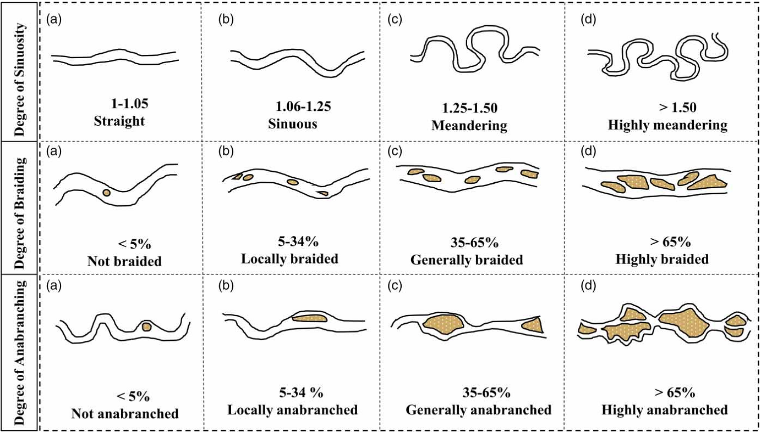
Figure 1: Definition of Channel Morphology Based on Feature Parameters
Source [12], [13]
Table 2. Logistical Performance Indicators (LPIs) for Inland Waterway Transport
Indicator | Definition | Measurement Unit | Relevance to Inland Waterway Logistics
Average Vessel Speed | Mean travel speed of vessels along navigable channels | km/h | Indicates navigation efficiency; affected by river depth, flow velocity, and obstructions
Voyage Duration | Total time taken for a vessel to complete a trip between loading and discharge points | Hours or days | Reflects the impact of channel morphology and delays on navigation time
Cargo Throughput | Total volume of goods transported over a given period | Tons/month or tons/year | Measures overall logistics productivity and capacity utilization
Fuel Consumption Rate | Quantity of fuel used per voyage or per ton-km | Litres/ton-km | Indicates operational efficiency and cost implications of navigation difficulties
Transport Cost per Ton-km | Total cost of moving one ton of cargo over one kilometre | ₦/ton-km | Measures economic efficiency and cost implications of morphological constraints
Channel Navigability Index | Ratio of navigable days per year to total days | % | Indicates the degree to which channel morphology supports year-round navigation
Delay Frequency | Number of navigation delays or stoppages per month | Frequency count | Measures reliability of navigation operations; linked to sedimentation and shallow depth
Cargo Loss/Damage Incidence | Proportion of cargo lost or damaged during transit | % | Assesses service reliability and safety under morphological challenges
Operational Cost Index | Total operating cost (fuel, labour, maintenance) relative to total revenue | Ratio (%) | Evaluates profitability and efficiency of logistics operations
Source: [11]
- Methodology
This study used explorative research techniques which involved field observations and hydrological study. Geospatial study was also done which involved GIS-based spatial mapping to provide a comprehensive understanding of morphological constraints and logistical implications. The study involved primary and secondary survey. Oral Interviews with boat operators were conducted to solicit information on logistical challenges. The field data covered a period of January 2011 to September 2023 to capture seasonal variabilities of channel depth. The study area is located within the riverine area of Ilaje Local Government Area of Ondo State, Nigeria. Ondo State lies specifically on Latitude 5⁰58’N and Longitude 4⁰59’E and Latitude in the south east, and 6⁰26’N and Longitude 4⁰36’E. As shown in Figures 2 and 3, it is located in the south-western geopolitical zone of Nigeria and bounded in the north by Ekiti and Kogi States, in the east by Edo State, in the west by Osun and Ogun states, and in the south by the Atlantic Ocean. Ondo State is located entirely within the tropics [14].
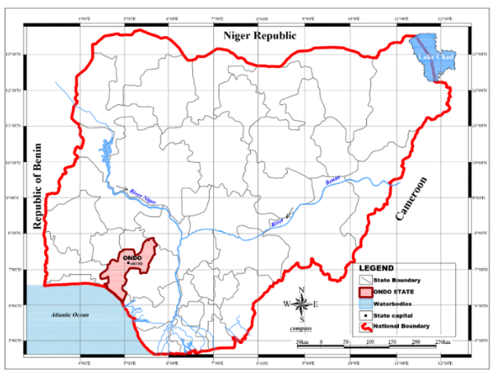
Figure 2: Ondo State Map in its National Setting;
Source: [15]
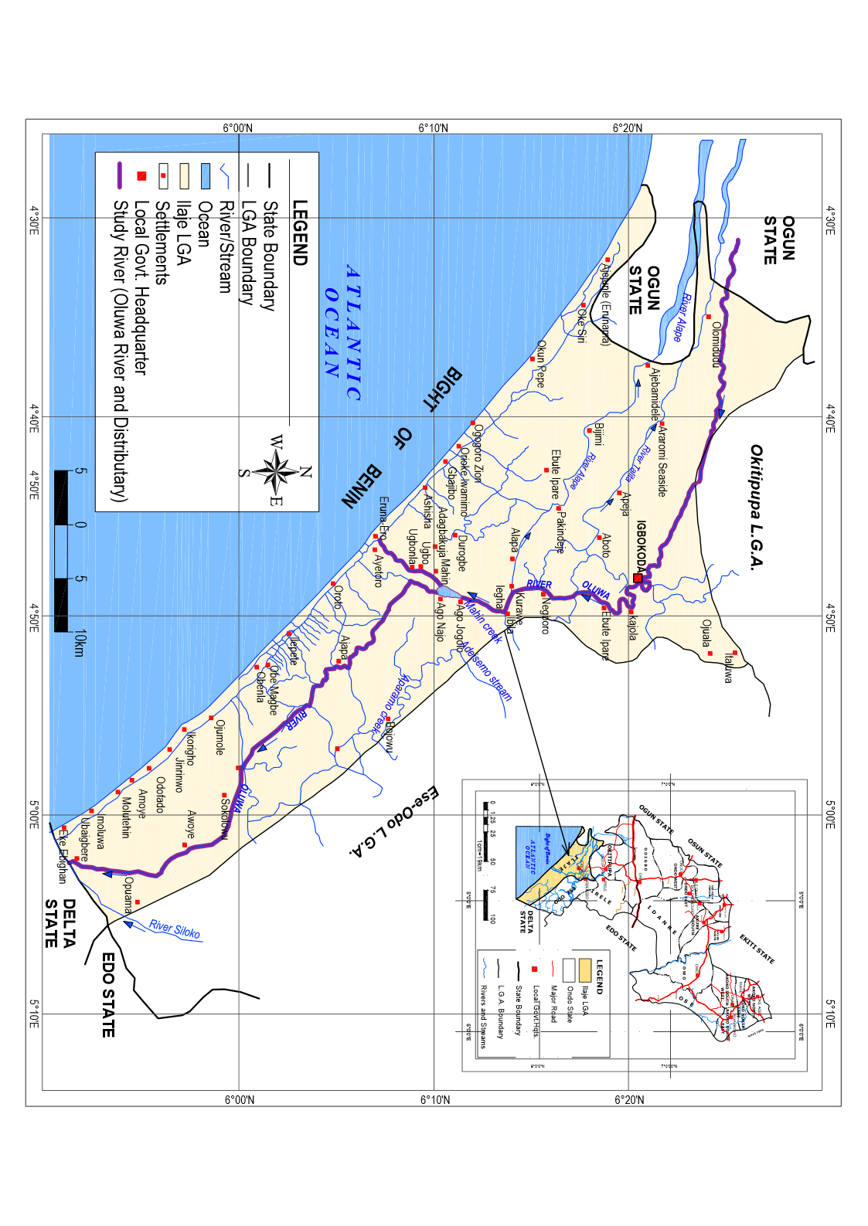
Figure 3: Study Area in its Ilaje Local Government Area Regional Setting; Source: [15]
Hydrographic measurements were carried out using echo sounder with bank to bank investigation at 150m distance to reveal the current condition of the river channel depth. The study relied on the post-dredged depths data of the river channel (reaches) done in the year 2011. Global Positioning System (GPS) handheld and calibrated staffs were used to confirm channel depth, and conduct ground truthing at selected reaches along the waterway. The river channel was dredged in the year 2011, hence the year was used as the base year for study. Figure 4 is the typical cross section of canal section.
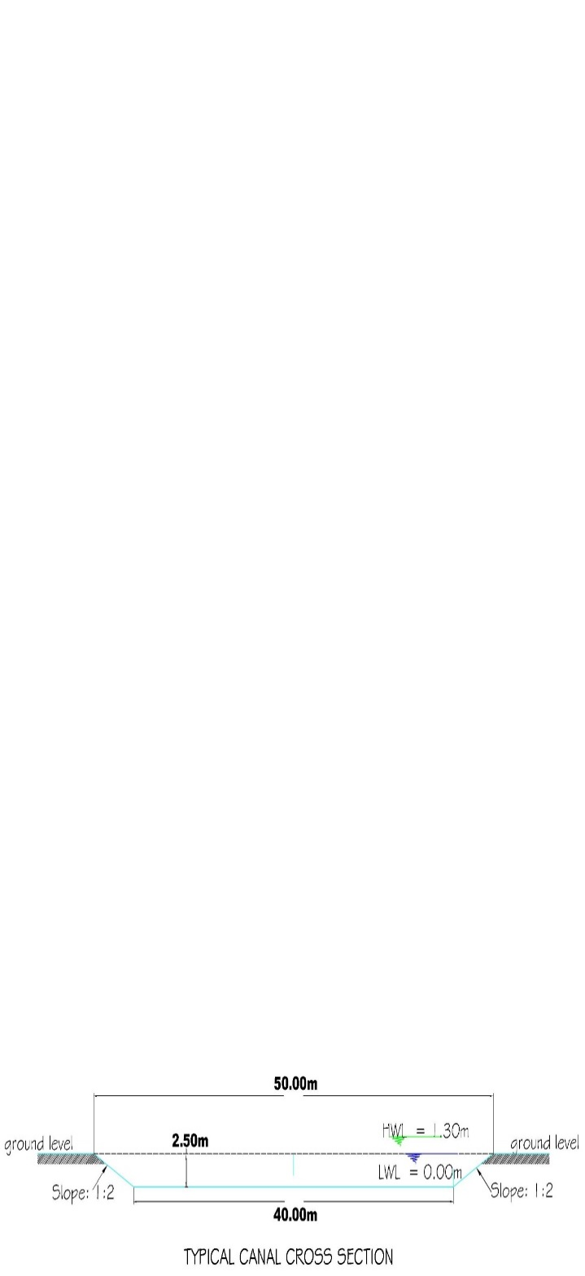
Figure 4: Typical Canal Cross Section Used for the waterway channel dredging.
Source: [16]
Spatial Analysis: GIS tools (ArcGIS 10.7) and AutoCAD, were used to map morphological variability, identify shallow sections, and visualize navigational constraints. Time-series analysis was applied to assess river planforms, seasonal trends in water levels and sedimentation. Overlay maps were generated and digitized to identify and correlate sedimentation zones with reported navigation disruptions. Policy documents, literature, articles and previous academic studies were reviewed to contextualize findings and identify gaps.
- Results and Discussion
Figures 5, 6 and 7 are chart extracts of the hydrographical results of study conducted, while table 2 indicates the average channel depth at three major zones in the river system. The study revealed significant depth variability in the inland waterway channel with average depths ranging between 2.5 and 3.5 m during the wet season as shown in the Table 3. There was depths reduction below 2m during the dry months due to sediment deposition. The upper stream zone of the river system maintains relatively stable depth and width due to steeper gradients and higher flow velocity. The average depth loss for twelve (12) years (between years 2011 and 2023) is relatively between -0.39 and -0.49 during the wet and dry seasons respectively.

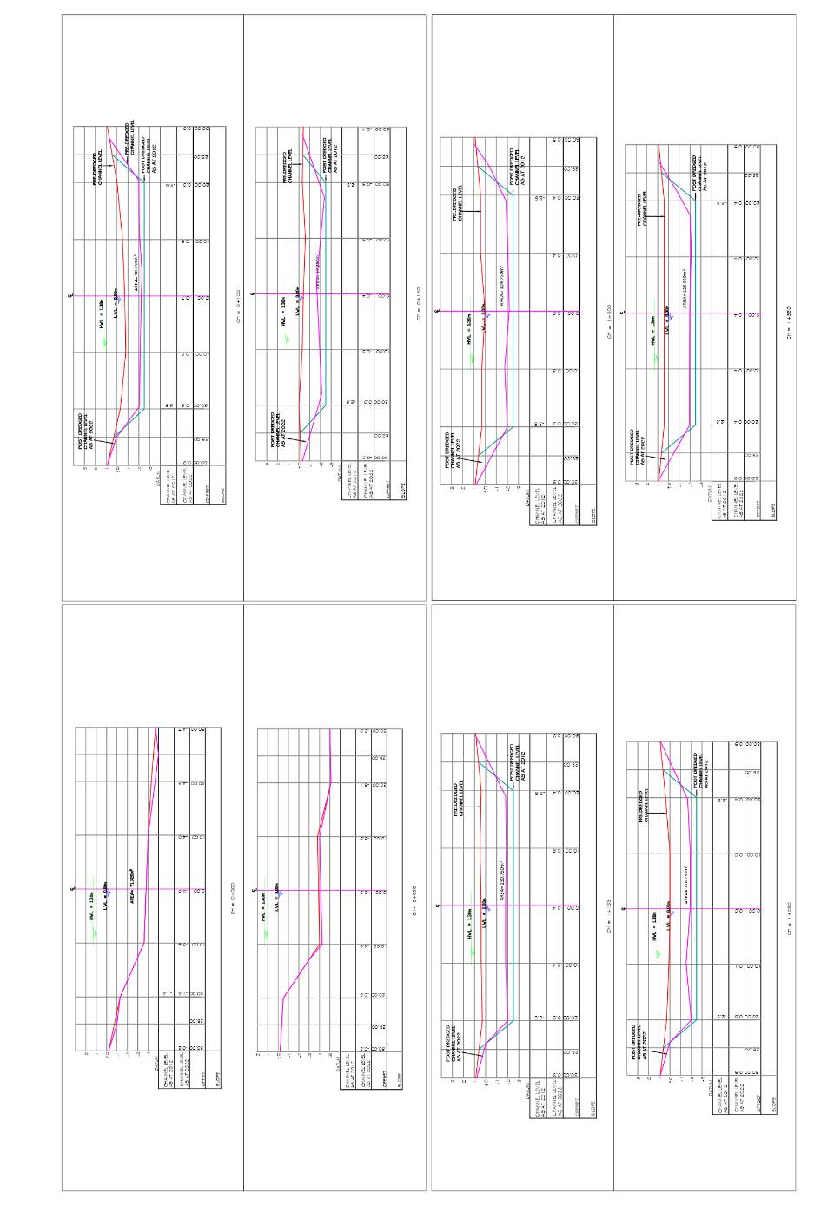
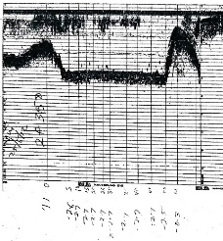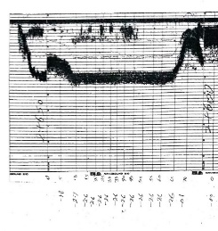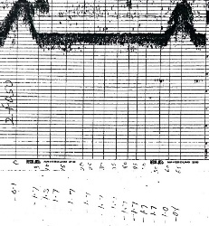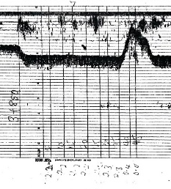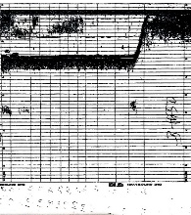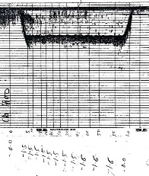
Figure 5: River Sounding data obtained during field study
Source: Authors, 2024

Figure 6: Cross Sectional Drawings of the channel draft
Source: Authors, 2024

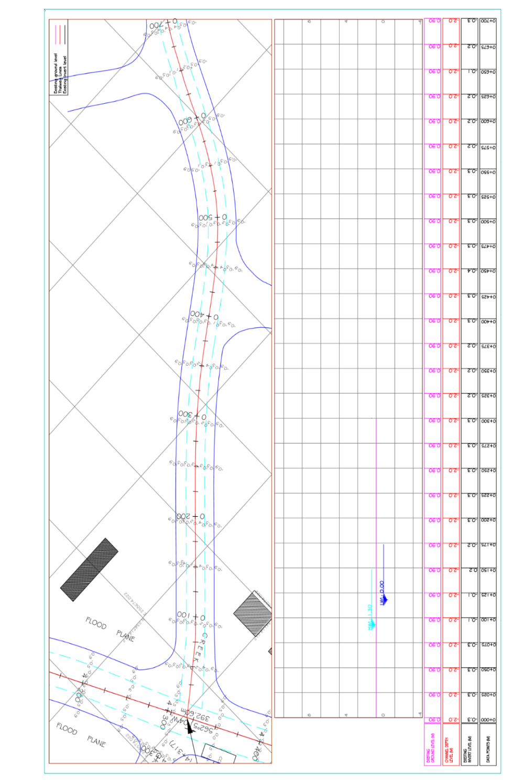
Figure 7: Profiling sections of the waterway channel in the study area
Source: Authors, 2024

Table 3: Water Depth of the River Channel Zones
Period | River sections | Water depth 2011 |  |  |  | Depth (m)  2023 | Depth  Loss due to silting
Period | River sections | Pre-dredge water depth in 2011 | Canal Depth after dredging in 2012 | HWL  Above LWL (0.00m) | Actual Depth  2012 | Water depth  2023 | Depth  Loss due to silting
Rainy Season | Upper stream Zone | 4.8 | 4.8 | - | 4.80 | 4.41 | -0.39
Rainy Season | Middle Stream Zone | 1.40 | 3.5 | 1.3 | 4.80 | 3.77 | -1.03
Rainy Season | Lower Stream zone | 1.80 | 2.5 | 1.3 | 3.80 | 1.33 | -2.47
Dry Season | Upper stream Zone | 1.75 | 3.5 | 1.3 | 3.5 | 3.10 | -0.40
Dry Season | Middle Stream Zone | -0.1 | -3.5 | 1.3 | 3.5 | 2.47 | -1.03
Dry Season | Lower Stream zone | -0.5 | -2.5 | 1.3 | 2.5 | 1.03 | -1.47
Source: Authors, 2024

The waterway channel exhibited some erosion and deposition processes causing such significant changes in its shapes and curves. This implies that there are continuous changes in the riverbed particularly at inner bends owing to the sediment depositions and unremitting protrusion on the concave (outer) bend of the river channel. As shown in Figure 8, cross sections A-A and C-C revealed actions of bottom and surface currents on erosion and deposition of sediments in the river reaches, while cross section B-B shows a passage free for save navigations. Identifying recurrent changes in the morphology of rivers is necessary in the production of nautical charts for safe ferry/vessel navigation.
Figure 8: Cross Section Formations at River Curvatures
Source: Adapted from [17]

According to Kastrisios and Ware, the need for constant updates of bathymetric data and the production of nautical charts has become more prominent in contemporary maritime navigation with the increasing sizes of watercraft that operate in tighter or narrower waterway spaces [18]. Highly meandering river status is most profound in Reach A with sinuosity index values greater than 1.5. The implication of these continuous changes is uncertainties in the river way navigability. This increases vessels’ vulnerability to accident by collision against river bank or another vessel; slower speed and difficulty in vessel manoeuvrability at river curvatures. Identifying recurrent changes in the morphology of rivers is necessary in the production of nautical charts for safe ferry/vessel navigation. The need for constant updates of bathymetric data and production of nautical charts becomes more prominent in contemporary maritime navigation with the increasing sizes of watercraft that operate in tighter or narrower spaces or waterway channels [18].

  - Morphological Attributes and Logistical Performance Indicators

The study revealed that river morphology attributes including river planforms, changing pattern of sinuosity index (SI), river width, river depth, river velocity significantly influenced inland navigation, movements of freight and transport Logistic in the study area. Historical data on the river channel characteristics was conducted using geospatial technique to assess patterns and trends in the morphology of the waterway channel (Igbokada-Ayetoro inland waterway). The analysis provided valuable insights into the processes that shaped the river channels, how they respond to environmental changes, and how they influence inland water channel, navigation and movement of freights in the study area. According to [19], the shape of the river plan is very important in waterway transport design and planning. It is seen as the appearance of a river system from above. In general, the planforms of alluvial rivers can be classified as sinuous, braided, straight, and meandering (curved).
As shown in Figure 9, Findings revealed that Reach A, Reach B, and Reach C exhibited significant changes in the patterns of the river course between 1972 and 2012 in forms of river widening and narrowing a lateral movement across its watershed or floodplain of the Ilaje riverine area. This is in consonance with [20], who opined that river channel shifting involves the lateral migration of an alluvial river channel across its floodplain. The effects of river channel migration/shifting on the inland waterway transport are highly significant as alterations were observed in the river course.

The study revealed spatial variations of the channel planforms of 1972 and 2022. Meanwhile, the enlarged six different sites (locations) along the waterway channel revealed a clear indication of bankline shifting (Figure 9). Location 6 revealed a migration distance of 254.39metres away from 1972 channel bankline. The location 1 showed a propensity of eventual joining of SRH4 and SRH7; Location 2 is an extension of Location 1 revealing the highly meandering status of the entire Reach 1. Location 5 exhibited braided channel patterns characterised by isolated islands of deposited materials.
Figure 9: Channel shifting from 1972 and 2022
Source: Authors, 2024

Channel siltation & variable depth: The high sand fraction combined with silt fractions in sheltered zones and the dynamic tidal regime favour sediment deposition in shallow channels, reducing navigable depth during low-water or dry periods. This impedes larger vessels or barges reliant on consistent draft.
Slower speeds and Increased Travel Time: Travel time between Igbokoda and Ayetoro increased due to the channel extension and an increase in the angle of deflection in some reaches of the waterway channel. Narrower and bend sections of the reaches require vessels (watercrafts) in transit to slow down, as there is less sight distance (visibility) and less room for two vessels (watercrafts) on the two-way manoeuvring lanes to manoeuvre and the risk of collisions is higher, resulting to increased travel times and reduced efficiency. Taking cognizance of speed and minimum sight distance, Benetou and Tate asserted that the operating speeds are considerably lower at locations where the minimum sight distances are below 250 feet (76.2 m) than at locations where the lowest sight distances are greater than 500 feet (152.4 m) [21]. The radius of the curve and the angle of deflection are directly related to visible sight distance and the speed of the vehicle on curvatures (see Figure 10).
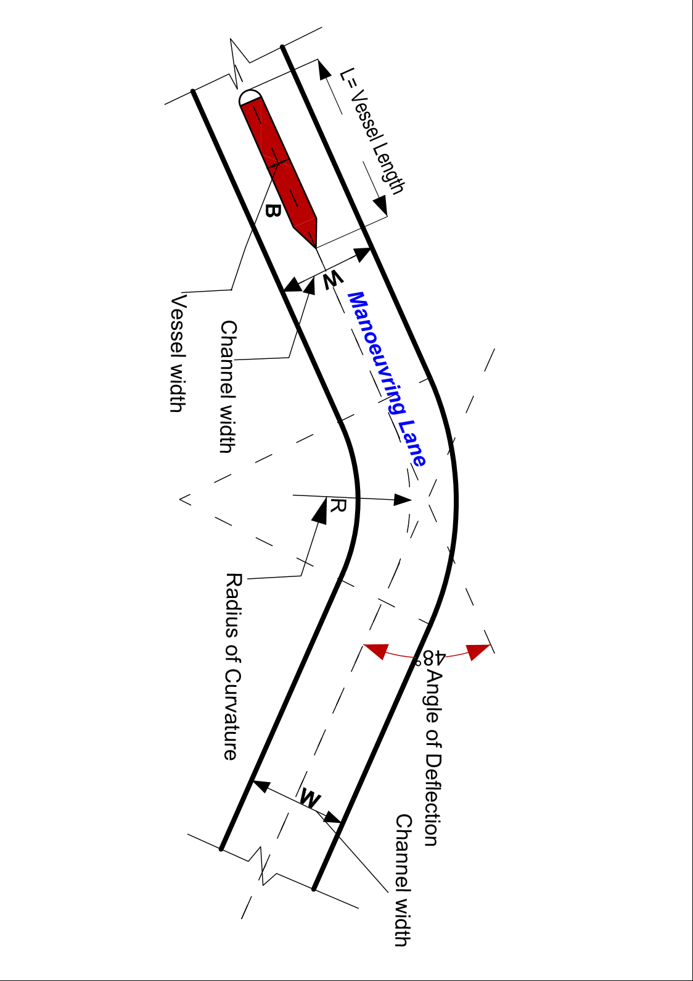
Figure 10: Illustration on the Angle of Deflection and vessel’s manoeuvrability at river curvature
Source: Author, 2024
The study revealed bankline shifting, channel elongations, increase in deflection angles at river curvatures/bends and the potential depth variability in river bed at bends. All of these occurrences had resultant effects on smooth navigation leading to increased travel time, distance and difficulty in watercrafts manoeuvres in the meandering river reaches. The results of sinuosity index show the effects of aggradation at inner bends and degradation at outer bends in the reaches during different flow conditions of the river. These caused variations in the channel patterns as there are observed differences in sinuosity indexes. Reach A (SRH 1-13) reveals more hazardous condition likely to result to grounding, ramming, collision and likely flood hazards as it exhibited the sinuosity index between 1.58, 2.09, 2.73 and 1.90 in 2022. Sub-reach (SRH) 6-10 with sinuosity index 2.09 and SRH 9-12 with sinuosity index 2.73 are highly vulnerable site to flood.
Bank instability and coastal erosion: Loose, permeable sandy sediments with low cohesion make the shoreline and riverbanks vulnerable to erosion and bank collapse, particularly where mangrove vegetation has been lost or compromised. This most noticeable at Ayetoro. This morphological instability alters navigation routes and increases dredging needs.
Transport logistics constraints: Frequent channel changes, shallow draft areas, and sediment‐induced routing detours translate into longer transit times, increased fuel consumption and heightened operational costs for inland waterway logistics. These are critical logistical performance indicators (LPIs) in waterway transport systems.
Increase cases of Grounding or Ramming: River bed exhibits a complex structure that has significant effects on depth variability, navigability, and manoeuvrability of watercrafts. The degree of depositions in the riverbed, and on the convex banks as well as erosion corkscrewing the concave banks contribute to uncertainty of river systems as the water continues to exaggerate the differences in depths between the inside and outside of a meander, making navigation more difficult, especially on meandering sections (Figure 11). Watercraft become susceptible to accidents such as collision, grounding, and ramming into submerged objects or sediments. This is in consonance with [22], that the safest path for vessel passage is the Thalweg line in a river channel. It is expected that this line path should be leteraly free of submerged obstructions.
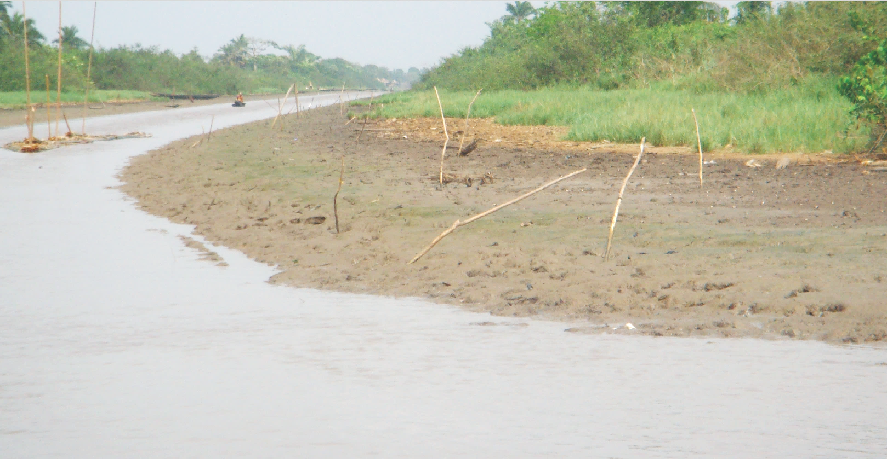
Silted area
Deposition at River bend
Figure 11: Appearance of sediments in the Bankline of a bend section of along the waterway
Source: Authors, 2024
Most of the boat operators in the study area rely on their pre-knowledge in identifying safer paths in red dotted lines (Thalweg line positions) on riverways; however, this is not safe enough for vessel navigations as the channel bed levels and Thalweg line positions at river bends exhibit continuous change over time.

Effects on Navigation Efficiency: The morphological dynamics directly affect navigation efficiency. Shallow channels, unstable banks, and unpredictable sedimentation patterns have resulted in frequent grounding of barges and passenger vessels, leading to increased voyage times and operational costs. Approximately 70% of surveyed boat operators reported navigation delays exceeding 3 hours on key inland routes during low-water periods. The presence of sharp meanders and shifting sandbars further limits maneuverability, particularly for cargo vessels with deeper drafts.
Socioeconomic and Environmental Dimensions: The morphological challenges also carry broader socioeconomic implications. Communities dependent on river transport for trade and mobility experience periodic isolation during dry seasons when navigation channels become impassable. Moreover, unregulated dredging and riverbank erosion have exacerbated habitat degradation, threatening fisheries and mangrove ecosystems.

  - Policy Implications
The results underscore the urgent need for an integrated river management framework that considers morphological dynamics in navigation planning. Periodic dredging, river training works, and the deployment of modern navigation aids can significantly enhance navigability. Strengthening institutional coordination among agencies such as NIWA, NIMASA, and state ministries of transport would also help optimize channel maintenance and logistics planning. Implementing data-driven hydrological modeling could further support predictive management of sedimentation and flow patterns to sustain year-round navigability. Given the dynamic sediment regime, there is an increased requirement for periodic dredging, real-time hydrographic monitoring and integrated coastal zone management to maintain navigability and support logistic efficiency.

- Conclusion and Future Scope
This study examined the influence of river morphology on inland navigation and transport logistics in Nigeria’s coastal regions, focusing on major waterways in the coastal region of Ilaje, Ondo State Nigeria. Results reveal that pronounced spatial variability in river morphology, with shallow and unstable channels, high sedimentation rates, increase in channel sinuosity index, frequent meander shifts and bank stability significantly affect smooth navigation, operational efficiency, and the overall performance of the inland waterway logistics sector. These morphological dynamics significantly increase voyage duration, fuel consumption, and operational costs, vessels’ vulnerability to submerged accumulated sediments, reducing cargo throughput and overall transport efficiency. These morphological constraints undermine the potential of inland waterways as a viable complement to road and rail transport networks in the region and Nigeria at large. The study also highlighted the ecological and socioeconomic implications of these morphological challenges. Reduced navigability disrupts trade flows, accessibility and community mobility. Therefore, understanding and managing river morphology is essential for enhancing inland navigation efficiency and promoting sustainable transport logistics in coastal regions.
The morphodynamic interactions diminish freight efficiency, raise maintenance dredging costs, and threaten the socio-economic viability of the riverine transport corridors. In recommendation, this synthesis underscores that without addressing underlying morphological instability, infrastructural and policy interventions alone cannot ensure reliable waterborne transportation in Nigeria’s dynamic coastal systems. Sustainable inland navigation in such environments as riverine areas requires an integrated river management framework that combines continuous hydro-morphological monitoring, sediment management, and adaptive navigation planning. The future scope of the study should focus on the strategic erosion control and bank stabilization Integrating engineering measures (revetments, vegetative reinforcement) with hydrological monitoring, Periodic Dredging and Channel Maintenance for adequate depth and width of navigable channels, hydrographic monitoring and data management for real-time data on channel dynamics, enabling predictive management of siltation and flow variations as well as research and capacity development
Data Availability
Data used for this study was gotten from field investigation, United State Geological Survey (USDS) ‘the satellite imageries for spatio-temporal analysis. Techniques adopted were adapted from literature reviews.
Study limitation: None

Conflict of Interest
The authors have no conflicts of interest to declare that are
relevant to the content of this article..

Funding Source
No funding was received for conducting this study.

Authors’ Contributions
B.S. Olisa carried out the study at all stages, develop the procedures used in carrying out the geospatial analysis using ArcGIS and Computer aided techniques. He did all typesetting and formatting of the document.
C.L Olisa participated in collection of primary data during field investigation and generation of geospatial maps and analysis for the study.

Acknowledgements
We acknowledge all the authors cited in the paper. Profound appreciations also go to Professor Ebisemiju, Professor M.S. Stephens and Professor (Engr.) Ajaka their good works and professional inputs really gave a light of knowledge to this research.

References
[1]. L. Joan Florsheim, F. Jeffrey Mount, Anne Chin. Bank Erosion
as a Desirable Attribute of Rivers. Bio Science, Vol. 58, No 6, pp 519–529, https://doi.org/10.1641/B580608. Published: 2008
[2]. I. A. Adewumi, A. S. Olalekan, Inland Waterways Transportation
in Nigeria: Challenges and Prospects. Journal of Transport and Logistics, Vol. 5 No 2, pp 45–58, 2020
[3]. S. I Nwankwo, C. A. Eze, C. Okoro, River Morphology and
Navigation Challenges in the Niger Delta. Nigerian Journal of Geography and Environment, Vol.12 No. 1, pp 23–37, 2019
[4]. Oni, S. I., & Okanlawon, K. R. (2008). Transport Infrastructure and
Logistics in Nigeria: The Role of Inland Waterways. African Journal of Economic Policy, Vol. 13, No. 2, pp 67–84.
[5] E. Kusratmoko, A. Wibowo, K.A.Ahmad.. Changes in the Value of Sinuosity Index in Komering River Channel, Province South Sumatera Years 1990 - 2016. Southeast Asian Geography Association (SEAGA) 13th Conference (p. IOP Conf. Series: Earth and Environmental Science pp 338 (2019) 012024). New York: IOP Publishing. doi:doi:10.1088/1755-1315/338/1/012024
[6] Geographic Information Science information and support, Using GIS to determine stream sinuosity. 2014.
[7] L. B. Leopold, M. G. Wolman, River Channel Patterns: Braided, Meandering, and Straight. Geological Survey Professional Paper 282. 2020 B, U.S. Government Printing Office.
[8] C. R. Thorne. Channel migration and hydraulic controls in meandering rivers. River Research and Applications, Vol. 37 No 5, pp 767–779. 2021.
[9] R. I. Ferguson, Braided rivers and their stability: Processes and sedimentary controls. Earth Surface Processes and Landforms, Vol. 46 No. 9, pp 1745–1760, 2021
[10] T. K. S. Abam. Morphological evolution of Niger Delta river channels and implications for inland navigation. Geomorphology, pp 412, 108320. 2022
[11] B. E. Eze, H. O. Nwankwoala. Channel dynamics and navigability in Nigeria’s coastal waterways. Journal of African Earth Sciences, pp 198, 104812. 2023
[12] J. C Brice, J. C. Blodgett. Countermeasures for Hydraulic Problems at Bridges. Analysis and Assessment. Report No. FHWA-RD-pp 78-162. Washington Federal Highway Administration, Washington. 1978.
[13] L. Ziwei, Y. Chaode, M. W. Boota, Review and Outlook of River Morphology Expression. Journal of Water and Climate Change, pp 1725–1747. doi: https://doi.org/10.2166/wcc.2022.449. 2022
[14] National Population Commission, Nigeria. 2006.
[15] Ondo State Ministry of Physical Planning and Urban Development, 2021
[16] Ondo State Oil Producing Area Development Commission (OSOPADEC), 2012
[17] Fahmy, W., & Hekal, N. (2023). Study of Damietta branch meander suitability for inland first-class river cargo transportation. Journal of King Saud University- Engineering Services, 35(7), 450-462. Retrieved from https://doi.org/10.1016/j.jksues.2021.06.003
[18] C. Kastrisios, C. Ware. Textures for Coding Bathymetric Data Quality Sectors on Electronic Navigational Chart Displays: Design and Evaluation. Cartogr. Geogr. Inf. Sci., Vol. 49, pp 1–20. 2022
[19] C .Hadrian. River Channel Planforms and Floodplains: A Study in the Wessex Landscape. (K.U. Department of Geography and Geology, Ed.) Landscape History, Vol. 38 issue 1, pp. 5-24. 2022, http://doi.org/10.1080/01433768.2018.1466548
[20] S. Baniya, R. Deshar, R. Chauhan, & S. Thakuri. Assessment of channel migration of Koshi River in Nepal using Remote Sensing and GIS. Elsevier-Environmental Challenges, pp 11, 2023. doi:https://doi.org/10.1016/j.envc.2023.100692
[21] S. L. Jamson, D. Benetou, & F. Tate (2015). The Impact of Arc Visibility on Curve Negotiation. Advances in Transportation Studies, Vol. 37, pp 79-92. http://eprints.whiterose.ac.uk/87622/
[22] M.A. Wilzbach,, & K. W. Cummins. Encyclopedia of Ecology (Second Edition ed.). (B. Fath, Ed.) Elsevier B.V. 2019
[23]A.D. Olabode, & O. A. Adekola. Assessment of fluvial geomorphology and its implication for inland waterway management in Nigeria. African Journal of Water Resources and Environmental Management, Vol. 5(3), pp 112–124. 2023

