Three-Week Combined Manual Hip Mobilization and Progressive Weight-Bearing Training Improves Pain, Range of Motion and Functional Disability in Young Adults with Early-Stage Avascular Necrosis of the Femoral Head: A Quasi-Experimental Study

Authors:
Pratiksha Sayam¹, Harshada Wasade², Asavari Barshikar³, Vedanti Bhure⁴, Khushi Gelda⁵, Rajas Mudey⁶

Affiliations:
Department of Musculoskeletal Physiotherapy, Datta Meghe College Of Physiotherapy, Nagpur, Maharashtra, India.¹
Department of Musculoskeletal Physiotherapy, Datta Meghe College Of Physiotherapy, Nagpur, Maharashtra, India.²
Department of Musculoskeletal Physiotherapy, Datta Meghe College Of Physiotherapy, Nagpur, Maharashtra, India.³
Department of Musculoskeletal Physiotherapy, Datta Meghe College Of Physiotherapy, Nagpur, Maharashtra, India^{.4}
Department of Musculoskeletal Physiotherapy, Datta Meghe College Of Physiotherapy, Nagpur, Maharashtra, India.⁵
Department of Musculoskeletal Physiotherapy, Datta Meghe College Of Physiotherapy, Nagpur, Maharashtra, India.⁶

Corresponding Author:
Pratiksha Sayam¹
ORCID ID: 0009-0008-3382-4125
Email: pratikshasayam90@gmail.com

ABSTRACT
Background: Avascular necrosis (AVN) of the femoral head is a progressive musculoskeletal condition characterized by compromised blood supply leading to bone tissue death, pain, reduced mobility, restricted hip joint range of motion, and functional disability. Early-stage AVN commonly affects young adults and may progress rapidly to femoral head collapse if left untreated.
Objective: To evaluate the effectiveness of manual hip mobilization combined with progressive weight-bearing training on pain, hip joint range of motion, and functional disability in young adults with early-stage avascular necrosis of the femoral head.
Methods: A quasi-experimental interventional study was conducted on 15 young adults diagnosed with radiographically confirmed early-stage AVN (Ficat–Arlet Stage I–II). Participants underwent a supervised physiotherapy intervention for three weeks consisting of Maitland Grade I, II and III manual hip mobilization combined with progressive weight-bearing training and routine physiotherapy exercises. Pain intensity, hip joint range of motion (ROM), and functional disability were assessed using the Numerical Pain Rating Scale (NPRS), universal goniometry, and Harris Hip Score (HHS). Statistical analysis was performed using paired t-test.
Results: Significant improvement in pain, hip joint range of motion, and functional outcomes was observed following the intervention. NPRS scores reduced from 6.2 ± 1.1 to 2.8 ± 0.9, while Harris Hip Score improved from 62.5 ± 6.8 to 84.2 ± 5.7 (p < 0.001). Hip joint range of motion was found to be restricted at baseline due to pain and capsular stiffness; however, following the three-week physiotherapy intervention, an increase in active hip range of motion was observed in all planes of movement as assessed using universal goniometry.

Conclusion: A three-week physiotherapy program consisting of Maitland Grade I,II and III manual hip mobilization combined with progressive weight-bearing training significantly reduced pain and improved hip joint range of motion and functional outcomes in young adults with early-stage avascular necrosis of the femoral head, suggesting its effectiveness as a conservative intervention to reduce disability and enhance hip function.
Keywords: Avascular Necrosis, Manual Therapy, Weight-Bearing Training, Harris Hip Score, Disability, Quasi-Experimental Study

INTRODUCTION
Avascular necrosis (AVN) of the femoral head is a progressive musculoskeletal disorder characterized by compromised blood supply to the femoral head, resulting in ischemic bone death and structural collapse of the articular surface. The condition commonly affects young adults and is associated with hip pain, joint stiffness, reduced range of motion, and functional limitations in weight-bearing activities such as walking, standing, and stair climbing. If left untreated, early-stage AVN may progress to femoral head collapse and secondary osteoarthritis, often necessitating total hip replacement at a relatively young age.
Restricted hip joint range of motion due to pain, capsular tightness, and altered joint biomechanics is one of the primary clinical impairments observed in individuals with early-stage AVN. These impairments significantly affect functional mobility and quality of life. Early conservative management strategies aimed at improving joint mobility and reducing disability are therefore essential to delay disease progression and minimize the need for surgical intervention.
Manual hip mobilization has been reported to improve joint congruency, decrease capsular stiffness, and enhance range of motion through mechanical and neurophysiological mechanisms. Similarly, progressive weight-bearing training facilitates neuromuscular activation, improves proprioception, postural control, and gait efficiency by promoting functional loading of the affected joint. Although individual physiotherapy interventions have shown potential benefits, limited evidence exists regarding the effectiveness of combined manual therapy and progressive weight-bearing training in improving pain, joint mobility, and functional disability in individuals with early-stage AVN. Therefore, the present study aimed to evaluate the effectiveness of manual hip mobilization combined with progressive weight-bearing training on pain, hip joint range of motion, and functional disability in young adults with early-stage avascular necrosis of the femoral head.

METHODOLOGY
A quasi-experimental interventional study was conducted in the outpatient department of a tertiary care hospital over a period of three weeks. Participants aged between 18–40 years with radiographically confirmed early-stage avascular necrosis of the femoral head (Ficat–Arlet Stage I–II), experiencing hip pain and having a Harris Hip Score between 60–90, were included in the study. Individuals with advanced AVN (Stage III–IV), previous hip surgery, fractures, acute trauma, infection, neurological conditions, or systemic comorbidities affecting gait were excluded.
A total of 15 participants fulfilling the inclusion criteria were recruited using simple random sampling after obtaining informed consent. Baseline assessment was conducted prior to initiation of the intervention and reassessed following completion of the three-week physiotherapy program.
Pain intensity was assessed using the Numerical Pain Rating Scale (NPRS), an 11-point scale ranging from 0 (no pain) to 10 (worst imaginable pain). Functional disability related to hip joint involvement was evaluated using the Harris Hip Score (HHS), which assesses pain, function, deformity, and range of motion in individuals with hip pathology. Hip joint range of motion including flexion, extension, abduction, adduction, internal rotation, and external rotation was measured in degrees using a standard universal goniometer following standardized patient positioning protocols. Three readings were recorded for each movement and the average value was considered for analysis.
Participants received supervised physiotherapy intervention three sessions per week for three weeks (total of nine sessions). The intervention protocol consisted of Maitland Grade I, II, and III manual hip mobilization, progressive weight-bearing training including gait retraining, sit-to-stand practice, and step-up exercises, along with routine physiotherapy exercises such as isometric strengthening of quadriceps, hamstrings, and gluteal muscles, heel slides, and straight leg raises.

INTERVENTION PROTOCOL
Participants received supervised physiotherapy intervention three sessions per week for three weeks (total of nine sessions). The intervention protocol consisted of Maitland Grade I, II, and III manual hip mobilization applied to the affected hip joint for approximately 15 minutes per session. Mobilization techniques were performed within patient tolerance to reduce pain, improve capsular mobility, and enhance joint range of motion.
This was followed by progressive weight-bearing training for 20 minutes per session, which included functional activities such as gait retraining, sit-to-stand practice, and step-up exercises. Weight-bearing activities were progressed gradually based on the participant’s tolerance and functional ability in order to promote neuromuscular control, joint stability, and improved functional mobility.
In addition to the primary intervention, routine physiotherapy exercises were administered, including isometric strengthening of the quadriceps, hamstrings, and gluteal muscles, along with active-assisted exercises such as heel slides and straight leg raises to maintain muscle strength and joint mobility.
Outcome assessment was carried out using standardized and validated measures. Functional disability related to hip joint involvement was assessed using the Harris Hip Score (HHS), which evaluates pain, function, deformity, and range of motion in individuals with hip pathology. Pain intensity was measured using the Numerical Pain Rating Scale (NPRS), an 11-point scale ranging from 0 (no pain) to 10 (worst imaginable pain). Hip joint range of motion including flexion, extension, abduction, adduction, internal rotation, and external rotation was measured in degrees using a universal goniometer following standardized assessment procedures.
Baseline assessment was conducted prior to initiation of the intervention and reassessment was performed after completion of the three-week physiotherapy program

RESULTS
The study demonstrated significant improvement in Pain, and Functional outcomes following the intervention.
Outcome Measure | Pre-Treatment (Mean ± SD) | Post-Treatment (Mean ± SD)
NPRS (0–10) | 6.2 ± 1.1 | 2.8 ± 0.9
Harris Hip Score (0–100) | 62.5 ± 6.8 | 84.2 ± 5.7
Statistical analysis using paired t-test revealed significant improvement in NPRS and HHS scores (p < 0.001).
Significant improvement in hip joint range of motion, outcomes was observed following the three-week physiotherapy intervention. Hip joint range of motion was restricted at baseline; however, post-intervention assessment demonstrated improvement in active range of motion across all planes of hip movement.
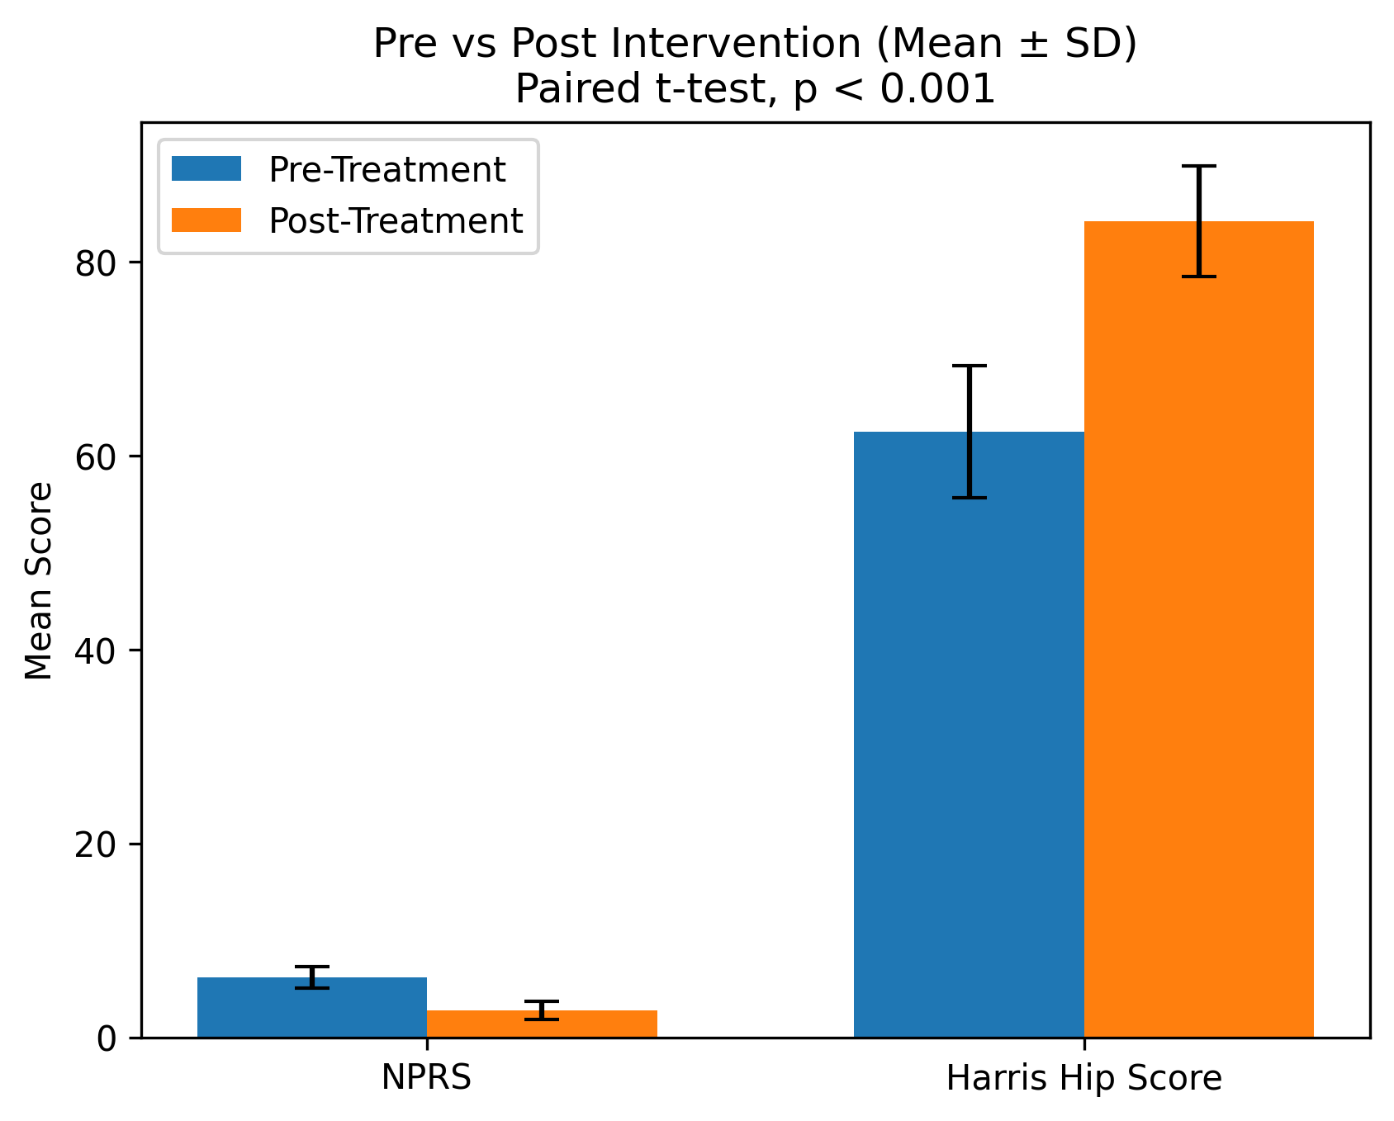
Pre and Post intervention of NPRS and Harris Hip Score
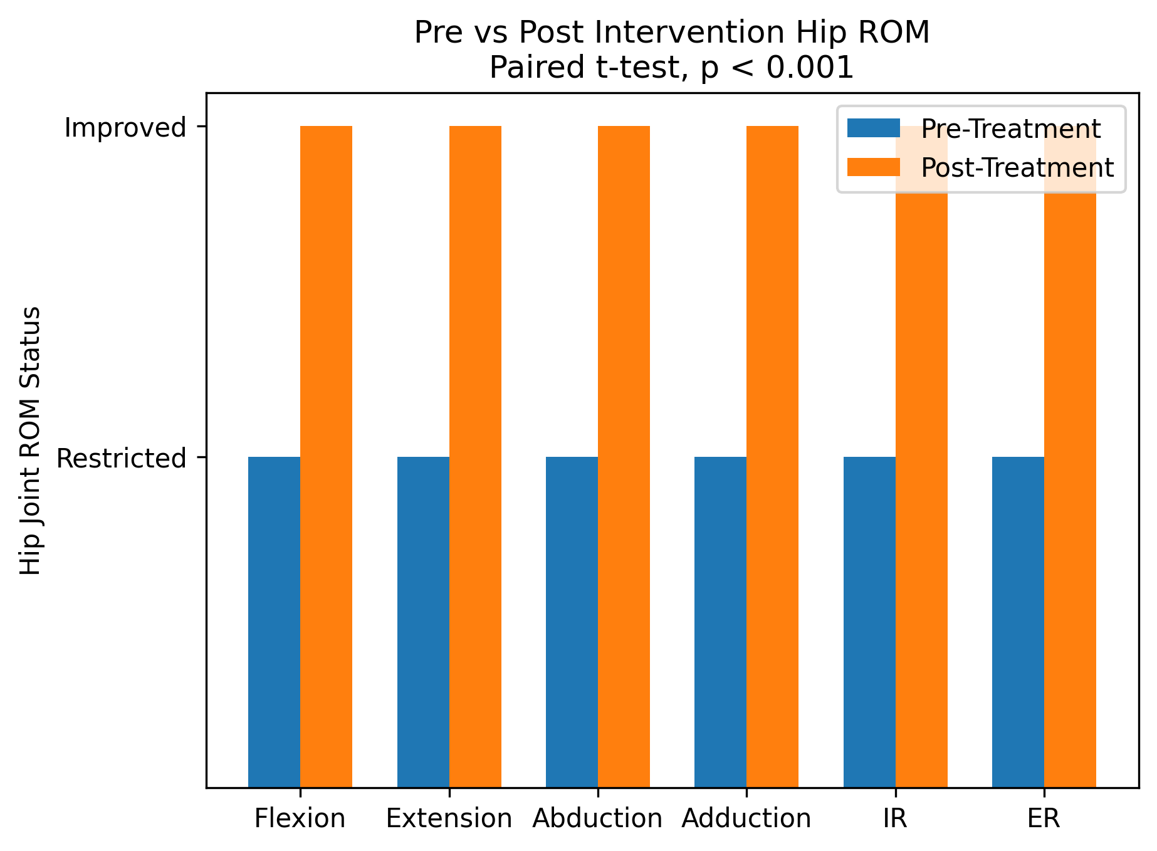
Pre and Post Intervetion Score of Hip ROM

DISCUSSION
The present quasi-experimental study demonstrated that a three-week physiotherapy intervention consisting of Maitland Grade I,II and III manual hip mobilization combined with progressive weight-bearing training resulted in significant reduction in pain and improvement in functional ability among young adults with early-stage avascular necrosis of the femoral head. The reduction in NPRS scores from 6.2 ± 1.1 to 2.8 ± 0.9 and improvement in Harris Hip Score from 62.5 ± 6.8 to 84.2 ± 5.7 indicate enhanced joint function and decreased disability following the intervention. Additionally, improvement in active hip range of motion across all planes of movement suggests increased joint mobility following the physiotherapy program.
Maitland mobilization Grades I and II are known to produce pain-relieving effects through stimulation of joint mechanoreceptors and inhibition of nociceptive transmission at the spinal cord level. Grade III mobilization, applied at larger amplitudes into tissue resistance, helps in improving capsular extensibility and joint mobility by stretching periarticular structures and enhancing synovial fluid distribution. These mechanical effects may contribute to improved joint nutrition and range of motion in the affected hip joint.
Progressive weight-bearing training facilitates neuromuscular re-education, improves proprioceptive input, and enhances muscle strength and postural stability. Functional loading activities such as gait retraining, sit-to-stand practice, and step-up exercises promote joint stability and improve weight transfer ability, thereby contributing to improved functional performance.
The combined application of manual mobilization and progressive weight-bearing exercises may therefore play an important role in reducing pain and improving functional outcomes in individuals with early-stage AVN.

CONCLUSION

The present quasi-experimental study demonstrated that a three-week physiotherapy program consisting of Maitland Grade I, II, and III manual hip mobilization combined with progressive weight-bearing training significantly reduced pain and improved hip joint range of motion and functional outcomes in young adults with early-stage avascular necrosis of the femoral head. The observed improvement in NPRS and Harris Hip Score along with increased hip joint mobility suggests that early, structured physiotherapy intervention may serve as an effective conservative strategy to reduce disability, enhance hip function, and potentially delay the need for surgical management.

LIMITATIONS
The study was limited by small sample size, short duration of intervention, lack of control group, and absence of long-term follow-up.

RECOMMENDATIONS FOR FURTHER RESEARCH
Future studies should include larger sample sizes with randomized controlled trial designs to strengthen evidence. Long-term follow-up is recommended to assess sustainability of functional improvements and disease progression. Incorporating imaging modalities and objective biomechanical assessments may provide better understanding of structural and functional changes associated with physiotherapy interventions in early-stage AVN.

REFERENCES :
- Mont MA, Cherian JJ, Sierra RJ, Jones LC, Lieberman JR. Nontraumatic osteonecrosis of the femoral head: where do we stand today? J Bone Joint Surg Am. 2015;97(19):1604-1627.
- Zhao DW, Yu M, Hu K, Wang W, Yang L, Wang BJ, et al. Prevalence of nontraumatic osteonecrosis of the femoral head in China. J Bone Miner Res. 2015;30(5):918-924.
- Moya-Angeler J, Gianakos AL, Villa JC, Ni A, Lane JM. Current concepts on osteonecrosis of the femoral head. World J Orthop. 2015;6(8):590-601.
- Ficat RP, Arlet J. Functional investigation of bone under normal conditions. In: Hungerford DS, editor. Ischemia and Necrosis of Bone. Baltimore: Williams & Wilkins; 1980. p. 29-52.
- Maitland GD, Hengeveld E, Banks K, English K. Maitland’s Vertebral Manipulation. 8th ed. London: Elsevier; 2014.
- Kisner C, Colby LA, Borstad J. Therapeutic Exercise: Foundations and Techniques. 7th ed. Philadelphia: FA Davis; 2017.
- Neumann DA. Kinesiology of the Musculoskeletal System. 3rd ed. St. Louis: Elsevier; 2017.
- Norkin CC, White DJ. Measurement of Joint Motion: A Guide to Goniometry. 5th ed. Philadelphia: FA Davis; 2016.
- Bijur PE, Silver W, Gallagher EJ. Reliability of the Numerical Pain Rating Scale for measurement of acute pain intensity. Acad Emerg Med. 2001;8(12):1153-1157.
- Harris WH. Traumatic arthritis of the hip after dislocation and acetabular fractures: treatment by mold arthroplasty. J Bone Joint Surg Am. 1969;51(4):737-755.
- French HP, Cusack T, Brennan A, Caffrey A. Exercise and manual therapy for hip osteoarthritis. Phys Ther Rev. 2011;16(3):196-204.
- Hoeksma HL, Dekker J, Ronday HK, Heering A, Van der Lubbe N, Vel C, et al. Manual therapy in osteoarthritis of the hip. Arthritis Rheum. 2004;51(5):722-729.
- Bennell KL, Egerton T, Pua YH, Abbott JH, Sims K, Metcalf B, et al. Efficacy of physiotherapy management for hip osteoarthritis. Ann Rheum Dis. 2014;73(2):317-323.
- Trudelle-Jackson E, Smith SS. Effects of exercise on pain and function in patients with hip osteoarthritis. Phys Ther. 2004;84(12):1142-1156.
- Fransen M, McConnell S. Exercise for osteoarthritis of the hip. Cochrane Database Syst Rev. 2014;4:CD007912

