Phytochemistry of medicinal plant –Piper longum
¹Dr.A.Anita,²J.J.Jerlin, ³R. Nigisha, ⁴J. Jesslin Blessy, ⁵ S. Breeza Roy, ⁶ J. Sweety Puspha
¹Assistant professor, Department of Chemistry, St. Alphonsa College of Arts and Science, Soosaipuram, Karinkal. Tamil Nadu, India.
2,3,4,5,6,^{III B.Sc Chemistry Students}
¹email: anitavasantham@gmail.com
ABSTRACT:
Medicinal plants constitute the main source of new pharmaceuticals and healthcare products. Plant based medicinal compounds is long established to be used as traditional treatment for innumerable human diseases from time immemorial in many parts of the world. Phytochemicals are responsible for medicinal activity of plants and these biochemicals are naturally occuring in the plants that have defense mechanisms and protect from various diseases.Their use has been multiplied through various researchers and application due to a number of side effects from use of synthetic drugs, antibiotics and high cost. In the present study, the dried parts of Piper longum was subjected to phytochemical, physicochemical and antimicrobial studies. Phytochemical analysis reveals maximum number of phytochemicals are present in piper longum chloroform leaves and fruit extracts compared to ethanol extract. Physico-chemical analysis showed that the plant contain appropriate amount of silica materials, contaminants and is less affected by microbial attack. Antimicrobial activity performed on bacterial strains also showed significant results. From this it is known that this medicinal plant is pharmaceutically important.

Key terms: antibiotic, bacterial strains, antimicrobial, defense, synthetic
INTRODUCTION:
Plant derived natural products hold great promise for discovery and development of new pharmaceuticals^{[1]}. WHO has considered phytotherapy in its health programmed; because these drugs are safe, cost effective and most importantly people have faith in them^{[2]}. The phytochemical found in plant parts which are natural bioactive compounds are divided into primary and secondary constituents. The secondary metabolites which include organic substances like alkaloids, terpenoids and phenolic compounds ^{[3]} are known to be responsible for the therapeutic potential of the herbal plants ^{[4]}. The phytochemicals also work as nutrients and fibers to activate the defense system against disease ^{[5]}. Medicinal herbs have been regarded as healthy sources of life by many people and now, the awareness is growing^{[6]}. Medicine from plant sources have been in use in Homeopathy, Ayurvedic, Allopathy and in traditional medicine since time immemorial. A medicinal plant plays a significant role among the traditional and modern systems their use has been multiplied through various researches and application due to a number of side effects from use of synthetic drugs, antibiotics and high cost. The people of rural area are mainly depending on the traditional medicine for curing their ailments because of the non availability of modern medicines and hospitals^{[7]}.

A wide variety of medicinal plants used traditionally have not yet been systematically investigated against various microbial pathogens ^{[8]}.It is well documented from ancient times that active principles from plant origin have been used as medicines for various diseases and microbial infections^{[9]}.
DESCRIPTION OF PIPER LONGUM:
Piper longum and plants belonging to the genus piper are common in Indian Ayurveda system of medicine^{[10]}. It has been used as medicine in rural and tribal areas in the world^{[11]}. The fruits and roots has numerous medicinal uses for diseases of respiratory tract, viz cough, bronchitis, asthma and analgesic when applied for muscular pains and inflammation; as snuff in coma and drowsiness and internally as carminative^{[12]}.
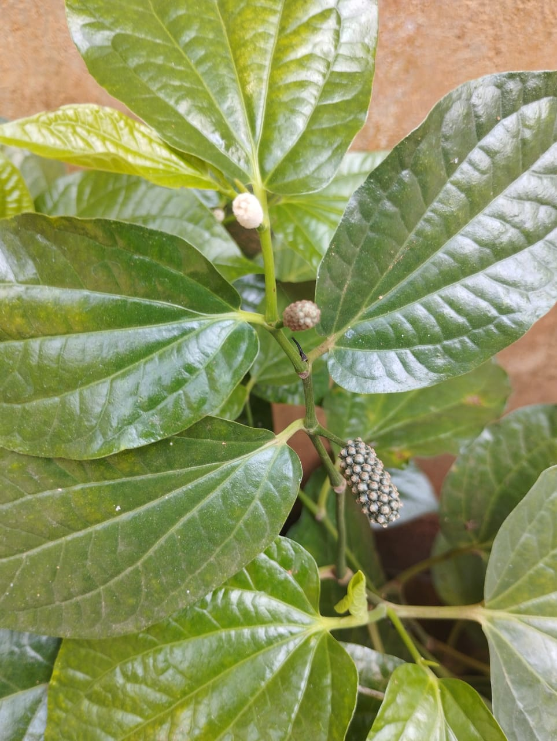
Fig:1 Represents Piper longum

MATERIALS AND METHODS:
Collection of plants:
The plant piper longum belongs to the family of Piperaceae has been collected from the areas of paloor and Muzhucode, Kanyakumari district.
Moisture content:
10 g of plant parts was weighed separately in pre weighed glass petri dishes and dried in hot air oven (80 - 95⁰C) for 3 hours. The dishes were then transferred to desiccators, cooled to room temperature and the weight was recorded. The drying was continued till the final weight became stable. The weight differences were noted and the moisture content was expressed in percentage weight of fresh plant parts^{[13]}.

Moisture content (%) =
Physicochemical analysis:
The leaves and fruits of piper longum were subjected to physico-chemical analysis. Total ash, acid insoluble ash, water soluble ash was done based on the standard methods^{[14]}.
i ) Determination of total ash

Total ash was determined by weighing 2 g of air dried sample in silica dish and incinerated at a temperature not exceeding 450⁰C until free from carbon and then was cooled and weighed.
ii) Determination of acid insoluble ash

The total ash was boiled with 25 ml of dilute HCl for five minutes. The insoluble matter was collected on ash less filter paper and was washed with hot water, ignited, cooled in a desiccator and weighed. The percentage of acid insoluble ash was calculated with reference to the air dried sample
iii) Determination of water soluble ash
The total ash was boiled with 25 ml of water for five minutes. The insoluble matter was collected on ash less filter paper and was washed with hot water, ignited for fifteen minutes at a temperature not exceeding 450⁰C. The weight of insoluble matter was subtracted from the weight of total ash. The difference in weight represents the water soluble ash. The percentage of water soluble ash was calculated with reference to the air dried sample.
Extraction of extracts from different solvents:
Maceration:
The dried fruits and leaves of piper longum is placed in a stoppered bottle with the chloroform and ethanol. It is allowed to stand at room temperature for a period of one week with frequent agitation until the soluble matter has dissolved. The mixture is then filtered and subjected to evaporation. The extracts were subjected to phytochemical screening analysis^{[15]}.
PRELIMINARY PHYTOCHEMICAL SCREENING ANALYSIS:
- Determination of Alkaloids:
About 3 ml of concentrated extract was taken in a test tube and 1 ml of HCl was added to the mixture which is heated gently for 20 minutes and is then cooled and filtered. The filtrate was used for the following tests.
i) Wagner’s test:
The filtrate was treated with Wagner’s reagent . Formation of brown reddish precipitate indicates the presence of alkaloids^{[16].}
- Test for Saponins:
- Froth test:
Exactly 0.5 g of the extract was dissolved in 2 ml distilled water in a test tube. Frothing which persisted on warming was taken as preliminary evidence for Saponins^{[17]}.
- Foam test:
5 ml of the extracts were mixed with 20ml of distilled water and then agitated in a graduated cylinder for about 15 minutes. Formation of foam indicates the presence of Saponins.
- Test for phenol:
Ferric chloride test:
Extracts were treated with 4 drops of alcoholic FeCl₃ solution. Formation of bluish black colour indicates
the presence of phenols^{[18]}.
- Test for Phytosterols
Libermann Burchard’s test:
Extracts were treated with chloroform and filtered. The filtrates were treated with few drops of acetic
anhydride, boiled and cooled. Concentrated sulphuric acid was added. The formation of brown ring at the
junction indicates the presence of phytosterols. Extracts were treated with chloroform and filtered. The
filtrates were treated with few drops of acetic anhydride, boiled and cooled. Concentrated sulphuric acid
was added. The formation of brown ring at the junction indicates the presence of phytosterols.
e) Test for Proteins
Xanthoprotein test

The extracts were treated with few drops of concentrated nitric acid. Formation of yellow colour indicates
the presence of proteins^{[19]}.

f) Test for Triterpenes
Salkowski test

Extracts were treated with chloroform solution and is then shaken with one or two drops of concentrated
sulphuric acid and then it is allowed to stand. Appearance of golden yellow colour indicates the presence of
triterpenes^{[20]}.
g) Test for Glycosides
i) Glycoside test

0.5 mg of the extract was dissolved in 1 ml of water and then the aqueous NaOH solution was added to the
extract. Formation of yellow colour indicates the presence of glycosides^{[21].}
ii) Concentrate H₂SO₄ test

To 5ml extract, add 2ml of glacial acetic acid, one drop 5% FeCl₃ and concentrated H₂SO₄. Appearance of
brown ring indicates the presence of glycosides^{[22]}.
h) Test for Tannins
Lead acetate test

To the extracts few drops of 10% lead acetate solution were added. Formation of precipitate indicates the
presence of tannins ^{[23]}.
i) Test for steroids
Salkowski’s test
5 ml of the extract was dissolved in 2 ml of chloroform and equal volume of concentrated sulphuric acid was
added along the sides of the test tube. The upper layer turns red and lower layer turns yellow with green
fluorescence, indicating the presence of steroids^{[24]}.
j) Test for coumarins:
10% NaOH (1ml) was added to 1 ml of the plant extracts. Formation of yellow colour indicates the presence of coumarins^{[25]}.
k)Test for Flavonoids
i) Pew’s test
To two ml of the extract zinc powder was added in a test tube, followed by dropwise addition of concentrated HCl. Formation of purple red or cherry colour indicates the presence of flavonoids..
ii) NaOH test:
To two ml of the extract sodium hydroxide were added in a test tube. Formation of intense yellow colour that becomes colourless on addition of few drops of dilute HCl indicates the presence of flavonoids^{[26].}
l) Test for carbohydrates
Molisch’s test
To two or three ml of the aqueous extract two drops of alpha napthol solution in alcohol is added and shaken well. Then add concentrated sulphuric acid from the sides of the test tube. Violet ring formation indicates the presence of carbohydrates^{[27].}

ANTIMICROBIAL ACTIVITY OF CHLOROFORM EXTRACTS OF PIPER LONGUM :
The antimicrobial activity of chloroform extracts of piper longum leaves and fruits was done by agar well diffusion method^{[28]}.Muller Hinton Agar plates were prepared and inoculated with test organisms (Staphylococcus aureus, Enterococus sps., Klebsiella pneumoniae, Pseudomonas aeruginosa) by spreading the bacterial inoculum on the surface of the media with the help of sterile swap. Wells (8mm in diameter) were punched in the agar by using cork borer. Extracts with concentration 50 ml were added. Positive control used is ciprofloxacin. The plates were incubated at 37 degree Celsius for 18 to 24 hours. The antibacterial activity was assessed by measuring the diameter of the zone of inhibition and recorded in mm.
Results and Discussions:
Yield of extracts
The dried fruits and leaves of piper longum subjected to Maceration process yields the extracts in appropriate proportions.
In case of piper longum fruits the maximum yield was obtained for ethanol extract (1.90g) and minimum yield is for chloroform extract (1.45g).
In case of piper longum leaves the maximum yield is obtained for chloroform extract (2.25g) and minimum yield is for ethanol extract (1.19g).
Physico-chemical parameters
The selected plant piper longum for the present study was subjected to physicochemical analysis. The results are discussed in the Table 1.1 and Fig 1.1

Table 1.1 Physico-chemical parameters of Piper longum
Sl. No | Name of the Physico-chemical constants | Piper longum leaves (% of composition) | Piper longum fruits  (% of composition)
1 | Moisture content | 28 | 23.6
2 | Total ash | 30.5 | 21
3 | Acid insoluble ash | 19 | 2.5
4 | Water soluble ash | 1.5 | 8

Table: 1.1 shows the physico-chemical analysis of piper longum fruits and leaves. The moisture content of piper longum fruits is found to be 23.6% and that of piper longum leaves was found to be 28%. The results showed that piper longum fruits is less affected by bacteria and fungal attacks. Total Ash values of piper longum leaves and fruits were found to be 30.5% and 21%. This reveals that the plant is less affected by contaminants. Acid insoluble ash results reveals that acid insoluble ash of piper longum leaves was found to be 19% and that of piper longum fruits was found to be 2.5%. The result shows that there is possibility of contamination with silica materials. Water soluble ash of piper longum leaves and fruits were found to be 1.5% and 8%. This indicates that the constituents present in piper longum fruits are more soluble in water. The percentage composition of crude powder of piper longum leaves and fruits were presented in the Fig 1.1.

Fig 1.1 Percentage composition of crude powder of Piper longum leaves
and fruits

Qualitative phytochemical screening analysis:
The phytochemical screening analysis performed on chloroform and ethanol extracts of piper longum leaves and fruits were discussed in the Table 1.2 ,1.3 and Fig 1.2.

Table 1.2 Preliminary phytochemical screening Analysis of Piper longum leaves:
Name of the phytochemical | Name of the test | C | E
Alkaloids | Wagner’s test | + | -
Saponins | Froth test | + | +
Saponins | Foam test | + | +
Phytosterols | Libermann- Burchard’s test | + | +
Proteins | Xanthoprotein test | + | +
Triterpenes | Salkowski test | - | -
Glycosides | Glycoside test | + | -
Glycosides | Concentrate sulphuric acid test | + | -
Tannins | Lead acetate test | + | +
Steroids | Salkowski’s test | + | -
Coumarins | 10%NaOH+1ml plant extract | - | -
Flavonoids | Pew’s test | - | -
Flavonoids | NaOH test | - | -
Carbohydrates | Molisch’s test | - | -

where, C - Chloroform extract, E - Ethanol extract + indicates present , - indicates absent

Table 1.1 represent the phytochemicals present in chloroform and ethanol extracts of piper longum leaves The phytochemical analysis was performed on Alkaloids, saponins, phytosterols, proteins, triterpenes, glycosides, Tannins, Steroids, Coumarins, Flavonoids and Carbohydrates. The results revealed that the phytochemicals Coumarins, Flavonoids, Triterpenes and Carbohydrates are absent in the chloroform extract of piper longum leaves. The phytochemicals Alkaloids, Glycosides and Steroids are present only in chloroform extract of piper longum leaves. In the ethanol extract the phytochemicals Saponins, Phytosterols, Proteins, Tannins were present. From the table, it is found that maximum number of phytochemicals are present in piper longum chloroform leaves extract compared to ethanol extract. From the table, it is found that maximum number of phytochemicals are present in piper longum chloroform leaves extract compared to ethanol extract.

Table 1.3 Preliminary phytochemical screening Analysis of Piper longum fruits

Name of the phytochemical | Name of the test | C | E
Alkaloids | Wagner’s test | + | -
Saponins | Froth test | + | +
Saponins | Foam test | + | +
Phytosterols | Libermann- Burchard’s test | + | -
Proteins | Xanthoprotein test | + | +
Triterpenes | Salkowski test | - | -
Glycosides | Glycoside test | + | +
Glycosides | Concentrate sulphuric acid test | + | +
Tannins | Lead acetate test | + | +
Steroids | Salkowski’s test | + | -
Coumarins | 10% NaOH + 1ml plant extract | - | +
Flavonoids | Pew’s test | - | -
Flavonoids | NaOH test | - | -
Carbohydrates | Molisch’s test | - | -

where, C - Chloroform extract E - Ethanol extract + indicates present - indicates absent

Table 1.2 represents the phytochemicals present in chloroform and ethanol extracts of piper longum fruits. The phytochemical analysis was performed on Alkaloids, saponins, phytosterols, proteins, triterpenes, glycosides, Tannins, Steroids, Coumarins, Flavonoids and Carbohydrates. The phytochemicals Saponins, Glycosides, Tannins and Coumarins were present in ethanol extract of piper longum fruits. The phytochemicals Alkaloids, Saponins, Phytosterols, Proteins, Glycosides, Tannins and Steroids were present in chloroform extract of piper longum fruits. The results performed on the analysis of phytochemical in ethanol extract of Piper longum fruits showed the presence of Saponins, Proteins, Glycosides. From the table, it is found that maximum number of phytochemicals are present in chloroform extract of piper longum fruits compared to ethanol extract.

Phytochemical screening analysis performed on chloroform and ethanol extracts of piper
longum fruits and leaves reveals that the maximum number of phytochemicals were present in
piper longum chloroform leaves extract compared to ethanol extract.

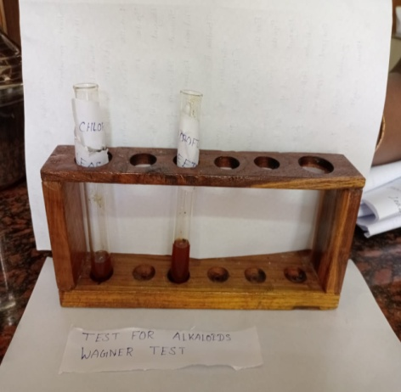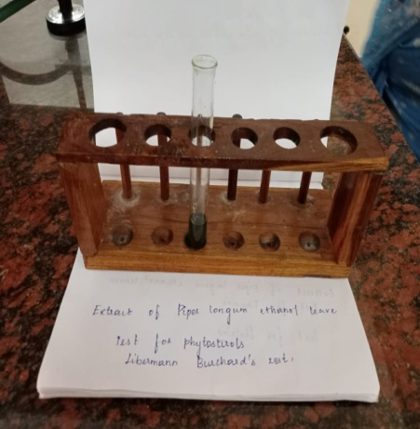

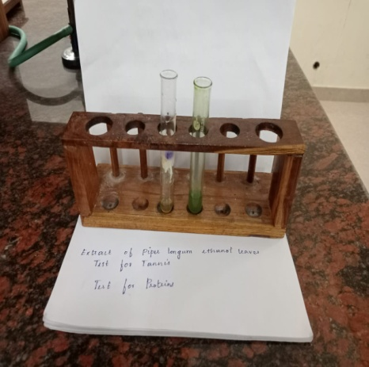

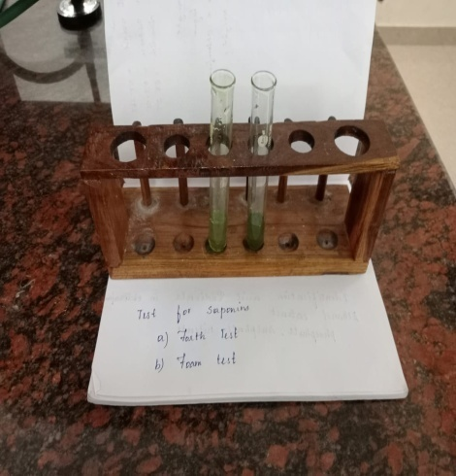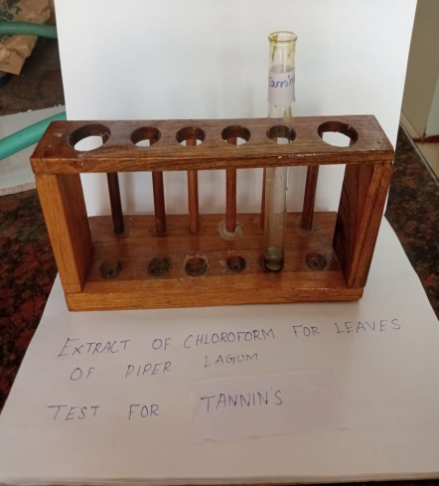

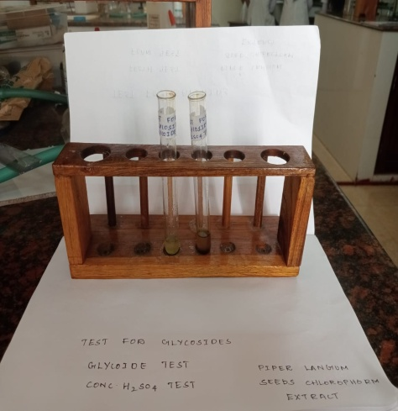
Fig 1.2 Represents the phytochemicals analysed by preliminary phytochemical screening analysis.

Antimicrobial activity of chloroform extracts of piper longum:
The chloroform extract of piper longum leaves and fruits were subjected to antimicrobial studies in gram positive and gram negative bacterias. The results were discussed in Table 1.4 and Fig 1.3.
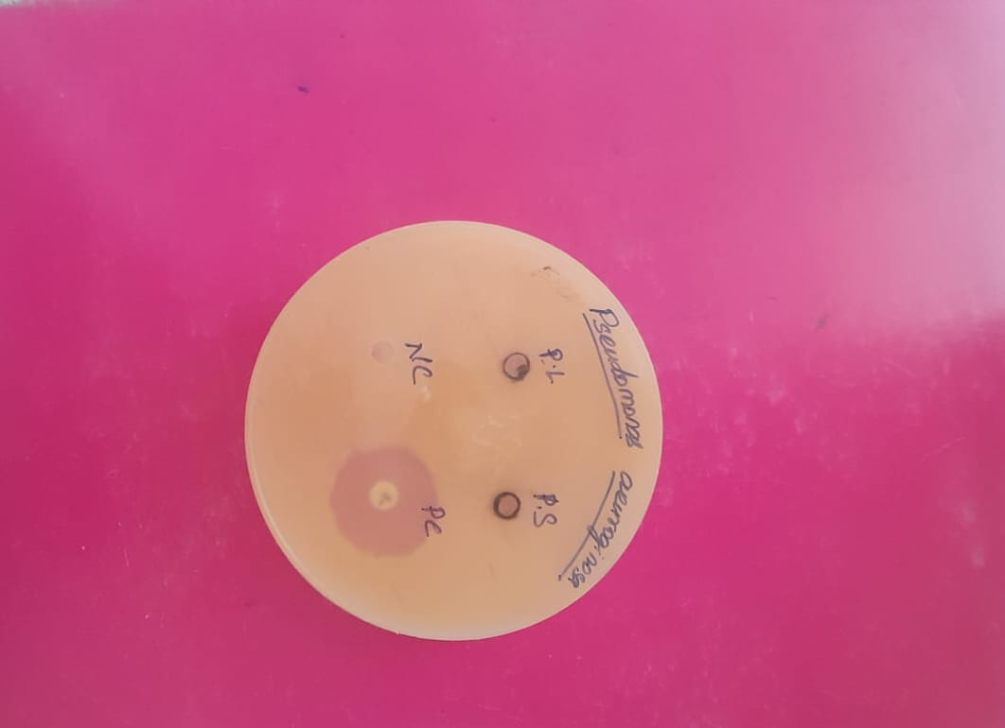
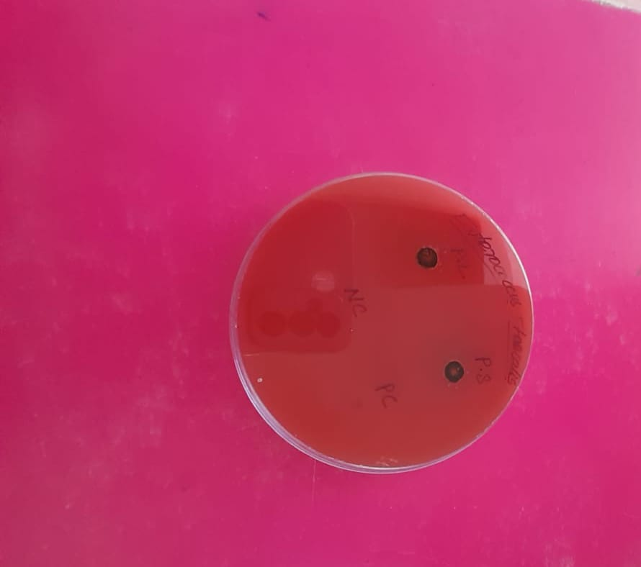

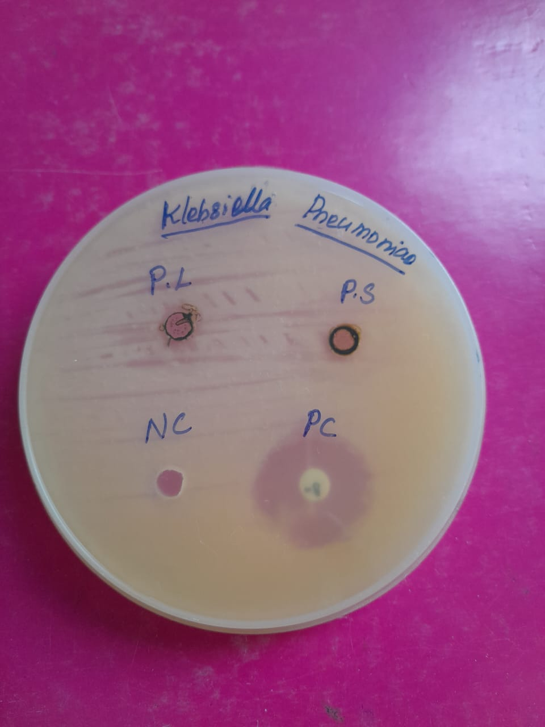
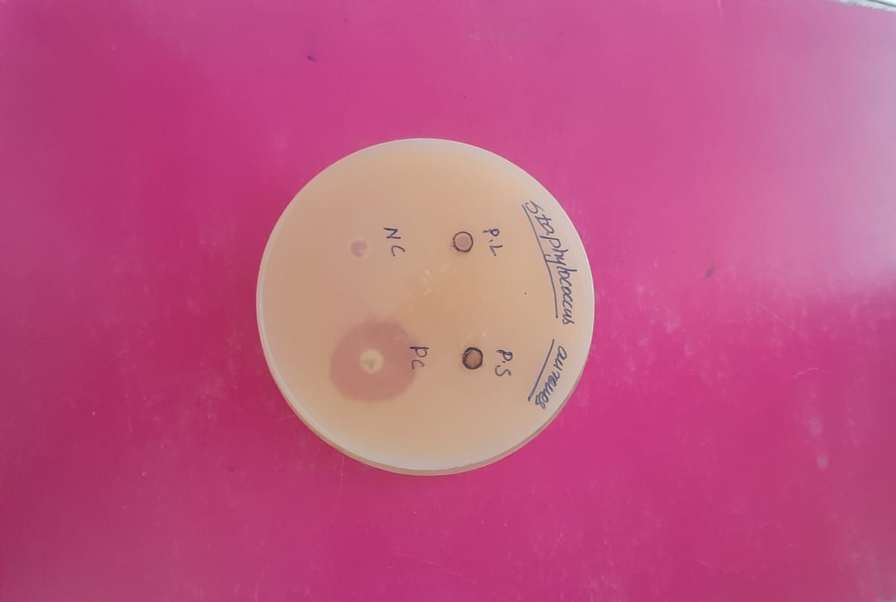

Fig 1.3 Represents the antimicrobial activity of chloroform extract of piper longum leaves and fruits
Table 1.4 Antimicrobial Activity of chloroform extract of Piper longum fruits and leaves
by Agar well diffusion method
Sl.No | Name of the bacterial strains | Zone size in diameter (mm)
Sl.No | Name of the bacterial strains | Positive control (Ciprofloxacin) | Chloroform extract of Piper longum fruits | Chloroform extract of Piper longum leaves
1. | Klebsiella pneumoniae | 26 mm | 6 mm | 6 mm
2. | Staphylococcus aureus | 26 mm | 6 mm | 6 mm
3. | Pseudomonas aeruginosa | 27 mm | 6 mm | 6 mm
4. | , | 24 mm | 6 mm | 6 mm

The Table 1.4 reveals the antimicrobial activity of chloroform extract of piper longum fruits and leaves on bacterial strains Klebsiella pneumoniae , Staphylococcus aureus, Pseudomonas aeruginosa and Enterococcus sps.
Antimicrobial studies were performed on chloroform extract of piper longum fruits and leaves on gram positive bacterias (Staphylococcus aureus, Enterococcus sps.,) gram negative bacterias (Klebsiella pneumoniae, Pseudomonas aeruginosa ). The positive control used is Ciprofloxacin. The results showed that 6mm zone of inhibition is observed for all the bacteria tested against the positive and negative control. This shows that the plant has minimum antimicrobial activity against the tested bacterial strains.

SUMMARY AND CONCLUSION:
The selected plant parts of piper longum revealed the presence of various phytochemicals in extract prepared from different solvents.
The fruits and leaves of piper longum were extracted with chloroform and ethanol and finally their yield was calculated. In case of piper longum fruits the maximum yield was obtained for ethanol extract (1.90 g). In case of piper longum leaves the maximum yield was obtained for chloroform extract (2.25 g). The piper longum leaves and fruits were subjected to physicochemical studies. Moisture content of piper longum fruits was found to be less (23.6%) compared to leaves (28%). This shows that piper longum fruits are less affected by microbial attacks.
The physicochemical analysis performed on piper longum leaves and fruits reveals that (Total ash, Acid insoluble ash, Water soluble ash) the medicinal plant may be less affected by contaminants, silica materials.
Phytochemical screening analysis performed on chloroform and ethanol extracts of piper longum fruits and leaves reveals that the maximum number of phytochemicals were present in piper longum chloroform leaves extract compared to ethanol extract.
In case of piper longum leaves the maximum number of phytochemicals are present in piper longum chloroform leaves extract compared to ethanol extract.
In case of piper longum fruits the maximum number of phytochemicals are present in piper longum chloroform fruits extract compared to ethanol extract.
Antimicrobial studies were performed on chloroform extract of piper longum fruits and leaves on gram positive bacterias (Staphylococcus aureus, Enterococcus sps.,) gram negative bacterias (Klebsiella pneumoniae, Pseudomonas aeruginosa ). It is found that there is minimum antimicrobial resistance for the chloroform and ethanol extracts of piper longum fruits and leaves. This shows that the bioactive components responsible for antibacterial activities were in inappropriate amounts.
From the above studies, the active bioactive components are present more in chloroform extract of leaves and fruits than ethanol extracts of piper longum leaves and fruits. Further the moisture content of piper longum leaves and fruits are not too high. Further studies should be extended for characterization and to find the amount of each bioactive component present in the chloroform extracts of leaves and fruits of piper longum. So that the active components responsible for antimicrobial activity of chloroform extract of piper longum leaves and fruits can be evaluated.
ACKNOWLEDGEMENT:
The author is thankful to the management for providing the necessary facilities.
REFERENCES:
1.McChesney J. Venkataraman S, and Henri J. Plant natural products: Back to the future or into extinction Phytochemistry, 2007; 68: 2015-2022.
2.Khalaf NA, Shakya AK, Othman A, Ahbar Z, and Farah H. Antioxidant activity of some common plants. Turk .J. Biol, 2007; 31: 1-5.
3.Krishnaiah D, Sarbatly R and Bono A. “Phytochemical antioxidants for health and medicine. A move towards nature,” Journal of molecular biology and biotechnology, 2007;1(4):97 – 104.
4. Joshi B, Lekhak S and Sharma A. “Antimicrobial property of different medicinal plants: Ocimum sanctum, Cinnamomumzeylanicum, Xanthorylumarmatum and Origanummajorana,” Kathmandu Univ. J. Sci. Eng. Technol., 2009; 5:143 – 150.
5.Prabakaran M, Merinal S and Panneerselvam A. “Investigation of phylloplanemycoflora from some medicinal plants,” European Journal of Experimental Biology, 2011; 1(2):215 – 219.
6.Rose P, Whiteman M, Moore PK and Zhu YZ.”Bioactive S- e S-alk(en)yl cysteine sulfoxide metabolites in the genus Allium: the chemistry of potential therapeutic agents,” Natural Product Reports, 2005; 22: 351– 368.
7.Arokiyaraj, S. “Studies on antimicrobial, antioxidant, Larvicidal, pesticidal activity and phytochemistry of Leaves of Alangium salvifolium (l.f) wang.” International Journal of Pharmacy and Pharmaceutical Sciences, 2013; 5(2): 86-89.
8.Farrukh A, Iqbal A. “Broad spectrum antibacterial and antifungal properties of certain traditionally used Indian medicinal plants.” World J Microbiol Biotechnol. 2003; 19: 653-7.
9.Borris RP., (1996): Natural products research: perspective from a major pharmaceutical company. Journal of Ethnapharmacology. 1l(51), 29-38.
10. Joshi B, Lekhak S and Sharma A. “Antimicrobial property of different medicinal plants: Ocimum sanctum, Cinnamomumzeylanicum, Xanthorylumarmatum and Origanummajorana”. Kathmandu Univ. J. Sci. Eng. Technol., 2009; 5:143 – 150.
11.Prabakaran M, Merinal S and Panneerselvam A. “Investigation of phylloplanemycoflora from some medicinal plants. European Journal of Experimental Biology,” 2011; 1(2):215 – 219.
12.Rose P, Whiteman M, Moore PK and Zhu YZ.Bioactive S- e S-alk(en)yl cysteine sulfoxide metabolites in the genus Allium: the chemistry of potential therapeutic agents. Natural Product Reports, 2005; 22: 351– 368.
13. Jain, LS &Argal, A, “Preliminary phytochemical Screening and micromeretic parameters of Ocimum sanctum”, Asian Journal of Plant Science and Research, vol. 3, no. 3, pp. 126-130, 2013
14.Vaghasiya, Y, Nair, R &Chanda, S 2008, ‘Antibacterial and preliminary phytochemical and physicochemical analysis of Eucalptus citriodora HK leaf’, Natural Products Research, vol. 22, no. 9, pp. 754-762.
15. Sukhdev Swami Handa, Suman Preet Singh Khanuja, Gennaro Longo, Dev Dutt Rakesh. 2008.
16.Godghate,A, Sawant, R &Sutar,A “Phytochemical analysis of ethanolic extract of roots of Carrisacarandus Linn”, Rasayan Journal of Chemistry,vol.5,no.4,pp.456-459, 2012,
17.Sanmugarajah,V.Thabrew,I&Sivapalan, SR 2013, Phyto, physicochemical standardization of medicinal plant Enicostemmalittorale, Blume’, ISOR Journal of Pharmacy, vol. 3, no. 2, pp. 52-58, 2015.
18. Mohanasundari, L &Suja, S., ‘Qualitative phytochemical screening of rhizomes on Apliniacalcarata and Alpiniaspeciosa’, Journal of Pharmacognosy and Phytochemistry, vol. 4, no. 2, pp. 53-56.
19.Shaik, GV, ‘Phytochemical analysis of the Indian medicinal plant Argyreia involucrate’, International Journal of research in pharmaceutical and Biomedical sciences, vol. 2, no. 4, pp. 1778-1782, 2011.
20. Ahuja, J, Suresh, J, Deep, A, Madhuri& Ravi, P, ‘Phytochemical screening of aerial parts of Artemisia parvifloraRoxb: a medicinal plant’, Der pharmacialettre, vol. 3, no. 6, pp. 116-124, 2011.
21.Geetha, TS &Geetha, N 2014, ‘Phytochemical screening, quantitative analysis of primary and secondary metabolites of Cymbopogencitratus(DC) stapf leaves from Kodaikanal hills, TamilNadu’, International Journal of Pharm Tech Research, vol. 6, no. 2, pp. 521-529.
22.Sheel, R & Nisha, K 2014, ‘Qualitative phytochemical analysis for isolation of terpenes from Clerodendroninfortunatum leaves’, ISOR Journal of Applied Chemistry, vol 7, no 7, pp. 14-18.
23.Saxena, M & Saxena, J 2012, ‘Phytochemical screening of Acoruscalamus and Lantana camara’, International Research Journal of Pharmacy, vol.3, no.5, pp.324-326.
24. Hossain, AM, Ragmi, KASA, Mijizy, ZHA, Weli, AM &Riyami, QA 2013, ‘Study of total phenol, flavonoids contents and phytochemical screening of various leaves crude extracts of locally grown Thymus vulgaris’, Asian Journal of Tropical Biomedicine, vol. 3, no. 9, pp. 705- 710.
25.Yogeshwari, C & kalaichelvi, K 2017, ‘Comparative phytochemical screening of Acmella calva (dc.) r.k. Jansen and Crotalaria ovalifoliawalli: potential medicinal herbs’, Journal of Medicinal plant Studies, vol. 5, no. 1, pp. 277-279.
26. Basumatary, AR 2016, ‘Preliminary phytochemical screening of some compounds from plant stem barks of Tabernaemontan adivaricata Linn. used by Bodo community at Kokrajhar district, Assam, India’, Archives of Applied Science Research, vol. 8, no. 8, pp. 47-52.
27.Saklani, S, Mishra, PA, Sati, B & Sati, H 2012, ‘Pharmacognostic, phytochemical and antimicrobial screening of Aphanamixis polystachya an endangered medicinal tree’, International Journal of Pharmacy and Pharmaceutical Sciences, vol. 4, no. 3, pp. 235-240.
28. Ganesh et.al, Phytochemical analysis and anti bacterial activity of pepper (piper nigrum L.,) against some human pathogens , Cent. Euro. J. Exp. Bio., 2014, 3(2): 36-41.

