Real-Time Traffic Flow Prediction Using Gradient Boosted
Regression Trees
P Logapriya¹, K Siddesh² , Dr. K Sumathi³
^{1,2}UG Student, Department of Computer Science and Data Science, Nehru Arts and Science College, Coimbatore, Tamil Nadu, India.
³Assistant Professor, Department of Computer Science and Data Science, Nehru Arts and Science College, Coimbatore, Tamil Nadu, India.
¹logapriyaperumal25@gmail.com , ²siddeshsiddesh6676@gmail.com,
³Nascsumathi.k@nehrucolleges.com.

ABSTRACT
Real-time traffic flow prediction is a significant aspect of intelligent transportation systems (ITS). It assists in traffic management, congestion relief, and route optimization. Conventional statistical models are generally not effective in modeling the complex, non-linear relationships that exist in traffic data. Traffic data is affected by various variables such as time, weather, road accidents, and special events. Gradient Boosting Regression Trees (GBRT) is a robust machine learning technique that can efficiently model the complexity of traffic data while maintaining high levels of prediction accuracy. GBRT involves the combination of multiple weak models through an iterative algorithm, minimizing prediction errors using gradient optimization. In this paper, we propose a GBRT-based system for short-term traffic flow prediction based on real-time traffic data from traffic sensors, GPS-equipped vehicles, and existing traffic data. Data preprocessing methods such as outlier elimination and feature construction are used to enhance the performance of the proposed system. The proposed system is tested on large-scale traffic data, ensuring its robustness to noisy and incomplete data. The performance is measured by metrics like Mean Absolute Error (MAE) and Root Mean Square Error (RMSE), which shows a substantial improvement over the baseline models. The adaptability of the model according to the traffic conditions makes it applicable for implementation in smart city infrastructure.The results of real-time predictions can be integrated with navigation systems and traffic management systems to handle congestion effectively. The model is also capable of continuous learning, which enables it to learn from new incoming data. The experimental results demonstrate that GBRT performs better in terms of computation speed and accuracy compared to the regression model.

Keywords:
Real-Time Traffic Flow Prediction, Intelligent Transportation Systems (ITS), Gradient Boosted Regression Trees (GBRT), Machine Learning in Transportation, Short-Term Traffic Forecasting, and Smart City Infrastructure.

1.INTRODUCTION
Intelligent Transportation Systems (ITS) also involve the use of various sensing and communication technologies such as traffic cameras, inductive loop detectors, radar sensors, connected vehicles, and Internet of Things (IoT) devices. These systems continuously produce massive amounts of real-time data that represent traffic density, speed, road occupancy, and travel time. Using centralized or distributed data processing systems, this data is analyzed to enable intelligent decision-making. Advanced traffic signal control systems, dynamic message signs, and adaptive toll pricing systems are some of the ITS applications that depend on accurate and timely predictions. By converting raw transportation data into valuable insights, ITS improves the coordination between infrastructure and traffic, ultimately leading to improved system performance.
Furthermore, the development of smart cities has also reinforced the importance of ITS as a core component of smart city planning and management. Smart cities seek to combine transportation infrastructure with energy, environment, and public safety services to develop a network of sustainable ecosystems. In this regard, predictive analytics emerges as a crucial tool in forecasting congestion before it happens, allowing the relevant authorities to take proactive measures such as diverting traffic flow, changing traffic signal times, or activating emergency response vehicles. The integration of cutting-edge machine learning algorithms in ITS systems enables the system to learn and adjust to the changing behavior of travelers. With the projected rise in urban population, smart transportation systems will play a pivotal role in providing efficient, safe, and sustainable transportation solutions.
Another key aspect of Intelligent Transportation Systems (ITS) is its capacity to facilitate data-informed policy formulation and strategic long-term planning for infrastructure development. By examining past and current traffic data, transport officials can determine areas of persistent congestion, underutilized road sections, and shifting traffic demand. This data-informed approach helps in informed decision-making on road network extensions, public transport upgrades, and development of new mobility solutions. In addition, predictive traffic analytics allow for the simulation of various policy options, such as the adoption of congestion pricing, changes in lane usage, or the creation of exclusive bus lanes, before their actual implementation.

2. CHARACTERISTICS OF TRAFFIC FLOW DATA
Traffic flow data shows complex spatial and time-based dependencies. Vehicle counts, speed, and density change based on the time of day, day of the week, season, and unexpected events like accidents or road construction. The data is collected from different sources including loop detectors, CCTV cameras, GPS-equipped vehicles, and mobile apps. These varied sources lead to differences in how often data is sampled, its accuracy, and its completeness. Additionally, traffic data is often noisy and can have missing or inconsistent entries due to sensor failures or communication delays. The non-linear interactions between factors like weather, road capacity, and driver behavior make traffic forecasting challenging. Therefore, effective modeling techniques that can handle irregular and complex data are crucial.
Another important aspect of traffic data is its strong periodic patterns mixed with sudden changes. For instance, daily commuting creates predictable peaks in the morning and evening, while weekends often show different flow patterns. However, unexpected events such as road closures, public gatherings, or severe weather can suddenly change these trends. This combination of regular patterns and irregular disruptions makes traffic data very dynamic and hard to model with simple linear methods.Spatial correlation is also a key feature of traffic systems. Traffic conditions in one area affect nearby segments, intersections, and alternative routes. Congestion in one location can spread to neighboring roads, creating effects throughout the network. Capturing these spatial connections requires models that can learn complex relationships across multiple linked features. The need to handle high-dimensional feature spaces and continuous data streams adds to the computational complexity, highlighting the importance of scalable predictive algorithms.

3. OVERVIEW OF MACHINE LEARNING IN TRAFFIC PREDICTION
Machine learning has become a strong tool for modeling complex systems where it is hard to create clear mathematical formulas. In traffic prediction, supervised learning algorithms are commonly used to link input features, such as historical traffic flow, weather, and time indicators, to future traffic values. Traditional methods like linear regression assume linear relationships, which limits their predictive ability. Support Vector Regression (SVR) is better at handling non-linear data but has trouble with large datasets. Neural networks, especially deep learning models like LSTM, are good at capturing time-related patterns, but they often need a lot of computing power and large training datasets. Ensemble learning methods, particularly tree-based models, strike a balance between accuracy and efficiency. Their ability to model non-linear relationships and interactions makes them well-suited for traffic forecasting tasks.
Recent progress in machine learning has led to hybrid and adaptive models that mix different techniques to improve prediction accuracy. Feature-based models include external variables like weather and public event schedules, helping the model grasp outside influences on traffic flow. Furthermore, incremental learning methods allow models to update continuously as new data comes in, making them fit for real-time systems.Another key benefit of machine learning approaches is their ability to automatically find patterns in large datasets without needing set mathematical rules. This flexibility helps traffic prediction systems adjust to changing urban travel patterns. As transportation networks become more complex, machine learning offers a scalable way to handle large amounts of sensor data while keeping reliable predictive performance.

4.FUNDAMENTALS OF GRADIENT BOOSTED REGRESSION TREES (GBRT)
Gradient Boosted Regression Trees are an ensemble learning technique that builds a strong predictive model by combining several weak learners, usually decision trees. Unlike bagging methods, boosting focuses on fixing the errors made by earlier models. Each tree is trained on the leftover errors of the previous ensemble using gradient descent to reduce a specific loss function. This repeated process gradually improves prediction accuracy. GBRT supports different loss functions, including squared error for regression tasks, which makes it suitable for various problem types. It uses regularization techniques like shrinkage, which controls the learning rate, limits tree depth, and subsamples data to prevent overfitting. The model balances bias and variance effectively, offering strong performance even with noisy datasets. The strength of GBRT comes from its additive modeling strategy. Each new tree improves the prediction by focusing on hard-to-predict samples.
This method allows the model to capture complex non-linear patterns that single decision trees struggle to represent. By gradually reducing leftover errors, GBRT achieves high predictive accuracy, even with varied data sources. Additionally, GBRT provides interpretability benefits through feature importance analysis. By assessing how often and effectively features are used in tree splits, the model reveals which variables most influence traffic flow. This transparency aids decision-making in transportation planning and system optimization. The flexibility, robustness, and interpretability of GBRT make it ideal for real-time traffic forecasting applications. Beyond its predictive capability, GBRT suits real-time and large-scale use due to its efficiency and adaptability.
The training process can be enhanced through parallelization and early stopping strategies, allowing the model to handle increasing data volumes effectively. GBRT also works well with mixed data types, managing both numerical and categorical features without needing much preprocessing. Its ability to handle outliers and missing values makes it reliable in real-world traffic settings, where data quality can vary significantly. These traits make GBRT a practical and effective choice for deployment in intelligent transportation systems that need accurate, fast, and adaptable traffic flow predictions.

5. PROPOSED GBRT-BASED TRAFFIC PREDICTION FRAMEWORK
The proposed framework combines real-time data collection, preprocessing, feature creation, model training, and deployment into a single structure. Data comes from various traffic sensors, GPS devices, and historical traffic databases. A preprocessing pipeline removes outliers, addresses missing values, and aligns time-series data. Feature creation techniques produce useful predictors like lag variables, rolling averages, and time indicators. The processed dataset then trains a GBRT model using cross-validation to confirm reliability. After training, the model is placed in a real-time prediction module that regularly receives live traffic data and generates short-term forecasts. A feedback system allows for periodic retraining to respond to changing traffic patterns, ensuring the system remains reliable over time.
The structure is built for modular growth, making it easy to add new data sources like weather APIs or event management systems. Data streaming tools process real-time traffic information with minimal delay. The prediction engine is designed for quick inference to meet operational needs in traffic management centers.To maintain scalability and flexibility, the framework includes monitoring tools that track prediction errors over time. If performance issues arise due to shifts in data patterns, retraining starts with updated datasets. This ongoing learning approach helps maintain accuracy as traffic conditions change.

Key Components of the Framework:
- Real-time data acquisition layer
- Data preprocessing and synchronization module
- Feature engineering engine
- GBRT model training and validation unit
- Real-time prediction and API integration module
- Continuous learning and monitoring system

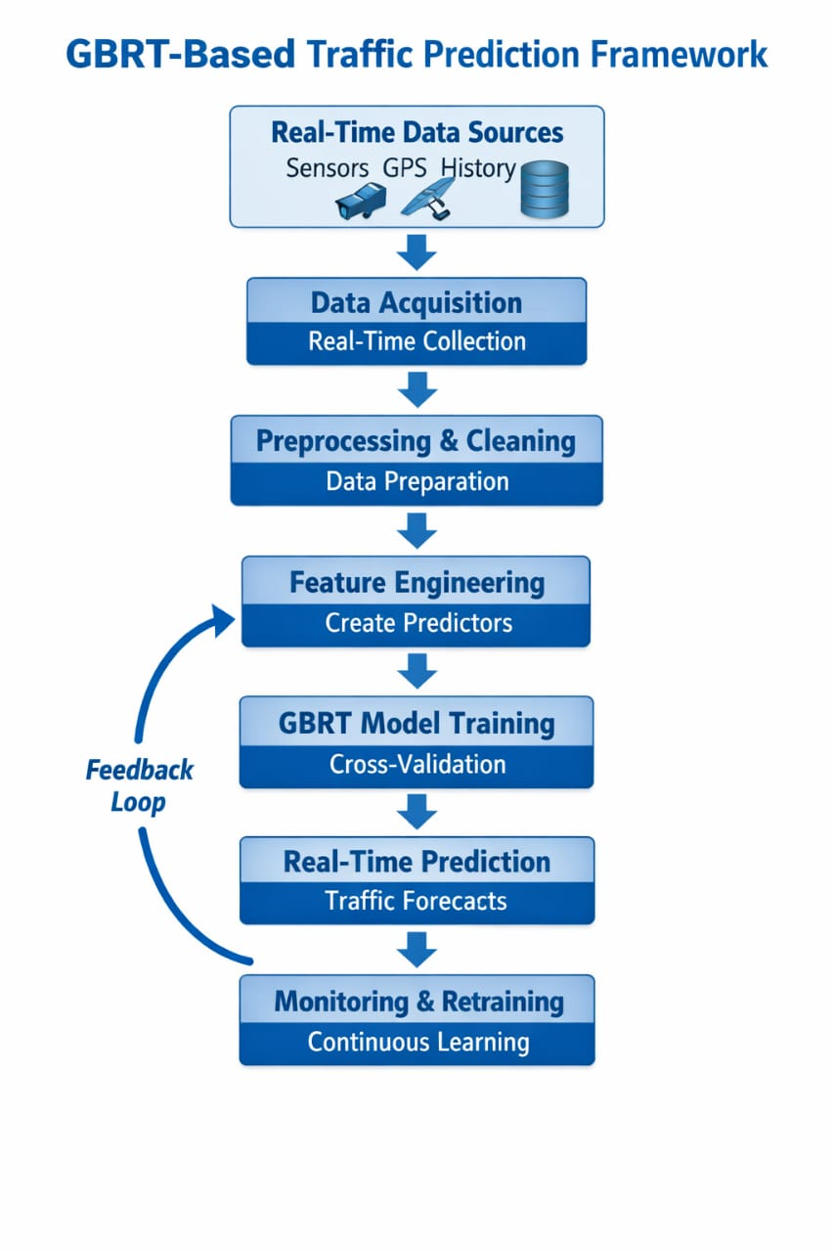fig 1 : PREDICTION FRAMEWORK

6. DATA PREPROCESSING AND FEATURE ENGINEERING TECHNIQUES
Data preprocessing is a vital step in improving predictive performance. Outlier detection uses statistical thresholds or interquartile range methods to remove unusual traffic spikes caused by sensor errors. Missing data is handled with interpolation or model-based imputation techniques. Feature engineering improves model capability by extracting time-based features like hour-of-day, day-of-week, and seasonal indicators. Lag features represent previous traffic flow values and help capture time-related dependencies. Rolling mean and variance statistics identify short-term fluctuations. Categorical variables, such as weather conditions, are encoded properly. Since tree-based models do not require feature scaling, normalization is usually unnecessary; this simplifies preprocessing tasks.
Some preprocessing techniques include smoothing filters to reduce high-frequency noise and clustering methods to group similar traffic patterns. Feature selection techniques remove redundant or irrelevant variables, which decreases computational costs and improves generalization performance. Effective feature construction greatly affects the predictive strength of the GBRT model. Well-designed lag features and rolling windows capture time correlations, while interaction features model the combined effects of time and weather variables. Good preprocessing ensures the dataset is organized, consistent, and informative for model training.
Additionally, dimensionality reduction techniques like principal component analysis (PCA) can capture the most useful patterns while minimizing redundancy in highly correlated traffic variables. It's important to integrate cross-validation strategies during preprocessing to avoid data leakage, especially when creating lagged and rolling features. Applying transformations consistently across training and testing sets maintains model integrity and strengthens robustness in real-world scenarios.

7. MODEL TRAINING, HYPERPARAMETER TUNING, AND OPTIMIZATION
Training a GBRT model effectively requires careful selection of hyperparameters. Key parameters include the number of trees, learning rate, maximum tree depth, and minimum samples per leaf. A smaller learning rate usually leads to better generalization, but it increases training time. Cross-validation techniques help prevent overfitting and assess model stability. You can use grid search or random search strategies for hyperparameter optimization. Early stopping criteria end training when performance improvements plateau. Computational efficiency is important to ensure the model can operate in near real-time environments. By optimizing these parameters, the GBRT model balances prediction accuracy and execution speed.
Regularization techniques like subsampling and shrinkage improve robustness by reducing variance. The trade-off between model complexity and generalization performance is managed carefully to avoid overfitting. Monitoring training and validation error curves helps identify the best stopping points. You can also use parallel processing and hardware acceleration techniques to speed up training on large-scale datasets. Efficient optimization keeps the model practical for real-time deployment in traffic management systems.

Important Hyperparameters:
- Number of boosting iterations
- Learning rate
- Maximum tree depth
- Subsample ratio
- Minimum samples per leaf

7.1. DATA CLEANING AND QUALITY ASSESSMENT
Data cleaning is a key step in ensuring high-quality input for predictive modeling. It involves detecting and removing outliers from sensor errors or unusual traffic spikes using statistical thresholds or interquartile range methods. Missing data is handled through interpolation, forward or backward filling, or model-based imputation to keep continuity. Noise reduction techniques like smoothing filters help reduce short-term fluctuations while maintaining important trends. Validating timestamps and checking for consistency further ensure that the dataset is reliable and suitable for effective model training.

7.2. FEATURE SELECTION AND DIMENSIONALITY REDUCTION
- Correlation analysis to detect redundant features
- Recursive Feature Elimination (RFE) for selecting key predictors
- Feature importance evaluation using GBRT
- Principal Component Analysis (PCA) for reducing dimensionality
- Removal of low-variance and irrelevant variables to improve generalization

7.3. TEMPORAL AND STATISTICAL FEATURE ENGINEERING
Temporal feature engineering improves the model’s ability to identify patterns and relationships in traffic flow data. Features such as hour of the day, day of the week, weekend indicators, and seasonal variables represent cyclical trends. Lag features are added to account for previous traffic values, allowing the model to learn temporal correlations. Rolling statistics, including moving averages and rolling variance, help capture short-term behaviors and trends. Interaction features between time and external variables like weather conditions further enhance predictive performance.

8. EXPERIMENTAL SETUP AND PERFORMANCE EVALUATION
The experimental evaluation involves training the GBRT model on large traffic datasets that include historical and real-time data. The dataset is split into training and testing subsets to check generalization performance. We implement baseline models like linear regression and ARIMA for comparison. We assess performance using metrics such as Mean Absolute Error (MAE), Root Mean Square Error (RMSE), and Mean Absolute Percentage Error (MAPE). Visualizing predicted versus actual traffic flow values shows the model's accuracy during peak and off-peak hours. Error analysis examines model performance under unusual traffic conditions, demonstrating how robust the GBRT method is.

Evaluation Metrics Used:
- Mean Absolute Error (MAE)
- Root Mean Square Error (RMSE)
- Mean Absolute Percentage Error (MAPE)
- R-squared (R²)
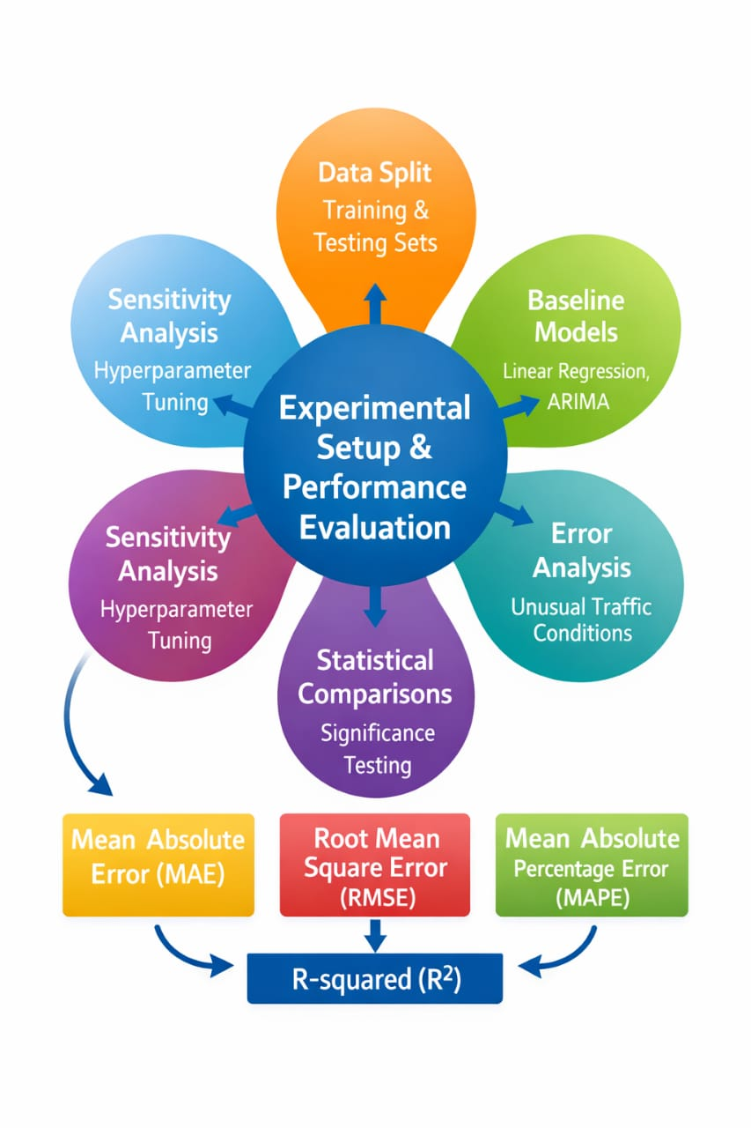Fig 2 : EXPERIMENTAL SETUP AND PERFORMANCE EVALUATION
To ensure fairness, all models are trained using the same dataset splits and evaluation metrics. We conduct multiple experimental runs to verify the consistency and stability of results. We perform statistical comparisons to confirm the significance of performance improvements achieved by GBRT. We also conduct sensitivity analysis to understand how changes in hyperparameters affect prediction accuracy. This analysis helps identify the best configurations and ensures the model stays stable under different operational conditions.

9. REAL-TIME DEPLOYMENT IN SMART CITY INFRASTRUCTURE
Deploying the GBRT model in a real-time setting requires integration with traffic management systems and navigation platforms. The model can run on cloud servers or edge computing devices for low-latency inference. APIs allow communication between the prediction engine and traffic signal controllers or route guidance systems. Scalability concerns ensure that the system can manage growing data volumes as cities expand their sensor networks. Continuous monitoring and regular retraining help the model adjust to changing traffic patterns. This integration supports proactive congestion control and dynamic route optimization in smart city environments.
Edge deployment strategies can be used to reduce latency in crowded urban areas. Distributed computing frameworks help ensure reliable data handling and fault tolerance. Security measures protect sensitive traffic and vehicle data from unauthorized access. Real-time dashboards offer visualization tools for traffic authorities. This setup allows them to monitor predicted congestion levels and respond proactively. Such integrated deployment improves urban mobility management and the commuter experience. Automated alert systems can trigger immediate responses when predicted congestion exceeds set thresholds. These alerts might activate adaptive traffic signal timing, rerouting recommendations, or emergency response coordination. Logging and tracking of performance should also be in place to assess prediction accuracy over time, supporting continuous improvement of the deployment framework.
The deployment architecture should allow interoperability with existing smart city components such as surveillance systems, public transportation management platforms, and emergency services networks. Streaming data pipelines should enable the continuous intake of sensor data, GPS traces, and weather updates in real time. Model versioning and containerization technologies can make updates seamless without interfering with ongoing operations. Failover mechanisms and redundancy planning ensure high availability and reliability, which are crucial for urban traffic management systems. With these enhancements, the GBRT-based prediction system becomes a strong, adaptable, and scalable solution for intelligent transportation infrastructure.

10. COMPARATIVE ANALYSIS WITH TRADITIONAL AND DEEP LEARNING MODELS
Comparative analysis shows that GBRT has advantages over traditional statistical methods and deep learning models. Linear regression cannot adequately model non-linear relationships. ARIMA mainly focuses on time-series trends and does not incorporate external factors. Deep learning models like LSTM effectively capture temporal dependencies, but they need a lot of computing power and extensive training data. GBRT offers a good balance. It provides strong predictive performance, faster training times, and clearer insights through feature importance analysis. Its ability to handle different input features makes it especially good for real-time traffic prediction.

Additionally, GBRT models are typically easier to fine-tune than deep neural networks, which need careful design and many adjustments to hyperparameters. GBRT also works well with moderate-sized datasets, making it suitable for cities with limited data. While deep learning models might outperform GBRT in very large-scale situations with strong spatiotemporal dependencies, their high computational cost and infrastructure needs may restrict their practical use. Thus, GBRT serves as a balanced solution for real-time traffic forecasting.

Furthermore, GBRT is robust against overfitting when proper regularization techniques, such as controlling the learning rate and limiting tree depth, are used. Unlike traditional models that assume linearity or stationarity, GBRT can flexibly adapt to complex, non-linear interactions between traffic, weather, and time-related factors. Its ensemble structure also lowers variance and enhances generalization compared to single decision tree models. From a deployment standpoint, GBRT models need much less hardware support than deep neural networks, making them more practical for edge computing and environments with limited resources.

10.1. Comparison with Traditional Statistical Models
Traditional statistical models like Linear Regression and ARIMA are commonly used for traffic forecasting. However, they have significant limitations. Linear Regression has difficulty modeling complex non-linear traffic behaviors because it assumes a straight-line relationship between input variables and predictions. ARIMA mainly looks at single time-series patterns and works best with stationary data. This limits its ability to consider various external factors like weather, special events, and road conditions. Moreover, traditional statistical methods depend on strong assumptions of linearity and stationarity, which often don't hold true in real-world traffic systems that are dynamic and unpredictable.

10.2. Computational Efficiency and Scalability
- Faster training and inference times compared to deep neural networks
- Lower hardware and memory requirements
- Suitable for edge computing and real-time deployment
- Scalable for moderate to large datasets

10.3. Comparison with Deep Learning Models
Deep learning models, such as LSTM and RNN, excel at capturing long-term temporal relationships and complex sequences in traffic data. However, these models usually need large labeled datasets, hefty computational resources, and ample memory. Designing deep neural networks requires careful choices of structure, activation functions, and many hyperparameters, making the tuning process intricate and time-consuming. In contrast, GBRT offers strong predictive performance with lower computational needs and easier implementation.

10.4. Interpretability and Practical Deployment
- Feature importance analysis available in GBRT
- Greater transparency compared to black-box deep learning models
- Easier hyperparameter tuning process
- Adaptability for real-world smart city traffic management systems

12. FUTURE RESEARCH DIRECTIONS
Future research can explore hybrid models that combine GBRT with deep learning architectures. These models can capture structured feature interactions and complex spatial and temporal dependencies. Integrating convolutional neural networks (CNNs) or graph neural networks (GNNs) with boosting frameworks could improve how we model interconnected road networks. Transfer learning approaches may help models trained in data-rich cities adapt efficiently to regions with limited historical data. By incorporating real-time weather updates, public event schedules, and incident reports through APIs, we can further improve predictive accuracy and responsiveness. Additionally, integrating reinforcement learning techniques with prediction systems may enable adaptive traffic signal control and dynamic congestion management strategies.
Graph-based modeling techniques show promise for representing spatial correlations among adjacent road segments. Since traffic flow in one location directly affects neighboring links, spatial dependency modeling can significantly enhance forecasting reliability. Improved embedding methods for categorical, temporal, and spatial variables may also refine representation learning. This would enable models to capture subtle contextual relationships. Moreover, multimodal data fusion, which combines traffic sensors, GPS trajectories, camera
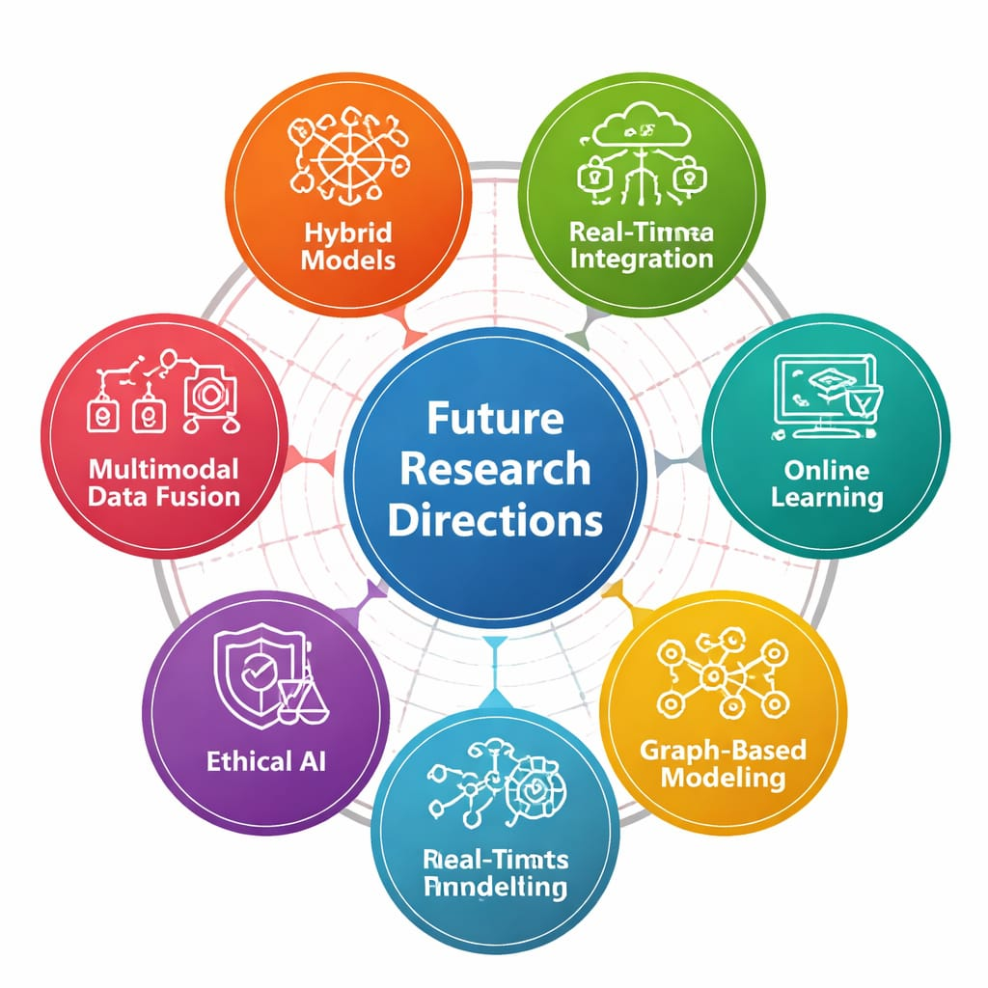
Fig 3 : FUTURE RESEARCH DIRECTIONS
feeds, and IoT devices, could create richer datasets for next-generation intelligent transportation systems. Another important direction is increasing robustness and adaptability through online learning and incremental model updating. Instead of relying solely on periodic retraining, adaptive learning frameworks could continuously update model parameters as new data streams become available. Research into uncertainty quantification methods may also help provide confidence intervals for predictions. This supports risk-aware decision-making in traffic management centers.
Energy-efficient deployment and sustainable AI practices are becoming more important as urban systems grow. We can optimize model architectures to reduce computational demands, use lightweight boosting variants, and apply model compression techniques to lower energy consumption. Developing standardized benchmarking datasets and open evaluation frameworks would further promote transparent comparison among predictive approaches. Such advances will lead to more sustainable, scalable, and intelligent traffic forecasting solutions for future smart cities.
In addition, future studies may focus on integrating ethical AI principles and policy-aware modeling into intelligent transportation systems. Ensuring fairness in predictive outcomes across different geographic regions, socio-economic areas, and transportation modes is crucial for equitable urban mobility planning. Privacy-preserving machine learning techniques, such as federated learning and differential privacy, could enable collaborative model training across multiple cities without sharing raw data. Furthermore, incorporating explainable AI frameworks can enhance stakeholder trust by offering clear reasoning behind congestion forecasts and control decisions. Long-term research may also look at the interaction between autonomous vehicles, connected vehicle networks, and predictive traffic systems. This could pave the way for fully coordinated, data-driven urban transportation ecosystems.

13. CONCLUSION
This study presents a GBRT-based framework for real-time traffic flow prediction. It shows how effective it is at handling complex and non-linear traffic data. Through careful preprocessing, feature engineering, and tuning of hyperparameters, the model achieves better prediction accuracy than traditional methods. Its ability to scale, adapt, and operate efficiently makes it a good fit for smart city infrastructures. The proposed approach contributes to data-driven urban mobility solutions that support efficient traffic management and sustainable transportation systems. The findings emphasize the need to integrate machine learning techniques into intelligent transportation systems to tackle modern urban mobility challenges. Continuous learning mechanisms help the system adjust to changing traffic conditions. Overall, this framework offers a scalable, accurate, and practical solution for short-term traffic forecasting. It lays the groundwork for future innovations in smart mobility and intelligent urban planning.

Moreover, the research shows that using strong preprocessing strategies with ensemble learning techniques greatly improves predictive reliability in dynamic traffic situations. By including factors like time, interactions, and context variables such as weather and events, the GBRT model effectively captures the complexities of real-world traffic. A comparative evaluation with traditional statistical and deep learning models confirms its balanced performance in terms of accuracy, interpretability, and computational needs. This balance makes the framework especially suitable for real-time applications where efficiency and reliability are crucial.
Additionally, the practical deployment considerations discussed in this study highlight the need for scalability, system integration, and ongoing monitoring in real-world scenarios. The adaptability of the GBRT-based system allows transportation authorities to react proactively to congestion, optimize signal control, and improve the commuter experience. As cities shift toward data-driven governance, the proposed framework acts as a foundational model that can be enhanced with hybrid learning methods, spatial modeling techniques, and adaptive control strategies. Ultimately, this research contributes to the growth of intelligent transportation systems and supports the long-term vision of resilient, sustainable, and smart urban mobility ecosystems.
Finally, this work points out the wider societal and environmental effects of accurate traffic forecasting. Effective prediction models can reduce travel time and congestion. They can also lower fuel consumption and decrease greenhouse gas emissions by enabling smoother traffic flow and optimized routing strategies. By aiding informed decision-making for urban planners and policymakers, the proposed GBRT framework supports sustainable development goals and encourages smarter resource use. As urban populations continue to grow, incorporating predictive analytics into transportation planning will be vital for creating cities that are not only technologically advanced but also environmentally responsible and socially inclusive.

REFERECES :
- Li, Xia, and Ruibin Bai. "Freight vehicle travel time prediction using gradient boosting regression tree." 2016 15th IEEE International Conference on Machine Learning and Applications (ICMLA). IEEE, 2016.

- Zhang Y, Haghani A. A gradient boosting method to improve travel time prediction. Transportation Research Part C: Emerging Technologies. 2015 Sep 1;58:308-24.

- Cheng, Juan, Gen Li, and Xianhua Chen. "Research on travel time prediction model of freeway based on gradient boosting decision tree." IEEE access 7 (2018): 7466-7480.

- Zhang, Shuaichao, Xingbin Zhan, and Xiqun Chen. "Gradient boosting regression tree for traffic flow prediction considering temporal and spatial correlations." 17th COTA International Conference of Transportation Professionals. Reston, VA: American Society of Civil Engineers, 2017.

- Zhan, Xingbin, et al. "Multi-step-ahead traffic speed forecasting using multi-output gradient boosting regression tree." Journal of Intelligent Transportation Systems 24.2 (2020): 125-141.

- Chen, Che-Ming, Chia-Ching Liang, and Chih-Peng Chu. "Long-term travel time prediction using gradient boosting." Journal of Intelligent Transportation Systems 24, no. 2 (2020): 109-124.

- Ma, Xiaolei, et al. "Prioritizing influential factors for freeway incident clearance time prediction using the gradient boosting decision trees method." IEEE Transactions on Intelligent Transportation Systems 18.9 (2017): 2303-2310.

- Lopez-Martin, Manuel, Belen Carro, and Antonio Sanchez-Esguevillas. "IoT type-of-traffic forecasting method based on gradient boosting neural networks." Future Generation Computer Systems 105 (2020): 331-345.

- Navarro-Espinoza, Alfonso, et al. "Traffic flow prediction for smart traffic lights using machine learning algorithms." Technologies 10.1 (2022): 5.

- Menguc, Kenan, Nezir Aydin, and Alper Yilmaz. "A data driven approach to forecasting traffic speed classes using extreme gradient boosting algorithm and graph theory." Physica A: Statistical Mechanics and its Applications 620 (2023): 128738.

- Xu, Zixian, et al. "Short-term bus passenger flow forecast based on the multi-feature gradient boosting decision tree." The International Conference on Natural Computation, Fuzzy Systems and Knowledge Discovery. Cham: Springer International Publishing, 2019.

- Li, Zili, Zuduo Zheng, and Simon Washington. "Short-term traffic flow forecasting: A component-wise gradient boosting approach with hierarchical reconciliation." IEEE Transactions on Intelligent Transportation Systems 21.12 (2019): 5060-5072.

- Alajali, Walaa, Wanlei Zhou, and Sheng Wen. "Traffic flow prediction for road intersection safety." 2018 IEEE SmartWorld, Ubiquitous Intelligence & Computing, Advanced & Trusted Computing, Scalable Computing & Communications, Cloud & Big Data Computing, Internet of People and Smart City Innovation (SmartWorld/SCALCOM/UIC/ATC/CBDCom/IOP/SCI). IEEE, 2018.

- Xin, Xiuying, et al. "Prediction of pedestrians’ wait-or-go decision using trajectory data based on gradient boosting decision tree." Transportmetrica B: transport dynamics 10.1 (2022): 693-717.

- Alam, I., Farid, D. M., & Rossetti, R. J. (2018). The prediction of traffic flow with regression analysis. In Emerging Technologies in Data Mining and Information Security: Proceedings of IEMIS 2018, Volume 2 (pp. 661-671). Singapore: Springer Singapore.

- Lv, Yisheng, et al. "Traffic flow prediction with big data: A deep learning approach." IEEE Transactions on Intelligent Transportation Systems 16.2 (2015): 865-873.

- Vlahogianni, Eleni I., Matthew G. Karlaftis, and John C. Golias. "Short-term traffic forecasting: Where we are and where we’re going." Transportation Research Part C: Emerging Technologies 43 (2014): 3-19.

- Ke, Jintao, et al. "Short-term forecasting of passenger demand under on-demand ride services: A spatio-temporal deep learning approach." Transportation Research Part C: Emerging Technologies 85 (2017): 591-608.

- Yu, Rose, et al. "Spatio-temporal graph convolutional networks: A deep learning framework for traffic forecasting." Proceedings of the International Joint Conference on Artificial Intelligence (IJCAI). 2018.

- Chen, Tianqi, and Carlos Guestrin. "XGBoost: A scalable tree boosting system." Proceedings of the 22nd ACM SIGKDD International Conference on Knowledge Discovery and Data Mining. 2016.

- Friedman, Jerome H. "Greedy function approximation: A gradient boosting machine." Annals of Statistics 29.5 (2001): 1189-1232.

- Polson, Nicholas G., and Vadim O. Sokolov. "Deep learning for short-term traffic flow prediction." Transportation Research Part C: Emerging Technologies 79 (2017): 1-17.

- Van Lint, Hans, and Serge Hoogendoorn. "A robust and efficient method for freeway travel time prediction." IEEE Transactions on Intelligent Transportation Systems 9.3 (2008): 482-492.

- Sun, Shiliang, Changshui Zhang, and Guoqiang Yu. "A Bayesian network approach to traffic flow forecasting." IEEE Transactions on Intelligent Transportation Systems 7.1 (2006): 124-132.

- Huang, Wenshuo, et al. "A hybrid model for short-term traffic flow forecasting using machine learning techniques." Transportation Research Part C: Emerging Technologies 43 (2014): 1-12.

