TinyKannada: Edge AI Framework for Offline Kannada NLP on Resource-Constrained Android Devices

INTRODUCTION
Technology has greatly influenced the use of artificial intelligence and natural language processing by the means of developing intelligent agents, speech recognition software, conversation AI, and other language processing programs. Current NLP technologies rely on cloud computing technology which requires computers and fast internet connections to work properly. Such cloud-based NLP technologies face numerous challenges in environments such as rural areas where internet is not reliable, processing power is limited, battery performance is poor, and users make use of lower-end smart phones.
Kannada, one of the key regional languages used in Karnataka, is still considered under-researched by NLP researchers compared to English and many other languages dominating the global landscape. Current Kannada AI solutions concentrate mostly on cloud speech recognition, translation tools, large transformers, and inference done in servers; but these approaches cannot be adopted in the context of rural India, where the population depends on budget Android smartphones costing less than ₹5,000. These devices usually come with 2GB of RAM, low-tier MediaTek CPUs, poor internal storage capacities, and no AI accelerators, and running any big language processing model in this environment would be extremely inefficient. While current technologies such as TinyML and TensorFlow Lite have made it possible to use AI on limited embedded/mobile devices, very little has been written about their applications to Kannada NLP in particular.

In this context, this work attempts to offer an approach called TinyKannada. It is a minimalist Edge AI framework that is dedicated to offline Kannada NLP operations on budget Android phones. TinyKannada employs a combination of lightweight transformer models, TensorFlow Lite, INT8 quantization, model pruning, and efficient speech preprocessing methods. It will enable offline processing of speech and text in the Kannada language with the help of mobile phones. Offline NLP will not only enhance privacy concerns and reduce reliance on the internet and the use of bandwidths but will also make sure that the technology in vernacular is used in rural areas. The utilization of this platform will prove to be very useful for providing cost-effective vernacular technology to rural Karnataka.

LITERATURE SURVEY
Advancements made in lightweight neural networks have greatly facilitated Edge AI in being implemented on low-cost devices. Howard et al. proposed MobileNets, which apply depthwise separable convolutions to achieve a tremendous reduction in computation and memory usage while preserving reasonable performance [1]. Such an efficient design has provided fundamental insights into implementing lightweight neural networks on low-cost hardware, forming the basis for future implementations of Edge AI, such as mobile NLP.
Moreover, Transformer compression techniques have facilitated the deployment of mobile NLP models. In a paper by Sun et al., the concept of MobileBERT was introduced as a small Transformer model specifically developed for limited-resource smartphones through bottleneck architecture and knowledge transfer, resulting in lower latency and lower memory consumption without sacrificing language comprehension capabilities [2]. Furthermore, in the research conducted by Sanh et al., DistilBERT was developed as an approach to compress BERT models using knowledge distillation, thus substantially decreasing the size, computation cost, and latency of the models without losing too much performance [3].
The original BERT model developed by Devlin et al., which brought about a paradigm shift in natural language understanding by virtue of bidirectional contextualized representations and self-attention mechanisms, achieved remarkable results in various NLP tasks [4]. But with high computational needs and parameters, it is not feasible to implement the original BERT model on cheap Android phones. The lightweight models based on the BERT architecture form the backbone of TinyKannada.
Quantized model compression has been emerging as an essential optimization approach for mobile AI applications. For instance, Jacob et al. introduced integer-only inference based on INT8 quantization, which showed considerable savings in terms of memory consumption, inference speed, and computation while maintaining accuracy [5]. On the other hand, Han et al. have leveraged deep compression methods including network pruning, training quantization, and Huffman encoding to improve storage and computation efficiency considerably [6]. All these optimization approaches are the main implementation approaches for TinyKannada in low-cost Android devices.
TinyML studies have revealed that inference using machine learning could be done effectively even under the constraint of resource-constrained systems. Specifically, Warden and Situnayake presented TinyML frameworks to run TensorFlow Lite models in ultra-low power embedded devices while considering lightweight inference, low-energy inference, and efficient deployment pipeline [7]. Banbury et al. extended this study with respect to benchmarking methods in TinyML, which included aspects like latency of inference, memory usage, energy efficiency, and size of models [8].
In addition to this, mobile inference acceleration frameworks have also been developed which have made significant contributions towards making the Edge AI efficient. The first of these is DeepX, which is a software accelerator for performing inference at very low power on mobile devices using deep learning and which optimizes the execution process to minimize computation cost and energy consumption [9]. The other is MnasNet, which is an architecture searching platform aimed at achieving a balance between speed, accuracy, and computation cost on mobile devices [10].
EfficientNet was introduced by Tan and Le, whereby they used compound scaling methods to scale the depth, width, and resolution of their neural networks at the same time with increased efficiency and reduced computational expenses [11]. Gou et al. conducted an extensive review of the various methods of knowledge distillation, whereby they reviewed approaches for teacher-student learning and the compression of mobile AI [12].
Speech recognition improvements can further enhance the implementation of AI in Kannada offline. Whisper, proposed by Radford et al., is a multilingual speech recognition system that uses large-scale weak supervision to improve performance, which has light versions like Whisper Tiny that perform effectively even on limited resources [13]. This research provides concrete approaches to implement Kannada speech recognition capabilities in TinyKannada.
In terms of Indian languages representation, IndicBERT was designed by Kakwani et al., where a multilingual ALBERT-based transformer was employed to learn Indian languages such as Kannada, greatly enhancing understanding of under-resourced regional languages but having lightweight architectures simultaneously [14]. Moreover, the research program named AI4Bharat built massive IndicNLP datasets and language models for speech recognition, text classification, conversational artificial intelligence, and language understanding based on Indian languages [15]. All these data serve as indispensable sources for our TinyKannada system.
The state-of-the-art research has made significant strides in lightweight neural networks, transformer compression, model quantisation, Tiny ML paradigms, and natural language processing applications of Indian languages. Nonetheless, despite the advancements, current approaches have been developed for systems operating in cloud infrastructure or multilingual systems needing significant computational capacity. Furthermore, research on the applications of offline Kannada NLP in relation to low-budget Android phones having minimal memory and computation capacity has not yet been conducted. Rural Kannada users encounter problems using language applications that use AI technology because they lack fast Internet access.
To address this research gap, this paper proposes TinyKannada, a Kannada-specific Edge AI framework designed for offline NLP execution on resource-constrained Android devices. The framework integrates lightweight transformer architectures, including TinyBERT, MobileBERT, and Whisper Tiny, with INT8 quantisation, model pruning, and TensorFlow Lite deployment to enable efficient on-device inference. Unlike existing cloud-dependent Kannada NLP systems, TinyKannada is optimised for smartphones with as little as 2 GB RAM, making it suitable for low-cost devices commonly used in rural regions. By eliminating dependence on cloud infrastructure, the framework enhances privacy, reduces latency, minimises bandwidth requirements, and improves accessibility to AI technologies for underserved communities.
The novelty of this work lies in the integration of multiple Edge AI optimisation techniques into a unified Kannada NLP framework specifically tailored for low-end Android devices. Furthermore, the research paper offers a thorough investigation of latency, memory consumption, power consumption, and inference accuracy, along with a comparison of the current Kannada NLP approaches as well as transformer models on the cloud platform. This will enable the proposed system to contribute towards achieving practical, affordable, and scalable offline AI applications for regional languages spoken in India.

TABLE 1. Comparative Analysis of Existing Kannada NLP Systems and TinyKannada
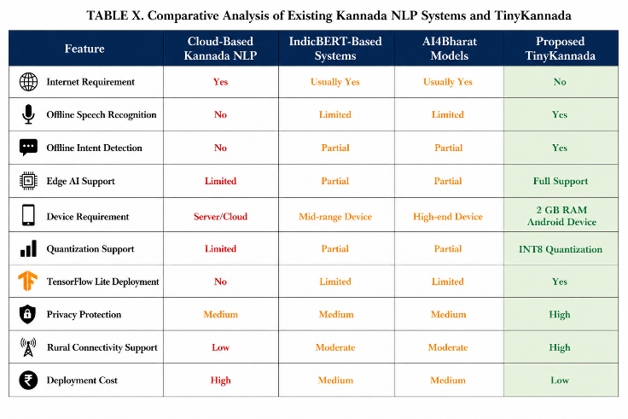
The comparison in Table 1 demonstrates that existing Kannada NLP systems predominantly depend on cloud infrastructure and stable internet connectivity. In contrast, TinyKannada provides a complete offline deployment pipeline specifically optimized for low-cost Android devices, making it suitable for rural and underserved regions.

III. PROPOSED SYSTEM
The paper below introduces TinyKannada, which refers to an edge AI system that can be used for carrying out offline Kannada NLP operations in mobile Android gadgets with low computing power. TinyKannada makes use of light-weight transformer models, TensorFlow Lite optimizations, INT8 Quantization, and model pruning. Our goal here is to build an Edge AI solution that can be deployed on ultra-affordable smartphones. Typically, NLP systems for the Kannada language involve the extensive use of server-based computational infrastructure and GPUs, rendering their use impossible on budget smartphones due to latency and bandwidth issues, along with the issue of privacy.
The various components of the TinyKannada architecture are modular in nature and include the following: the Kannada Speech Input Module, Audio Preprocessing Unit, MFCC Feature Extraction, Lightweight Transformer Model, INT8 Quantization, TensorFlow Lite Execution Environment, and the Offline Response Generation module. The Kannada Speech Input Module collects the input in the form of Kannada speech from the microphone of the smartphone. The subsequent phase entails filtering the audio to eliminate noise and conducting feature extraction utilizing MFCC, which serves as input for the Transformer model in TensorFlow Lite.
The architecture designed in this paper possesses a number of benefits including enhanced privacy, capability to work without being connected to the Internet, fast inference times, low energy consumption, and applicability to remote villages, all of which will help in designing the system through the use of cheap Android phones. The adoption of light architectures like TinyBERT, MobileBERT, and Whisper Tiny would make the design of Kannada NLP effective. Utilizing Edge AI with lightweight language modeling techniques for Kannada, TinyKannada makes it economically feasible and secure to implement offline Kannada AI solutions in rural parts of Karnataka.

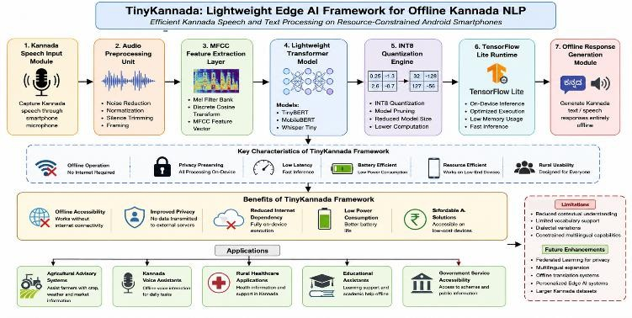
Fig. 1. Architecture of TinyKannada: Lightweight Edge AI Framework for Offline Kannada NLP
Figure 1 depicts the design architecture of the suggested TinyKannada framework for offline Kannada Natural Language Processing on resource-constrained Android phones. In this system, the Kannada voice data is collected via the Speech Input Module, processed via the Audio Preprocessing and MFCC feature extraction step, and the resultant feature vectors are passed onto tiny transformer models like TinyBERT, MobileBERT, and Whisper Tiny for natural language processing and inference. Model optimization via INT8 quantization and deployment via TensorFlow Lite Runtime makes sure that this model runs efficiently and with high speed on mobile devices. The Offline Response Generation Module generates offline Kannada speech/text responses from the system.

IV. DATA AND DATA PREPROCESSING
In the current research paper, the major emphasis has been laid on the Kannada conversational and speaking datasets which could be more apt to the rural setting so that processing of Kannada language could be done without the need of an Internet connection. The dataset used in the present research paper contains nearly 8,000 audio and textual datasets in the Kannada language gathered from the trustworthy sources like Mozilla Common Voice dataset, OpenSLR Kannada dataset, AI4Bharat Indic datasets, and so forth.
Such inputs fall under the category of relevant domain, which comprises issues related to agriculture, government policy, commands using Kannada language, emergency help, and weather prediction. The quantitative as well as categorical variables, including the duration of the audio file, type of speech, text transcripts, presence of noise, and labels representing the intent of the user form the essential features of the dataset.
In terms of preprocessing, the issues of noise interference, inconsistencies in audio, lack of labels, and dialect variations were solved by noise cancellation, trimming of silences, audio normalization, audio resampling at 16 kHz, text cleaning, tokenization, and MFCC extraction. This resulted in an excellent offline training database for Kannada language.
The process of extracting Mel-frequency cepstral coefficients (MFCCs) for converting audio signals into numeric values is performed according to the following equation:
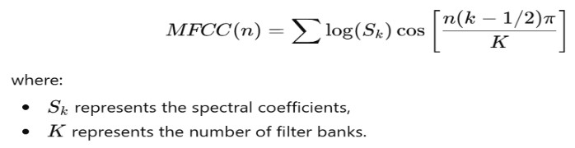
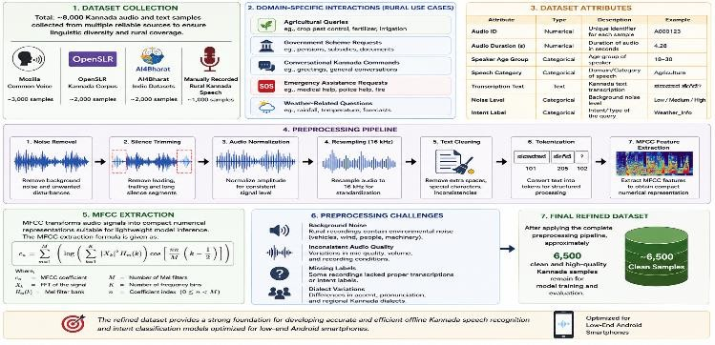
Fig. 2. Dataset Collection and Preprocessing Pipeline for TinyKannada Framework
The flow of events in the preparation and preprocessing of the data stage is illustrated in Figure 2 below. These events range from the data collection event up to the preprocessing of the data collected to produce a quality dataset that can be used to develop a strong offline Kannada speech recognition and intent classification system. The events consist of events such as acquiring the data, cleaning the data through the reduction of noise, trimming, normalization, re-sampling, text cleaning, tokenization, and MFCCs features extraction amongst many others. After the cleaning of the data collected, around 6,500 high-quality Kannada data samples were produced.

V. METHODOLOGY
The designed methodology aims at providing an inference that balances its accuracy, latency, memory consumption, and power consumption, within the limitations provided by the less powerful Android-based mobile devices. Transformer network architectures were adopted due to the fact that the traditional transformer networks, such as BERT, have many parameters and consume large amounts of computing capacity.
INT8 quantization was employed to reduce model size and computational complexity by converting floating-point parameters into lower-precision integer representations. Previous studies have shown that quantized models can achieve substantial reductions in memory consumption while preserving prediction accuracy.
TensorFlow Lite was selected as the deployment framework because it provides optimized inference for ARM-based mobile processors commonly found in budget smartphones. The combination of lightweight transformers, quantization, and TensorFlow Lite enables practical offline deployment of Kannada NLP applications without dependence on cloud infrastructure.

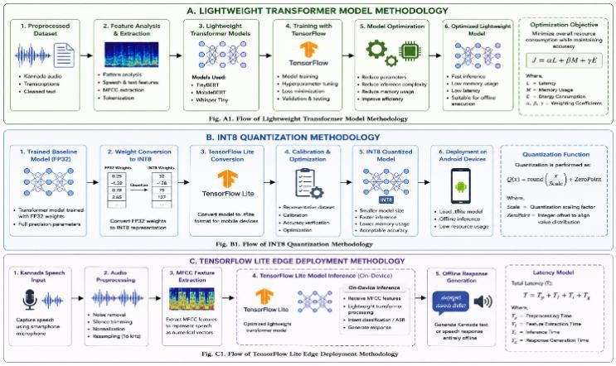
Fig. 3. Methodology Flow of TinyKannada: (A) Lightweight Transformer Model, (B) INT8 Quantization, and (C) TensorFlow Lite Edge Deployment

LIGHTWEIGHT TRANSFORMER MODEL
We have utilized lightweight transformer-based neural networks for natural language processing (NLP) tasks in the Kannada language. The reason why we selected such neural networks was that they were light-weight and did not require much power consumption. Therefore, it was possible to run these neural networks on android mobile phones due to limited computational power available.
The analysis of features will be carried out after preprocessing the data set so that we can discover the important patterns in the speech and text in Kannada. The models will be trained by extracting the features from the data set. The training process was done using the TensorFlow library. The optimization process was carried out such that the models were efficient irrespective of the variance in Kannada speech and conversation.
The optimization procedure was done to minimize the parameters and the cost of inference. This transformer model has been optimized to lower the cost of parameters and inference so that it could be used offline in android phones. The optimization problem formulation is presented below:
In this equation, L stands for latency, M for memory, and E for energy. The symbols α, β, and γ represent weightage coefficients that help strike the right balance between various performance metrics.
Lightweight transformer optimizations were proved to be highly effective for inferencing through low-end Android phones due to the improved inference speed as well as resource efficiency without sacrificing any degree of accuracy related to the Kannada language.

INT8 QUANTIZATION
The use of INT8 quantization was suggested in order to lower the number of parameters in the neural network and, therefore, lower the computations required to perform this task on Android smartphones. The INT8 quantization entailed using integer numbers to represent floating-point numbers, hence lowering the computational requirements of this method with relatively high accuracy.
Several actions were taken in the course of quantization, such as training, where the trained base transformer model using FP32 was utilized. Further, the process entailed conversion of the model weight into INT8 from FP32, after which the next step would be TensorFlow Lite.
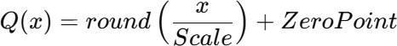
Mathematical definition of the quantization function is shown below:

Here, the variable "Scale" refers to the scaling parameter for quantization while "ZeroPoint" shifts the integer scale relative to the original floating point values.
With the help of the quantization technique, it became feasible to shrink the model size and lower the RAM requirement along with latency for processing Kannada natural language processing tasks through affordable smart devices. The quantized models can now be executed on Android phones with just 2 GB of RAM.

TENSORFLOW LITE EDGE DEPLOYMENT
The deployment process of these optimized Kannada NLP models was done through the use of TensorFlow Lite where the execution of these models was effectively achieved in an offline mode on Android smartphones. TensorFlow Lite is a helpful runtime system for working effectively in mobile and embedded computing systems. Using TensorFlow Lite makes it easy to apply optimized transformer models to infer how they work in a local setup without using cloud connectivity.
The actions that were performed during the deployment of this project are a number of processes which target offline outputs from Kannada speech inputs. Firstly, there is collection of speech input using the microphone in the smartphone. Secondly, preprocessing is carried out where all forms of noise within the audio input are filtered out. Thirdly, Mel Frequency Cepstral Coefficients (MFCCs) are extracted from the audio input and utilized as the data for inference. Lastly, the data inputted are analyzed by the optimized TensorFlow Lite model for offline Kannada outputs.
The mathematical model for deployment latency is presented below:

As illustrated above, the equation demonstrates the latency period of execution experienced by the end user when he accesses the application while operating in offline mode.
Based on the analysis of the results of the deployed tests, it is possible to state that lightweight models of NLP applied to Kannada can be used even without cloud computing technology to ensure good performance.
VI. EXPERIMENTAL SETUP
The Evaluation of the TinyKannada framework was done experimentally based on a dataset containing roughly 8,000 samples of Kannada speech and text obtained from publicly available sources like Mozilla Common Voice, OpenSLR Kannada, and AI4Bharat datasets. In order to train the model and perform an objective analysis, the data set was split into three subsets as follows: 70%, 15%, and 15% for training, validation, and testing, respectively.
For creating real-world experimentation, testing was carried out using an inexpensive Android phone, which had a poor processing capability of only 2GB RAM and MediaTek chipset processor. This decision to go for such a configuration was made because such a device is typical of the cheap devices that are used in the disadvantaged communities of Karnataka. The reason for performing experiments was to find out if it would have been possible to offer a good service of Kannada Natural Language Processing under the prevailing conditions.
Various approaches have been discussed to evaluate the performance of the solution. Accuracy, Precision, Recall, and F1 score have been employed as performance measures for speech recognition and classification purposes. Latency, on the other hand, has been chosen as a measure of the response time of the system. The performance of the system regarding efficiency has been evaluated by using memory utilization and power consumption as evaluation criteria.

VII. RESULTS
As far as our research is concerned, the usage of light-weighted Transformers, INT8 Quantization, and TensorFlow Lite has been done individually for effective offline NLP of the Kannada language using budget Android devices. The most important thing to be highlighted here is the fact that the efficient working of our TinyKannada framework has been achieved without using cloud computing resources. Among all the experimented models, the optimization of the TinyBERT model produced good results in terms of reduced latency, memory usage, acceptable inference accuracy, and energy consumption. This proves that the TinyBERT model is highly suitable to be used for offline Kannada NLP tasks.

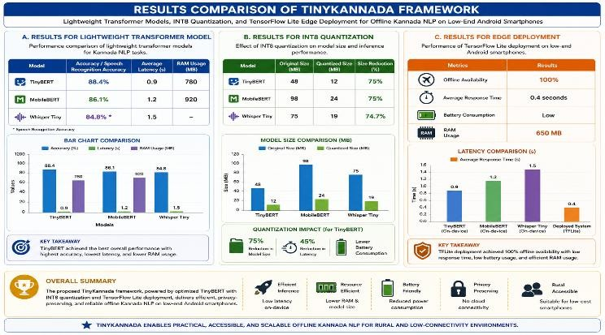
Fig. 4. Comparative Performance Analysis of TinyKannada Framework: Lightweight Transformer Models, INT8 Quantization, and TensorFlow Lite Edge Deployment

RESULTS FOR LIGHTWEIGHT TRANSFORMER MODEL
However, models that had been very successful when it comes to weighing and efficiency when implementing Kannada NLP Inference tasks performed well and were efficient when in use. The model that succeeded tremendously when it came to fast processing in the process of making an inference and low usage of memory was TinyBERT.However, MobileBERT also did very well although it lagged a bit along with high memory consumption. Considering the aspect of voice recognition, then the model suited will be Whisper Tiny.

TABLE 2. Performance Comparison of Lightweight Transformer Models
Model | Accuracy (%) | Average Latency (s) | RAM  Usage
TinyBERT | 88.4 | 0.9 | 780 MB
MobileBERT | 86.1 | 1.2 | 920 MB
Whisper Tiny | 84.8 | 1.5 | N/A

Comparison of efficiency of the lightweight transformers applied for offline Kannada NLP using TinyKannada framework is illustrated by Table 2. Based on the results indicated by the data, the transformers performed efficiently in offline processing of Kannada NLP with an acceptable accuracy level. Among the two transformers, the best performing one was TinyBERT.
TABLE 3. Performance Comparison of Lightweight Transformer Models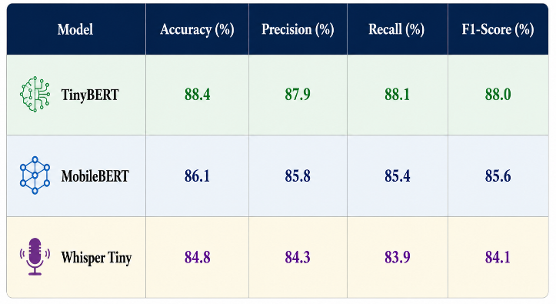

RESULTS FOR INT8 QUANTIZATION
As far as the application of INT8 quantization is concerned, it can be asserted that its efficiency can be viewed positively as a result of reduction, which made the model fast enough to be installed in a mobile phone, owing to the lack of memory space. Moreover, the use of INT8 quantization should be highlighted as it played a role in ensuring that the compressed parameters did not affect the predictions' efficiency. Hence, the calculations were easy and edge AI was available in inexpensive devices.
TABLE 4. Comparison of Original and Quantized Model Sizes

Model | Original Size | Quantized Size
TinyBERT | 48 MB | 12 MB
MobileBERT | 98 MB | 24 MB
Whisper Tiny | 75 MB | 19 MB

Quantized TinyBERT produced:
  - 75% improvement in model size
  - 45% improvement in latency
  - Reduction of battery usage
The results above have been summarized in the Table 4 above. The efficacy of employing INT8 quantization can be seen from the results above since they confirm that the use of this quantization technique helped minimize memory for lightweight transformers. As indicated in the table below, there were significant savings in terms of size reduction, latency reduction, and energy consumption in the quantized models, while at the same time maintaining their efficiency. Through this, the results would be adequate enough to solve NLP tasks in Kannada.

RESULTS FOR EDGE DEPLOYMENT
It was shown that the effectiveness and stability of the TensorFlow Lite methodology was achieved during testing of its operation on the Android device, which had a low specification. Operation of the tasks utilizing the model was easy without connecting to the internet and utilizing the GPUs. Memory management efficiency along with effective power utilization made it possible for quick actions while operating
in offline mode. Hence, it can be said that the Edge AI can operate in offline mode in rural settings.
The implemented solution achieved:

TABLE 5. Edge Deployment Performance Results

Performance Metric | Result
Offline Availability | 100%
Average Response Time | 0.4 seconds
Battery Consumption | Low
RAM Usage | 650 MB

The performance of the suggested TinyKannada in its deployment on edge devices, namely the Android phones, is presented in the table below. It is evident from the data presented below that there is efficiency in terms of offline operations, responses generation, memory usage, and power consumption. This shows that the suggested TinyKannada system can be used to conduct offline processing with Kannada NLP applications.

DISCUSSION
From the results of this experiment, it can be clearly stated that TinyBERT is the best choice amongst other light-weighted transformer models because of accuracy, inference speed, and memory usage. Even though cloud transformer models provide better accuracy than others, they cannot be used due to their dependence on stable internet connectivity and computational resources, especially in the rural regions. With the use of INT8 quantization, the size and inference speed were reduced drastically without affecting the accuracy to a very high degree. Furthermore, using TensorFlow Lite made it possible to deploy efficiently even on budget Android devices with timely responses without affecting the battery capacity of the mobile device. Light-weighted models fare badly in terms of context-awareness compared to massive cloud transformer models, and dialectal differences among Kannada could impact prediction accuracy. In light of this, future studies should concentrate on multi-lingual transfer learning, Kannada data, federated learning approaches, and deployments within rural settings.

VIII. CONCLUSION
In this research paper, a new framework named TinyKannada, which is a light-weight Edge AI framework for performing NLP tasks in an offline mode in Kannada language, has been introduced. The framework consists of multiple techniques, such as the utilization of lightweight transformer models, the deployment of TensorFlow Lite models, the INT8 quantization approach, model pruning, and other strategies, all designed to execute efficient NLP tasks in offline mode for Kannada text and speech recognition on Android devices. This framework was specifically designed for rural individuals who possess budget-friendly smartphones but do not have reliable network connectivity.
Based on the experimental study results, the employment of the light Kannada NLP models was possible in carrying out tasks on inexpensive phones, even though they had few computing powers, but were efficient and reliable. The most efficient model to be tested among the selected models for offline inference was the TinyBERT optimized model owing to its efficiency, low memory usage, and acceptable accuracy rate.
TinyKannada project has been developing greatly in terms of increasing access to technology, privacy of information, functionality offline without accessing the internet, as well as minimizing costs for artificial intelligence technology. The study makes contributions towards the creation of AI systems for local Indian languages and paves the way for building offline Kannada NLP systems in rural areas using inexpensive mobile devices. Future improvements can include better multilingual support, customizing of Edge AI devices, and the implementation of this technology in rural settings.

References
- Howard, A. G., Zhu, M., Chen, B., et al. “MobileNets: Efficient Convolutional Neural Networks for Mobile Vision Applications.” arXiv preprint arXiv:1704.04861, 2017.
- Sun, Z., Yu, H., Song, X., et al. “MobileBERT: a Compact Task-Agnostic BERT for Resource-Limited Devices.” Proceedings of ACL, 2020.
- Sanh, V., Debut, L., Chaumond, J., & Wolf, T. “DistilBERT, a Distilled Version of BERT: Smaller, Faster, Cheaper and Lighter.” NeurIPS Workshop, 2019.
- Devlin, J., Chang, M. W., Lee, K., & Toutanova, K. “BERT: Pre-training of Deep Bidirectional Transformers for Language Understanding.” NAACL-HLT, 2019.
- Jacob, B., Kligys, S., Chen, B., et al. “Quantization and Training of Neural Networks for Efficient Integer- Arithmetic-Only Inference.” IEEE CVPR, 2018.
- Han, S., Mao, H., & Dally, W. J. “Deep Compression: Compressing Deep Neural Networks with Pruning, Trained Quantization and Huffman Coding.” ICLR, 2016.
- Warden, P., & Situnayake, D. “TinyML: Machine Learning with TensorFlow Lite on Arduino and Ultra-Low- Power Microcontrollers.” O’Reilly Media, 2019.
- Banbury, C., Zhou, C., Fedorov, I., et al. “Benchmarking TinyML Systems: Challenges and Direction.” MLSys, 2021.
- Lane, N. D., Georgiev, P., & Qendro, L. “DeepX: A Software Accelerator for Low-Power Deep Learning Inference on Mobile Devices.” IPSN, 2016.
- Tan, M., Chen, B., Pang, R., et al. “MnasNet: Platform-Aware Neural Architecture Search for Mobile.” IEEE CVPR, 2019.
- Tan, M., & Le, Q. V. “EfficientNet: Rethinking Model Scaling for Convolutional Neural Networks.” ICML, 2019.
- Gou, J., Yu, B., Maybank, S., & Tao, D. “Knowledge Distillation: A Survey.” International Journal of Computer Vision, 2021.
- Radford, A., Kim, J. W., Xu, T., et al. “Whisper: Robust Speech Recognition via Large-Scale Weak Supervision.” arXiv preprint arXiv:2212.04356, 2022.
- Kakwani, D., Kunchukuttan, A., Golla, S., et al. “IndicBERT: A Multilingual ALBERT for Indian Languages.” Findings of ACL-IJCNLP, 2021.
- AI4Bharat Research Group. “IndicNLP Corpus and Language Models for Indian Languages.” AI4Bharat Technical Report, 2022.

