Optimisation of Water, Surfactant and Dual-Biodiesel Concentration for a Least-Phase-Separation Emulsified Neem–Palm Blend in a Diesel Engine: Stability, Performance and Emission Study

Abstract
Fossil-fuel depletion and the harmful exhaust emissions of compression-ignition (CI) engines have intensified the search for cleaner alternative fuels. Emulsification of water into biodiesel–diesel blends is an attractive technique because the micro-explosion of dispersed water droplets improves atomisation and lowers the peak combustion temperature, simultaneously enhancing performance and reducing oxides of nitrogen. This study optimises the water, surfactant and dual-biodiesel content of a least-phase-separation emulsified fuel and evaluates it in a single-cylinder CI engine. A B30 blend of Neem and Palm biodiesel (15% Neem + 15% Palm + 70% diesel, denoted N15P15D70) was selected as the base fuel. Water-in-oil emulsions were prepared with water concentrations of 1–5 v/v %, surfactant (SPAN 80 / TWEEN 80) of 1–2 v/v %, and hydrophile–lipophile balance (HLB) values of 4.3, 5.3 and 6, using a mechanical stirrer. Emulsion stability was assessed from the phase-separation percentage over six hours, and the optimum formulation was tested for engine performance and exhaust emissions against neat diesel. The emulsion with 5% water, 2% surfactant and HLB 6 (W5S2HLB6) gave the best stability, with only 8% separation after six hours. Relative to diesel, this fuel delivered about 14% higher brake thermal efficiency, 42% higher carbon dioxide (indicating more complete combustion), and roughly 60% lower carbon monoxide and 61% lower NOx, although brake specific fuel consumption rose by about 16.7% and smoke increased marginally. The study concludes that an emulsified fuel of 30% dual biodiesel, 2% surfactant, 5% water and HLB 5.3–6 markedly reduces harmful emissions while improving engine performance, and can be used in existing engines with little or no modification.
Keywords: CI engine; Alternative fuel; Dual biodiesel; Neem; Palm; Emulsification; Emulsion stability; Engine performance; Emission analysis; Micro-explosion
1. Introduction
The internal-combustion engine remains the dominant prime mover for transportation worldwide, and the diesel (compression-ignition, CI) engine in particular is favoured for its robust design, high thermal efficiency, high motive power and low fuel consumption relative to the spark-ignition engine. However, the combustion of petroleum diesel emits hydrocarbons (HC), carbon monoxide (CO), carbon dioxide (CO₂), oxides of nitrogen (NOₓ), oxides of sulphur and particulate matter (PM), all of which degrade air quality and harm human health. Coupled with the finite nature of fossil reserves, these concerns have driven a search for renewable, economical and environmentally friendly alternative fuels that can reduce emissions without penalising engine performance.
Biodiesel produced from vegetable oils, animal fats or waste cooking oil by transesterification is a promising alternative because its properties are close to those of diesel and it can be used in existing engines, fully or as a blend, with little or no modification. Biodiesel is biodegradable, non-toxic and offers a high cetane number, high flash point, good lubricity and improved combustion. Non-edible feedstocks such as Neem and Palm are particularly attractive because they do not compete with the food supply, grow with little care on poor soils, and offer high calorific value and yield. The direct use of neat vegetable oil is avoided owing to its high viscosity and low volatility, which can cause poor atomisation, injector choking and incomplete combustion; transesterified biodiesel mitigates these issues, though blends can slightly raise NOₓ emissions and reduce power.
Emulsification is a complementary technique in which two immiscible fluids — here water and the biodiesel–diesel blend — are dispersed into a homogeneous mixture using surface-active agents (surfactants) under mechanical agitation. Adding water to the fuel reduces the peak combustion temperature because the water droplets absorb heat and act as an internal coolant, suppressing the thermal formation of NOₓ. More importantly, during combustion the dispersed water, having a lower boiling point than the surrounding fuel, vaporises explosively and shatters the parent fuel droplet into finer secondary droplets. This “micro-explosion” phenomenon (Fig. 1) enlarges the fuel surface area, promotes turbulent mixing and improves combustion efficiency, thereby raising brake power, torque and brake thermal efficiency (BTE).
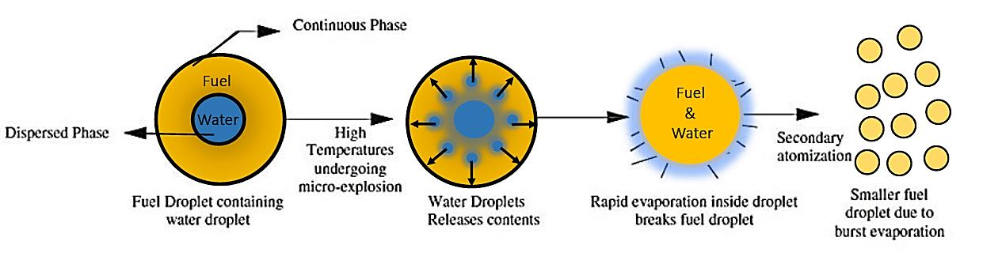
Fig. 1. Schematic of the micro-explosion phenomenon of a water-in-oil emulsion fuel: the dispersed water droplet vaporises explosively and shatters the parent fuel droplet into finer secondary droplets.
Emulsions are classified by droplet size into macro-, micro- and nano-emulsions, and by structure into two-phase (water-in-oil, W/O, or oil-in-water, O/W) and three-phase (O/W/O or W/O/W) systems. The water-in-oil emulsion is generally regarded as the practical alternative for CI engines. The present work examines a two-phase water-in-oil emulsion of water dispersed in a dual-biodiesel (Neem–Palm) diesel blend. The aim is to identify the formulation — in terms of water content, surfactant quantity and HLB value — that yields the least phase separation (greatest stability) while delivering the best engine performance and the lowest emissions relative to neat diesel.
2. Literature Review
A large body of work has established that biodiesel and water-in-diesel emulsions can reduce engine emissions while maintaining performance. Up to 20% biodiesel (methyl ester) can be blended with diesel without affecting performance or emissions, and Jatropha-blended fuels reduce CO, HC and smoke at the expense of slightly higher NOₓ (Jain & Sharma, 2010; Venkanna & Reddy, 2012).
2.1 Water-in-Diesel and Emulsified Fuels
Vellaiyan and Amirthagadeswaran (2016) reported that water-in-diesel emulsions with additives reduce NOₓ by about 45% and PM by 80–90%, with thermal efficiency, brake power and torque all improving with water content owing to the micro-explosion effect. Abu-Zaid (2004) observed improvements in torque, brake power and BTE (about 3.5% at 20% water) for emulsified diesel, with exhaust-gas temperature falling as water content rose. Samec et al. (2002) found a 50% reduction in soot and a longer ignition delay with 10–15% water emulsions, accompanied by a 26% rise in heat-release rate. Mohammed Yahaya Khan et al. (2014) summarised the field, confirming reductions in NOₓ, PM, peak cylinder temperature and BSFC alongside gains in brake power and BTE. Some studies, however, report increased HC and CO with water addition (Ithnin et al., 2014; Fahd et al., 2013), underlining the sensitivity of the outcome to formulation and operating conditions.
2.2 Biodiesel Emulsions and Stability
Raheman and Kumari (2014) tested Jatropha-biodiesel emulsions with 10–15% water and found longer ignition delays at high load, decreasing BSFC and increasing BTE with water, and reduced CO, CO₂ and NOₓ; an HLB of about 5 gave the best stability. Debnath et al. (2013, 2014) studied palm-oil methyl-ester emulsions, reporting a 7–11% rise in BTE with 5% water and improved two-phase stability with hydrophilic surfactant addition. The Cherng-Yuan Lin group examined two- and three-phase emulsions extensively, showing that 2% SPAN 80 / TWEEN 80 surfactant at HLB 6–8 yields more stable emulsions, that higher stirring speed reduces the mean droplet diameter, and that higher water content raises emulsion viscosity and the sediment layer (Lin & Wang, 2003, 2004; Lin & Chen, 2006; Lin & Lin, 2007). Chen and Tao (2005) identified an optimum stirring intensity of about 2500 rpm for emulsion stability.
2.3 Research Gap and Objectives
While biodiesel blends and water-in-diesel emulsions have each been studied widely, comparatively little work has optimised a dual-biodiesel emulsion — combining two complementary non-edible feedstocks — with respect to water content, surfactant quantity and HLB simultaneously, and then linked the resulting emulsion stability to engine performance and emissions. The present study addresses this gap. Its objectives are: (i) to determine the optimum split of a 30% Neem–Palm biodiesel blend; (ii) to prepare two-phase water-in-oil emulsions of the N15P15D70 base fuel with water (1–5%), surfactant (1–2%) and HLB (4.3–6) and identify the least-phase-separation (most stable) formulation; and (iii) to compare the performance, combustion and emission characteristics of diesel, the dual-biodiesel blend and the optimised emulsion in a CI engine at a normalised load condition.
3. Materials and Methods
3.1 Experimental Setup
Experiments were performed on a computerised single-cylinder, four-stroke, water-cooled Kirloskar diesel engine test rig (Fig. 2). Engine load was applied through a water-cooled rope-brake dynamometer adjusted from the control panel. Cooling water was circulated through the engine and a pipe-in-pipe calorimeter, with flow controlled by two rotameters. K-type thermocouples and RTD sensors measured inlet and outlet temperatures, and a crank-angle encoder enabled combustion analysis. The rig records performance parameters such as specific fuel consumption, indicated and brake power, BMEP, brake and indicated thermal efficiency, air–fuel ratio, volumetric and mechanical efficiency over a range of compression ratio, injection pressure and injection timing. The principal specifications are listed in Table 1, and the actual rig is shown in Fig. 3.
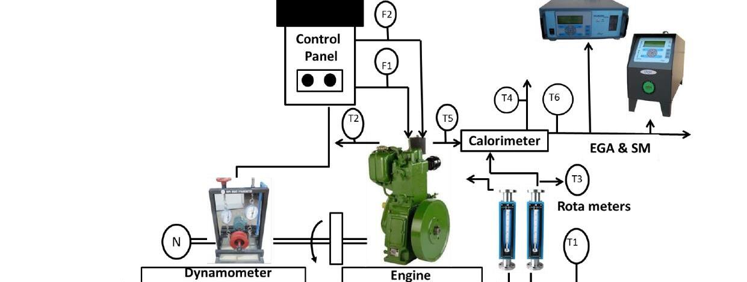
Fig. 2. Line diagram of the engine test setup: T1–T2 engine water inlet/outlet, T3–T4 calorimeter water inlet/outlet, T5–T6 exhaust-gas temperatures before/after calorimeter, F1 fuel and F2 air measurement, N speed; EGA & SM denote the exhaust-gas analyser and smoke meter.
Table 1. Engine test-rig specifications.
Component / parameter | Specification
Engine | Single cylinder, four-stroke, multi-fuel, water-cooled
Bore × stroke | 87.5 mm × 110 mm
Rated power (diesel mode) | 3.5 kW at 1500 rpm
Compression ratio | 18:1 (range 12.1–18.1)
Fuel injection pressure | 180–220 bar
Injection timing | 20° BTDC (range 0–25°)
Dynamometer | Rope-brake type, water-cooled, with loading unit
Calorimeter | Pipe-in-pipe type
Rotameter | Engine cooling 40–400 LPH; calorimeter 25–250 LPH
Crank-angle sensor | Resolution 1°, up to 5500 rpm with TDC pulse
Temperature sensors | RTD PT100 and K-type thermocouples
Fuel tank | 15 L, single compartment with glass metering pipe
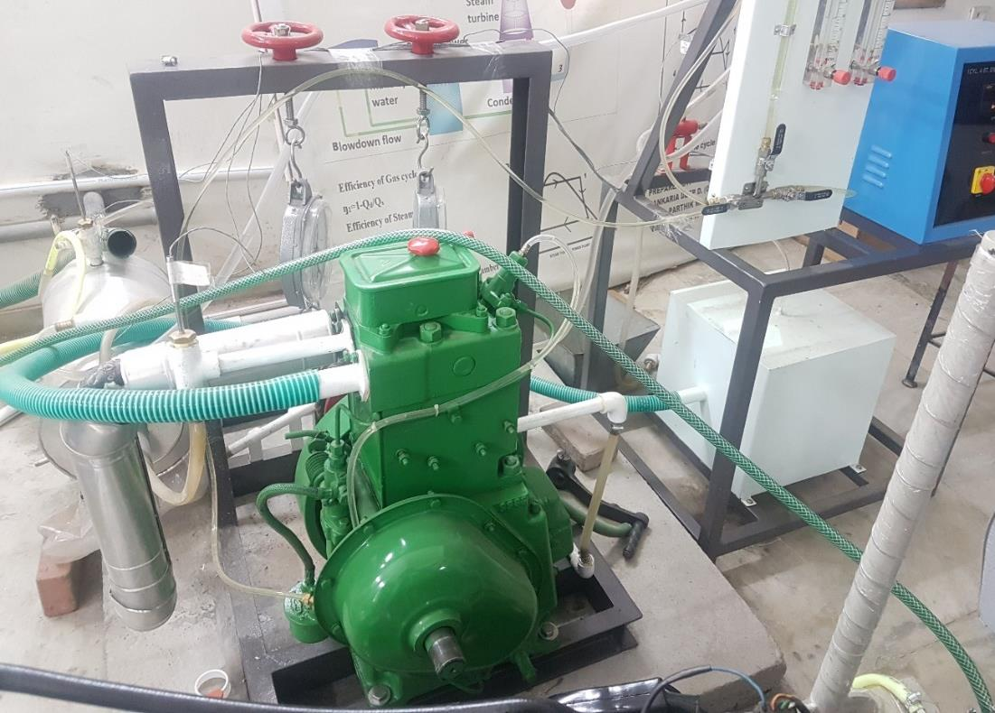
Fig. 3. Photograph of the actual engine test rig at Gandhinagar Institute of Technology.
3.2 Emission and Smoke Measurement
Exhaust gases were measured with a five-gas analyser covering CO, CO₂, HC, O₂ and NOₓ, and smoke opacity was measured with a light-absorption smoke meter. The measurement ranges and accuracies are summarised in Table 2.
Table 2. Measurement ranges of the five-gas analyser and smoke meter.
Parameter | Method | Range | Accuracy
Carbon monoxide (CO) | NDIR | 0–15 % vol | ±5%
Unburned hydrocarbons (HC) | NDIR | 0–20000 ppm | ±5%
Carbon dioxide (CO₂) | NDIR | 0–20 % vol | ±5%
Oxygen (O₂) | Electrochemical | 0–25 % vol | ±5%
Nitrogen oxides (NOₓ) | Electrochemical | 0–5000 ppm | ±5%
Smoke opacity (HU) | Light absorption | 0–99.99 % | –
Smoke opacity (K) | Light absorption | 0–21.439 m⁻¹ | ±0.1 m⁻¹
3.3 Selection of Biodiesel
Neem and Palm were selected as complementary second-generation non-edible feedstocks owing to their high calorific value, high cetane number, ready availability and ability to grow on poor soils. A total biodiesel content of 30% (B30) was fixed. To identify the optimum split, five candidate blends were considered (Table 3), each holding diesel at 70%. The measured properties of diesel and the two biodiesels (per ASTM D6751) are given in Table 4; Palm biodiesel has the higher viscosity and density, while Neem has the higher oxidation stability and cetane number, motivating their combined use.
Table 3. Candidate dual-biodiesel blends evaluated (diesel fixed at 70%).
Set | Neem (%) | Palm (%) | Diesel (%) | Notation
1 | 25 | 5 | 70 | N25P5D70
2 | 20 | 10 | 70 | N20P10D70
3 | 15 | 15 | 70 | N15P15D70
4 | 10 | 20 | 70 | N10P20D70
5 | 5 | 25 | 70 | N5P25D70
Table 4. Properties of diesel and biodiesels (per ASTM D6751).
Property | Unit | Diesel | Neem | Palm
Kinematic viscosity | cSt @40°C | 2.55 | 4.66 | 13.5
Specific gravity | kg m⁻³ | 824 | 865 | 896
Higher heating value | MJ kg⁻¹ | 45.6 | 39.63 | 37.31
Oxidation stability | h | – | 3.16 | 1.19
Flash point | °C | 64 | 180.2 | 273.1
Acid number | mg KOH g⁻¹ | 0.571 | 0.42 | 0.981
Oxygen content | % v/v | 0.125 | 10.97 | 14.83
Cetane number | – | 47 | 58.6 | 50
3.4 Preparation of Emulsified Fuel
The base blend N15P15D70 (70% diesel, 15% Neem, 15% Palm) was used for emulsification. Because diesel/biodiesel is immiscible with water, a surfactant combination of SPAN 80 (lipophilic, HLB 4.3) and TWEEN 80 (hydrophilic, HLB 15.0) was used; their properties are given in Table 5. The resultant HLB of a surfactant mixture is calculated as the volume-weighted sum of the component HLB values:
HLB = (H_L × V_L) + (H_H × V_H) (1)
where H_L and H_H are the HLB values and V_L and V_H the volume fractions of the lipophilic and hydrophilic surfactants. An emulsifier is lipophilic below HLB 9 and hydrophilic above 11; the 4–6 range suits water-in-oil emulsifiers.
Table 5. Properties of the surfactants used.
Property | SPAN 80 | TWEEN 80
Chemical formula | C₂₄H₄₄O₆ | C₆₄H₁₂₄O₂₆
Molar mass | 428.6 g mol⁻¹ | 1310 g mol⁻¹
HLB | 4.3 (lipophilic) | 15.0 (hydrophilic)
Density | 0.986 g mL⁻¹ | 1.09 g mL⁻¹
Nature | Non-ionic, non-toxic | Non-ionic, non-toxic
Two-phase water-in-oil emulsions were prepared with a mechanical stirrer at room temperature. In the first screening stage, 200 mL batches were prepared at 5% and 10% water, with surfactant at 1–3% and HLB of 4.3, 5.3 and 6 (18 blends in total), stirred at 1500 rpm for 15 minutes and then left motionless for six hours, with the separation percentage recorded every 60 minutes. The most stable composition (HLB 6, 2% surfactant) was then carried into a second stage in which the water content was varied from 1% to 5% (W1–W5 S2 HLB6). Because the larger batch did not stabilise at 1500 rpm, the stirring intensity was raised to 3000 rpm, and most blends stabilised within four hours.
3.5 Engine Test Procedure and Load Normalisation
All engine tests were run at a fixed compression ratio of 18, injection pressure of 220 bar and injection timing of 20° BTDC. The engine was warmed at no load for 30–40 minutes to reach steady state, then loaded at 0%, 25%, 50%, 75%, 100% and 110% (overload) using the rope-brake dynamometer; three successive readings were averaged at each condition. Because engines rarely operate at rated load, the results were combined into a single normalised value using the load factors of the U.S. EPA NR-005b modelling document (Table 6), with each load reading weighted and summed to yield a representative operating point. Equal 50% weightings were assigned to the emission and performance groups in the comparative ranking of fuels.
Table 6. Load-factor weighting applied to combine readings (EPA NR-005b).
Load (%) | Load factor
0 | 0.05
25 | 0.15
50 | 0.60
75 | 0.15
100 | 0.05
3.6 Statistical and Uncertainty Analysis
Each measured quantity was recorded six times and analysed at a 95% confidence level. The mean, deviation and standard deviation were computed, Chauvenet’s criterion was applied to reject outliers, and the confidence interval was estimated from Student’s t-distribution as Δ = tS/√n, where S is the standard deviation, t the t-statistic at ν = n−1 degrees of freedom and n the number of observations. The propagated uncertainty in a derived result R = R(V₁, V₂, …, Vₙ) was estimated by the method of Holman:
ω_R = [ (∂R/∂V₁ · ω₁)² + (∂R/∂V₂ · ω₂)² + … + (∂R/∂Vₙ · ωₙ)² ]^{1/2} (2)
The component uncertainties were taken from instrument resolution or manufacturer data: temperature (RTD) ±1°C, voltage ±1 V, current ±0.1 A, time ±0.1 s, volume flow ±1 mL, emission ±5% / ±1 ppm, pressure (piezo) ±0.1 bar, crank angle ±1° and load ±0.25%.
4. Results and Discussion
4.1 Fuel Characterisation (GC–MS and FT-IR)
Gas chromatography–mass spectrometry (GC–MS, Shimadzu GC-2010 Plus, RTX-5 column) was used to determine the fatty-acid composition of the biodiesels (Fig. 4). Palm biodiesel was dominated by palmitic acid (about 69.3%) with oleic acid (about 25.4%), whereas Neem biodiesel was dominated by stearic acid (about 59.9%) with palmitic acid (about 29.3%). The corresponding methyl esters — hexadecanoic acid methyl ester and 9-octadecenoic acid methyl ester — were the principal peaks. Fourier-transform infrared (FT-IR) spectroscopy confirmed the characteristic C–H, C=O, C–O and C–C functional-group bands of the diesel and biodiesel samples, consistent with their ester chemistry. The high palmitic-acid content of Palm explains its higher viscosity and density relative to Neem.
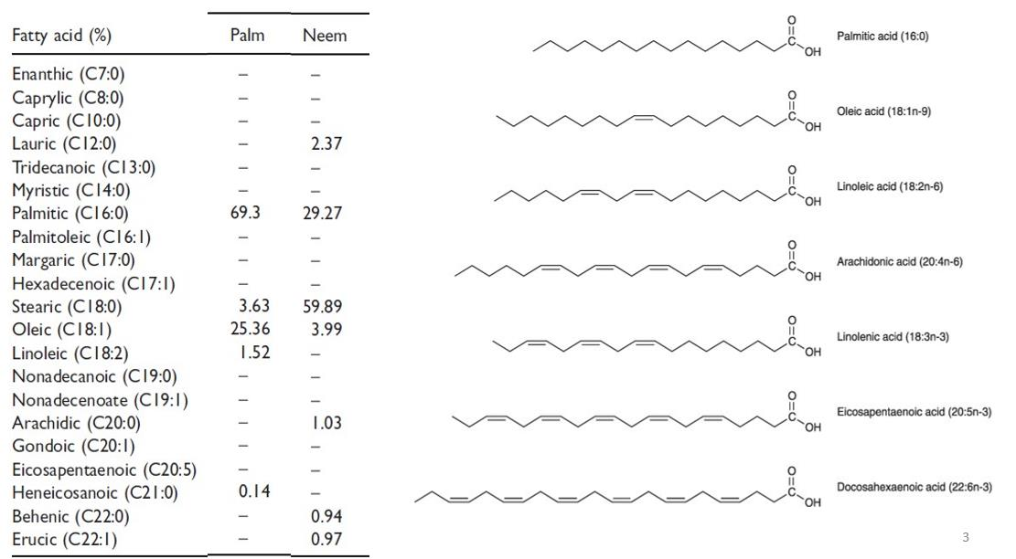
Fig. 4. Fatty-acid composition of Palm and Neem biodiesel from GC–MS, with the molecular structures of the principal fatty acids.
4.2 Emulsion Stability
Stability was quantified by the phase-separation percentage of the two-phase water-in-oil emulsion held motionless for six hours. A creamy separated layer formed at the base of the beaker owing to interaction between water, fuel and surfactant, and this layer grew with increasing water and surfactant content. Among all screened blends, the formulation with HLB 6, 5% water and 2% surfactant was the most stable, showing only 8% separation after six hours, while the corresponding 3%-surfactant blend separated by 10%. Stability improved with 2–3% surfactant and, in the second stage, with the higher stirring intensity (3000 rpm); the stabilisation time lengthened as the water fraction increased. The measured density and calorific value of the test fuels are given in Table 7: density and calorific value both fall as water is added, the calorific value of the 5%-water emulsion being about 5% below that of the base blend.
Table 7. Density and calorific value of the test fuels (per ASTM D6751).
Fuel | Density (kg m⁻³) | Calorific value (kJ kg⁻¹)
Diesel | 824 | 42500
N15P15D70 | 852 | 41878.9
W1S2HLB6 | 822.36 | 41951.8
W2S2HLB6 | 815.12 | 41527.8
W3S2HLB6 | 807.88 | 41103.8
W4S2HLB6 | 800.64 | 40679.8
W5S2HLB6 | 793.4 | 40255.8
4.3 Engine Performance
The normalised brake thermal efficiency (BTE) and brake specific fuel consumption (BSFC) of the fuels are compared in Fig. 5. The maximum BTE of 21.24% was obtained with the W5S2HLB6 emulsion, against 18.29% for neat diesel — an improvement of about 14%. This gain occurs despite the lower calorific value of the emulsion and is attributed to the micro-explosion of the dispersed water, which shatters the parent fuel droplets into finer secondary droplets, enhancing atomisation and turbulent fuel–air mixing. The high compression ratio (18:1) and reduced clearance volume further raised the in-cylinder temperature, intensifying the micro-explosions and improving the burning rate. Conversely, BSFC rose with water content: the W5S2HLB6 blend consumed about 16.7% more fuel than diesel, because the governor supplied additional fuel to maintain power output given the lower energy density and the energy absorbed by water vaporisation.
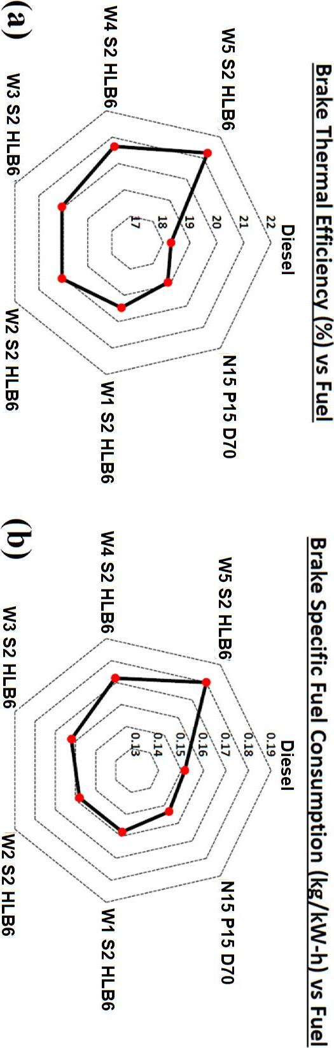
Fig. 5. Engine performance at normalised load (EPA NR-005b weighting): (a) brake thermal efficiency and (b) brake specific fuel consumption for diesel, the N15P15D70 blend and the water emulsions (W1–W5 S2 HLB6).
4.4 Emission Characteristics
Smoke and CO₂ emissions are compared in Fig. 6. Smoke rose marginally with water addition — diesel produced about 4% less smoke than W5S2HLB6 — attributable to the higher viscosity, lower volatility and richer local mixture of the emulsion, which slow combustion slightly. The CO₂ emission, an indicator of complete combustion, was highest for the emulsion: N15P15D70 emitted about 20% more CO₂ than diesel, and W5S2HLB6 about 42% and 28% more than diesel and the base blend respectively, reflecting the oxygen content of the biodiesel and the improved atomisation that converts CO to CO₂.
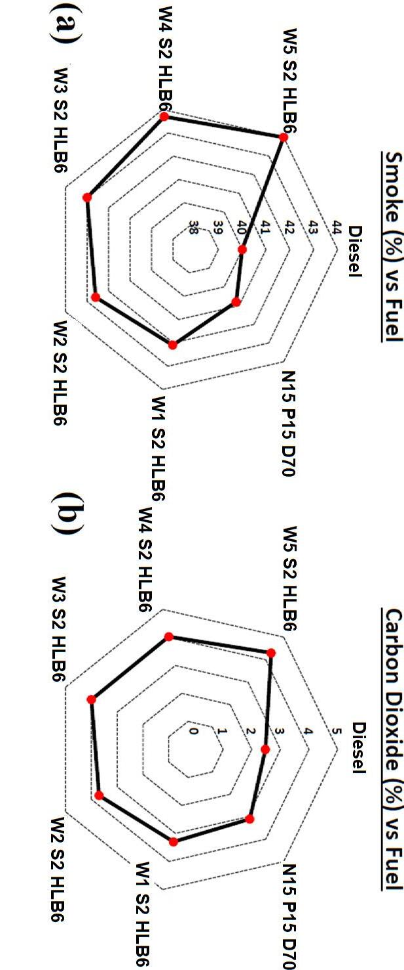
Fig. 6. Engine emissions at normalised load: (a) smoke and (b) carbon dioxide for diesel, the N15P15D70 blend and the water emulsions.
Hydrocarbon (HC) and carbon-monoxide (CO) emissions are compared in Fig. 7. The lowest HC value of 20 ppm was obtained with W5S2HLB6, roughly 6–15% below the base blend, because the in-cylinder water raises local turbulence and promotes more uniform, complete burning. CO emissions also fell sharply with the emulsion: W5S2HLB6 emitted about 124 ppm, some 60% and 56% below diesel and N15P15D70 respectively, driven by the additional oxygen and improved mixing that complete the oxidation of CO.
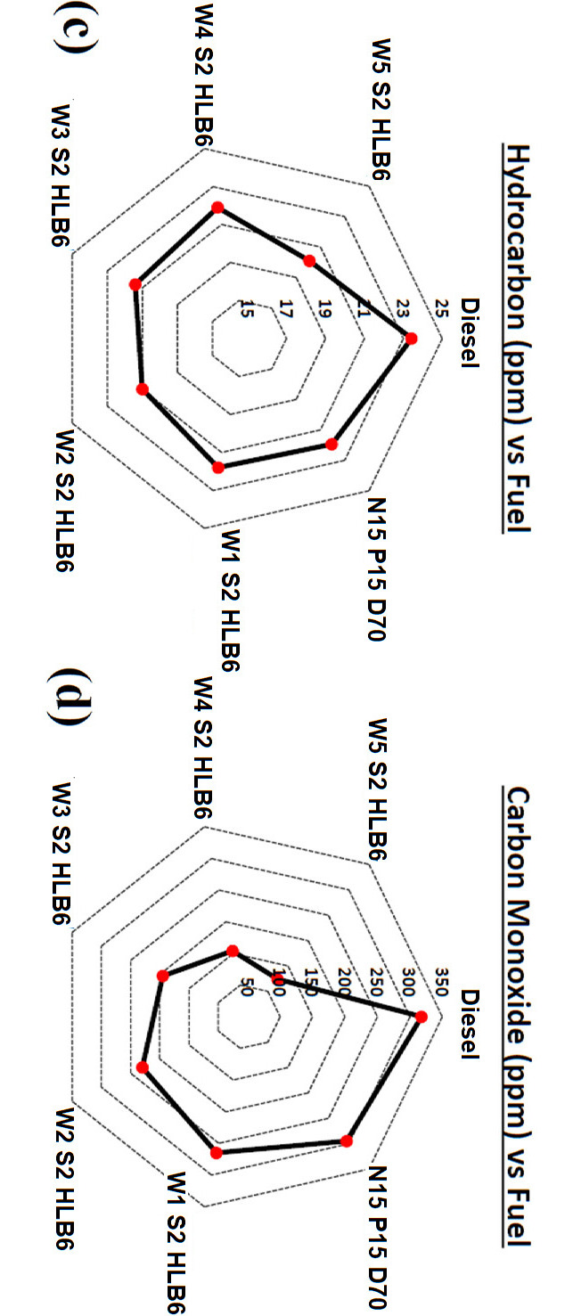
Fig. 7. Engine emissions at normalised load: (c) hydrocarbons and (d) carbon monoxide for diesel, the N15P15D70 blend and the water emulsions.
The NOₓ emission, shown in Fig. 8, is governed chiefly by peak combustion temperature. Diesel produced 212.4 ppm NOₓ, which was 18%, 27%, 41%, 48%, 56% and 61% higher than N15P15D70, W1S2HLB6, W2S2HLB6, W3S2HLB6, W4S2HLB6 and W5S2HLB6 respectively. The steady decline with increasing water content arises because the high latent heat of vaporisation of the dispersed water lowers the in-cylinder gas temperature, suppressing the thermal (Zeldovich) formation of NOₓ; the reduced viscosity and calorific value of the emulsion reinforce this trend. The W5S2HLB6 emulsion thus achieves the largest NOₓ reduction while simultaneously improving combustion completeness.
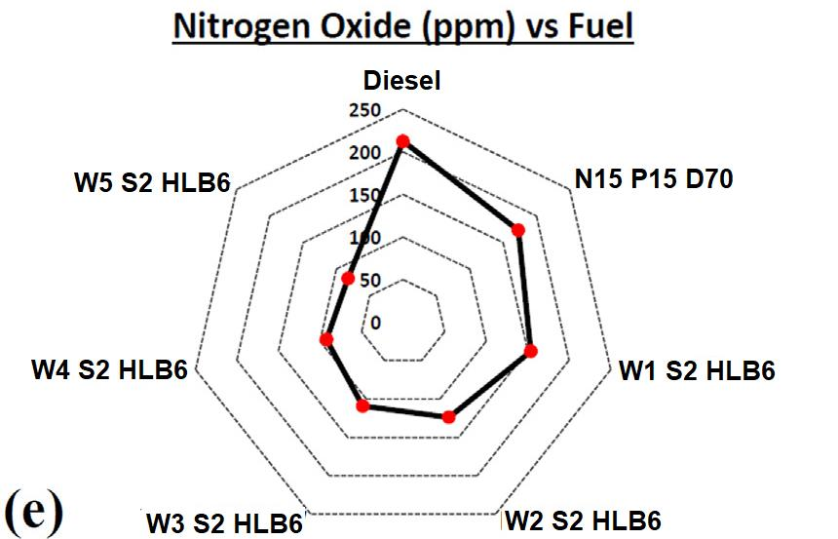
Fig. 8. Oxides of nitrogen (NOₓ) at normalised load for diesel, the N15P15D70 blend and the water emulsions; NOₓ falls steadily as the water fraction increases.
5. Conclusion
The performance, combustion and emission characteristics of diesel, a Neem–Palm dual-biodiesel blend (N15P15D70) and its water-in-oil emulsions were compared in a single-cylinder CI engine, following optimisation of the emulsion for least phase separation. The principal conclusions are:
- Among the screened formulations, the emulsion with HLB 6, 5% water and 2% surfactant (W5S2HLB6) was the most stable, showing only 8% phase separation after six hours; stability improved with 2–3% surfactant and higher stirring intensity (3000 rpm).
- The W5S2HLB6 emulsion raised brake thermal efficiency by about 14% relative to diesel (21.24% versus 18.29%), despite its lower calorific value, owing to the micro-explosion mechanism that improves atomisation and fuel–air mixing.
- Brake specific fuel consumption increased by about 16.7% with the emulsion, as additional fuel was supplied to compensate for the lower energy density and the heat absorbed by water vaporisation.
- The emulsion improved combustion completeness, producing about 42% more CO₂ and about 60% less CO than diesel, while smoke increased only marginally (about 4%).
- NOₓ fell steadily with water content, the W5S2HLB6 emulsion emitting about 61% less NOₓ than diesel, because the latent heat of the dispersed water lowers the peak combustion temperature.
Overall, an emulsified fuel comprising 30% dual biodiesel (Neem–Palm), 2% surfactant, 5% water and an HLB of 5.3–6 markedly reduces harmful emissions and improves engine performance, and can be used in existing diesel engines with little or no modification.
6. Future Scope
- Spray-characteristics analysis of the optimum emulsion to quantify the spray pattern, droplet diameter and the effect of injection pressure.
- Tribo-corrosion (wear and corrosion) studies of the emulsified fuel on CI-engine components to assess long-term durability.
- Extension to nanoparticle-doped emulsions and additional HLB/surfactant systems to further improve stability and combustion.
- Long-duration endurance testing to evaluate deposit formation and performance retention over extended operation.
7. Acknowledgements
The authors gratefully acknowledge the Mechanical Engineering Department, Gandhinagar Institute of Technology, Gandhinagar University, for providing the engine test-rig and laboratory facilities used in this work, and thank the faculty and technical staff for their guidance and support throughout the experimental campaign.

References
Abu-Zaid, M. (2004). Performance of single cylinder, direct injection diesel engine using water fuel emulsions. Energy Conversion and Management, 45(5), 697–705.
Chen, G., & Tao, D. (2005). An experimental study of stability of oil–water emulsion. Fuel Processing Technology, 86(5), 499–508.
Debnath, B. K., Saha, U. K., & Sahoo, N. (2013). Thermodynamic analysis of a variable compression ratio diesel engine running with palm oil methyl ester. Energy Conversion and Management, 65, 147–154.
Debnath, B. K., Sahoo, N., & Saha, U. K. (2013). Adjusting the operating characteristics to improve the performance of an emulsified palm oil methyl ester run diesel engine. Energy Conversion and Management, 69, 191–198.
Debnath, B. K., Saha, U. K., & Sahoo, N. (2015). A comprehensive review on the application of emulsions as an alternative fuel for diesel engines. Renewable and Sustainable Energy Reviews, 42, 196–211.
Fahd, M. E. A., Wenming, Y., Lee, P. S., Chou, S. K., & Yap, C. R. (2013). Experimental investigation of the performance and emission characteristics of a direct injection diesel engine by water emulsion diesel under varying engine load. Applied Energy, 102, 1042–1049.
Holman, J. P. (2012). Experimental methods for engineers (8th ed.). McGraw-Hill.
Ithnin, A. M., Noge, H., Kadir, H. A., & Jazair, W. (2014). An overview of utilizing water-in-diesel emulsion fuel in diesel engine and its potential research study. Journal of the Energy Institute, 87(4), 273–288.
Ithnin, A. M., Yahya, W. J., Ahmad, M. A., Ramlan, N. A., Kadir, H. A., Sidik, N. A. C., & Koga, T. (2018). Emulsifier-free water-in-diesel emulsion fuel: Its stability behaviour, engine performance and exhaust emission. Fuel, 215, 454–462.
Jain, S., & Sharma, M. P. (2010). Biodiesel production from Jatropha curcas oil. Renewable and Sustainable Energy Reviews, 14, 3140–3147.
Khan, M. Y., Abdul Karim, Z. A., Hagos, F. Y., Aziz, A. R. A., & Tan, I. M. (2014). Current trends in water-in-diesel emulsion as a fuel. The Scientific World Journal, 2014, 527472.
Kumar, S. M., Kerihuel, A., Bellettre, J., & Tazerout, M. (2005). Effect of water and methanol fractions on the performance of a CI engine using animal fat emulsions as fuel. Proceedings of the Institution of Mechanical Engineers, Part A, 219(7), 583–592.
Lin, C.-Y., & Wang, K.-H. (2003). The fuel properties of three-phase emulsions as an alternative fuel for diesel engines. Fuel, 82(11), 1367–1375.
Lin, C.-Y., & Wang, K.-H. (2004). Effects of an oxygenated additive on the emulsification characteristics of two- and three-phase diesel emulsions. Fuel, 83(4–5), 507–515.
Lin, C.-Y., & Chen, L.-W. (2006). Emulsification characteristics of three- and two-phase emulsions prepared by the ultrasonic emulsification method. Fuel Processing Technology, 87(4), 309–317.
Lin, C.-Y., & Lin, S.-A. (2007). Effects of emulsification variables on fuel properties of two- and three-phase biodiesel emulsions. Fuel, 86(1–2), 210–217.
Nwafor, O. M. I., & Rice, G. (1996). Performance of rapeseed oil blends in a diesel engine. Applied Energy, 54(4), 345–354.
Qi, D. H., Chen, H., Matthews, R. D., & Bian, Y. Z. (2010). Combustion and emission characteristics of ethanol–biodiesel–water micro-emulsions used in a direct injection compression ignition engine. Fuel, 89(5), 958–964.
Raheman, H., & Kumari, S. (2014). Performance and emissions of emulsified biodiesel operated diesel engine. International Conference on Biological, Civil and Environmental Engineering, 17–18.
Samec, N., Kegl, B., & Dibble, R. W. (2002). Numerical and experimental study of water/oil emulsified fuel combustion in a diesel engine. Fuel, 81(16), 2035–2044.
Syu, J. Y., Chang, Y. Y., Tseng, C. H., Yan, Y. L., Chang, Y. M., Chen, C. C., & Lin, W. Y. (2014). Effects of water-emulsified fuel on a diesel engine generator’s thermal efficiency and exhaust. Journal of the Air & Waste Management Association, 64(8), 970–978.
Vellaiyan, S., & Amirthagadeswaran, K. S. (2016). The role of water-in-diesel emulsion and its additives on diesel engine performance and emission levels: A retrospective review. Alexandria Engineering Journal, 55(3), 2463–2472.
Venkanna, B. K., & Venkataramana Reddy, C. (2012). Direct injection diesel engine performance, emission and combustion characteristics using diesel fuel, non-edible honne oil methyl ester and blends. International Journal of Energy Research, 36, 1247–1261.

