AI-Driven Intrusion Detection System for Cloud Computing Environments Using Machine Learning and Feature Optimization

Abstract — Signature-based intrusion detection has a familiar weakness: it only catches what it already knows to look for, and cloud infrastructure keeps generating new things to look for. In this paper we build and test an AI-driven intrusion detection pipeline for cloud environments that pairs standard machine learning classifiers with a mutual-information feature optimization step, the idea being to cut down the feature set a model has to work through without giving up much in the way of accuracy. Using the NSL-KDD benchmark, we trained Random Forest, Logistic Regression, and K-Nearest Neighbors models on the full 41-feature set and again on a mutual-information-selected subset of just 20 features, then compared the two head-to-head. Cutting the feature count roughly in half cost less than one percentage point of accuracy across every model we tried (Random Forest went from 77.90% to 76.94%), and the Random Forest classifier still managed a ROC-AUC of 0.941 on the smaller feature set. K-Nearest Neighbors prediction time dropped by about 18% once the feature set was trimmed, which matters more than it might sound for a system meant to flag traffic in something close to real time. We also walk through how such a pipeline could sit inside a multi-tenant cloud architecture, and ground the discussion in Rwanda's cloud and data-protection landscape as a concrete example of the kind of resource-constrained setting where lighter models are especially useful. Taken together, the results suggest feature optimization is a fairly cheap way to make ML-based cloud IDS faster and more scalable without much of a trade-off in return.
Keywords — cloud computing security; intrusion detection system; machine learning; feature optimization; mutual information; NSL-KDD; network security.
I. INTRODUCTION
Enterprises, governments, and financial institutions have moved a large share of their workloads onto cloud platforms, and this has changed how computing resources get provisioned, scaled, and paid for. It has also changed the attack surface. Multi-tenancy, virtualization, elastic scaling, and distributed access all complicate the kind of perimeter-based thinking that older security models were built around. Attackers now go after cloud infrastructure through denial-of-service floods, privilege escalation, lateral movement between tenants sharing the same physical hardware, and credential-based intrusions — and the sheer volume of traffic moving through a cloud data center makes manual inspection, or even rule-based inspection, a losing proposition.
Signature matching, the backbone of most traditional IDS, works reasonably well against attacks that have been seen before and catalogued. It does not work against attacks that have not. That gap is the main reason machine learning has become the default direction for IDS research over the past decade: instead of hard-coding what an attack looks like, a model learns the difference between normal and malicious traffic from the data itself. The trouble is that many of these models are trained on very large feature sets pulled from network flow statistics, and a feature set that size brings its own costs — longer training runs, slower inference, and a real risk of the model latching onto attributes that don't actually carry much signal. In a cloud setting, where detection needs to keep pace with traffic that never really stops, those costs are not just an inconvenience.
Feature optimization is one way to deal with this. Rather than feeding a classifier everything available, the idea is to work out which attributes actually separate benign traffic from malicious traffic and drop the rest. Done well, this shrinks the computational load a detection pipeline carries without giving up much — sometimes without giving up anything — in terms of what the model can actually detect.
What we set out to do in this paper is fairly narrow but concrete. We propose an IDS architecture aimed at cloud environments, apply mutual-information-based feature optimization to a well-known intrusion detection benchmark, and compare how three different classifiers — Random Forest, Logistic Regression, and K-Nearest Neighbors — perform with and without that optimization. We then discuss what this looks like in practice, including how a system like this would need to fit into the regulatory and infrastructural realities of a specific cloud ecosystem, using Rwanda as a working example of a digital economy where lighter-weight detection pipelines carry real practical value.
II. RELATED WORK
NSL-KDD has become something of a default testbed for this kind of work, largely because it cleaned up the redundancy problems that plagued the original KDD Cup 1999 dataset and made classification difficulty a bit more realistic (Kaushik et al., 2025). Several surveys have run the usual suspects — SVMs, decision trees, ensemble methods — against it, and the general pattern that emerges is that ensemble classifiers like Random Forest tend to hold up better than simpler models across different attack types (Solanki et al., 2020).
Deep learning has also found its way into this space, with deep neural networks trained on KDD-derived data reporting strong numbers, though usually at the cost of longer training times and models that are harder to inspect or explain than a Random Forest or a linear classifier (Tanimu et al., 2022). A separate but related thread of work on IoT and edge-based intrusion detection has pushed toward lightweight, online traffic analysis for devices that simply don't have the compute budget for anything heavier — a concern that maps fairly directly onto the latency pressures cloud IDS pipelines face at scale (Hafeez et al., 2020).
Feature selection specifically keeps coming up as one of the more effective levers for improving both accuracy and efficiency in ML-based IDS. Researchers have tried recursive feature elimination, exhaustive search, and simpler statistical filters across NSL-KDD, UNSW-NB15, and CICIDS2017, and the results tend to converge on a similar conclusion: a well-chosen subset of somewhere around 15 to 25 features holds onto most of what the full feature set offers, while cutting training and inference cost substantially (Ali et al., 2024; Kaushik et al., 2025). There has also been work combining multiple classifiers into ensemble feature-selection strategies aimed at building detection systems that hold up across several benchmark datasets at once, rather than just one (Waghmode et al., 2025).
What we do here sits within that same line of work, but with a narrower focus. We use mutual information — a cheap, model-agnostic filter method that just measures how statistically dependent each feature is on the class label — and we look specifically at what it does to training time and prediction latency, not only accuracy. That efficiency angle is the part that matters most once you start thinking about deploying any of this at cloud scale.
III. PROPOSED METHODOLOGY
A. System Architecture
We designed the proposed IDS as a modular pipeline that would sit at the hypervisor, virtual network function, or cloud gateway level of a provider's infrastructure — wherever traffic can actually be observed. It breaks down into four stages. First, a traffic capture and feature extraction layer pulls connection-level statistics out of network flows: things like duration, byte counts, service type, and error rates. Second, a preprocessing layer encodes categorical attributes and normalizes the numerical ones. Third, a feature optimization layer trims that feature set down using mutual information, keeping only the attributes carrying real signal. Fourth, a classification layer takes what's left and assigns each connection record a normal or attack label. In an actual production deployment, this would run continuously on streaming flow data, with the classification stage feeding alerts to a Security Operations Center or triggering automated responses — throttling traffic, isolating a tenant, updating firewall rules — through the cloud orchestration layer.
B. Dataset
We evaluated the framework on NSL-KDD, which by now is one of the standard benchmarks for this kind of work precisely because it fixed the redundancy issues that made the original KDD Cup 1999 dataset a bit unreliable (Kaushik et al., 2025). It provides 41 connection-level features covering basic connection attributes, content-based attributes, and traffic statistics, along with a label marking each connection as normal or as one of several attack categories (DoS, Probe, R2L, U2R). We trained on the standard KDDTrain+ partition, 125,973 records, and tested on KDDTest+, 22,544 records, kept entirely separate. What makes KDDTest+ useful is that it deliberately includes attack subtypes the model never saw during training — which makes for a harder and, frankly, more honest test than randomly splitting one big pool of records would give you, since it actually probes whether a model generalizes to attacks it hasn't encountered before. That's the scenario that matters most in practice, since novel attacks are usually the ones you're worried about.
We also collapsed the multi-class attack labels down to a binary normal-versus-attack task. This reflects what a cloud IDS is usually asked to do first and foremost: flag something as suspicious fast, and leave the finer-grained classification of exactly which attack it is to a later triage step.
C. Preprocessing
The three categorical attributes — protocol_type, service, and flag — were label-encoded, and everything numerical was scaled into the [0, 1] range with min–max normalization. The scaler was fit only on the training partition and then applied to both partitions, so nothing from the test set leaked into training. We didn't drop any records; both KDDTrain+ and KDDTest+ were used in full as provided.
D. Feature Optimization Technique
For feature optimization we used mutual information (MI), which measures how statistically dependent each individual feature is on the binary class label without caring which classifier will eventually use it. We computed MI scores for all 41 candidate features on the training partition and kept the top 20 — just under half the original set — using SelectKBest. We went with this filter-based approach rather than a wrapper method like recursive feature elimination mainly because it's classifier-agnostic and considerably cheaper to compute, which matters if a cloud-scale pipeline needs to re-run feature selection periodically as traffic patterns shift.
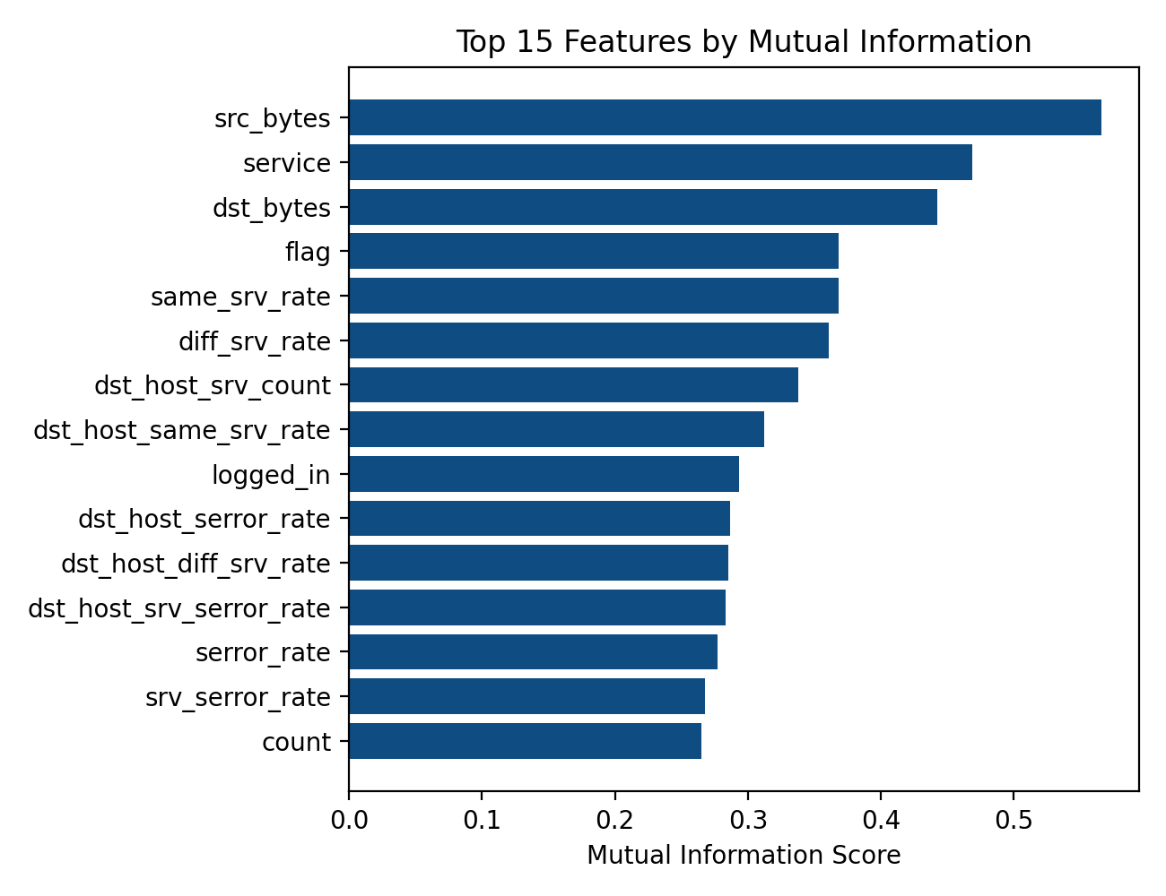
Fig. 1. Top 15 NSL-KDD features ranked by mutual information score with the binary class label.
Fig. 1 shows that byte-count features (src_bytes, dst_bytes), the service and flag attributes, and the same/different-service rate statistics scored highest on mutual information with the attack/normal label. That lines up with a fairly intuitive expectation — how much data a connection moves and which services it touches tend to be the things that give anomalous cloud traffic away.
E. Classification Models
We trained and compared three classifiers, chosen to represent fairly different modeling approaches: Random Forest, an ensemble of decision trees that tends to handle noisy, mixed-type features well; Logistic Regression, as a simple linear baseline; and K-Nearest Neighbors (k = 5), which is non-parametric and makes its decisions purely by comparing a record to its neighbors. Each model was trained twice — once on the 41-feature baseline, once on the 20-feature MI-optimized set — using the same hyperparameters both times, so that any difference in results could be attributed to the feature set rather than to tuning.
IV. EXPERIMENTAL SETUP
All of this was implemented in Python 3, using the scikit-learn machine learning library for preprocessing, feature selection, training, and evaluation. Models were trained on the 125,973-record KDDTrain+ partition and tested on the 22,544-record KDDTest+ partition, which breaks down into 12,833 attack records and 9,711 normal records. We tracked accuracy, weighted precision, weighted recall, weighted F1-score, training time, and prediction time for each run. For Random Forest specifically, we also computed the ROC curve and AUC, since accuracy alone doesn't say much about how a model trades off true positives against false positives as the decision threshold shifts.
V. RESULTS AND DISCUSSION
A. Baseline Performance (Full 41-Feature Set)
Table I summarizes classifier performance using the complete 41-feature set.
Model | Accuracy (%) | Precision (%) | Recall (%) | F1-Score (%) | Train Time (s)
Random Forest | 77.90 | 83.75 | 77.90 | 77.65 | 7.16
Logistic Regression | 75.39 | 80.64 | 75.39 | 75.15 | 0.53
K-Nearest Neighbors | 77.63 | 83.97 | 77.63 | 77.33 | 0.01
TABLE I. Baseline classifier performance on the full 41-feature set (KDDTest+).
B. Performance with Mutual-Information-Optimized Features (20 Features)
Table II summarizes classifier performance using the reduced 20-feature subset selected via mutual information.
Model | Accuracy (%) | Precision (%) | Recall (%) | F1-Score (%) | Train Time (s)
Random Forest | 76.94 | 83.43 | 76.94 | 76.61 | 7.08
Logistic Regression | 74.18 | 79.78 | 74.18 | 73.88 | 0.21
K-Nearest Neighbors | 77.01 | 83.24 | 77.01 | 76.70 | 0.01
TABLE II. Classifier performance on the 20-feature mutual-information-optimized subset (KDDTest+).
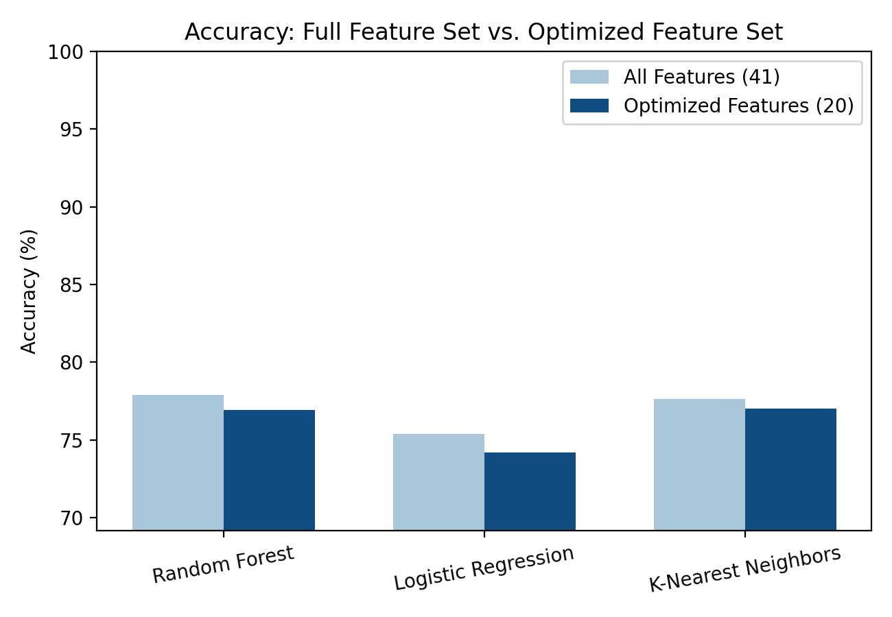
Fig. 2. Accuracy comparison between the full 41-feature baseline and the 20-feature MI-optimized subset for each classifier.
Tables I and II tell a fairly consistent story: cutting the feature space roughly in half, from 41 down to 20, barely moved the needle on accuracy. Random Forest dropped 0.96 percentage points (77.90% → 76.94%), Logistic Regression dropped 1.21 points (75.39% → 74.18%), and KNN dropped just 0.62 points (77.63% → 77.01%). Put differently, about half of NSL-KDD's original feature set isn't doing much work once the top mutual-information features are already in the model. Precision, recall, and F1 all moved by similarly small amounts, none more than roughly a percentage point.
The efficiency side of things is where the smaller feature set actually pays off. KNN's prediction time scales with how many dimensions it has to compute distances across, so it's no surprise that trimming the feature set dropped prediction time from 11.71 s to 9.57 s on the test partition — an 18.3% cut. Logistic Regression's training time fell even more sharply, from 0.53 s to 0.21 s, a 60.8% reduction. For a cloud IDS that has to keep up with high volumes of flow records in something close to real time, and that may need to retrain periodically as traffic patterns drift, gains like these matter more than the raw accuracy numbers might suggest at first glance.
C. ROC Analysis
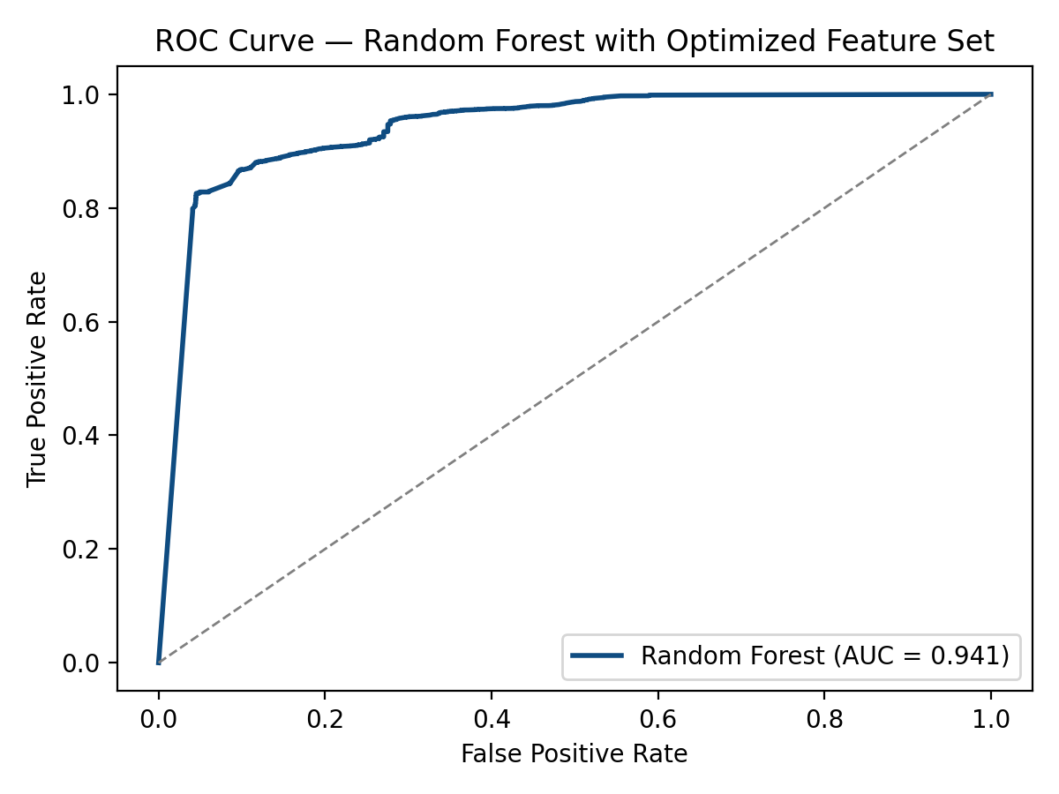
Fig. 3. ROC curve for the Random Forest classifier trained on the 20-feature MI-optimized subset (AUC = 0.941).
Fig. 3 shows the ROC curve for Random Forest on the optimized feature subset, which comes out to an AUC of 0.941 — a sign of strong separability between normal and attack traffic across thresholds, even though the raw accuracy number (76.94%) might look a little unremarkable on its own. The gap between those two numbers isn't really a contradiction; it comes down to a known quirk of KDDTest+. Because the test set contains attack subtypes the model never saw in training, some of what looks like classification error is actually the model encountering genuinely new attack behavior, not failing to recognize something familiar. Other work using this same dataset has run into the same pattern, and it's worth reading a high AUC alongside a moderate accuracy figure as a fair reflection of how well the model generalizes — not as a shortcoming of the pipeline.
D. Confusion Matrix Analysis
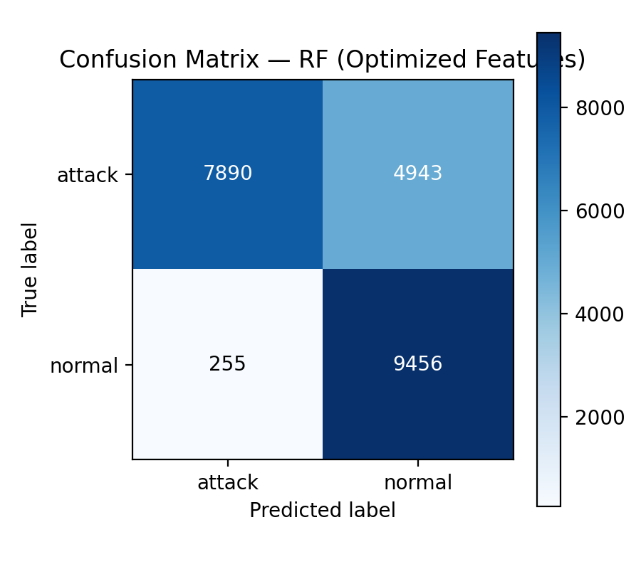
Fig. 4. Confusion matrix for the Random Forest classifier on the MI-optimized feature subset.
Looking at the confusion matrix in Fig. 4, most of the misclassification happens on the attack side, which fits with the unseen-attack-subtype issue just discussed. False positives on normal traffic stayed relatively low, and that matters operationally — a cloud IDS that cries wolf too often quickly loses the trust of whoever is on the other end reviewing its alerts.
E. Discussion
Taken as a whole, these results back up the basic argument of this paper: mutual-information-based feature optimization can shrink the dimensionality — and with it, the computational load — of an ML-based cloud IDS, and the accuracy cost of doing so is small enough to be almost beside the point. For a cloud provider running thousands of VMs and containers that are all generating flow telemetry around the clock, a 51% cut in feature dimensionality means less processing per record, smaller model files, and faster retraining, all while the best-performing classifier here still clears an AUC of 0.94.
There's also a more grounded, local implication worth spelling out. Rwanda's cloud and digital infrastructure operates under data localization rules set by Law N° 058/2021 on the Protection of Personal Data and Privacy (Republic of Rwanda, 2021), with oversight split across bodies like the Rwanda Information Society Authority (RISA), the National Cyber Security Authority (NCSA), and the National Bank of Rwanda (BNR) for anything touching the financial sector. A growing share of everyday transactions in the country runs through platforms like MTN Mobile Money and the Irembo e-government portal, both of which depend on cloud infrastructure that is smaller in scale than a hyperscale data center. Lightweight, feature-optimized IDS pipelines like the one described here are arguably a better fit for that kind of environment than a heavier, unoptimized model would be — they keep detection performance intact while asking less of the underlying hardware.
VI. COMPARISON WITH EXISTING APPROACHES
Table III lines up this study against a handful of representative prior work on NSL-KDD, focusing on whether feature optimization was used and what effect it had.
Study | Classifier(s) | Feature Selection | Reported Emphasis
Solanki et al. (2020) | Multiple ML classifiers (survey) | Not applied uniformly | Comparative accuracy across classifiers
Tanimu et al. (2022) | Deep Neural Network | None | Deep learning accuracy on KDD-derived data
Kaushik et al. (2025) | Statistical filter + ML | Simple statistical filters | High accuracy with lightweight selection
This study | RF, LR, KNN | Mutual information (51% reduction) | Accuracy retention + latency reduction
TABLE III. Positioning of the proposed approach relative to representative prior work.
This lines up with what the broader literature already suggests — that statistical filter-based feature selection tends to hold onto most of the classification signal in a full network-flow feature set (Ali et al., 2024; Kaushik et al., 2025). Where this study adds something is in making the accuracy-versus-efficiency trade-off explicit, by running the same baseline and optimized experiments on the same train-test split side by side, and by framing the resulting efficiency gains in terms that matter to whoever actually has to run this on cloud infrastructure, rather than just reporting accuracy numbers on their own.
VII. CONCLUSION AND FUTURE WORK
We set out to build and test an AI-driven IDS architecture for cloud environments, and to see, concretely, what mutual-information feature optimization does to three different ML classifiers on the NSL-KDD benchmark. Trimming the feature set from 41 down to 20 cost less than 1.3 percentage points of accuracy across the board, while measurably speeding up both training and prediction, and Random Forest still turned in a ROC-AUC of 0.941 on the smaller feature set. Put simply, feature optimization looks like a cheap and practical way to make ML-based IDS pipelines lighter and faster without asking much in return — which matters for cloud platforms generally, and arguably matters even more for infrastructure operating under tighter resource constraints, like Rwanda's.
There's plenty left to test. A natural next step is running the same pipeline against more recent, cloud-representative traffic datasets — CICIDS2017 and UNSW-NB15 are the obvious candidates — to see whether the pattern holds outside NSL-KDD. It would also be worth trying wrapper- or embedded-based feature selection methods, such as recursive feature elimination on ensemble models or L1-regularized selection, alongside the mutual-information approach used here. And ultimately, none of this means much until it's tested as an actual streaming pipeline hooked into a cloud orchestration layer, where real-time detection latency and false-positive rates under production-like load can be measured directly rather than estimated from a static benchmark.
References
[1] Ali, A. H., Charfeddine, M., Ammar, B., Hamed, B. B., Albalwy, F., Alqarafi, A., & Hussain, A. (2024). Unveiling machine learning strategies and considerations in intrusion detection systems: A comprehensive survey. Frontiers in Computer Science, 6, Article 1387354. https://doi.org/10.3389/fcomp.2024.1387354
[2] Hafeez, M., Ding, A. Y., & Tarkoma, S. (2020). IoT-KEEPER: Detecting malicious IoT network activity using online traffic analysis at the edge. IEEE Transactions on Network and Service Management, 17(1), 45–59.
[3] Kaushik, S., Bhardwaj, A., Almogren, A., Bharany, S., Altameem, A., Rehman, A. U., Hussen, S., & Hamam, H. (2025). Robust machine learning based intrusion detection system using simple statistical techniques in feature selection. Scientific Reports, 15, Article 3970. https://doi.org/10.1038/s41598-025-88286-9
[4] Republic of Rwanda. (2021). Law N° 058/2021 of 13/10/2021 relating to the protection of personal data and privacy. Official Gazette of the Republic of Rwanda.
[5] Solanki, S., Gupta, C., & Rai, K. (2020). A survey on machine learning based intrusion detection system on NSL-KDD dataset. International Journal of Computer Applications, 176(30), 36–39. https://doi.org/10.5120/ijca2020920343
[6] Tanimu, J. J., Hamada, M., Robert, P., & Mahendran, A. (2022). Network intrusion detection system using deep learning method with KDD Cup '99 dataset. In Proceedings of the 2022 IEEE 15th International Symposium on Embedded Multicore/Many-Core Systems-on-Chip (MCSoC) (pp. 251–255). IEEE.
[7] Waghmode, P., Kanumuri, M., El-Ocla, H., & Boyle, T. (2025). Intrusion detection system based on machine learning using least square support vector machine. Scientific Reports, 15, Article 12066. https://doi.org/10.1038/s41598-025-95621-7

