A STUDY ON THE AWARENESS OF CENTRAL BANK DIGITAL CURRENCY (CBDC) ISSUED BY RBI

Author:
SHASHANK S
Assistant Professor
Department of Commerce
St Joseph’s University
shashank.s@sju.edu.in

Co-Author:
BHUVANA R
Assistant Professor
Department of Commerce
St Joseph’s University
bhuvana.r@sju.edu.in

Abstract:
This study investigates the awareness and perception of the Central Bank Digital Currency (CBDC) issued by the Reserve Bank of India (RBI) among residents of Bengaluru City. The rapid evolution of digital payment systems and the increasing interest in CBDCs globally prompted this research. The primary aim is to assess the level of awareness, understanding, sources from which they get awareness about CBDC or factors contributing their lack in the awareness about CBDC and acceptance of CBDCs among the urban population, considering various demographic factors. A structured questionnaire was designed and distributed among a diverse sample of Bengaluru residents to collect primary data. The questionnaire covered areas such as general awareness of digital currencies, specific knowledge about RBI's CBDC initiatives. Descriptive statistics were used to summarize the demographic data and the general awareness levels. Statistical tests such as Mann- Whitney U test was employed to check if there was any difference between the overall awareness level about CBDC between male and female in Urban Bengaluru. Kruskal-Wallis test was conducted to check if there is any significant difference between the sources from which individual obtain information about CBDC and the level of awareness and to check if there is any difference between factors contributing to the lack of awareness about CBDC and their level of awareness. The study concludes that there is a need for increased public education and transparent communication from the RBI to enhance the understanding and acceptance of CBDCs. The insights gained from this research could inform policymakers and financial institutions in designing effective strategies for CBDC implementation and adoption.
Keywords: Central Bank Digital Currency (CBDC), Reserve Bank of India (RBI), Digital Payments, Financial Awareness, Public Perception, Urban Population, Statistical Analysis, Financial Inclusion

Introduction:
In recent years, the concept of Central Bank Digital Currency (CBDC) has emerged as a pivotal topic in the discourse surrounding monetary policy and financial innovation. As countries navigate the complexities of a rapidly evolving digital landscape, central banks worldwide are exploring the potential benefits and implications of introducing their own digital currencies. Among these, the Reserve Bank of India (RBI), as the country's central banking authority, stands at the forefront of this transformative shift.
The aim of this research paper is to delve into the awareness levels of residents in Bengaluru City regarding the Central Bank Digital Currency issued by the RBI. Bengaluru, often referred to as the Silicon Valley of India, represents a microcosm of India's dynamic urban landscape, making it an ideal location for studying the awareness and perceptions surrounding CBDCs. The introduction of a Central Bank Digital Currency by the RBI holds profound implications for various stakeholders, including policymakers, financial institutions, businesses, and the public. CBDCs have the potential to reshape the traditional banking system, revolutionize payment systems, enhance financial inclusion, and even influence monetary policy transmission mechanisms. Therefore, understanding the awareness levels and perceptions of residents towards this emerging form of digital currency is imperative for informing future policy decisions and fostering public trust and acceptance
This study seeks to address several key questions:
- What is the overall awareness level of awareness of CBDC?
- From which source do you get information about CBDC?
- If you are aware of CBDC, are you using it?
- From which source do you prefer to get information about CBDC if you are not aware of it?
- What is the framework of CBDC used by the Reserve Bank of India (RBI)? (Secondary Data)
By exploring these questions, this research paper aims to contribute to the existing body of knowledge on CBDCs and provide valuable insights that can inform policy decisions and public discourse surrounding digital currencies in India. Moreover, by focusing specifically on Bengaluru City, this study aims to capture the unique dynamics and challenges shaping the awareness and acceptance of CBDCs in one of India's most prominent urban centers.
Overall, this research paper endeavors to shed light on the evolving landscape of digital currencies in India and assess the readiness of residents in Bengaluru City to embrace the future of finance facilitated by the issuance of a Central Bank Digital Currency by the RBI.

Central Bank Digital Currency – Conceptual Framework
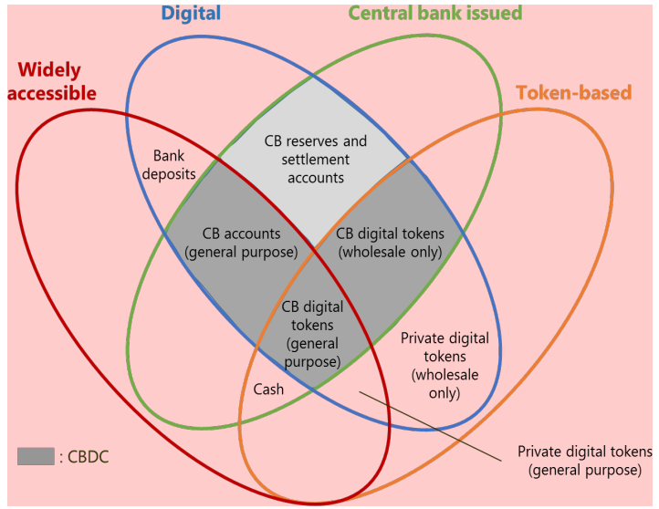
The report by the CPMI-MC published in 2018 defines CBDCs as new variants of central bank money different from physical cash or central bank reserve/settlement accounts. That is, a central bank liability, denominated in an existing unit of account, which serves both as a medium of exchange and a store of value. The four different properties of money are: (i) issuer (central bank or not); (ii) form (digital or physical); (iii) accessibility (wide or narrow); and (iv) technology (peer-to-peer tokens, or accounts) (Bech and Garratt (2017)). Based on these four properties, the CPMI-MC report provides a taxonomy of money (‘The Money Flower’), which delineates two broad types of CBDC: general purpose and wholesale – with the former type coming in two varieties (Figure 1)
Figure: 1 The money flower: a taxonomy of money. CB = central bank. Source: CPMI-MC (2018); Bech and Garratt (2017)).
Source: Report on CBDC by RBI
Reserve Bank defines CBDC as the legal tender issued by a central bank in a digital form. It is the same as a sovereign currency and is exchangeable one-to-one at par (1:1) with the fiat currency9. While money in digital form is predominant in India—for example in bank accounts recorded as book entries on commercial bank ledgers—a CBDC would differ from existing digital money available to the public because a CBDC would be a liability of the Reserve Bank, and not of a commercial bank.

Objectives of the study:
- To identify the overall awareness of CBDC among people in Bengaluru
- To identify the sources from which individuals get information about CBDC
- To identify the factors contributing to the lack of awareness about CBDC
- To recommend the means to increase the awareness of CBDC
- To outline the framework of CBDC- RBI in INDIA

Variables:

Independent Variables:
    - Age
    - Gender
    - Sources of Information about CBDC
    - Literacy
    - Exposure to Banking Products
    - Access to Technology
    - Less marketing
    - Less Usage

Dependent Variables:
- Overall awareness level of CBDC

Scope of the study:
The present study was made to understand the awareness of CBDC in Bengaluru. This is because of the rapid and more use of UPI payments people are reluctant to move to the new form of payment system. Therefore, this study aims to determine how many and how well people in Bengaluru city are aware of CBDC. If they are aware, which source helped them to gather the information on CBDC. After they get to know about this are they using CBDC or not and if they are not aware which source would they prefer to get more information about CBDC. Also, this study has touched upon explaining the framework of CBDC that the Reserve Bank of India uses for the functioning of Central Bank Digital Currency (CBDC).

Review of Literature:
Engert, Walter, et al., 2017 in their study on “Central bank digital currency: Motivations and implications” The emergence of digital currencies like Bitcoin and its blockchain-based circulation ledger technologies have generated considerable interest. Additionally, these developments open the possibility of significant impacts on the financial system and potentially the economy. This paper addresses the question of whether central banks should issue digital currencies that can be used by the public. First, let us discuss possible reasons why central banks issue digital currencies. The paper then introduces a benchmark central bank digital currency (CBDC) with cash-like functionality. The implications of such digital currencies will be considered with a focus on central bank seignories, monetary policy, banking systems and financial stability, and payments. Finally, CBDCs are likely to be very different from digital reference currencies.

Ulrich Bindseil, 2019 in their research paper “Central Bank Digital Currency: Financial System Implications and Control” in this paper tells us that the development of IT and its use in the financial sector has encouraged academics and central banks to consider the advantages of publicly accessible central bank digital currencies, or CBDCs. This paper first summarizes the benefits that have been linked to CBDC and goes over some pertinent background information from the history of the issuance of various central bank currencies. The two main criticisms of CBDC are then covered in detail: (i) the possibility of structural bank disintermediation and central bank control over credit distribution; and
(ii) the possibility of systemic bank runs during times of crisis being made easier. This research suggests a two-tier CBDC compensation plan as a tried-and-true, easy-to-use method of managing the amount of CBDC during both regular and emergencies. This solution is contrasted with Kumhof and Noone's (2018). It is widely understood, though, that limiting the amount of CBDC does not always mean limiting its effects on the financial system. Lastly, the article notes the similarities and contrasts in terms of the implications on the financial system between the financial account implications of CBDC and those of crypto assets, stable currencies, and narrow bank digital money. The conclusion is that a well-managed CBDC appears to be doable, without necessarily meaning that CBDC would not catalyze financial sector reform.
Mr. John Kiff, Jihad Alwazir, et al., 2020 in their paper “A Survey of Research on Retail Central Bank Digital Currency”, is based on a comprehensive review of current research, central bank experiments, and ongoing discussions among stakeholders, this paper provides an overview of the major central bank digital currencies (CBDCs) that the public uses. Consider the considerations. Its about why central banks are considering issuing CBDCs to retail customers, and the political and design considerations. legal, governance, and regulatory aspects. This paper contributes to the CBDC literature by proposing a structured framework for organizing the debate on whether to issue a CBDC, with an operational focus and a project management perspective.
Auer, Raphael A. et al., 2020 in their article “Rise of the Central Bank Digital Currencies: Drivers, Approaches, and Technologies” tell us that the topic of central bank digital currencies, or CBDCs, is gaining more and more attention. However, the reasons for issuing them differ between nations, as do the technical designs and approaches to policy. They assess the state of design efforts and investigate the institutional and economic forces behind the establishment of CBDCs. This paper's author used technical reports and speeches from central banks to lay out an extensive library of issuance-related technical techniques and policy positions. Most initiatives are in highly innovative digital economies. Where the informal sector is more prevalent, retail CBDC work is more advanced. Next, they assess the possibilities available for technological design. A growing number of central banks are examining retail CBDC architectures, where all customer-facing operations are handled by the private sector and the CBDC represents a direct cash-like claim on the central bank. They wrap off with a thorough explanation of the three different CBDC strategies used by the central banks of Canada, Sweden, and China.
Wouter Bossu, Masaru Itatani, et al., 2020 in their study “Legal Aspects of Central Bank Digital Currency: Central Bank and Monetary Law Considerations” tell us that the central banking community is actively evaluating the benefits of releasing so-called "central bank digital currency" ("CBDC") in response to advancements in blockchain, digital ledger technology, and other fields. Additionally, the community is studying the potential issuance of private virtual currencies, or "stablecoins." Numerous central banks have initiated comprehensive conversations regarding the suitability and practicability of releasing this kind of money. The results of a poll indicate that while most central banks seem to have understood the difficulties involved in establishing a CBDC, they are still not persuaded that the advantages will exceed the drawbacks.
David Chaum, Christian Grothoff et al., 2021 in their study “How to issue a central bank digital currency” tell us that with the advent of Bitcoin and recent stablecoins proposed by Big Tech such as Diem (formerly Libra), central banks are facing competition from private players offering their digital alternatives to physical cash. is facing escalation. This paper does not address the normative question, of whether central banks should issue central bank digital currencies (CBDCs). Instead, this paper
contributes to the current research debate by showing how central banks can do this if they wish. This paper proposes a token-based system that does not use distributed ledger technology and how to improve on previously introduced software-only electronic cash to maintain transaction confidentiality and convincingly demonstrate how you can meet regulatory requirements and deliver the quantum level you deliver.
Munish Gupta, Sanjay Taneja et al. (2023) studied how previous experience with UPI affects CBDC usage. They explain that while UPI is a payment interface, CBDC is a digital form of currency with legal tender status. UPI enables instant bank transfers via mobile, using technologies like USSD and IMPS. Both UPI and CBDC aim to enhance financial inclusion, reduce costs, and support monetary policy. The study found UPI experience influenced behavioral intention and usage of CBDC. Social influence played a key role in CBDC adoption during the pilot. However, UPI experience weakened the link between social influence and CBDC usage. It also reduced the impact of performance expectancy on behavioral intention. There was no major effect on perceived risk or hedonic motivation. The study focused on usage behavior, not awareness of CBDC benefits in metro areas. It also missed identifying barriers to shifting from UPI to CBDC and needed measures..

Research Problem:
Based on the review of the literature, it is found that various studies have been conducted on the financial system implications of CBDC, the various drivers, approaches, and technology used in the development of CBDC, the functions, scope, and pricing model of CBDC, the challenges faced by CBDC, CBDCs issued by various countries and its success factors, etc. However, no known literature studies on the awareness of CBDC in INDIA especially in the capital of KARNATAKA that is BENGALURU. There is a lack of research that examines the awareness of CBDC in Bengaluru as it was launched in 2022 and many of the citizens are not aware of this facility available to them. Also, there is a lack of understanding of the usage of CBDC. The present study has attempted to cover this gap.

Research Design:
  - Source of Data:
Primary data: A well-structured questionnaire was prepared to obtain the objectives. The questionnaires were distributed electronically via Google form through various social media platforms such as Instagram, Facebook, and WhatsApp media. Also, the respondents were personally approached to fill out the questionnaire. The respondents to the questionnaire were individuals aged between 18 to 80 in any profession (ex: employed or unemployed, students, housewives, senior citizens, etc.) from Bengaluru, Karnataka. The study was conducted in Mrach 2024. The collection of data was done by effective means by contacting the individuals and requesting them to aid the study in data collection.
Population | Bengaluru Urban City
Sample size | 385
Sampling Technique | Convenience Sampling
- Sample Design:

Research Hypothesis:
  - Difference between Genders and Overall Awareness about CBDC
H0: There is no significant difference in the overall awareness about CBDC between male and female in Bengaluru.
H1: There is significant difference in the overall awareness about CBDC between male and female in Bengaluru

To find is there any difference between sources from which individuals obtain information about CBDC and their awareness level
H0: There is no significant difference between the sources from which individual obtain information about CBDC and their level of awareness.
H1: There is significant difference between the sources from which individual obtain information about CBDC and their level of awareness.

To find is there any difference between factors contributing to the lack of awareness about CBDC and their awareness level
H0: There is no significant difference between factors contributing to the lack of awareness about CBDC and their level of awareness
H1: There is significant difference between factors contributing to the lack of awareness about CBDC and their level of awareness.

Data Analysis:
  - Reliability Test Table: 1
Case Processing Summary
N %
Cases | Valid | 385 | 100.0
Cases | Excludedª | 0 | .0
Cases | Total | 385 | 100.0
Source: SPSS Output

Table: 2
Reliability Statistics
Cronbach's
Alpha N of Items
.705 6
Source: SPSS Output
Cronbach's Alpha is a measure of internal consistency reliability, which indicates the degree to which the items in a scale or test are interrelated and measure the same underlying construct. In this case, the Cronbach's Alpha coefficient is 0.705, which is a moderate-to-good level of internal consistency reliability.
The number of items in the scale or test is 6, which is not large number of items. This number of items might indicate that the scale is measuring a complex construct or that it includes multiple sub-constructs. Overall, a Cronbach's Alpha of 0.705 suggests that the scale is relatively reliable, and the items measure the same underlying construct to a moderate-to-good extent.
- Normality Test
Independent Variable: 1 – Sources of Information Hypothesis:
H0: Distribution of data is equal to the normal distribution
H1: Distribution of data is different from the normal distribution. Table: 3
Tests of Normality
Kolmogorov-Smirnovª |  |  |  | Shapiro-Wilk
Statistic |  | df | Sig. | Statistic | df | Sig.
Sources where  individuals get Information | .101 | 213 | .000 | .971 | 213 | .000
Source: SPSS Output

Chart: 1

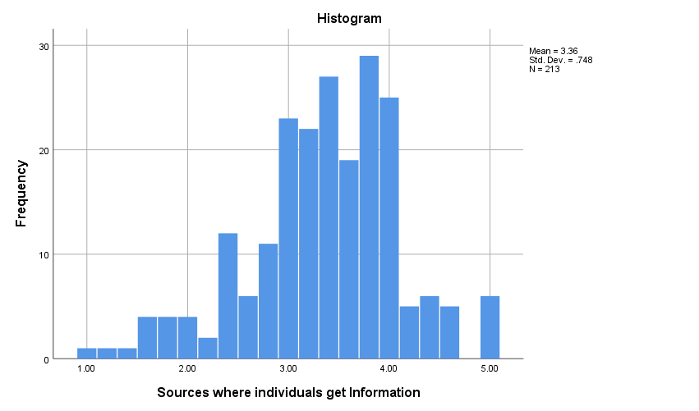
Source: SPSS Output
Conclusion: Both the Kolmogorov-Smirnov and Shapiro-Wilk tests suggest that the data for "Sources where individuals get Information" does not follow a normal distribution. This could imply that the distribution of sources individuals use for information is skewed or has outliers, violating the normality assumption. It's important to consider this when analyzing the data and choosing appropriate statistical methods for further analysis. Therefore, we should use a non-parametric test for this variable.

Independent Variable: 2 – Factors affecting to the lack of awareness on CBDC Hypothesis:
H0: Distribution of data is equal to the normal distribution
H1: Distribution of data is different from the normal distribution.
Table: 4
Tests of Normality
Kolmogorov-Smirnovª |  |  |  | Shapiro-Wilk
Statistic |  | df | Sig. | Statistic | df | Sig.
FACTORS AFFECTING TO THE LACK OF AWARENESS ON  CBDC | .096 | 172 | .001 | .964 | 172 | .000
Source: SPSS Output

Chart: 2
Source: SPSS Output
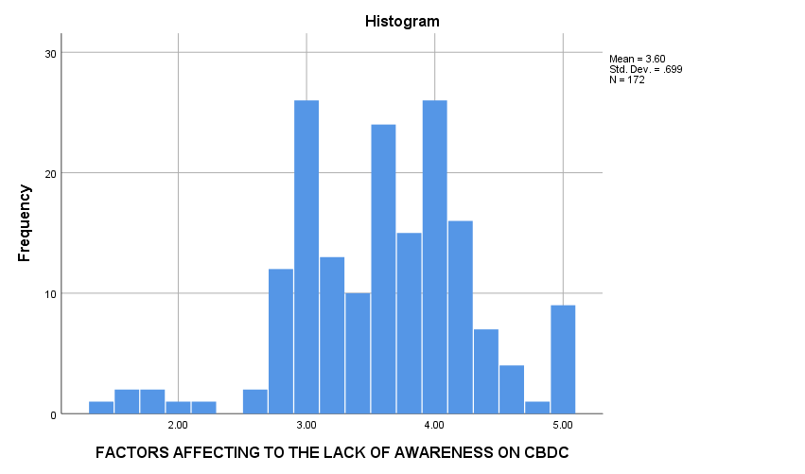
Conclusion: Both the Kolmogorov-Smirnov and Shapiro-Wilk tests indicate that the data for "Factors affecting the lack of awareness on CBDC" does not adhere to a normal distribution. This suggests that the distribution of factors affecting awareness of CBDC lacks the characteristics of a normal distribution, which could affect the validity of certain statistical analyses that assume normality. It's important to be aware of this when interpreting the results and selecting appropriate analytical techniques. Therefore, we should use a non-parametric test for this variable.
  - Hypothesis Testing
Hypothesis: 1
To find is there any difference in Overall Awareness about CBDC between Genders

H0: There is no significant difference in the overall awareness about CBDC between male and female in Bengaluru.
H1: There is significant difference in the overall awareness about CBDC between male and female in Bengaluru

Table : 5
Test Statisticsa,b
OVERALL AWARENESS LEVEL
Mann-Whitney U | 16825.000
Wilcoxon W | 34030.000
Z | -1.636
Asymp. Sig. (2-tailed) | .102

Source: SPSS Output
- Grouping Variable: GENDER

Interpretation: The p-value associated with the test is .102, which is greater than the conventional significance level of .05. Therefore, we fail to reject the null hypothesis (H0), indicating that there is no significant difference in the overall awareness about CBDC between male and female residents in Bengaluru. In simpler terms, the analysis suggests that gender does not have a significant influence on the overall awareness level about CBDC in Bengaluru. Both male and female residents appear to have similar levels of awareness about CBDC, according to the data collected.

Hypothesis: 2
To find is there any difference between sources from which individuals obtain information about CBDC and their awareness level
H0: There is no significant difference between the sources from which individual obtain information about CBDC and their level of awareness.
H1: There is significant difference between the sources from which individual obtain information about CBDC and their level of awareness.

Table: 6
Test Statisticsa,b
OVERALL AWARENES S LEVEL
Kruskal-Wallis H | 20.755
df | 4
Asymp. Sig. | .000

Source: SPSS Output
- Kruskal Wallis Test
- Grouping Variable:
OVERALL SOURCES
Interpretation: The Kruskal-Walli’s test yielded a test statistic (H) of 20.755 with 4 degrees of freedom. The associated p-value is 0.000, which is less than the conventional significance level of 0.05. As the p-value is less than the significance level, we reject the null hypothesis (H0), suggesting that there is a significant difference between the sources from which individuals obtain information about CBDC and their level of awareness. This implies that the sources individuals rely on for information about CBDC do have an impact on their overall awareness level.In practical terms, this means that the effectiveness of various sources, such as official announcements, news media, social media, or personal networks, in disseminating information about CBDC varies and can influence how well individuals are informed about CBDC.

Effect Size:
Effect Size formula | Critical values
η^2 = (H - k - 1) / (N - k) | Small 0.01
η^2 = (H - k - 1) / (N - k) | Medium 0.06
η^2 = (H - k - 1) / (N - k) | Large 0.14
Where H is the Kruskal-Wallis H statistic, k is the number of groups being compared, and N is the total sample size.

η^2 = (20.755 - (5 - 1)) / (213 - 5)
η^2 = 0.080552
A Kruskal-Walli’s test was conducted to examine the difference between sources from which individuals obtain information about CBDC and their awareness level. The test yielded a significant result, H = 20.755, p
< 0.001. An effect size was calculated using eta-squared, which indicated a medium to large effect size. η^2 = 0.080

Hypothesis: 3
To find is there any difference between factors contributing to the lack of awareness about CBDC and their awareness level
H0: There is no significant difference between factors contributing to the lack of awareness about CBDC and their level of awareness
H1: There is significant difference between factors contributing to the lack of awareness about CBDC and their level of awareness

Table: 7
Test Statisticsa,b
OVERALL AWARENESS LEVEL
Kruskal-Wallis H | 12.101
Df | 4
Asymp. Sig. | .017

Source : SPSS Output
- Kruskal Wallis Test
- Grouping Variable: FACTORS AFFECTING

Interpretation: The Kruskal-Wallis test yielded a test statistic (H) of 12.101 with 4 degrees of freedom. The associated p-value is 0.017, which is less than the conventional significance level of 0.05. Given that the p- value is less than the significance level, we reject the null hypothesis (H0), suggesting that there is a significant difference between factors contributing to the lack of awareness about CBDC and individuals' awareness level. This implies that the factors individuals perceive as contributing to their lack of awareness about CBDC do have an impact on their overall awareness level. In other words, certain factors may hinder individuals from being adequately informed about CBDC, and addressing these factors could potentially improve awareness levels.

Effect Size:

Effect Size formula | Critical values
η^2 = (H - k - 1) / (N - k) | Small 0.01
η^2 = (H - k - 1) / (N - k) | Medium 0.06
η^2 = (H - k - 1) / (N - k) | Large 0.14
Where H is the Kruskal-Wallis H statistic, k is the number of groups being compared, and N is the total sample size.

η^2 = (12.101 - (5 - 1)) / (172 - 5)
η^2 = 0.048508
A Kruskal-Walli’s test was conducted to examine the difference between factors contributing to the lack of awareness about CBDC and their awareness level. The test yielded a significant result, H = 12.101, p < 0.05. An effect size was calculated using eta-squared, which indicated a small to medium effect size.
η^2 = 0.048.

Conclusion:
This study, titled " A STUDY ON THE AWARENESS OF CENTRAL BANK DIGITAL CURRENCY
(CBDC) ISSUED BY RBI IN BENGALURU " delved into understanding the levels of awareness, information sources, factors influencing awareness, and gender disparities concerning CBDC among Bengaluru residents. The aim was to provide valuable insights into the current awareness status and perceptions surrounding CBDC, with implications for policy-making, educational endeavors, and awareness initiatives. The study uncovered several noteworthy findings regarding CBDC awareness in Bengaluru. Notably, a substantial proportion of the sample population exhibited unfamiliarity with CBDC, with only 55.3% indicating awareness. Among those aware, varying degrees of awareness were evident, ranging from low to very high. These findings underscore the necessity for tailored efforts to enhance CBDC awareness and comprehension among the populace. In conclusion, the study emphasizes the importance of bolstering CBDC awareness among the public, addressing underlying factors inhibiting awareness, and leveraging effective communication channels to ensure broad understanding and acceptance of this emerging digital currency form. By promoting informed engagement, stakeholders can facilitate a smoother transition toward CBDC adoption in Bengaluru and beyond.

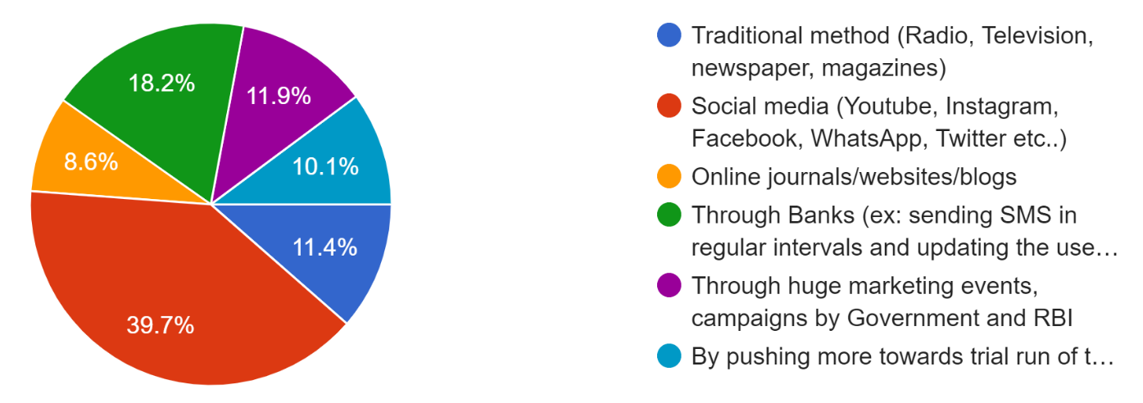
Suggestions:
Figure: 2, Suggestion on Improving the Awareness
Source: Data Collection, Google Form
- Continuously evaluate the effectiveness of awareness campaigns and initiatives by monitoring awareness levels over time and soliciting feedback from the target audience to make informed adjustments and improvements.
- Foster partnerships with industry stakeholders to amplify the reach and impact of awareness campaigns about CBDC.
- Collaborate with educational institutions to integrate information about CBDC into curriculums and enhance awareness among students.
- Explore innovative approaches to engage individuals across different age groups and genders in awareness initiatives about CBDC.

Further Scope for the Study:
- While this study focused specifically on Bengaluru, extending the research to encompass other cities or regions in India could provide a more comprehensive understanding of CBDC awareness nationwide.
- Further exploration of demographic factors such as education level, income level, occupation, and urban/rural residence could offer valuable insights into how these variables impact CBDC awareness.
- Comparing CBDC awareness with awareness of other digital payment systems or financial innovations could provide context and benchmark for understanding CBDC awareness. Exploring how awareness of CBDC compares to existing payment methods like cash, cards, and digital wallets could highlight unique challenges and opportunities in promoting CBDC adoption.

References:

Engert, W., & Fung, B. S. C. (2017). Central bank digital currency: Motivations and implications (No. 2017-16). Bank of Canada Staff Discussion Paper. https://www.bankofcanada.ca/wp-content/uploads/2017/11/sdp2017-16.pdf

Bindseil, U. (2019). Central bank digital currency: Financial system implications and control. International Journal of Political Economy, 48(4), 303–335. https://doi.org/10.1080/08911916.2019.1699192

Kiff, M. J., Alwazir, J., Davidovic, S., Farias, A., Khan, M. A., Khiaonarong, T., ... & Zhou, P. (2020). A survey of research on retail central bank digital currency (IMF Working Paper No. 20/104). International Monetary Fund. https://www.imf.org/en/Publications/WP/Issues/2020/06/18/A-Survey-of-Research-on-Retail-Central-Bank-Digital-Currency-494076

Auer, R., Cornelli, G., & Frost, J. (2020). Rise of the central bank digital currencies: Drivers, approaches and technologies. BIS Bulletin, (No. 1). Bank for International Settlements. https://www.bis.org/publ/bisbull01.pdf

Bossu, W., Itatani, M., Margulis, C., Rossi, A., Weenink, H., & Yoshinaga, A. (2020). Legal aspects of central bank digital currency: Central bank and monetary law considerations (IMF Working Paper No. 2020/254). International Monetary Fund. https://www.imf.org/en/Publications/WP/Issues/2020/11/20/Legal-Aspects-of-Central-Bank-Digital-Currency-Central-Bank-and-Monetary-Law-Considerations-49827

Chaum, D., Grothoff, C., & Moser, T. (2021). How to issue a central bank digital currency. arXiv preprint arXiv:2103.00254. https://arxiv.org/abs/2103.00254

Bindseil, U., Panetta, F., & Terol, I. (2021). Central bank digital currency: Functional scope, pricing and controls (ECB Occasional Paper Series No. 286). European Central Bank. https://www.ecb.europa.eu/pub/pdf/scpops/ecb.op286~9b842333fd.en.pdf

Alexander, C. P., & Durai, T. (2024). Digital currency: An awareness of the future of central bank digital currency in India. International Journal of Services, Economics and Management, 15(6), 667–676. https://doi.org/10.1504/IJSEM.2024.142456

Banerjee, S., & Sinha, M. (2023). Promoting financial inclusion through central bank digital currency: An evaluation of payment system viability in India. Australasian Accounting, Business and Finance Journal, 17(1), 1–14. https://doi.org/10.14453/aabfj.v17i1.14

Eichengreen, B., Gupta, P., & Marple, T. (2022). A central bank digital currency for India? Indian Public Policy Review, 3(4), 1–15. https://doi.org/10.55763/ippr.2022.03.04.001

Garg, M., & Kumar, P. (2023). To get insight into issuance motivations behind introducing CBDC in India. Sachetas, 2(2), 73–77. https://doi.org/10.55955/220008

Jindal, K., & Khera, K. (2025). Factors affecting the adoption of CBDCs for financial transactions. Ushus Journal of Business Management, 23(4), 1–22. https://doi.org/10.12725/ujbm.69.1

Kapoor, A., Sindwani, R., & Goel, M. (2024). Digital revolution in finance: A comprehensive analysis of central bank digital currency implementation. Sachetas, 3(2), 1–5. https://doi.org/10.55955/320001

Kurian, A. (2023). Central bank digital currencies: Evolution and implications to the monetary system. Jindal Journal of Public Policy, 7(2), 144–154. https://doi.org/10.54945/jjpp.v7i2.223

Muthukrishnan, U., Bhattacharyya, S. S., & Jain, N. K. (2024). Explicating the factors driving retail central bank digital currency adoption in India: An empirical investigation applying the unified theory of acceptance and use of technology model. International Journal of Electronic Banking, 2(3), 273–293. https://doi.org/10.1504/IJEBANK.2024.139220

Ozili, P. K. (2023). Central bank digital currency in India: The case for a digital rupee. Munich Personal RePEc Archive. https://mpra.ub.uni-muenchen.de/118801/

Philip, C., & Durai, T. (2024). Digital currency: An awareness of the future of central bank digital currency in India. International Journal of Services, Economics and Management, 15(6), 667–676. https://doi.org/10.1504/IJSEM.2024.142456
- Webliography:
  - https://www.investopedia.com/terms/c/central-bank-digital-currency- cbdc.asp#:~:text=Key%20Takeaways,implementing%20monetary%20and%20fiscal%20policy.
  - https://rbi.org.in/Scripts/PublicationReportDetails.aspx?UrlPage&ID=1218
  - https://rbidocs.rbi.org.in/rdocs/PublicationReport/Pdfs/CONCEPTNOTEACB531172E0B4DFC9A6E506C2C24FFB6.PDF

