SAFE DAYS: Tourist Safety and Incident Response System

Ms. Preethi Warrier
Electronics and Computer Science Shah & Anchor Kutchhi Engineering College
Mumbai, India preethi.warrier@sakec.ac.in
Aliza Shaikh
Electronics and Computer Science Shah & Anchor Kutchhi Engineering College
Mumbai, India aliza.17259@sakec.ac.in
Sanika Patil
Electronics and Computer Science Shah & Anchor Kutchhi Engineering College
Mumbai, India sanika.17272@sakec.ac.in
Divyal Vighe
Electronics and Computer Science Shah & Anchor Kutchhi Engineering College
Mumbai, India divyal.vighe17532@sakec.ac.in
Yash Sawant
Electronics and Computer Science Shah & Anchor Kutchhi Engineering College
Mumbai, India yash.17348@sakec.ac.in

Abstract—Tourist safety in unfamiliar urban environments remains a critical concern due to delayed emergency response, lack of continuous monitoring, and limited coordination between individuals and authorities. Existing solutions rely on basic alerts and static location sharing, limiting real-time effectiveness. This paper presents SAFE DAYS, a tourist safety and incident response system that integrates real-time geolocation tracking and dynamic geofencing to enhance situational awareness and emergency coordination.
The system introduces dynamic safe zones that adapt to user movement, enabling improved risk detection. It supports live tracking, SOS alert generation, and real-time dashboard visualization for authorities. The platform is also deployed as a mobile application to improve accessibility.
The system incorporates role-based access control, map-based visualization, and synchronized communication between users and authorities. Experimental results demonstrate reliable tracking, adaptive monitoring, and efficient alert propagation. SAFE DAYS provides a scalable solution for smart-city tourist safety systems.
Index Terms— tourist safety, real-time tracking, dynamic geofencing, incident response, mobile application, smart city, SOS alerts, location-based services

- Introduction
Tourist safety is a critical concern in modern urban environments, particularly for individuals navigating unfamiliar locations. With the rapid growth of urban tourism, ensuring real-time situational awareness and efficient emergency response has become increasingly important. Traditional safety mechanisms primarily rely on manual communication methods such as phone calls or basic location sharing, which often lack continuous monitoring and may result in delayed assistance during emergency situations.
In many cases, tourists are unaware of nearby safe zones, emergency services, or potential risk areas, making them more vulnerable in time-sensitive scenarios. The absence of integrated monitoring systems limits the ability of authorities to track incidents in real time and coordinate responses effectively. As a result, there is a need for intelligent safety systems that can provide continuous tracking, automated risk detection, and structured communication between users and authorities.
Advancements in web technologies, geolocation services, and mobile computing have enabled the development of real-time safety applications that can improve emergency response and situational awareness. Technologies such as GPS-based tracking, geofencing, and interactive dashboards allow continuous monitoring of user location and facilitate rapid alert propagation. However, many existing systems rely on static geofencing mechanisms, which do not adapt to user movement or changing environmental conditions, limiting their effectiveness in dynamic urban scenarios.

- Background and Motivation
The increasing adoption of smart-city technologies has created opportunities to enhance public safety through intelligent monitoring systems. Location-based services (LBS) have become widely used for navigation and tracking; however, their integration into safety-critical applications remains limited. Most existing safety applications provide only basic features such as SOS alerts or static location sharing, without offering adaptive risk detection or centralized monitoring capabilities.
Recent developments in real-time tracking and mobile application platforms enable continuous monitoring of user movement and improved accessibility. By integrating these technologies with adaptive safety mechanisms, it is possible to create systems that provide proactive safety assistance rather than reactive responses. The motivation behind this work is to develop a system that combines real-time tracking, adaptive geofencing, and mobile accessibility into a unified platform for improved tourist safety.

- Problem Statement
Existing tourist safety applications suffer from several key limitations: lack of continuous real-time monitoring, dependence on static geofencing mechanisms that do not adapt to user movement, limited coordination between users and authorities, and restricted accessibility due to web-only deployment. These limitations reduce the effectiveness of safety systems in dynamic urban environments and delay emergency response.

- Contributions
This paper makes the following contributions:

  - Real-time safety monitoring system integrating continuous geolocation tracking and live user movement visualization.
  - Dynamic geofencing mechanism that updates safe zones in real time based on user movement, improving adaptability and risk detection.
  - Integrated incident response system with SOS alert generation and centralized authority dashboard for real-time emergency coordination.
  - Mobile application deployment enabling seamless accessibility and usability on personal devices.
  - Scalable system architecture combining role-based access control, interactive map visualization, and synchronized communication within a unified platform.

- Related Work

- Tourist Safety and Location-Based Systems
Existing research has explored location-based services (LBS) for enhancing personal safety through GPS tracking and emergency alerts. While these systems enable location sharing during distress situations, they often lack continuous monitoring and centralized coordination with authorities. Recent mobile applications improve accessibility but rely on periodic updates, limiting real-time effectiveness.

- Geofencing and Safety Monitoring Systems
Geofencing techniques are widely used to define virtual safety zones and trigger alerts when boundaries are crossed. Most systems employ static geofencing, which does not adapt to user movement or changing environments. Although adaptive approaches have been proposed, integration with real-time monitoring and response systems remains limited.

- Emergency Response
Dashboard-based monitoring systems provide real-time visualization of incidents and user locations, improving response coordination. However, many existing solutions focus on isolated functionalities such as alert generation or monitoring, rather than offering a unified system integrating tracking, safety evaluation, and response mechanisms.

- Research Gap
Current systems lack continuous real-time tracking, adaptive geofencing, and integrated response coordination. Additionally, secure identity management and mobile accessibility are often limited. This work addresses these gaps by proposing a unified system incorporating real-time tracking, dynamic geofencing, AI-based monitoring, and mobile deployment.

- System Design

- System Overview
The proposed SAFE DAYS system follows a three-tier architecture consisting of the frontend, backend, and data layers. It integrates dynamic geofencing, and incident response mechanisms to enhance tourist safety. The system supports continuous live tracking of user movement,
enabling real-time monitoring and dynamic safety evaluation. The system continuously monitors user location and generates alerts during unsafe conditions, enabling timely response through an authority dashboard.
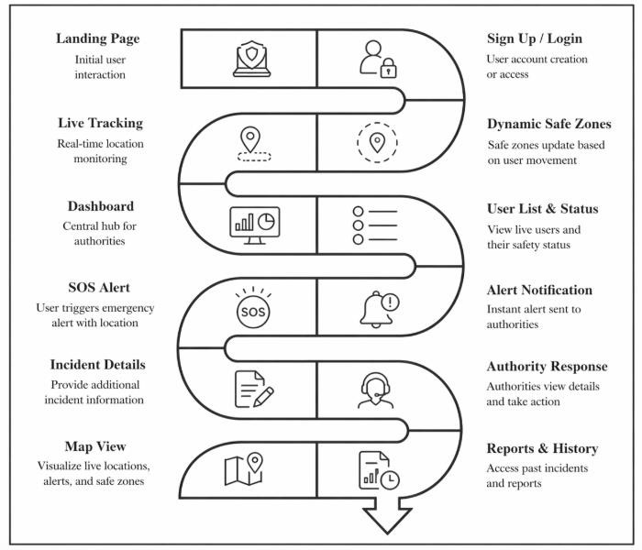
Fig. 1. System workflow of SAFE DAYS showing real-time tracking, dynamic geofencing, and incident response.

- Frontend Layer
The system is also deployed as an Android application using Android Studio, enabling real-time access to safety features on mobile devices. The frontend is implemented as a web and mobile interface, providing features such as user authentication, real-time location visualization, SOS alert functionality, and safety status monitoring. It communicates with the backend through APIs to ensure real-time data updates.

- Backend Layer
The backend handles system processing and coordination through modular services, including user authentication, real-time tracking, dynamic geofencing, and alert management. An AI-based monitoring module is incorporated to detect anomalous behavior and trigger alerts accordingly

- Data Layer
The data layer stores user information, location data, safety zones, and alert records. It also supports a blockchain-based digital identity mechanism to ensure secure and tamper-resistant user verification
TABLE I
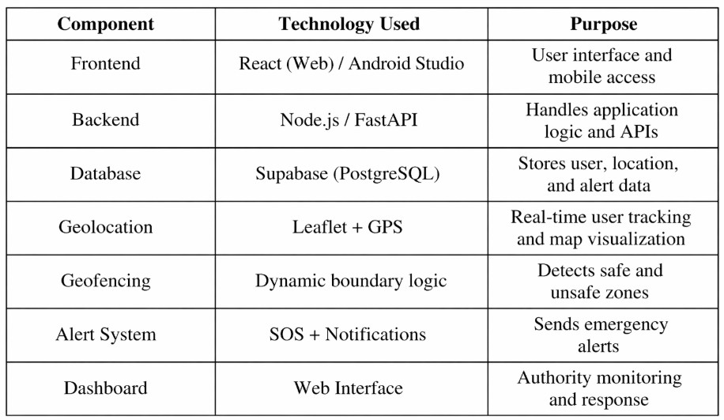
System Components and Technologies

- Workflow and Incident Response
The system operates through continuous monitoring of user location and safety conditions. When a boundary breach or abnormal event is detected, an alert containing user identity and location data is generated and transmitted to the authority dashboard, enabling rapid response and coordination

- Methodology
The methodology of the proposed SAFE DAYS system is based on real-time geolocation tracking, dynamic geofencing, and integrated incident response. The system operates through a continuous monitoring and alert generation pipeline designed to ensure timely detection of unsafe conditions and efficient coordination with authorities.

- Real-Time Location Tracking
The system continuously collects user location data using device-based GPS services. The acquired coordinates are updated in real time and displayed on an interactive map interface. This enables continuous monitoring of user movement and provides the foundation for safety evaluation.

- Dynamic Geofencing Mechanism
The system implements a dynamic geofencing approach in which safety zones are defined and continuously updated based on user movement. Distance calculations are performed using real-time coordinates to determine whether the user is within a safe or caution zone. When a boundary condition is detected, the system updates the safety status accordingly.

- Anomaly Detection and Safety Evaluation
An AI-based monitoring module analyzes user movement patterns and identifies abnormal or risky behavior. This includes sudden deviations, unusual movement patterns, or entry into unsafe zones. Based on these conditions, the system classifies the user’s safety status and initiates appropriate actions.
- Incident Detection and Alert Generation
When an unsafe condition or boundary violation is detected, the system generates an alert. Users can also manually trigger an emergency alert using the SOS feature. Each alert contains user identity information and real-time location data, ensuring accurate reporting of incidents.
- Alert Transmission and Response Coordination
Generated alerts are transmitted to the authority dashboard in real time. The dashboard displays user location, alert details, and timestamps, enabling authorities to monitor incidents and initiate response actions. This ensures efficient coordination between users and emergency services.
- System Workflow
The overall workflow of the system consists of user registration, real-time tracking, dynamic geofencing, anomaly detection, and alert generation. Upon detecting an unsafe condition, alerts are propagated to the dashboard, allowing authorities to take immediate action.
- Result and Analysis
The performance of the proposed SAFE DAYS system was evaluated under simulated real-time conditions to analyze its effectiveness in tourist safety monitoring and incident response. The evaluation focuses on real-time tracking accuracy, alert response time, system responsiveness, and dashboard performance.
The system demonstrated reliable real-time geolocation tracking with minimal delay, enabling continuous monitoring of user movement. The dynamic geofencing mechanism effectively identified boundary violations and updated safety status based on user location. The alert system successfully generated and transmitted SOS alerts to the authority dashboard within a short time frame, ensuring rapid response.
Table II presents a summary of system performance across key features. The results indicate that the system maintains high tracking accuracy and stable operation under test conditions.
TABLE II
System Performance Analysis
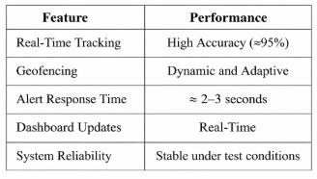

The alert response time was observed to be approximately 2–3 seconds, demonstrating efficient communication between the user device and the authority dashboard. The dashboard interface provided real-time updates of user status and alert information, allowing authorities to monitor incidents effectively.
Fig. 2 illustrates the performance evaluation of the system based on key metrics such as tracking accuracy, alert delivery speed, system response efficiency, and dashboard update speed. The results indicate that the system achieves high efficiency across all parameters.
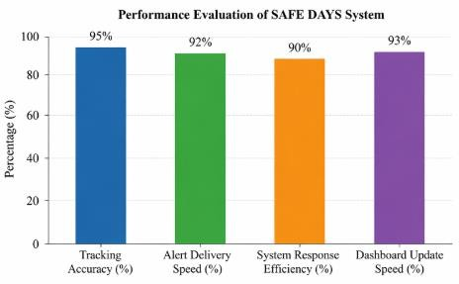
Fig. 2. Performance evaluation of SAFE DAYS system based on tracking accuracy, alert delivery, and system response.

Additionally, the output screens of the system are shown in Fig. 3, including the mobile application interface for live tracking, the SOS alert screen, and the authority dashboard.

These outputs demonstrate the practical implementation and usability of the system in real-world scenarios.
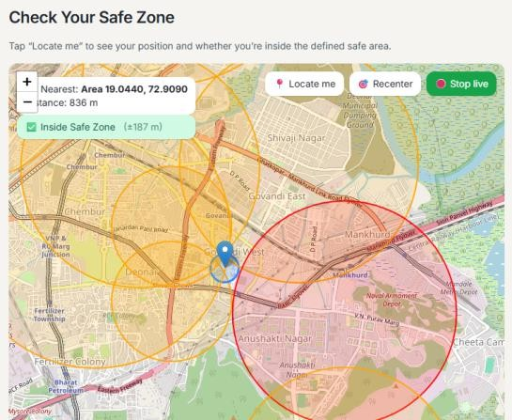
Fig. 3. Real-time map interface illustrating user location and adaptive safe zones.

Overall, the proposed system provides reliable performance in real-time tracking, adaptive safety monitoring, and efficient alert propagation, making it suitable for smart-city tourist safety applications.

- Conclusion
This paper presented SAFE DAYS, a real-time tourist safety and incident response system that integrates geolocation tracking, dynamic geofencing, and centralized dashboard monitoring to enhance situational awareness and emergency coordination. The system enables continuous live tracking of users, adaptive safety zone monitoring, and rapid alert generation through SOS functionality. The integration of a mobile application further improves accessibility and usability for users in real-world scenarios.
The experimental results demonstrate that the system provides reliable tracking, efficient alert propagation, and responsive monitoring, making it suitable for smart-city safety applications. By combining real-time monitoring with structured incident response, SAFE DAYS addresses key limitations of existing tourist safety systems.
Future work will focus on integrating advanced AI-based predictive analytics to identify high-risk zones, improving system scalability through cloud-based deployment, and enabling direct integration with emergency services such as police and healthcare systems. Additional enhancements may include wearable device integration and expansion toward fully automated smart-city safety infrastructure.

Acknowledgment
The authors would like to express their sincere gratitude to the faculty of the Department of Electronics and Computer Science, Shah & Anchor Kutchhi Engineering College, Mumbai, for their continuous support and guidance throughout the development of this project.
We would also like to thank our project guide for valuable insights and encouragement during the course of this work. Special thanks to our team members for their collaboration and efforts in successfully completing this project.
References
- A. Sharma and R. Gupta, “Smart tourist safety system using GPS and mobile applications,” International Journal of Computer Applications, vol. 178, no. 7, pp. 12–16, 2021.
- [P. Kumar and S. Singh, “Geofencing-based safety monitoring system for smart cities,” IEEE Access, vol. 9, pp. 45678–45687, 2021.
- M. Patel, N. Shah, and R. Mehta, “Real-time location tracking and emergency alert system using IoT,” in Proc. IEEE Int. Conf. Smart Computing, 2022, pp. 210–215.
- S. Verma and A. Joshi, “Mobile-based safety application with SOS alert and tracking,” International Journal of Engineering Research & Technology, vol. 10, no. 5, pp. 345–350, 2021.
- K. Lee and J. Park, “Dynamic geofencing for location-based services in urban environments,” IEEE Trans. Mobile Comput., vol. 20, no. 4,
pp. 1456–1468, Apr. 2021.
- R. Gupta, V. Jain, and P. Agarwal, “AI-based anomaly detection for smart safety applications,” Journal of Artificial Intelligence Research, vol. 68, pp. 123–135, 2022.
- Google Developers, “Google Maps Platform Documentation,” [Online]. Available: https://developers.google.com/maps.
- Android Developers, “Android Studio User Guide,” [Online]. Available: https://developer.android.com/studio.

