Customers’ Buying Behavior in Relation to Online Food Delivery
(Evidence from National Capital Region (NCR) of India)
Rao Kushagra Yadav¹ and Dr. Shruti Mathur²

ABSTRACT

The growth of e-commerce, Digital India initiatives and the changing urban lifestyle of the Indian consumers are the drivers for online food order services. The seamless delivery of food at the doorstep with few clicks influence the Indian Consumers to order their favourite cuisines online from the restaurant of their choices. Companies look ahead huge potential in e-food industry segment and came up with food aggregator apps. The aim of this study is to determine the effect of huge discounts on LifeTime Value and buying behaviour of customers. The primary objective is to know the effect of discounts and services provided by the apps on the customer lifetime value. The secondary objective is to know the consumer perception towards different online food ordering apps and effect of discounts on buying behaviour of consumers.
Keywords: Doorstep delivery, cashback, discounts, loyalty, apps, customer preference

INTRODUCTION

Digital revolution has made it possible to shop without going into the shops. Customer dependency of technology has motivated them to do everything online from ordering of food to delivering their favourite snacks and meals to their homes, offices or some other places they want it to be. One of the factors for consumers to move online is the convenience. Today, placing an order for a meal can be easily done by simply clicking few items in the apps or websites provided by the company. Technological dependency, cost-effectiveness, convenience, flexibility and less time taken for the food to be delivered are the reasons for the consumers behind choosing the services offered by the online food ordering and delivery service portals. With the increasing exposure and the popularity of the food delivery apps the demands and expectations of the consumers are also increasing day by day. The Internet has also provided new opportunities for marketers by offering them innovative ways to promote, communicate, and distribute products and information to their target consumers as well as giving huge discounts to their customers for ordering online.

1. Rao Kushagra Yadav: 211 Civil Lines, Gurugram 122 001 Haryana
Email: kushagrayadav94@gmail.com
2. Dr. Shruti Mathur: Faculty of Management, Shyam University, Dausa, Rajasthan - 303511

Email: shrutimathur03@gmail.com
​OBJECTIVE OF THE STUDY

Primary Objective

- To determine the effect of huge discounts on LTV of customers.

- To determine the effect of customers services on CLV.
Secondary Objective

- To analyse what are the various factors that influence the customers to choose online food delivery services.
- To analyse what are the various factors that hinders the customers to choose online food delivery services.
- How 50% discounts affect the buying behaviour of customers.

HYPOTHESIS BRIEFING

S.No. | HYPOTHESIS DESCRIPTION
H1(a) | Huge discount(50% discount) on CLV(Cross-sell,Up-sell)
 | in online food ordering firms.
H1(b) | Huge discount(50% discount) on CLV(RFM) in online food
 | ordering firms.
H2(a) | Facilities(Membership) provided by apps on
 | CLV(Referrals) in online food ordering firms.
H2(b) | Facilities(Customization) provided by apps and CLV
 | (Referrals) in online food ordering firms.
H3 | Factors affecting usage on food delivery apps(Zomato &
 | Swiggy).
H4 | Heavy discounts on dissatisfaction with food delivery
 | apps.
H5 | 50% discounts on motivation to buy.

RESEARCH METHODOLOGY

The study consists of two independent variables- Customer Services and Discounts and one dependant variable - Customer Lifetime Value. The first independent variable - Customer service was measured by the facilities provided by the food delivery apps to their customers. The dependent variable is measured by loyalty, profitability and referrals. If the customers are satisfied with the services (membership programs, customizations, doorstep delivery) they are getting then they would refer these services to their friends and family which will affect the customer lifetime value.

DATA COLLECTION AND ANALYSIS

Quantitative research method is used with primary data collection from the population belonging to NCR of India with random sampling method. A structured questionnaire was designed with close ended and open ended questions. The questionnaire was divided into several parts- Demographic Information, awareness and usage of apps, services provided by the apps, discounts and consumer behaviour towards the apps.

Sample Size: ​Total sample size was 1560 respondent

Research Tools & Techniques​: Non-probability sampling i.e. Convenience sampling was used.

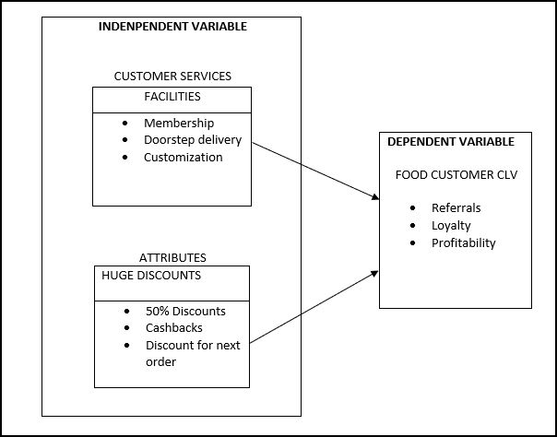

Fig1 Framework of study

RESULTS AND DISCUSSIONS

Respondent’s Profile

S.NO | Characteristics | Description | Distribution | Percentage (%)
1. | Gender | Female | 780 | 50
 |  | Male | 780 | 50
2. | Age | 15-30 | 1520 | 97
 |  | 31-45 | 10 | 0.64
 |  | 46-60 | 30 | 1.92
3. | Income | Nil | 1170 | 75
 |  | Below 2.5 lakhs | 50 | 3.2
 |  | 2.5-5 lakhs | 190 | 12
 |  | 5-10 lakhs | 120 | 7
 |  | 10 and above | 30 | 1.9
4. | Occupation | Private | 280 | 18
 |  | Govt. | 50 | 3
 |  | Business | 10 | 0.6
 |  | Student | 1200 | 77
5. | Residence | Rural | 90 | 5.8
 |  | Urban | 1470 | 94
 |  | TABLE 1 Respondent demographic profile

99.4% of the respondents are aware of the online food delivery apps. Most of them are more aware of Zomato and Swiggy as compared to Ubereats, faasos and foodpanda.

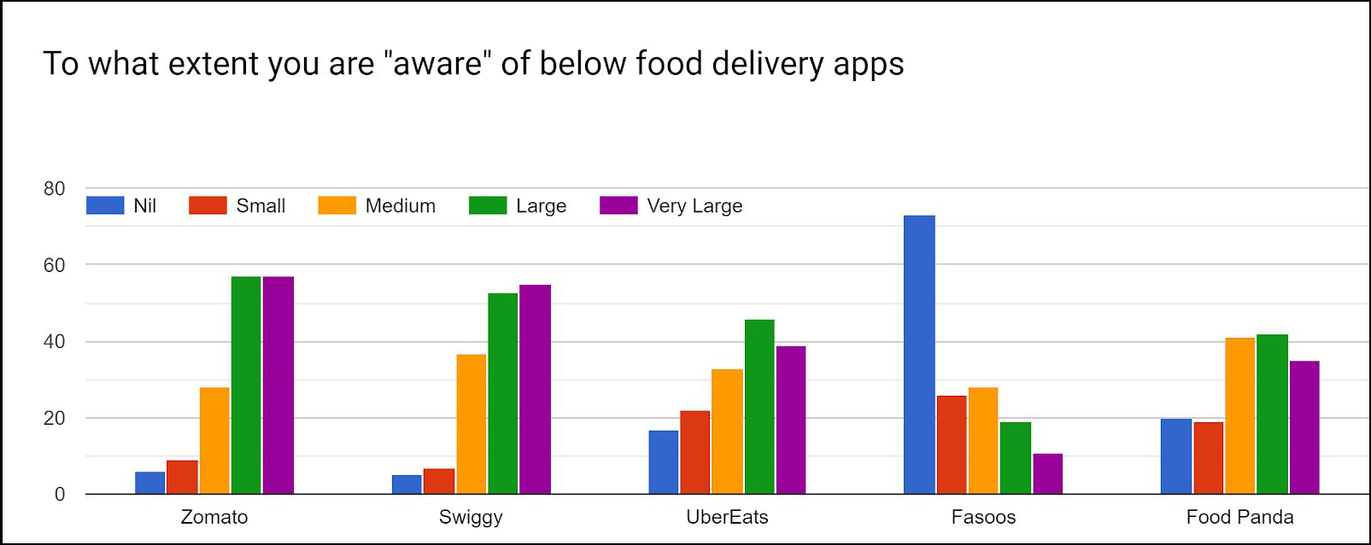

Fig 2 The awareness of Zomato and Swiggy is more as compared to other food delivery apps.

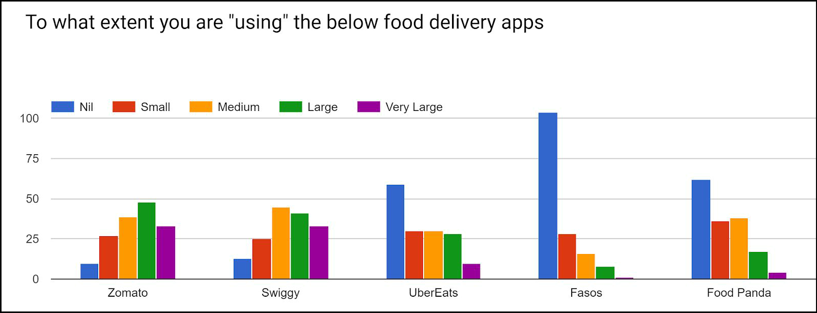

Fig 3 ​Consumers are using zomato & swiggy more as compared to other apps
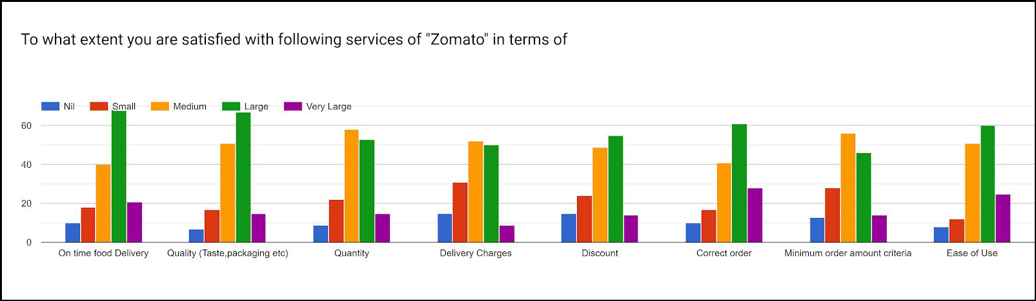

Fig 4​ ​Consumers are most satisfied with the On-time delivery followed by Quality of Zomato
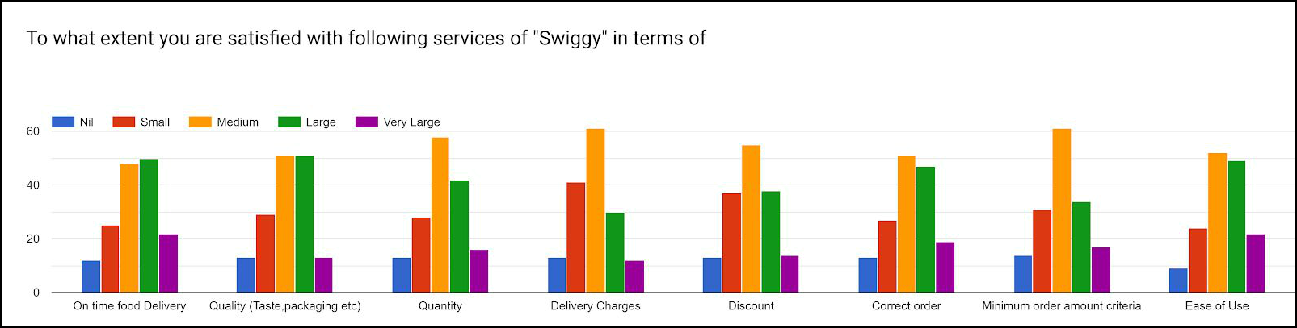

Fig 5 Customers are most satisfied with the delivery charges followed by Minimum order criteria of Swiggy

Awareness and usage of Services/facilities provided by food delivery apps

The services provided by Zomato are Piggy Bank, Self pickup, Zomato Easy, Book a Table, Corporate discounts, Free​ Meals(Share & Earn), Events and Express Delivery. Services like Piggy Bank, ​Zomato Easy, Events​ of Zomato are lesser known to the respondents. Book a Table service is known to consumers to a larger extent. The services provided by Swiggy are Swiggy POP, Self Pickup, Express Delivery and Free Delivery, Swiggy POP. Among these services, Swiggy POP is not known to most of the consumers. Most of the consumers are familiar with Self-pickup service. The services provided by Ubereats are Pock Eats and Deliver with uber. Bolt and Party order are the two services provided by Faasos. Much like the apps, services of the Ubereats and Fasoos are unpopular amongst the consumers. One-third of the consumers are using Self pickup, Book a Table and Express​ Delivery services of Zomato. Majority of the consumers who use Swiggy app are using Self Pickup, Express Delivery and Free Delivery services of Swiggy in ordering food online. 66% of the consumers are not using any services of Faasos and Ubereats. More than 30% of the consumers are using the occasional offers provided by the apps. Some of the occasional offers given by Zomato are Zomato Premier League during IPL matches and Navratri Offer during the Navratri Fast. Swiggy also provides its users similar offers with the names “Match Day Mania” and Navratri Offer. UberEats provide “​Fast & Falahari” during the Navratri. “​Zomato Gold​” is a membership provided by Zomato. ​31% of the consumers have already availed this membership whereas 29% of the app users are planning to use the membership provided by the app in the future. “​Swiggy SUPER​” is the membership provided by Swiggy​. Only 19%​ of the consumers have taken this membership and 18% are planning to take this in future. Less than 1% of the consumers use “​Faasos ELITE​”- the membership of Faasos. 85% of the respondents will refer the "Membership" provided by food ordering apps to their friends/family.

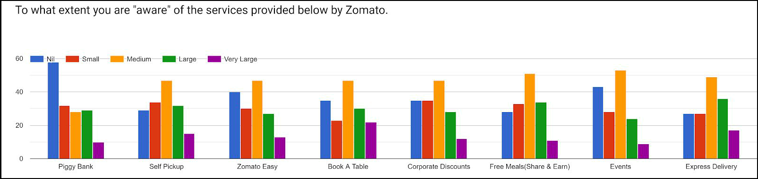

Fig 6 Customers are well known about services like Book-a-table,express delivery, self Pick up provided by Zomato.

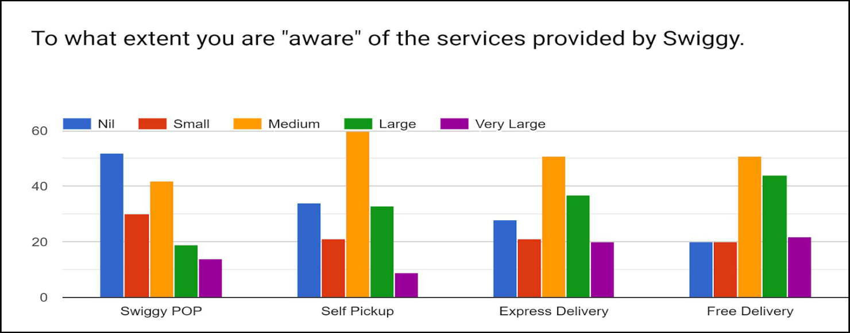

Fig 7 Customers are well known about services like Free delivery & self pickup provided by Swiggy

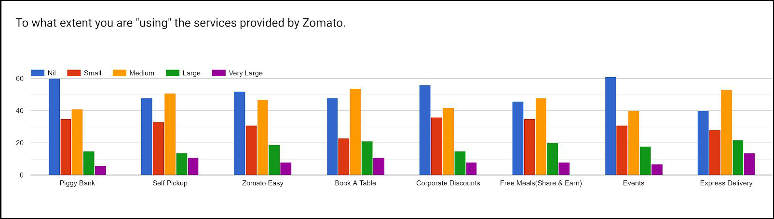

Fig 8 Customers are using services like Book-a-table,express delivery, self Pick up provided by Zomato.

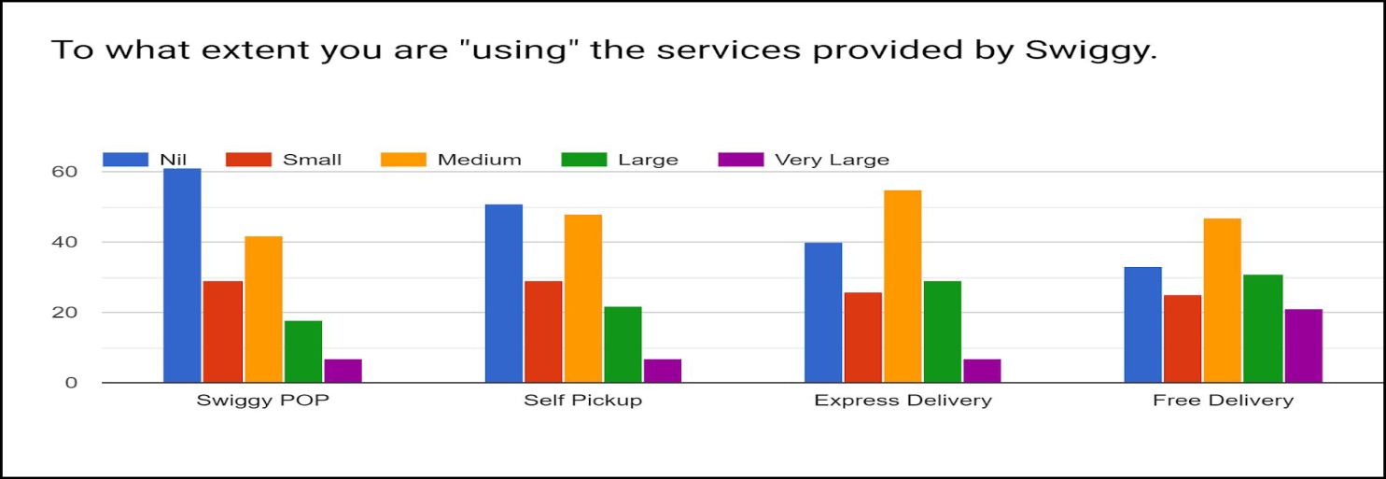

.

Fig 9 Customers are using services like free delivery, self Pick up provided by Swiggy

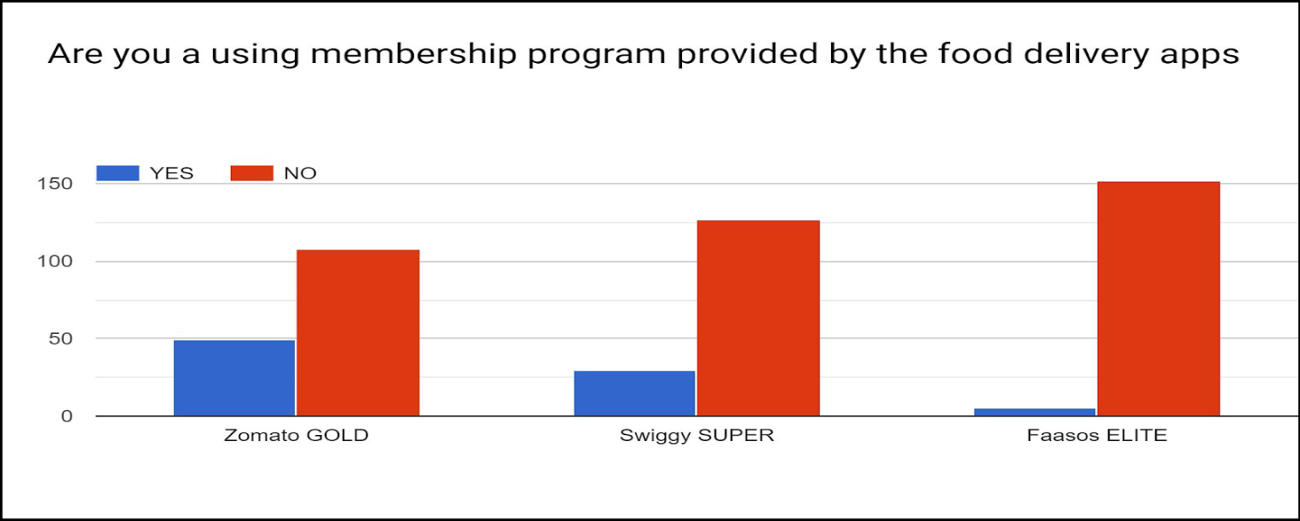

Fig 10 Zomato Gold is most preferred membership program and used by many as compared to other services.

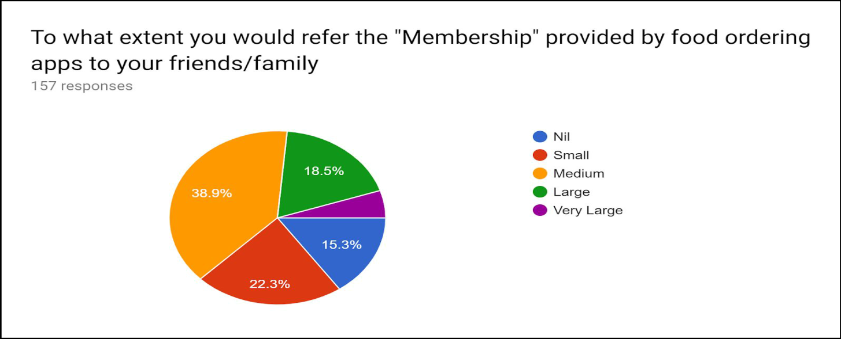

Fig 11 All the people who are using membership program around 85% will refer the membership to their friends and family.

Discount and food delivery apps

Discount is one the factors that encourages a customer to buy products. Although 90% of consumers have​ ordered food online "without any discount”, 94% of them agreed that "discount" motivate them to order food online. ​But the more loyal consumers will be unaffected by the discounts. 50% discounts largely motivate people to buy online. 50% , 40% and 30% discounts motivate customers more as compared to other discounts to order online.

​Cashbacks are the most preferred form of offers for the consumers. Cashbacks, Discounts and coupons received by the consumers results in using various digital payment modes while paying for an order and thus motivate them to order online. 89% of the people visit restaurant less frequently because they can order their favourite meals online at a lesser price due to discounts offered by food delivery apps. 86% will switch an app due to better discounts by other apps for ordering a dish. Thus, discount will affect the loyalty of consumers for different apps. Most of the users of the apps will repurchase from the same app if their current order provides discounts on the next orders. 80% of people stopped visiting restaurant frequently because of discounts provided by food delivery apps.

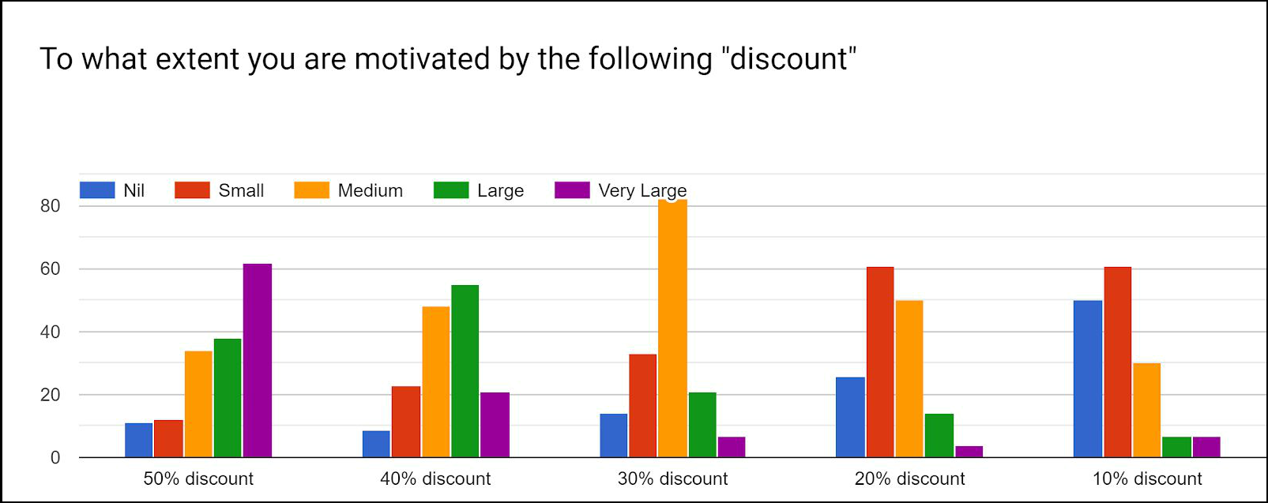

Fig 12 50% , 40% and 30% discounts motivate customers more as compared to other discounts to order online.

Fig 13 Paytm, Debit and credit cards, UPI are most preferred payment option and motivate people to order more
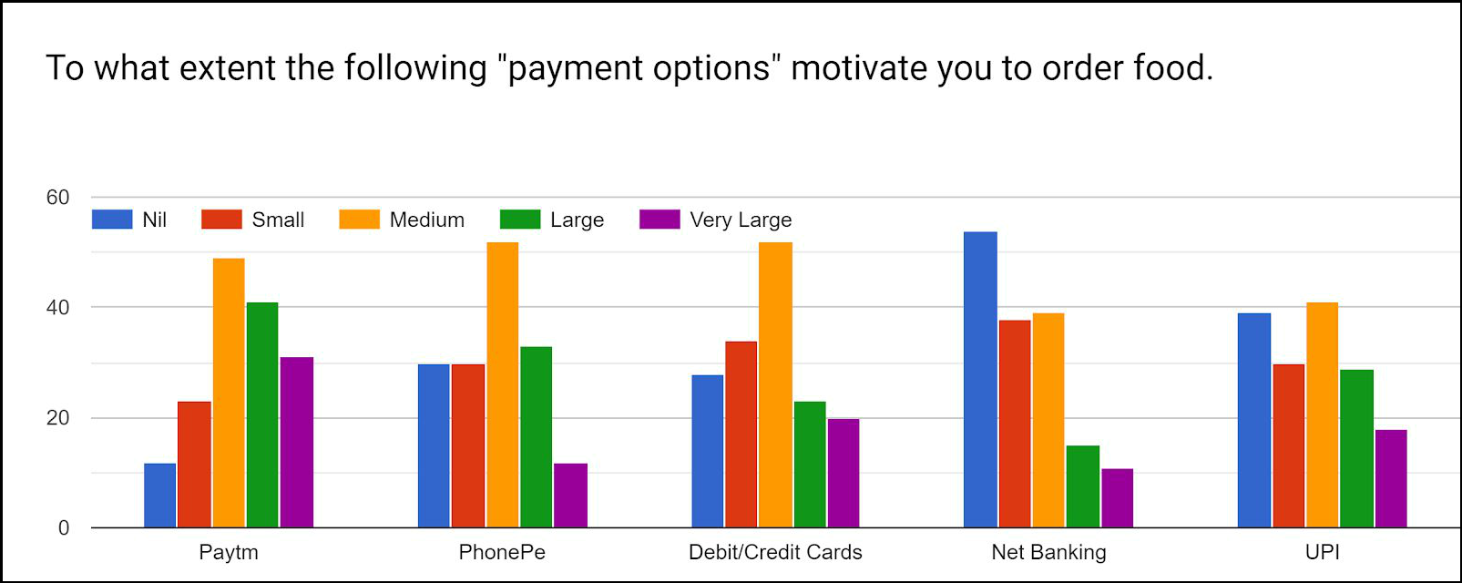

Fig 14 Cashback and discounts motivates people to use digital payment apps for ordering food online

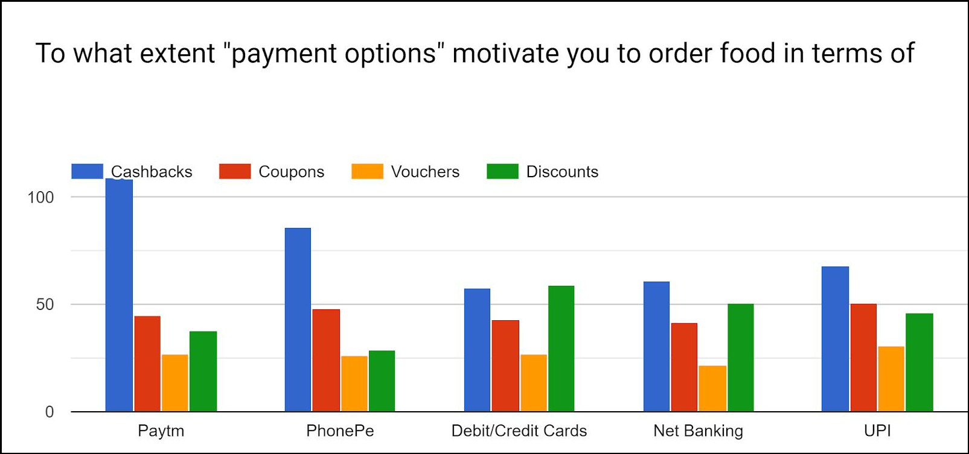

Consumer Dissatisfaction with apps

There are many factors which affect the satisfaction of the consumers for the online service of food delivery. Bad​ service, Quality, Quantity, Packaging, Taste, Late delivery of food, Privacy issues, Minimum Delivery amount, Bad past experience etc. are some of them. Late​ delivery of food, minimum delivery amount and​ bad past experience are the main reasons for consumer dissatisfaction with the food delivery apps. Quality, quantity and taste are less significant for the consumers. This is because most of the apps deliver food of the same quality and quantity. ​Also, quantity, late delivery of food, minimum order criteria are the main reasons for dissatisfaction with app when there are huge discounts offered by the apps. This may be due to the fact that consumers think that they are getting discounts by sacrificing with the quantity and speed of delivery.

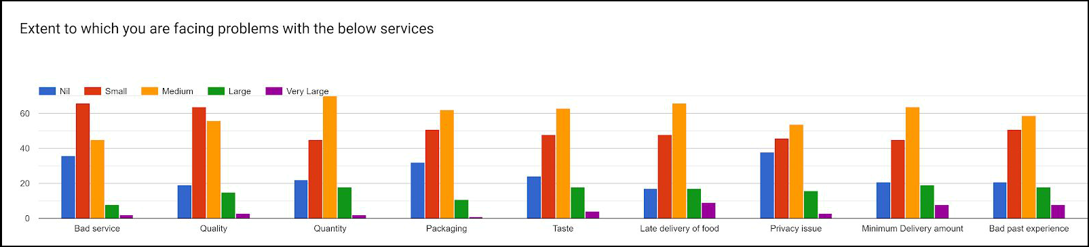

Fig 15 Late delivery of food, minimum order criteria are the main reasons for dissatisfaction with app

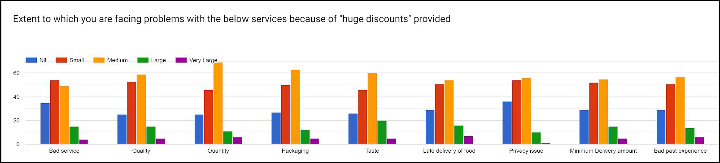

Fig 16 Due to huge Discounts, Quantity, Late delivery of food, minimum order criteria are the main reason for dissatisfaction with app

Consumers prefer online mode of ordering food through the apps because of the following factors:

- Ease & Convenience

- Cost Effectiveness

- 24/7 Availability

- Doorstep Delivery

- Choices of Restaurants at home

- Easy Mode of Payment

- Food reviews

Out of the total respondents, 82% like to order food online due to doorstep delivery followed by Ease​ & Convenience(74%) and 24/7 Availability(69%). Thus, ​Doorstep delivery​is an important parameter for using these apps. Around ​40% of the population prefer to order food ​2-3 times a month on an average. More than ​85% people spends more than 100 ​and above on an average on ordering food. Customization is an enhancer for any service business. It is the factor by which satisfaction of the consumers can be increased. Around 90% of the consumers are satisfied with this facility. Also, it can be improved further for better customer experience satisfaction. If the customer has a high satisfaction rating, cross-selling and up-selling can also be increased by giving discounts in the form of cashbacks/vouchers on related products or on more quantity ordered. Around 95% of the population will refer these apps to their friends and family. Majority of the consumers will stop ordering food online, if the company stops providing offers/discounts to them in future. ​Discount is the major factor which will motivate ​customers to switch ​between different apps.

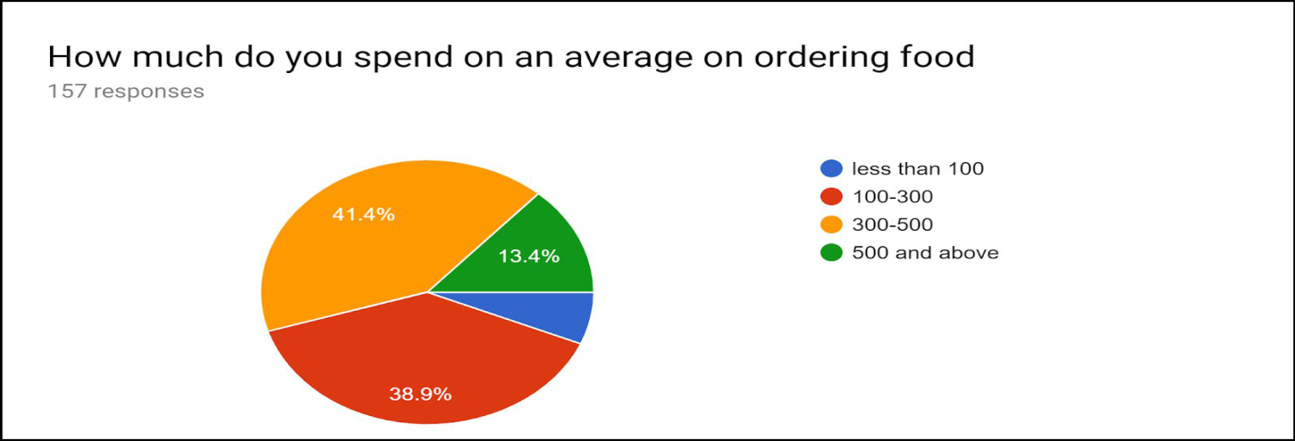

Fig 17 More than 85% people spends more than 100 and above on an average on ordering food

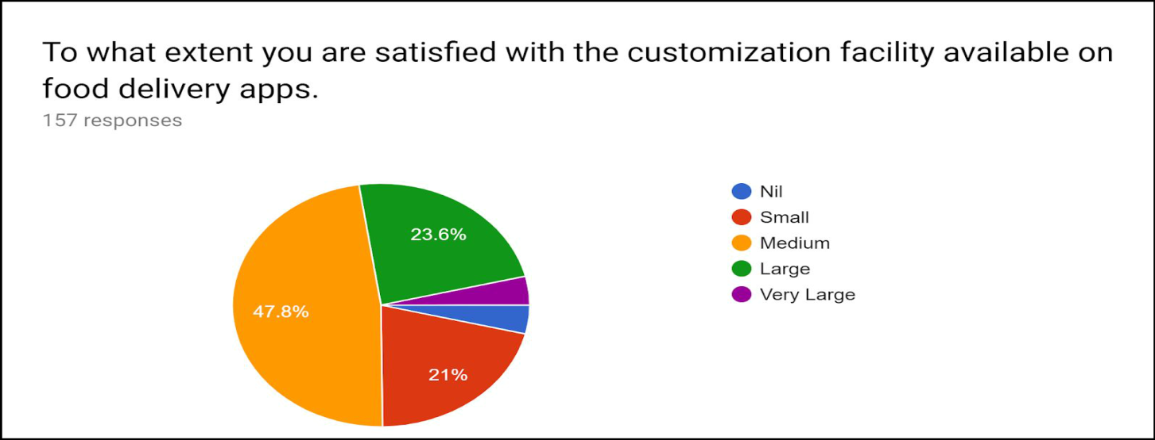

Fig 18 Customization is the factor with which an individual desire can be fulfilled around 90% are satisfied with this facility and it can be improved for better customer satisfaction

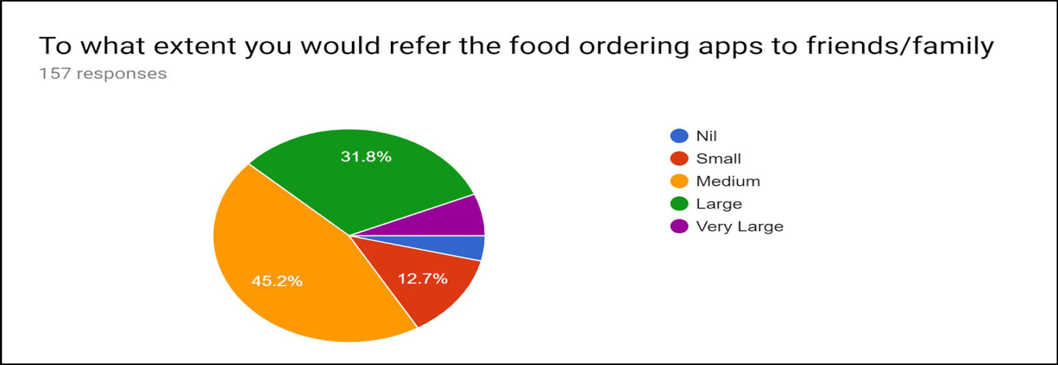

Fig 19 Around 95% of the population will refer these apps to their friends and family

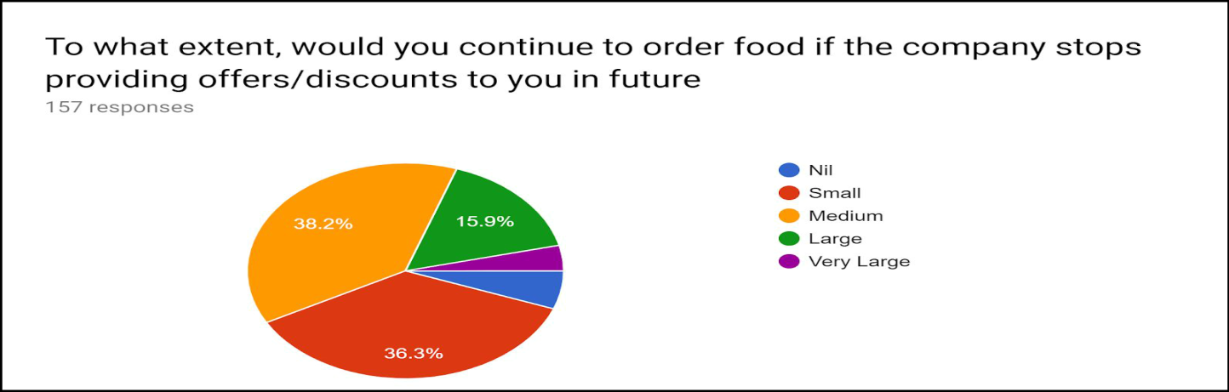

Fig 20 Around 60% of the population will stop ordering food online, if the company stops providing offers/discounts to them in future

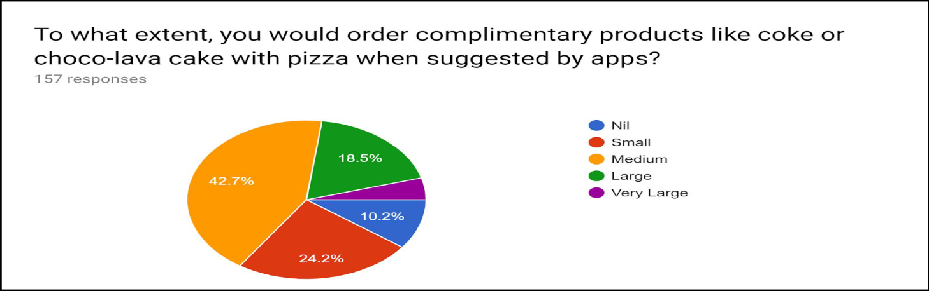

Fig 21 Cross-selling

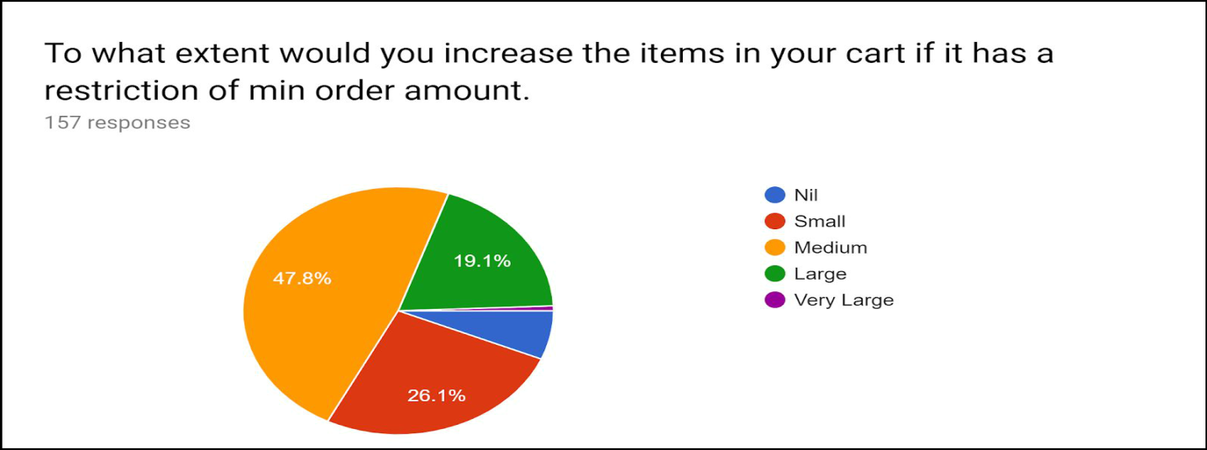

Fig 22 Up-selling

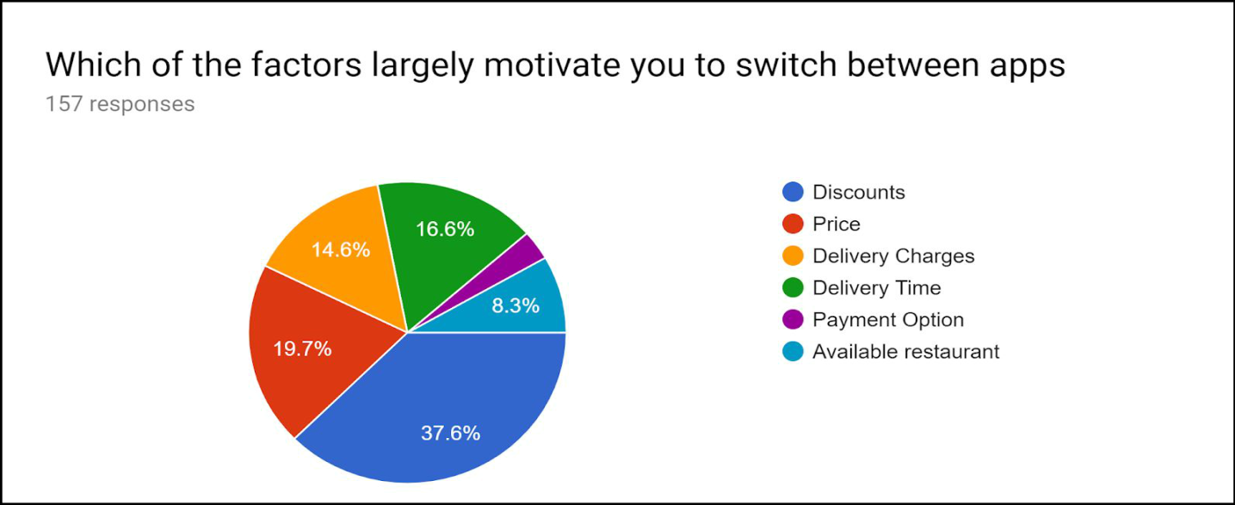

Fig 22 Discount is the major factor which will motivate customers to switch between different apps

Framework used for the study

Hypothesis for the Primary Objective

Hypothesis 1(a).

- H0: there is no significant relationship between the huge discount(50% discount) and CLV(Cross-sell, Up-sell) in online food ordering firms.

- H1​: there is significant relationship between the huge discount(50% discount) and CLV(Cross-sell, Up-sell) in online food ordering firms.



Offered 50% Discount to the customers

Activity | Correlation Coefficient | Remarks
Cross-Sell | 0.534 | Significant
Up-Sell | 0.440 | significant
 | Table 2 Output for H1
Table shows that 50% discount offered to the customers have a ​significant relationship between cross-selling & upselling because correlation coefficient is 0.534 & 0.440 respectively.

So we reject the null hypothesis(H0​) and accept the alternate hypothesis(H1).

Hypothesis 1(b).

- H0: there is no significant relationship between the huge discount(50% discount) and CLV(RFM) in online food ordering firms.

- H1​: there is significant relationship between the huge discount(50% discount) and CLV(RFM) in online food ordering firms.


Offered 50% Discount to the customers

Activity | Correlation Coefficient | Remarks
Frequency | 0.475 | Significant
Monetary | 0.106 | Insignificant
 | TABLE 3 Output for H1(b)

Table shows that 50% discount offered to the customers have a significant relationship with frequency of ordering food online i.e. correlation coefficient is 0.475.
So we reject the null hypothesis(H0​) and accept the alternate hypothesis(H1).

Hypothesis 2(a).

- H0: there is no significant relationship between the facilities(Membership) provided by apps and CLV(Referrals) in online food ordering firms.

H1​: there is significant relationship between the facilities(Membership)provided by apps and CLV(Referrals) in online food ordering firms.


Services such as memberships

Activity | Correlation Coefficient |  | Remarks
 | Zomato gold | Swiggy Super | Zomato gold |  | Swiggy Super
Referrals | 0.644 | 0.313 | significant |  | significant
TABLE 4 Output for H2(a)

Table shows that Service such as membership offered to the customers have a significant relationship with referrals. The customer will refer membership program of Zomato “Zomato Gold” to their friends and family. The correlation coefficient is 0.644.
So we reject the null hypothesis(H0​) and accept the alternate hypothesis(H1).

Hypothesis 2(b).

- H0: there is no significant relationship between the facilities(Customization) provided by apps and CLV(Referrals) in online food ordering firms.

H1​: there is significant relationship between the facilities(Customization)provided by apps and CLV(Referrals) in online food ordering firms.


Service such as customization facility

Activity | Correlation Coefficient |  | Remarks
Referrals | 0.604 |  | Significant
 | TABLE 5 Output for 2(b)
Table shows that customization facility provided to the customers have a significant relationship with referrals. i.e. correlation coefficient is 0.604.
So we reject the null hypothesis(H0​) and accept the alternate hypothesis(H1).

Secondary Objective
- To analyse what are the various factors that influence the customers to choose online food delivery services.

- To analyse what are the various factors that hinders the customers to choose online food delivery services.
- How 50% discounts affect the buying behaviour of customers.

Hypothesis for the Secondary Objective

Hypothesis 3:

- Factors that influence the customers to choose online food delivery services.
H0: there is no significant relationship between factors affecting usage & food delivery apps(Zomato & Swiggy).
H1​: there is significant relationship between the factors affecting usage & food delivery apps(Zomato & Swiggy).


Factor that influence customers the most to order online

Factors |  | Correlation Coefficient |  | Remark
 |  | Zomato | Swiggy | Zomato | Swiggy
On-Time delivery |  | 0.621 | 0.596 | significant | Significant
Quality |  | 0.590 | 0.589 | significant | significant
Quantity |  | 0.512 | 0.539 | significant | significant
Delivery charges |  | 0.345 | 0.662 | significant | significant
Discounts |  | 0.734 | 0.694 | Significant | Significant
Correct Order |  | 0.530 | 0.583 | significant | significant
Minimum order |  | 0.430 | 0.579 | significant | significant
criteria
Ease of use |  | 0.509 | 0.553 | Significant | Significant
 |  | TABLE 6 Output for H3

Hypothesis 4:

- Factors that hinders the customers to choose online food delivery services.
H0: there is no significant relationship between heavy discounts & dissatisfaction with food delivery apps.

H1​: there is significant relationship between heavy discounts & dissatisfaction with food delivery apps.

Factors leading to dissatisfaction due heavy discounts

(Hinderance)

Factors | Correlation Coefficient | Remark
Bad Service | 0.264 | significant
Quality | 0.455 | Significant
Quantity | 0.151 | significant
Packaging | 0.241 | significant
Taste | 0.229 | significant
Late delivery of orders | 0.581 | Significant
Privacy issues | 0.129 | Insignificant
Minimum order criteria | 0.418 | Significant
Bad experience in Past | 0.152 | Insignificant
 | Table7 Output of H4

Table shows that factors leading to dissatisfaction(​Hinderance​)have a significant relationship with Huge discounts. From table above, Late delivery of orders(0.581), Minimum order criteria(0.418) and quality(0.455) are the main reason behind dissatisfaction.
Hypothesis 5:
- How 50% discounts affect the buying behaviour of customers.

H0: there is no significant relationship between 50% discounts & motivation to buy.

H1​: there is significant relationship between 50% discounts & motivation to buy.



Offered 50% Discount to the customers

Activity | Correlation Coefficient | Remarks
Motivation to Order food online | 0.454 | Significant
Table 8 Output for H5
Table shows that 50% discounts offered to the customers have a significant relationship with motivation to order food online. i.e. correlation coefficient is 0.454 and p-value is 0.000 which is less than 0.05.
Table 9 Acceptance/Rejection of Hypothesis

S.No. | HYPOTHESIS DESCRIPTION | RESULTS
H1(a) | Huge discount(50% discount) on CLV(Cross-sell,Up-sell) | Accepted
 | in online food ordering firms.
H1(b) | Huge discount(50% discount) on CLV(RFM) in online food | Accepted
 | ordering firms.
H2(a) | Facilities(Membership) provided by apps on | Accepted
 | CLV(Referrals) in online food ordering firms.
H2(b) | Facilities(Customization) provided by apps and CLV | Accepted
 | (Referrals) in online food ordering firms.
H3 | Factors affecting usage on food delivery apps(Zomato & | Accepted
 | Swiggy).
H4 | Heavy discounts on dissatisfaction with food delivery | Accepted
 | apps.
H5 | 50% discounts on motivation to buy. | Accepted

LIMITATIONS OF THE STUDY

The sample size i.e. 1560 respondents of this study is very small for Indian market analysis and tht too a zone restricted parameter of NCR. The research covers a small part of the population and findings may not be applied to the other parts of the country because of social and cultural differences. We can only identify the trends in online food ordering behavior but we cannot formulate rules in online buying behaviour based on this study.
CONCLUDING REMARKS

At present food delivery apps provides huge offers and discounts to the existing customers to enhance their experience of online ordering of food and to attract new customers and retain them. The offer and discounts vary from cashbacks, vouchers, coupons, to 10-50% discounts.Through this study, it is found that these huge discounts and different services offered by the food delivery apps have a significant impact on the lifetime value and the buying behaviour of customers. There is a significant relationship between the discounts and cross-selling and upselling & between discounts and frequency of order by the customer. Thus, Discount affects the loyalty of the customers, profitability of the firm and referrals of the services by the firm. The profitability, loyalty and referrals have a direct impact on the lifetime value of the customers. Also, If the customers are giving high satisfaction ratings to the services they are getting such as membership programs, customizations, doorstep delivery etc. then they would refer these services to their friends and family as well which will affect the customer lifetime value. The study finds a significant relationship of referral with customization and membership Thus, both discount and facilities/services have a positive effect on CLV.

REFERENCES

- Chavan, V., Jadhav, P., Korade, S., and Teli, P., (2015), “Implementing Customizable Online Food Ordering System Using Web Based Application”, International Journal of Innovative Science, Engineering & Technology, Vol 2 Issue 4, April 2015.

- Hong, W. L., (2016), “Food Ordering System Using Mobile Phone”, A report submitted to BIS (Hons) Information Systems Engineering. Faculty of Information and Communication Technology (Perak Campus), UTAR.

- Malhotra, N. (2013). Review of marketing research. Bradford: Emerald Group Publishing Limited.
- Onditi, A., (2014), “Implications of Customer Service on Customer LifeTime Value in Tourism Sector in Kisumu County, Kenya”, International Journal of Sciences: Basic and Applied Research (IJSBAR) (2014) Volume 17, No 1, pp 236-258.

- Sethi, H. K., (2017), “Product and Brand Strategy of Zomato”, International Journal of Engineering Research & Technology (IJERT), Vol. 6 Issue 06, June - 2017.

- Sethu, H. S., & Saini, B. (2016), “Customer Perception and Satisfaction on Ordering Food via Internet, a Case on Foodzoned.Com, in Manipal”, Proceedings of the Seventh Asia-Pacific Conference on Global Business, Economics, Finance and Social Sciences (AP16Malaysia Conference) ISBN: 978-1-943579-81-5. Kuala Lumpur, Malaysia. 15-17, July 2016. Paper ID: KL631.

