New Innovations in IVF Technologies

Abstract

Recent innovations in in vitro fertilization (IVF) technologies have significantly improved reproductive success and patient outcomes. Advances such as time-lapse embryo imaging, artificial intelligence-based embryo selection, preimplantation genetic testing, and microfluidic culture systems enhance embryo quality assessment and implantation rates. Cryopreservation techniques, including vitrification, have increased the survival of oocytes and embryos during storage. Additionally, stem cell research and personalized hormonal stimulation protocols contribute to safer and more effective fertility treatments. These emerging technologies reduce treatment failure, improve pregnancy rates, and minimize complications, offering new hope to infertile couples while advancing the field of assisted reproductive biotechnology and precision reproductive medicine.

Key words: Artificial Intelligence, Cryopreservation, IVF technologies, Innovations, stem cells

Introduction
In Vitro Fertilization (IVF) has transformed reproductive medicine and provided hope to millions of infertile couples around the world. Since the birth of the first IVF baby in 1978, the field has undergone remarkable progress. Modern IVF technologies now combine artificial intelligence, genetics, robotics, and advanced laboratory systems to improve success rates and patient safety. Today, IVF is becoming more personalized, efficient, and accurate than ever before.
Recent innovations such as AI-based embryo selection, time-lapse imaging, non-invasive genetic testing, microfluidics, and stem-cell research are reshaping fertility treatment. These technologies aim to improve embryo quality assessment, reduce failed cycles, and increase healthy live births while lowering emotional and financial burdens on patients.

1. Artificial Intelligence (AI) in IVF
Artificial Intelligence has emerged as one of the most significant breakthroughs in IVF technology. AI systems analyze large amounts of cli nical and embryo-development data to help embryologists select the healthiest embryos for transfer. Modern AI algorithms evaluate embryo images obtained through microscopes and identify subtle developmental patterns that may not be visible to the human eye. AI-assisted embryo grading improves the accuracy of embryo selection and reduces subjectivity in decision-making. Studies show that AI can improve implantation success and reduce miscarriage risk.

Advantages of AI in IVF
- Improved embryo selection
- Faster and more accurate diagnosis
- Personalized treatment planning
- Reduced human error
- Increased pregnancy success rates
A major innovation in 2025 was the development of the IVF foundation model “FEMI,” trained using nearly 18 million embryo images. This advanced AI system can predict embryo quality and developmental outcomes with high accuracy.


AI-assisted embryo analysis system in a modern IVF laboratory

2. Time-Lapse Embryo Imaging
Time-lapse imaging technology allows continuous monitoring of embryo development without removing embryos from incubators. Special incubators equipped with cameras capture thousands of embryo images at different developmental stages. This innovation helps embryologists observe embryo growth patterns, cell division timing, and developmental abnormalities more precisely. Unlike traditional methods, embryos remain in a stable environment, improving their survival and development potential. Deep-learning systems now combine time-lapse imaging with AI to predict embryo viability more accurately than traditional visual assessment.

Benefits
- Continuous embryo monitoring
- Better embryo selection
- Reduced disturbance to embryos
- Higher implantation success
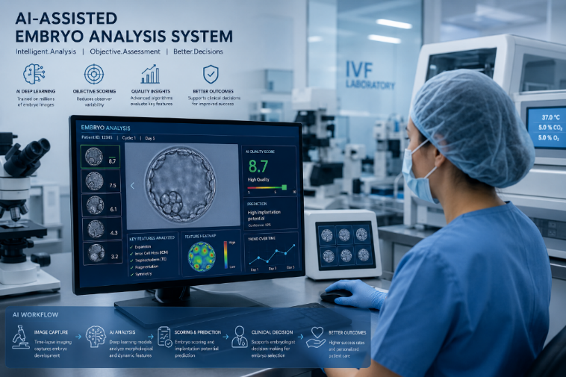

Time-lapse embryo incubator used in fertility clinics

3. Preimplantation Genetic Testing (PGT)
Preimplantation Genetic Testing has revolutionized IVF by allowing doctors to screen embryos for genetic disorders before implantation. Using advanced sequencing technologies, embryologists can identify chromosomal abnormalities and inherited diseases. Modern next-generation sequencing methods have improved the speed and accuracy of genetic testing while reducing risks to embryos.
There are three different forms of PGT:
- PGT-A – detects chromosomal abnormalities
- PGT-M – identifies single-gene disorders
- PGT-SR – screens structural chromosome rearrangements

Importance
- Reduces genetic disorders
- Improves healthy pregnancy rates
- Lowers miscarriage risk
- Helps older women achieve successful pregnancies

4. Microfluidic Technology in IVF
Microfluidics is another groundbreaking innovation in IVF. Microfluidic devices use tiny channels to handle sperm, eggs, and embryos under conditions that mimic the natural reproductive system. Traditional IVF procedures use petri dishes, while microfluidic systems create a more physiological environment for fertilization and embryo growth. Studies suggest that this technology can improve embryo quality and pregnancy outcomes. Microfluidic chips can also automate laboratory procedures and reduce the need for manual handling by embryologists.

Advantages
- Better sperm selection
- Reduced stress on embryos
- Improved fertilization environment
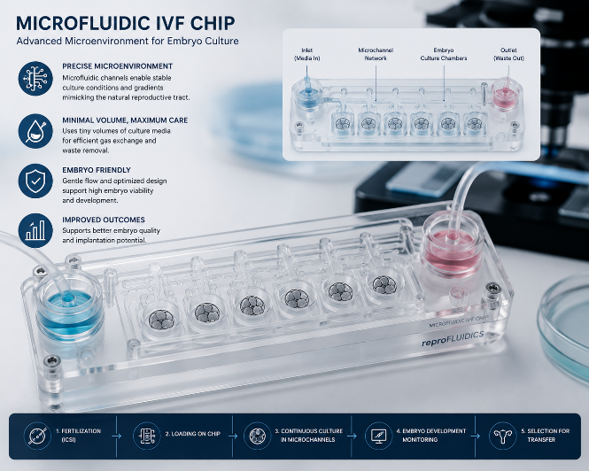
- Lower contamination risk

Microfluidic IVF chip used for embryo culture

5. Cryopreservation and Vitrification
Cryopreservation technology has significantly advanced over the past decade. The introduction of vitrification, a rapid freezing technique, has dramatically improved the survival rate of frozen eggs and embryos. Unlike older slow-freezing methods, vitrification prevents ice crystal formation that can damage cells. Today, frozen embryo transfer cycles often show success rates comparable to or better than fresh transfers. Egg freezing has become increasingly popular among women wishing to preserve fertility for future family planning.

Benefits
- Fertility preservation for cancer patients
- Delayed parenthood options
- Better embryo survival after thawing
- Increased flexibility in treatment timing

6. Personalized IVF and Precision Medicine
Modern IVF is moving toward personalized medicine, where treatments are tailored to individual patient characteristics such as hormone levels, age, ovarian reserve, and genetics. AI-based predictive models and hormone profiling help fertility specialists customize ovarian stimulation protocols for better outcomes and reduced complications such as ovarian hyperstimulation syndrome (OHSS).

Key Features
- Personalized hormone stimulation
- Data-driven treatment decisions
- Reduced medication side effects
- Improved patient comfort

7. Stem Cell Research and Future Innovations
Scientists are exploring the use of stem cells and gene-editing technologies to address infertility problems that were previously untreatable. Experimental research focuses on creating artificial gametes (sperm and eggs) from stem cells. Gene-editing technologies such as CRISPR-Cas9 may eventually help correct inherited genetic disorders before embryo implantation, although ethical concerns remain significant.
Future IVF innovations could further improve accessibility, affordability, and success rates of fertility treatments:
- Fully automated IVF laboratories
- AI-driven fertility prediction systems
- Advanced embryo metabolism analysis
- Robotic embryo handling
- Virtual fertility monitoring

Ethical and Social Concerns

Despite technological progress, IVF innovations raise important ethical and social issues. Medical professionals and governments must ensure that IVF technologies are used responsibly and ethically.
- Genetic selection concerns
- Data privacy in AI systems
- High treatment costs
- Unequal access to fertility care
- Ethical debates over gene editing

Conclusion
Innovations in IVF technologies are transforming reproductive medicine and providing new hope for infertile couples worldwide. Artificial intelligence, time-lapse imaging, genetic testing, microfluidics, and personalized medicine are significantly improving IVF outcomes and reducing treatment risks. Emerging technologies such as stem-cell therapy and gene editing may further revolutionize fertility care in the future. As science advances, IVF is becoming more precise, efficient, and patient-centered. However, ethical considerations and equal accessibility remain important challenges that must be addressed alongside technological progress.

References
- Rajendran S., Rehani E., Phu W., Zhan Q., Malmsten J.E., Meseguer M., Miller K.A., Rosenwaks Z., Elemento O., Zaninovic N. and Hajirasouliha I. (2025). A foundational model for in vitro fertilization trained on 18 million time-lapse images. Nature Communications. 16:6235.
- kaveh S., Ghaffari A. and Sohrabei S. (2025). Artificial intelligence in predicting and evaluating sperm and embryo quality in the in vitro fertilization: a systematic review. Discover Artificial Intelligence. 5:183. https://doi.org/10.1007/s44163-025-00420-8.
- AlSaad R., Abusarhan L., Odeh N., Abd-alrazaq A., Choucair F., Zegour R., Ahmed A., Aziz S. and Sheikh J. (2025). Deep learning applications for human embryo assessment using time-lapse imaging: scoping review. Vol 7. doi: 10.3389/frph.2025.1549642.
- Alieva Z. (2026). Precision in vitro fertilization in 2025: AI, Genomics, and Microfluidic Technologies Reshaping Assisted Reproduction. Journal of Clinical and Biomedical Research, 2(1), 76–81. https://www.medjournal.it.com/index.php/jcbr/article/view/68
- Official guidelines and educational resources on assisted reproductive technologies. (2026). American Society for Reproductive Medicine (ASRM). https://www.asrm.org/?utm_source=chatgpt.com
- European Society of Human Reproduction and Embryology (ESHRE) International research and clinical guidance related to in vitro fertilization and fertility treatment. (2026). https://www.eshre.eu/?utm_source=chatgpt.com
- Mayo Clinic – In Vitro Fertilization Overview Clinical explanation of in vitro fertilization procedures, benefits, and risks. (2026). https://www.mayoclinic.org/tests-procedures/in-vitro-fertilization/about/pac-20384716?utm_source=chatgpt.com
- World Health Organization – Infertility Factsheet Global data and public health information regarding infertility and reproductive care. (2026). https://www.who.int/news-room/fact-sheets/detail/infertility?utm_source=chatgpt.com

